**Project Log Book**

**Group Members:**

|  |  |
| --- | --- |
| **Entry Date** | **Work Done** |
| September 7th, 2021 | Discussed the basic plan to build the prototype for CRM in class, noting down all constraints to be taken care of. Furthermore, we decided our next group meeting would be on September 15th, 2000 (Friday) at 5:30, meeting place: Zaida Morales' House. |
| September 15th, 2000 | Meeting at Zaida's Place: We discussed about the project objective. Using the Software Management Plan template printed from the web site, we stepped through each section and discussed what was required and what resources were available to us. We also discussed how this prototype should be flexible for other countries. There was constant reference to the "Chinese Railway Passenger Reservation System" and other related articles. |
| September 16th, 2000 | Finished a rough draft prototype and set it up on the online account. |
| September 19th, 2000 | Zaida M. Morales checked the document of the Software Project Management Plan, and she made some correction marking the corrections in red. |
| September 20th, 2000 | The mistakes were corrected on the web site, and email was sent to Zaida M. morales to check the document for any more mistakes |
| September 20th, 2000 | The document was checked by Zaida M. Morales and few more mistakes were found. These mistakes were corrected and put on the web. |
| September 22th, 2000 | Meeting at Zaida's Place: We discussed the Reservation System in more detail and added more information to the SPMP document. |
| September 25th, 2000 | Zaida M. Morales checked the document of the Software Project Management Plan, and she made some corrections. |
| September 27th, 2000 | The mistakes were corrected on the web site, and email was sent to Zaida M. morales to check the document for any more mistakes. |
| September 29th, 2000 | Meeting at Zaida's Place: We discussed parts 4 and 5 of the Software Project Management Plan in more detail and decided to update some information in the SPMP document. The different parts of the document were divided between the team for updates. |
| October 3th, 2000 | Finished updating the rough draft prototype and set it up on the online account. Sent all team members email with link to latest copy of the document. |
| October 4th, 2000 | Zaida M. Morales checked the document of the Software Project Management Plan. The mistakes were corrected on the web site. The latest version of the document is available online. |

***Last Updated on Novemeber 7th, 2000***

**Software Requirements Specification**

*for*

***Employee Management***



***Nimra humayun***

***Ramsha Mansoor***

***Zainab Fatima***

***December 04, 2020***

|  |  |  |
| --- | --- | --- |
| Version | Changes Made | Date |
| 1.0 | [First Pass for Review](http://www.geocities.com/cs5391/SRS1.htm) | 15/03/2022 |
| 1.2 | [Second Pass for Review](http://www.geocities.com/cs5391/SRS2.htm) |  |
| 1.3 | [Third Pass for Review](http://www.geocities.com/cs5391/SRS3.htm) |  |
| 1.4 |  |  |
|  | | |

**Table of Contents**

1. Introduction

2. The General Description

3. Specific Requirements

4. Supporting Information

**1. Introduction**

**1.1 Purpose**

This document describes the software requirements for the Employee Management System built for the Small Businesses.

**1.2  Scope In**

The Small Businesses are requesting proposals to build a prototype of an Employee Management System (EMS) for their current system. This new EMS needs to be scalable enough so that it can accommodate the increase in employee hiring in any offices and department.

The system will be designed to provide an user interface that will help a business manage their employees. The system will have a user-friendly graphical interface and will be more cost effective compared to the current on paper version of the employee management system.

The objectives of this development effort are:

1. To provide existing clerks with a new environment in which to make management for employees.
2. To provide an avenue for businesses to manage employees in a more convenient way.
3. To regain control of the employee management to avoid scalping and reorganizing of employees.
4. To implement a prototype of a scaled down version of the final system to test the solution and further develop requirements.
5. To collect statistics in a more efficient manner for future employee management and project assigning.
6. To increase efficiency of business.

**1.3  Scope Out**

The following features will not be the part of this Project:

1. Over the internet connectivity.
2. mobile app

**1.3 Definitions, Acronyms, and Abbreviations.**

EMS – Employee Management System

CASE – Computer Aided Software Engineering

PP - Project Plan

SDD - Software Design Description

SRS - Software Requirement Specification

SDS – Software Design Specification

SPMP - Software Project Management Plan

GUI – Graphical User Interface

QAM – Quality Assurance Manager

PDM – Project Development Manager

PMP – Project Management Professional

TBD – To be determined

UML – Unified Modeling Language

**1.4 References**

**1.5 Overview**

Chapter 2 of the SRS is a brief description of the characteristics of the software to be built, its functions, its users, its constraints and its dependencies.

Chapter 3 is about specific requirements, such as functional requirements, external interface requirements, performance requirements, and also design constraints and quality characteristics.

Finally, chapter 4 includes all the supporting information, such as the Table of Contents, the Appendices, and the Index.

**2. The General Description**

This section describes the general factors that affect the product and its requirements. This section consists of five subsections that follow. This section does not state specific requirements. Each of the subsections makes those requirements easier to understand, it does not specify design or express specific requirements. Such detail is provided in section 3.

**2.1 Product Perspective**

The Employee Management System diagram showing the overview of the system’s modules and the relationship of the system to external interfaces is presented in Figure 2.1.

## Figure 2.1 Overview/Architecture Diagram of the EMS

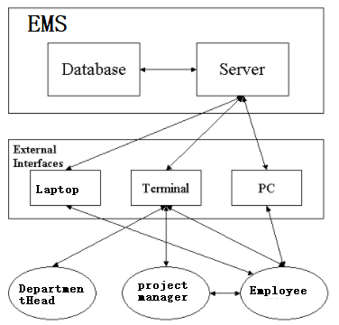

**Functions of System Components:**

Database:

∙       Stores data

∙       Creates reports

∙       Provides access to data

∙       Updates information

Server:

∙       Provides access to the database

∙       Authenticates users

∙       Processes reservations

∙       Performs backups

∙       Produces reports

**External Interfaces:**

Terminal

∙       Users use terminals to access the server

∙       Employee and Project managers can use terminals to access the EMS.

∙       Department Head may use terminals to see the employees and projects.

Personal Computers/laptops

∙       Users (Employee, Project manager and Department head) may use personal computers or laptop to obtain a remote access to the server and the reservation database via the Internet.

Computer Hardware and Peripheral Equipment to be used:

∙       30 workstations, which include CPUs, monitors, keyboards, and mice

∙       Printers

∙       Network

∙       Terminals

∙       Cell phones to test connection to the server via remote access

**2.2 Product Functions**

This section provides a summary of the functions that the software will perform.

**2.2.1 Function Relationships**

Figure 2.2 to 2.6 depicts the relationships among the functions to be implemented by the system.  
  
Figure 2.2 EMS General Function Relationship/**Higher Level Usecase** Diagram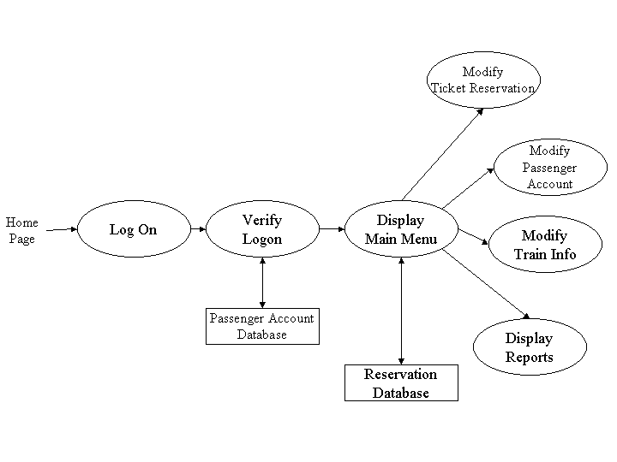

Employee Module

Department Module

Project Module

Module 3

**2.2.2 Function Descriptions (Functional Requirement Listings)**

**2.2.2.1 Log In Function**

***Description:*** This function ensures that only authorized users gain access to the Employee Management databases. An authorized user is a user who has an account on the system. Users include Employees, Project managers and Department heads. The user must type a valid username and password to gain access.

**2.2.2 Module 1 nimra: Employee Management**

***Description:*** Employees can login and see their details.

Employees can see the department they are assigned to.

Employees can see projects they are assigned to (complete and in-progress).

.

**2.2.3 Module 2:**

***Description:*** This function

**2.2.4 Module 3 ZAINAB : PROJECT MANAGEMENT**

***Description:*** Employees can login and

Employees can see projects they are assigned to complete and in-progress. Project manager can update ,view and delete their projects.

**2.3 User Characteristics**

The main users of the system will be the Employee who can login and view their info and update that they can view all the projects assigned to them and can search projects from all the projects assigned to them. The users are not required to have knowledge in the computer field. The graphical interface provides an easy way of using the EMS system with minimum training.

**2.4 General Constraints**

The constraints for the project are:

* The functional prototype should be available after 30 days upon the arrival of the management team to Business. This may prove to be a serious time constraint on the development of a successful prototype.
* Team members are restricted from bringing their own equipment, and insufficient equipment supply may hinder project development.
* Team members are restricted to bringing only the analysts of the team to Client. This might affect the project development if more people are needed or the required skills are not available.

**2.5 Assumptions and Dependencies** **or Business Logic**

The assumptions for the project are:

* Employees can login and see their details.
* Employees can see the department they are assigned to.
* Employees can see projects they are assigned to(complete and in-progress).
* Department heads can login.
* Department heads can view all employees and projects in their department.
* Department heads can create projects and declare projects (complete or in-progress).
* Department heads can assign employees to projects.
* Project Managers can assign employees to projects.
* Project Managers can view all employees and projects.

## <ADD OOAD REPORT DIAGRAMS HERE>

**3. Specific Requirements**

This section of the SRS contains design requirements for the Employee Management System.

**3.1 Functional Requirements**

**3.1.1 Module 1 Nimra: complete CRUD Employee Module**

1. ***Description:*** This function ensures that only authorized users gain access to the Employee Management System. An authorized user is a user who has an account on the system. Users include employees, department heads, and project managers. The user must type a valid username and password to gain access.

1. ***Usage Scenario/ Use case Description/******Specification:***

|  |  |
| --- | --- |
| Description | Allows access to EMS |
| Inputs | Username, password |
| Source | 1. User inputs username and password 2. Press Login Button |
| Alternate case |  |
| Outputs | Successful login; unsuccessful login |
| Destination | None |
| Precondition | Authorized User |
| Post Condition | No change to Passenger Accounts Database |
| Side Effects | Failures and successful logins are sent to Reservation Database |

1. ***Detailed Use case Diagram for* Employee Module**

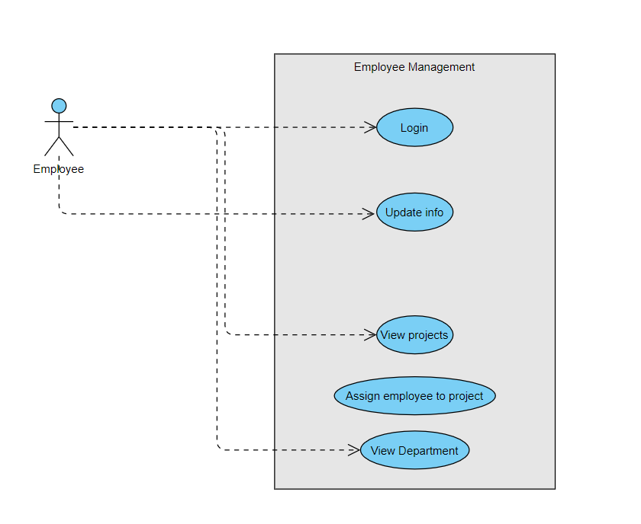

1. ***Use case Realization for* Employee Module**

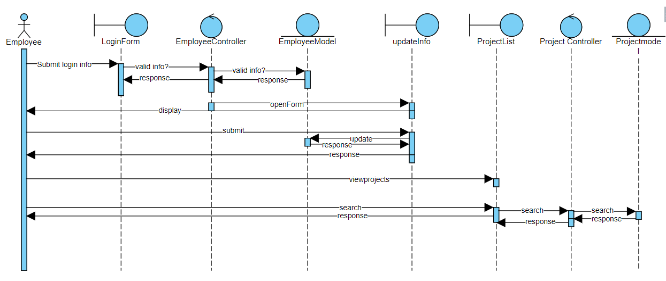

1. ***Flow of Event or Data Flow Diagram for* Employee Module**

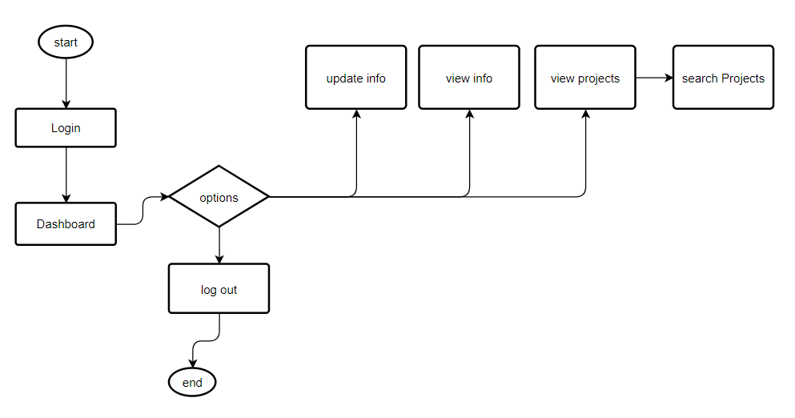

1. ***Sequence Diagram for* Employee Module**

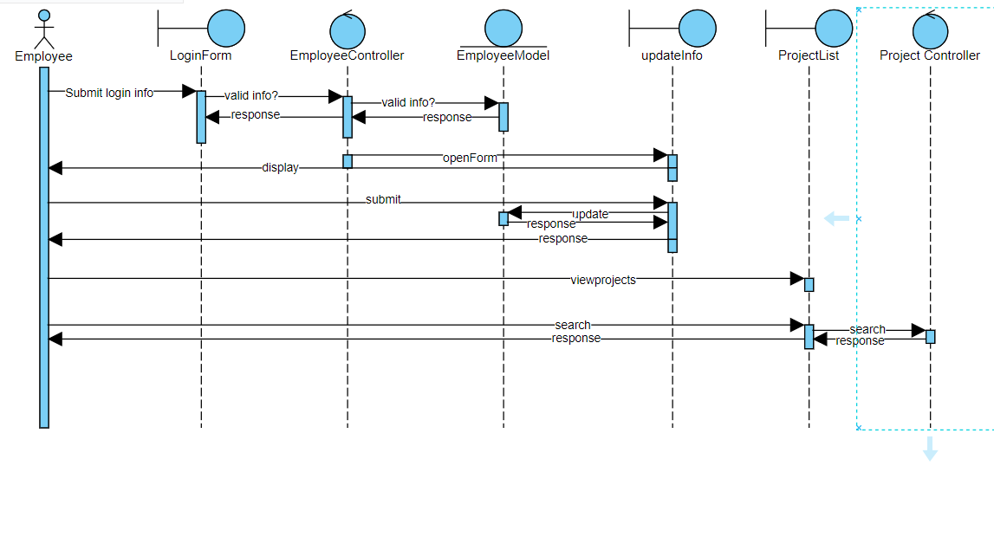

1. ***Collaboration Diagram for* Employee Module**

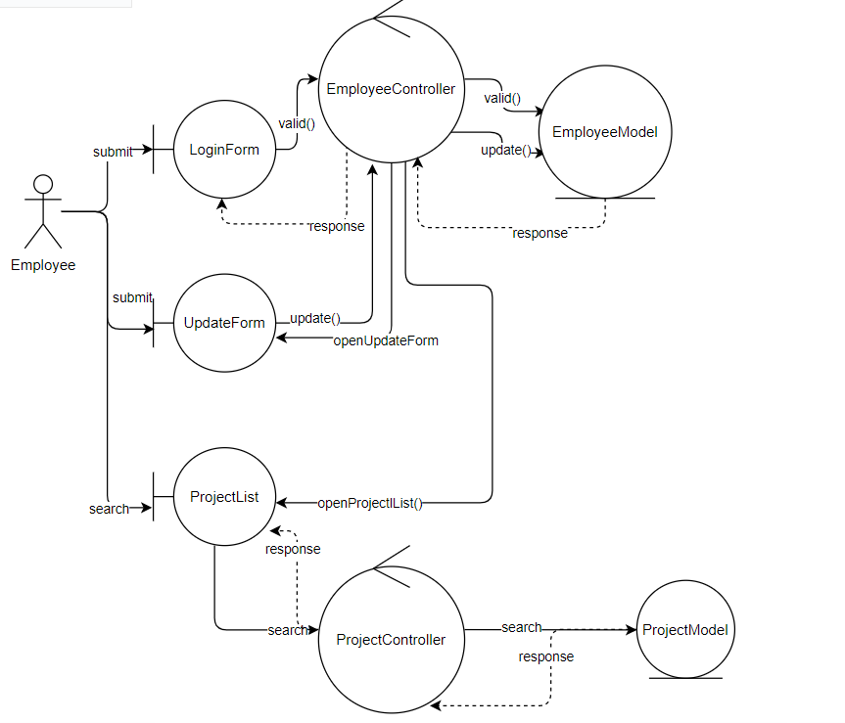

1. ***Activity Diagram for* Employee Module**

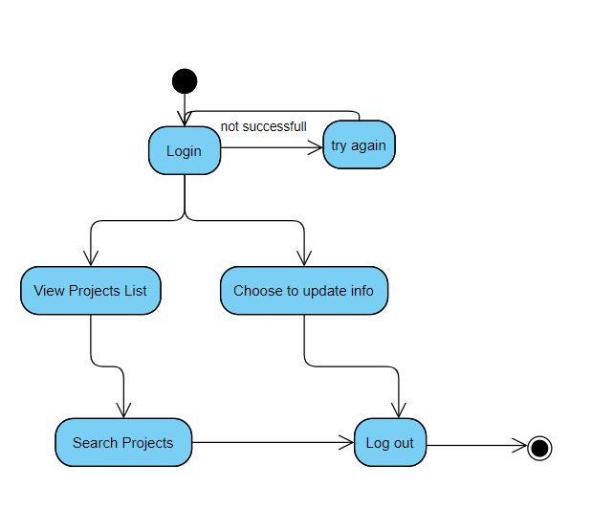

1. ***Class Diagram for* Employee Module**

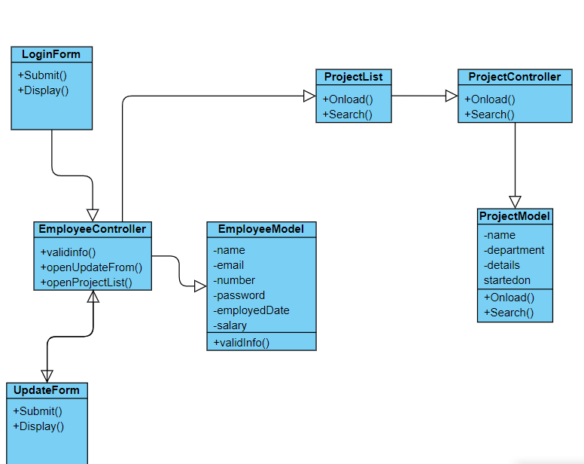

1. ***State Chart Diagram for* Employee Module**

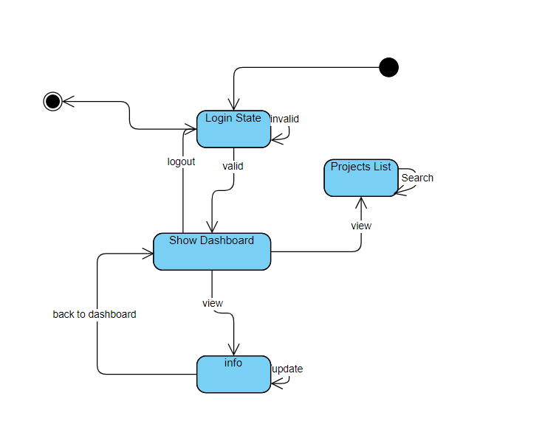

* + 1. **Module 2 Ramsha complete CRUD Make a Reservation Function**

1. ***Description:*** Employees can login and see their details.Employees can see the department they are assigned to. Employees can see projects they are assigned to(complete and in-progress).
2. ***Usage Scenario/ Use case Description/******Specification:***

|  |  |
| --- | --- |
| Description | [ make | drop | view | update] a reservation to the user’s account |
| Inputs | From city, to city, seat type, travel date, return date and time |
| Source | 1. User inputs from city, to city, seat type, travel date, return date and time 2. Press Button … |
| Alternate Case |  |
| Outputs | Added | Deleted | Viewed | Modified reservation |
| Destination | Computer screen  Reservation database  Passenger Account database |
| Precondition | Valid information; train route and tickets available; user does not have another reservation at the same time |
| Post Condition | Reservation added to passenger account |
| Side Effects | User’s current reservations adjusted  Balance due adjusted |

1. ***Use case Diagram:***
2. ***Use case Realization:***
3. ***Flow of Event or Data Flow Diagram:***

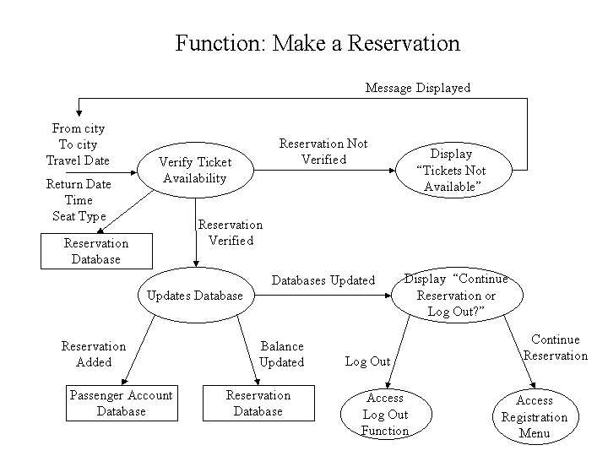

1. ***Sequence Diagram:***
2. ***Collaboration Diagram:***
3. ***Activity Diagram:***
4. ***Class Diagram:***
5. ***State Chart Diagram:***
   * 1. **Module 3 Zainab Fatima: complete CRUD Project Management**
6. ***Description:***

Project manager can assign a new project to employees; he can delete, update and view projects. Employees can also view their old and recent projects. Project manager is responsible for assigning the projects to employees.

1. ***Usage Scenario/ Use case Description/******Specification:***

|  |  |
| --- | --- |
| Description | Allows access to PMS |
| Inputs | Username, password |
| Source | 1. User inputs username and password 2. Press Login Button |
| Alternate case |  |
| Outputs | Successful login; unsuccessful login |
| Destination | None |
| Precondition | Authorized User |
| Post Condition | No change to Passenger Accounts Database |
| Side Effects | Failures and successful logins are sent to Reservation Database |

1. ***Use case Diagram:***

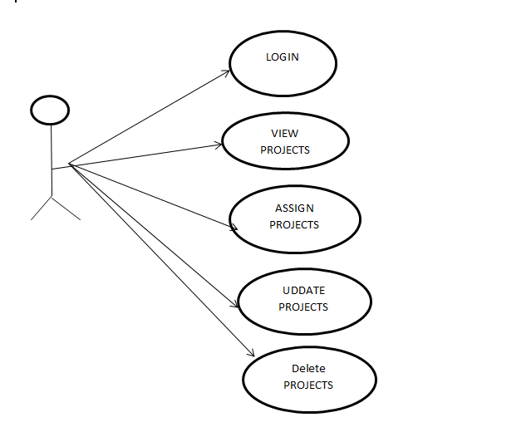

1. ***Flow of Event or Data Flow Diagram:***



1. ***Sequence Diagram:***

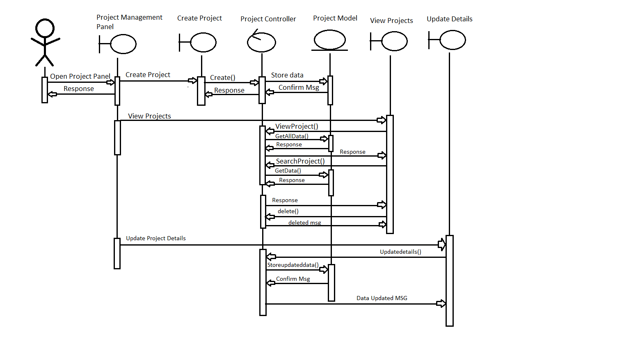

1. ***Collaboration Diagram:***

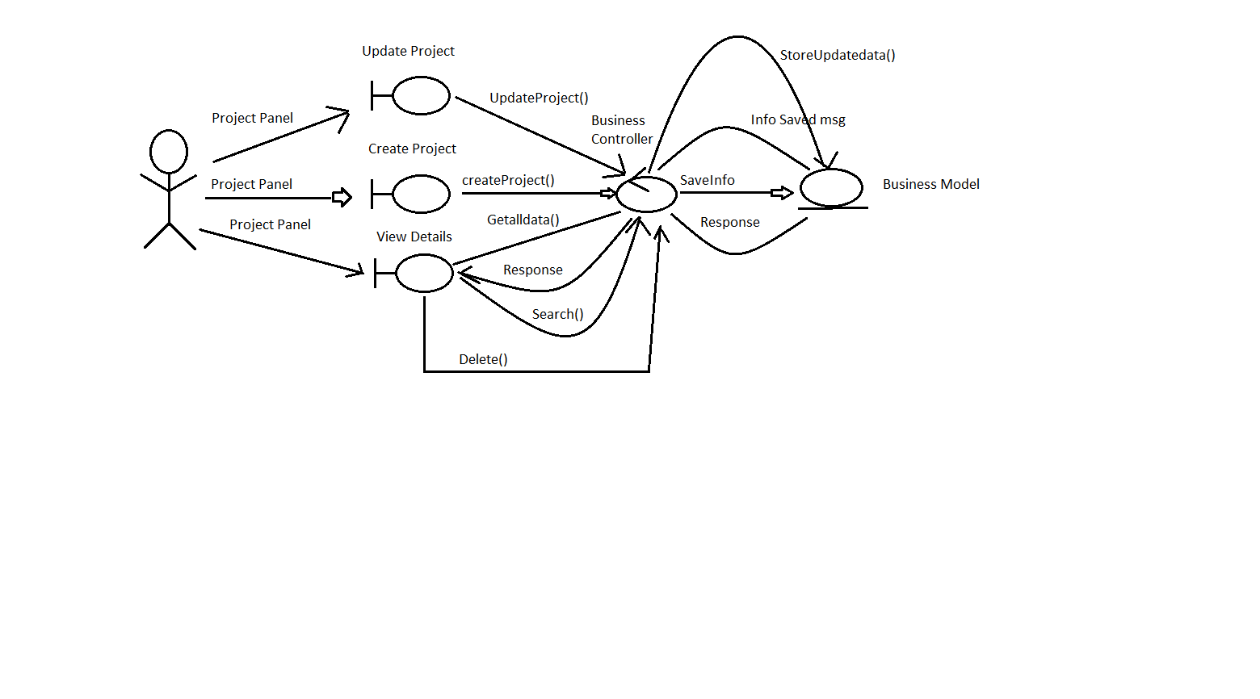

1. ***Activity Diagram:***

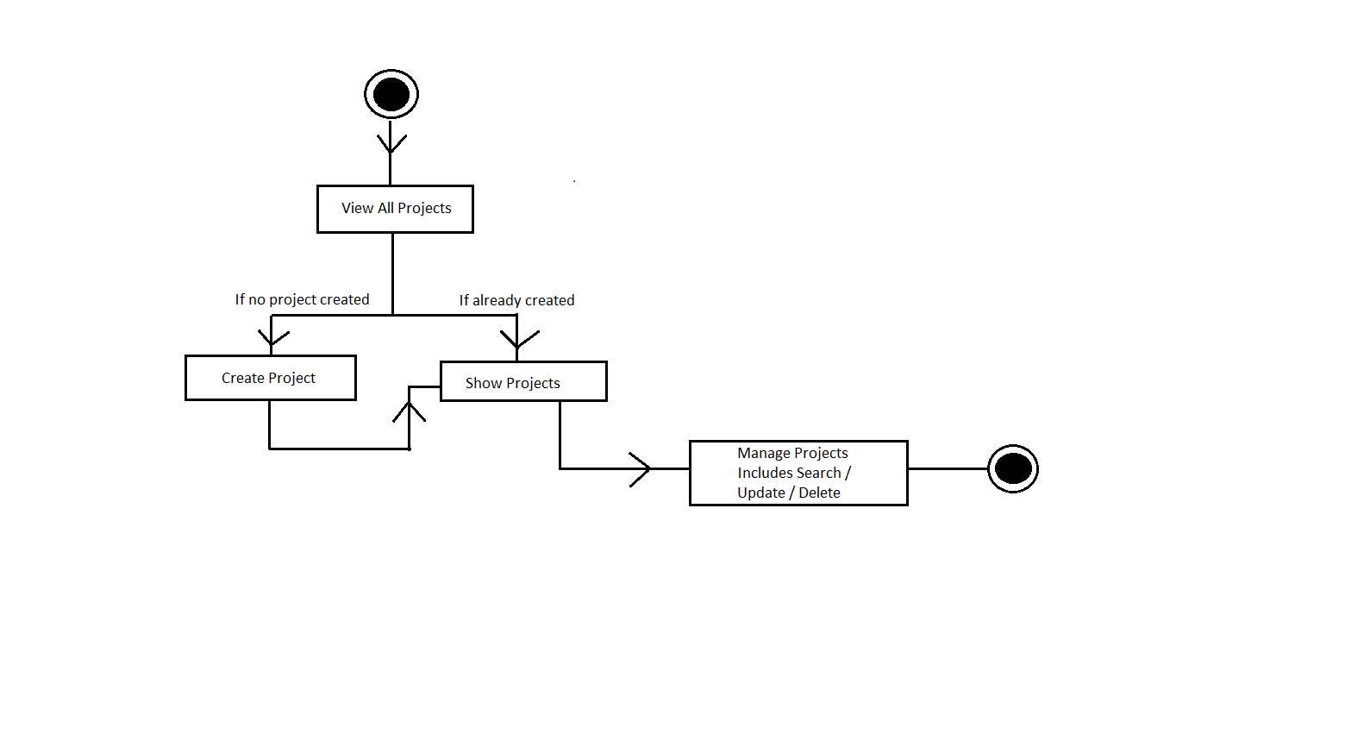

1. ***Class Diagram:***

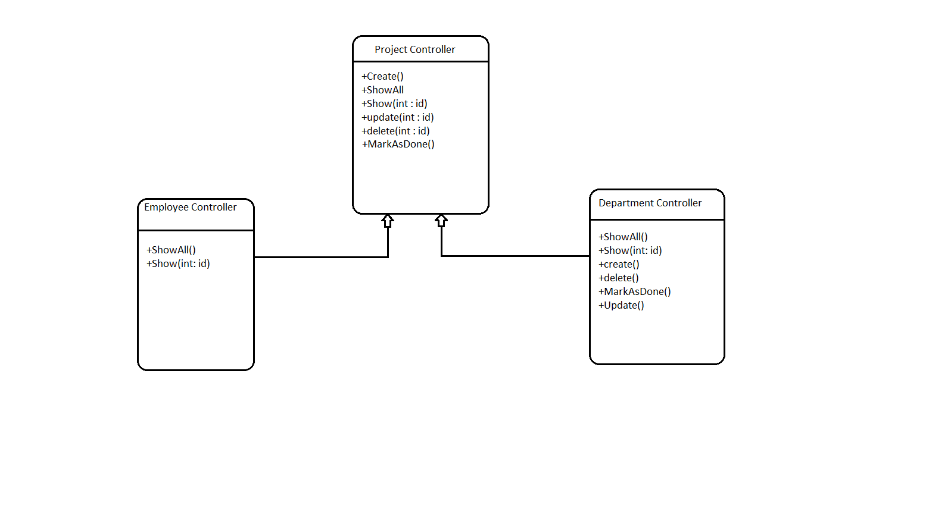**3.2. External Interface Requirements**

**3.2.1 User Interfaces**

 The user interfaces are divided into two major components. One part includes the user accessing the system using a employee. The other portion involves accessing the system through a remote site or at a particular location specifically designed to access the system. For instance, the clerks and the (EMS) access the reservation system from the reservation or (EMS) .

The diagrams and explanations below demonstrate the major transition from one user interface to another. This is a brief description. However, a more detailed demonstration is done in the prototype. The purpose of this interaction is to illustrate the overall view of the (EMS).

The diagram below illustrates the four **major functionalities or modules.** These functionalities will be displayed depending on the user. For instance, the (EMS) will see all three functionalities while the normal user will only login the employee and create Account.

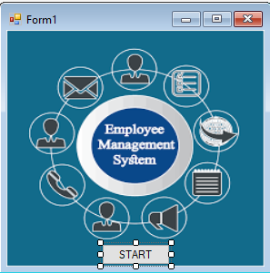 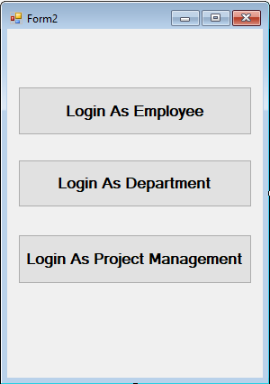

Selecting one of these functions will take the user to a different user interface. For instance, choosing Employee management system will display the following web page. The title of this page is consistent with the function selected, and since the employee management was selected, the title displays employee management. The purpose of this is to allow the user know what part of the system they are accessing. Furthermore, the user can select any of the three functions.

 : 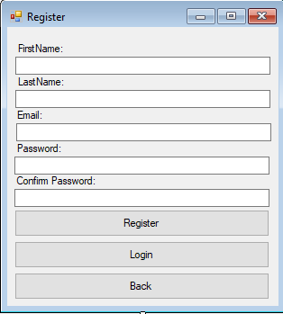 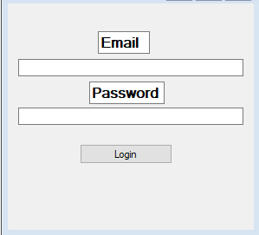

The user can select any of the three functionalities. For the sake of this demonstration, if the user clicks on the add function the diagram below is displayed. Once again the title is the same as the main function and a subtitle indicates the second function selected. In addition, the person can fill up the following information and the date of register or return if he/she wishes. The three buttons allow the user to navigate through the interfaces. For instance, the back button will take the user to the above page, and the clear button will clear the form of any selection he/she made before.

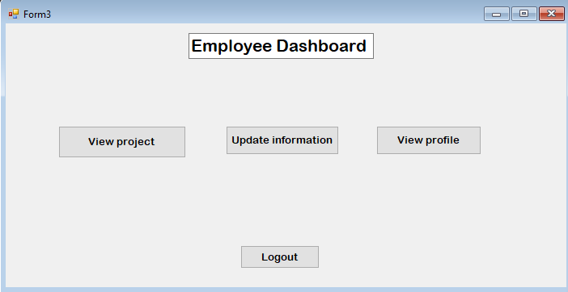

The Display Available function displays all the employee dashboard from employee can view update their details. Furthermore, the last option displays the employee profile. The logout button will take the user to the above picture to leave.

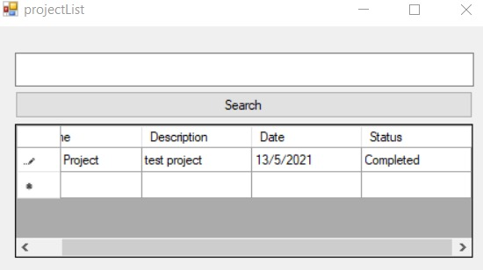

The following page allows the employee to search for the project as appropriate. Now, this page is part of the employee module, and it is used here to make project for the status. This makes it easier for the employee since they do not have to go back to the main menu and to access their project list.

Finally, the update button displays the update info page as shown below with a button to update your information.

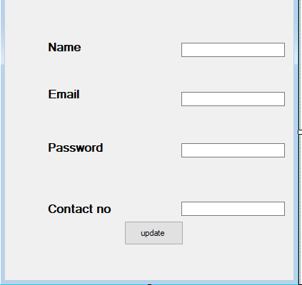

The above illustration has shown a brief overview of the employee management involved for the normal and employee. However, the EMS have specifically requested a number of reports, and they must be able to adjust their train schedule as the trains become unavailable. Therefore, the EMS interface is able to access all three functionalities as shown in the main menu (first diagram). Once the EMS selects the Reports function, a list of five reports is displayed as linked list. This is shown in the diagram below:

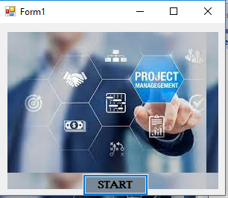

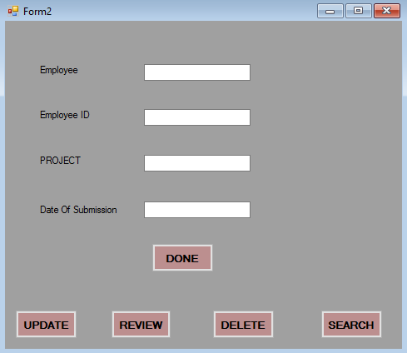

As mentioned earlier, the system can also be accessed through the application. In that case, the overall system will be the same as the above presentation except that the format will be simplified, since the application do not have graphic support. The web application will have access to the Make employee management system , however it is difficult to display the reports and trains information on a small screen for the EMS.

**3.2.2 Hardware Interfaces**

The EMS includes two major hardware components: cellular phones and regular PC's. The cell phones require WAP (wireless application protocol) network protocol, which is already programmed in the latest phones.

The second component involves the regular PC’s, which communicate with the server. The server then communicates with the database. The protocol involved between the PC's and the server is the HTTP protocol, which allows communication between the PC's and the Server. The remote PC's, such as someone accessing the EMS from home using the Internet, are able access the information through the CGI. The requests come in through the HTTP protocol, and using an ODBC the database results are returned and processed using Perl to give an HTML web page. The format of the output is displayed as web pages.

**3.2.3 Software Interfaces**

An Oracle DBMS will be used to manage the database and any changes made to it. Furthermore, the DBMS will make regular backups of the database and generate reports regularly so that they can be accessed by the CRM. The Apache server between the client and the database will handle all communication, and the server will run on a Linux operating system. Furthermore, the HTML pages must be implemented such that they can be displayed on two common browsers: Netscape and Internet Explorer.

Information about the products used for the EMS:

(1) Name: Oracle

(2) Mnemonic: Oracle

(3) Version Number: ?

(4) Source: Oracle

(1) Name: Linux

(2) Mnemonic: Linux

(3) Version Number: 6.2

(4) Source: Unix

(1) Name: Internet Explorer

(2) Mnemonic: IE

(3) Version Number: 5.00

(4) Source: Microsoft

(1) Name: Apache

(2) Mnemonic: Apache

(3) Version Number: 1.3.14

(4) Source: Apache Software Foundation

**3.3 Performance Requirements**

The following sections list the performance requirements for the system.

**3.3.3 Host Requirements**

|  |  |
| --- | --- |
| HOST | Type of Host or  Equipment |
| Host A | PC |
| Host B | Database Server |
| Host C | Application Server |

**3.4.1 Standards Compliance**

There are no design constraints that can be imposed by other standards limitations.

**3.4.2 Software Limitations**

∙        must be able to run Internet Explorer or Netscape Communicator web browsers to access the system.

∙        must have cell-phone web based capability to access the system from a mobile phone.

**3.4.3 Hardware Limitations**

∙        Input/Output: One or two-button mouse, keyboard, cell-phone, or touch screen required.

∙        Network card required at thin-client terminals to make communication with server possible.

**3.5 Quality Characteristics**

There are a number of quality characteristics that apply to the Employee Management system.

**3.5.1 Portability**

The EMS will be developed using HTML and Java so that it can be accessed from any type of system using just a regular web browser. It will also be available to users that have web access on their cellular phones. The system will be tested on all types of hardware before being released to ensure that is it compliant with this requirement.

**3.5.2 Reliability**

The system should be capable of processing a given number of reservations within a give time frame with no errors and the system should be available and operational all the time. During the development of the prototype for the 3 cities, the system will be tested in its actual environment to ensure that it can handle the load of reservations that occur during a regular workday.

**3.5.3 Usability**

The EMS will be developed so that it is an easy to use system that requires the least amount of user input possible. Every input will be validated. The user should only have general computer use knowledge. Error messages will be displayed if the user enters an invalid value or tries to access a function without the required permissions. An easy and well-structured user manual will be provided to the EMS and the system will include descriptive help for all operations allowed.

**3.5.4 Correctness**

The EMS will be considered correct when the approves the prototype presented and agrees that all the functions they require are implemented as stated in the Software Requirements Specification.

**3.5.5 Flexibility**

The EMS system should be developed in such a way that it is easily customizable. If new functions are required by , there will be little effort required to update the system to support new cities or new transactions.

**3.5.6 Security**

The EMS system should not compromise the customer information at any time. The user information will never be sold to other parties and will be kept secure at all times. Users will be authenticated to ensure that no unauthorized users gain access to private information.

**3.5.7 Maintainability**

The EMS source code will be kept well structure and documented so that it is easier to maintain and extend the system. All changes to the system shall be documented.

**3.6.2 Operations**

The normal operations required by the user can be viewed as the following:

User-initiated Operations:

These operations include the login operation, which is initiated by the users. Also, the process of becoming a new user is in this category. , changing, and viewing itineraries, as well as paying for the itinerary are all initiated by the users. The user initiates the report generation activity, as well as changing train schedules.

Interactive Operations and Unattended Operations:

The users initiate all the operations mentioned above, and almost all of them are somehow interactive. Displaying the EMS schedule is non-interactive. The report display is a non-interactive operation, although selecting the desired reports will require user input.

Data Processing Support Functions:

The user account data is used to create new accounts, as well as to validate user id's during login functions. For building itineraries, user input, user account data, and schedule data are used, and processed.

**3.6.3 Site Adaptation Requirements**

There are no site adaptation requirements for this project.

**4. Supporting Information.**

There is no supporting information required for this project.