Lab Session 01
OBJECT

Introduction of Assembly language: 8086 Assembler
THEORY
What is an assembly language?
Assembly language is a low-level programming language. You need to get some knowledge about computer structure in order to understand anything. The simple computer model as I see it:
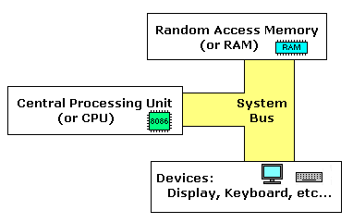
The system bus (shown in yellow) connects the various components of a computer.
The CPU is the heart of the computer, most of computations occur inside the CPU.
RAM is a place to where the programs are loaded in order to be executed.
Inside the CPU
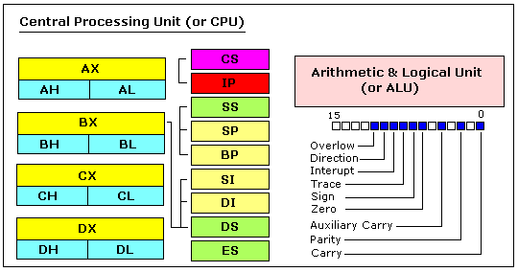
GENERAL PURPOSE REGISTERS
8086 CPU has 8 general purpose registers, each register has its own name:
- AX - the accumulator register (divided into AH / AL).
- BX - the base address register (divided into BH / BL).
- CX - the count register (divided into CH / CL).
- DX - the data register (divided into DH / DL).
- SI - source index register.
- DI - destination index register.
- BP - base pointer.
- SP - stack pointer.
Despite the name of a register, it's the programmer who determines the usage for each general purpose register. The main purpose of a register is to keep a number (variable). The size of the above registers is 16 bit, it's something like: 0011000000111001b (in binary form), or 12345 in decimal (human) form.
4 general purpose registers (AX, BX, CX, DX) are made of two separate 8 bit registers, for example if AX= 0011000000111001b, then AH=00110000b and AL=00111001b. Therefore, when you modify any of the 8 bit registers 16 bit register is also updated, and vice-versa. The same is for other 3 registers, "H" is for high and "L" is for low part.
Because registers are located inside the CPU, they are much faster than memory. Accessing a memory location requires the use of a system bus, so it takes much longer. Accessing data in a register usually takes no time. Therefore, you should try to keep variables in the registers. Register sets are very small and most registers have special purposes which limit their use as variables, but they are still an excellent place to store temporary data of calculations.
SEGMENT REGISTERS
- CS - points at the segment containing the current program.
- DS - generally points at segment where variables are defined.
- ES - extra segment register, it's up to a coder to define its usage.
- SS - points at the segment containing the stack.
Although it is possible to store any data in the segment registers, this is never a good idea. The segment registers have a very special purpose - pointing at accessible blocks of memory.
Segment registers work together with general purpose register to access any memory value. For example if we would like to access memory at the physical address 12345h (hexadecimal), we should set the DS = 1230h and SI = 0045h. This is good, since this way we can access much more memory than with a single register that is limited to 16 bit values.
CPU makes a calculation of physical address by multiplying the segment register by 10h and adding general purpose register to it (1230h * 10h + 45h = 12345h):
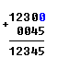
The address formed with 2 registers is called an effective address.
By default BX, SI and DI registers work with DS segment register;
BP and SP work with SS segment register.
Other general purpose registers cannot form an effective address!
Also, although BX can form an effective address, BH and BL cannot!
SPECIAL PURPOSE REGISTERS
- IP - the instruction pointer.
- Flags Register - determines the current state of the processor.
IP register always works together with CS segment register and it points to currently executing instruction.
Flags Register is modified automatically by CPU after mathematical operations, this allows to determine the type of the result, and to determine conditions to transfer control to other parts of the program.
Generally you cannot access these registers directly.

Memory Access
To access memory we can use these four registers: BX, SI, DI, BP.
Combining these registers inside [ ] symbols, we can get different memory locations. These combinations are supported (addressing modes):
[BX + SI]  [BX + DI]  [BP + SI]  [BP + DI] | [SI]  [DI]  d16 (variable offset only)  [BX] | [BX + SI] + d8  [BX + DI] + d8  [BP + SI] + d8  [BP + DI] + d8
[SI] + d8  [DI] + d8  [BP] + d8  [BX] + d8 | [BX + SI] + d16  [BX + DI] + d16  [BP + SI] + d16  [BP + DI] + d16 | [SI] + d16  [DI] + d16  [BP] + d16  [BX] + d16
d8 - stays for 8 bit displacement.
d16 - stays for 16 bit displacement.
Displacement can be a immediate value or offset of a variable, or even both. It's up to compiler to calculate a single immediate value.
Displacement can be inside or outside of [ ] symbols, compiler generates the same machine code for both ways.
Displacement is a signed value, so it can be both positive or negative.
Generally the compiler takes care about difference between d8 and d16, and generates the required machine code.
For example, let's assume that DS = 100, BX = 30, SI = 70.
The following addressing mode: [BX + SI] + 25
is calculated by processor to this physical address: 100 * 16 + 30 + 70 + 25 = 1725.
By default DS segment register is used for all modes except those with BP register, for these SS segment register is used.
There is an easy way to remember all those possible combinations using this chart:
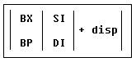
You can form all valid combinations by taking only one item from each column or skipping the column by not taking anything from it. As you see BX and BP never go together. SI and DI also don't go together. Here is an example of a valid addressing mode: [BX+5].
The value in segment register (CS, DS, SS, ES) is called a "segment",
and the value in purpose register (BX, SI, DI, BP) is called an "offset".
When DS contains value 1234h and SI contains the value 7890h it can be also recorded as 1234:7890. The physical address will be 1234h * 10h + 7890h = 19BD0h.

MOV instruction
- Copies the second operand (source) to the first operand (destination).
- The source operand can be an immediate value, general-purpose register or memory location.
- The destination register can be a general-purpose register, or memory location.
- Both operands must be the same size, which can be a byte or a word.
These types of operands are supported:
MOV REG, memory
MOV memory, REG
MOV REG, REG
MOV memory, immediate
MOV REG, immediate
REG: AX, BX, CX, DX, AH, AL, BL, BH, CH, CL, DH, DL, DI, SI, BP, SP.
memory: [BX], [BX+SI+7], variable, etc...
immediate: 5, -24, 3Fh, 10001101b, etc...

For segment registers only these types of MOV are supported:
MOV SREG, memory
MOV memory, SREG
MOV REG, SREG
MOV SREG, REG
SREG: DS, ES, SS, and only as second operand: CS.
REG: AX, BX, CX, DX, AH, AL, BL, BH, CH, CL, DH, DL, DI, SI, BP, SP.
memory: [BX], [BX+SI+7], variable, etc...
The MOV instruction cannot be used to set the value of the CS and IP registers.
Here is a short program that demonstrates the use of MOV instruction:
#MAKE_COM# ; instruct compiler to make COM file.
ORG 100h ; directive required for a COM program.
MOV AX, 0B800h ; set AX to hexadecimal value of B800h.
MOV DS, AX ; copy value of AX to DS.
MOV CL, 'A' ; set CL to ASCII code of 'A', it is 41h.
MOV CH, 01011111b ; set CH to binary value.
MOV BX, 15Eh ; set BX to 15Eh.
MOV [BX], CX ; copy contents of CX to memory at B800:015E
RET ; returns to operating system.

Task:
- Define purpose of MOV and why we use it?
By using the MOV operation, create an assembly program by using the following instructions:

MOV SREG, memory
MOV memory, SREG
MOV REG, SREG
MOV SREG, REG

- Define purpose of general-purpose register.
- Define purpose of segments.

