
Lab: 3
INTRODUCTION TO C++
Programming Fundamentals Lab (CMC111L)
Week 3 | Credit Hours: 0+1
Course Information | Details
Instructor | Ms. Purva Fatima
Prerequisite | -
Academic Term | Fall 2026
Programming Environment | C++ / GCC / IDE

LAB 3 — INTRODUCTION TO C++ - COMPILER INSTALLATION, BASIC PROGRAM, DATA TYPES & I/O
Week 3 | Contact Hours: 3 | Focus: Compiler Installation, Basic Program, Data Types & I/O

Student Information | Details
Student Name: | Zainab Irfan
Degree Program: | [ YES ] BS(CS)
Lab Instructor: | Purva Fatima
Roll Number: | 26BSCS140
Conduction Date: | 3 / 10 / 2026
Course Code: | CMC111L (Credit: 0 + 1)

1. LAB OBJECTIVES & CLO MAPPING
Primary Objective: To install and configure a C++ compiler/IDE, understand the structure of a basic C++ program, and use fundamental data types with input/output constructs.
CLO ID | Course Learning Outcome (CLO) Statement | Taxonomy | Mapped GA
CLO-1 | Performs a Lab Task as demonstrated. Follows instructions to build a solution. Responds to hand-signals of instructor while learning to use an IDE. | P3 | GA3
CLO-2 | Applies knowledge of C++ programming concepts (conditional statements, loops, functions, arrays, structures, pointers, and file handling) using critical thinking and debugging strategies to solve computational problems. | C3 | GA2 / ACM KA #14 PL / SGDs 9
Specific Learning Outcomes:
- Install and verify a C++ compiler (G++) and a code editor/IDE (e.g. Code::Blocks / Dev-C++).
- Explain the role of the compiler and the linker in building an executable.
- Identify the structure of a basic C++ program (headers, main function, statements).
- Declare and use basic data types (int, float, char, double) and variables.
- Use cin and cout for basic C++ input and output.

2. EQUIPMENT & SOFTWARE ENVIRONMENT
Requirement | Minimum / Recommended
Hardware | Standard PC / Laptop with Intel Core i3 or equivalent processor, 4GB RAM, and sufficient storage.
Software | GCC compiler, Code::Blocks / Dev-C++ (or an equivalent C++ IDE / online GCC compiler).
Internet | Required where an online editor / online compiler is used.

3. LAB PROCEDURE & STEP-BY-STEP INSTRUCTIONS

Phase 1: Compiler & IDE Setup
- Install G++ and Code::Blocks / Dev-C++.
- Verify the installation using g++ --version in the terminal.

Phase 2: First C++ Program
- Write, compile, and run a “Hello, World!” program.
- Identify the role of #include, main(), and the return statement.

Phase 3: Data Types & Variables
- Declare variables of different data types and print their values and sizes using sizeof().

Phase 4: Input/Output
- Use cin to accept user input and cout to display formatted output, e.g. a program that reads a name and age and prints a greeting.

4. STUDENT WORK & PRACTICAL DELIVERABLES (TO BE COMPLETED BY STUDENT)
Item | Required Deliverable Content | Student Status
Compiler Setup Log | Screenshot of the g++ --version output | [ ] Completed  [ ] Verified
Source Code | Screenshots for Hello World and I/O programs | [ ] Completed  [ ] Verified
Console Output | Screenshot of the program execution | [ ] Completed  [ ] Verified

Practical Output / Execution Evidence Proof
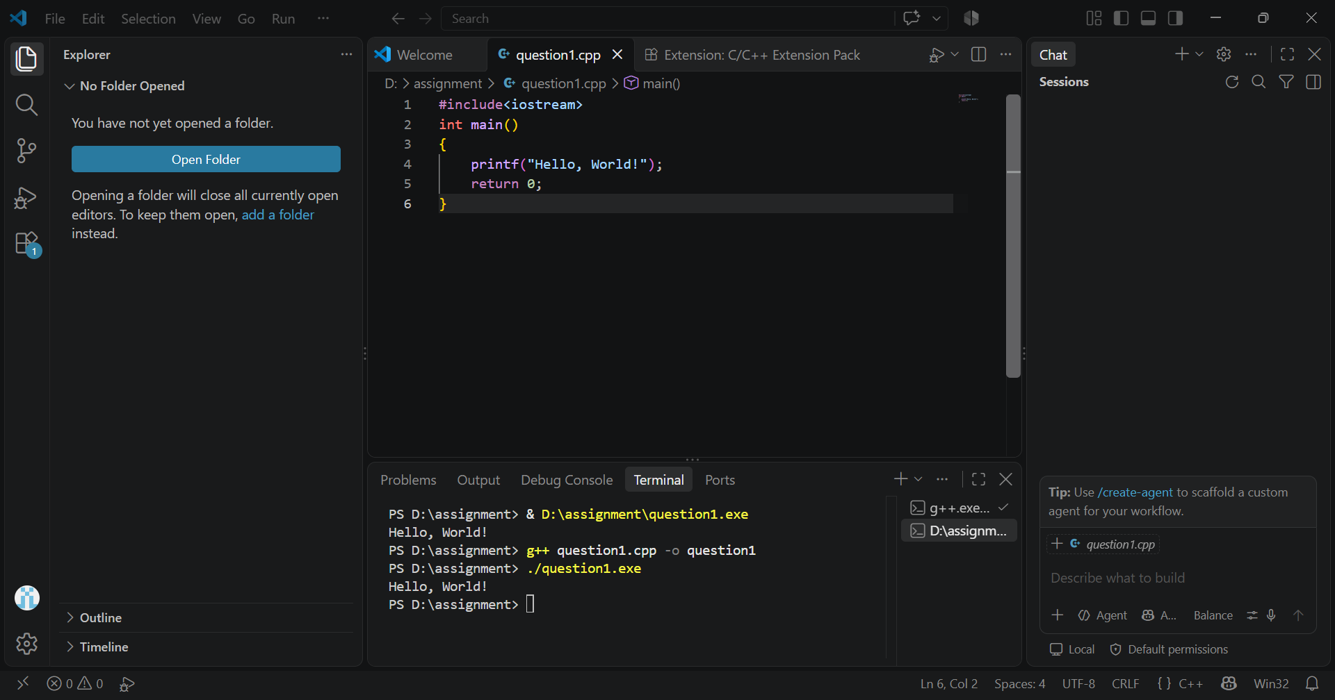

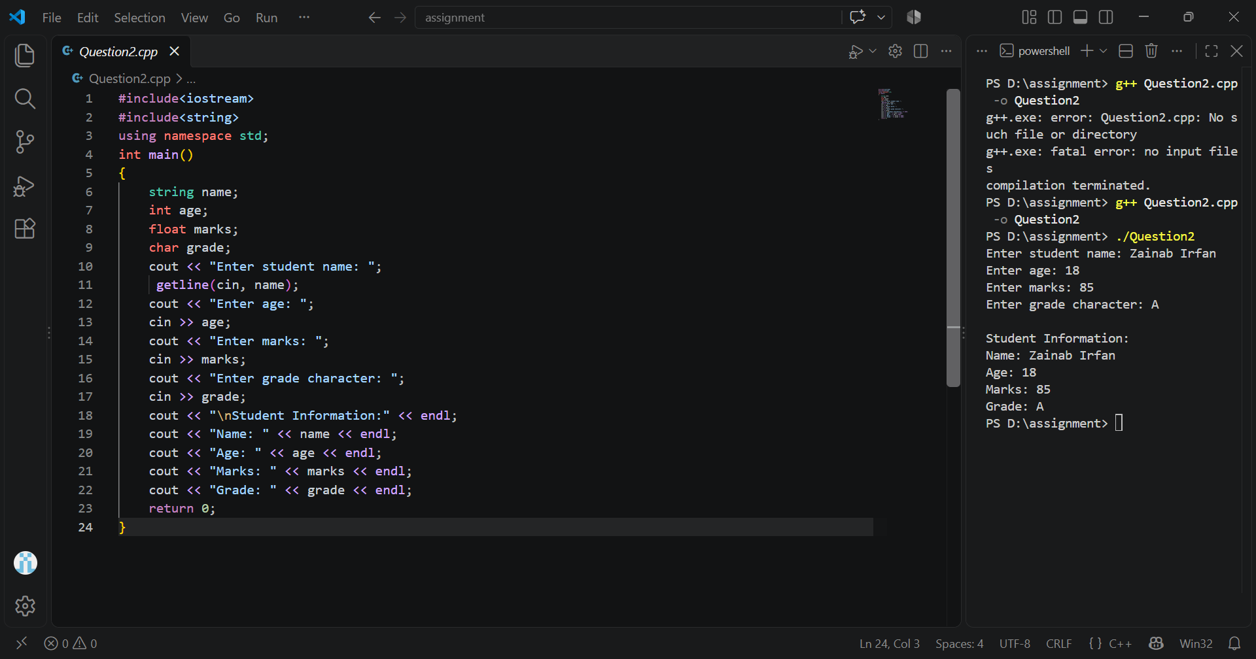
Submitted File Name / Repository Link: ____________________________________________________________

5. POST-LAB CONCEPTUAL REVIEW & CRITICAL ANALYSIS

Q1. What is the role of the compiler and the linker when building a C++ program?
Ans: The compiler and linker are important tools used to build a C++ program.
- Compiler: It converts the C++ source code written by the programmer into object code and checks the program for syntax and other errors.
- Linker: It combines the object code with the required libraries and other object files to create the final executable program that can run on a computer.

Q2. What is the difference between int, float, and char data types in C++?
Ans: In C++, int, float, and char are different data types used to store different kinds of values.
- int: Used to store whole numbers without decimal points, such as 10, 25, or -5.
- float: Used to store numbers that have decimal points, such as 3.5, 7.25, or 9.8.
- char: Used to store a single character, such as 'A', 'b', or '5'.

Q3. What is the role of the std namespace and the << / >> operators in C++?
Ans: The std namespace is used to access the standard features of C++, such as cout and cin.
- << is used to show output on the screen.
- >> is used to take input from the user.
For example:
std::cout << "Hello";
std::cin >> age;
In simple words, std provides standard C++ features, << gives output, and >> takes input.
6. LAB EVALUATION RUBRIC & INSTRUCTOR SIGN-OFF RECORD
Evaluation Criteria & CLO Mapping | Performance Standard & Description | Max Marks
Code Correctness & Functionality (CLO-1) | Program compiles and correctly implements: Introduction to C++ – Compiler Installation, Basic Program, Data Types & I/O | 3.0
Coding Standards & Structure (CLO-1) | Consistent naming, formatting, comments, and modular structure | 2.5
Tool / Technique Application (CLO-2) | Correct and effective use of the tools/techniques introduced in this session | 2.5
Debugging & Problem-Solving (CLO-2) | Evidence of systematic debugging / testing / verification | 2.0
Participation, Documentation & Viva (CLO-3) | Active participation, complete deliverables, and satisfactory viva responses | 5.0
Assessment Result: [ ] Accepted & Approved [ ] Resubmission Required
Total Marks: 15
Marks Obtained: _______ / 15
Evaluation Date: ____/____/2026
Lab Instructor: Purva Fatima

