

**Faculty of Engineering and Technology**

**Electrical and Computer Engineering Department**

**ENCS3130 Linux Laboratory**

**Shell scripting project**

**Prepared by:**

Zainab Jaradat 1201766

Maryan Kassis 1200861

**Instructor:** Dr. Mohammad Jubran

**Assistant:** Eng.Ibrahim Injas

**Section:** 1

**Date**: Aug,15/2022

# Code & Idea:

First, we asked the user to choose '1' for Encryption or '2' for Decryption.

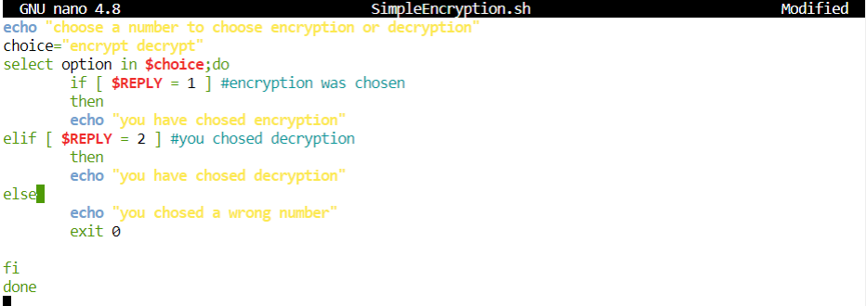

User Interface:

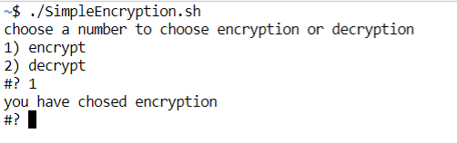

## ENCRYPTION

If user entered "1" Then we asked him to enter the name of the text file and check if it is existed or not.

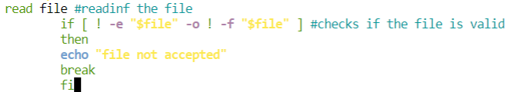

Then if the file contains any non-alphabet characters an error massage will appears.

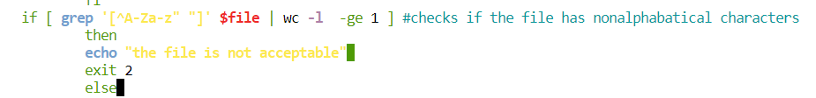

1. Generate key

Key = Max [(sum of characters index in the word) mod 256]

The index was to equalize every character to its size A=1, B=2…Z=26

And to do that we transit all to lower-case characters and got their ascii code which it is sequence a=97 … etc. then difference it by 96.

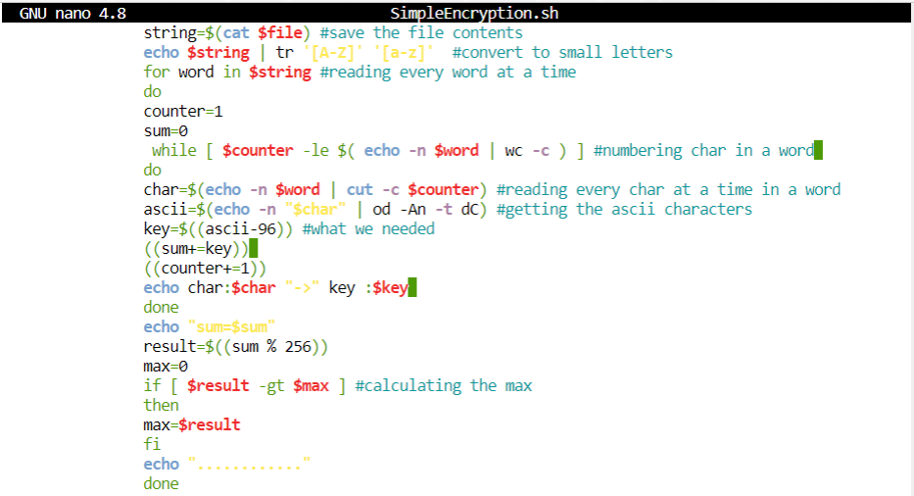

Exp:

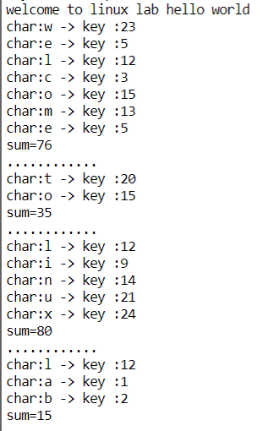

1. Represented the key in 8-bit binary



#We added to read the cipher file to store the XOR result in the file

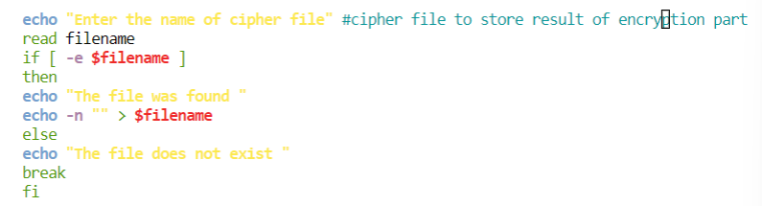

1. XOR operation

Getting the ascii for each char then convert it to 8-bit binary then we found the XOR between the binary for each char and the key in binary

1. Swapping the result binary 1st 4-bit with last 4-bit
2. Swap the 1st 4-bit and last 4-bit for the key value also

Finally, the file will ask to input the name of the cipher text file and print the generated cipher text in it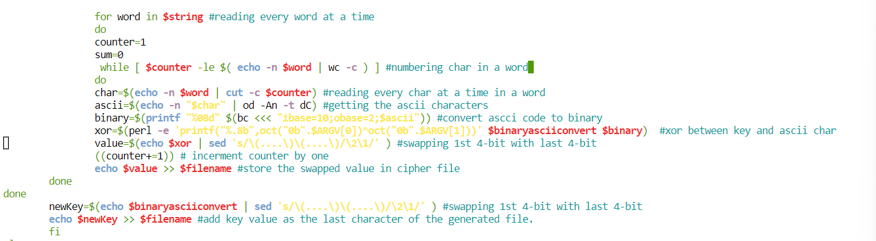

## DECRYPTION

If user entered "2" Then we asked him to enter the name of the cipher file and check if it is existed or not.

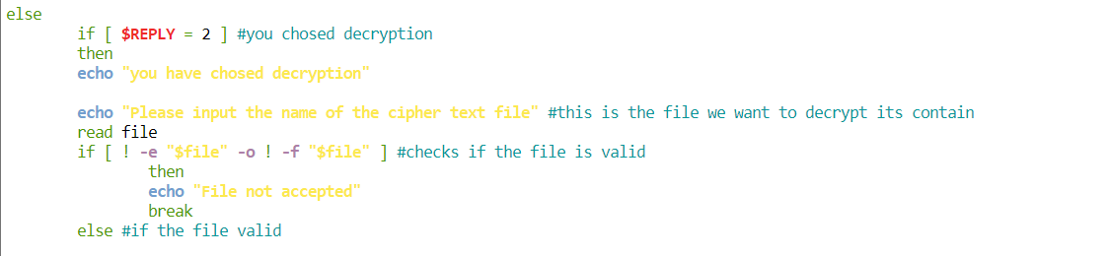

1. Getting the key by get the tail of the file and swap the 1st 4-bit digit with last 4-bit, and convert it to decimal value.



## asking the problem about the plain text file to store the result direct to the file to make the solution much easier

1. swap the first 4-bit with the last for bit, for each character in the encrypted file, then convert it do decimal.

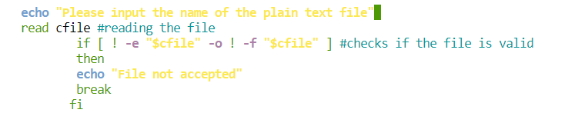

1. XOR between the key and each character with their decimal values, then convert it to ascii value.

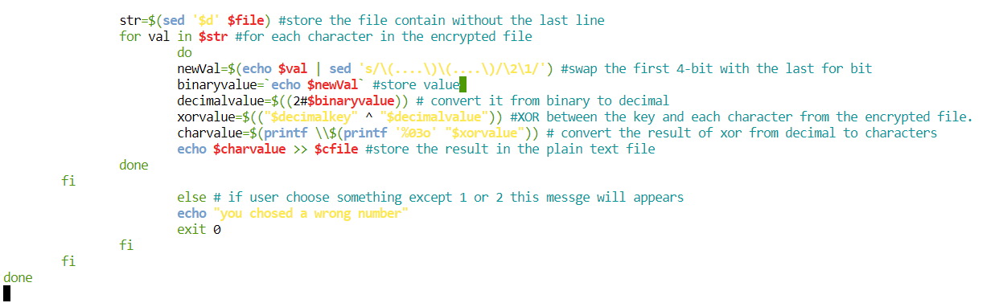Finally, after asking the user to enter the name of the plain text file, and print the generated plain text on it.

## CODE

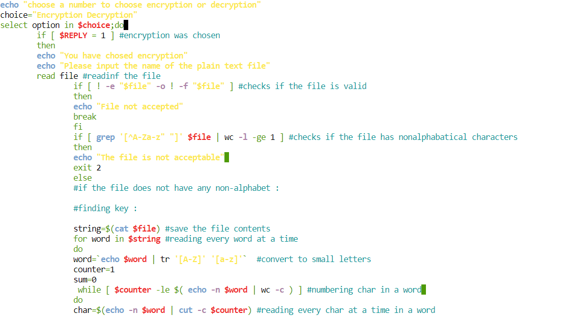

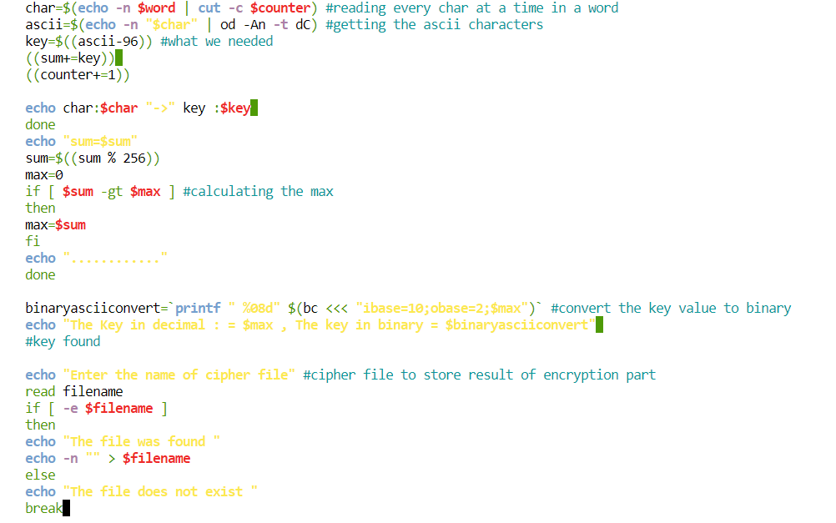

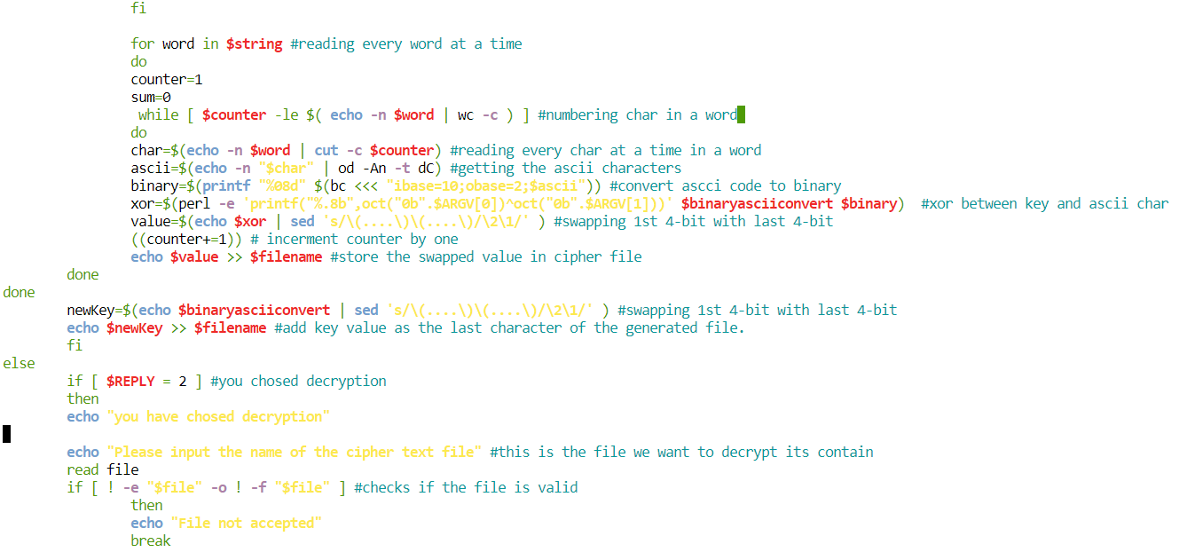

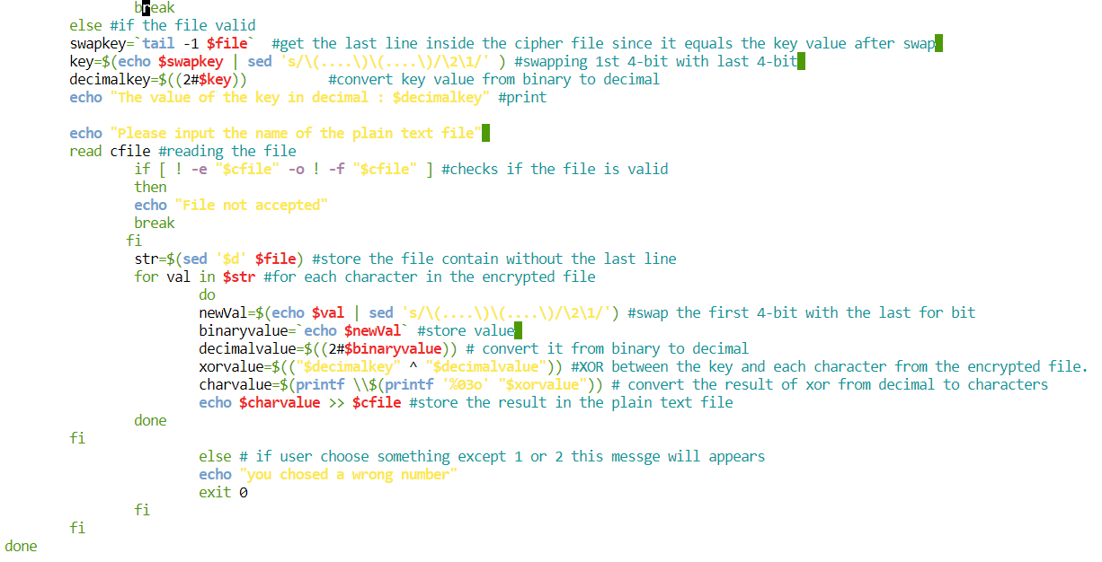

# EXAMPLES

## Exp1:

Encryption:

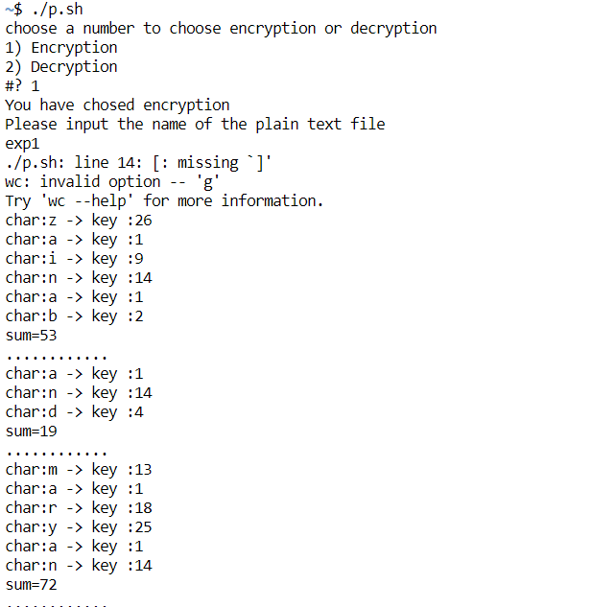

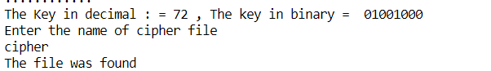

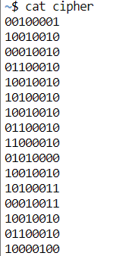

Output:

Decryption:

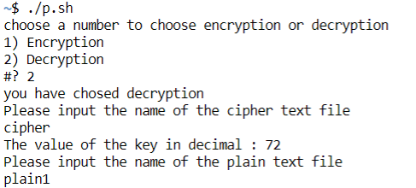

Output:

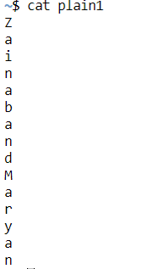

## Exp2

Encryption:

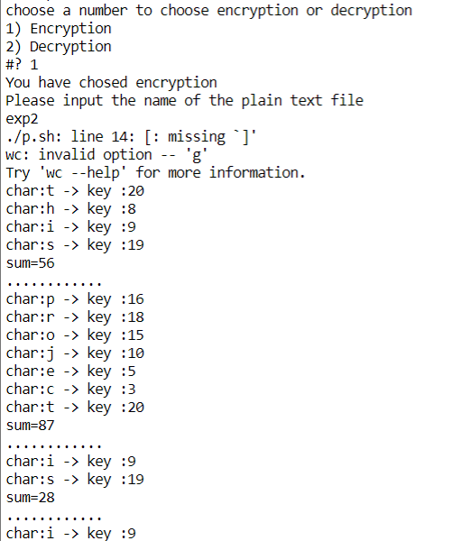

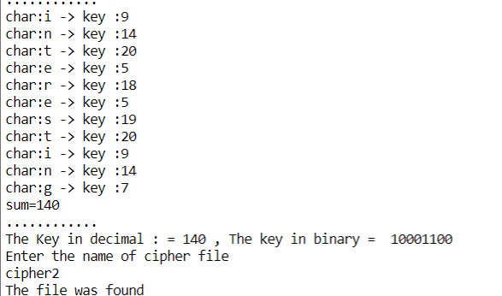

Output:

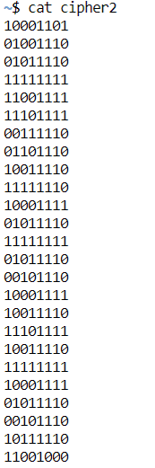

Decryption:

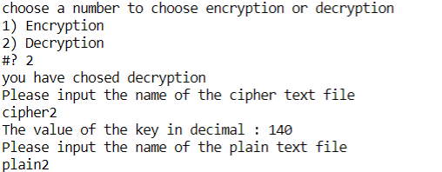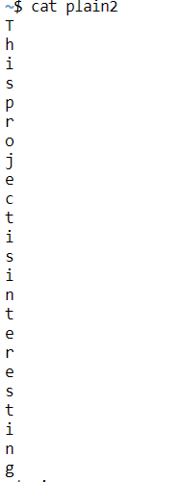

Output: