Lab Qs 1.2.3

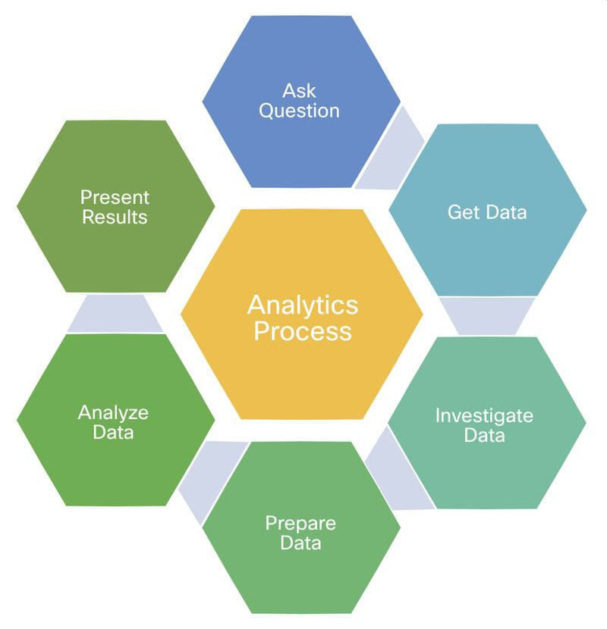Qs1 selected *

* What happened?
* What might happen in future?
* What should be done next?
* Why did this happen?

What happened?

Decline in sales

Reasons which may cause decline:

* ***Food spoilage***
* ***Management problems (behavior of the staff etc.)***
* ***Quality downfall***
* ***Poor Marketing***
* ***Infrastructure***
* ***New competitors***
* ***Not going with trends***
* ***High prices***

**Getting data**

**Investigation for downfall**

* *Competitors like layers, hot buns, bread n butter locations.*
* *Trends like matilda cake, dream cake, apricot cake not being followed*
* *Low prices and special offers are not up to mark*
* *Not active participation on Instagram, Facebook*
* *Collaborations with cities famous bloggers*

**Analyzing the data**

* ***Most of the customers rate is at night as they may be free from all day work and likes to chill with families***
* ***there is also a huge amount of freelancing who works at night due to their timings with foreign and nighters***
* ***universities students are also taking advantage of lively environment and working on their assignments***

**Results**

***The shop is seeing decline in sales and there’s a rapid decrease in its customers rate due to other huge chains branches opened nearby and quantity and prices aren’t up to the mark.***