AL AIN UNIVERSITY  College of Engineering (CoE) | 

Object-Oriented Analysis & Design: (0103430)
Course Project

Student Name | Hend Nasser Saeed
Student ID | 2 | 0 | 2 | 3 | 1 | 0 | 1 | 2 | 5
Student Name | Zainab Mujeeb Ahamed
Student ID | 2 | 0 | 2 | 3 | 1 | 0 | 7 | 3 | 1
Due Date | 19th April 2026 on Moodle @ 23:59

Question # | Course Learning  Outcomes (CLO) | Total  Mark | Student  Mark
1 |  | 15
Total |  | 15

GitHub Repository: https://github.com/zainabm27/Smart-Recipe-Recommender

Table of Contents
1. Introduction……………………………………………………………………..4
1.1 Purpose ………………………………………………………………………...4
1.2 Scope …………………………………………………………………………..4
2. Positioning ……………………………………………………………………...4
2.1 Business Opportunity ………………………………………………………….4
2.2 Problem Statement ……………………………………………………………..4
2.3 Product Position Statement …………………………………………………….5
3. User and Stakeholder Descriptions …………………………………………...5
3.1 Market Demographics …………………………………………………………5
3.2 User Environment ……………………………………………………………...5
4. Product Overview ……………………………………………………………..5
4.1 Product Perspective ……………………………………………………………5
5. Product Features ……………………………………………………………….5
6. Domain Model………………………………………………………………….7
7. Glossary…………………………………………………………………………7
8. Functional Requirements ……………………………………………………...8
9. Non-Functional Requirements ………………………………………………..9
9.1 Performance Requirements …………………………………………………….9
9.2 Security Requirements ………………………………………………………....9
9.3 Usability Requirements ………………………………………………………..9
9.4 Scalability Requirements ……………………………………………………..10
10. Use Case Diagram …………………………………………………………...11
11. Use Case Specification ………………………………………………………11
12. System Sequence Diagram…………………………………………………..20
13. Architecture Description…………………………………………………….22
14. Design Class Diagram……………………………………………………….24
15. Interaction Diagram…………………………………………………………25
16. State Machine Diagram……………………………………………………26
17. Grasp Principles……………………………………………………………27
18. Implementation Notes………………………………………………………27
19. Source code…………………………………………………………………28
20. Code- Design Traceability…………………………………………………28
21. User Interface…………….…………………………………………………40

1. Introduction
1.1 Purpose
The aim of this document is to gather, analyze, and specify the high-level requirements and architecture of the Sizzle & Stir Recipe Recommender web application. The system will assist home cooks in minimizing the wastage of food by giving intelligent recipe suggestions according to the ingredients they already possess in their pantry with a particular focus on consuming the items that are about to expire.
1.2 Scope
The Sizzle & Stir: Recipe_OS is a inventory and recipe optimization automation platform that aims to minimize food waste in households by means of smart automation. The main functionality of the system includes the digital pantry with automated expiration tracking, recommendation engine which uses the Strategy pattern to recommend meals to be prepared based on the shelf-life of the ingredients, and the powerful substitution logic in case of missing ingredients. Although the site offers advanced scaling of recipes and sequential cooking instructions, its coverage is very narrow, with regard to the logical processing of internal data, with no external supermarket API connections, multi-user authentication, or long-term storage of a database in this version. Its main objective is to deliver a Minimum Viable Product (MVP) to bridge the gap between the inventory in the pantry and the actionable and diet-conscious meal planning.
2. Positioning
2.1 Business Opportunity
As grocery prices are increasing and sustainability is gaining more and more relevance, people are looking into how they can use food that they already have to the fullest before it goes bad. Sizzle & Stir is an intelligent, data-driven home cooking solution that allows users to save money, minimize food waste, and answer the question of the day: What can I make with what I have.
2.2 Problem Statement
Element | Description
The issue of | Uncertainty and food waste because of the possible recipes.
Targets | Home cooks, students, and low-income earners.
The effect of which is | Higher grocery costs, time wastage on food searching, and food going to waste.
An effective solution would be | A sorting engine that ranks a database of recipes by the precise percentage of ingredients that the user already has at hand.

2.3 Product Position Statement
To everyday home cook.
Sizzle and Stir Recipe Recommender is a web based culinary intelligence. That scans the inventory of the pantry in real-time in order to suggest feasible meals, highlight the food that is at risk of going to waste, and recommend intelligent replacements. Our product also offers actionable and personalized meal suggestions depending on your readiness and dietary needs, unlike the other cookbook or static recipe websites, which do not take into account what is in your kitchen.
3. User and Stakeholder Descriptions
3.1 Market Demographics
The targeted market is :
- College students preparing meals using inexpensive food.
- Professional people in need of fast meal options without picking and choosing in the grocery stores.
- Homemakers that are environmentally conscious and aim at minimizing food waste.
- People who have dietary limitations and require safe recipes.
3.3 User Environment
The app can be accessed via a modern web browser (Chrome, Firefox, Safari, Edge) on either desktop, tablet or mobile devices. The backend uses a Java Runtime Environment (JRE) 17 or above.
4. Product Overview
4.1 Product Perspective
The Sizzle and Stir is an in-house full-stack web application that consists of:
- Frontend: Single-page, responsive application based on HTML5, CSS3 and vanilla JavaScript.
- Backend: Spring Boot REST API that delivers the responses in the form of JSON.
- Data Layer: Recipe repository of sample data in memory.
The system is compatible to be deployed on the cloud or to operate locally.
5. Product Features
ID | Feature | Description
F-01 | Pantry Inventory Management | Add, update and delete food items including the quantities and expiry date.
F-02 | Waste Risk Assessment | See ingredients by priority to spoil.
F-03 | Cooking Advice | Personalized meal ideas on what is in the pantry.
F-04 | Dietary Profile Settings | Establish dietary type, allergies and flavor preferences.
F-05 | Ingredient Substitution Discovery | Discover viable options when ingredients are not available.
F-06 | Scaling Recipes | Scale ingredients to other serving sizes.
F-07 | Recipe Favorites | save and organize your own book of favorite recipes.
F-08 | Meal Planning | Plan meals on specific days.
F-09 | Meal plans to shopping | lists Generation Consolidated grocery lists based on meal plans.
F-10 | Expiry Notifications. | Receive notifications on food that is about to expire
F-11 | Recipe Search | Locate recipes based on ingredient name or type of cuisine.
F-12 | Responsive Design | Use the application on desktop, tablet or mobile.

6. Domain Model

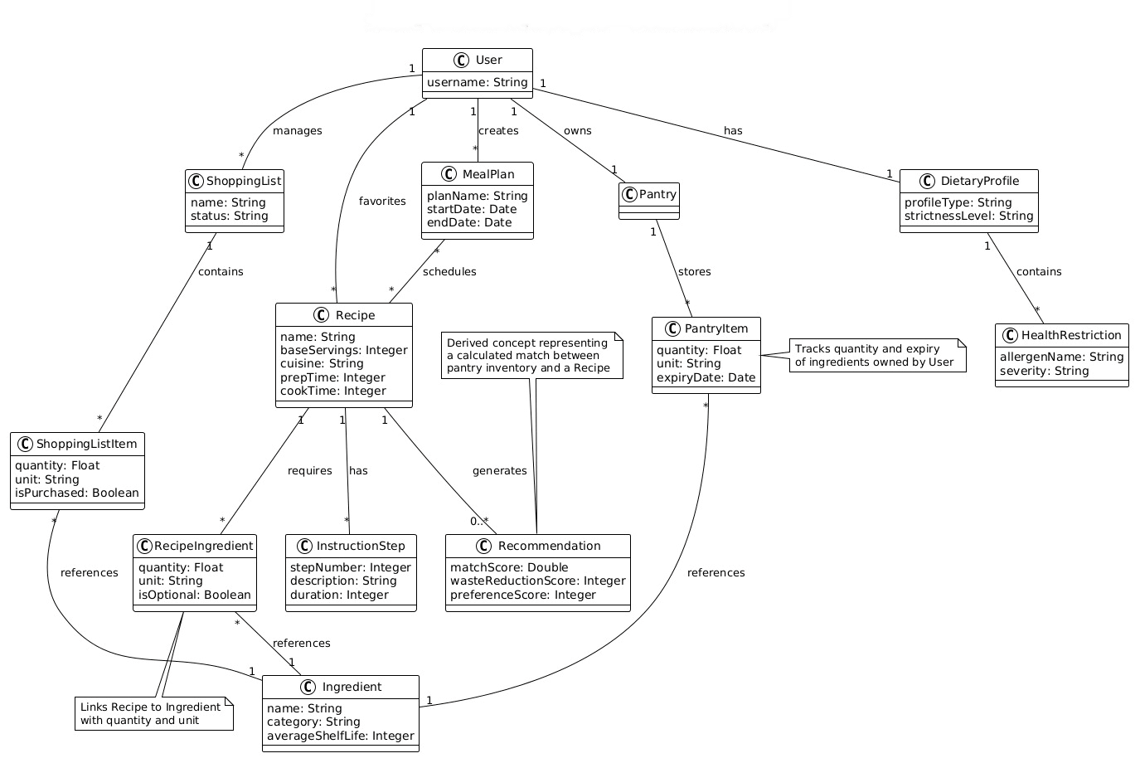
7. Glossary
Term | Definition
API | Application Programming Interface - endpoints for client-server communication
CORS | Cross-Origin Resource Sharing - security mechanism for browser requests
DTO | Data Transfer Object - simplified object for API responses
Expiry Alert | Notification about food approaching expiration date
Match Score | Percentage of recipe ingredients available in pantry
Pantry | Virtual inventory of food items owned by user
POJO | Plain Old Java Object - simple Java class without framework dependencies
REST | Representational State Transfer - architectural style for APIs
Strategy Pattern | Design pattern enabling interchangeable algorithms
Substitution | Alternative ingredient that can replace a missing one
Waste Risk Score | Numerical urgency indicator based on days until expiry

8. Functional Requirements
FR-01 The system will enable users to add ingredients to their virtual pantry with a quantity, unit and expiry date.
FR-02 The system will enable users to delete ingredients out of their pantry when used or gone bad.
FR-03 The system will determine a waste risk score of each pantry item in terms of the number of days to expiry.
FR-04 The system will offer the recommendations of recipes based on the percentage of the match with pantry inventory.
FR-05 When Waste Reduction strategy is chosen, the system will emphasize recipes in which the ingredients will be near expiration.
FR-06 The system will sieve recipe suggestions on the diet profile of the user (Vegan, Vegetarian, Keto,..)
FR-07 The system will not recommend recipes that have ingredients to which the user has declared a fatal allergy.
FR-08 The system will recommend alternative ingredients in case a necessary ingredient is not available in the pantry.
FR-09 The system will enable users to adjust amounts of ingredients in recipes according to the number of servings wanted.
FR-10 The system will enable users to save recipes to the personal favorites list. FR-11 The system will enable the user to generate meal plans and schedule the recipes to be followed on certain days.
FR-12 The system will produce a combined shopping list based on a meal plan, and this will consider the current pantry stock.
FR-13 The system will alert the users that the pantry items are nearly out of date. FR-14 The system will enable the search of recipes by the name of an ingredient. FR-15 The system will enable users to filter recipes according to the cuisine type
FR-16 The system will show a detailed overview of the recipes with the ingredients, quantities, and preparation procedures.
9. Non-Functional requirements
9.1 Performance Requirements
ID | Requirement | Target
NFR-01 | Response time of API to recommendations | Less than 500ms in response to 100 recipes.
NFR-02 | Page load time | < 2 seconds on broadband connection
NFR-03 | Simultaneous user support | At least 50 simultaneous users

9.2 Security Requirements
ID | Requirement | Target
NFR-04 | CORS Configuration | In production, API must only allow cross-origin requests to trusted domains.
NFR-05 | Input Validation | All inputs by the user will be validated and sanitized.
NFR-06 | No Data storage | Sensitive Data User data will not include any personally identifiable information.

9.3 Usability Requirements
ID | Requirement | Target
NFR-07 | Responsive Design | Interfaces will be responsive to desktop viewports, tablet viewports and mobile viewports.
NFR-08 | Intuitive Navigation | One or two clicks to core functions.
NFR-09 | Error Messaging | Provide user friendly error messages in case of any failure.
NFR-10 | Visual Feedback | Loading states and confirmation messages of all actions.

9.4 Scalability Requirements
ID | Requirement | Target
NFR-11 | Pantry Item Capacity | System must have the capacity of 200 pantry items per user.
NFR-12 | Horizontal Scalability | Backend will be stateless to allow numerous instances.

10. Use Case Diagram
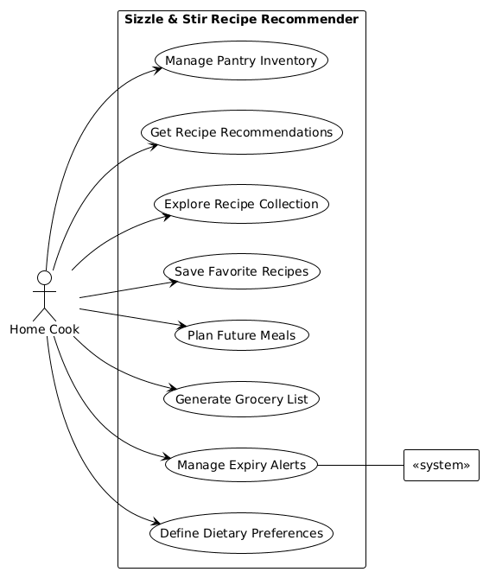
11. Use Case Specifications
1. UC1: Manage Pantry Inventory (Add Item)
Section | Content
Name | Add Pantry Item
Actors | Home Cook
Description | The user adds a specific ingredient with its quantity and expiry date to the digital pantry.
Trigger Event | User selects the "Add Item" button in the Pantry UI.
Pre-conditions | The system is active and the Pantry object is initialized.
Post-condition | A new PantryItem is created and stored in the user's Pantry.
Result | The pantry list reflects the new item and its waste risk score.
Main Scenarios | 1. System prompts for ingredient name, quantity, unit, and expiry date.  2. User enters details (e.g., "Milk", "1", "Liter", "2026-05-01").  3. System validates the date format.  4. System creates a PantryItem linked to the Ingredient database.  5. System adds the item to the Pantry list.
Alternative Scenarios | If the expiry date is in the past, the system displays "Invalid Date" and requests a future date.

2. UC2: Get Recipe Recommendations
Section | Content
Name | Request Smart Recommendations
Actors | Home Cook
Description | The system suggests recipes that match the user's current pantry items and dietary needs.
Trigger Event | User clicks "Get Recommendations" on the dashboard.
Pre-conditions | The Pantry contains at least one ingredient.
Post-condition | The system generates a list of RecipeRecommendation objects.
Result | A list of recipes is displayed, sorted by the selected strategy.
Main Scenarios | 1. User selects a strategy (e.g., Waste Reduction).  2. RecommenderController fetches all recipes from RecipeRepository.  3. System filters recipes based on DietaryProfile (e.g., Vegan).  4. System calculates match scores using RecommendationStrategy.  5. System displays the top results.
Alternative Scenarios | If no recipes match the pantry, the system suggests a "Shopping Trip" and shows recipes requiring only 1-2 new items.

3. UC3: Manage Expiry Alerts (System Check)
Section | Content
Name | Automatic Expiry Monitoring
Actors | System
Description | The system periodically checks the pantry for items approaching their expiration date.
Trigger Event | System clock reaches the scheduled check time (e.g., daily at 8 AM).
Pre-conditions | The system is running in the background.
Post-condition | NotificationManager identifies items with a high waste risk.
Result | Alerts are queued for the User.
Main Scenarios | 1. System iterates through all PantryItem objects.  2. System calls isExpiringSoon(thresholdDays).  3. NotificationManager updates the alert history.  4. System flags these items in the UI.
Alternative Scenarios | If the pantry is empty, the system skips the check.

4. UC4: Define Dietary Preferences
Section | Content
Name | Set Health Restrictions
Actors | Home Cook
Description | The user specifies allergies or health-related dietary exclusions.
Trigger Event | User opens "Profile Settings."
Pre-conditions | A User profile exists.
Post-condition | The DietaryProfile is updated with new HealthRestriction objects.
Result | Incompatible recipes are automatically hidden or flagged.
Main Scenarios | 1. User selects an allergen from a list (e.g., "Peanuts").  2. User sets severity (e.g., "High").  3. System adds the restriction to the DietaryProfile.  4. System re-runs isRecipeSafe() logic for saved recipes.
Alternative Scenarios | If the user removes a restriction, the system refreshes the recommendation list to include previously hidden recipes.

5. UC5: Explore Recipe Collection
Section | Content
Name | Request Smart Recommendations
Actors | Home Cook
Description | The system suggests recipes that match the user's current pantry items and dietary needs.
Trigger Event | User clicks "Get Recommendations" on the dashboard.
Pre-conditions | The Pantry contains at least one ingredient.
Post-condition | The system generates a list of RecipeRecommendation objects.
Result | A list of recipes is displayed, sorted by the selected strategy.
Main Scenarios | 1. User selects a strategy (e.g., Waste Reduction).  2. RecommenderController fetches all recipes from RecipeRepository.  3. System filters recipes based on DietaryProfile (e.g., Vegan).  4. System calculates match scores using RecommendationStrategy.  5. System displays the top results.
Alternative Scenarios | If no recipes match the pantry, the system suggests a "Shopping Trip" and shows recipes requiring only 1-2 new items.

6. UC6: Save Favorite Recipes
Section | Content
Name | Bookmark Recipe
Actors | Home Cook
Description | The user saves a recipe for quick access in the future.
Trigger Event | User clicks the "Heart" icon on a recipe card.
Pre-conditions | A recipe is currently being viewed.
Post-condition | The recipe is added to the User.favorites list.
Result | The recipe appears in the "Favorites" tab.
Main Scenarios | 1. User views "Spicy Tacos."  2. User clicks "Favorite."  3. System calls User.addToFavorites(recipe).  4. UI confirms "Saved to Favorites."
Alternative Scenarios | If the recipe is already a favorite, clicking the icon again removes it from the list.

7. UC7: Plan Future Meals
Section | Content
Name | Add Recipe to Meal Plan
Actors | Home Cook
Description | The user assigns a recipe to a specific date range.
Trigger Event | User selects "Add to Meal Plan" from a recipe page.
Pre-conditions | A recipe and a MealPlan duration are selected.
Post-condition | MealPlan object is updated with the new Recipe.
Result | The recipe is scheduled on the user's calendar.
Main Scenarios | 1. User selects "Weekly Plan."  2. User drags "Pasta" to "Wednesday."  3. System updates the scheduledRecipes list in MealPlan.
Alternative Scenarios | If the date is already full, the system asks if the user wants to replace the existing meal.

8. UC8: Generate Grocery List
Section | Content
Name | Automate Shopping List
Actors | Home Cook
Description | The system identifies missing ingredients from a Meal Plan and creates a shopping list.
Trigger Event | User clicks "Generate Shopping List."
Pre-conditions | A MealPlan is active.
Post-condition | A ShoppingList object is created.
Result | A list of needed items and quantities is displayed.
Main Scenarios | 1. System compares MealPlan ingredients vs. Pantry items.  2. System calculates gaps in quantities.  3. ShoppingListItem objects are created for missing items.  4. System displays the final list.
Alternative Scenarios | If the user already has enough ingredients, the system displays "Everything in stock!"

9. UC9: Handle Ingredient Substitutions (System)
Section | Content
Name | Find Ingredient Substitute
Actors | System
Description | The system suggests an alternative ingredient if a primary one is missing.
Trigger Event | RecommenderController finds a "Missing" status for a recipe ingredient.
Pre-conditions | SubstitutionEngine has pre-defined rules.
Post-condition | The RecipeRecommendation is updated with substitution notes.
Result | User sees a recommendation they can actually cook.
Main Scenarios | 1. System notices "Milk" is missing.  2. SubstitutionEngine finds a rule for "Almond Milk."  3. System checks if "Almond Milk" is in the Pantry.  4. System applies the ratio (e.g., 1:1).  5. System flags the recipe as "Cookable with Substitutes."
Alternative Scenarios | If no substitute is available in the pantry, the item remains marked as "Missing."

10. UC10: Scale Recipe
Section | Content
Name | Adjust Serving Size
Actors | Home Cook
Description | The user scales the recipe ingredients up or down based on the number of people.
Trigger Event | User changes the "Servings" number on the recipe page.
Pre-conditions | A recipe is open.
Post-condition | RecipeIngredient quantities are recalculated.
Result | The recipe displays new quantities for all ingredients.
Main Scenarios | 1. User changes servings from 2 to 4.  2. System calculates scaleFactor (2.0).  3. System calls scaleQuantity() on all RecipeIngredient objects.  4. UI updates the measurements.
Alternative Scenarios | If the user enters "0" or a negative number, the system defaults to the base servings.

11. UC11: Manage Expiry Alerts (User Action)
Section | Content
Name | Resolve Expiry Alert
Actors | Home Cook
Description | The user acknowledges an alert and decides what to do with the expiring item.
Trigger Event | User clicks on a notification.
Pre-conditions | An alert exists in the NotificationManager.
Post-condition | The alert is cleared or the pantry is updated.
Result | Alert history is updated.
Main Scenarios | 1. User sees "Spinach is expiring."  2. User selects "Used it."  3. System removes the item from the Pantry.  4. System clears the notification.
Alternative Scenarios | User selects "Show recipes for this," and the system triggers UC2.1 (Get Recommendations).

12. UC12: Clear Pantry Items
Section | Content
Name | Manual Pantry Cleanup
Actors | Home Cook
Description | The user removes multiple items at once to sync with their physical kitchen.
Trigger Event | User selects "Clean Pantry."
Pre-conditions | Multiple items exist in the pantry.
Post-condition | Pantry.removeItem() is called for selected items.
Result | The pantry list is shortened.
Main Scenarios | 1. User checks boxes for "Old Bread" and "Finished Jam."  2. User clicks "Remove Selected."  3. System confirms deletion.  4. Pantry list is updated.
Alternative Scenarios | If the user cancels the confirmation, no items are removed.

13. UC13: Update Shopping List Status
Section | Content
Name | Check off Grocery Item
Actors | Home Cook
Description | User marks an item as "Purchased" while at the store.
Trigger Event | User clicks the checkbox next to a ShoppingListItem.
Pre-conditions | A ShoppingList is open.
Post-condition | isPurchased boolean is set to True.
Result | The item is visually struck through.
Main Scenarios | 1. User buys "Eggs."  2. User clicks the item in the UI.  3. System updates the item status.
Alternative Scenarios | If the user unchecks the item, the status returns to "Unpurchased."

14. UC14: Define Flavor Preferences
Section | Content
Name | Rate Ingredient Preference
Actors | Home Cook
Description | User tells the system which ingredients they like or dislike to tune the AI.
Trigger Event | User opens the "Flavor Map" in settings.
Pre-conditions | DietaryProfile is initialized.
Post-condition | flavorWeights map is updated.
Result | Preference scores change in the recommendation engine.
Main Scenarios | 1. User searches for "Cilantro."  2. User sets preference to "-5" (Dislike).  3. System stores weight in FlavorPreference.
Alternative Scenarios | If the user gives a high score (+10), the system prioritizes recipes with that ingredient.

15. UC15: View Cooking Steps
Section | Content
Name | Execute Cooking Mode
Actors | Home Cook
Description | The user follows the step-by-step instructions for a recipe.
Trigger Event | User clicks "Start Cooking."
Pre-conditions | A recipe is selected.
Post-condition | System displays the first InstructionStep.
Result | The user completes the recipe.
Main Scenarios | 1. System shows "Step 1: Boil Water."  2. User clicks "Next."  3. System shows "Step 2: Add Pasta."  4. User reaches the final step and clicks "Finished."
Alternative Scenarios | User can click "Back" to see previous instructions.

16. UC16: Browse/Filter with Category
Section | Content
Name | Filter by Cuisine
Actors | Home Cook
Description | The user browses the collection of 50+ recipes by specific cuisine types.
Trigger Event | User selects a cuisine tag (e.g., "Italian").
Pre-conditions | RecipeRepository is populated with data.
Post-condition | The UI updates to show filtered results.
Result | Only recipes belonging to the chosen cuisine are visible.
Main Scenarios | 1. User clicks the "Cuisine" dropdown.  2. User selects "Mexican."  3. RecipeRepository executes fetchRecipesByCuisine("Mexican").  4. System displays the matching Recipe cards.
Alternative Scenarios | If no recipes exist for a cuisine, the system displays "No results found" and suggests another category.

12. System Sequence Diagram
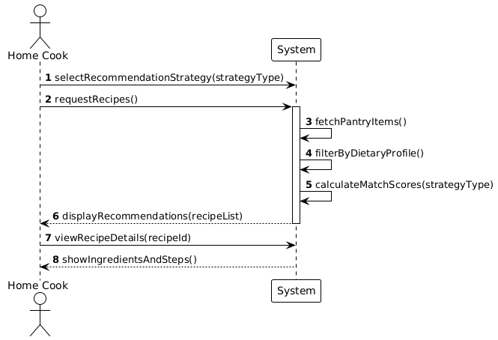
SSD for UC1: Get Recipe Recommendations

SSD for UC2: Manage Expiry Alerts
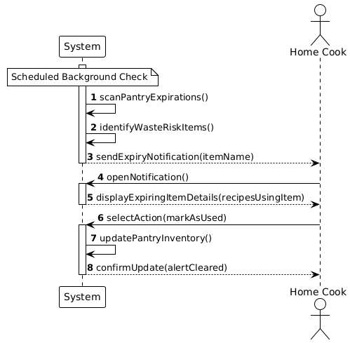

13. Architecture Description
Sizzle and Stir uses Layered Architecture where there is separation of concerns between client and server.
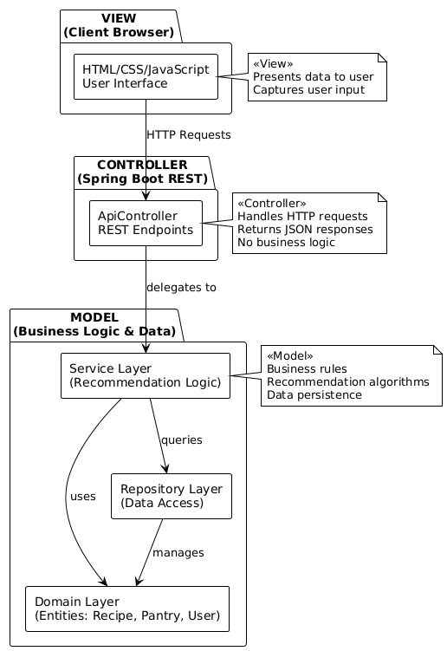

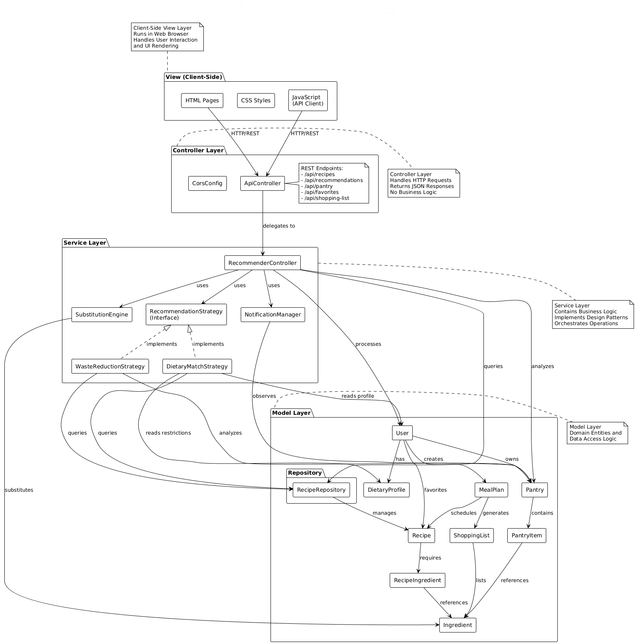

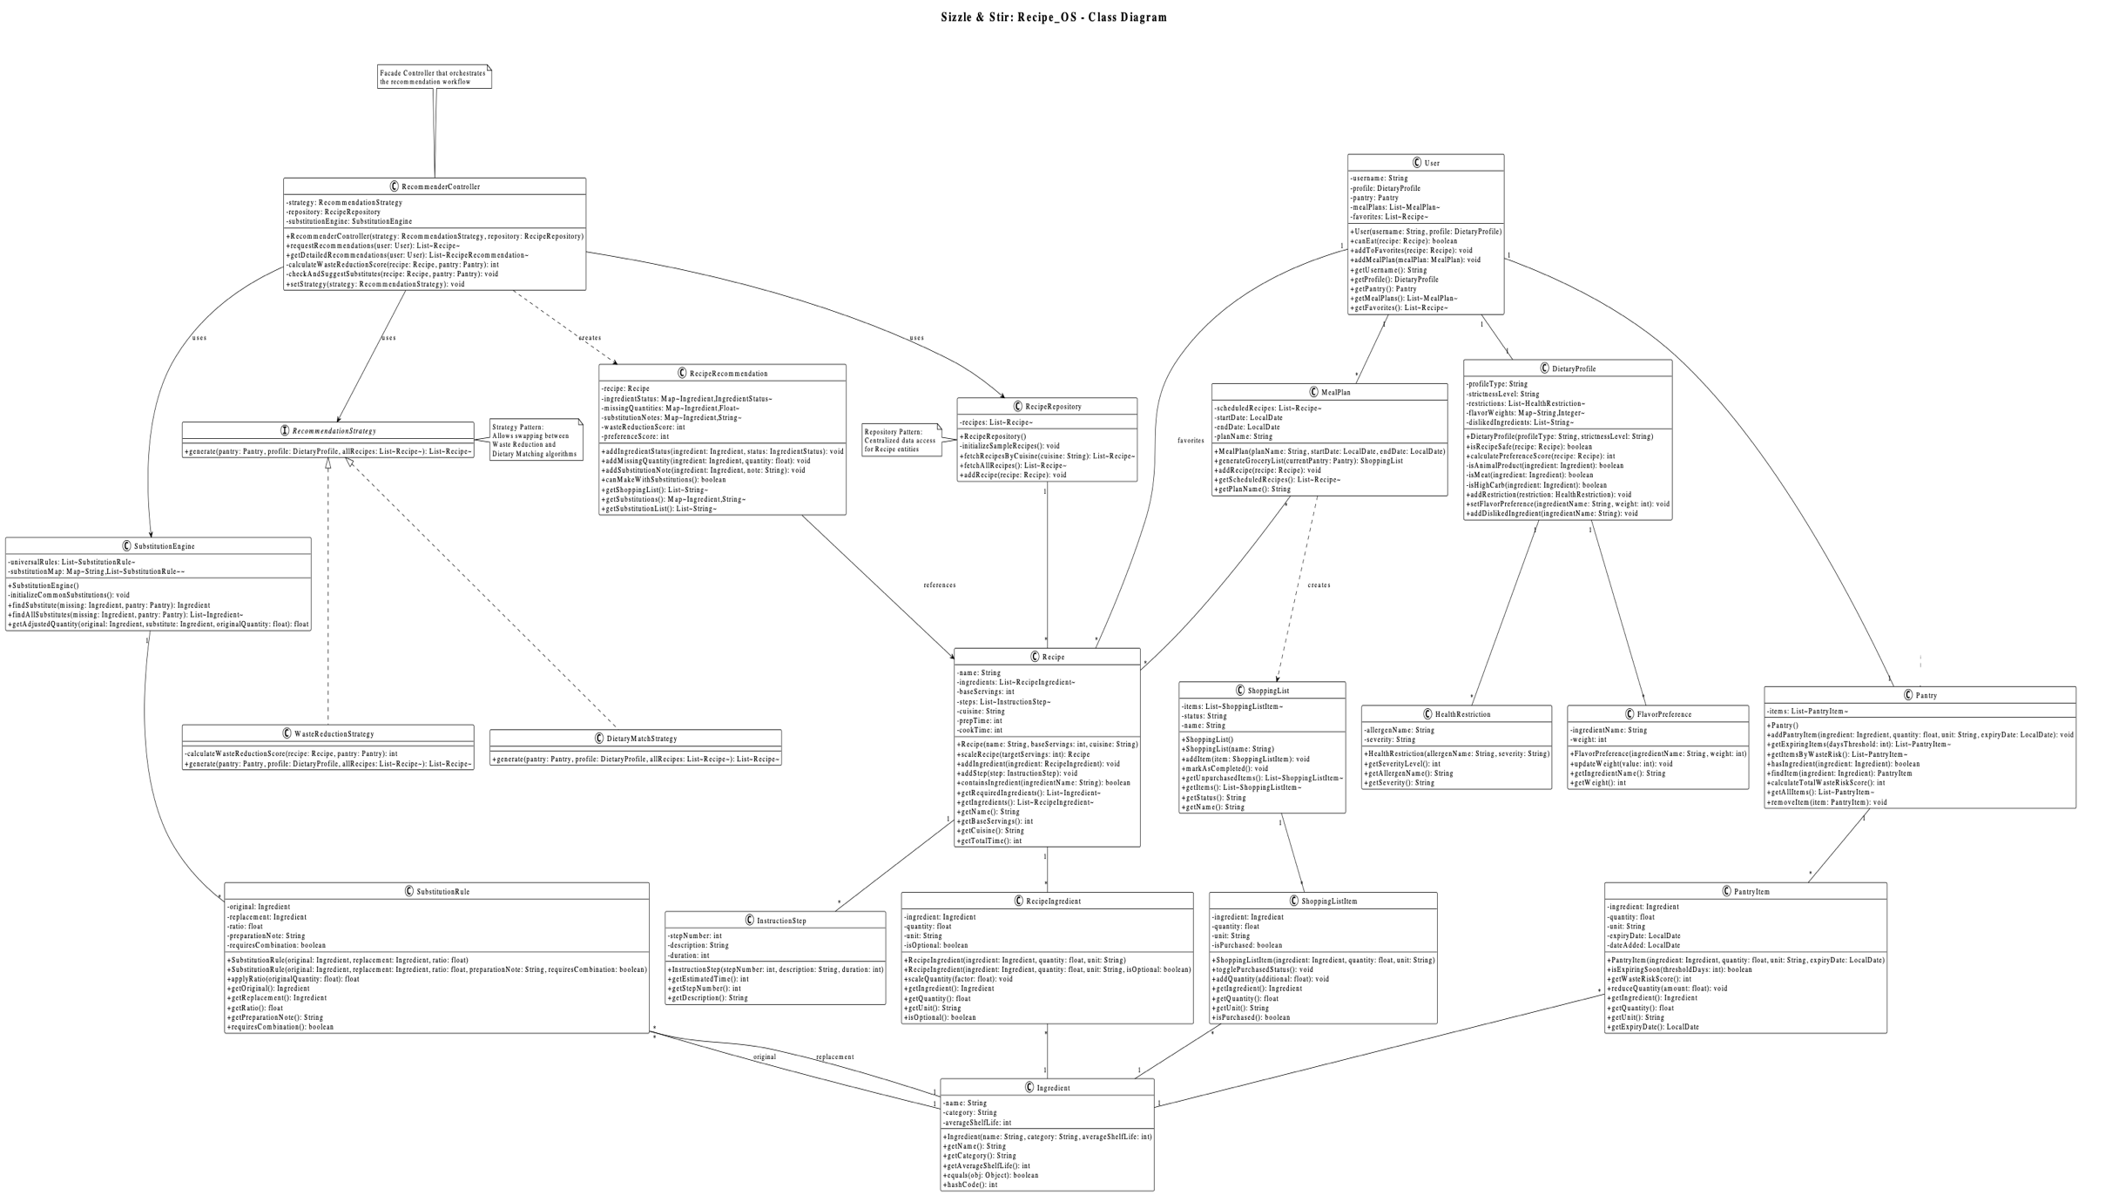
14. Design Class diagram

15. Interaction diagram
Get recommendation
This shows how the ApiController coordinates with the RecommenderController and the RecipeRepository to find a meal.
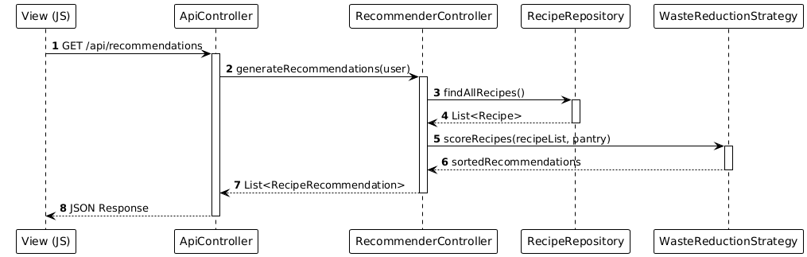

Add to Pantry
This captures the flow from the UI through the business logic to data persistence.
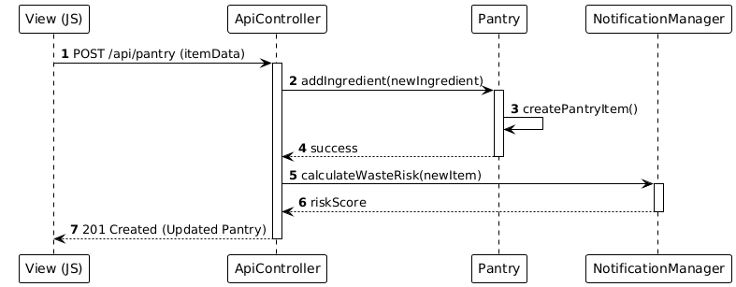

16. State Machine Diagram
The PantryItem is the best object for a state machine because it has a clear lifecycle from being bought to being consumed or wasted.
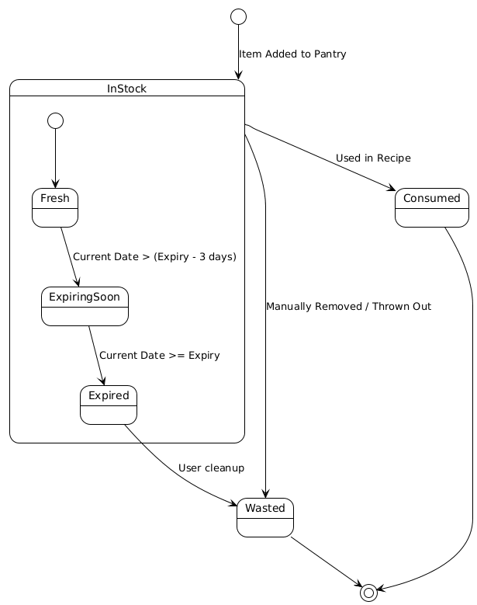
17. Grasp Principles
Class | Primary GRASP Principle | Justification
ApiController | Controller | Makes it as an entry point beyond the UI layer to accept and organize events of the system. It does not do business logic but delegates it to the Service layer
RecommenderController | High Cohesion | Only deals with the logic of ingredient/recipe matching, leaving any substitution work to another class, and thus makes it maintain its responsibilities very small and manageable.
Pantry | Information Expert | The Pantry is the owner of list of PantryItems and it is the expert that would ensure whether an ingredient is available or total inventory
NotificationManager | Low Coupling | By letting the alerts be handled separately, other classes (such as PantryItem) do not need to know how to send alerts. This reduces dependencies within the system.
SubstitutionEngine | Pure Fabrication | This class is not an actual object in a kitchen, but was designed to deal with the specifics of ingredient swaps to achieve high cohesion in the Recommender

18. Implementation Notes
The actual implementation of Sizzle and Stir: Recipe_OS was achieved as a strong Java-based application using a contemporary layered architecture to guarantee a clear separation of concerns. The system is based on the Spring Boot framework to handle a complex REST API layer, which serves as the main point of interaction between the user (front-end) and the intricate back-end business logic. The essence of the application is that the core is based on a dynamical inventory control system where the pantry items are not just entries in the table, but instead the intelligent objects whose dynamical behaviour continuously tracks the expiration dates and computes the risk of waste levels. In order to enable a smooth cooking process, the recommendation engine was developed based on the Strategy design pattern, which enables the system to switch between such algorithms as waste reduction and dietary matching, without changing the codebase. This flexibility makes sure that the application is able to effectively cross-reference users, health restrictions and real-time pantry levels to filter the recipe database into a customized list of options.
The system ensures data integrity by using a special repository layer, which emulates a persistent database, which manages storage and retrieval of more than 50 different recipes and their respective metadata. One of the key technical successes of this implementation was the creation of a unit normalization utility that enables the system to effectively compare non-comparable measurements, e.g. converting pantry stock in kilograms to the grams needed by a particular recipe. Moreover, the addition of a purely fabrication category, the Substitution Engine, gives the application a fallback mechanism that is smart, implying alternative ingredients in case primary ingredients are unavailable so that users can still make the meals of their choice. The strict use of GRASP principles of high cohesion and low coupling leads to the end product being a highly extensible platform with newly added features, e.g. meal planning calendars or automated shopping list generation, as independent but integrated modules interacting via standardised JSON interfaces.
19. Source Code
The source code is in the following GitHub link:
https://github.com/zainabm27/Smart-Recipe-Recommender

20. Code-Design Traceability

1. Domain Model Classes
Design Class | Implementation Class | Package | Key Methods with Parameters | Status
User | User.java | com.recipeapp.model | User(String username, DietaryProfile profile)  canEat(Recipe recipe): boolean  addToFavorites(Recipe recipe): void  addMealPlan(MealPlan mealPlan): void  getUsername(): String  getProfile(): DietaryProfile  getPantry(): Pantry  getMealPlans(): List<MealPlan>  getFavorites(): List<Recipe> | Complete
DietaryProfile | DietaryProfile.java | com.recipeapp.model | DietaryProfile(String profileType, String strictnessLevel)  isRecipeSafe(Recipe recipe): boolean  calculatePreferenceScore(Recipe recipe): int  addRestriction(HealthRestriction restriction): void  setFlavorPreference(String ingredientName, int weight): void  addDislikedIngredient(String ingredientName): void  getProfileType(): String  getStrictnessLevel(): String  -isAnimalProduct(Ingredient): boolean  -isMeat(Ingredient): boolean  -isHighCarb(Ingredient): boolean | Complete
Pantry | Pantry.java | com.recipeapp.model | addPantryItem(Ingredient, float, String, LocalDate): void  getExpiringItems(int daysThreshold): List<PantryItem>  getItemsByWasteRisk(): List<PantryItem>  hasIngredient(Ingredient): boolean  findItem(Ingredient): PantryItem  calculateTotalWasteRiskScore(): int  getAllItems(): List<PantryItem>  removeItem(PantryItem): void | Complete
PantryItem | PantryItem.java | com.recipeapp.model | PantryItem(Ingredient, float, String, LocalDate)  isExpiringSoon(int thresholdDays): boolean  getWasteRiskScore(): int  reduceQuantity(float amount): void  getIngredient(): Ingredient  getQuantity(): float  getUnit(): String  getExpiryDate(): LocalDate | Complete
Recipe | Recipe.java | com.recipeapp.model | Recipe(String name, int baseServings, String cuisine)  scaleRecipe(int targetServings): Recipe  addIngredient(RecipeIngredient): void  addStep(InstructionStep): void  containsIngredient(String): boolean  getRequiredIngredients(): List<Ingredient>  getSteps(): List<InstructionStep>  getIngredients(): List<RecipeIngredient>  getName(): String  getBaseServings(): int  getCuisine(): String  getTotalTime(): int | Complete
RecipeIngredient | RecipeIngredient.java | com.recipeapp.model | RecipeIngredient(Ingredient, float, String)  RecipeIngredient(Ingredient, float, String, boolean)  scaleQuantity(float factor): void  getIngredient(): Ingredient  getQuantity(): float  getUnit(): String  isOptional(): boolean | Complete
Ingredient | Ingredient.java | com.recipeapp.model | Ingredient(String name, String category, int averageShelfLife)  getName(): String  getCategory(): String  getAverageShelfLife(): int  equals(Object): boolean  hashCode(): int | Complete
InstructionStep | InstructionStep.java | com.recipeapp.model | InstructionStep(int stepNumber, String description, int duration)  getEstimatedTime(): int  getStepNumber(): int  getDescription(): String | Complete
HealthRestriction | HealthRestriction.java | com.recipeapp.model | HealthRestriction(String allergenName, String severity)  getSeverityLevel(): int  getAllergenName(): String  getSeverity(): String | Complete
FlavorPreference | FlavorPreference.java | com.recipeapp.model | FlavorPreference(String ingredientName, int weight)  updateWeight(int value): void  getIngredientName(): String  getWeight(): int | Complete
Equipment | Equipment.java | com.recipeapp.model | Equipment(String name, String category)  isAvailable(List<Equipment>): boolean  getName(): String  getCategory(): String | Complete

2. Strategy Pattern Implementation
Design Class | Implementation Class | Package | Pattern Role | Key Methods
RecommendationStrategy | RecommendationStrategy.java | com.recipeapp.model | Strategy Interface | generate(Pantry, DietaryProfile, List<Recipe>): List<Recipe>
DietaryMatchStrategy | DietaryMatchStrategy.java | com.recipeapp.model | Concrete Strategy 1 | generate(Pantry p, DietaryProfile d, List<Recipe> r): List<Recipe>
WasteReductionStrategy | WasteReductionStrategy.java | com.recipeapp.model | Concrete Strategy 2 | generate(Pantry, DietaryProfile, List<Recipe>): List<Recipe>  -calculateWasteReductionScore(Recipe, Pantry): int

3. Repository Pattern
Design Class | Implementation Class | Package | Pattern Role | Key Methods
RecipeRepository | RecipeRepository.java | com.recipeapp.model | Repository | fetchRecipesByCuisine(String): List<Recipe>  fetchAllRecipes(): List<Recipe>  addRecipe(Recipe): void  -initializeSampleRecipes(): void

4. Observer Pattern
Design Class | Implementation Class | Package | Pattern Role | Key Methods
ExpiryObserver | ExpiryObserver.java | com.recipeapp.model | Observer Interface | update(PantryItem): void
NotificationManager | NotificationManager.java | com.recipeapp.model | Concrete Observer | update(PantryItem): void  sendPushNotification(String): void  checkExpiringItems(Pantry): void  getNotificationHistory(): List<String>

5. Controller Classes (GRASP Patterns)
Design Class | Implementation Class | Package | GRASP Pattern | Key Methods
RecommenderController | RecommenderController.java | com.recipeapp.model | Controller | RecommenderController(RecommendationStrategy, RecipeRepository)  requestRecommendations(User): List<Recipe>  getDetailedRecommendations(User): List<RecipeRecommendation>  setStrategy(RecommendationStrategy): void  -calculateWasteReductionScore(Recipe, Pantry): int  -checkAndSuggestSubstitutes(Recipe, Pantry): void
ApiController | ApiController.java | com.recipeapp.controller | REST Controller | GET /api/recipes: List<RecipeDTO>  GET /api/recipes/{name}: RecipeDTO  GET /api/recommendations: List<RecommendationDTO>  GET /api/pantry: List<PantryItemDTO>  POST /api/pantry: ResponseEntity  DELETE /api/pantry/{name}: ResponseEntity  GET /api/favorites: List<RecipeDTO>  POST /api/favorites/{name}: ResponseEntity  GET /api/shopping-list: List<ShoppingItemDTO>  GET /api/notifications: List<String>  GET /api/profile: ProfileDTO
RecipeController | RecipeController.java | com.recipeapp.controller | REST Controller | GET /recipes: List<String>

6. Subsystem & Support Classes
Design Class | Implementation Class | Package | Purpose | Key Methods
MealPlan | MealPlan.java | com.recipeapp.model | Meal Planning | MealPlan(String, LocalDate, LocalDate)  generateGroceryList(Pantry): ShoppingList  addRecipe(Recipe): void  getScheduledRecipes(): List<Recipe>  getPlanName(): String
ShoppingList | ShoppingList.java | com.recipeapp.model | Shopping Management | ShoppingList()  ShoppingList(String)  addItem(ShoppingListItem): void  markAsCompleted(): void  getUnpurchasedItems(): List<ShoppingListItem>  getItems(): List<ShoppingListItem>  getStatus(): String  getName(): String
ShoppingListItem | ShoppingListItem.java | com.recipeapp.model | Shopping Items | ShoppingListItem(Ingredient, float, String)  togglePurchasedStatus(): void  addQuantity(float): void  getIngredient(): Ingredient  getQuantity(): float  getUnit(): String  isPurchased(): boolean
SubstitutionEngine | SubstitutionEngine.java | com.recipeapp.model | Ingredient Substitution | SubstitutionEngine()  findSubstitute(Ingredient, Pantry): Ingredient  findAllSubstitutes(Ingredient, Pantry): List<Ingredient>  getAdjustedQuantity(Ingredient, Ingredient, float): float  -initializeCommonSubstitutions(): void
SubstitutionRule | SubstitutionRule.java | com.recipeapp.model | Substitution Rules | SubstitutionRule(Ingredient, Ingredient, float)  SubstitutionRule(Ingredient, Ingredient, float, String, boolean)  applyRatio(float): float  getOriginal(): Ingredient  getReplacement(): Ingredient  getRatio(): float  getPreparationNote(): String  requiresCombination(): boolean

7. Enumeration Types
Design Enum | Implementation Enum | Package | Values
IngredientStatus | RecommenderController.IngredientStatus | Inner enum | HAVE_ENOUGH, NEED_MORE, MISSING, CAN_SUBSTITUTE, OPTIONAL

8. DTO & Request Classes
Class Name | Location | Fields | Status
RecipeDTO | ApiController.RecipeDTO | name, cuisine, baseServings, totalTime, ingredients, steps | Complete
InstructionStepDTO | ApiController.InstructionStepDTO | stepNumber, description, durationMinutes | Complete
IngredientDTO | ApiController.IngredientDTO | name, quantity, unit, optional | Complete
RecommendationDTO | ApiController.RecommendationDTO | recipe, wasteReductionScore, preferenceScore, canMake, missingItems, substitutions | Complete
PantryItemDTO | ApiController.PantryItemDTO | name, quantity, unit, expiryDate, wasteRiskScore | Complete
ShoppingItemDTO | ApiController.ShoppingItemDTO | name, quantity, unit, purchased | Complete
ProfileDTO | ApiController.ProfileDTO | username, dietaryType, pantryItemCount, favoriteCount | Complete
PantryItemRequest | ApiController.PantryItemRequest | name, category, quantity, unit, expiryDays | Complete
DietaryProfileRequest | ApiController.DietaryProfileRequest | profileType, strictnessLevel | Complete

9. Application Entry Point
Design Class | Implementation Class | Package | Key Methods
Application | Application.java | com.recipeapp | main(String[]): void  demo(): CommandLineRunner

10. Method Traceability (Detail)
Design Method | Implementation Method (with Parameters) | Class
generateRecommendations() | requestRecommendations(User user, String strategyType) | RecommenderController
checkDietaryCompliance() | isRecipeSafe(Recipe recipe) | DietaryProfile
calculateWasteScore() | getWasteRiskScore() | PantryItem
findSubstitutes() | findSubstitute(Ingredient ingredient) | SubstitutionEngine
scaleRecipe() | scaleRecipe(int targetServings) | Recipe
generateShoppingList() | generateGroceryList(Pantry currentPantry) | MealPlan
notifyExpiry() | update(PantryItem item) | NotificationManager
checkSafety() | canEat(Recipe recipe) | User
processStrategy() | generate(Pantry p, DietaryProfile d, List<Recipe> r) | DietaryMatchStrategy
verifyAvailability() | isAvailable(List<Equipment> kitchenInventory) | Equipment

21. User Interface
