Adventist University of Central Africa

PRODUCT REGULATORY & INSPECTION SYSTEM

A final year project

Presented in partial fulfillment of the

Requirement for the degree of

BACHELOR OF SCIENCE IN INFORMATION TECHNOLOGY

Major in

NETWORKS AND COMMUNICATION SYSTEMS

By

NYINAWUMUNTU Zainab Suleiman

July 2023

# DECLARATION

I, **Nyinawumuntu Zainab Suleiman**, a student at Adventist University of Central Africa in Faculty of Information Technology, Department of Networks and Communication Systems.

I do hereby declare that this research project report is entirely the real reflection of my own original work and experience to the best of my knowledge. It has never been either partially or wholly presented in any university or any higher learning institution.

**STUDENT**

NYINAWUMUNTU Zainab Suleiman

# DEDICATION

With great pleasure, I dedicate this Research Project

To Almighty God,

To my lovely parents,

To my lovely brothers and sisters,

To my relatives and all my colleagues at AUCA.

# ABSTRACT

Adventist University of Central Africa

Research project for the Bachelor Degree of science in Information Technology

Emphasis in Networks and Communication Systems

**Title: PRODUCT REGULATORY & INSPECTION SYSTEM**

**Name of a researcher: NYINAWUMUNTU Zainab Suleiman**

**Name and the degree of the faculty advisor: Mr. .Nteziryayo Deogratias, MSc.IT**

**Date completed: MAY 2023**

The objective of this study was to develop a web application that provides support of recording information of Food Processing companies, applying for License certificate and registering Premises. Once the Industry needs to use this system it will be required to register and by doing that, the Industry will be admitted into the system to inspect their produced products before putting them on the market. Industries will be able to request approval for their license certificate application to RFDA and they will approve or deny.

The system will provide a way for the Industries to create accounts, and for RFDA administrators to be able to receive applications they will have accounts too, the system will have inspectors who will check if product meets with regulations from RFDA, the industries will be able to view the status of their applications and Payment Gateway for their license certificate. This development of this system was done using different technologies, the one used for the UI is bootstrap and REACTJS and for backend there is PYTHON and for database management there is MySQL.

# DEFINITION OF TERMINOLOGIES

**Industry:**

is a branch of an [economy](https://en.wikipedia.org/wiki/Economy) that [produces](https://en.wikipedia.org/wiki/Production_(economics)) a closely-related set of [raw materials](https://en.wikipedia.org/wiki/Raw_material), [goods](https://en.wikipedia.org/wiki/Good_(economics)), or [services](https://en.wikipedia.org/wiki/Service_(economics)). (Norton, 26 March 2015)

**Payment Gateway:**

Is a technology used by merchants to accept [debit or credit card](https://www.investopedia.com/articles/personal-finance/050214/credit-vs-debit-cards-which-better.asp) purchases from customers (Fernando, November 30, 2021)

**Low-Risk Food:**

Low-risk foods are ambient-stable such as; bread, biscuits, cereals, crisps and cakes (not cream cakes)

# LIST OF ABBREVIATIONS

AUCA: Adventist University of Central Africa

RFDA : Rwanda Food and Drugs Authority

IT: Information Technology

UML: Unified Modeling Language

DBMS: Database Management System

HTML: Hyper Text Markup Language

CSS: Cascading Style Sheet

JDBC : Java Database Connectivity

# ACKNOWLEDGMENT

My praise and sincere thanks go to the Almighty God who blessed me with His grace and mercy throughout my life. I genuinely offer my recognition to the academic staff of the Department of Information Technology and the whole Administration at large at the Adventist University of Central Africa for the work done during my stay at the University, the knowledge that I acquired helped me to conduct this work, and I take this opportunity to thank the whole AUCA staffs.

My gratitude and unreserved recognition are addressed to Mr. Nteziryayo Deogratias, who, despite multitudes of his daily tasks and multiple responsibilities, accepted to supervise this work. His guidance, insight, patience, and support played important roles in the fulfillment of this work.

I would like to gratefully and sincerely thank my dear beloved brothers, sisters and family who have always encouraged and supported me during my studies to the completion of this work; for sure, no one is truly self-made, and hence I pass on a cordial thanks to my colleagues at AUCA.

May the Almighty God bless you with his most amazing blessings I pray.

Nyinawumuntu Zainab Suleiman

# CHAPTER 1

# GENERAL INTRODUCTION

## **Introduction**

Technology is the application of scientific knowledge for practical purpose, especially in industry. Indeed, technology can also be defined as a set of tools and techniques that are used to transform a problem into a solution. (Skolnikoff, (1993))

Verily, technology, nowadays, has emerged as the salient tool in the development of the world. And IT (information technology) which is the use of systems for storing, retrieve, transmit and manipulate data often in the context of a business or other enterprise, is the currently most used technology in enterprises’ data manipulation.

Thus for the industries’ transactions or the make of payment gateway information technology is the most advantageous way that is being used.

## **Background of the study**

Rwanda Food and Drugs Authority (RFDA) hereafter designated as the “Authority”, was established by the law Nº 003/2018 of 09/02/2018 The mandate of the Authority is to protect public health through regulation of human and veterinary medicines, vaccines and other biological products, processed foods, poisons, medicated cosmetics, medical devices, household chemical substances, tobacco and tobacco products. Product Regulatory and improved service delivery time.

Since in our Country processed product is on the rise in Rwanda and at an unprecedented pace, that’s where an idea started to strikes in my mind to produce the system that will help many industries in Rwanda which is Product regulatory &inspection system because in the past until today, industries were used to manual system for recording the industry information and report and thus this was very inconvenient, as it would result into burglary or any other incident. Indeed, as the world kept developing, people came up with intriguing thoughts of creating digital way of recording information and online payment.

Online payment is the electronic transfer of funds via the internet, usually between a merchant and a consumer. (GoCardless, nov 2022)

As the life goes on in the world, most of the data manipulation, payment transactions are made through the Internet.

## **Statement of the problem**

As our world is moving very faster, especially my country in technology we are trying to move from analog system to digital system very faster. In Rwanda, they are many private Food Processing companies, which used to provide Food on the market with Quality and standard to local. But they use manual system for recording the industry information and report (License certificate) where they store those data in the book (handwriting).So there are some issues that caused by this manual system which is loss of data, difficulties in updating information and many products reach their expiration date due to its slowness .

## **Choice and motivation in the study**

After observing the way of recording the industry information, application for the license certificate and report way payment transaction was being done to the RFDA, it wasn’t an appropriate way to do so. Indeed, that pulled my attention and thus thought solution it is to develop a system that would improve it. This was an opportunity to put in practice the knowledge gained throughout my academics in IT at Adventist University of Central Africa (AUCA).

Again it would be a big chance to fulfill one of AUCA’s objectives which is to help AUCA students to become useful member of society, empowered by the desire to develop the society not only with theoretical intellectual skills but also with a demonstrated desire of practical research endeavors that lead to the country’s development.

## **Objectives of the Study**

Each project tends to have different objectives and goals to be achieved. This project will also have both general and specific objectives as they are stated below:

### **General Objective**

Indeed, the main objective of this study is to develop a well-improved tool, which is a web application, which will help industries apply for their license and premises certificate online without wasting time to the RFDA office for the application, for the RFDA finance unit get payment transactions done to their accounts in real time and thus does reconciliation for them. Hence no client will have to carry license application form and bank slip to the RFDA office for the approval of their product on the market

### **Specific Objectives**

It should systematically address the various aspects of the problem and the key factors that are assumed to influence or cause the problem. They should specify what we will do in our study, where and for what purpose.

* Analyze how license applications is done by RFDA, and how getting confirmation of the license certificate, were being done in order to discover problems that lead the industries not get their

License on time and for the RFDA finance unit not getting their account payment transactions in real time.

* Develop an application (product regulatory & inspection) that will bring solutions to the above stated problems and thus allow industries to get license certificate without wasting time of going to RFDA office and for the RFDA evaluate application without checking into different notebooks and files as they were used to manual system.
* Test the application to see if the application has responded to industries’ problems.

## **Scope of the Study**

My study will only focus on computerizing the way of applying for license certificate and inspection of product that is intended to be on the market from the industries to the RFDA in real time, do reconciliation and thus help them to know who paid for the application.

## **Techniques and Methodology Used in the Study**

Research methodology describes how to conduct a research. Many facts are involved in conducting a research. To understand deeply the requirements and the problem domain, some techniques will help to achieve the aim of this research. Data can be gathered from a number of sources, which include documents, the workplace, the internet search, field notes, questionnaires and social interaction or interviews.

To collect data on the existing internal way of requesting support by RFDA, the following techniques will be used.

### **Documentation**

Documentation involves systematic data collection from existing records, such as books, websites and so on. This technique was used in this study while consulting documents online, past memories with related topics on industries and it helped me to collect the useful information different Food Processing companies and RFDA. The analysis of existing system from information gathered from a review of the documents helped identify problems and help to assess improvements needed to correct current system. (Dunne, 2021)

### **Observation**

Observation is a way of gathering data by watching behavior, events or noting physical characteristics in their nature setting. The observation will be indispensable to collect data on the actual work reality. I have used this one to observe different industries, how they struggle finding the license and premises certificate. (Hoover, 2021)

### **Interview**

Interview is defined as a systematic conversation between an interviewer and an interviewee, initiated for obtaining information relevant to a specific study. This technique was used to interview different industries who were having hard time in the process of finding license and premises certificate for their product to be on the market. One of the interviewee who has premises in Gasabo District. They have explained the challenges they met with in the process of finding license and premises certificate.

## **Expected Results**

Surely, after analyzing problems for the existing system, and thought of solutions for them because in our daily life, mostly, every problem might have a solution for it. The main solution that discovered is the creation and design of the improved system, which is a Product regulatory & inspection system

Once the new system has been deployed into the working environment, and thus it’s started to be used, all the operations will be done effectively and efficiently.

Hence once the industry finishes the application of license certificate, immediately the RFDA division manager will see all pending application waiting for the approval, and all information about who did it, for RFDA finance unit will see the payment for license certificate instead of bringing the bank slip to the RFDA office. So no movements with application documents and bank slip anymore.

The new system will wipe off manual way and expiration of product on the side of industries. However there is no waste of much time for everything becomes easy and faster.

## **Organization of the Report**

Our study contains five chapters:

First chapter entitled General Introduction will present briefly the problem that faces the management of the activities within the industries, motivation, objectives, methods and techniques of the study, scope of the study, expected results and organization of the report.

The second chapter will emphasis on the analysis of the existing system where we will describe activities and how they are distributed among employees using the organization structure, the structure of activities and the structure of the reporting period, deeply discover their issues, and suggested solutions proposed on those problems. This chapter will describe the organizational environment in which the new system will be implemented.

Third chapter will be entitled Analysis and Design of the new system is normally the logical conception of the new system. It will portray the conceptual process of the solutions proposed to solve the problems of the existing system.

Fourth chapter will highlight the technical realization of the application. Technologies Used, presentation of the new system (screenshots and brief description), software Testing, hardware and software requirements and deployment.

Fifth chapter will conclude our project as well as recommendations for future development.

# 

# CHAPTER 2

# ANALYSIS OF CURRENT SYSTEM

## **Introduction**

Within this chapter a brief presentation of the Product regulatory & inspection System is given, a deep analysis of the current system is the key for the conception of the new system because knowing every single details of the existing system is very important to the development of the new one, that’s why we are going to study well the existing system and analyze it. Then we will decide whether the proposed system is desirable or not and whether the existing system needs improvements.

## **Description of Current System Environment**

### **History**

Rwanda Food and Drugs Authority hereafter designated as the “Authority”, was established by the law Nº 003/2018 of 09/02/2018 determining its mission, organization and functioning. The mandate of the Authority is to protect public health through regulation of human and veterinary medicines, vaccines and other biological products, processed foods, poisons, medicated cosmetics, medical devices, household chemical substances, tobacco and tobacco products

In Rwanda Food and Drugs Authority, they have their way of managing the information of the industries at the organization.

If someone wants to get a premises certificate, he or she has to apply it in the manual way of using paper. If he or she has successfully fulfilled the entire requirement for getting the certificate, he or she will be able to get the certificate and after that process, he or she will be recorded in the journal as a new industry.

Indeed, if the industry want to launch new product on the market they have to ask for permission from Rwanda Food and drugs which is license certificate means they have to apply for that manually at the organization.

### **Mission**

To promote and protect public health by ensuring quality, safety and effectiveness

human and veterinary medicines, vaccines and other biological products, diagnostics,

medical devices, medicated cosmetics and other health related products, and Processed foods.

### **Vision**

A world class regulatory Authority effectively protecting and promoting public health.

## **Description of the current System**

In general, the private Food Processing companies that provide Food to different Market, the method or Existing system they used is a manual system, where to record information, they write all in notebooks with handwriting known as handbook and for the industry which is Applying for License certificate they have to fill form manually on the papers and submit them, after that they have to take their time to the bank to pay for license . This system can leads to loss of information, wasting long time to verify or check if the form filled as stated or if the product that is being produced meet with standard stated by RFDA. This normally lead to what we call checking in book; stress, inefficient time due to many people, normally their system does not regulateand inspect **for** the industry easier.

## 

## **Overview of the current System**

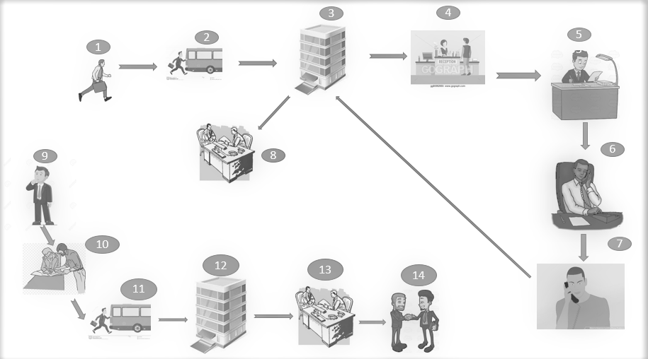

Figure 1: Modelling of current system

## **Description of the current system**

|  |  |
| --- | --- |
| Step 1-3 | It shows us a person running so fast going to the organization office to submit the document. |
| Step 4 | It show us the person after reaching the organization office and submit the document to the organization secretariat. |
| Step 5 | It show us the council of the organization review the document of the applicant in order to make a decision. |
| Step 6 | It show us the director of the organization calling applicant to tell result of the premises certificate application that applicant was involved in. |
| Step 7 | it show us the applicant receiving a call from the organization telling the result of the application he was involved in. |
| Step 8 | It show us the applicant taking a journey returning to the organization to ask for the progress of the application he or she has made |
| Step 9 | It show us a person trying to think how he or she can launch new product on market. |
| Step 10 | It show us two people discussing and passing through document which include details about product to be Published. |
| Step 11 | It show us a person running so fast going to the office of RFDA to ask for license certificate to launch new product on market. |
| Step 12-13 | It show us industry owner and secretary shaking hands after receiving certificate. |

Table 1: description of the current system's overview

### **Problems of the Existing System**

With the time taken, collecting all data to study the existing system, there are frailties that found with it. Let us keep taking the Rwanda Food and Drugs Authority as an organization example.

Indeed, those frailties are listed as follows:

* With the current system the service for applying for premises certificate is done manually and sometimes there is a lot risk in that process like loss of applicant paper , taking long time to respond to the applicant.
* As they are waiting for the response some of the product can reach their expiration date
* There is no control or security because we are using a non-digitized based on papers to collect and store information.
* After processing, the document of the applicant and the membership is successfully provided the record of that process are not directly kept in the system in the real time.
* When there is a need of retrieving information about registered industries it will be difficult as they will need to pass through many journals. As it is a duty of the Rwanda Food and drugs Authority to provide the community with that service but with their current system the service not provided.

## **Proposed Solutions**

For each problem in this world, there might be a solution for it. Thus, after discovering the above listed problems, and therefore figured out solutions for them. The following are the solutions found:

* **A simplified way of finding a License certificate:** The system will provide a way of applying for license certificate and get a feedback immediately from the system when needed and no need of going to the RFDA for the information, even the registration of industry will be done online and in need of immediate help they will be able to get help.
* **Easy way of communication between industry and Evaluators:** The system will allow a user to receive a notifying message in form of SMS when there is any response from the side of evaluators.
* **Industry ethics will be considered:** the Industry will be able to trust the system because their information will be confidentially kept and they will be helped by evaluators so that no others industries will know about their products.
* **Accessibility of useful information:** The system will be providing any information about the regulations and services they provide. It will also allow industries to know where to start and how they can track the status of their applications.

## **Requirements of the new System**

Functional [System requirements](https://www.sebokwiki.org/wiki/System_Requirement_(glossary)) are all of the [requirements](https://www.sebokwiki.org/wiki/Requirement_(glossary)) at the system level that describe the functions which the system as a whole should fulfill to satisfy the [stakeholder needs and requirements](https://www.sebokwiki.org/wiki/Stakeholder_Requirement_(glossary)), and is expressed in an appropriate combination of textual statements, views, Whereas non-functional requirements; the latter expressing the levels of safety, security, reliability, etc., that will be necessary.

### **Functional requirements**

These are statements of services, the system should provide, how the system should react to particular inputs and how the system should behave in particular situations. It specifies the software functionality that the developers must build into the product to enable users to accomplish their tasks.

* The System should allow its users to create their account.
* The system should provide an easy way of getting access to services provided.
* The system should provide a separate Login area with appropriate functionality for users.
* The system should provide a way for RFDA Evaluator to admit the industry into the system
* The system should notify industry with admission email or SMS containing the industry Admitted credentials the password in the credentials should be the default password created by the system
* The system should provide a way for the industry to change the password generated by the system
* The system should notify industry with an SMS which include the path for payment of business permit
* The system will provide a way to download a business permit after payment
* The system should to provide a way industry to fill the License application form
* The system should provide a way to list their license applications according to Pending , Approved , Rejected
* The system should provide a way to view and download license certificate for the approved application
* The system should provide a way to resume rejected license application
* The system should provide a way to list license application according to status : pending , Approved , Rejected and their stage: Review , Revaluation , Approval in order to act on them
* The system should provide a way to view pending applications in a table in order to Approve or reject them
* The should provide a way to send a notifying SMS to the industry which will show details about payment for Approved license certificate
* The system should provide a way to send a notifying SMS for the applications which is rejected in order to resume it.
* The system should provide a way for a user to enter into his/her account to pay for the license certificate
* The system must be able to generate barcode automatically on the license certificate
* The system must be able to do backup

### **Non-functional requirements**

Nonfunctional Requirements (NFRs) define system attributes such as security, reliability, performance, maintainability, scalability, and usability. They serve as constraints or restrictions on the design of the system across the different backlogs

### **Maintainability**

* + The system should be easily to maintain it, once is needed

### **Security**

* + The system must be able to hide the user’s information
  + Only RFDA Evaluator can generate reports
  + Only Admin can view the personal records of the Industry
  + The system includes all available safeguards from viruses, worms and Trojans Etc.
  + Direct users, staff and the admin to their respective portals.
  + Privacy and Security is guaranteed.
  + Password authentication key
  + The System will block you once you clicks 3 times on login steps

### **Operational**

* The system should be able to run on any OS

### **User friendly**

* + The System will be user friendly
  + The system must be easy for a user to user.

### **Privacy**

* The system shall be able to protect the user’s privacy

### **Availability**

* + The system hall has high availability
  + The system shall not have unexpected downtime

***Other non-functional requirements can be:***

* Allows your management more flexibility to make business decisions.
* Future year-to-year time consumption while applying business permit for new industries.
* Improving the service that given to the Private Food processing industries
* Improving data security
* provide a user with the information needed to do any task effectively and efficiently

# CHAPTER 3

# REQUIREMENT ANALYSIS AND DESIGN OF THE NEW SYSTEM

## **Introduction**

Undoubtedly, to build a powerful and successful system that meets the user needs, a deep analysis and clear design are required.

System development generally involves two major components:

* ***System Analysis.***
* ***System Design.***

System analysis is the process of gathering and interpreting facts, diagnosing problems and using the information to recommend improvements of system. Indeed, the end user’s requirements should be determined and documented, what their expectations are for the system, and how it will perform. A feasibility study, will be made for the project as well, involving determining whether it is organizationally, economically, socially, and technologically feasible. It is very important to maintain strong communication level with the clients to make sure you have a clear vision of the finished product and its function.

The design phase comes after a good understanding of customer’s requirements; this phase defines the elements of a system, the components, the security level, modules, architecture and the different interfaces and type of data that goes through the system.

With this system development phase, the developer and the user develop a concrete understanding of how the new system will operate. A good system design is impossible without careful, accurate system analysis.

## **Unified Modeling Language (UML)**

The Unified Modeling Language (UML) is a general-purpose modeling language in the field of software engineering. It provides a set of graphic notation techniques to create visual models of object-oriented software-intensive systems. Grady Booch Ivar Jacobson and James Rumbaugh at Rational Software developed it in the 1990s. It was adopted by the Object Management Group (OMG) in 1997, and has been managed by this organization ever since. In 2000, the International Organization accepted the Unified Modeling Language for Standardization (ISO) as a standard for modeling software-intensive systems.

UML combines techniques from data modeling (entity relationship diagrams), business modeling (workflows), object modeling, and component modeling. It can be used with all processes, throughout the software development life cycle, and across different implementation technologies. It offers a standard way to visualize a system’s architectural blueprints, including elements such as:

* Activities
* Actors
* business processes
* database schemas
* (logical) components
* programming language statements
* Reusable software components.

UML has synthesized the notations of the Booch method, the Object-modeling technique (OMT) and Object-oriented software engineering (OOSE) by fusing them into a single, common and widely usable modeling language. UML aims to be a standard modeling language that can model concurrent and distributed systems. (Booch, 1994)

### **Use Case Diagram**

***Introduction***

Use-case diagrams describe the high-level functions and scope of a system. These diagrams also identify the interactions between the system and its actors. The use cases and actors in use-case diagrams describe what the system does and how the actors use it, but not how the system operates internally.

***Notations & Definition of tools to be used***



Figure 2: Use case symbol

**Actor:** is a role that a user can play while interacting with the system. An actor can also represent another system in which the current system interacts. Here, below, is the representation of the actor.

User



Figure 3: Actor diagram

**System boundary boxes (optional)** is a rectangle drawn around the use cases, called the system boundary box, to indicate the scope of the system. Anything within the box represents functionality that is in scope and anything outside the box is not.



Figure 4: System boundary boxes diagram

A use case is the description of the model "View" by the actors in the system. It corresponds to the expected needs of each actor (the WHAT and WHO). Use cases are used to represent the operation of the system vis-à-vis the user, so this is a view of the system in its external environment.

***Design of the diagram***

The figure below describes the operations of new system and the stakeholders through the use case diagram

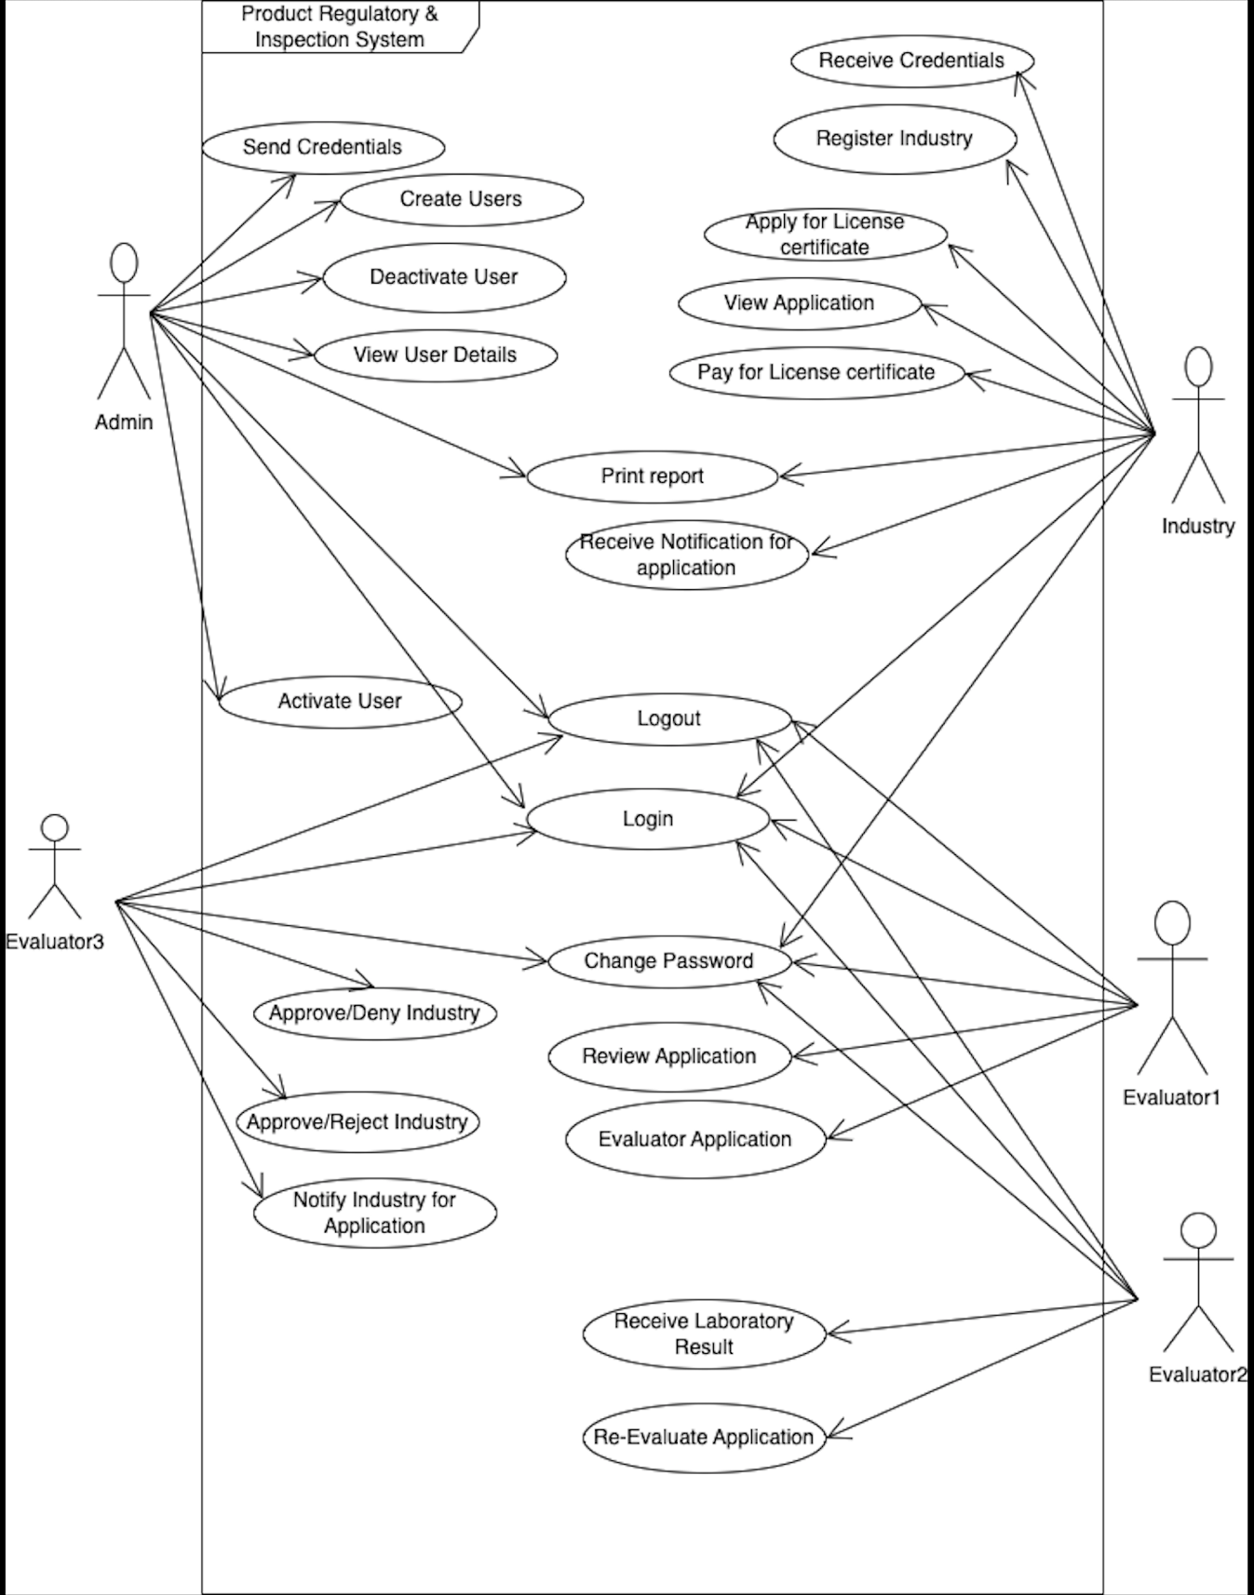

Figure 5: New systems Use Case diagram

**Use Case description**

Use Case description details what a use case does, and what it requests in order to be well executed. Each use case looks like this:

- **Name**: A name of a use case

- **Actor**: The actor involved in the use case

- **Description**: What a system intends to do

- **Pre-condition:** The system state before the use case can begin

- **Post-condition:** The system state when the use case is over

- **Normal flow:** The actual steps of the use case

- **Alternative flow:** Steps which may happen in case a normal flow fails.

|  |
| --- |
| **Name:**  **Create Account** |
| **Actor:** Admin |
| **Description:** To create a new account in the system |
| **Pre-condition:** Admin must access the system. |
| **Post-condition:** The system should return a successful message if the data are well recorded. |
| **Main Flow:** 1.1 Admin request the form for recording information,  1.2 System displays a form to fill the information,  1.3 Admin fills in the requested data,  1.4 Admin sends the filled form to System,  1.5 System validates data,  1.6 System adds data in database,  1.7 System return a message and displays it on the screen |
| **Alternative flow:**   * 2.1 If the information is not valid the system shows the error where is not correct. * 2.2 Admin fills and sent the information again. * 2.3 The system gives the message that” registration failed try again”. |

Table 2: Create Account Use Case Description

|  |
| --- |
| **Name: Login** |
| **Actor (s):** Admin , Industry , Evaluator1 , Evaluator2 , Evaluator3 |
| **Description:** allows all Users of the system to login into system before continue to do something |
| **Pre-condition:** Users must be registered in the system. |
| **Post-condition:** in return there must be a Successful Message: “login successfully”. |
| **Normal flow:**   * 1. Users request a login form.   2. System gives the form to fill the information.   3. They login into system.   4. The system gives a welcome message. |
| **Alternative flow:**   * 1. If the information is not valid the system shows the error where is not correct.   2. The Admin or users fill and login again.   3. The system gives an error message” Invalid username or Password, please try again”. |

Table 3: Login Use Case Description

|  |
| --- |
| **Name:**  **Approve Application** |
| **Actor:** Evaluator 3 |
| **Description:** To approve application from an industry |
| **Pre-condition:** Evaluator 3 must have valid username and password. |
| **Post-condition:** The system should return a successful message if the data are well updated. |
| **Main Flow:** 1.1 Evaluator 3 request the form for viewing all applications,  1.2 System displays a table of applications,  1.3 Evaluator 3 approve application,  1.4 System update data,  1.5 System return a message and displays a notification on the screen |
| **Alternative flow:**   * 2.1 If the information is not valid the system shows the error where is not correct. * 2.2 Evaluator 3 approve and sent the information again. * 2.3 The system gives the message that” failed try again”. |

Table 4: Approve Application Use Case Description

|  |
| --- |
| **Name:**  **Reject Application** |
| **Actor:** Evaluator 1 , Evaluator 2 , Evaluator 3 |
| **Description:** To reject application from a couple |
| **Pre-condition:** Evaluators must have valid username and password. |
| **Post-condition:** The system should return a successful message if the data are well updated. |
| **Main Flow:** 1.1 Evaluators request the form for viewing all applications,  1.2 System displays a table of applications,  1.3 Evaluators reject an application,  1.4 System update data,  1.5 System return a message and displays a notification on the screen |
| **Alternative flow:**   * 2.1 If the information is not valid the system shows the error where is not correct. * 2.2 Evaluators reject and sent the information again. * 2.3 The system gives the message that” failed try again”. |

Table 5: Reject application Use Case Description

|  |
| --- |
| **Name: View User details** |
| **Actor:** Admin, |
| **Description:** To allows Admin to view User’s information |
| **Pre-condition(s):** Admin should have logged on system. |
| **Post-condition(s):** Admin will access a list of data from the database. |
| **Main Flow:** 1.1 Admin request the form for viewing data,  1.2 System displays a table,  1.3 Admin view data, |
| **Alternative flow:**  2.1 If the information is not valid the system shows errors.  2.2 The Admin fill and login again.  2.3 The system gives an error message” Invalid username or Password, please try again”. |

Table 6: View user details Use Case Description

|  |
| --- |
| **Name: Generate Report** |
| **Actor:** Admin, |
| **Description:** To allows Admin view Generate Reports |
| **Pre-condition(s):** Admin should have logged on system. |
| **Post-condition(s):** Admin will access data from the database. |
| **Main Flow:** 1.1 Admin make request for transforming data into report,  1.2 System displays a table,  1.3 Admin view data and generate report, |
| **Alternative flow:**  2.1 If the information is not valid the system shows the error where is not correct.  2.2 Users fill and login again.  2.3 The system gives an error message” Invalid username or Password, please try again”. |

Table 7: Generate report Use case Description

|  |
| --- |
| **Name: Print Reports** |
| **Actor:** Admin, Industry |
| **Description:** To allows Users view and Print Reports |
| **Pre-condition(s):** Users should have logged on system. |
| **Post-condition(s):** Users will access a list of data from the database. |
| **Main Flow:** 1.1 Users request the form for viewing data,  1.2 System displays a table,  1.3 Users view data and print report, |
| **Alternative flow:**  2.1 If the information is not valid the system shows the error where is not correct.  2.2 Users fill and login again.  2.3 The system gives an error message” Invalid username or Password, please try again”. |

Table 8: Print reports Use case Description

|  |
| --- |
| **Name:**  **Apply for license** |
| **Actor:** Industry |
| **Description:** To apply for license certificate |
| **Pre-condition:** Industry must have valid username and password. |
| **Post-condition:** The system should return a successful message if the data are well saved. |
| **Main Flow:** 1.1 Industry request the form for license application,  1.2 Industry read all requirement and fill the form with required information,  1.3 The system validate the entered information ,  1.4 System displays table of applications,  1.5 System return a message and displays a notification on the screen |
| **Alternative flow:**   * 2.1 If the information is not valid the system shows the error where is not correct. * 2.2 Industry apply and sent the information again. * 2.3 The system gives the message that” failed try again”. |

Table 9: Apply for license Use case Description

|  |
| --- |
| **Name:**  **Create users** |
| **Actor:** Admin |
| **Description:** To create a new account for the users of the system |
| **Pre-condition:** All users must access the system. |
| **Post-condition:** The system should return a successful message if the data are well recorded. |
| **Main Flow:** 1.1 Admin request the form for recording information,  1.2 System displays a form to fill the information,  1.3 Admin fills in the requested data,  1.4 Admin sends the filled form to System,  1.5 System validates data,  1.6 System adds data in database,  1.7 System return a message and displays it on the screen |
| **Alternative flow:**   * 2.1 If the information is not valid the system shows the error where is not correct. * 2.2 Admin fills and sent the information again. * 2.3 The system gives the message that” registration failed try again”. |

Table 10: Create Users Use case Description

|  |
| --- |
| **Name:**  **Deactivate users** |
| **Actor:** Admin |
| **Description:** To deactivate account for the users of the system |
| **Pre-condition:** All users will not access the system. |
| **Post-condition:** The system should return a successful message if the data are well recorded. |
| **Main Flow:**   * 1.1 Actor requests list all user * 1.2 The system displays the list * 1.3 The actor right click deactivate button from action * 1.4 The system update the database on changes made by the actor. |
| **Alternative flow:**   * 2.1 If the information is not valid the system shows the error where is not correct. * 2.2 If the system find that the user was deactivated it shows the error message |

Table 11: Deactivate user Use case Description

### **Class Diagrams**

#### **Introduction**

A class diagram in the [Unified Modeling Language (UML)](https://en.wikipedia.org/wiki/Unified_Modeling_Language) is **a type of static structure diagram** that describes the structure of a system by showing the system's classes, their attributes, operations (or methods), and the relationships among objects. (Cantu, 2018)

***Tools to be used***

|  |  |
| --- | --- |
| Term and definition | Symbol |
| An attribute:   * Represents properties that describe the state of an object. * Can be derived from other attributes, shown by   placing a slash before the attribute’s name. | |  | | --- | | **Class Name** | | +attribute1 : int  -attribute2 : float  #attribute3 : Circle | |  | |
| An operation:   * Represents the actions or functions that a class can perform. * Can be classified as a constructor, query, or update operation. * Includes parentheses that may contain parameters or information needed to perform the operation. | |  | | --- | | **Class Name** | |  | | +op1 ()  -op2 ()  #op3() | |
| An association:   * Represents a relationship between multiple classes or a class and itself. * Is labeled using a verb phrase or a role name. whichever better represents the relationship. * Can exist between one or more classes. * Contains multiplicity symbols, which represent the minimum and maximum times a class instance can be associated with the related class instance. |  |
| A generalization:   * Represents a-kind-of relationship between multiple   classes. |  |
| An aggregation:   * Represents a logical a-part-of relationship between multiple classes or a class and itself. * It is a special form of an association. |  |
| A composition:   * Represents a physical a-part-of relationship between multiple classes or a class and itself * It is a special form of an association. |  |

Table 12: Meaning of Symbols used on Class Diagram

***Design of the class diagram***

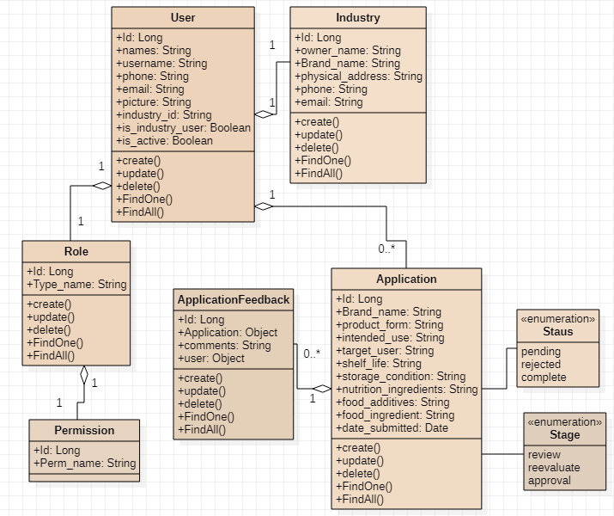

Figure 6 : Class Diagram

### **Sequence Diagram**

#### Introduction

A sequence diagram is a type of interaction diagram because it describes how—and in what order—a group of objects works together. These diagrams are used by software developers and business professionals to understand requirements for a new system or to document an existing process. Sequence diagrams are sometimes known as event diagrams or event scenarios. (Markham, 2018)

***Notation & definition of tools to be used***

|  |  |
| --- | --- |
| **Term and definition** | **Symbol** |
| **An actor:**   * It can be a person or system that derives benefit from and is external to the system. * It participates in a sequence by sending or receiving messages. * It is placed across the top of the diagram. | actor |
| **An object lifeline:**   * It participates in a sequence by sending or receiving messages. * It is placed across the top of the diagram. | lifeline |
| **An activation**:   * It is a long narrow rectangle placed on top of a lifeline. * It denotes when an object is sending or receiving messages |  |
| **A message**:   * It conveys information from one object to another one. * An operation call is labeled with the message being sent and a solid arrow, whereas a reply one is labeled with the value being returned and shown as a dashed arrow. | : Message send  Reply Message  Self-Message |

Table 13: Meaning of symbols to be used in Sequence Diagram

Sequence Diagram for Registering Industry

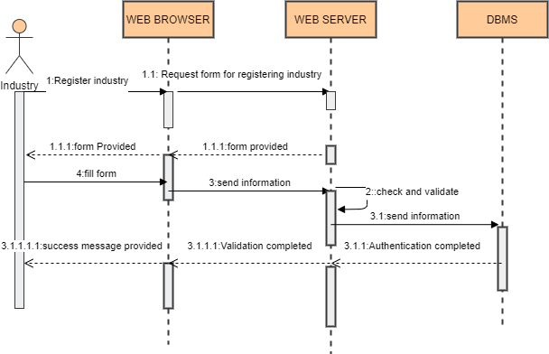

Figure 7: Sequence Diagram for Registering Industry

* This is sequence of how industry will registered into the system

Sequence Diagram of Applying for license certificate

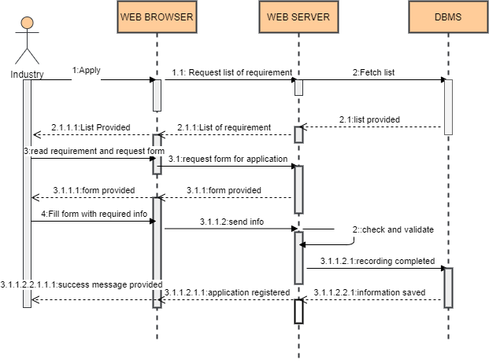

Figure 8: Sequence Diagram of Applying for License certificate

* This is sequence of how industry will Apply for license

Sequence Diagram for Reviewing Application

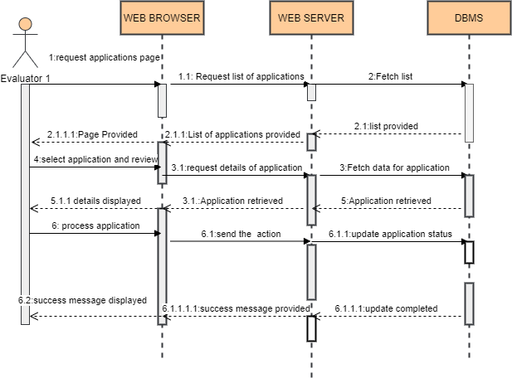

Figure 9: Sequence Diagram for review Application

* This is how Evaluator 1 will review Applications

Sequence Diagram for revaluation of Application

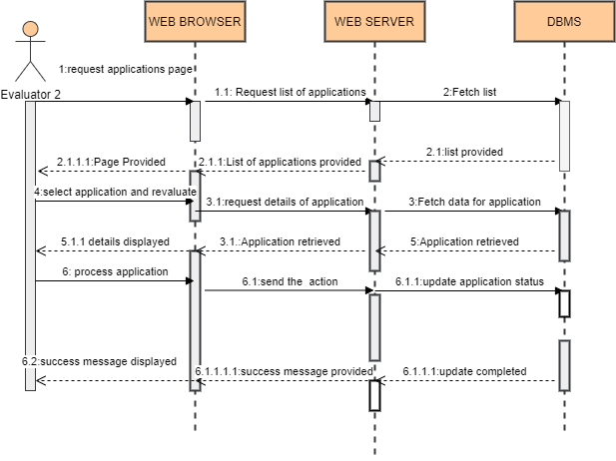

Figure 10: Sequence Diagram for Revaluation of Application

* This is how Evaluator 2 will reevaluate Applications

Sequence Diagram for Approving Application

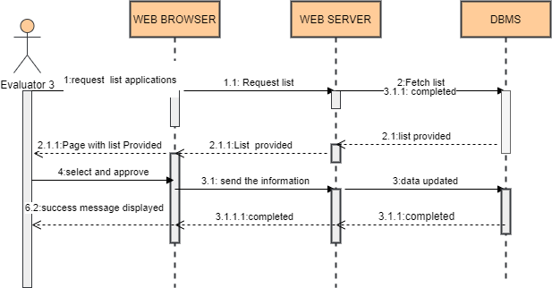

Figure 11: Sequence Diagram for Approving application

* This is how Evaluator 3 will Approve Applications

### **Activity Diagram**

#### **Introduction**

Activity diagram is another important diagram in UML to describe the dynamic aspects of the system. Activity diagram is basically a flowchart to represent the flow from one activity to another activity. The activity can be described as an operation of the system.

The control flow is drawn from one operation to another. This flow can be sequential, branched, or concurrent. Activity diagrams deal with all type of flow control by using different elements such as fork, join, etc.

***Definition of tools to be used***

|  |  |  |
| --- | --- | --- |
| Symbol | Name | Description |
| start Symbol | Start symbol | Represents the beginning of a process or workflow in an activity diagram. It can be used by itself or with a note symbol that explains the starting point. |
| activity Symbol | Activity symbol | Indicates the activities that make up a modeled process. These symbols, which include short descriptions within the shape, are the main building blocks of an activity diagram. |
| connector Symbol | Connector symbol | Shows the directional flow, or control flow, of the activity. An incoming arrow starts a step of an activity; once the step is completed, the flow continues with the outgoing arrow. |
| decision Symbol | Decision symbol | Represents a decision and always has at least two paths branching out with condition text to allow users to view options. This symbol represents the branching or merging of various flows with the symbol acting as a frame or container. |
| end symbol | End symbol | Marks the end state of an activity and represents the completion of all flows of a process. |

|  |  |  |
| --- | --- | --- |
| ***Design of the diagram***  **Login**    Figure 12: Login Activity Diagram   * This activity diagram shows how login activity takes place   **Register Industry**    Figure 13: Registering Industry Activity Diagram   * This activity diagram shows how Registering Industry activity takes place   **List of Users**    Figure 14 : Requesting List Users Activity   * This activity diagram shows how Requesting list of users activity takes place   **Apply For License**    Figure 15: Applying for license Activity Diagram   * This activity diagram shows how Applying for license activity takes place   **Approval for Application**    Figure 16: Approval for Application Activity Diagram   * This activity diagram shows how Approving Application activity takes place   **Print Report**    Figure 17: Printing report Activity Diagram   * This activity diagram shows how printing report activity takes place |  |  |
|  |  |  |
| **Database Design**Introduction Database designs and structures are a critical component to many development projects. Support for UML database diagrams in [UModel](https://www.altova.com/umodel) makes it easy to extend the advantages of visual UML modeling to databases, whether you need to create UML diagrams from existing tables, modify diagrams to and synchronize the database, or design new tables and relationships. (Hoffman, 2018)  *Notations and their usage*  This is an overview of the entire database Design notations, which we will use when drawing Database Model Diagrams and entities relationship diagrams.  Entity: In entity Relationship model, an entity notation is a thing of the real world that can be distinguished from other aspects of the real world. An entity may be a physical object such as a house.  Key Attribute: A key attribute is the unique characteristic of the entity.  Relationship: Relationships in Entity Relationship Models show how two entities share information in the database structure. **Database Schema diagram** A database schema of a database system is its structure described in a formal language supported by the database management system (DBMS) and refers to the organization of data to create a blueprint of how a database will be constructed (divided into database tables). The formal definition of database schema is a set of formulas (sentences called integrity constraints imposed on a database. These integrity constraints ensure compatibility between parts of the schema. Here, below, is the graphic of the database schema.    Figure 18 : Database Design Data Dictionary A data dictionary is a collection of descriptions of the [data](https://searchdatamanagement.techtarget.com/definition/data) objects or items in a data model for the benefit of programmers and others who need to refer to them. A first step in analyzing a system of [object](https://searchmicroservices.techtarget.com/definition/object)s with which users interact is to identify each object and its relationship to other objects. User   Figure 19 : Data dictionary of the User Industry   Figure 20: Data dictionary of Industry Application   Figure 21: Data dictionary of Application Permission   Figure 24 : Data Dictionary of Permission Application Feedback   Figure 22 : Data dictionary of Application Feedback Role   Figure 23: Data dictionary of Role **System Architecture Design** is the process of defining the architecture, components, modules, interfaces, and data for a system to satisfy specified requirements, Systems design implies a systematic approach to the design of a system.    Every user of the system will access the webservices of Product Regulatory & Inspection System which will be protected from any outsider by using firewall, the system will be hosted on the webserver where user will be using browser within laptop to access different services provided by Product Regulatory & Inspection System. |  |  |
|  |  |  |
| CHAPTER 4**IMPLEMENTATION AND TESTING OF THE NEW SYSTEM****Introduction** This chapter describes the development of “PRODUCT REGULATORY &INSPECTION SYSTEM. It includes a brief overview of the technologies used to make the application, operational, the presentation of screenshots for the new system, tests that have been applied. Last but not least, software and hardware compatibility requirements. **Technologies Used** This project was done by using different tools:   * **Vscode IDE 16.2:** an open-source integrated development environment (IDE) for developing with JavaScript and other programming languages. * **MySQL:** an open-source relational database management * **Python:** is a computer programming language often used to build websites and software, automate tasks, and conduct data analysis. * **Bootstrap:** a free and open-source CSS framework directed at responsive, mobile-first front-end web development. * **CSS:** a style sheet language used for describing the presentation of a document written in a markup language like HTML. * **Javascript:** a high-level, interpreted programming language that conforms to the ECMAScript specification. * **Django Rest Framework:** The Django REST framework (DRF) is a toolkit built on top of the Django web framework that reduces the amount of code you need to write to create REST interfaces.   **Visual studio Code IDE** : is a [source-code editor](https://en.wikipedia.org/wiki/Source-code_editor) made by [Microsoft](https://en.wikipedia.org/wiki/Microsoft) with the [Electron Framework](https://en.wikipedia.org/wiki/Electron_(software_framework)), for [Windows](https://en.wikipedia.org/wiki/Windows), [Linux](https://en.wikipedia.org/wiki/Linux) and [macOS](https://en.wikipedia.org/wiki/MacOS). Features include support for [debugging](https://en.wikipedia.org/wiki/Debugging), [syntax highlighting](https://en.wikipedia.org/wiki/Syntax_highlighting), [intelligent code completion](https://en.wikipedia.org/wiki/Intelligent_code_completion), [snippets](https://en.wikipedia.org/wiki/Snippet_(programming)), [code refactoring](https://en.wikipedia.org/wiki/Code_refactoring), and embedded [Git](https://en.wikipedia.org/wiki/Git). Users can change the [theme](https://en.wikipedia.org/wiki/Theme_(computing)), [keyboard shortcuts](https://en.wikipedia.org/wiki/Keyboard_shortcut), preferences, and install [extensions](https://en.wikipedia.org/wiki/Plug-in_(computing)) that add functionality. extensions for languages like [PHP](https://en.wikipedia.org/wiki/PHP), [C](https://en.wikipedia.org/wiki/C_(programming_language)), [C++](https://en.wikipedia.org/wiki/C%2B%2B), [HTML5](https://en.wikipedia.org/wiki/HTML5), and [JavaScript](https://en.wikipedia.org/wiki/JavaScript). Applications based on NetBeans, including the NetBeans IDE, can be extended by [third party developers](https://en.wikipedia.org/wiki/Third_party_developer). (Lowery, 2016)  **MySQL :** MySQL is an Oracle-backed open source relational database management system ([RDBMS](https://searchdatamanagement.techtarget.com/definition/RDBMS-relational-database-management-system)) based on Structured Query Language ([SQL](https://searchsqlserver.techtarget.com/definition/SQL)). MySQL runs on virtually all platforms, including [Linux](https://searchdatacenter.techtarget.com/definition/Linux-operating-system), [UNIX](https://searchdatacenter.techtarget.com/definition/Unix) and [Windows](https://searchwindowsserver.techtarget.com/definition/Windows). Although it can be used in a wide range of applications, MySQL is most often associated with web applications and online publishing. MySQL is an important component of an open source enterprise stack called [LAMP](https://whatis.techtarget.com/definition/LAMP-Linux-Apache-MySQL-PHP). LAMP is a web development platform that uses Linux as the operating system, [Apache](https://whatis.techtarget.com/definition/Apache) as the web server, MySQL as the relational database management system and [PHP](https://whatis.techtarget.com/definition/PHP-Hypertext-Preprocessor) as the object-oriented scripting language. (Moore, 2019)  **Bootstrap:** Is a [free and open-source](https://en.wikipedia.org/wiki/Free_and_open-source) [CSS framework](https://en.wikipedia.org/wiki/CSS_framework) directed at responsive, mobile-first [front-end web development](https://en.wikipedia.org/wiki/Front-end_web_development). It contains [CSS](https://en.wikipedia.org/wiki/CSS) and (optionally) [JavaScript](https://en.wikipedia.org/wiki/JavaScript)-based design templates for [typography](https://en.wikipedia.org/wiki/Web_design#Typography), [forms](https://en.wikipedia.org/wiki/Form_(HTML)), [buttons](https://en.wikipedia.org/wiki/Button_(computing)#HTML), [navigation](https://en.wikipedia.org/wiki/Web_navigation#Local_website_navigation) and other interface components.  Bootstrap is the third-most-starred project on [GitHub](https://en.wikipedia.org/wiki/GitHub), with more than 131,000 stars, behind only [freeCodeCamp](https://en.wikipedia.org/wiki/FreeCodeCamp" \o "FreeCodeCamp) (almost 300,000 stars) and marginally behind [Vue.js](https://en.wikipedia.org/wiki/Vue.js) framework According to [Alexa Rank](https://en.wikipedia.org/wiki/Alexa_Internet), Bootstrap getbootstrap.com is in the top-2000 in US while vuejs.org is in top-7000 in US. (Kavanagh, 2021)  **CSS**: is a [style sheet language](https://en.wikipedia.org/wiki/Style_sheet_language) used for describing the [presentation](https://en.wikipedia.org/wiki/Presentation_semantics) of a document written in a [markup language](https://en.wikipedia.org/wiki/Markup_language) like [HTML](https://en.wikipedia.org/wiki/HTML). CSS is a cornerstone technology of the [World Wide Web](https://en.wikipedia.org/wiki/World_Wide_Web), alongside HTML and [JavaScript](https://en.wikipedia.org/wiki/JavaScript).  CSS is designed to enable the separation of presentation and content, including [layout](https://en.wikipedia.org/wiki/Page_layout), [colors](https://en.wikipedia.org/wiki/Color), and [fonts](https://en.wikipedia.org/wiki/Typeface). This separation can improve content [accessibility](https://en.wikipedia.org/wiki/Accessibility), provide more flexibility and control in the specification of presentation characteristics, enable multiple [web pages](https://en.wikipedia.org/wiki/Web_page) to share formatting by specifying the relevant CSS in a separate .CSS file, and reduce complexity and repetition in the structural content. (Tyler, 2020)  **Javascript:** often abbreviated as JS, is a [high-level](https://en.wikipedia.org/wiki/High-level_programming_language), [interpreted](https://en.wikipedia.org/wiki/Interpreted_language) [programming language](https://en.wikipedia.org/wiki/Programming_language) that conforms to the [ECMAScript](https://en.wikipedia.org/wiki/ECMAScript) specification. JavaScript has [curly-bracket syntax](https://en.wikipedia.org/wiki/List_of_programming_languages_by_type#Curly-bracket_languages), [dynamic typing](https://en.wikipedia.org/wiki/Dynamic_programming_language), [prototype-based](https://en.wikipedia.org/wiki/Prototype-based_programming) [object-orientation](https://en.wikipedia.org/wiki/Object-oriented_programming), and [first-class functions](https://en.wikipedia.org/wiki/First-class_function).  Alongside [HTML](https://en.wikipedia.org/wiki/HTML) and [CSS](https://en.wikipedia.org/wiki/CSS), JavaScript is one of the core technologies of the [World Wide Web](https://en.wikipedia.org/wiki/World_Wide_Web) JavaScript enables interactive [web pages](https://en.wikipedia.org/wiki/Web_page) and is an essential part of [web applications](https://en.wikipedia.org/wiki/Web_application). The vast majority of [websites](https://en.wikipedia.org/wiki/Website) use it, and major [web browsers](https://en.wikipedia.org/wiki/Web_browser) have a dedicated [JavaScript engine](https://en.wikipedia.org/wiki/JavaScript_engine) to execute it.  As a multi-paradigm language, JavaScript supports [event-driven](https://en.wikipedia.org/wiki/Event-driven_programming), [functional](https://en.wikipedia.org/wiki/Functional_programming), and imperative (including [object-oriented](https://en.wikipedia.org/wiki/Object-oriented_programming) and [prototype-based](https://en.wikipedia.org/wiki/Prototype-based_programming)) [programming styles](https://en.wikipedia.org/wiki/Programming_paradigm). It has [APIs](https://en.wikipedia.org/wiki/Application_programming_interface) for working with text, [arrays](https://en.wikipedia.org/wiki/Array_data_type), dates, [regular expressions](https://en.wikipedia.org/wiki/Regular_expression), and the [DOM](https://en.wikipedia.org/wiki/Document_Object_Model), but the language itself does not include any [I/O](https://en.wikipedia.org/wiki/Input/output), such as [networking](https://en.wikipedia.org/wiki/Computer_network), [storage](https://en.wikipedia.org/wiki/Data_storage), or [graphics](https://en.wikipedia.org/wiki/Computer_graphics) facilities. It relies upon the host environment in which it is embedded to provide these features. (Valdez, 2019) **Presentation of the New System** **Login**    Figure 1 : Login   * This above image shows a page which is used to log into the system.   **Admin Dashboard**    Figure 2 : Admin Dashboard   * The above image shows a dashboard for administrator.   **Create User**    Figure 3 : Create User   * The above image shows a page for creating user by Administrator.  **Industry Dashboard**   Figure 4 :Industry Dashboard   * The above image shows a dashboard for Industry administrator.  **Payment Form**   Figure 5 : Payment Form   * The above image shows a page for payment form.  **License Certificate**   Figure 6 : License Certificate   * The above image shows a page for License certificate  **Industry Report**   Figure 7: Industry Report   * The above image shows a page for Industry Report.  **Applications Report**   Figure 8 : Applications Report   * The above image shows a page for Applications Report that industry has made.  **Software Testing** Software testing is a process of executing a program or application with the intent of finding the [software bugs](http://tryqa.com/what-is-defect-or-bugs-or-faults-in-software-testing/). (Gillespie, 2019)   * It can also be stated as the **process of**[validating](http://tryqa.com/what-is-validation-in-software-testing-or-what-is-software-validation/)**and**[verifying](http://tryqa.com/what-is-verification-in-software-testing-or-what-is-software-verification/)that a software program or application or product: * Meets the business and technical requirements that guided it’s design and development * Works as expected * Can be implemented with the same characteristic.  **Unit Testing** Unit testing is a [software](https://searchmicroservices.techtarget.com/definition/software) development process in which the smallest testable parts of an [application](https://searchsoftwarequality.techtarget.com/definition/application), called units, are individually and independently scrutinized for proper operation. Unit testing can be done manually but is often [automated](https://searchitoperations.techtarget.com/definition/agile-test-automation-pyramid).  Unit testing is a component of [test-driven development (TDD)](https://searchsoftwarequality.techtarget.com/definition/test-driven-development), a pragmatic methodology that takes a meticulous approach to building a product by means of continual testing and revision. Test-driven development requires that developers first write failing unit tests. (Benitez, 2019) **Integration testing** Integration testing is a software testing methodology used to test individual software components or units of code to verify interaction between various software components and detect interface defects. Components are tested as a single group or organized in an iterative manner. After the integration testing has been performed on the components, they are readily available for system testing. (Dean, 2015) **Validation testing** The process of evaluating software during the development process or at the end of the development process to determine whether it satisfies specified business requirements.  Validation Testing ensures that the product actually meets the client's needs. It can also be defined as to demonstrate that the product fulfills its intended use when deployed on appropriate environment. (Russo, 2016) **Hardware and Software Requirements Deployment****Client-side requirements**:  * A web browser (Google Chrome, Mozilla Firefox, Opera, Torch, etc.) * Operating System (Windows 7, 8, 8.1 10; Linux, Mac OS). * A RAM of 512 Megabyte (minimum) * A hard disk of 8 Gigabyte of free space  **Server-side requirements**:  * Operating System: Windows Server® 2008 R2 Enterprise. * XAMPP, WAMP etc… * MYSQL Database; * Network card: 1GB/Second; * RAM: 1GB minimum; * 2GB or Free hard disk space.  CHAPTER 5**CONCLUSION AND RECOMMENDATIONS****Conclusion**  **Recommendations**REFERENCES**Websites** Benitez. (2019, October 02). *What is unit testing*. Retrieved July 19, 2020, from searchsoftwarequality.techtarget.com: https://searchsoftwarequality.techtarget.com/definition/unit-testing  Booth, Z. (2019, January 13). *Unified Modeling Language*. Retrieved from sciencedirect: https://www.sciencedirect.com/topics/computer-science/unified-modeling-language  Brush, K. (2017, June 21). *Use Case*. Retrieved from techtarget: https://www.techtarget.com/searchsoftwarequality/definition/use-case  Cantu, D. (2018, February 11). *UML Class Diagram Tutorial with Examples*. Retrieved June 17, 2020, from guru99.com: https://www.guru99.com/uml-class-diagram.html  Dean, P. (2015, July 02). *What is integration testing*. Retrieved August 19, 2020, from techopedia.com: https://www.techopedia.com/definition/7751/integration-testing  Dunne, V. (2021, November 02). *Documentation*. Retrieved from surveycto: https://docs.surveycto.com/04-monitoring-and-management/02-managing-for-quality/03.advanced-data-correction-workflows.html  Gillespie, O. (2019, April 29). *What is Software Testing?* Retrieved from guru99: https://www.guru99.com/software-testing-introduction-importance.html  Gottman, J. P. (2018). *Why Marriages Succeed or Fail: And How You Can Make Yours Last.* Alkansas: Harlequin Presents.  Hoffman, J. (2018, March 24). *data dictionary*. Retrieved 08 20, 2019, from searchmicroservices: https://searchmicroservices.techtarget.com/definition/data-dictionary  Hoover, E. (2021, August 24). *Observational Field Research*. Retrieved from faculty.washington: https://faculty.washington.edu/wpratt/MEBI598/Methods/Collecting%20Data%20Through%20Observation.htm  Kavanagh, H. (2021, November 24). *Why is Bootstrap the go-to for web developers?* Retrieved from careerfoundry: https://careerfoundry.com/en/blog/web-development/what-is-bootstrap-a-beginners-guide/  Lowery, A. (2016, October 13). *The Smarter and Faster Way to Code*. Retrieved from oracle: https://www.oracle.com/tools/technologies/netbeans-ide.html  Markham, K. (2018, July 14). *What is Sequence diagram in UML?* Retrieved from ucidchart.com: https://www.lucidchart.com/pages/uml-sequence-diagram  Mccarty, S. (2021, March 24). *wikipedia*. Retrieved from wikipedia.org: https://en.wikipedia.org/wiki/Couples_therapy  Moore, L. (2019, March 11). *MySQL*. Retrieved from techtarget: https://www.techtarget.com/searchoracle/definition/MySQL  Pickett, I. (2019, Febrary 11). *indeed*. Retrieved from indeed.com: https://in.indeed.com/career-advice/interviewing/what-is-interview  Russo, G. (2016, July 02). *What is validation testing*. Retrieved June 19, 2020, from tutorialspoint.com: http://www.tutorialspoint.com/software_testing_dictionary/validation_testing.htm  Tyler, E. (2020, January 14). *CSS*. Retrieved August 13, 2020, from Wikipedia.org: https://en.wikipedia.org/wiki/Cascading_Style_Sheets  Valdez, A. (2019, March 14). *Java Script*. Retrieved June 11, 2020, from Wikipedia.org: https://en.wikipedia.org/wiki/JavaScript APPENDICES**CURRICULUM VITAE** |  |  |