Glovia Network Design Report

Course: CS 2091 – Computer Networks

Students:

Natali Soukh

Zainab taha

Submission Date:

26/04/2025

Organization Overview
Organization Name: Glovia
Organization Size: Medium (20–200 devices) (Glovia currently operates with 20+ connected devices.)
Departments:
- Administration
- Server Room
- Development
- End Users

Primary Services and Operations:
    - Server Hosting & Web Services
The Server Room hosts centralized DNS and web servers, supporting both internal and external access. This enhances performance, simplifies administration, and ensures service reliability.

    - Wireless Connectivity & Security
Secure wireless access is provided via a WPA2-PSK protected access point, enabling device mobility without compromising network security. Departmental access is segmented for additional control.

    - Secure Printing Services
Networked printers are available for secure group document printing in the Administrative and Development departments.

    - Dynamic IP Addressing (DHCP)
A DHCP server automates IP allocation, improving management efficiency.

    - Department-Based Network Segmentation
Logical segmentation enhances security, manageability, and performance by grouping devices based on their department.

Primary Objective:
To deliver reliable, secure, and scalable connectivity across all departments, supporting communication, shared services, and centralized infrastructure.

Glovia Logical Diagram:
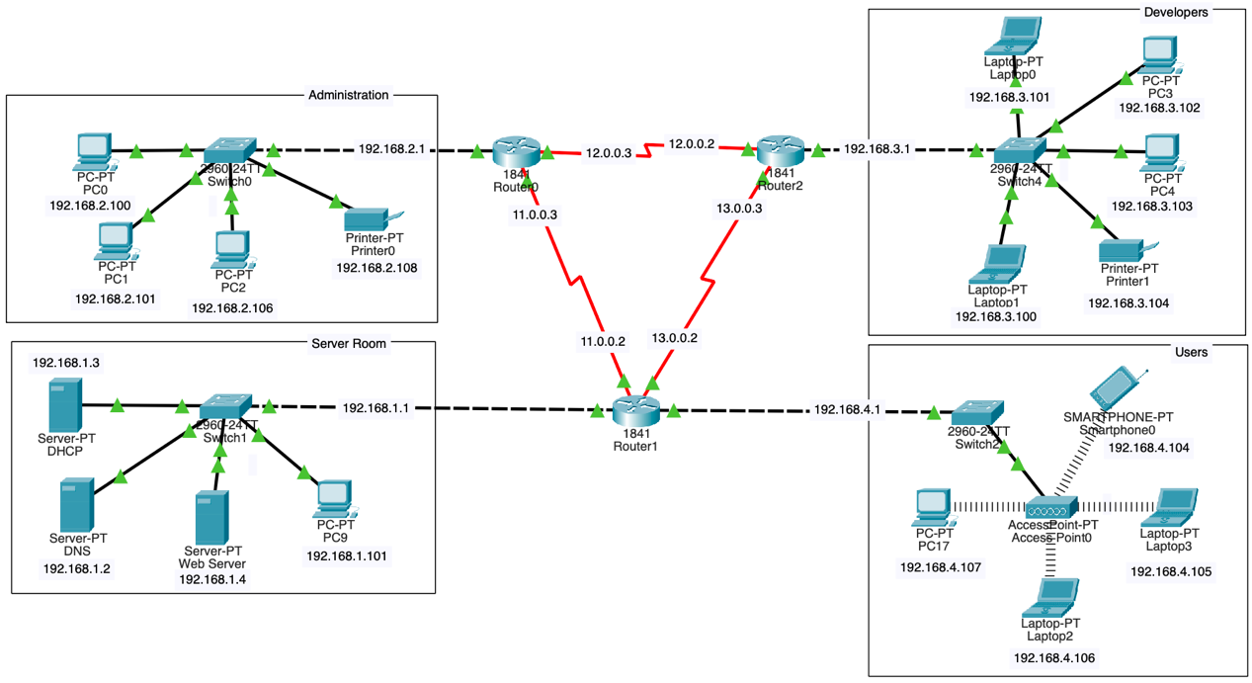

VLAN Configuration & Purpose
To optimize security, performance, and management, the network is divided into four VLANs:
- Server Room VLAN
Hosts critical services: DHCP, DNS, and web servers. This VLAN is the backbone of IP assignment, domain resolution, and web hosting.
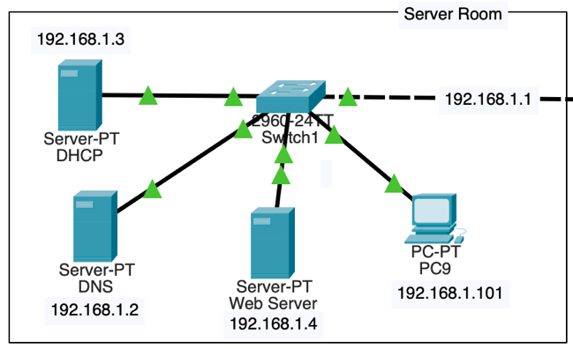

- Administrative VLAN
Connects office PCs and a printer via a Layer 2 switch. Devices are assigned IPs via DHCP for efficient configuration.
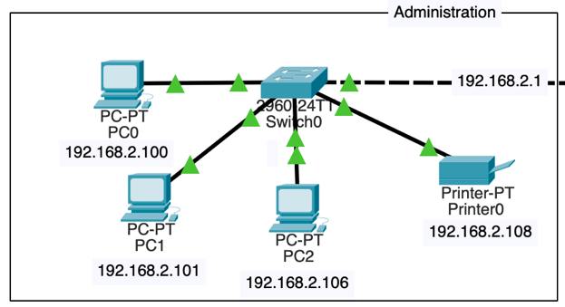

- Development VLAN
Isolated network for developer workstations and a printer. Uses DHCP-assigned IPs for stability in testing environments.
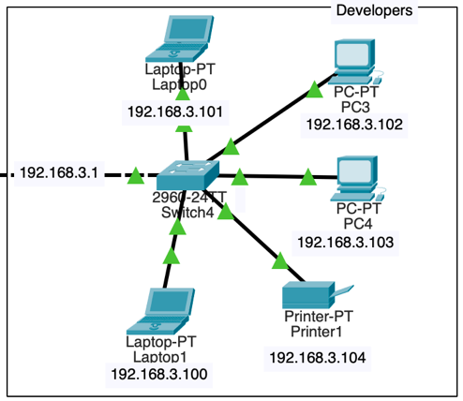

- User VLAN (Wireless)
Designed for mobile laptops and devices. Connected via a secure WPA2-PSK wireless access point. VLAN isolation and encryption ensure secure wireless mobility.
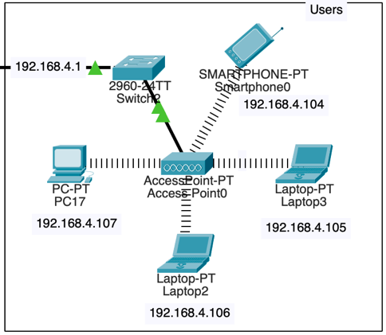

Network Overview & Configuration
The network follows a star topology, ensuring centralized control with scalable expansion capabilities. Layer 2 switches manage local traffic within VLANs, while a Layer 3 router handles inter-VLAN communication and routing between departments.

- Router LAN (Inter-Router LAN)
Two Layer 3 routers are linked via a serial connection (11.0.0.2 ↔ 11.0.0.3, 12.0.0.2 ↔ 12.0.0.3, and 13.0.0.2 ↔ 13.0.0.3), simulating communication between separate network zones or remote branches.

To facilitate DHCP address distribution across different VLANs, we configured the routers using the ip helper-address command – ip helper-address 192.168.1.3 – was added to the relevant router interfaces to forward DHCP requests to the centralized DHCP server. This ensures that clients in VLANs without direct DHCP access can still receive IP configurations from the server.

Configuration of Router LAN:
- Assign static IPs to router serial interfaces
  - Router 0: Serial0/1/0: 11.0.0.3 Serial0/1/1: 12.0.0.3
  - Router 1: Serial0/1/0: 11.0.0.2 Serial0/1/1: 13.0.0.2
  - Router 2: Serial0/1/0: 12.0.0.2 Serial0/1/1: 13.0.0.3
- Use RIP routing protocol for dynamic route discovery
  - On each router sub-interface associated with a VLAN, enter:
ip helper-address 192.168.1.3
  - This forwards DHCP broadcasts to the centralized DHCP server.
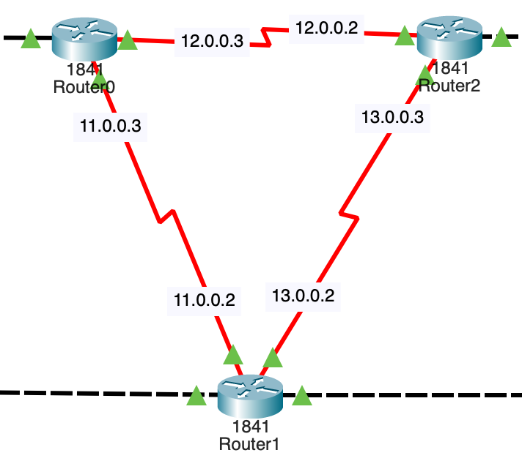
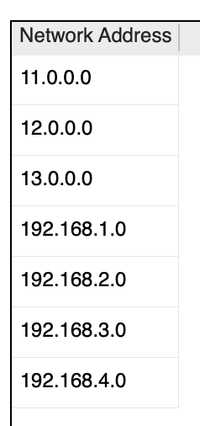
- Enable interfaces

- Server LAN (Service Backbone)
Located in the Server Room, this LAN supports core network services:
- DHCP Server: Automatically assigns IP addresses to all end devices (except for statically configured). This reduces manual configuration and ensures efficient IP address management across all VLANs.
- DNS Server: Handles the resolution of domain names to IP addresses, enabling users to access internal services using memorable names instead of numeric IPs.
- Web Server: Hosts web content internally and externally.

Configuration of Server LAN:
- Assign dynamic IPs to all LANs
  - All end devices receive a default gateway and a DNS server – which are the IP address of DHCP and the DNS.
- Set DHCP pools for remaining devices
  - In services of DHCP, for each pool, we have added the default gateway, DNS server, Start IP address, and Max users.
- Configure appropriate gateway settings
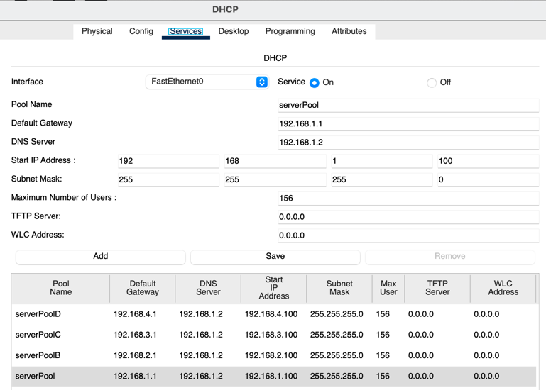

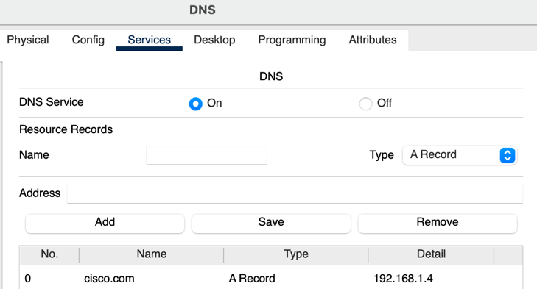

- Wired LANs (Administrative & Development VLANs)
The Administrative and Development VLANs are physically connected through Layer 2 switches and logically separated to ensure security, improve performance, and streamline management.

Configuration of Wired LANs:
- Enable DHCP for automatic IP assignment
  - By changing the gateway of each end device from static to dynamic, we are able to communicate with the DHCP and receive the assignment.
- Created a trunk – router to switch link – for multiple VLAN support
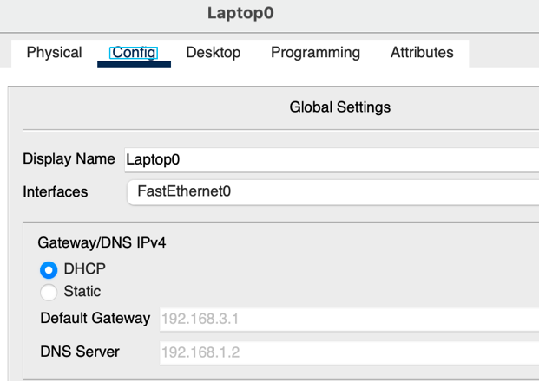

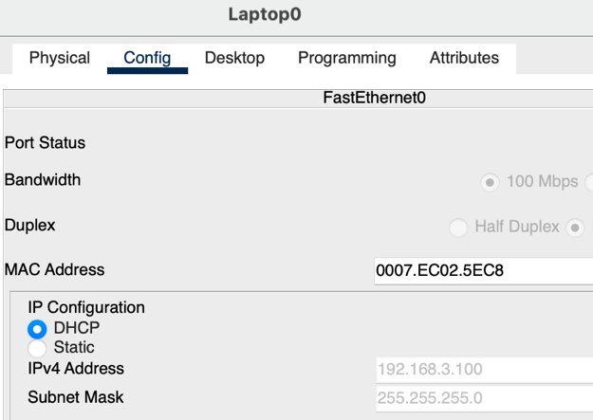

- Wireless User LAN (Mobility VLAN)
The Wireless User LAN provides wireless network access for users that use mobile devices, laptops, and other Wi-Fi-enabled equipment. This VLAN is specifically designed to offer mobility within the workplace while ensuring strong security and efficient traffic management. It ensures that users can move freely across different areas of the office while staying connected to the network.

Configuration of Wireless User LAN:
- Configure Access Point
  - To ensure secure wireless communication, the Access Point (AP-PT) was configured with a specific SSID ("Wi-fi") and key ("Network123") using WPA2-PSK encryption.
  - This setup protects the network from unauthorized access and ensures only permitted users can join the wireless LAN.
- Place the access point in its own VLAN
  - To allow wireless connection, we added a wireless device (AP-PT) to allow connection with end devices.
- End Devices Configuration to connect
  - Each wireless end device was configured by replacing the wired network interface card with a wireless module (WMP300N).
  - Through the device’s settings (Desktop → PC Wireless → Connect), users are able to scan for available networks, select the Wi-fi SSID, and connect by entering the password.
- Ensure DHCP is available (via router )
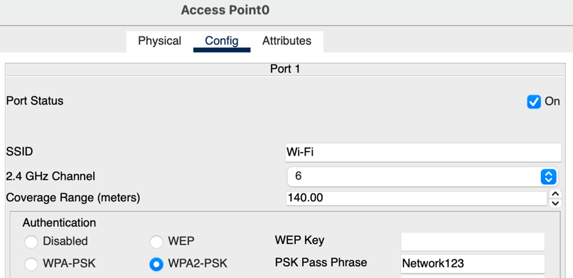
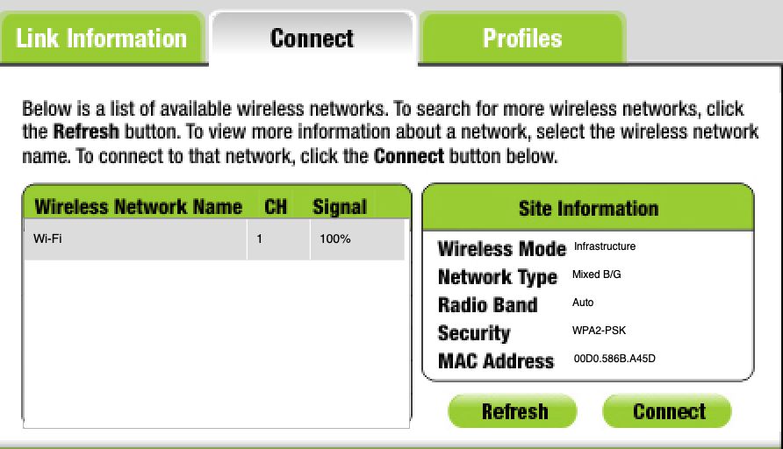

Conclusion
Glovia’s network architecture delivers a strong, secure, and future-ready infrastructure tailored to the company’s needs. The use of VLANs ensures organized segmentation, improved performance, and controlled access. Dynamic IP allocation via DHCP streamlines management, while static IPs in critical areas guarantee reliability.

Wireless access is securely isolated, allowing mobile users to connect without jeopardizing internal systems. The system is designed with scalability and central management in mind—ready to grow with Glovia’s expanding operations.

