|  |  |  |  |  |  |  |  |  |
| --- | --- | --- | --- | --- | --- | --- | --- | --- |
| **Computer Engineering Department**  **Course Name: Networks Lab Number: 10636594**  **Lab Report Grading Sheet** | | | | | | | | |
| Instructor: **Dr. Sharif Yaseen** | | | Experiment #: **8+9** | | | | | |
| Academic Year: 2023 – 2024. | | | Experiment Name: **VLANs.** | | | | | |
| Semester: second semester. | | |  | | | | | |
| **Students** | | | | | | | | |
| 1- Nancy Sawalmeh | | | | 2- Masa Abu Aisheh | | | | |
| 3- Shahd Yaseen | | | | 4- | | | | |
| Performed on: 22/3/2024. | | | | Submitted on: /3/2024. | | | | |
| **Report’s Outcomes** | | | | | | | | |
| ILO =( ) % | ILO =( ) % | ILO =( ) % | | | ILO =( ) % | | ILO =( ) % | |
| **Evaluation Criterion** | | | | | | **Grade** | | **Points** |
| **Abstract**  Answers of the questions: “What did you do? How did you do it? What did you find?” | | | | | | 0.5 | |  |
| **Introduction and Theory**  Sufficient, clear and complete statement of objectives. In addition to  Presents sufficiently the theoretical basis. | | | | | | 1.5 | |  |
| **Apparatus**/ **Procedure**  Apparatus sufficiently described to enable another experimenter to identify the equipment needed to conduct the experiment. Procedure sufficiently described. | | | | | | 2 | |  |
| **Experimental Results and Discussion (In-Lab Worksheet)**  Crisp explanation of experimental results. Comparison of theoretical predictions to experimental results, including discussion of accuracy  and error analysis in some cases. | | | | | | 4 | |  |
| **Conclusions and Recommendations**  Conclusions summarize the major findings from the experimental results with adequate specificity. Recommendations appropriate in  light of conclusions. Correct grammar. | | | | | | 1 | |  |
| **Appearance**  Title page is complete, page numbers applied, content is well organized, correct spelling, fonts are consistent, good visual appeal. | | | | | | 1 | |  |
| **Total** | | | | | | 10 | |  |

## Objectives:

1. To be familiar with wireless network installation.
2. Set up the adhoc mode and infrastructure for the wireless network.
3. Give the wireless network security.
4. Learn about the Access point's operation and its underlying principles.
5. Construct a network and use the network we have created to send files and data.

## Introduction:

There are two sorts of networks: the broadly address network (WAN or WLAN), which mostly depends on wireless technology, and the local area network (LAN), which primarily depends on Ethernet technology.

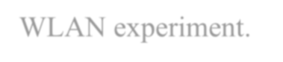

In order to understand its operation and working concept, we shall construct a WLAN experiment.

## Tools:

1. Cisco access point.
2. 2x PCs.
3. 1 straight forward Ethernet cable.
4. Console cable.

## Procedure:

Part 1: WLAN infrastructure:

**Getting and Assigning an IP Address** First, we use the console cable to connect the first station to the access point so that we can begin configuring the AP. Once we enter the terminal to begin the configuration process, the access point asks for a password, which is CISCO. Please refer to the following image for clarification.

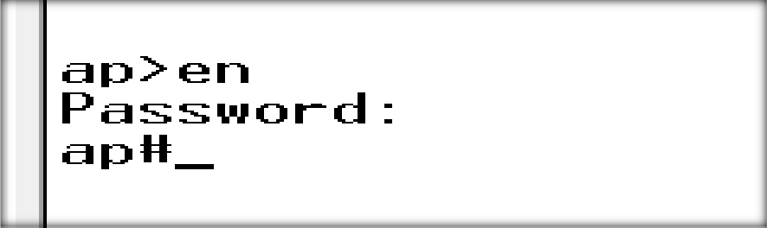

**Next, we were instructed to use the (sh run) command**, which will display details about the settings of the access point, including the model number, the encryption used, the IP and MAC addresses, and so forth.

**Following that, we assign IP addresses to both stations (PCs)**. It is important to ensure that we assign IP addresses to the wireless network card rather than the Ethernet, as shown in the following image:

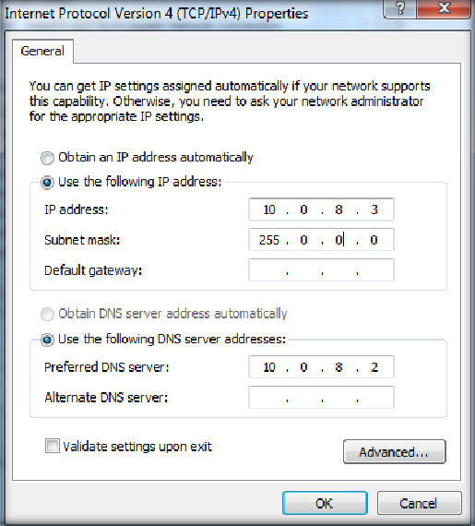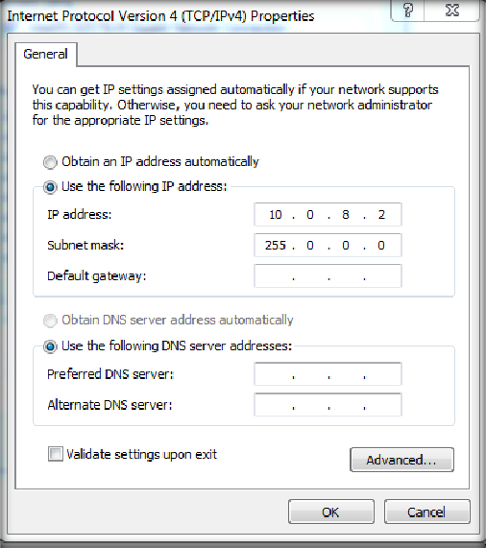

Next, we were requested to provide the access point an IP address. To do this, we first went into the AP's setup mode and selected the interface that was connected to the first station, as seen in the following image:

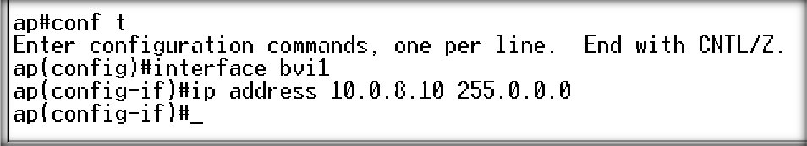

Configuring Basic Settings: After entering the browser's address and the access point's name in this section, the following page appears:Cisco was the username and password.After that, we logged in.

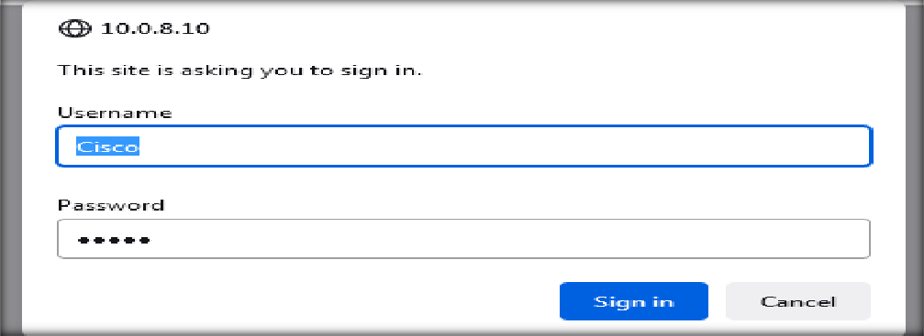

Following our sign-in, the following page—dubbed the "Summary Status page"—was displayed.

The summary status (Association, Network Identity, Network Interface, and Event Log) is available on this page.

On the left side of it is a tiny menu as well.

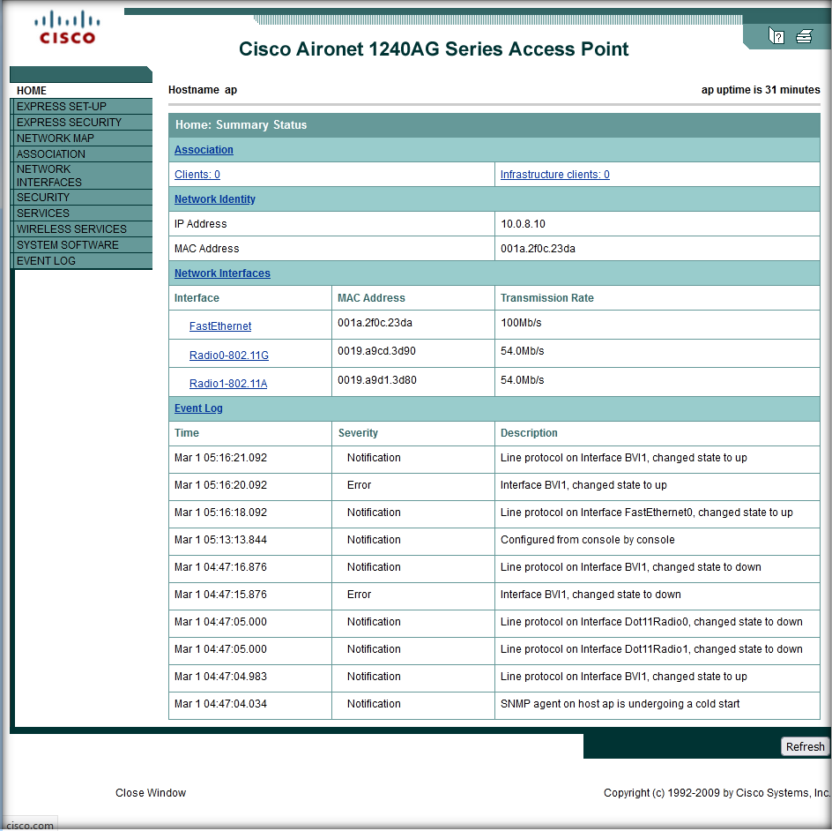

Next, we clicked on the Express Setup button to access the Express Setup page, where we modified the host name to AP-8 as shown in the following image:

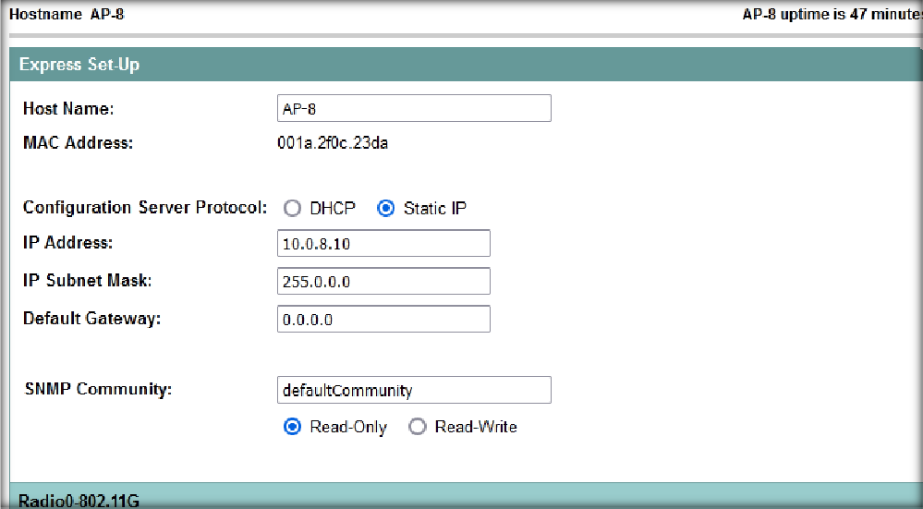

Setting up Security Configuration:The following screen shows up once we've navigated to the Express Security page:

We configured the setting as shown in the picture:

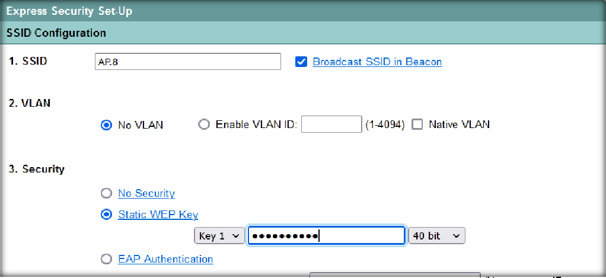

This screen appears after applying the express security settings:

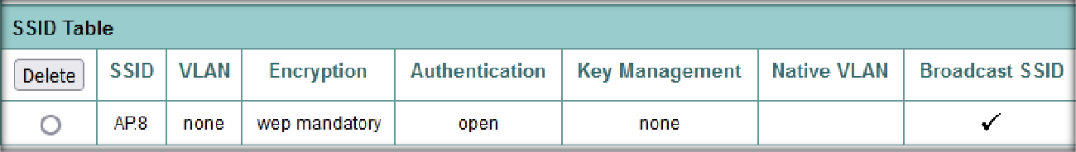

Radio Interface Enabling:We selected 802.11G from the Summary Status page.

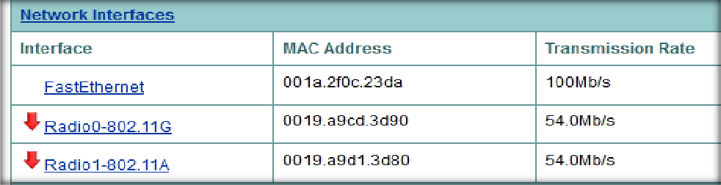

The radio 802.11G home page appears. Then, we turned on 802.11G from the settings:

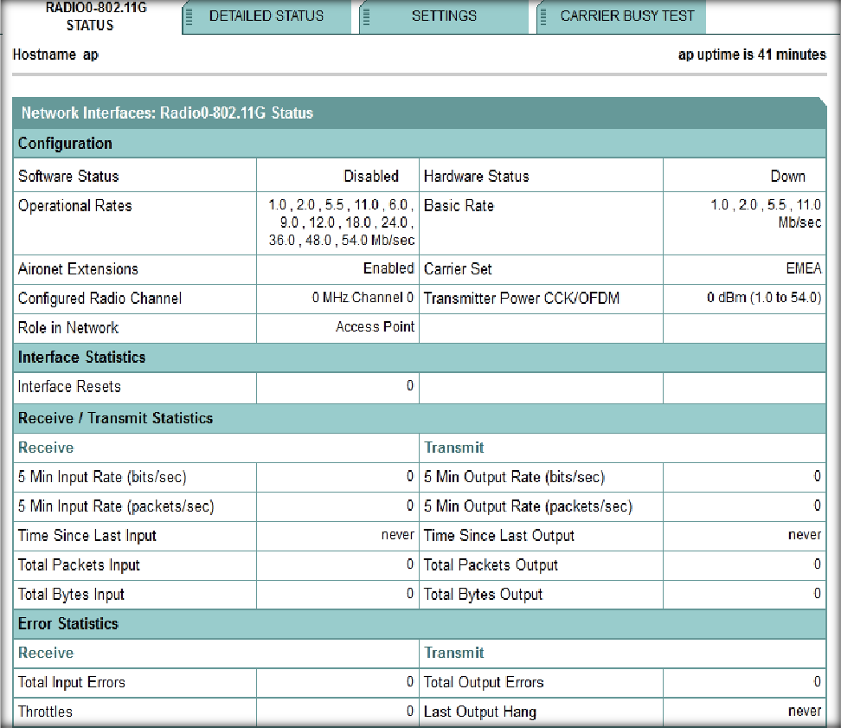

Then clicked apply.

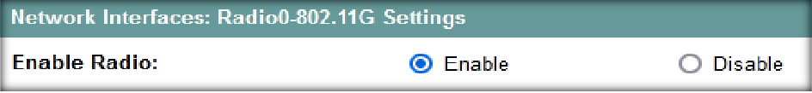

Then we did the same steps for 802.11A.



Network interfaces in the home page after enabling the radio 802.11G and 802.11A.

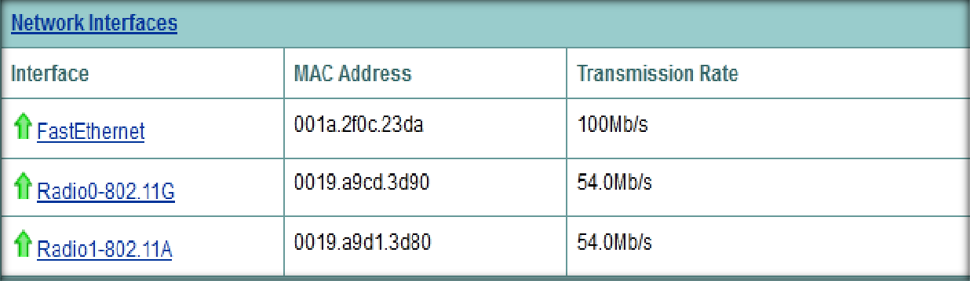

Setting Up Wireless Settings: We saw that the wireless network connection list included the AP.8.It requested the Security key (123456) when we joined.

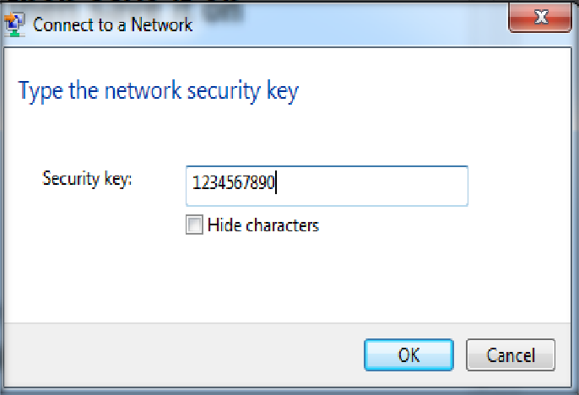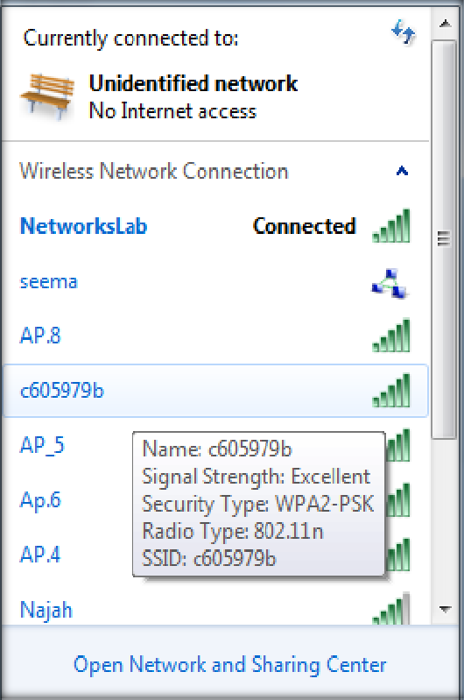

### Then we pinged between the PCs.

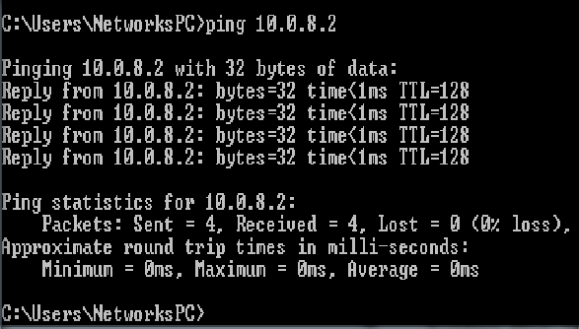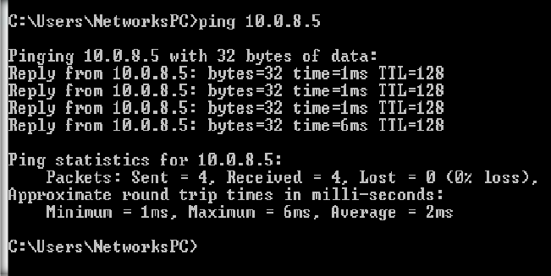

Finally, we selected System Configuration from System Software and saved it by clicking on config.txt. If we ever needed to use it again, we saved it.

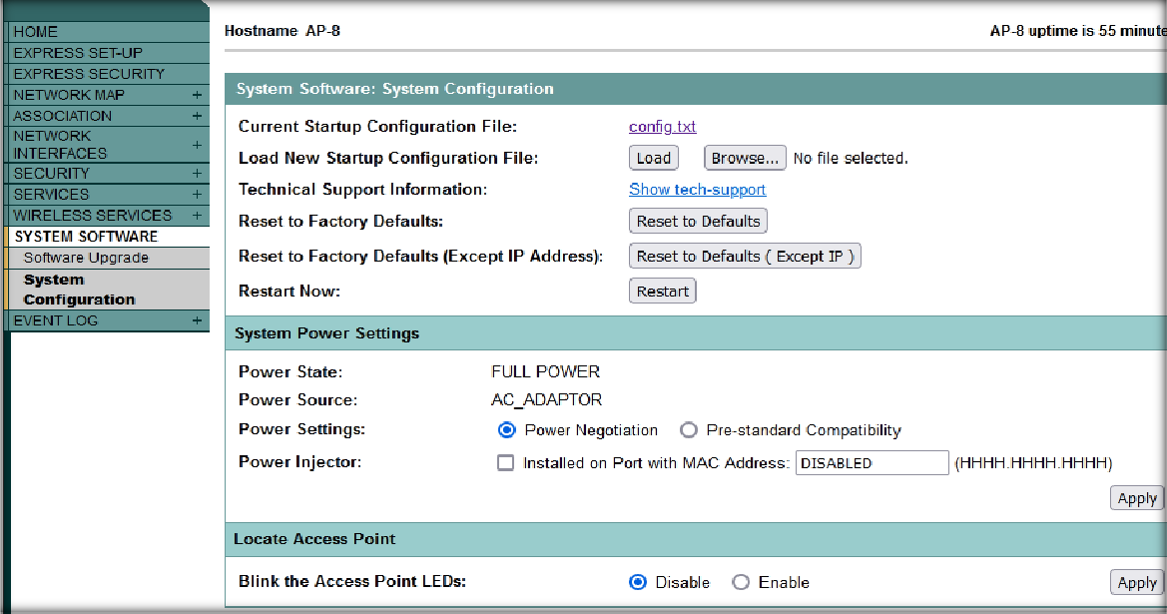

### Part 3 : Configuring an Ad Hoc Mode WLAN with Windows 7.

We did the configuration by following these steps:

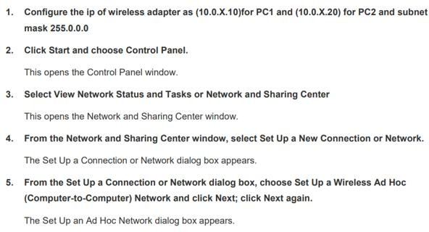

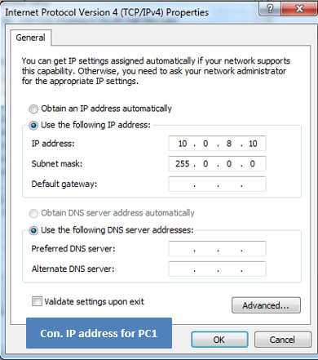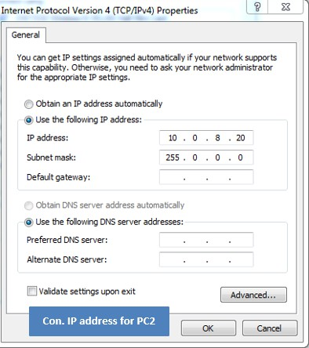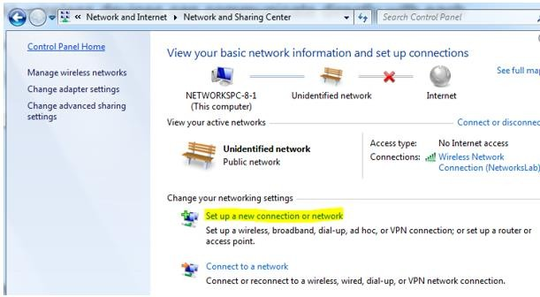

We set up the Ad Hoc network by give it the name (Adhoc_lab_8), security type (WEP), security key (Net123456).

Then we save the network.

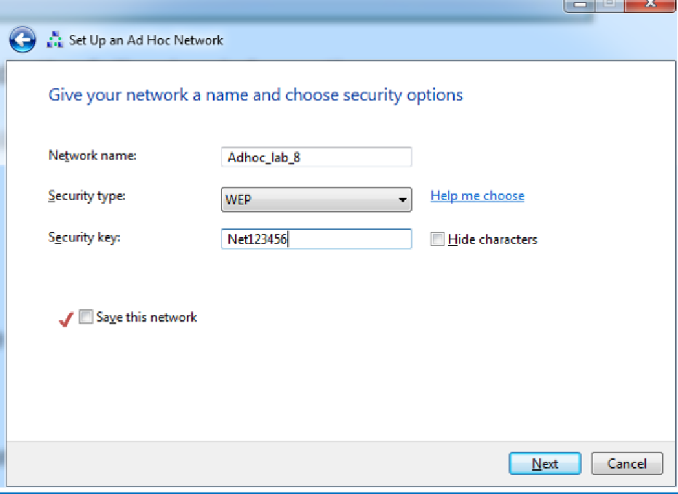

Then, we noticed that the (Adhoc_lab_8) was shown in the wireless network connection list, and we connected to it from the two PC’s.

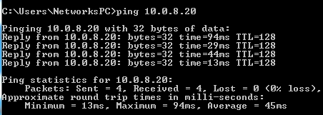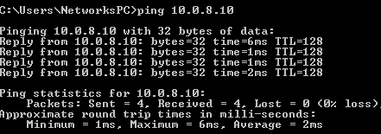

**Each PC's was ping properly.**

**Ping from PC1 to PC2**

**Ping from PC2 to PC1**

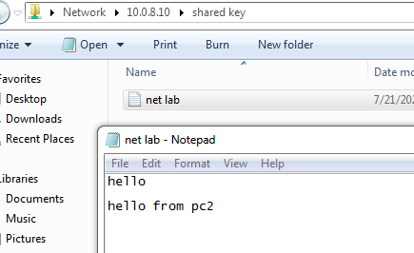We made a folder on the PC1, then shared it with PC2 as we learned in the lab before, when we opened the folder on PC2, we wrote on it, and we saw the folder after update it on PC1, and everything was right.

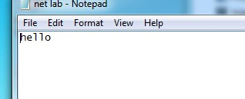

**On PC1 before update.**

**Conclusion:**

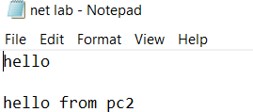

**On PC1 after update.**

In this experiment we learned how to install and set up a wide area network (WAN), and how to configure the access point and create a WLAN that any station can connect to it, also we know how to build the WLAN in both modes the infrastructure and the adhoc mode, in addition to the difference between these 2 modes and there pros and cons, we also get to know how to transmit the files using a wireless connection.

|  |  |  |  |  |  |  |  |  |
| --- | --- | --- | --- | --- | --- | --- | --- | --- |
| **Computer Engineering Department**  **Course Name: Networks Lab Number: 10636594**  **Lab Report Grading Sheet** | | | | | | | | |
| Instructor: **Dr. Sharif Yaseen** | | | Experiment #: 9 | | | | | |
| Academic Year: 2023 – 2024. | | | Experiment Name: **Network Metrics by**  **simulator (NS2)** | | | | | |
| Semester: 2nd semester, 1st interval | | |  | | | | | |
| **Students** | | | | | | | | |
| 5- Masa Abu Aisheh | | | | 6- Nancy Sawalmeh | | | | |
| 7- Shahed Yassin | | | | 8- | | | | |
| Performed on: 19/3/2024 | | | | Submitted on: 24/3/2024 | | | | |
| **Report’s Outcomes** | | | | | | | | |
| ILO =( ) % | ILO =( ) % | ILO =( ) % | | | ILO =( ) % | | ILO =( ) % | |
| **Evaluation Criterion** | | | | | | **Grade** | | **Points** |
| **Abstract**  Answers of the questions: “What did you do? How did you do it? What did you find?” | | | | | | 0.5 | |  |
| **Introduction and Theory**  Sufficient, clear and complete statement of objectives. In addition to  Presents sufficiently the theoretical basis. | | | | | | 1.5 | |  |
| **Apparatus**/ **Procedure**  Apparatus sufficiently described to enable another experimenter to identify the equipment needed to conduct the experiment.  Procedure sufficiently described. | | | | | | 2 | |  |
| **Experimental Results and Discussion (In-Lab Worksheet)**  Crisp explanation of experimental results. Comparison of theoretical predictions to experimental results, including discussion of accuracy  and error analysis in some cases. | | | | | | 4 | |  |
| **Conclusions and Recommendations**  Conclusions summarize the major findings from the experimental results with adequate specificity. Recommendations appropriate in light of conclusions. Correct grammar. | | | | | | 1 | |  |
| **Appearance**  Title page is complete, page numbers applied, content is well organized, correct spelling, fonts are consistent, good visual appeal. | | | | | | 1 | |  |
| **Total** | | | | | | 10 | |  |

# Objectives:

* To get familiar with the routing algorithms such as DSDV protocol.
* To get familiar with the wireless networks and its types.
* To get familiar with the adhoc wireless network.

# Introduction:

The experiment focuses on exploring routing protocols within wireless ad hoc networks, particularly emphasizing the performance evaluation of the Destination- Sequenced Distance-Vector (DSDV) protocol. It distinguishes between infrastructured networks, which rely on access points for communication and face challenges with mobility, and ad hoc networks, which facilitate direct peer-to-peer communication among devices without centralized infrastructure.

Within ad hoc networks, routing protocols are categorized as proactive (table-driven) or reactive (on-demand), with examples including DSDV, Dynamic Source Routing (DSR), Ad Hoc On-Demand Distance Vector Routing (AODV), and Temporally Ordered Routing Algorithm (TORA). The experiment aims to provide practical insights into these protocols' functionality and performance.

Using simulation tools like Ns2 and Nam on Ubuntu 14.04, students create network topologies, script simulation scenarios, and analyze trace files to extract performance metrics. These metrics include packet transmission, routing efficiency, and network behavior under varying conditions. Through experimentation and analysis, students gain a deeper understanding of wireless network dynamics, routing protocols, and performance evaluation methodologies.

The experiment also highlights challenges inherent in wireless routing, particularly in dynamic environments characterized by mobility. It encourages students to consider alternative metrics, such as Average End-to-End packet delivery time, and leverage visualization tools like Nam for deeper insights into network behavior.

Overall, the experiment offers a comprehensive exploration of routing protocols in wireless ad hoc networks, providing valuable insights into their operation and performance evaluation.

# Tools:

* 1. Ubuntu 14.04 (O.S.)
  2. Ns2 (application)
  3. Nam (application)
  4. Xgraph (application)

# Procedure:

## Part1: Simple Network Topology

In the initial phase of our experiment, we were tasked with simulating a basic network setup featuring a Drop Tail queue. This involved initiating the process by compiling the primary file, known as **ns-simple.tcl**. Once compiled, this file yields an output in the form of a NAM file. NAM files are typically employed for modeling groundwater flows, but in our context, they serve as essential data repositories for our network simulation.

Additionally, as part of the setup process, we launch **Xgraph**, a visualization tool. Xgraph provides graphical representation of the simulation, displaying various metrics and behaviors of the nodes within the network. Before commencing the actual simulation, it's crucial to make necessary adjustments to the code within (ns- simple.tcl). These modifications ensure that the network topology aligns with our experimental requirements, laying the groundwork for an accurate and meaningful simulation. For further clarification, refer to the accompanying images illustrating the network configuration and simulation setup.

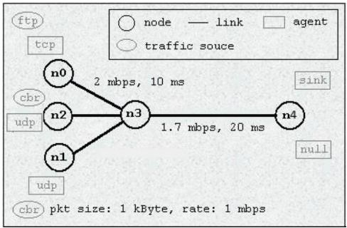

And here are the modified code to match the required network, see the following picture:

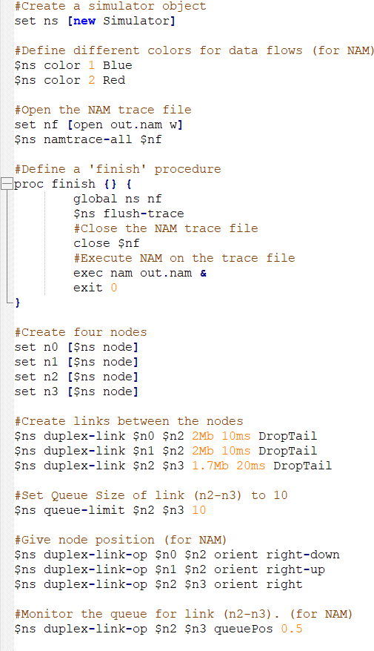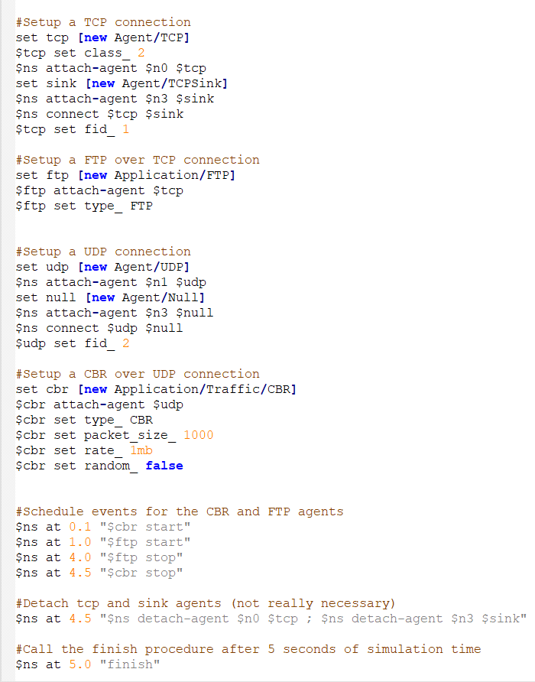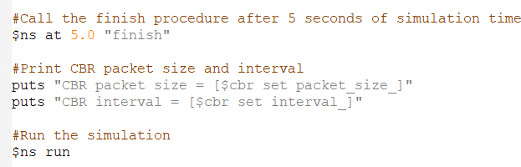

And now for the code's compilation result. As you can see in the following image, node 0 will begin transmitting data after 1.2 seconds based on TCP configuration, and data will also be lost after a certain amount of time because node 3 has reached its maximum. Node 0 and node 1 begin sending data to node 2 at the start of the simulation.

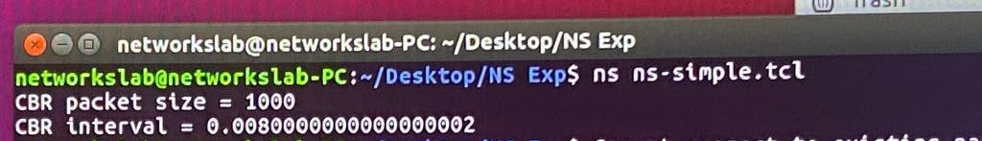

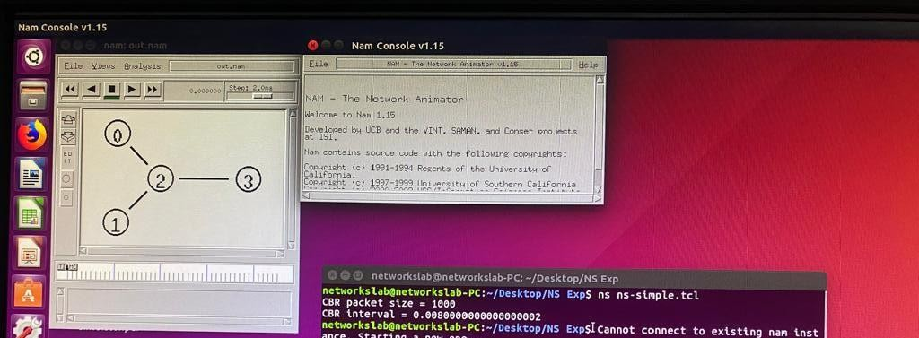

Then we were asked to get the dropped and received packets in the simulated network, see the following results:



## Part2: Three node ad hoc with DSDV

We begin by generating the simple-dsdv.tcl file, which will include the adhoc network configuration, as we were instructed to establish three Wi-Fi nodes using the adhoc configuration mode in addition to the DSDV protocol.

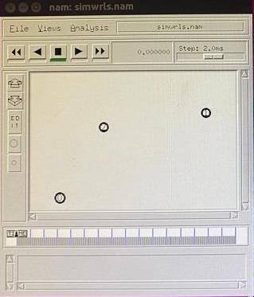

The written code is then compiled using the terminal, producing a file with the

.tr extension. Following that, we discover both sent and received packets; the ensuing image illustrates this.



So we can the packet delivery fraction by dividing the received on the sent packets, so **5204 / 5225** which equal to **0.995.**

Then after that we found the total number of routing packet sent, see the following picture:



So we can figure out the routing load fraction which equal the routing packets dividing on the received packets, so it will equal to **41/5204** which equal to **0.0078**.

Conclusion:

In conclusion, this experiment has provided valuable insights into the distinction between ad hoc and infrastructure configuration modes, along with an understanding of various routing protocols and their practical application within specific network environments.

Furthermore, we have acquired essential skills in network simulation using NS2 and NAM, supplemented by visualization through Xgraph. Overall, this hands-on experience has enriched our comprehension of wireless networking concepts and simulation techniques, laying a solid foundation for further exploration and study in this field.