APAI2025 - LAB01
PULP_Embedded_Programming

Authors: Davide Nadalini, Lorenzo Lamberti, Alberto Dequino, Manuele Rusci, Francesco Conti
Contacts: d.nadalini@unibo.it, alberto.dequino@unibo.it
Links: GitHub Link (code)

Summary
- Subject(s):
  - PULP architecture, vector sum, matrix-vector mul, profiling code execution;
- Programming Language: C;
- Lab duration: 3h
- Objective: Embedded programming & profiling
you will learn the basics of embedded programming, the pulp architecture, basic operations (sum & matmul), and how to profile your code execution (MAC, cycles) !
- Assignment:
  - 2 tasks
  - Time for delivery: 2 weeks
  - Submission deadline: Oct 10th 2025

How to deliver the assignment
You will deliver ONLY THIS TEXT FILE, no code
- Download this file.
- Fill in the required results.
- Export to pdf format.
- Rename the file to: LAB<number_of_the_lesson>_APAI_<your_name>.pdf
- Use Virtuale platform to load ONLY your .pdf file

LAB STARTS HERE

0. (ONLY LAB1) Access to the local VM
- On the lab’s PCs, open the file explorer and go to This PC, C:/VM_APAI
- Double click on PULP-box.ova
- VirtualBox opens, just click on “Fine”
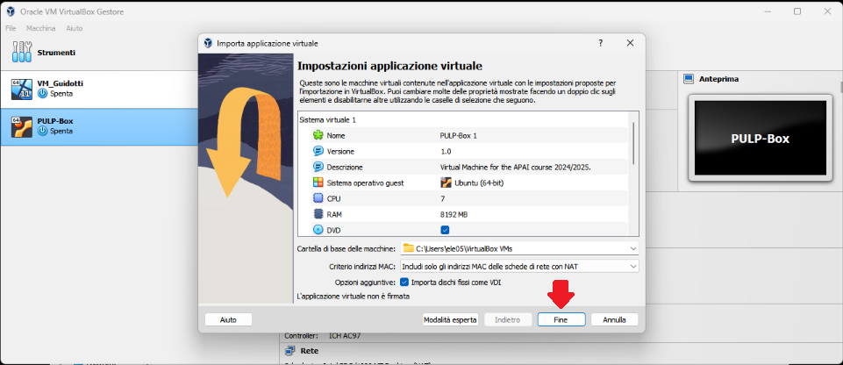
- Wait for the VM to be imported
- Open the VM with “Avvia”
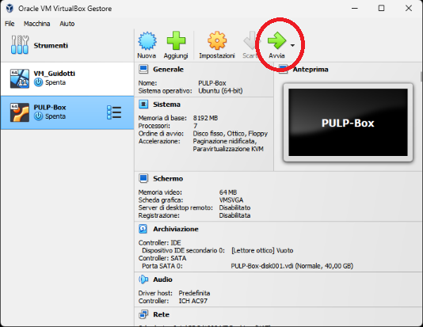
- Password is ‘pulp’

1. (ALL) Open Docker Container with VSCode
- Open a terminal (right click – open a new terminal)
- Go in the APAI-Docker folder: cd APAI-Docker
- Open Docker with VSCode: code .
- Select the pop-up option “Reopen in container”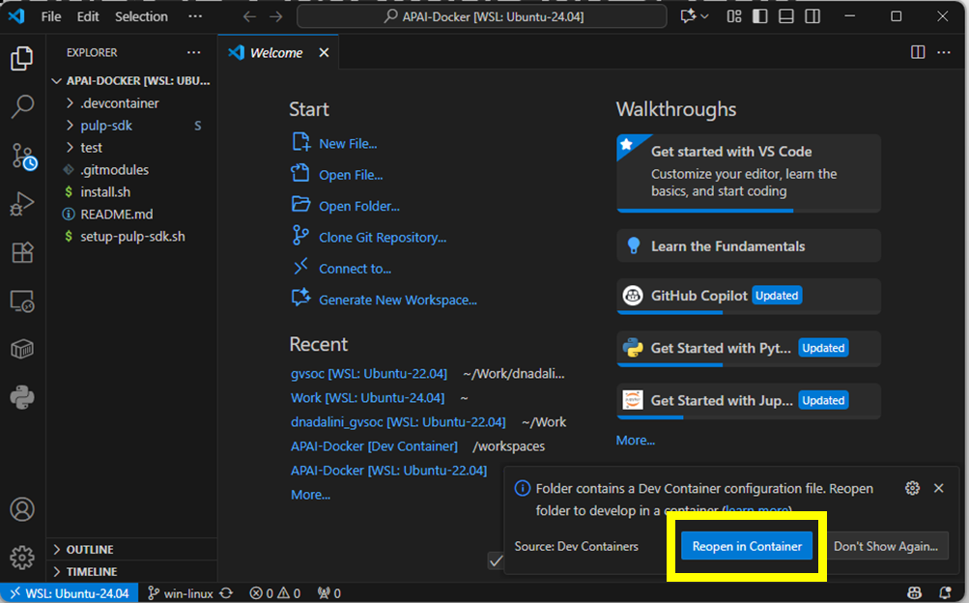
- Setup PULP-SDK: source setup-pulp-sdk.sh
- Clone GitHub repository of today’s lab: git clone https://github.com/EEESlab/APAI25-LAB01-PULP-Embedded-Programming
- cd APAI25-LAB01-PULP-Embedded-Programming
- cd pulp-helloworld
- make clean all run
If the output is a “Hello World!”, then everything is correctly set up!

Task 1: vector sum
0. Setup:
- Go to “vector_sum/” folder
- Every time you want to run the code, SAVE your file and write in the terminal “make clean all run”

1.1. Define N to 50 (N= vector size) and run the code:

 | Question | Anwer
1 | What’s the result of the vector_sum() function?
2 | Is the checksum correct ?
3 | Print all the elements of “array_1”.  What’s the output?

Tips:
- Question 3: to print the element of the array, uncomment the function call “print_array(array_1, N)” inside the main()

1.2. Define N to 350 (N= vector size) and run the code:

 | Question | Anwer
1 | What’s the result of the vector_sum() function?
2 | Is the checksum correct ?
3 | Print all the elements of “array_1”.  What’s the output?
4 | Array_1 should be filled with increasing values from 1 to N. Why isn’t the case here?

Tips:
- Question 3: to print the element of the array, uncomment the function call “print_array(array_1, N)” inside the main()
- Question4: what range of values a “char” data type can represent?

1.3. Fix the issue: cast “array_1” and the function’s arguments to int (or short int)
Write down your solution

before | After your fix
unsigned char array_1[N];
int init_array(unsigned char * A_ar, int size)
void print_array(unsigned char * A_ar, int size)
int vector_sum(unsigned char * A_ar, int size)
After the fix, answer again

 | Question | Anwer
1 | What’s the result of the vector_sum() function?
2 | Is the checksum correct ?
3 | Print all the elements of “array_1”.  What’s the output?

Task 2: matrix-vector product & profiling
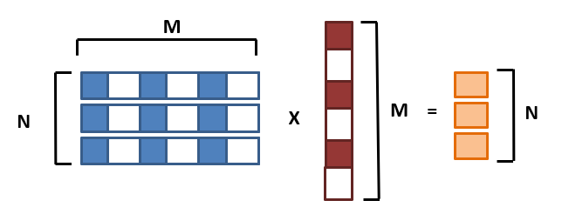
0. Setup:
- Go to “matrix_vector_product/” folder
- Every time you want to run the code, SAVE your file and write in the terminal “make clean all run”

2.1. Implement missing code
GOAL: We want to count how many Multiply-ACcumulate operations we perform for a GEMV
TASK: Increment a counter every time we perform a MAC inside the GEMV inner loop. I prepared a variable called mac_counter. This is the reference code
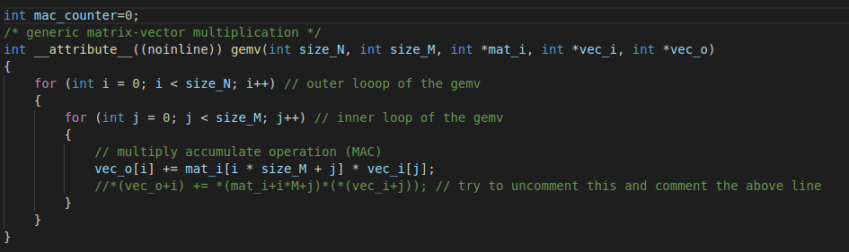
Put your solution below (code)
[HERE]

2.2. Implement missing code part II
Add performance counters to profile the gemv. The gemv is calculated with this line of code in the main():
gemv(N, M, matrix, vector, output_vec);
To profile it, exploit these two functions I prepared for you. You should start the profiling right before and stop it right after
start_perf_counter();
stop_perf_counter();

Put your solution below (code)
[HERE]

2.3. Implement missing code part III
Enable the performance counters of our interest. We want to profile:
- Execution cycles (total)
- N° instructions executed
Here’s the full list of the performance counters
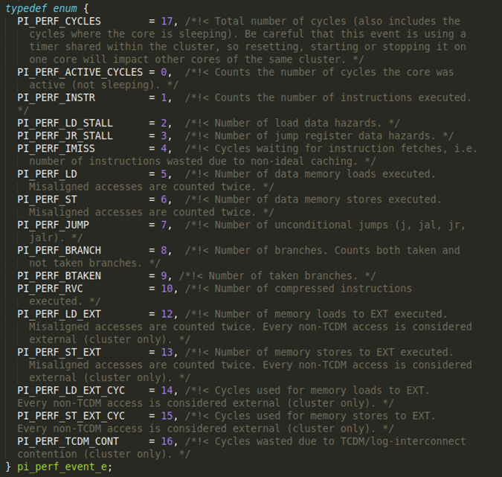
Ref: /rtos/pmsis/pmsis_api/include/pmsis/chips/default.h

You can enable them in the start_perf_counter() function.
Complete the code where you find /* YOUR CODE HERE */ with the right performance counters (see previous figure)
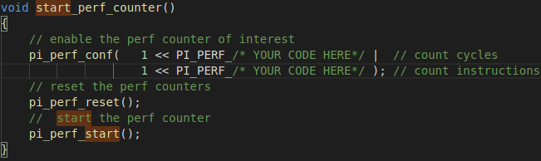
Put your solution below (code)
[HERE]

2.4. Implement missing code part IV
GOAL: we now are able to measure Cycles & instructions (thanks to performance counters), and MAC operations (your implementation in the code)
TASK: calculate and print the following metrics in the code (fill in where you read /*YOUR CODE HERE*/)
- CPI = cycles/instructions
- MAC/cycles
- Instructions/Cycles
- Instructions/MACs
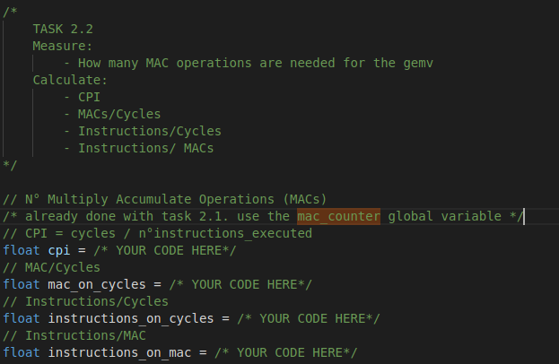
Put your solution below (code)
[HERE]

2. The size of the matrix is NxM=50x50 and the vector is M=50. Run the code and fill the table:
Note:
- Profile the matrix-vector product with different compiler optimizations: -O1, -O3, -O3 with HW Loops (default is -O1)

 | -01 | -03 -mnohwloops | -03
Cycles
N°Instructions
MACs
CPI
Instructions/Cycles
Instructions/MACs

