APAI2025 - LAB06
On-Device Learning with PULP-TrainLib

Authors: Davide Nadalini, Lorenzo Lamberti, Alberto Dequino, Francesco Conti
Contacts: d.nadalini@unibo.it, lorenzo.lamberti@unibo.it, alberto.dequino@unibo.it
Links: GitHub Link (code)

Summary
- Subject(s):
  - Deep Neural Network Training, PULP architecture, Deployment of On-Device Learning;
- Programming Language: C, Python;
- Lab duration: 3h
- Objective:
you will learn the basics of On-Device Learning deployment on a microcontroller!
- Assignment:
  - 5 tasks
  - Time for delivery: 2 weeks
  - Submission deadline: Nov 21th 2025

How to deliver the assignment
You will deliver ONLY THIS TEXT FILE, no code
- Download this file.
- Fill in the required results.
- Export to pdf format.
- Rename the file to: LAB<number_of_the_lesson>_APAI_<your_name>.pdf
- Use Virtuale platform to load ONLY your .pdf file

LAB STARTS HERE

0. (ONLY LAB1) Access to the local VM
- On the lab’s PCs, open the file explorer and go to This PC, C:/VM_APAI
- Double click on PULP-box.ova
- VirtualBox opens, just click on “Fine”
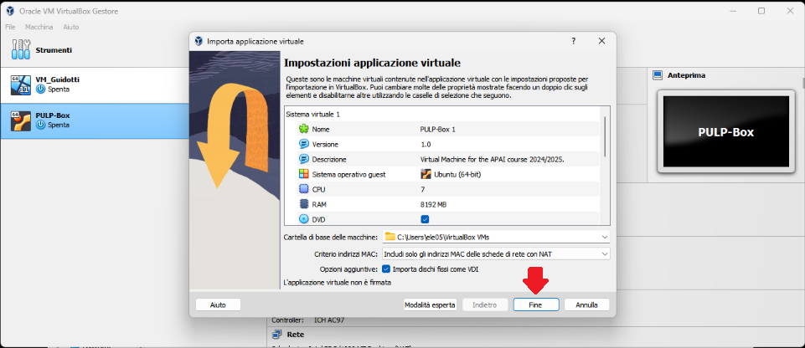
- Wait for the VM to be imported
- Open the VM with “Avvia”
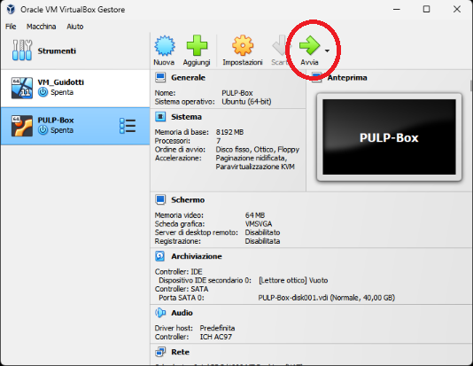
- Password is ‘pulp’

1. (ALL) Open Docker Container with VSCode
- Open a terminal (right click – open a new terminal)
- Go in the APAI-Docker folder: cd APAI-Docker
- Open Docker with VSCode: code .
- Select the pop-up option “Reopen in container”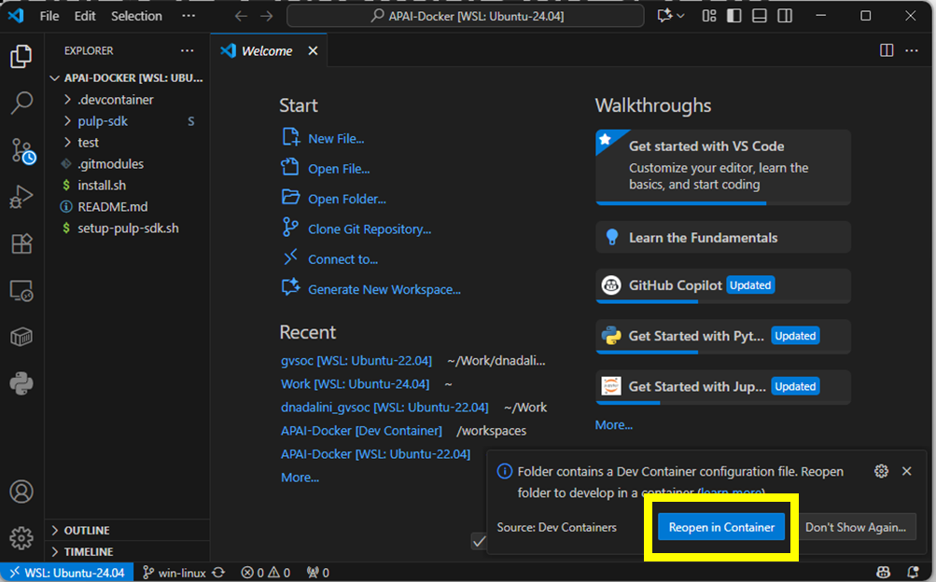
- Setup PULP-SDK: source setup-pulp-sdk.sh
- Clone GitHub repository of today’s lab: git clone https://github.com/EEESlab/APAI25-LAB06-On-Device-Learning
- cd APAI25-LAB06-On-Device-Learning

Setup
- Every time you want to run the code, SAVE your file and write in the terminal “make clean get_golden all run”
- Open “README.md” to follow the exercise in VSCode

TIP: The code sections which require editing are underlined as follows (there might be multiple of them for a single exercise, BE CAREFUL):
/**
* EXERCISE XX -
* /
CODE
/**
* END OF EXERCISE XX -
* /

In this lab you will learn how to code a simple On-Device Learning (ODL) workload on a PULP-based System-on-Chip. In this exercise, you will train a simple Deep Neural Network on a sample data and label, and you will profile its performances over an epoch of training.
First, the DNN architecture is the following:
- Conv2D layer
- ReLU activation
- Fully-Connected layer (classifier)
In this test, the reference data (i.e., the input data, the expected output and the label) is generated by a Golden Model (utils/GM.py) or GM, which is written in Python/PyTorch. Running the GM will trigger the creation of several .h files which contain the data to be fed to the C code, and will serve to train and validate the DNN.
To compile the project, run: rm -rf BUILD/; make clean get_golden all run.
During the exercise, check carefully the existing functions in net.c!! They are VERY useful!!
As a reference for this exercise, please point to PULP-TrainLib.

Exercise 0: Print and analyze the reference data
Here, you will familiarize with the input and output data. To start, print the input and the label, which will be used to make the DNN learn. First, compile with rm -rf BUILD/; make clean get_golden all run from your terminal. Then, complete the print_input() and print_label() in net.c, then use them into net_step() to print the arrays. Once you compiled the first time, you can find the data you're looking for into io_data.h.

QUESTIONS:

- 0A) What is the size of the input data (elements)?
- 0B) What values are contained in the input data?
- 0C) What is the size of the label (elements)?
- 0D) What values are contained in the label?

Exercise 1: Forward prediction
You will now perform a forward prediction with the non-initialized DNN. If you look at net.c, the forward() function performs a forward prediction by calling all layers in sequence. Each layer computes its output, using the previous data provided by the previous layer in sequence. The first layer takes the input data as input, and the output of the last layer is the DNN's prediction. Let's see what happens inside.
First, modify the net_step() function to perform a forward prediction. Then, print the output of the DNN.
QUESTIONS:
- 1A) Does the output of the DNN approximate the ideal label?

Then, let's evaluate the performances of the DNN. To have a very good estimate of the latency of a given workload, let's monitor PULP's Performance Counters. In practice, these counters count the number of events of a given type, e.g., the clock cycles to execute a program, the number of instructions, and more. Performance Counters are managed by the macros contained in stats.h. To start measuring the stats, call START_STATS(). To stop and print the stats, call STOP_STATS().
NOTE: Be careful not to profile functions/workloads which contain printf() functions!! They take so many clock cycles to execute that you WILL END UP misreading the performances of your code!!
QUESTIONS:
- 1B) How many clock cycles does the forward take?
- 1C) How many instructions?
- 1D) How high is the IPC (instruction-per-cycle)?
- 1E) The number of MAC operations of the DNN is 10656. How many are the MAC/cycle to execute the forward?

Exercise 2: Loss Function
Now, it's time to start working on the backpropagation!! First of all, we need to compute the loss function to compute the prediction error of our forward function with respect to the ground-truth label.
Let's dig a bit into the code: lib/sources/pulp_losses_fp32.c, in the function pulp_MSELoss(). You will complete the code of a MSELoss! Its formula is:
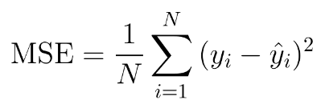
In our code, 1/N is already computed as meanval. Complete the code to compute the loss. When you're done, you can visualize the value of the loss by uncommenting the line APP_CFLAGS += -DDEBUG_LOSS inside the Makefile.
PUT YOUR CODE FOR THE LOSS FUNCTION HERE:

QUESTIONS:
- 2A) What is the value of the loss (this may vary from run to run)?
Now, we need to make the loss function compute the output gradient of the DNN. To do so, let's consider its expression:
Complete the code with the output gradient.
PUT YOUR CODE OF THE OUTPUT GRADIENT HERE:

QUESTIONS:
- 2B) What is the value of the output gradient (this may vary)?

Now, COMMENT the APP_CFLAGS += -DDEBUG_LOSS or you will have printf()s during the training!!!

Exercise 3: Backward step
In this exercise, you will learn how to design the backward steps of an On-Device Learning primitive, and how to call it!!
Let's start top-down: the sequence of operations during the backward step is reversed with respect to the forward. That's because we want to bring the output gradient towards the input, and compute the gradient of the weights! The sequence of layers to be backpropagated is contained into the backward() function in net.c. Looking at the forward() function as a reference, complete the backward() function for the whole network. You can look into the library to find the forward and backward primitives (e.g., conv2d fp32).
PUT YOUR BACKWARD CODE HERE:

Now, uncomment print_gradients() and compile the code. You will see that the gradients are all zeroes. Why? Because the primitives of the fully-connected (or linear) do not compute any gradient at all! Let's implement the two steps. In most training backends, the fully-connected training steps - i-e., the forward, weight grad and input grad - are computed as matrix multiplication. In case of a Fully-Connected, the three steps are expressed as follows:
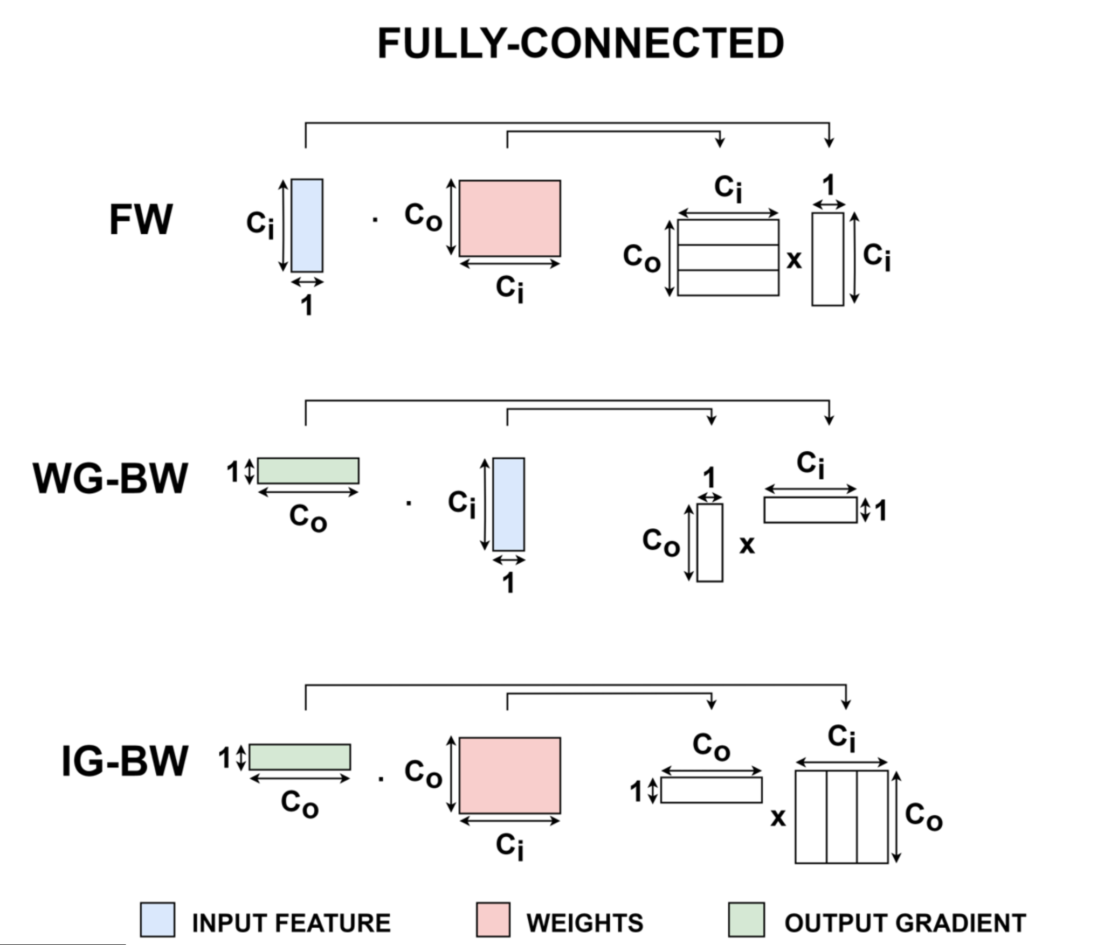
On the right, you have the matrix expressions of the three training steps. Note that, in the code, N is the number of rows of the left matrix, K is the shared size (columns of the first, rows of the second) and M is the number of columns of the matrix on the right. Complete the primitives of the fully-connected.
PUT YOUR CODE OF THE INPUT AND WEIGHT GRADIENT HERE:

When you're done, compile the code again. Now the gradients should be computed for all the DNN!! If so, comment the print_gradients() function. Now, profile the backward() with the performance counters.
QUESTIONS:
- 3A) How many cycles does it take to compute the backward?
- 3B) How many instructions?
- 3C) IPC?
- 4D) The total MAC are 27360. MAC/cycle?
Now, remove/comment the profiling functions around the backward to continue.

Exercise 4: Weight Update
Now, let's move to the weight update! After computing the weight gradient, you can now update the weights and enhance the DNN! You can do it with the update_weights() function. What this function does is calling the optimizer - here the Gradient Descent - to update the weight using the formula:

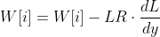
The formula is called only on layers which possess weights (i.e., not the ReLU!). Now, you will set the function to call the weight update to the correct layers. In PULP-TrainLib, the data is contained into 1-D arrays that store the tensors. To wrap the tensors, a struct blob is defined for each tensor, containing both their data and the gradients. Complete the code of update_weights() in net.c with the most suitable blobs to update the DNN.
PUT YOUR CODE OF THE WEIGHT UPDATE HERE:

Now, print the weights of the last layer before and after the update, using print_weights().
QUESTION:
- 4A) Do you notice any difference in the weights values before and after the update? Which one?
To complete Exercise 4, comment all the printf() and print_weights() around the update_weights() function.

Exercise 5: Training the classifier
Now, let's finally run a training! You will test the convergence of the DNN against the sample input and label generated by the GM. To start this exercise, uncomment the code at the bottom of net.c (both the profiling and the last block of net_step()). BE CAREFUL TO HAVE THE PRINTS COMMENTED AS SUGGESTED IN EXERCISE 4! The dataset, in this case, is composed of a single data. Therefore, the training will iterate on this only sample for a given number of epochs, to test the convergence and validate the model.
First, let's define the learning_rate and the epochs hyperparameters in GM.py. Leave the batch_size to 1, as we have a single sample. Note that batch_size = 1 is a common setup for training DNNs on Microcontrollers, due to the very limited amount of available memory (i.e., the single sample is acquired and we learned, then it's discarded).
When you call the compilation command (make clean get_golden all run), the GM will set the C code to execute the training with the given hyperparameters. Now, compile the code with learning_rate = 0.5, epochs = 1:
QUESTIONS:
- 5A) How many cycles does it take to perform the training loop?
- 5B) Which percentage of cycles takes to execute the forward?
- 5C) Which percentage of cycles takes to execute the backward?
- 5D) Does the output of the updated DNN approximate the label?
Now, set learning_rate = 1, epochs = 400:
- 5E) How many cycles does it take to perform the training loop?
- 5F) Is it coherent with the number of epochs?
- 5G) Does the output of the updated DNN approximate the label?

THE LAB ENDS HERE 🙂

