X-Agent Integration with Odoo
Meeting Minutes & Project Plan
Phase 1: Odoo AI Assistant | Phase 2: Extended X-Agent Integration

Email / MOM Summary
Subject: MOM - X-Agent Integration with Odoo
Dear Team,
Following our discussion regarding the X-Agent integration with Odoo, below is the agreed high-level plan. The detailed implementation notes and team responsibilities are included in the next section of this document.

Phase 1 - Odoo AI Assistant
- Integrate the Odoo AI chat interface with X-Agent.
- Allow users to ask ERP-related questions and perform data analysis from inside Odoo.
- Keep Phase 1 read-only. X-Agent can view and analyze data, but it will not create, update, or delete ERP records.
- All data access must follow the logged-in user's Odoo permissions, record rules, and company access.
- ERP answers should be based on Odoo data/tools and approved Knowledge Base sources.
- ERP Team will evaluate the Odoo 19 AI modules and adapt the required capabilities for our Odoo 18 environment.
- ERP Team will prepare the application and database environment, including required Python libraries and pgvector if needed.
- X-Agent Team will provide the required model/service integration details and tool-calling interface.
- Where possible, reuse X-Agent's existing embedding and retrieval capabilities for the Knowledge Base instead of creating a separate RAG stack in Odoo.
- ERP Team will build controlled Odoo tools that X-Agent can call for ERP data and analysis.

Initial POC
The first POC should validate the full flow: Odoo User -> Odoo AI Chat -> X-Agent -> Odoo Tool -> X-Agent Analysis -> Odoo Chat.
The POC should also confirm user access control, Odoo record context, grounded answers, tool calling, and auditability.

Phase 2 - Actions & X-Agent to Odoo
- Add controlled AI actions such as creating requests/tasks and sending emails.
- Add confirmation or approval for sensitive actions.
- Allow users to interact with Odoo from the existing X-Agent UI.
- Use X-Agent's wider capabilities such as chat history, memory, RAG, vision, and other approved tools together with Odoo.
The final target is to support both directions: Odoo UI -> X-Agent -> Odoo, and X-Agent UI -> Odoo.
Please review the detailed implementation plan below and share any comments or required changes.
Best regards,
Zainalabdeen

Detailed Project Plan

1. Objective
The goal is to bring X-Agent into Odoo without building a second independent AI platform. X-Agent will remain the AI reasoning and chat layer, while Odoo remains responsible for ERP data, business rules, permissions, and controlled tools.

2. Phase 1 Scope
- Odoo users access X-Agent from the Odoo AI/chat interface.
- The integration is read-only for ERP data.
- X-Agent can request Odoo data only through approved tools.
- Odoo executes requests under the current user's access rights and record rules.
- The current Odoo context can be passed to X-Agent, such as active page data, active record, company, and selected records.
- Answers should be grounded in Odoo tool results or approved Knowledge Base content.
- External/general answers should be restricted in the initial ERP mode to reduce hallucination risk.

3. ERP Team Responsibilities
- Review Odoo 19 Enterprise AI modules and identify the parts required for our Odoo 18 environment.
- Adapt/backport the required Odoo AI integration components to Odoo 18.
- Prepare the Odoo AI/chat interface and connection with X-Agent.
- Prepare the ERP environment and install the required Python dependencies.
- Verify PostgreSQL compatibility and install/configure pgvector if it is required by the selected Odoo AI components.
- Build the Odoo tools and business services used by X-Agent.
- Ensure tool execution follows Odoo ACLs, record rules, multi-company rules, and business logic.
- Provide logging/auditing for X-Agent calls to Odoo tools.

4. X-Agent Team Responsibilities / Required Information
The X-Agent team will provide the integration details required for Odoo to use the existing X-Agent services.
Area | Current Service | Required from X-Agent Team
Chat / Reasoning | GPT-OSS / Groq | Base URL, authentication/API key, request/response format, streaming support, structured output support
Vision | Qwen / Groq | Base URL, authentication, supported file/image input and response format
Embeddings | mxbai-embed-large / Ollama | Base URL, authentication if applicable, embedding API details
Tool Calling | X-Agent agent runtime | How tools are defined, registered, authorized, called, and how tool results/errors are returned
Web Search | Google Custom Search | API/configuration details if we decide to enable web search in ERP mode
Chat Context | X-Agent | How Odoo can pass ERP mode, user context, active record context, and conversation/session information

5. Knowledge Base / RAG
The Knowledge Base will be hosted and managed in Odoo using PostgreSQL pgvector. Odoo will manage the approved documents/URLs, content chunks, embeddings, and stored vectors.
The main architecture point to agree with the X-Agent team is where the RAG process should be implemented. X-Agent already provides RAG capabilities, but it does not provide the Knowledge Base that Odoo will use. We therefore need to decide which side will manage retrieval and RAG orchestration while keeping the Knowledge Base and vector storage in Odoo.

Proposed Knowledge Base Flow
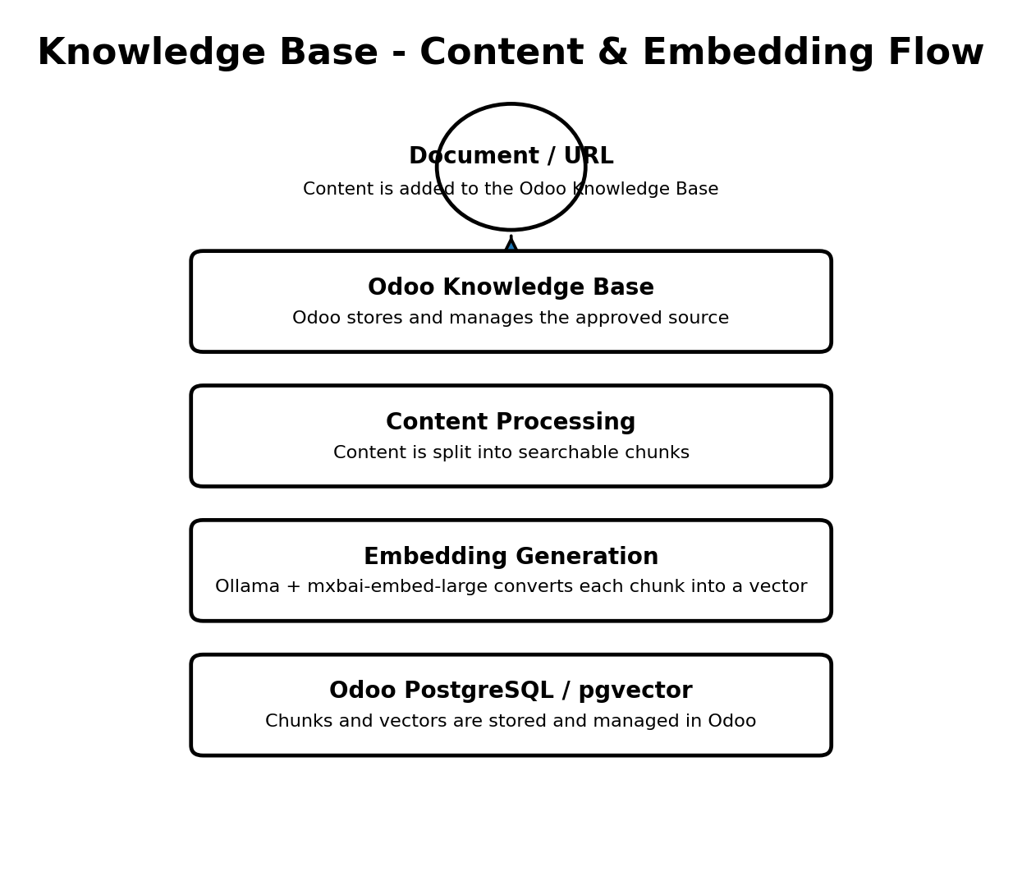

Proposed Query-Time RAG Flow
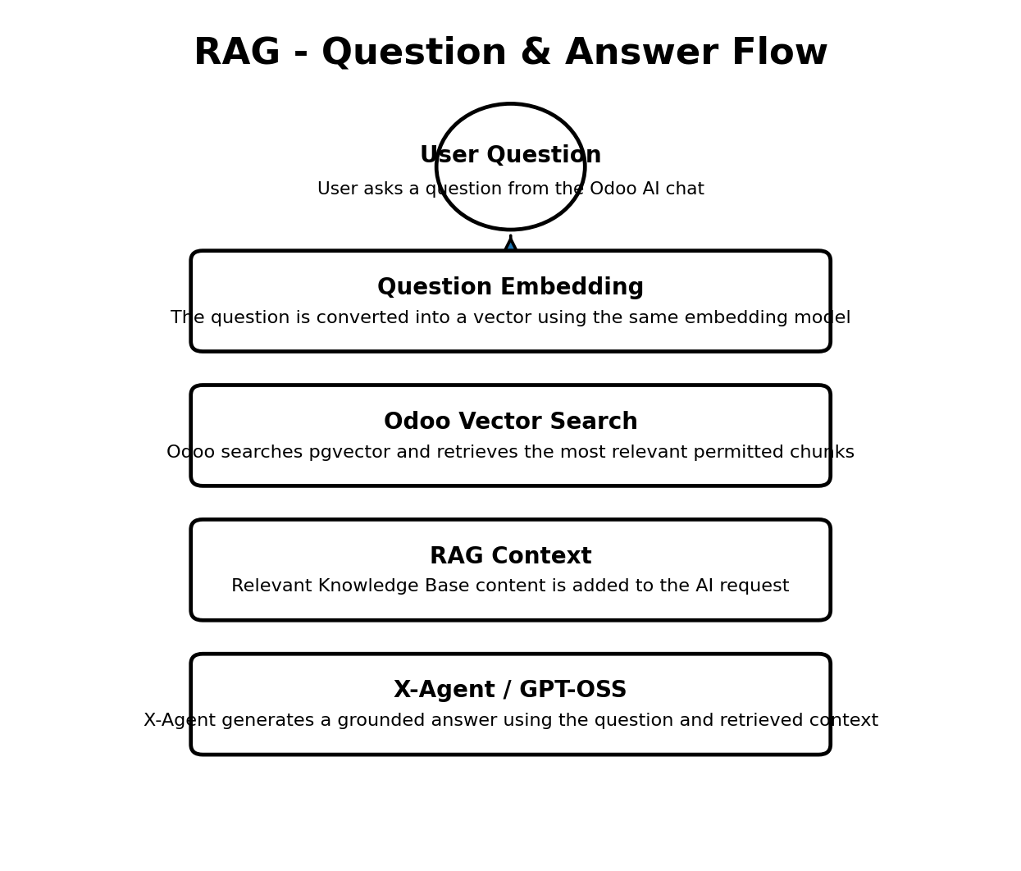

RAG Ownership - Decision Required
The Knowledge Base and pgvector storage will remain in Odoo. The open point is which component should manage the retrieval flow and prepare the RAG context for the model.
- Option 1 - Odoo-managed RAG: Odoo performs the vector search, retrieves the permitted relevant content, and sends the question together with the RAG context to X-Agent for answer generation.
- Option 2 - X-Agent-managed RAG: X-Agent manages the RAG orchestration and requests relevant Knowledge Base content from Odoo through a controlled retrieval interface. Odoo still owns the Knowledge Base, pgvector storage, and access control.
- The final option should be selected based on security, access control, reuse of X-Agent capabilities, maintainability, performance, and avoiding duplicated RAG logic.

Points to Confirm with X-Agent Team
- Can X-Agent manage RAG when the Knowledge Base and vectors are stored in Odoo?
- What interface does X-Agent need to request and receive relevant chunks from Odoo?
- Should Odoo send the retrieved RAG context to X-Agent, or should X-Agent control the retrieval sequence?
- How will Knowledge Base source references be returned with the final answer?
- For Phase 1, do we keep external Google Search disabled and depend only on Odoo data and the Odoo Knowledge Base?

6. Odoo Tools
Odoo tools will be the controlled interface between X-Agent and ERP data. X-Agent decides which tool is needed; Odoo executes the business operation and returns structured data.
- Get current/selected record information
- Search permitted Odoo records
- Get sales summary and breakdown
- Get customer summary
- Get project information and profitability
- Get receivables aging
- Get approved finance/revenue metrics
Phase 1 tool rules:
- Read-only.
- Use Odoo ORM/business logic; no unrestricted SQL access.
- Respect the requesting user's Odoo permissions.
- Return structured and limited data suitable for AI analysis.
- Log tool calls for troubleshooting and security review.

7. Hallucination / Grounding Controls
For the initial rollout, the Odoo chat should run X-Agent in a dedicated ERP/Odoo mode. The main rule is: no ERP factual answer should be presented as verified unless it is supported by an Odoo tool result or an approved ERP Knowledge Base source.
- Disable or restrict general web search initially.
- Do not use general model knowledge to invent ERP values or business facts.
- If the required information cannot be retrieved, X-Agent should clearly state that it cannot verify the answer from Odoo.
- Pass active Odoo record context as temporary conversation context, not permanent memory.

8. Phase 1 POC / Acceptance Criteria
1. User opens the AI/X-Agent chat inside Odoo.
2. Odoo sends the user question together with the relevant ERP context.
3. X-Agent identifies the required Odoo tool.
4. X-Agent calls the tool using the agreed integration mechanism.
5. Odoo executes the tool under the user's access rights.
6. Odoo returns structured data to X-Agent.
7. X-Agent analyzes the result and returns a grounded answer to the Odoo UI.
8. The request and tool execution can be traced for troubleshooting/audit purposes.

9. Phase 2 Scope
- Introduce controlled write/action tools such as creating requests, tasks/activities, and sending emails.
- Require confirmation/approval for sensitive or high-impact operations.
- Enable Odoo access from the existing X-Agent UI.
- Combine Odoo tools with X-Agent memory/history, RAG, vision, and other approved capabilities.
- Expand into dashboards, proactive analysis, and additional ERP business areas after Phase 1 is stable.

10. Target Architecture
Odoo UI -> X-Agent -> Odoo Tools / ERP Data
X-Agent UI -> Odoo Tools / ERP Data (Phase 2)
X-Agent remains the AI reasoning, conversation, and orchestration layer. Odoo remains the ERP source of truth, security authority, business-logic layer, and provider of controlled tools.

