**Lab Manual for**

**Artificial Intelligence**

Instructor: Abdul Hammad Rasheed

Lab # 06

Semester: Spring 2024

Department of AI & DS

National University of Computer and Emerging Sciences

Islamabad Campus

Carefully read the following instructions

1. Make a Jupyter Notebook file (.ipynb) with the convention “ROLLNO_NAME_SECTION_LABNO”

(E.g., 22I-1234_XYZ_BAI-A_01).

1. Write a code for each of the following tasks one after the other, in the same order.
2. At the end, when you are done with your lab tasks, make your submission on Google Classroom.

# Depth-Limited Search Algorithm

A depth-limited search algorithm is similar to depth-first search with a predetermined limit. Depth- limited search can solve the drawback of the infinite path in the Depth-first search. In this algorithm, the node at the depth limit will treat as it has no successor nodes further.

Depth-limited search can be terminated with two Conditions of failure:

* Standard failure value: It indicates that problem does not have any solution.
* Cutoff failure value: It defines no solution for the problem within a given depth limit.

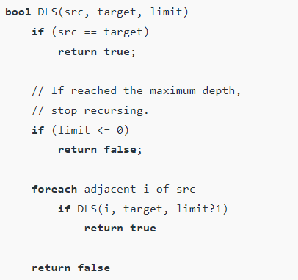

# Iterative deepening depth-first Search:

The iterative deepening algorithm is a combination of DFS and BFS algorithms. This search algorithm finds out the best depth limit and does it by gradually increasing the limit until a goal is found.

This algorithm performs depth-first search up to a certain "depth limit", and it keeps increasing the depth limit after each iteration until the goal node is found.

## LAB TASK 1: Solve the 8 PUZZLE PROBLEM

We will explore different search options for this problem. 8 Puzzle Problem

The 8 puzzle consists of eight numbered, movable tiles set in a 3x3 frame. One cell of the frame is always empty thus making it possible to move an adjacent numbered tile into the empty cell. Such a puzzle is illustrated in following diagram.

Find solution to the 8-puzzle problem using iterative depth first search.