**Wappalizer chrome extension**

It will tell you about what libraries the website using

**Locomotive :-** use for smooth scroll(librari)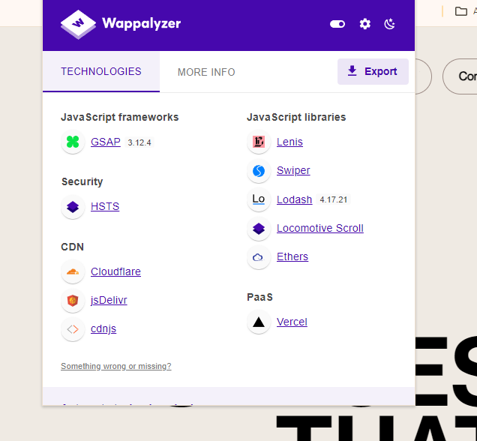

**CSS boiler palette code:-**

**\* {**

**margin: 0 ;**

**padding: 0;**

**box-sizing: border-box;**

**font-family: 'Gilroy';**

**}**

**html, body{**

**height: 100%;**

**width: 100%;**

**}**

**Wrapper:-**

First of all we will make a main div which will act like a wrapper . wrapper means which wrappe things together . like a toffee wrapper . we are using it **because we will use Locomotive and for Locomotive we need a wrapper .**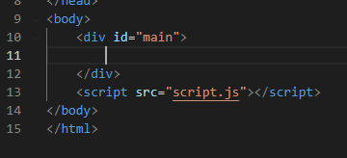

**Now,**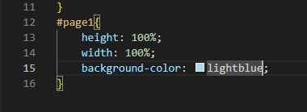

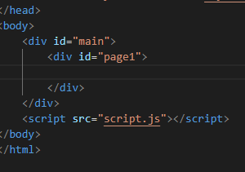

Now when we make a div **#page** and give it a 100% height or width .it will not show us in the display because when we say 100% its means parents 100% and we haven't give **#main** a height so what we gonna do now is just we will give its

**Height : 100vh;**  view port height and now it will display .

**Note:-** we are not giving **#main** height because we are going to use a locomotive. but if we give **parent(#main)** height width it will display.

**Colorzilla extension:-**

Use ton pick the colour from any website just click the page colour picker active and click on the colour and it will copy the colour in your clipboard

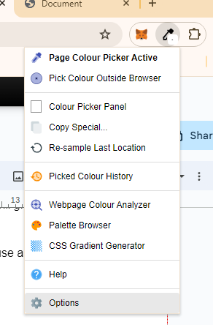

.A good developer approach when you make a parent div **position: relative** its child will be in control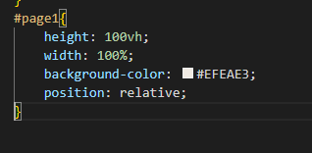

We can create the div for **navbar.** We can also use **nav as a tag** which will help us in **SEO.** give the width 100% & height 100px for responsivenes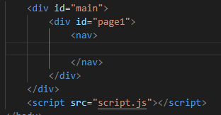

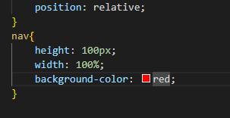

You shouldn't give height to your name instead give it padding from top and from left view port width vw

**Before**

**After padding** 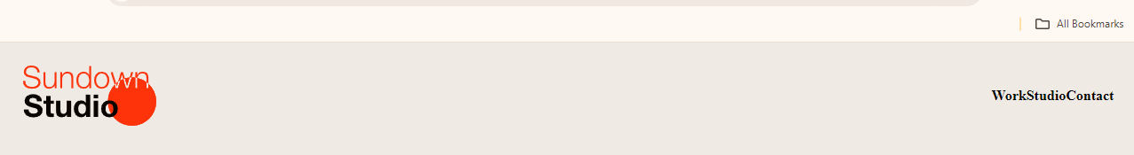

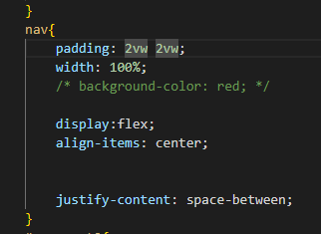

**After and before :- (pseudo elements)**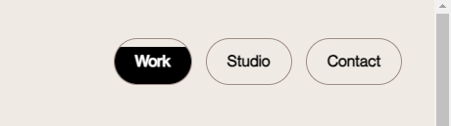

To create the hover effect.

**:- alway write content in after and make it empty if u write something in tit it will show in the tag**

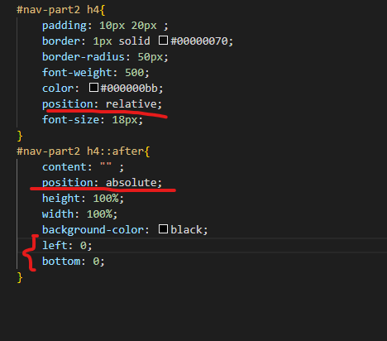

**Position : absolute:-**

When you give a child absolute it is like it is the prince it will occupy the whole page so to avoid from this make the parent **position :- relative** which will control its child . after all the **::after is the child of h4 .** and left and bottom = 0 means it will catch the button from left and bottom

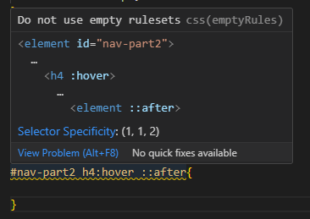

**Note:- when you give space between hover_::after it will see it as hover on h4 and after of an element inside it .which is wrong so u dont have to give space here.**

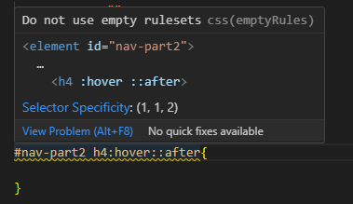

**When you remove space it will take hover on h4 and after on the h4**

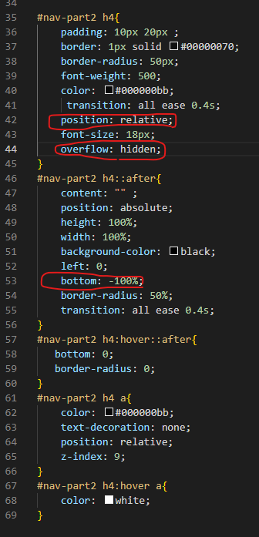

Here the **overflow** will hide anything that gets

Overflow from h4 .this is the code for the button

transactions

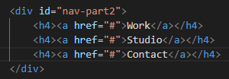

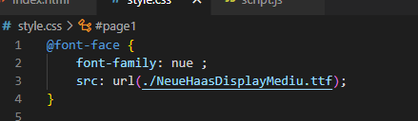

Used to import the font family just paste it in your project folder and use this .

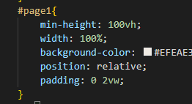

Will tell the that the min height should be the but can be exceed no problem

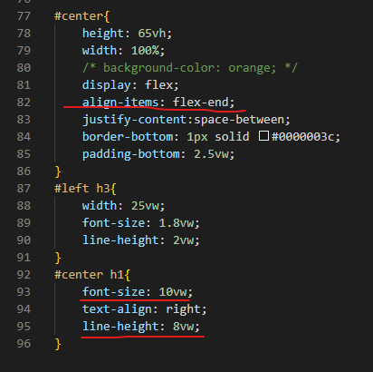

align-item>flex-end will take the item to

The end of div.

Line- height is use to give space between

The line of p or h tags

Font size is in 10vw is use to to make

It responsive for the page



Make the video autoplay muted and on loop.

**How to add locomotive to your Wrap page ?**

After adding the animation we are going to use **locomotive** to use it search it on google **locomotive js cdn** go to first website click on **locomotive scroll js** and copy its URL and paste it just above the **script tag** and inside a **script tag.**

And aslo go to the **locomotive scroll css** and also copy its url and paste it just above your **css file in link tag** in html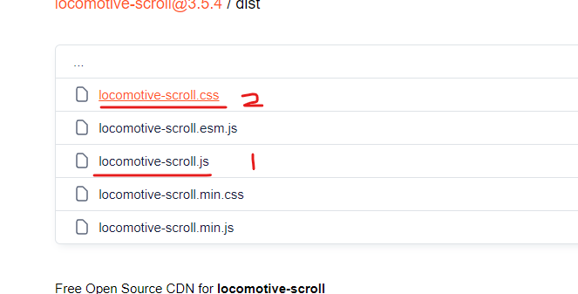

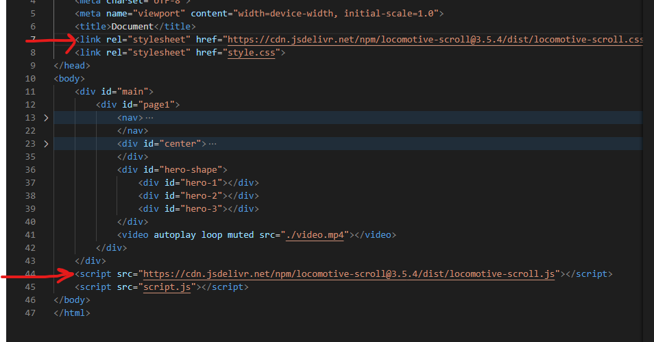

After that go to **locomotive js github** go to the first website and and scroll u will get **smooth .** copy the 2nd box of it and only just **const scroll** part .paste it in your **javascript file and use #main** in its document selector.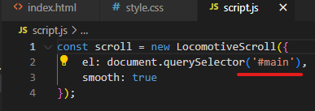

***[make sure while adding locomotive you***

***Didnot have given your wrap page***

***A height and width]***

**How to creat fav icon?**

Go to favicon.io click on text -> icon and you can generate the icon download it .

**HOW to use fav icon in your html ?**

Extract the favicon download file and select the 192x192 icon ot the one u like it .

And paste it in your project folder, link it just above your css link file like this.

Write link and select the fav icon one and use icon link.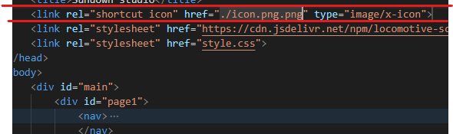

**How to creat this scrolling effect of the website**

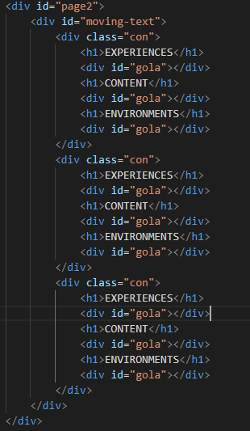

**HTML OF this sCrol effect**

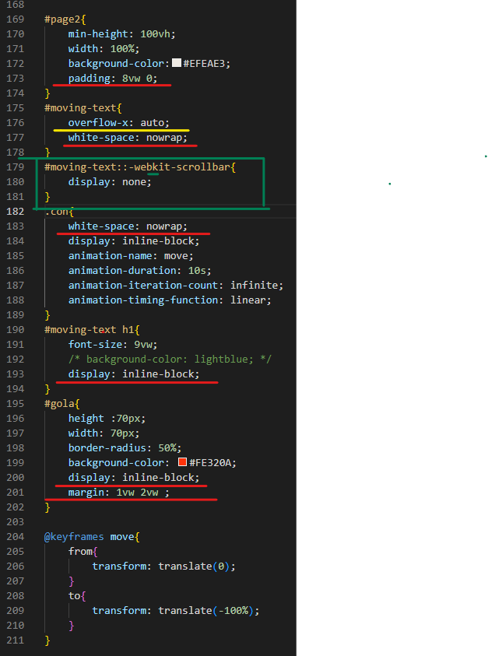

**Padding to page2** is so its come little bit

Down.

**Overflow-x:auto** will make the a **scroll bar**

Under the text only not on the whole page

**Webkit-scrollbar** will remove the scroll bar

That comes under the text

**White-space :nowrap** will make all the line

To come in single line of a div or class

**Display: inline-block** will make the h1

Display Change it will only cover the space

its need .

**Margin to gola** is so that its come in centre

**Gsap:- an animation library used to help in moving animation.**

1.search  **gsap cdn** . 2 go to first cdn website and copy the **script tag** of first link and paste it just below **locomotive link** in **html** .

2. Scroll down and also copy **the scroll trigger** and paste it below the **gsap link.**

**Font family weight 100**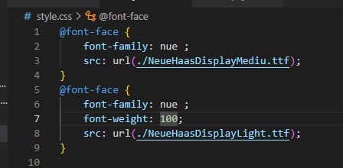

This will only apply when font weight

Is 100.

This code is use to make **2nd orange animation**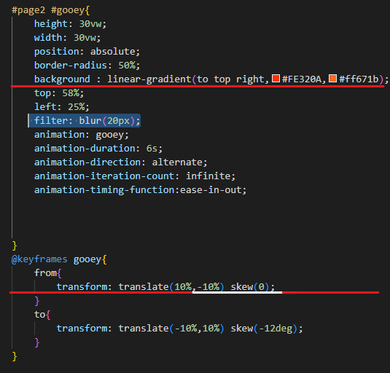

**The gradient** is use to add two colour

In the background .

The **to top** right means colours will

Go from left to right .

**skew()** is use to change or transform

The shape while in transition .

**How to use swiper js library**

**How to make website responsive**