Software Construction Development
Prepared by:
Muhammad Zain Mehboob
Sap Id: 67771
Section: BSSE 5
lab: 11
Date: 14, May 2026


Task:1 Temprature creater:
Here is final screen: Output
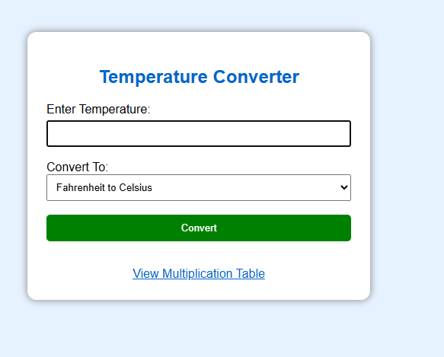
Here is Celsius to Fahrenheit :
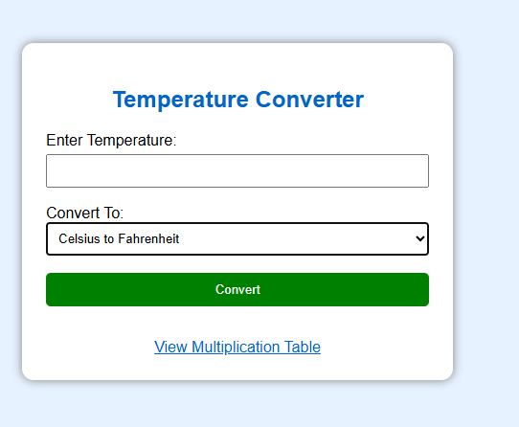
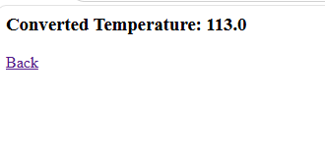
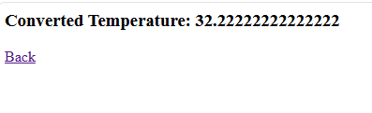
Here is unit testing :
