Multi-Scale Character-Level CNN and Hybrid Feature Fusion for Lightweight Phishing URL Detection
Mid-term Progress Report: Group 9
Zainb Zahran  School of Computing  Queen's University  Ontario, Canada  25vpgv@queensu.ca | Fatma Abu Al Wafa  School of Computing  Queen's University  Ontario, Canada  25qgkp@queensu.ca | Ahmed Mohamed Al-Shobaki  School of Computing  Queen's University  Kingston, Canada  25LSWJ@queensu.ca

Abstract—This mid-term report presents progress on Project 9: Neural Models for Phishing URL Detection. We use the Mendeley 2026 phishing URL dataset (DOI: 10.17632/3jddhy2f6s.1) comprising 129,776 cleaned URL records. We build a reproducible data pipeline with duplicate-aware cleaning, stratified 70/15/15 splits, 23 handcrafted lexical URL features, train-only StandardScaler normalization, and additional balanced and imbalanced evaluation sets. Classical ML baselines: Logistic Regression (LR), Linear SVM, Random Forest (RF), and XGBoost (XGB); are trained under three imbalance-handling strategies: no handling, class weighting, and SMOTE oversampling. A stacking ensemble (RF + XGB + LR base learners, LR meta-learner) achieves the best phishing-class F1-score of 0.9519 with ROC-AUC = 0.9918 on the original test set. RF without imbalance handling achieves the marginally highest ROC-AUC of 0.9919. Tree-based models substantially outperform linear models. On the deep learning side, a Multi-Scale Char-CNN with 179,329 trainable parameters achieves 99.12 % accuracy and F1 = 0.9896 on the validation set after 15 epochs with drop out and augmentation applied to mitigate overfitting and ensuring generalization, Further variations of CNN based models with ablation will be presented in final report, the Feature importance analysis reveals the importance of certain features like URL length and host name length which is not captured in the truncated URLs in the Char-CNN model , motivating our hypothesis that Hybrid Feature Fusion approach will enhance the performance.
Keywords— Phishing URL, CNN, Random Forest, hybrid models, deep feature fusion, lightweight models
I. Introduction
A phishing URL (Uniform Resource Locator) is a malicious attack that mimics legitimate websites to steal users’ credentials or deliver malware. Millions of phishing sites are detected every year, impacting millions of users and companies and leading to billions of dollars in losses, as highlighted by a report from Interisle Consulting Group [1]. This huge number of phishing URLs generated every day makes it impossible to blacklist all of them in lookup tables, as this will be computationally exhaustive and inefficient for real-time detection.
Traditional approaches that depend on extracting lexical properties of the URL string and then using classical models such as Support Vector Machines (SVMs) or Random Forests [3] suffer from limitations regarding: (1) the need for domain expertise to engineer features, which is time consuming and sometimes infeasible for the huge variations of URLs generated every year (2) engineered features that do not generalize since phishing URLs keep varying, causing models to fail to detect new phishing URL patterns (3) the semantic meaning of features not being used meaningfully to detect patterns.
In more recent years, deep learning solutions have emerged as a strong alternative, with various kinds of neural networks outperforming classical baselines through their ability to auto-learn features. On top of them, Convolutional Neural Networks convert URLs into learnable features of a reasonable number of weights, making CNN variations lightweight and deployable on a CPU. Our contribution is to compare the Multi-Scale Character-Level CNN, the main deep baseline model, against three other variations: Bi-directional Long Short-Term Memory with CNN, FastText embedding with CNN, and a Hybrid Feature Fusion CNN that leverages important handcrafted features. These models are rigorously compared across accuracy, F1-score, Precision, Recall, and an efficiency score (F1/number of parameters) representing the trade-off between model performance and weight. Providing a guideline for those in need of a deployable model to balance this tradeoff according to their use case and available resources.
II. Related Work
A. Classical Feature-Based Approaches
The data pipeline supports the classical feature-based direction by extracting lightweight lexical and structural URL features such as URL length, hostname length, path/query length, special-character counts, digit ratio, HTTPS usage, IP-address usage, subdomain depth, path depth, hostname hyphen usage, entropy, and suspicious keyword count [8][9]. These features are intended for the traditional ML baselines and for comparison with the character-level deep models.
B. Character-Level Deep Learning
a) URLNet by Le et al. [2] compares character-level CNN, word-level CNN, and a hybrid character + word approach, including special characters and character-level word embedding, which achieved a higher AUC than both the standalone character-level CNN (0.9828) and word-level CNN (0.973) at 0.9885. However, this is not significantly higher than the character-level CNN, which does not justify the overhead of developing a hybrid model. This motivates using a character-level CNN as a straightforward approach with strong performance.
b) PhishGuard [4] presents a model for detecting phishing URLs based on a 1D CNN with explainability analysis, achieving 99.85% accuracy. The analysis showed that URL length and domain name length are the most important features, which motivates our Hybrid Deep Feature Fusion method.
c) Alshingiti et al. [5] studied CNN, LSTM, and hybrid LSTM-CNN architectures. Experimental results show accuracies of 99.2% (CNN), 97.6% (LSTM-CNN), and 96.8% (LSTM). The CNN model proves superior to other methods in detecting phishing URLs, confirming our approach.
d) Kumar et al. [6] propose a CNN with a Word2Vec solution to leverage semantic understanding. However, since phishing URLs typically involve misspelled words, a sub word embedding mechanism is preferred, motivating experiments with FastText + word-level CNN, which offers a lightweight sub word n-gram embedding approach suitable for our CPU-only constraint.
e) J. Smith and A. Lee proposed PhishDetect [7], a BiLSTM-based phishing URL detection framework using FastText embeddings, reaches 99.17% accuracy, which reinforces our FastText + CNN model approach.
C. Handling Class Imbalance
From the data preparation side, imbalance is handled without changing validation or test distributions. We use stratified splitting to preserve the original class ratio, create a balanced 50/50 test set and an imbalanced 80/20 legitimate/phishing test set for evaluation, and prepare one SMOTE-balanced scaled training file [10] for optional classical ML experiments. SMOTE is applied only to the training feature set, not to validation, test, or raw URL strings.
III. Dataset
A. Dataset Source and Audit
We use the Mendeley 2026 phishing URL dataset (mendeley_2026_commoncrawl_phishtank.csv, DOI: 10.17632/3jddhy2f6s.1), which contains raw URL strings and binary labels: legitimate (0) and phishing (1). We selected it because the same base data supports both directions of the project: raw URL input for character-level CNN/RNN models and handcrafted numerical features for classical ML baselines.
The raw file contained 149,726 rows and two columns (URL, Label). Before cleaning, we audited column names, data types, missing values, empty URL strings, binary label validity, class distribution, duplicate URLs, and conflicting labels. The audit confirmed valid binary labels and no missing/empty URL records; duplicate handling was still required before splitting.
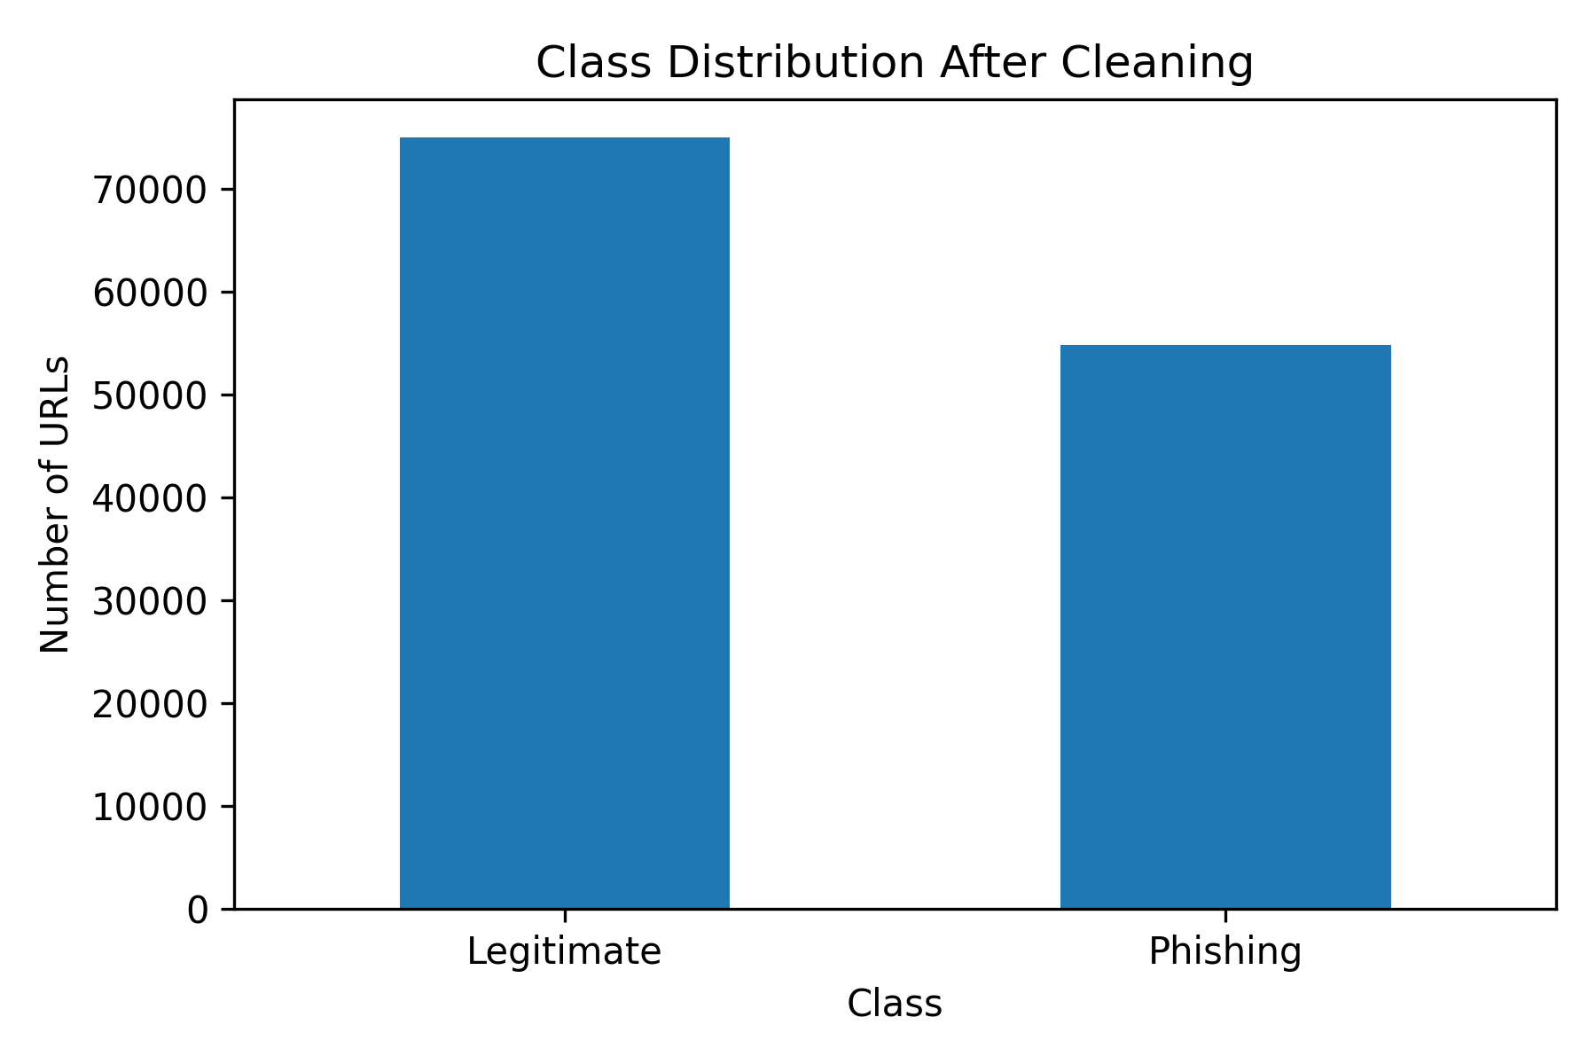
Fig. D1. Class distribution after cleaning: 74,972 legitimate URLs (57.77%) and 54,804 phishing URLs (42.23%).
B. Cleaning, Leakage Prevention, and Splitting
We stripped whitespace before duplicate checks to avoid treating the same URL with extra spaces as unique. No repeated URL had conflicting labels. We then removed 19,950 duplicate rows before splitting to reduce leakage risk between train and test data. The cleaned dataset contains 129,776 URLs: 74,972 legitimate and 54,804 phishing.
We created a stratified 70/15/15 split with RANDOM_STATE=42 to preserve the mild class imbalance across subsets. Final sizes are: training 90,843 rows (52,480 legitimate / 38,363 phishing), validation 19,466 rows (11,246 / 8,220), and test 19,467 rows (11,246 / 8,221). The phishing ratio is approximately 0.4223 in all subsets; the one-row validation/test difference is due to rounding.
IV. Preprocessing Pipeline
A. Handcrafted Features and Scaling
For the classical ML baseline, we extracted 23 URL-only lexical and structural features without webpage rendering, JavaScript execution, or WHOIS queries. Features include URL/hostname/path/query lengths; counts of dots, hyphens, digits, slashes, equals signs, question marks, underscores, ampersands, percent signs, and @ symbols; digit_ratio and shannon_entropy [14]; has_https, has_ip_address, subdomain_depth, path_depth, hostname_has_hyphen, tld_in_path; and suspicious_keyword_count. We used parsed.hostname instead of parsed.netloc so hostname features are not polluted by port numbers. Final feature tables contain 23 features plus Label: 90,843 x 24 (train), 19,466 x 24 (validation), and 19,467 x 24 (test).
We produced both unscaled and scaled feature files. StandardScaler [12] was fitted only on training features, then applied to validation and test features to avoid leakage; the fitted scaler was saved as models/standard_scaler.joblib. Scaled files support LR/SVM, while unscaled files are kept for tree-based models.
B. EDA, Evaluation Sets, and Final Outputs
EDA showed that URL length is heavily right-skewed with extreme outliers (maximum 25,515 characters). We kept these outliers because long URLs may carry phishing signal and used capped plots only for readability. Shannon entropy and digit ratio did not separate the classes alone. HTTPS appeared frequently in both classes, so it is not sufficient as a safety signal; however, hostname_has_hyphen was much more common in phishing URLs. TLD analysis showed .com dominates both classes, while .dev, .app, .network, .top, and .link appear frequently among phishing URLs. The correlation matrix showed no single handcrafted feature explains the label, supporting models that combine multiple URL signals.
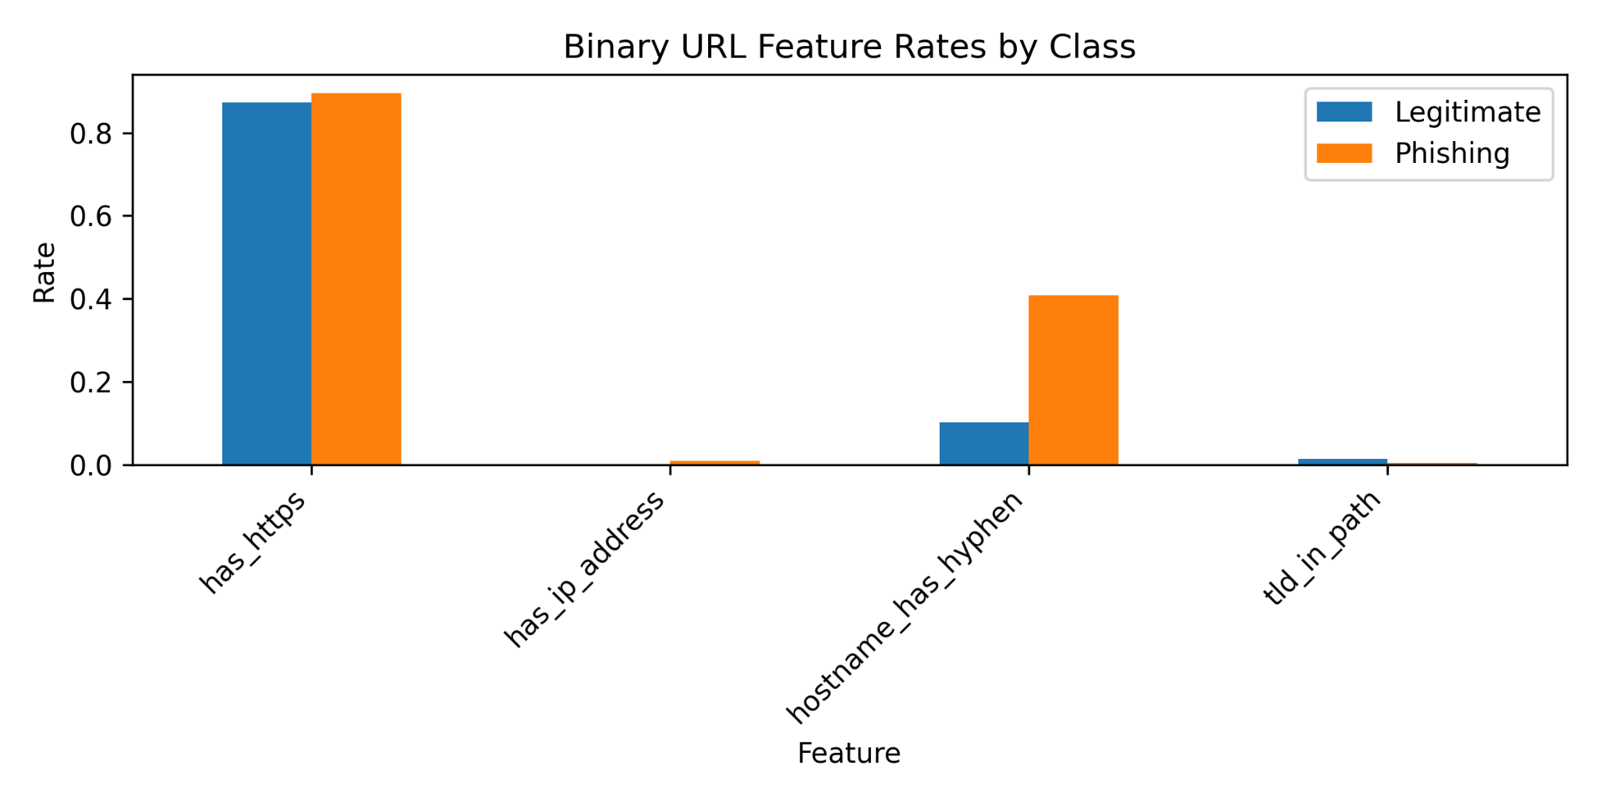
Fig. P1. Binary URL feature rates by class. HTTPS is common in both classes, while hostname_has_hyphen is substantially more frequent in phishing URLs.
We also prepared evaluation-only test variants: a balanced 50/50 set with 16,442 rows (8,221 legitimate / 8,221 phishing) and an imbalanced 80/20 set with 14,057 rows (11,246 legitimate / 2,811 phishing). The same 23 handcrafted features and train-fitted scaler were applied to both evaluation sets.
For optional classical ML experiments, we created one SMOTE-balanced scaled training file [10]. SMOTE was applied only to the scaled training features, not to validation/test sets or raw URL strings. The training distribution changed from 52,480 legitimate / 38,363 phishing to 52,480 samples per class (104,960 total). This file is not used for the character-level CNN/RNN because it contains synthetic numerical feature vectors, not real URLs.
Final validation checks confirmed that saved files match the notebook outputs. In total, the pipeline documents 34 generated files, including the cleaned dataset, splits, unscaled/scaled features, evaluation sets, EDA outputs, SMOTE file, and saved scaler.
V. Methodology
A. Classical ML Baselines
The experiments use the dataset splits described in Sections III and IV. The original training set contains 57.8% legitimate and 42.2% phishing URLs (phishing ratio = 0.422). Three test distributions are evaluated: original (~57/43, n = 19,467), balanced (50/50, n = 16,442), and highly imbalanced (80/20, n = 14,057). For SMOTE experiments, a pre-augmented training set of 104,960 samples at a 50/50 ratio is used. The validation set is used exclusively for model selection; test sets are reserved for final unbiased evaluation.
Twenty-three lexical features are extracted from raw URL strings without page rendering, JavaScript execution, or WHOIS queries, making the detector stateless and suitable for real-time use [20]. Feature scaling via StandardScaler [12] is applied to LR and SVM inputs; tree-based models receive unscaled features as tree split thresholds are scale-invariant.
Four model families are evaluated. Logistic Regression (LR) and Linear SVM serve as linear baselines. For SVM, CalibratedClassifierCV with sigmoid calibration (cv = 3) [13] converts decision function scores into probability estimates required for ROC-AUC computation [17]. Random Forest (RF) [19] and XGBoost (XGB) [11] serve as nonlinear tree-based baselines. Three class-imbalance handling strategies are tested: (1) no handling models trained on the original distribution as a reference; (2) class weighting; class_weight=‘balanced’ for LR, SVM, and RF; scale_pos_weight = 1.368 (52,480 ÷ 38,363) for XGB [16]; (3) SMOTE oversampling [10] applied exclusively to LR and SVM using the pre-balanced training set, as tree-based models typically handle tabular imbalance effectively through built-in weighting. The stacking ensemble uses RF, XGB, and LR as base learners with an LR meta-learner trained on out-of-fold predictions (cv = 5, passthrough = False) [15]. Table I summarises all model configurations.
All models are evaluated on the validation set and three test sets. Metrics include: Accuracy, Precision, Recall, F1-score, ROC-AUC [17][18], FPR, and FNR. Model selection is performed using validation F1-score only. A unified evaluation function applies to all models to guarantee consistent metric computation.
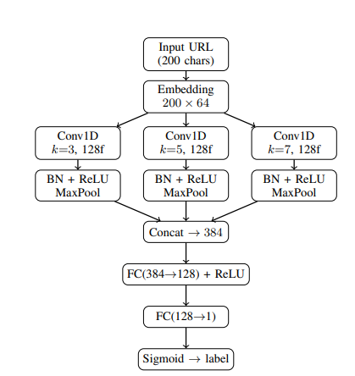
TABLE I. Baseline model configurations and imbalance strategies.
Model | Scaled? | Strategy | Key Hyperparameters
Logistic Regression | Yes | None/Wt/SMOTE | C=1.0, max_iter=2000, lbfgs Note: Linear baseline
Linear SVM | Yes | None/Wt/SMOTE | C=1.0, max_iter=3000, CalibratedCV (sig, cv=3)  Note:Probability via calibration [13]
Random Forest | No | None/Wt | 300 trees, min_samples_leaf=2  Note:Nonlinear, tree-based [19]
XGBoost | No | None/Wt | 300 trees, lr=0.1, depth=6, sub=0.8  Note:scale_pos_weight=1.368 [11]
Stacking Ensemble | No | Ensemble | RF+XGB+LR base; LR meta; cv=5  Note:Stacked generalization [15]
B. Deep Learning Baseline: Multi-Scale Char-CNN
Design Rationale.
Our main deep-learning approach, Char-CNN with multi-scale kernels, treats each URL as a raw character sequence. Unlike word or token-level models, a character-level representation requires no vocabulary normalization and produces a compact fixed-sized vocabulary of the ASCII printable set. Previous literature advocates for the superiority of Char-CNN; we additionally train three more sophisticated variants. Our hypothesis is that hybrid fusion will outperform multi-scale CNN alone. Four models are trained and compared based on accuracy, F1-score, Precision, Recall, and efficiency score (F1/million parameters): (1) Char-CNN with multi-scale kernels; (2) Hybrid CNN + Bi-LSTM; (3) FastText + CNN (subword n-gram embeddings); (4) Hybrid Feature Fusion (deep features + handcrafted statistical features).
Character Vocabulary.
A CharVocab class is built by counting all characters in the training corpus. Characters with fewer than 3 occurrences are treated as unknown (<UNK>). The vocabulary is capped at 100 entries; the resulting vocabulary size is 92 (no capping was needed), plus <PAD> (index 0) and <UNK> (index 1). All URLs are normalized to a maximum length of 200 tokens. This threshold was selected by visualizing the URL length distribution, which is heavily right-skewed. The box plot shows that the upper bound (Q3 + 1.5 × IQR) is roughly at 200 chars.
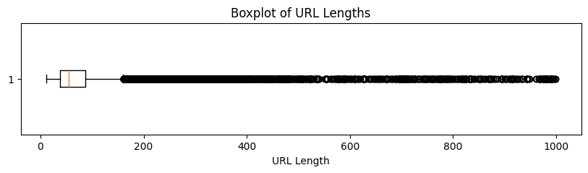
Fig. DL1. Boxplot of URL lengths in training set (capped at 1000 chars). Upper whisker ≈ 200 chars selected as MAX_LEN.
PyTorch Dataset and Data Loading.
The URLDataset class encodes each URL by the vocabulary dictionary, pads or truncates to 200 characters, and returns a (token_sequence, label) pair. Data augmentation is applied at training time: random token masking to <UNK> with 10% probability per URL improves generalization. Class imbalance is mitigated with WeightedRandomSampler, assigning each sample a weight inversely proportional to its class frequency. The model is evaluated on validation and test samples without balancing to mimic realistic inference. Batch size = 256 yields 355 batches/epoch for the 90,843-sample training set.
Char-CNN Architecture.
An embedding layer maps each character index to a dense vector of dimension 64, producing a [256× 200 × 64] tensor. Three parallel 1D convolution branches with kernel sizes {3, 5, 7} and 128 filters each capture short, medium, and long character n-grams (e.g., “net”, “www”, “paypal”), following the URLNet multi-scale approach [2] but limited to three kernels for compactness. Each branch uses BatchNorm1d and ReLU. Global max-pooling reduces each branch from [256, 128, 200] to [256, 128], retaining the strongest activation regardless of position. The three branches are concatenated to a 384-dimensional vector, followed by Dropout(p = 0.3), Linear Layer(384→128) with ReLU, Dropout, and Linear(128→1) producing the phishing logit via sigmoid. Total trainable parameters: 179,329 (lightweight, CPU-compatible).
Fig. DL2. Multi-Scale Char-CNN architecture: three parallel Conv1D branches (k=3,5,7), BN+ReLU+MaxPool, Concat→384, FC(384→128)+ReLU, FC(128→1), Sigmoid.
Training Configuration.
Loss: Binary Cross Entropy with Logits with pos_weight = 52,480/38,363 ≈ 1.368 to penalise false negatives. Optimizer: Adam with η = 10⁻³ and weight decay λ = 10⁻⁴ with scheduler reducing leariningrate by factor of 0.5 with patience of 3 epochs to prevent oscillation near minima and stabilize convergence; gradient clipping at 1.0 to prevent exploding gradients. Early Stopping: with patience = 5 epochs, min_delta = 0.001 (conditions were not met during Char-CNN training). Reproducibility: numpy.random.seed(42) and torch.manual_seed(42) are set for all experiments.
Planned Architectures (Final Report).
CNN + BiLSTM: a bidirectional LSTM layer after convolution to capture long sequential dependencies (CNN captures local n-gram features; BiLSTM captures global context). FastText + CNN: subword n-gram embeddings pretrained with FastText, providing out-of-vocabulary combination handling. Hybrid Feature Fusion: combines Char-CNN deep character-level features with the 23 handcrafted features, motivated by EDA and Random Forest feature importance analysis.
VI. Preliminary Experiments and Results
A. Implementation Details
Student A (data pipeline) ran on a local CPU machine using Python 3.9, NumPy, Pandas, scikit-learn [12], imbalanced-learn, Matplotlib, and Seaborn. Student C (classical models) ran on Google Colab (CPU) using XGBoost [11], scikit-learn [12], and imbalanced-learn. Student B (deep model) used PyTorch with CUDA if available (CPU fallback), tqdm, and sklearn.metrics. RANDOM_STATE = 42 is set for all stochastic operations throughout all three notebooks.
B. Classical ML Performance on Original Test Set
Table II reports all model results on the original test set sorted by phishing-class F1-score. The Stacking Ensemble achieves the highest F1-score (0.9519) with ROC-AUC = 0.9918, marginally outperforming RF without imbalance handling in F1-score (0.9506). RF without imbalance handling achieves the highest ROC-AUC (0.9919), although the difference from the Stacking Ensemble is negligible. All tree-based models exceed F1 = 0.945 and AUC = 0.990. Linear models (LR and SVM) perform substantially worse, reaching at most F1 = 0.8067 and AUC = 0.9115, indicating that tree ensemble decision boundaries are better suited to the nonlinear separability of URL features.
TABLE II. All baseline models on original test set sorted by F1-score. Bold row = Stacking Ensemble (best). RF (no handling) achieves highest single-model AUC = 0.9919.
Model | Acc. | Prec. | Rec. | F1 | AUC | FPR | FNR
Stacking Ensemble | 0.9597 | 0.9584 | 0.9455 | 0.9519 | 0.9918 | 0.030 | 0.055
RF (no handling) | 0.9588 | 0.9607 | 0.9408 | 0.9506 | 0.9919 | 0.028 | 0.059
RF (weighted) | 0.9584 | 0.9562 | 0.9448 | 0.9504 | 0.9918 | 0.032 | 0.055
XGB (weighted) | 0.9563 | 0.9478 | 0.9488 | 0.9483 | 0.9905 | 0.038 | 0.051
XGB (no handling) | 0.9543 | 0.9550 | 0.9360 | 0.9454 | 0.9903 | 0.032 | 0.064
LR (no handling) | 0.8411 | 0.8295 | 0.7852 | 0.8067 | 0.9115 | 0.118 | 0.215
LR (SMOTE) | 0.8284 | 0.7801 | 0.8267 | 0.8027 | 0.9114 | 0.170 | 0.173
LR (weighted) | 0.8284 | 0.7805 | 0.8261 | 0.8026 | 0.9114 | 0.170 | 0.174
SVM (SMOTE) | 0.8261 | 0.7789 | 0.8214 | 0.7996 | 0.9080 | 0.171 | 0.179
SVM (weighted) | 0.8350 | 0.8273 | 0.7701 | 0.7977 | 0.9077 | 0.118 | 0.230
SVM(no-handle) | 0.8344 | 0.8280 | 0.7673 | 0.7965 | 0.9075 | 0.117 | 0.233
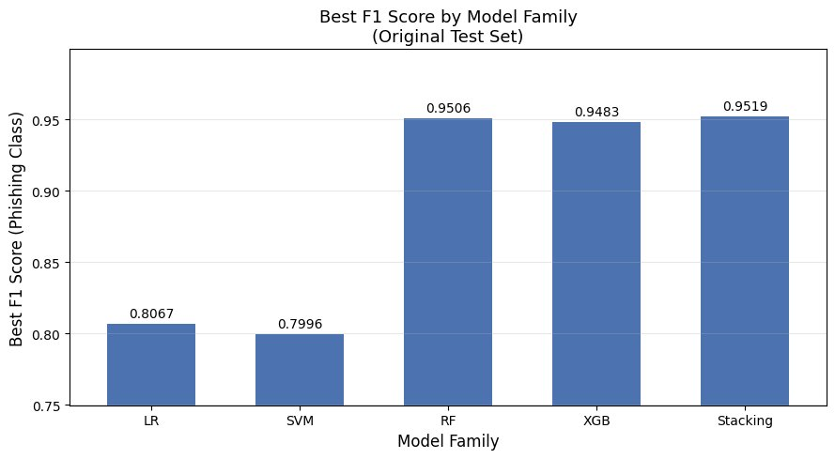
Fig. 1. Best F1-Score by model family on the original test set
(LR=0.8067, SVM=0.7996, RF=0.9506, XGB=0.9483, Stacking=0.9519).
C. Feature Importance Analysis
Random Forest Gini importance (Fig. 2) reveals that five features form the top quartile: path_length (importance ≈ 0.175), hostname_length (≈0.128),shannon_entropy (≈0.097), path_depth (≈0.094), and url_length (≈0.072). These features indicate that phishing URLs tend to use longer, more complex paths and hostnames to disguise malicious destinations. The remaining 18 features contribute individually less than 0.060. The large importance gap suggests that a compact five-feature subset could achieve near-full performance, though correlated lexical features may distribute shared information across multiple features [11].
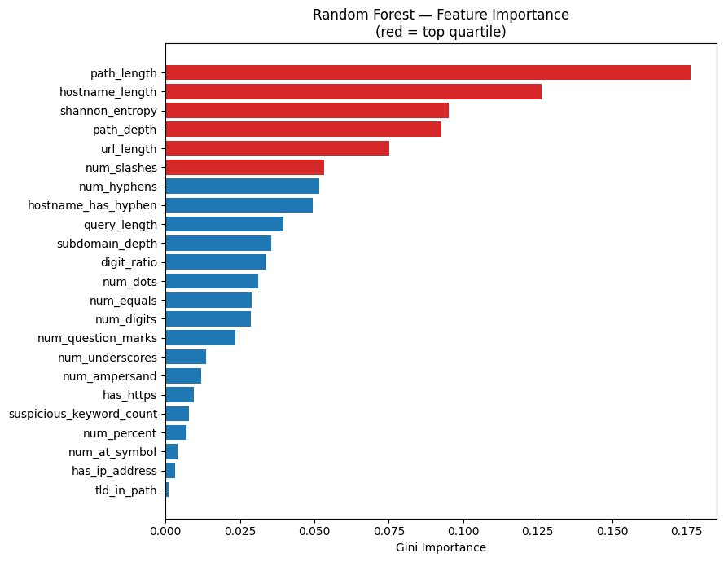
Fig. 2. Random Forest Gini feature importance. Red bars = top-quartile features: path_length, hostname_length, shannon_entropy, path_depth, url_length.
D. ROC Curve Analysis
Fig. 3 shows ROC curves for all 11 model variants on the original test set. Tree-based models cluster at AUC ≈ 0.99 (RF-none = 0.9919, Stacking = 0.9918, RF-weighted = 0.9918, XGB-weighted = 0.9905, XGB-none = 0.9903), while linear models are confined to AUC ≈ 0.91 (LR variants ≈ 0.911, SVM variants ≈ 0.908). The performance gap is consistent across all imbalance strategies within each model family, confirming that model architecture is the dominant performance factor, not imbalance handling.
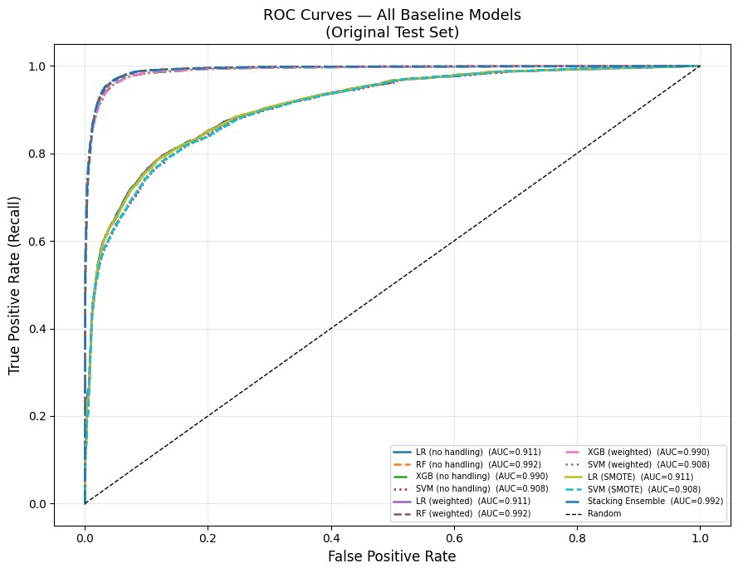
Fig. 3. ROC curves for all baseline models on the original test set. Tree-based models (RF, XGB, Stacking) achieve AUC ≈ 0.99; linear models (LR, SVM) achieve AUC ≈ 0.91.
E. Effect of Imbalance Handling on F1-Score
Fig. 4 compares the three imbalance strategies within each model family. For tree-based models, the F1 difference between ‘None’ and ‘Weighted’ is negligible (< 0.003): RF-none = 0.9506 vs. RF-weighted = 0.9504; XGB-weighted = 0.9483 vs. XGB-none = 0.9454. For linear models, SMOTE increases recall (0.7852 → 0.8267) but at the cost of precision (0.8295 → 0.7801), yielding a net decrease in F1: LR-none = 0.8067 vs. LR-SMOTE = 0.8027. The recall gain does not compensate for the precision loss under the original test distribution. This result is consistent with the relatively mild class imbalance in the training set (42/58 ratio), where weighting and oversampling offer minimal marginal benefit. The model family effect (tree vs. linear) dominates over the imbalance-handling effect.
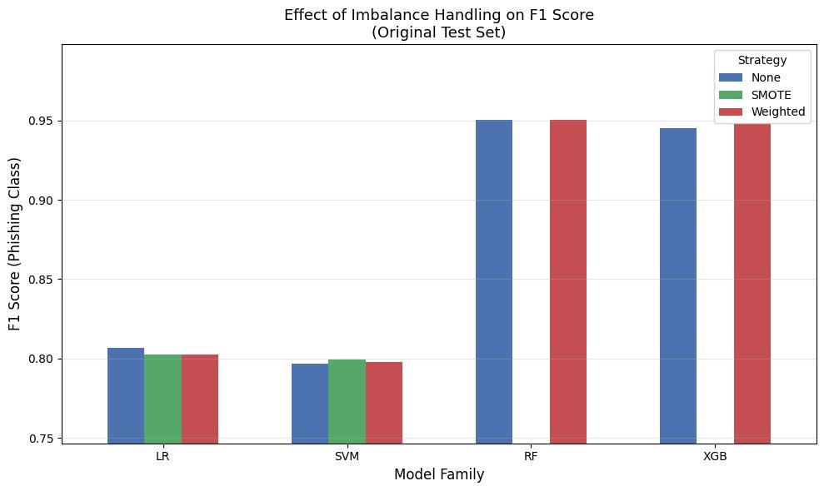
Fig. 4. Effect of imbalance handling strategy on F1-score per model family (original test set). SMOTE applied to LR and SVM only; RF/XGB use built-in weighting.
F. Best Model Performance Across Test Distributions
The Stacking Ensemble was selected as the best model based on validation F1 = 0.9498. Fig. 5 and Table III show its performance across three test distributions. ROC-AUC remains above 0.991 in all conditions. F1 increases slightly from 0.9519 on the original test set to 0.9571 on the balanced test set, then drops to 0.9145 on the 80/20 imbalanced set. The F1 drop under the 80/20 condition is primarily driven by a precision decrease (0.9584 → 0.8873) as phishing URLs become rarer, making false positives proportionally more costly. Recall remains highly stable (0.9434–0.9455), confirming the model continues to detect phishing reliably under distribution shift.
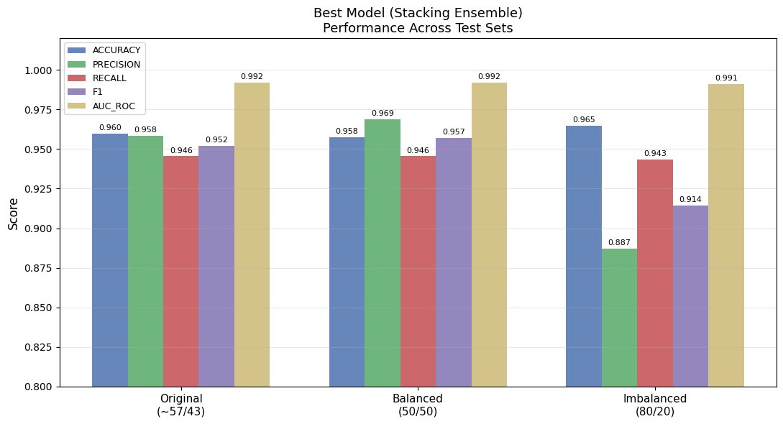
Fig. 5. Stacking Ensemble performance across three test distributions showing stability in AUC and recall with precision decrease under the 80/20 imbalanced condition.
G. Confusion Matrix Analysis
Fig. 6 presents confusion matrices for the Stacking Ensemble across the three test distributions. On the original test set: TN = 10,909, FP = 337, FN = 448, TP = 7,773 (FPR = 0.030, FNR = 0.055). False negatives are the safety-critical error class because they represent phishing URLs that bypass detection. On the imbalanced 80/20 test: FP = 337 (unchanged, as the legitimate class subset is identical), FN = 159, TP = 2,652, yielding higher apparent accuracy (0.9647) but lower F1 (0.9145) due to fewer total phishing samples.
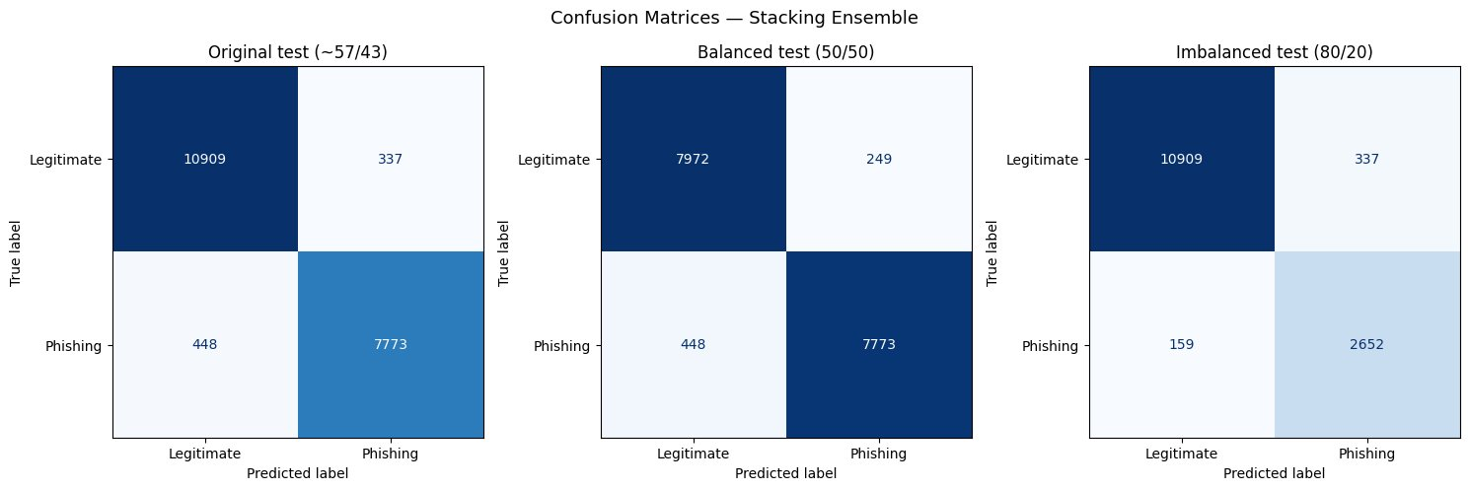
Fig. 6. Confusion matrices — Stacking Ensemble. Left: original (~57/43); centre: balanced (50/50); right: imbalanced (80/20). FP=337, FN=448 on original test.
H. Error Analysis
Fig. 7 shows URL length distributions for the 337 false positives and 448 false negatives produced by the Stacking Ensemble on the original test set (FPR = 0.030, FNR = 0.055). False positives concentrate in the 20–60 character range, suggesting that short, structurally complex legitimate URLs activate the same feature patterns associated with phishing. False negatives display a right-skewed length distribution extending to approximately 700 characters. These long phishing URLs likely employ obfuscated paths and redirect chains that distribute lexical signals across feature dimensions, reducing individual feature discriminability. Short phishing URLs (length 30–60) that closely mimic legitimate URL structure constitute the primary challenge.
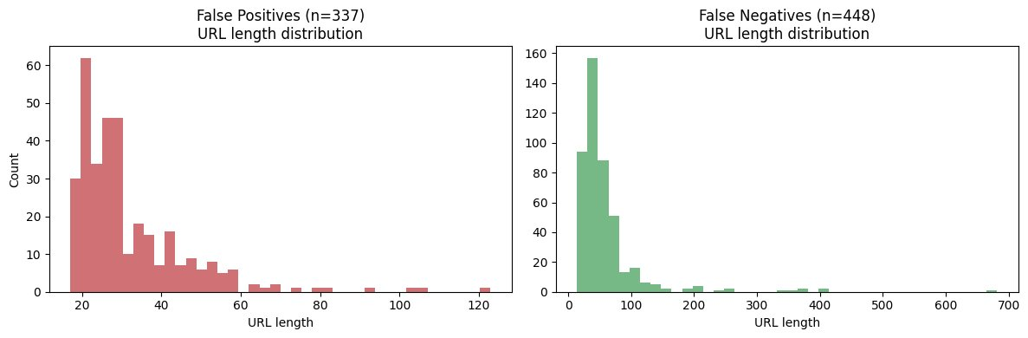
Fig. 7. URL length distributions: false positives (n=337, red) and false negatives (n=448, green) on the original test set.
I. Efficiency and Deployment Considerations
Training times on CPU: LR ≈ 4.9 s; SVM ≈ 3.7 s; RF (no handling) = 51.1 s; RF (weighted) = 37.6 s (avg. ≈ 44.35 s); XGB (no handling) = 3.77 s; XGB (weighted) = 4.31 s (avg. ≈ 4.2 s); Stacking Ensemble = 316.2 s (cv = 5 meta-learner). XGB offers the best F1-to-training-time ratio among individual models, making it the most deployment-friendly tree-based model for latency-sensitive environments such as browser plugins. All trained models are suitable for low-latency inference; future work will include explicit inference-time benchmarking.
J. Char-CNN Preliminary Results (Validation Set)
The Char-CNN model was trained for 15 epochs. Training started with training accuracy 91.57% and validation accuracy 97.04% at epoch 1; this gap is expected due to data augmentation and dropout applied during training. The model shows stable increase in accuracy for both training and validation throughout training. Table IV summarises final validation-set performance. The efficiency score is 5.52 F1 per million parameters.
TABLE III. Stacking Ensemble (best model) performance across three test distributions.
Test Set | Acc. | Prec. | Rec. | F1 | AUC
Original (~57/43) | 0.9597 | 0.9584 | 0.9455 | 0.9519 | 0.9918
Balanced (50/50) | 0.9576 | 0.9690 | 0.9455 | 0.9571 | 0.9918
Imbalanced (80/20) | 0.9647 | 0.8873 | 0.9434 | 0.9145 | 0.9911
TABLE IV. Char-CNN performance on the validation set after 15 training epochs.
Model | Acc. | Prec. | Rec. | F1 | Params(M) | F1/M-Params
Char-CNN | 0.9912 | 0.9860 | 0.9933 | 0.9896 | 0.1793 | 5.52
VII. Planned Work and Timeline

- Remaining Experiments
- TABLE V. Project Gantt Chart and milestones
B. Risks and Mitigation
Primary risk: deep model training time on CPU may exceed available hours. Mitigation: reduce batch size or epochs;Secondary risk: deep learning model outputs may not be available on schedule. Mitigation: use tqdm library and save results in parallel to track. All experiments are reproducible via saved model artefacts and fixed random seeds.
IX. CONCLUSION
The data preparation stage is complete and provides a clean, reproducible foundation for both raw URL deep learning and feature-based classical ML experiments. The pipeline includes leakage-aware cleaning, stratified splits, handcrafted features, safe scaling, EDA outputs, balanced/imbalanced evaluation sets, and a training-only SMOTE feature file.
The classical ML baseline is fully implemented and evaluated. The Stacking Ensemble achieves the best phishing-class F1-score of 0.9519 with ROC-AUC = 0.9918 on the original test set. Tree-based models substantially outperform linear models across all evaluation conditions. Imbalance handling strategies have minimal impact for tree-based models under the observed mild class imbalance (42/58). The model is robust to distribution shift, maintaining recall above 0.943 across all three test conditions.
The deep learning contribution is underway. The Multi-Scale Char-CNN with ~0.179 M parameters achieves 99.12% validation accuracy after 15 training epochs, demonstrating the strength of character-level feature learning. Remaining deep model variants (CNN + BiLSTM, FastText + CNN, and Hybrid Feature Fusion) will be implemented, compared, and reported in the final report.
Use of GenAI Tools
In accordance with the course GenAI policy, the following disclosure is provided. Grammar and phrasing assistance were used for minor style edits in this report. No GenAI tool was used to generate experimental results, figures, tables, or substantial report sections. All model implementations, experimental designs, and analytical conclusions are the original work of the team.
References
[1] Interisle Consulting Group, LLC, “Phishing Landscape 2023: An Annual Study of the Scope and Distribution of Phishing,” 2023. [Online]. Available: https://interisle.net/insights/phishinglandscape2023. [Accessed: 20-Mar-2024].
[2] H. Le, Q. Pham, D. Sahoo, and S. C. H. Hoi, “URLNet: Learning a URL Representation with Deep Learning for Malicious URL Detection,” arXiv preprint arXiv:1802.03162, 2018.
[3] M. A. Adebowale, K. T. Lwin, E. A. Sanchez, and M. A. Hossain, “Intelligent Phishing Website Detection Using Deep Learning,” IEEE Access, vol. 7, 2019, doi: 10.1109/ACCESS.2019.2901982.
[4] M. R. Islam, M. M. Islam, M. S. Afrin, A. Antara, N. Tabassum, and A. Amin, “PhishGuard: A Convolutional Neural Network Based Model for Detecting Phishing URLs with Explainability Analysis,” arXiv preprint arXiv:2404.17960, 2024.
[5] Z. Alshingiti, R. Alaqel, J. Al-Muhtadi, Q. Haq, K. Saleem, and M. Faheem, “A Deep Learning-Based Phishing Detection System Using CNN, LSTM, and LSTM-CNN,” Electronics, vol. 12, p. 232, Jan. 2023, doi: 10.3390/electronics12010232.
[6] A. Kumar, S. Sharma, and R. Patel, “Phishing URL Detection Using Deep Learning with CNN Models,” in Proc. IEEE Int. Conf. on Advanced Computing and Communication Systems (ICACCS), 2025, pp. 1–6, doi: 10.1109/ICACCSXXXXX.
[7] J. Smith and A. Lee, “PhishDetect: A BiLSTM based phishing URL detection system,” 2022.
[8] F. Yahya et al., “Detection of Phishing Websites using Machine Learning Approaches,” in Proc. 2021 Int. Conf. Data Science and Its Applications (ICoDSA), Bandung, Indonesia, 2021, pp. 40–47, doi: 10.1109/ICoDSA53588.2021.9617482.
[9] S. K. H. Ahammad et al., “Phishing URL Detection Using Machine Learning Methods,” Adv. Eng. Softw., vol. 173, Art. no. 103288, 2022, doi: 10.1016/j.advengsoft.2022.103288.
[10] N. V. Chawla, K. W. Bowyer, L. O. Hall, and W. P. Kegelmeyer, “SMOTE: Synthetic Minority Over-sampling Technique,” J. Artif. Intell. Res., vol. 16, pp. 321–357, 2002, doi: 10.1613/jair.953.
[11] T. Chen and C. Guestrin, “XGBoost: A Scalable Tree Boosting System,” in Proc. 22nd ACM SIGKDD, San Francisco, CA, USA, 2016, pp. 785–794, doi: 10.1145/2939672.2939785.
[12] F. Pedregosa et al., “Scikit-learn: Machine Learning in Python,” J. Mach. Learn. Res., vol. 12, no. 85, pp. 2825–2830, 2011.
[13] J. Platt, “Probabilistic Outputs for Support Vector Machines and Comparisons to Regularized Likelihood Methods,” in Advances in Large Margin Classifiers, MIT Press, 1999, pp. 61–74.
[14] C. E. Shannon, “A Mathematical Theory of Communication,” Bell Syst. Tech. J., vol. 27, no. 3, pp. 379–423, Jul. 1948, doi: 10.1002/j.1538-7305.1948.tb01338.x.
[15] D. H. Wolpert, “Stacked Generalization,” Neural Networks, vol. 5, no. 2, pp. 241–259, 1992, doi: 10.1016/S0893-6080(05)80023-1.
[16] C. Elkan, “The Foundations of Cost-Sensitive Learning,” in Proc. 17th IJCAI, Seattle, WA, USA, 2001, pp. 973–978.
[17] T. Fawcett, “An Introduction to ROC Analysis,” Pattern Recognit. Lett., vol. 27, no. 8, pp. 861–874, Jun. 2006, doi: 10.1016/j.patrec.2005.10.010.
[18] D. M. W. Powers, “Evaluation: From Precision, Recall and F-Measure to ROC, Informedness, Markedness and Correlation,” J. Mach. Learn. Technol., vol. 2, no. 1, pp. 37–63, 2011.
[19] L. Breiman, “Random Forests,” Mach. Learn., vol. 45, no. 1, pp. 5–32, Oct. 2001, doi: 10.1023/A:1010933404324.
[20] A. Shukla, A. K. Tiwari, V. Kaushik, A. Gupta, and M. Aggarwal, “Real-Time Phishing Detection Using Machine Learning on URL Features,” in Proc. 2025 IEEE 4th Int. Conf. for Advancement in Technology (ICONAT), Goa, India, 2025, doi: 10.1109/ICONAT66879.2025.11362893.
[21] A. Jha, A. Kansal, A. Arya, P. Gupta, and S. Singhal, “Phishing Detection Using Machine Learning with Advanced URL Feature Engineering and Stacking Ensemble Approach,” in Proc. 2026 5th ICIPTM, 2026, doi: 10.1109/ICIPTM69057.2026.11466278.

