**IFB299 – Application Design and Development**

Zaine Ashe Portfolio 09469010

Unit: IFB299 - Project Design and Development

Group 114

Tutor: Ahmed Shoeb Talukder

Tutorial: 6pm Thursday

Version: 1.2

Date 27/10/2017

Contents

Artefact 1 – Release 1 Burndown Chart 3

Artefact 2 – Page Implementation 6

Artefact 3 – Data Creation Testing 13

Artefact 4 – Page implementation 16

Artefact 5 – Data Creation Testing 18

Links index:

Artefact 1 Release 1 burndown chart:

<https://bitbucket.org/leexsen/ifb299/src/56ce7221856cf27c2616d4facafdd9ab7e11353d/n9469010/Sprint_2/Artefact_1_Release_1_burndown_chart/?at=master>

Artefact 2 Page Implementation:

<https://bitbucket.org/leexsen/ifb299/src/56ce7221856cf27c2616d4facafdd9ab7e11353d/n9469010/Sprint_2/Artefact_2_Page_Implementation/?at=master>

Artefact 3 Data Creation Testing:

<https://bitbucket.org/leexsen/ifb299/src/56ce7221856cf27c2616d4facafdd9ab7e11353d/n9469010/Sprint_2/Artefact_3_Data_Creation_Testing/?at=master>

Artefact 4 Manual Tests:

<https://bitbucket.org/leexsen/ifb299/src/56ce7221856cf27c2616d4facafdd9ab7e11353d/n9469010/Sprint_2/Artefact_4_Manual_Tests/?at=master>

Artefact 5 Automated Tests:

<https://bitbucket.org/leexsen/ifb299/src/56ce7221856cf27c2616d4facafdd9ab7e11353d/n9469010/Sprint_2/Artefact_5_Automated_Tests/?at=master>

# Artefact 1 – Release 1 Burndown Chart

Bitbucket link (n9469010/Sprint_2/Artefact_1_Release_1_burndown_chart): <https://bitbucket.org/leexsen/ifb299/src/56ce7221856cf27c2616d4facafdd9ab7e11353d/n9469010/Sprint_2/Artefact_1_Release_1_burndown_chart/?at=master>

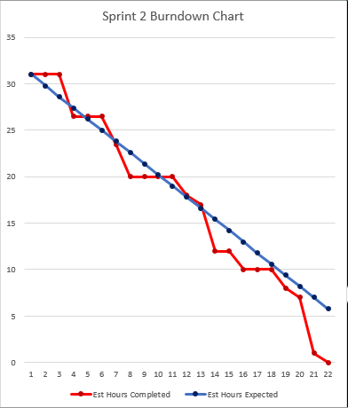

*Figure 1:*

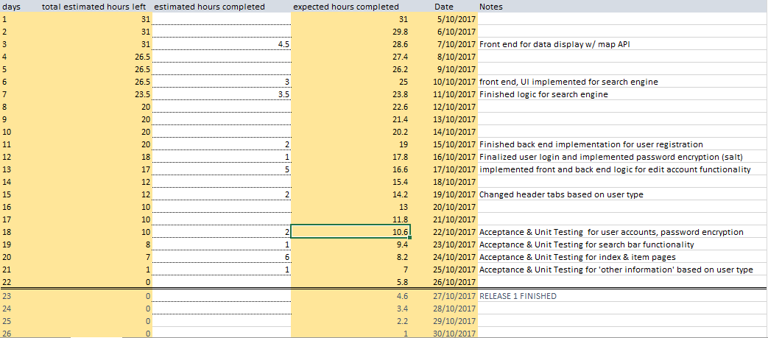

*Figure 2:*

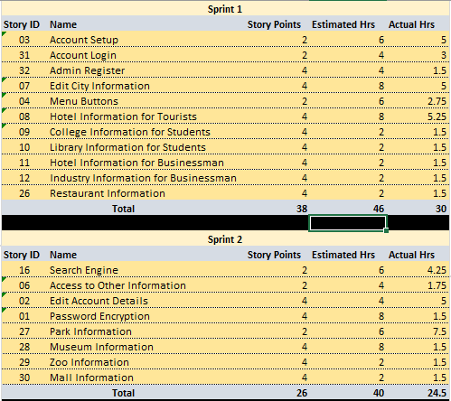

*Figure 4:*

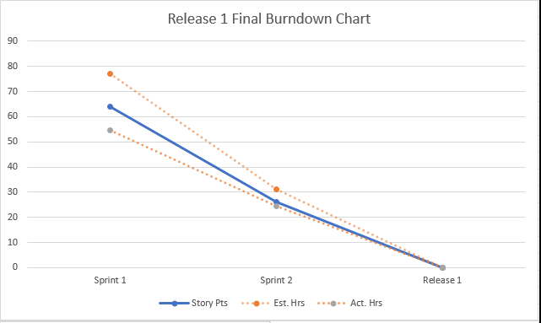

*Figure 3:*

Artifact 1 Writeup

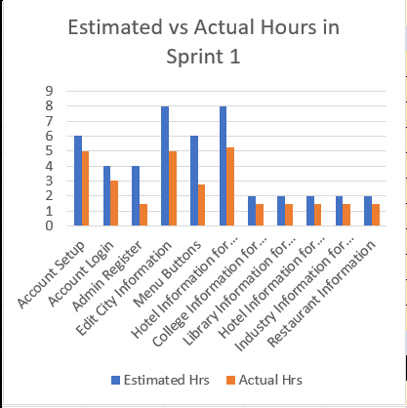

*Figure 5:*

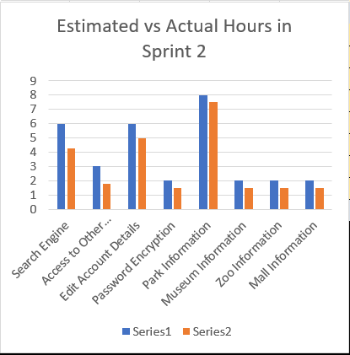

*Figure 6:*

# Artefact 2 – Page Implementation

Bitbucket link (n9469010/Sprint_2/Artefact_2_Page_Implementation): <https://bitbucket.org/leexsen/ifb299/src/56ce7221856cf27c2616d4facafdd9ab7e11353d/n9469010/Sprint_2/Artefact_2_Page_Implementation/?at=master>

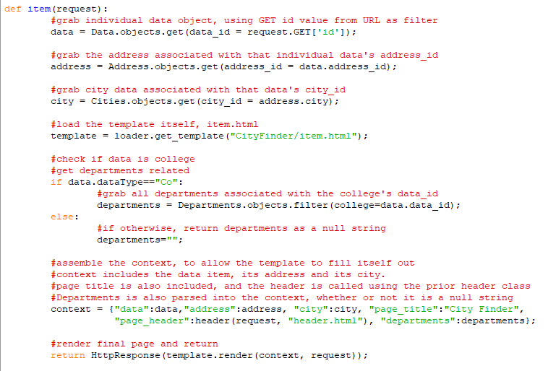

*Figure 8:*

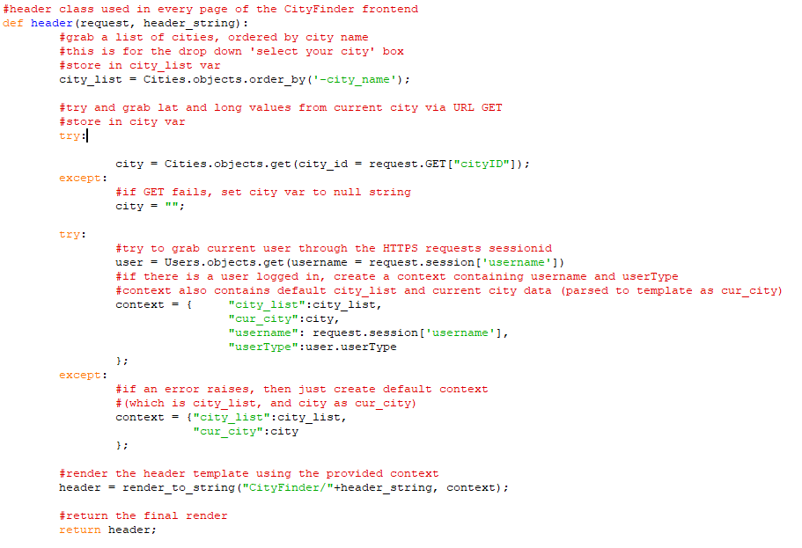

*Figure 7:*

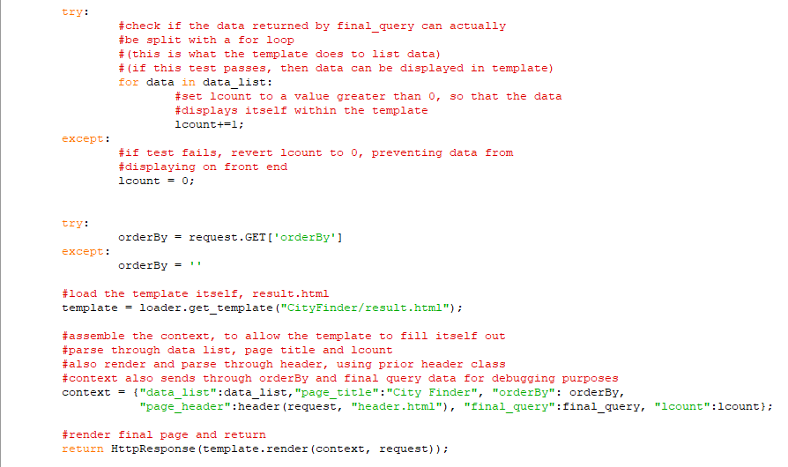

*Figure 10:*

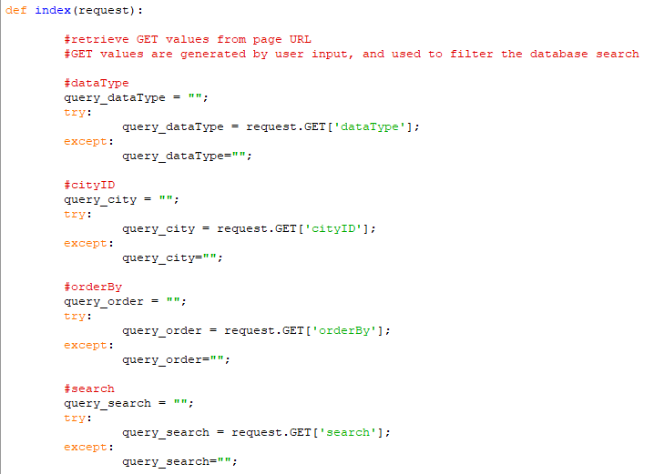

*Figure 9:*

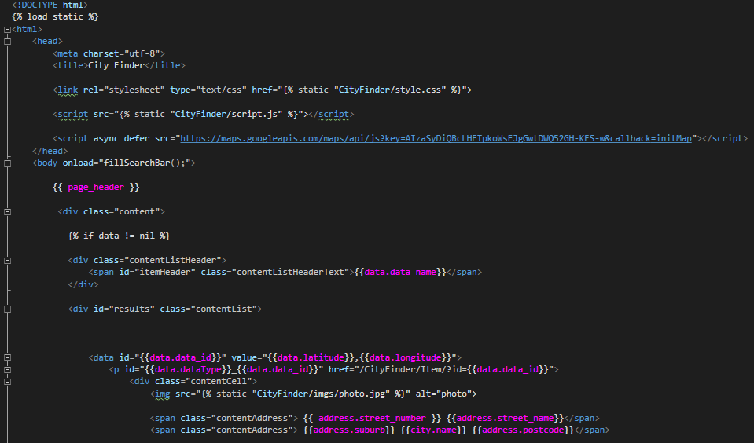

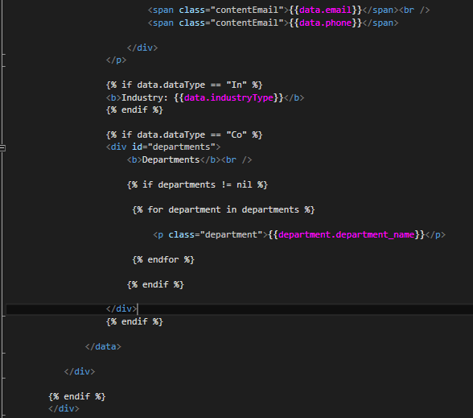

*Figure 11:*

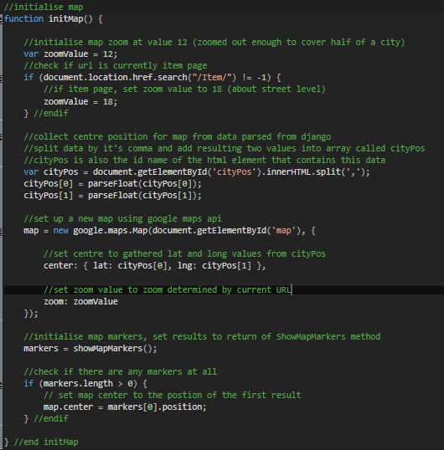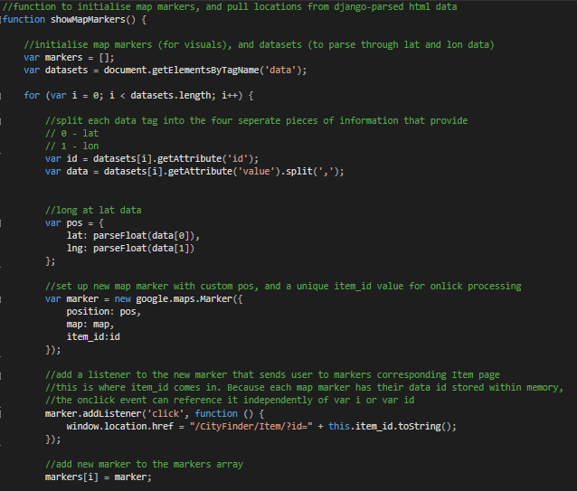

*Figure 12:*

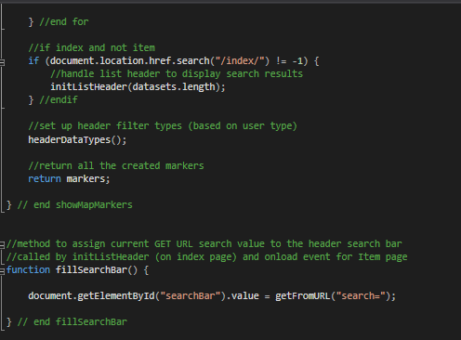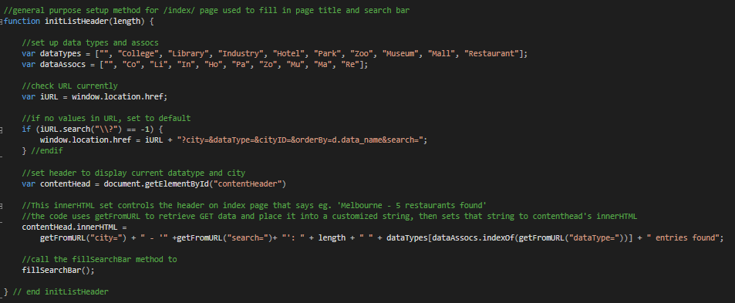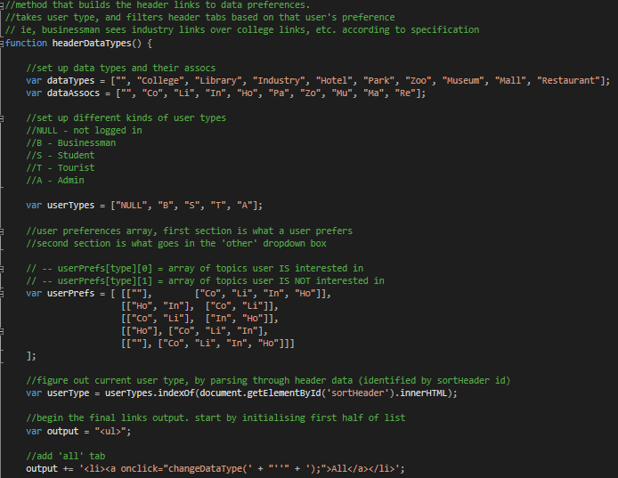

*Figure 13:*

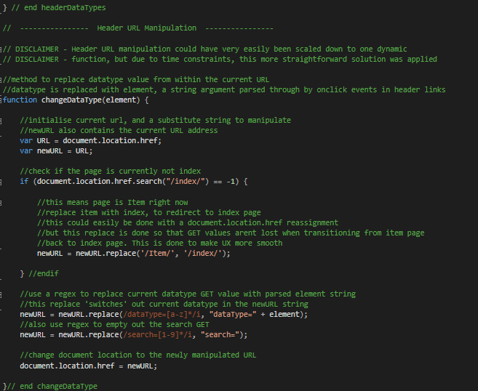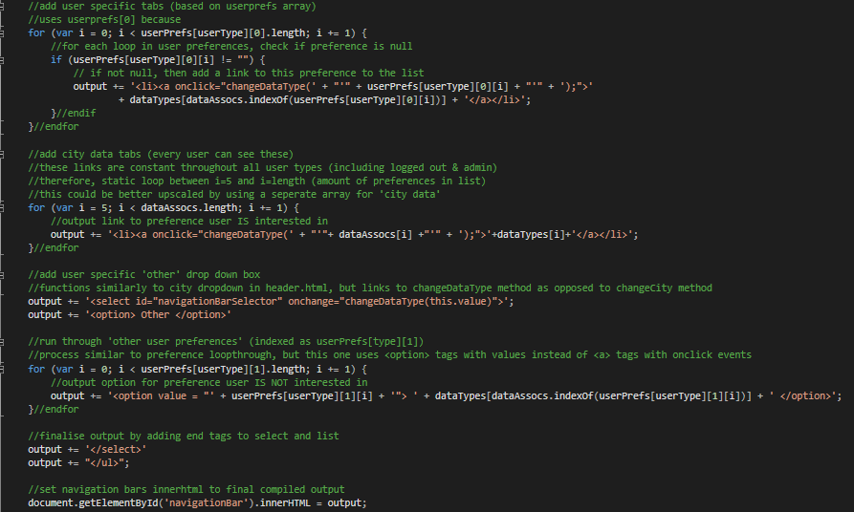

*Figure 14:*

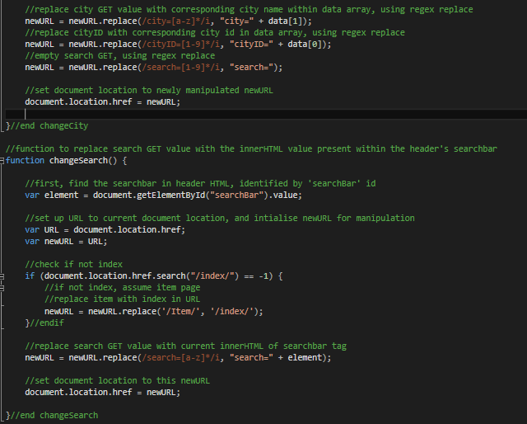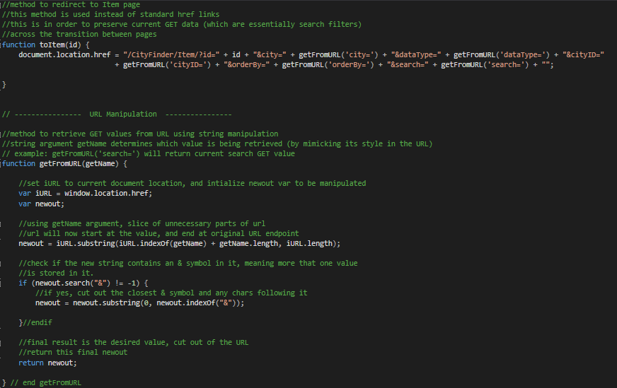

*Figure 15:*

Artifact 2 Writeup

# Artefact 3 – Data Creation Testing

Bitbucket link (n9469010/Sprint_2/Artefact_3_Data_Creation_Testing): <https://bitbucket.org/leexsen/ifb299/src/56ce7221856cf27c2616d4facafdd9ab7e11353d/n9469010/Sprint_2/Artefact_3_Data_Creation_Testing/?at=master>

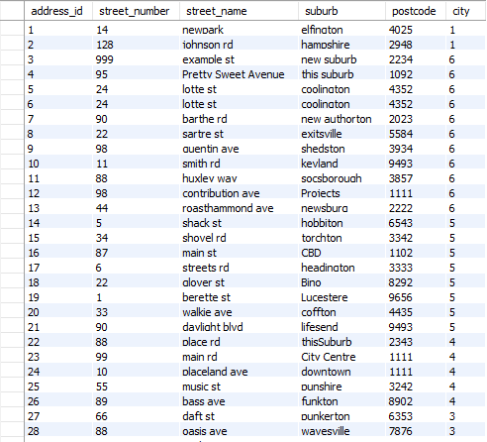

*:Figure 17*

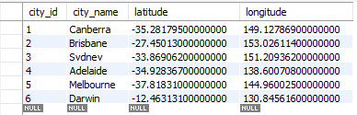

*Figure 16*

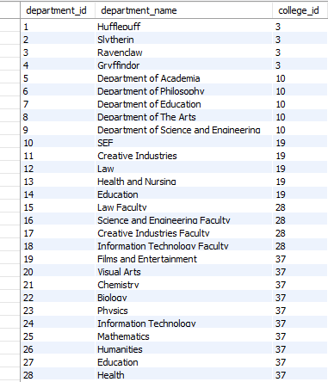

*:Figure 19*

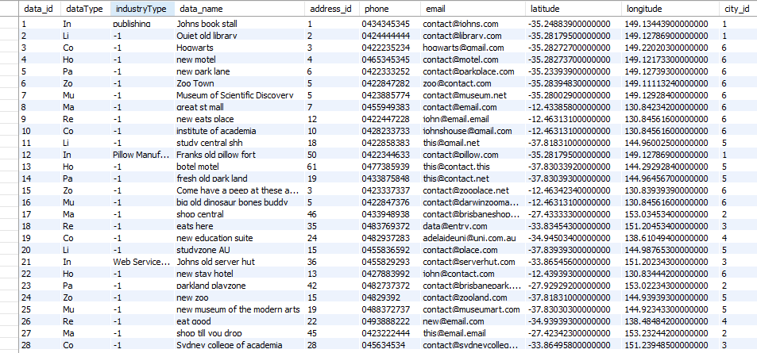

*:Figure 18*

Artifact 3 Writeup

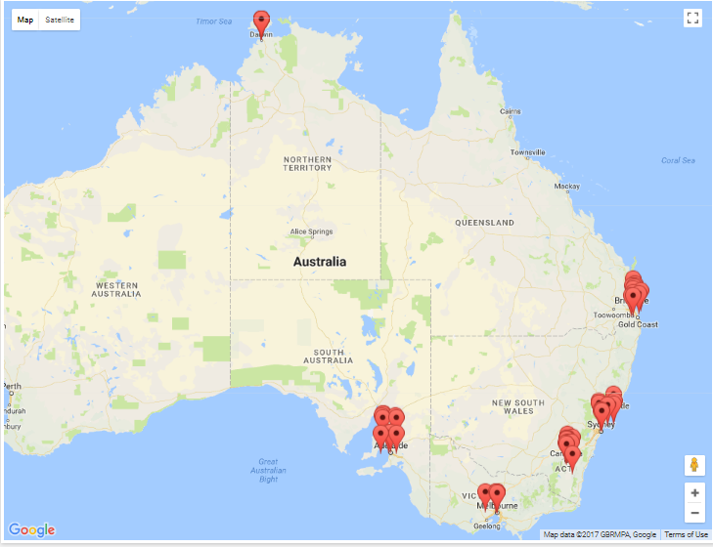

*Figure 21:*

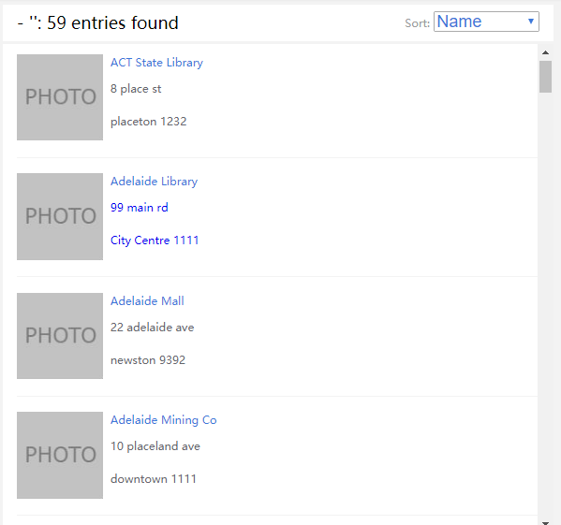

*Figure 20:*

# Artefact 4 – Page implementation

Bitbucket link (n9469010/Sprint_2/Artefact_4_Manual_Tests): <https://bitbucket.org/leexsen/ifb299/src/56ce7221856cf27c2616d4facafdd9ab7e11353d/n9469010/Sprint_2/Artefact_4_Manual_Tests/?at=master>

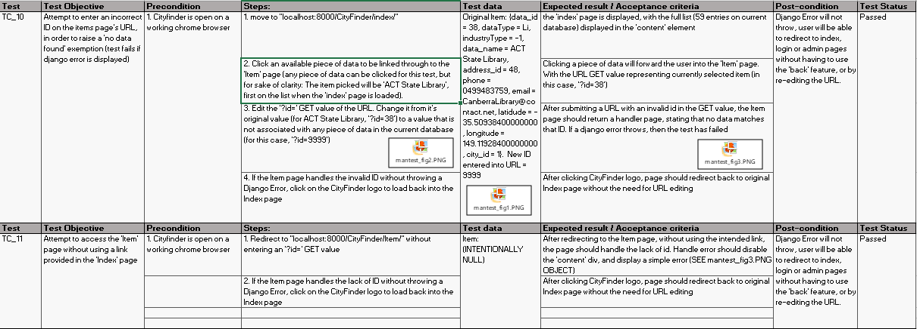

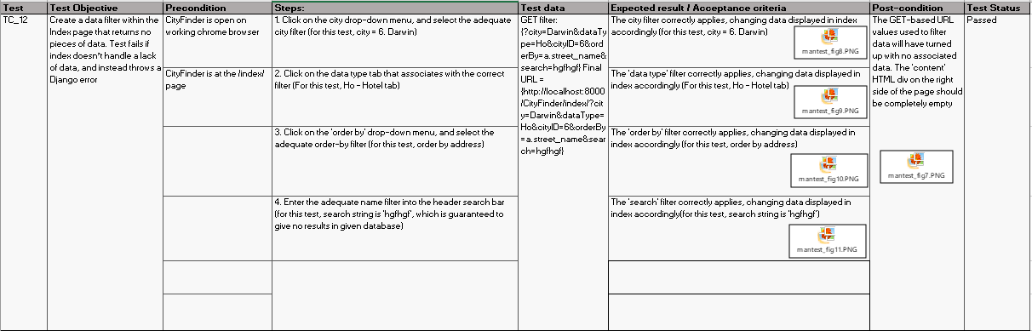

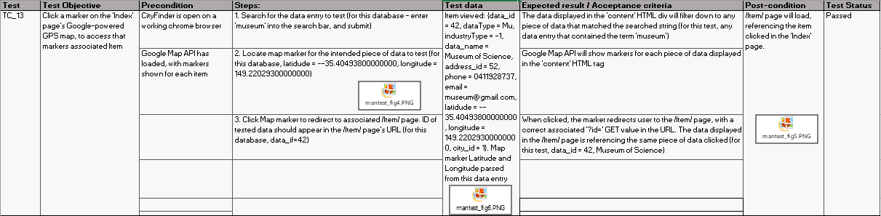

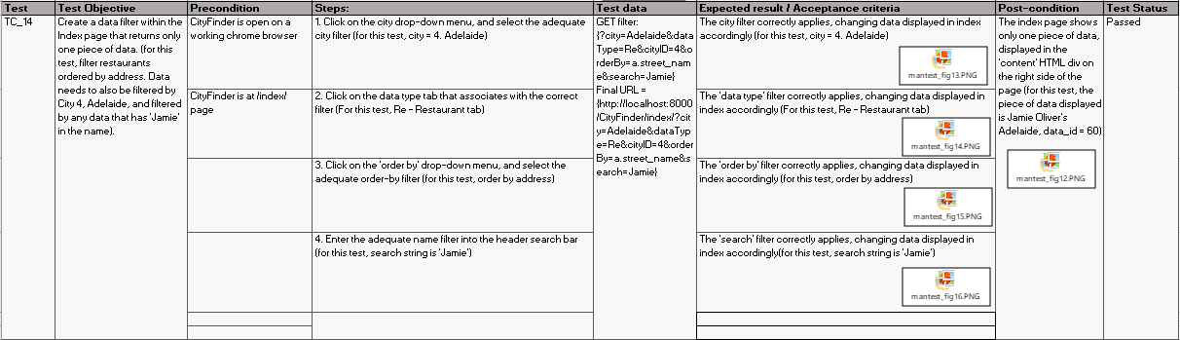

*Figure 22:*

Artifact 4 Writeup

# Artefact 5 – Data Creation Testing

Bitbucket link (n9469010/Sprint_2/Artefact_5_Automated_Tests): <https://bitbucket.org/leexsen/ifb299/src/56ce7221856cf27c2616d4facafdd9ab7e11353d/n9469010/Sprint_2/Artefact_5_Automated_Tests/?at=master>

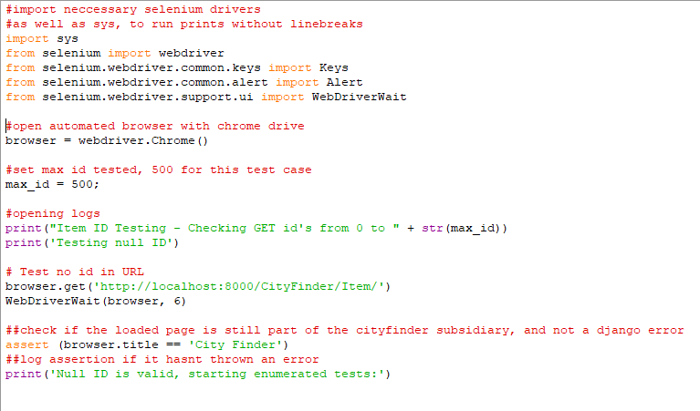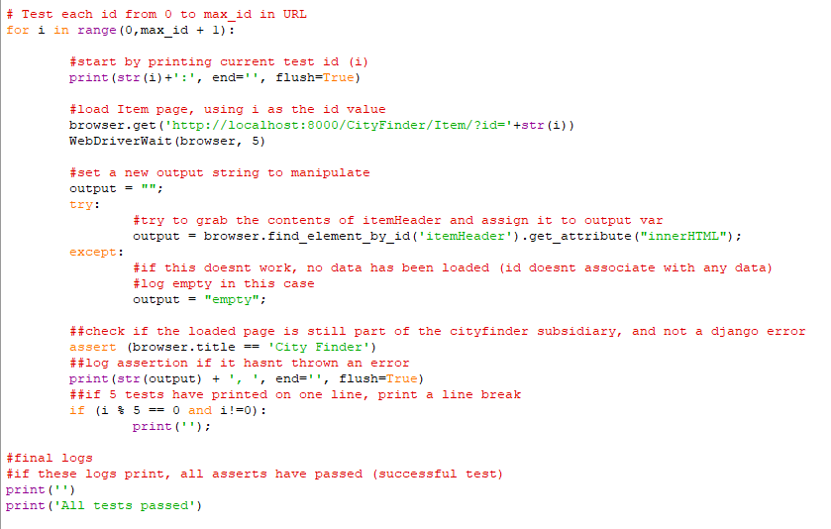

*Figure 23:*

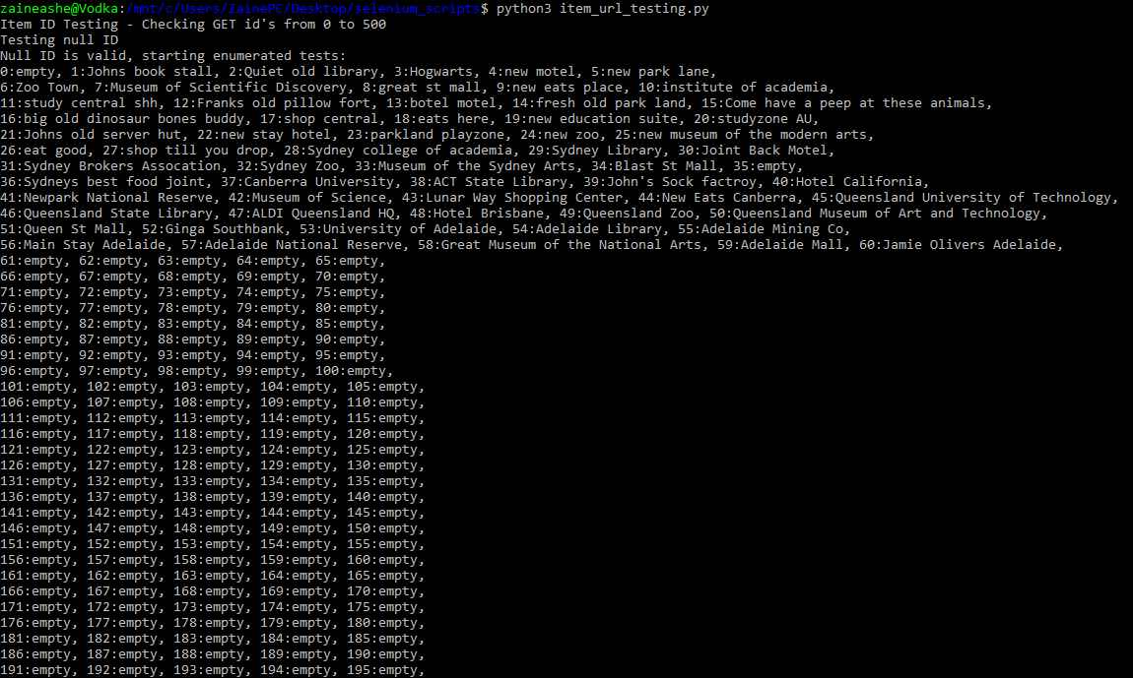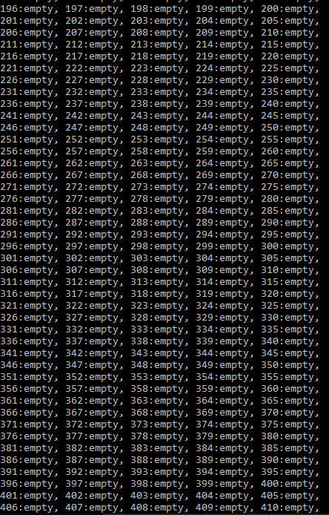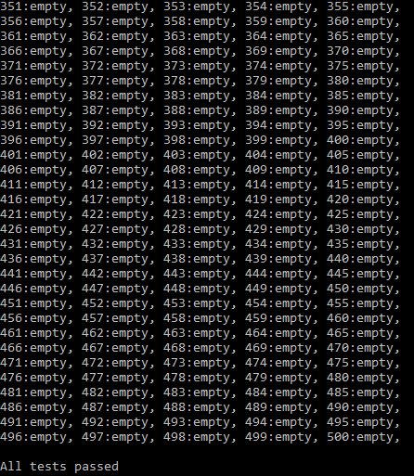

*Figure 24:*

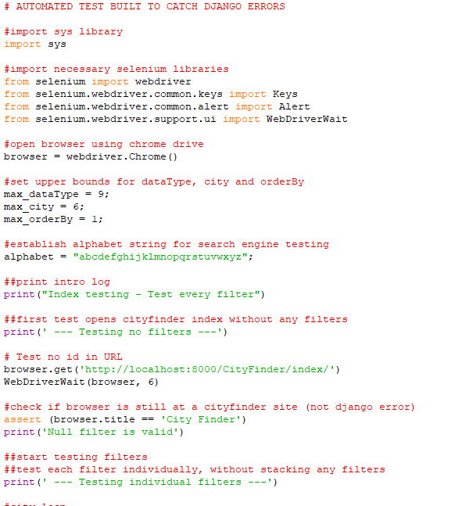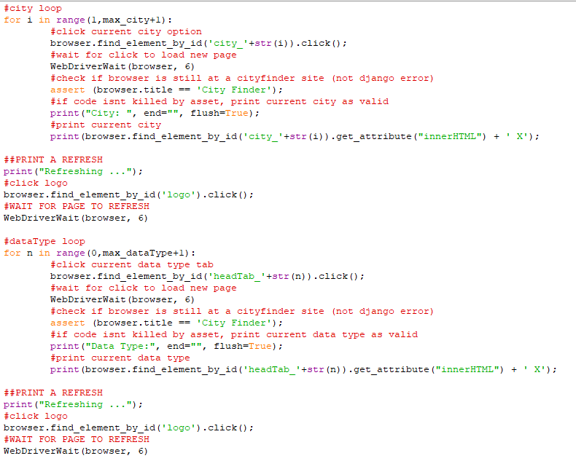

*Figure 25:*

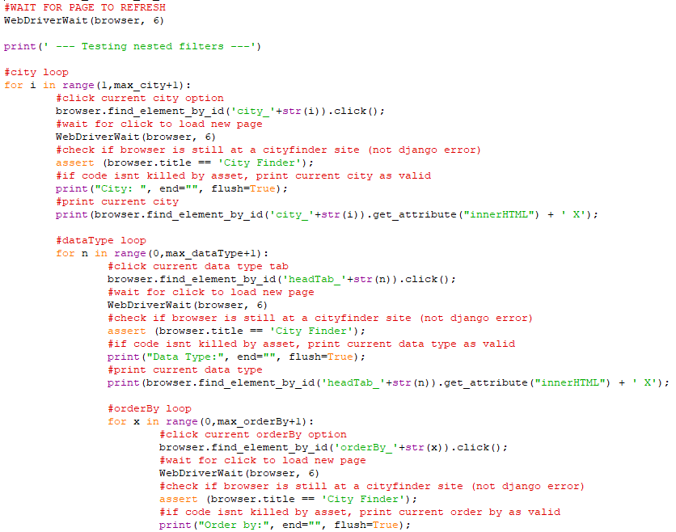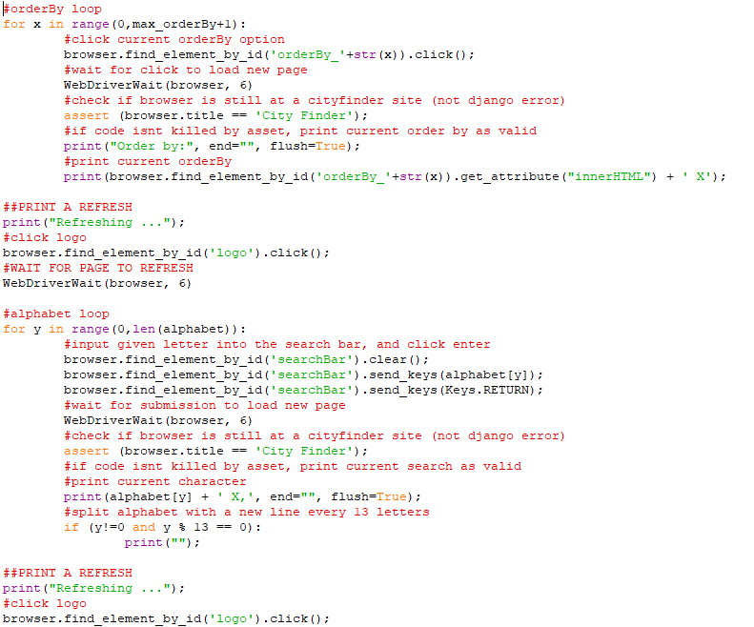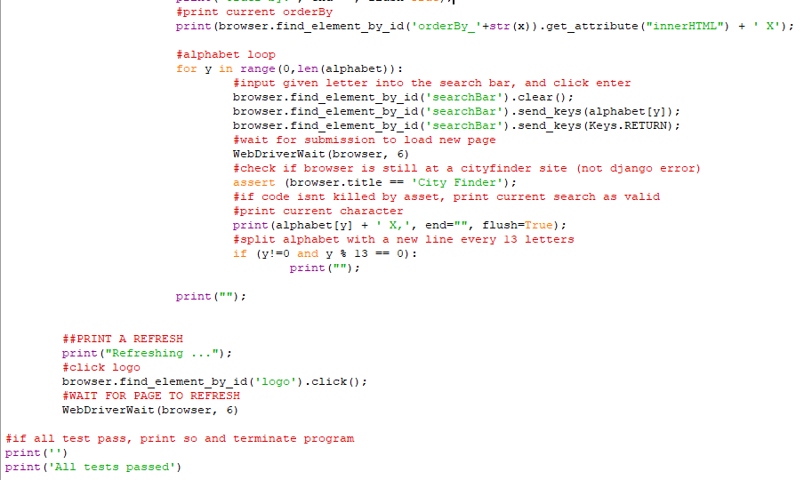

*Figure 26:*

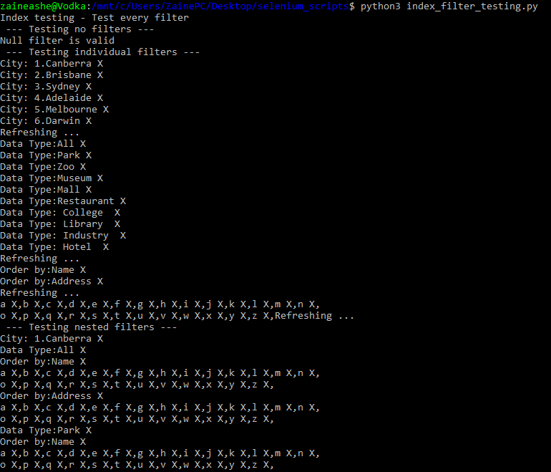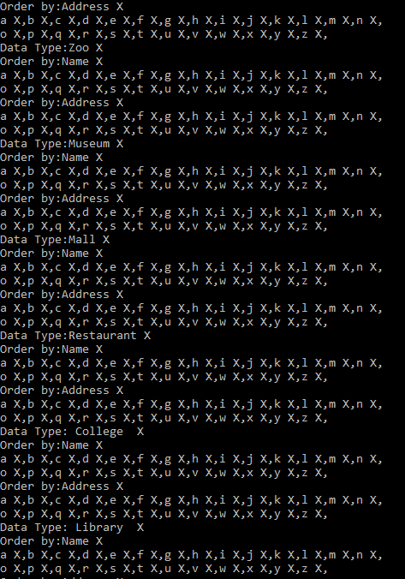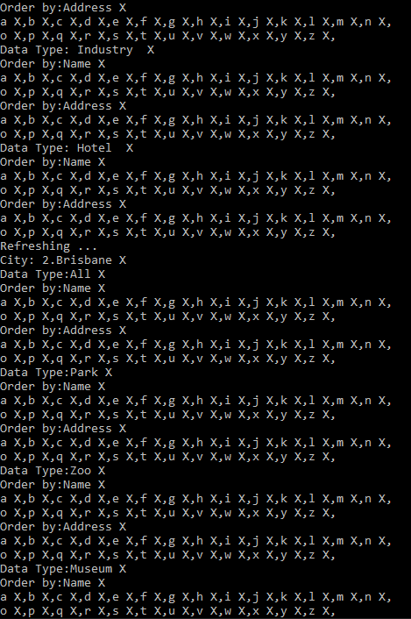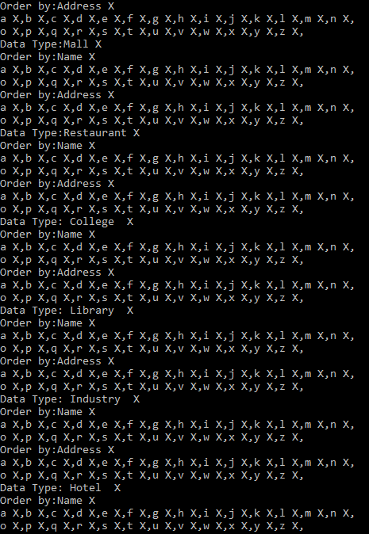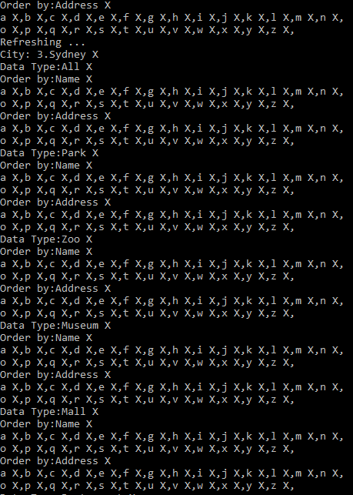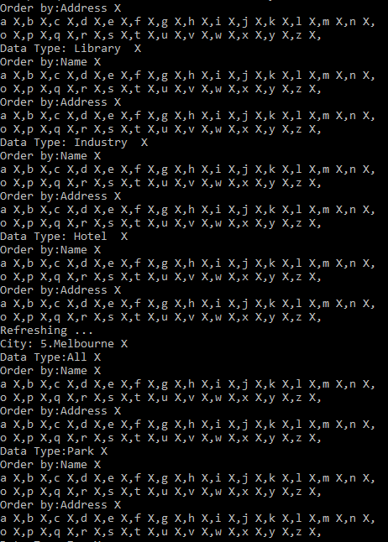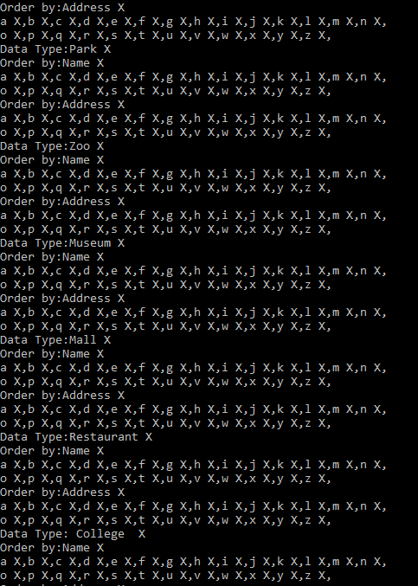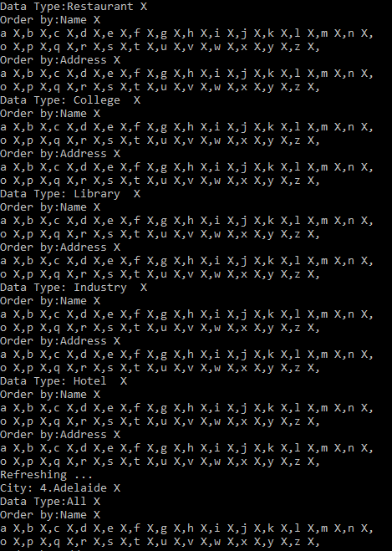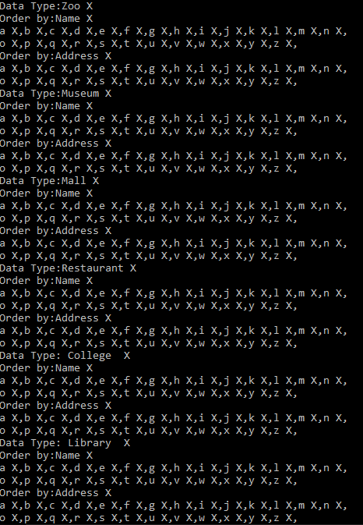

*Figure 27:*

Artifact 4 Writeup