Table of Contents
Executive Summary 1
Overview 1
Data exploration and Findings 1
Feature Selection 1
Data Modeling 1
Model Building 1

Executive Summary

Overview

Data exploration and Findings

Data Exploration
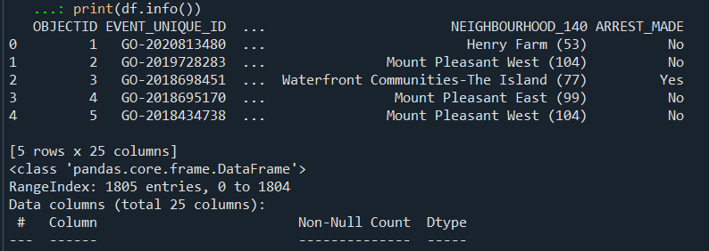

Our dataset has 25 columns and 1805 rows

Missing Values
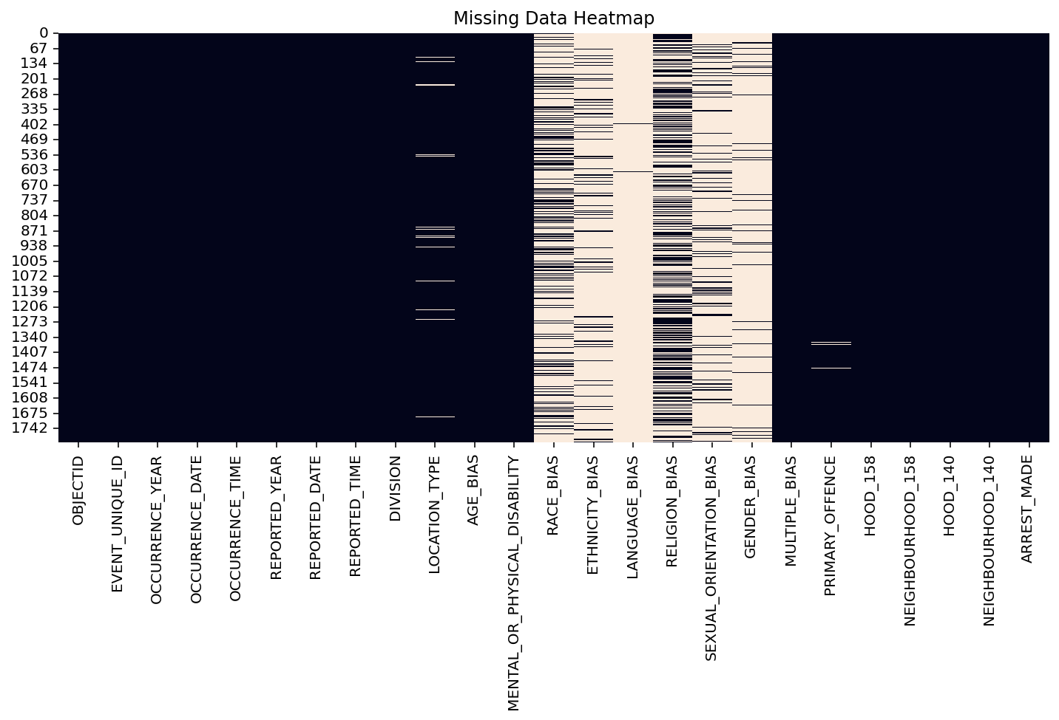
Values are heavily missing in RACE_BIAS, ETHINICITY_BIAS, LANGUAGE_BIAS, SEXUAL_BIAS, GENDER_BIAS (80% -> 90% missing)
- We handle it by removing these columns as our model wont give the accurate patterns and results.

Target variable distribution (Arrest Made column)
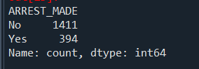
From here we see that out of 1805 rows, 1411 cases were Un-arrested (78%) and 394 cases were Arrested (22%)
- The dataset is imbalanced
- It means that the model might lean towards the un-arrested chance
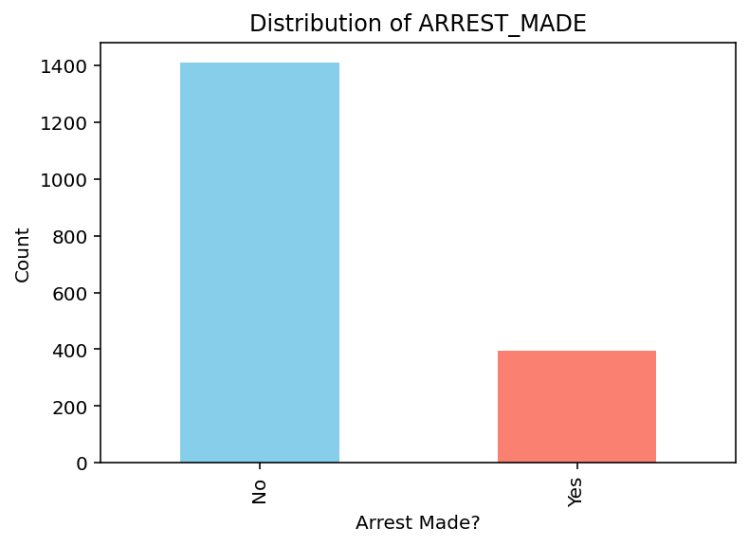

To avoid biased predictions, imbalance-handling techniques we choose will be class weighting or SMOTE oversampling.

Summary Statistics
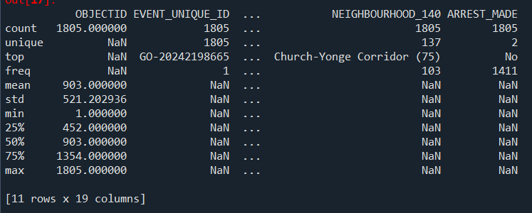
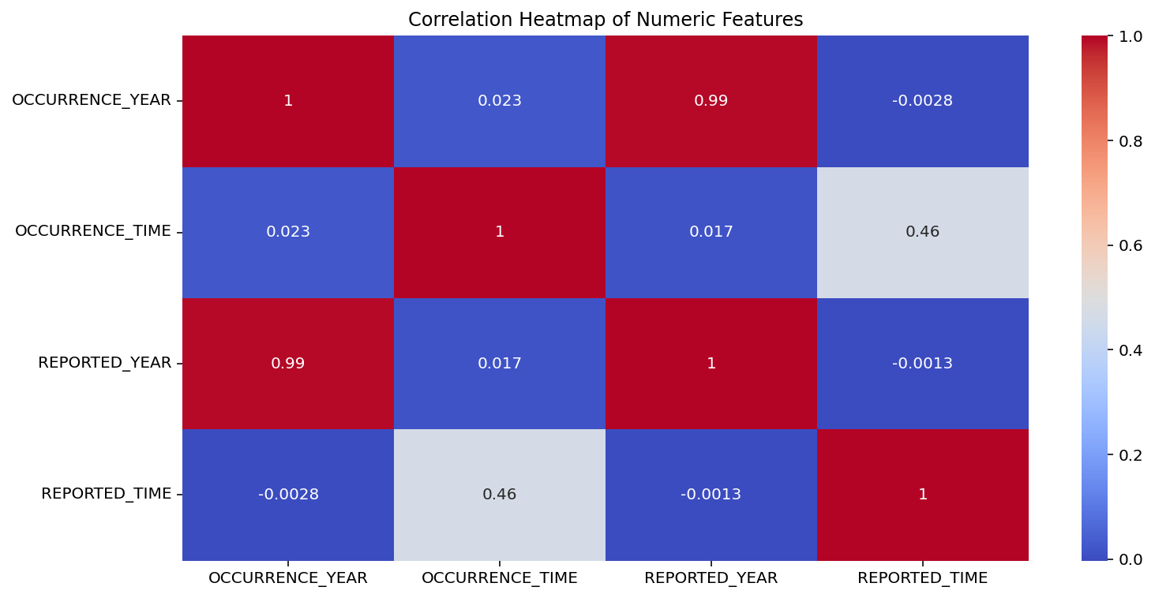
- Very strong correlation between occurred year and reported_year, meaning the incident was reported at the same time, therefore using 2 columns will be duplicated so we will only use Occurrence_year

Data cleaning
- Drop: OBJECTID, REPORTED_YEAR, 'RACE_BIAS', 'ETHNICITY_BIAS', 'LANGUAGE_BIAS', 'SEXUAL_ORIENTATION_BIAS', 'GENDER_BIAS' columns
- Replace missing values with “Unknow”

Feature Selection
We chose PRIMARY_OFFENCE, LOCATION_TYPE, NEIGHBOURHOOD_158, RELIGION_BIAS, Police division as the data is relevant to what we will explore
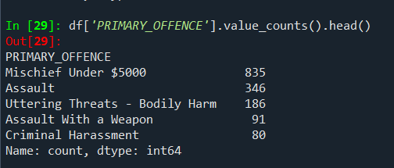
- It shows that the most frequently reported is Mischief Under $5000 with 833 occurrences, followed by “Assault” (346 cases), indicating that most hate-related incidents involve property damage, threats or violent confrontations
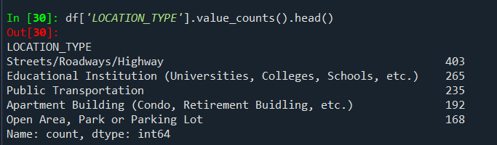
Most incidents happened in the public and followed by Education environment
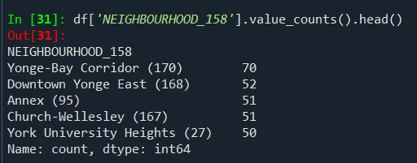
- Downtown and Yonge-bay corridor is where incidents happened the most
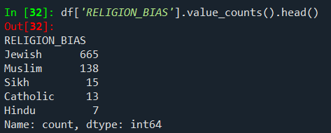
Also these incidents mostly impacted Jewish and Muslim
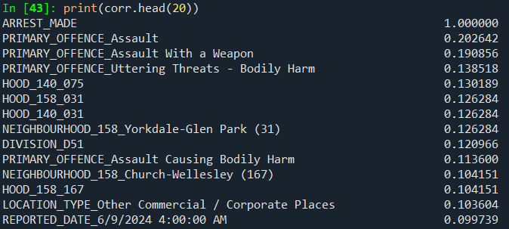
- And Also Police Division (0,1209)
- Different precincts have different arrest patterns.

Data Modeling
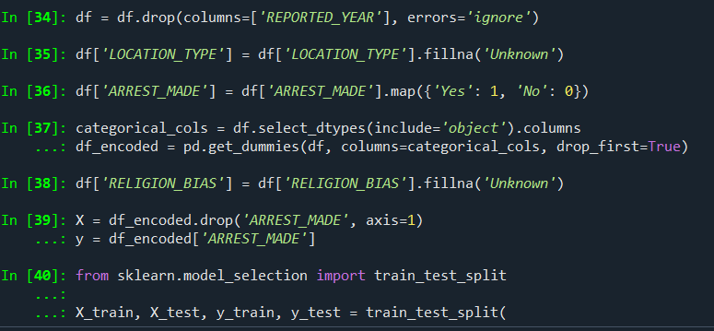
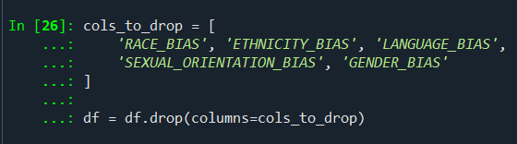

Model Building

