Consumer Preferences in the Used Vehicle Market: Willingness to Pay for Powertrain Type, Driving Range, Vehicle Condition, and Operating Cost
Zain Hoda¹, Xiatian Iogansen¹,², Christina Gore²*, Joshua D. Kneifel², Sindhu Ranganath¹,², John Helveston¹
¹ Department of Engineering Management and Systems Engineering, George Washington University, Washington D.C., USA ² Applied Economics Office, Engineering Laboratory, National Institute of Standards and Technology, USA * Corresponding author
Keywords: Battery electric vehicle; Used vehicle market; Discrete choice experiment; Willingness to pay; Mixed logit; Consumer preferences

Background and Objective
Used vehicles account for roughly 70% of U.S. vehicle transactions, yet most alternative fuel vehicle (AFV) research focuses on new-vehicle buyers. This study estimates willingness to pay (WTP) for powertrain type and other attributes among prospective U.S. used-vehicle buyers and compares WTP with real-market used-vehicle prices.

Data and Methods
An online survey (Dynata and Prolific, December 2025 – April 2026) of U.S. adults planning to buy a used car or SUV within two years yielded 2,254 respondents. Each completed six discrete choice tasks varying powertrain (conventional, gas hybrid [HEV], battery electric [BEV]), price, operating cost, BEV range, model year, and mileage. Six mixed logit models (by car/SUV segment and budget tier) were estimated in WTP space, and simulated net WTP was compared with real-market price premiums for matched used-vehicle pairs.

Results
Preference heterogeneity. Mean BEV utility is negative and highly significant in all models (−$10.4k to −$26.1k), with large standard deviations indicating within-segment polarization. HEVs carry a significant premium only among high-budget buyers (about $4,200 for cars, $2,300 for SUVs).
WTP for vehicle attributes (Figure 1). The BEV penalty narrows sharply with range, from about −$8,200 to −$18,800 at 100 miles to −$2,600 to −$11,700 at 300 miles, depending on segment and budget. Only high-budget car buyers considering a 300-mile BEV are statistically indistinguishable from the conventional baseline. Mileage, age, and operating cost are penalized in every subgroup, mileage most heavily (about $1,000–$3,800 per 10,000 miles).
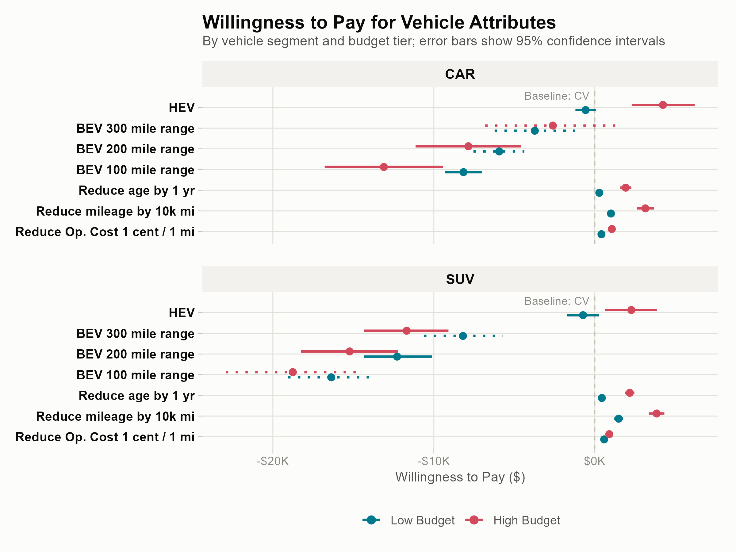
Figure 1. WTP for vehicle attributes by segment and budget tier (95% confidence intervals; thousands of dollars). Solid BEV range intervals fall within the range shown to that segment; dotted intervals are extrapolated.
Model WTP versus real-market prices. Observed used-BEV premiums exceed the WTP-implied parity requirement in every matched pair, by about $6,100 for the high-budget car and $15,700 (car) and $16,900 (SUV) for the lower-budget pairs. HEV results are mixed: the high-budget car HEV appears underpriced, while the high-budget SUV HEV is priced above its WTP-implied premium.

Implications
- Incentive size. The former $4,000 used clean vehicle credit covers only the gap for high-budget car buyers considering longer-range BEVs; other segments would need roughly $8,000–$19,000.
- Targeting. Its $25,000 price cap excludes most 250–300-mile used BEVs, the configuration nearest parity.
- Non-price instruments. Battery health disclosure, certification, and transferable warranties could address age-related uncertainty at lower fiscal cost.
- Hybrids. HEVs already carry a positive WTP premium among high-budget buyers.
Overall, the results support segment-aware policy rather than a single instrument.

Limitations
Results rely on stated preferences from an online panel, and the real-market comparison uses few matched pairs at a single vehicle age. Future work could add a PHEV level, estimate latent-class models, and validate against revealed data.

