UNIVERSITY OF ENGINEERING AND TECHNOLOGY, LAHORE
OBJECT ORIENTED PROGRAMMING
WEEK 6 LAB
Lab Title: Composition & Aggregation
Submitted By
Name: Zainab Sohail
Roll No.: 76
Submitted To: Hafiz Muhammad Mubashar Imran

WEEK 6 OOP LAB
Composition, Association and Aggregation
Course: Object Oriented Programming (CMPE 221L)
Lab No.: 6
Department: Computer Engineering

Task 1: Digital Timer

Question from the Lab PDF
Write a DigitalTimer class that represents 24-hour time using hours and minutes. Hours must be from 00 through 23, and minutes must be from 00 through 59. Use two Counter objects: one for hours and one for minutes. Provide these constructors and methods:
- public DigitalTimer() — initialize the timer to 00:00.
- public DigitalTimer(int hours, int minutes) — initialize the timer to the given time and check the preconditions.
- public String toString() — print the current time correctly.
- public void tick() — increase the time by one minute, wrapping when needed.
- public void set(int hours, int minutes) — set the time and check the preconditions.

Program 1: Counter.java
public class Counter {
private int count;
private int limit;

public Counter(int limit) {
count = 0;
this.limit = limit;
}

public void set(int value) {
count = value;
}

public void increment() {
count++;

if (count == limit) {
count = 0;
}
}

public int getCount() {
return count;
}

public String toString() {
if (count < 10) {
return "0" + count;
} else {
return "" + count;
}
}
}

Program 2: DigitalTimer.java
public class DigitalTimer {
private Counter hours;
private Counter minutes;

public DigitalTimer() {
hours = new Counter(24);
minutes = new Counter(60);
}

public DigitalTimer(int h, int m) {
if (h < 0 || h > 23 || m < 0 || m > 59) {
throw new IllegalArgumentException("Invalid time");
}

hours = new Counter(24);
minutes = new Counter(60);
hours.set(h);
minutes.set(m);
}

public String toString() {
return hours.toString() + ":" + minutes.toString();
}

public void tick() {
if (minutes.getCount() == 59) {
minutes.set(0);
hours.increment();
} else {
minutes.increment();
}
}

public void set(int h, int m) {
if (h < 0 || h > 23 || m < 0 || m > 59) {
throw new IllegalArgumentException("Invalid time");
}

hours.set(h);
minutes.set(m);
}
}

Program 3: TimerDriver.java
public class TimerDriver {
public static void main(String[] args) {
DigitalTimer t = new DigitalTimer();

System.out.println(t);

t.set(10, 59);
System.out.println(t);

t.tick();
System.out.println(t);

t.set(23, 59);
t.tick();
System.out.println(t);
}
}

Output
The following screenshot is the timer output supplied in the ZIP file.
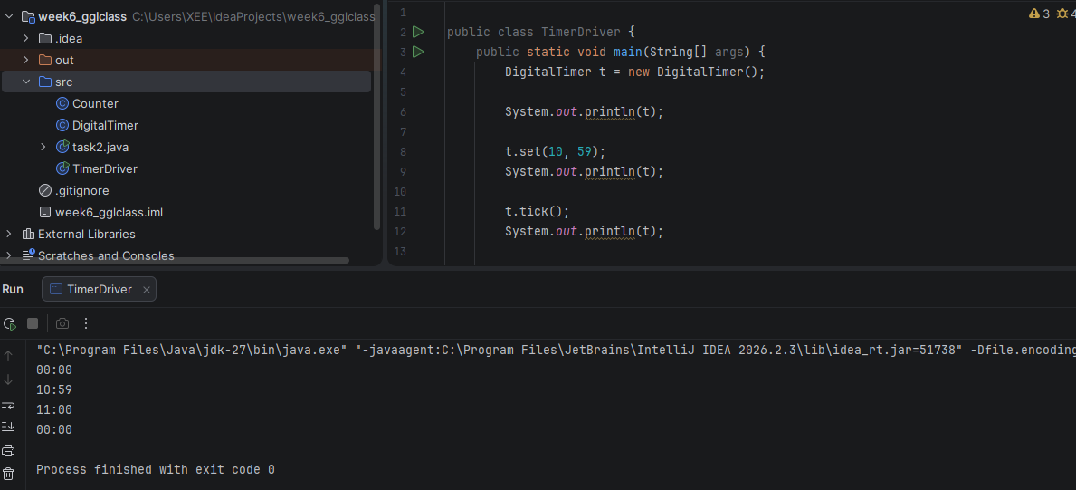
Figure 1: TimerDriver.java and its console output

Task 2: Something Is Brewing

Question from the Lab PDF
Rewrite the earlier walker program using object-oriented programming and association. Ali is an object of DirectedWalker and follows the user's directions. Hassan is an object of RandomWalker and moves randomly. Both walkers must avoid the same obstacles. Simulate both walk patterns at the same time and show their locations.

Program: task2.java
import java.util.Scanner;
import java.util.Random;

class World {
boolean hasHurdle(int x, int y) {
return x == 1 && y == 2;
}
}

class DirectedWalker {
int x = 0;
int y = 0;
World world;

DirectedWalker(World w) {
world = w;
}

void move(char direction) {
int a = x;
int b = y;

if (direction == '^') {
b++;
} else if (direction == 'v') {
b--;
} else if (direction == '>') {
a++;
} else if (direction == '<') {
a--;
}

if (world.hasHurdle(a, b)) {
System.out.println("Ali encounters hurdle at [" + a + ":" + b + "]");
} else {
x = a;
y = b;
}
}
}

class RandomWalker {
int x = 0;
int y = 0;
World world;
Random random = new Random();

RandomWalker(World w) {
world = w;
}

void move() {
int direction = random.nextInt(4);
int a = x;
int b = y;

if (direction == 0) {
b++;
} else if (direction == 1) {
b--;
} else if (direction == 2) {
a++;
} else {
a--;
}

if (world.hasHurdle(a, b)) {
System.out.println("Hassan encounters hurdle at [" + a + ":" + b + "]");
} else {
x = a;
y = b;
}
}
}

public class task2 {
public static void main(String[] args) {
Scanner sc = new Scanner(System.in);

World world = new World();
DirectedWalker ali = new DirectedWalker(world);
RandomWalker hassan = new RandomWalker(world);

while (true) {
System.out.print("Enter direction (^, v, <, >) or q to quit: ");
char direction = sc.next().charAt(0);

if (direction == 'q') {
break;
}

ali.move(direction);
hassan.move();

System.out.println("Ali: " + ali.x + " : " + ali.y);
System.out.println("Hassan: " + hassan.x + " : " + hassan.y);
}

sc.close();
}
}
Note: Save this file as task2.java because the public class is named task2. The random walker's output can differ on each run.

Output
The following screenshot is the walker program output supplied in the ZIP file.
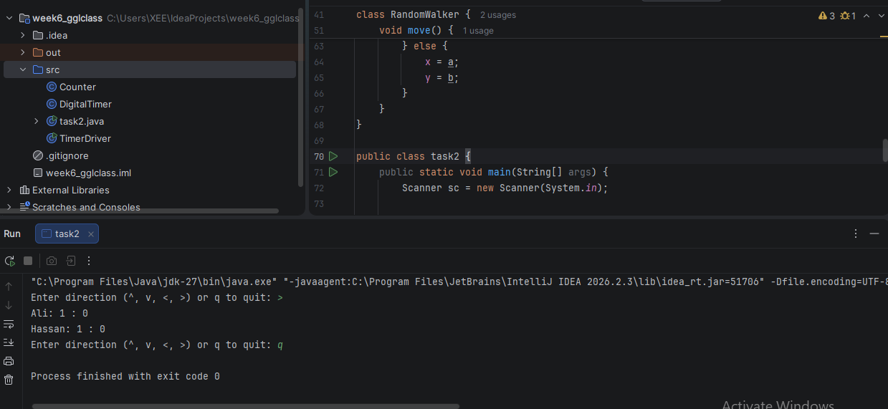
Figure 2: Walker program and its console output

