UNIVERSITY OF ENGINEERING AND TECHNOLOGY, LAHORE
COMPUTER ENGINEERING DEPARTMENT
OBJECT ORIENTED PROGRAMMING
LAB NO. 7 – ASSOCIATIONS
Lab Assignment: 7
Lab Title: Associations
Session: 2026(S)

Student Name | Zainab Sohail
Roll Number | 76
Course Code | CMPE 221L
Semester | 2nd
Teacher Name | Hafiz Muhammad Mubashar

Lab Tasks / Questions
Task 1 – Bank Class
Write a class named Bank having the following attributes: name; List ClList of type Client; List AcList of type Account.
Task 2 – Account Class
Write a class named Account having the following attributes: number; amount; ACholder of type Client; static count for account number generation and keeping track of count.
Task 3 – Client Class
Write a class named Client having the following attributes: Id; PersonDetails of type Person; List AcList of type Account; static count for client ID generation and keeping track of count.
Task 4 – Person Class
Write a class named Person having the following attributes: Name, CNIC, and phoneNo.
Task 5 – Common Functions for All Classes
Write getter and setter methods for each data member, a toString() function for appropriate display, and constructors for appropriate object creation.
Task 6 – Functions for Client Class
Implement totalAmount(), toString(), withdraw(float amount, String accNo), deposit(float amount, String accNo), and addAccount(Account a).
Task 7 – Functions for Account Class
Implement withdraw(float amount), deposit(float amount), and toString() to display account amount details and the account holder's name.
Task 8 – Functions for Bank Class
Implement addClient(Person p), addAccount(String id, float amount, Client c), searchAccount(String id), removeClient(String id), totalAmount(), and searchCustomerDetail(String CNIC).
Task 9 – Main Method
Test all the functionality through main(). The updated main method also creates Bank.txt, loads saved records, and saves changes after operations.

Program Code
The program is written in a simple student-style format. Each class is saved in a separate Java file in the same project. Run Bank_Main.java to test the program. The updated version stores the records in Bank.txt so that data is available again after closing and reopening the program.

Program 1 – Person.java
public class Person
{
String Name;
String CNIC;
String phoneNo;

public Person()
{
}

public Person(String name, String cnic, String phone)
{
Name = name;
CNIC = cnic;
phoneNo = phone;
}

public String getName()
{
return Name;
}

public void setName(String name)
{
Name = name;
}

public String getCNIC()
{
return CNIC;
}

public void setCNIC(String cnic)
{
CNIC = cnic;
}

public String getPhoneNo()
{
return phoneNo;
}

public void setPhoneNo(String phone)
{
phoneNo = phone;
}

public String toString()
{
return "Name: " + Name +
"\\nCNIC: " + CNIC +
"\\nPhone: " + phoneNo;
}
}

Program 2 – Account.java
public class Account
{
String number;
float amount;
Client ACholder;

static int count = 0;

public Account()
{
}

public Account(float amount, Client c)
{
count++;
number = "A" + count;
this.amount = amount;
ACholder = c;
}

public String getNumber()
{
return number;
}

public void setNumber(String number)
{
this.number = number;
}

public float getAmount()
{
return amount;
}

public void setAmount(float amount)
{
this.amount = amount;
}

public Client getACholder()
{
return ACholder;
}

public void setACholder(Client c)
{
ACholder = c;
}

float deposit(float money)
{
if(money > 0)
{
amount = amount + money;
}
return amount;
}

float withdraw(float money)
{
if(money > 0 && money <= amount)
{
amount = amount - money;
}
else
{
System.out.println("Insufficient balance");
}

return amount;
}

public String toString()
{
return "\\nAccount Number: " + number +
"\\nAmount: " + amount +
"\\nHolder: " + ACholder.getPersonDetails().getName();
}
}

Program 3 – Client.java
import java.util.ArrayList;

public class Client
{
String Id;
Person PersonDetails;
ArrayList<Account> AcList;

static int count = 0;

public Client()
{
AcList = new ArrayList<Account>();
}

public Client(Person p)
{
count++;
Id = "C" + count;
PersonDetails = p;
AcList = new ArrayList<Account>();
}

public String getId()
{
return Id;
}

public void setId(String id)
{
Id = id;
}

public Person getPersonDetails()
{
return PersonDetails;
}

public void setPersonDetails(Person p)
{
PersonDetails = p;
}

public ArrayList<Account> getAcList()
{
return AcList;
}

public void setAcList(ArrayList<Account> list)
{
AcList = list;
}

void addAccount(Account a)
{
AcList.add(a);
}

float totalAmount()
{
float total = 0;

for(int i = 0; i < AcList.size(); i++)
{
total = total + AcList.get(i).getAmount();
}

return total;
}

void deposit(float money, String accNo)
{
for(int i = 0; i < AcList.size(); i++)
{
if(AcList.get(i).getNumber().equals(accNo))
{
AcList.get(i).deposit(money);
System.out.println("Current Amount: " +
AcList.get(i).getAmount());
return;
}
}

System.out.println("Account not found");
}

void withdraw(float money, String accNo)
{
for(int i = 0; i < AcList.size(); i++)
{
if(AcList.get(i).getNumber().equals(accNo))
{
AcList.get(i).withdraw(money);
System.out.println("Remaining Amount: " +
AcList.get(i).getAmount());
return;
}
}

System.out.println("Account not found");
}

public String toString()
{
String details = PersonDetails.toString();
details = details + "\\nClient ID: " + Id;

for(int i = 0; i < AcList.size(); i++)
{
details = details + AcList.get(i).toString();
}

return details;
}
}

Program 4 – Bank.java
import java.util.ArrayList;
import java.io.File;
import java.io.FileWriter;
import java.io.IOException;
import java.io.FileNotFoundException;
import java.util.Scanner;

public class Bank
{
String name;
ArrayList<Client> ClList;
ArrayList<Account> AcList;

public Bank()
{
ClList = new ArrayList<Client>();
AcList = new ArrayList<Account>();
}

public Bank(String name)
{
this.name = name;
ClList = new ArrayList<Client>();
AcList = new ArrayList<Account>();
}

// Create the text file if it does not already exist.
void createFile() throws IOException
{
File file = new File("Bank.txt");

if(file.createNewFile())
{
System.out.println("Bank.txt file created");
}
}

// Save the current data in the text file.
void saveData() throws IOException
{
FileWriter fw = new FileWriter("Bank.txt");

for(int i = 0; i < ClList.size(); i++)
{
Client c = ClList.get(i);

fw.write("CLIENT," + c.getId() + "," +
c.getPersonDetails().getName() + "," +
c.getPersonDetails().getCNIC() + "," +
c.getPersonDetails().getPhoneNo() + "\\n");
}

for(int i = 0; i < AcList.size(); i++)
{
Account a = AcList.get(i);

fw.write("ACCOUNT," + a.getNumber() + "," +
a.getAmount() + "," +
a.getACholder().getId() + "\\n");
}

fw.close();
}

// Read saved clients and accounts when the program starts.
void loadData() throws FileNotFoundException
{
File file = new File("Bank.txt");

if(!file.exists())
{
return;
}

Scanner s = new Scanner(file);
int clientCount = 0;
int accountCount = 0;

while(s.hasNextLine())
{
String line = s.nextLine();
String[] data = line.split(",");

if(data[0].equals("CLIENT"))
{
Person p = new Person(data[2], data[3], data[4]);
Client c = new Client(p);
c.setId(data[1]);
ClList.add(c);

int idNumber = Integer.parseInt(data[1].substring(1));
if(idNumber > clientCount)
{
clientCount = idNumber;
}
}

else if(data[0].equals("ACCOUNT"))
{
String accountNo = data[1];
float amount = Float.parseFloat(data[2]);
String clientId = data[3];

for(int i = 0; i < ClList.size(); i++)
{
if(ClList.get(i).getId().equals(clientId))
{
Account a = new Account(amount, ClList.get(i));
a.setNumber(accountNo);
AcList.add(a);
ClList.get(i).addAccount(a);

int idNumber = Integer.parseInt(accountNo.substring(1));
if(idNumber > accountCount)
{
accountCount = idNumber;
}
}
}
}
}

Client.count = clientCount;
Account.count = accountCount;
s.close();
}

public String getName()
{
return name;
}

public void setName(String name)
{
this.name = name;
}

public ArrayList<Client> getClList()
{
return ClList;
}

public void setClList(ArrayList<Client> list)
{
ClList = list;
}

public ArrayList<Account> getAcList()
{
return AcList;
}

public void setAcList(ArrayList<Account> list)
{
AcList = list;
}

Client addClient(Person p) throws IOException
{
Client c = new Client(p);
ClList.add(c);

System.out.println("Client added successfully");
System.out.println("Client ID: " + c.getId());

saveData();
return c;
}

Account addAccount(String id, float amount, Client c) throws IOException
{
if(ClList.contains(c) && c.getId().equals(id))
{
Account a = new Account(amount, c);
AcList.add(a);
c.addAccount(a);

System.out.println("Account added successfully");
System.out.println("Account Number: " + a.getNumber());

saveData();
return a;
}

System.out.println("Client not found");
return null;
}

Account searchAccount(String id)
{
for(int i = 0; i < AcList.size(); i++)
{
if(AcList.get(i).getNumber().equals(id))
{
return AcList.get(i);
}
}

return null;
}

boolean removeClient(String id) throws IOException
{
for(int i = 0; i < ClList.size(); i++)
{
if(ClList.get(i).getId().equals(id))
{
Client c = ClList.get(i);
AcList.removeAll(c.getAcList());
c.getAcList().clear();
ClList.remove(i);

saveData();
return true;
}
}

return false;
}

float totalAmount()
{
float total = 0;

for(int i = 0; i < AcList.size(); i++)
{
total = total + AcList.get(i).getAmount();
}

return total;
}

Client searchCustomerDetail(String CNIC)
{
for(int i = 0; i < ClList.size(); i++)
{
if(ClList.get(i).getPersonDetails().getCNIC().equals(CNIC))
{
return ClList.get(i);
}
}

return null;
}

public String toString()
{
String details = "Bank Name: " + name;

for(int i = 0; i < ClList.size(); i++)
{
details = details + "\\n\\n" + ClList.get(i).toString();
}

return details;
}
}

Program 5 – Bank_Main.java
import java.util.Scanner;
import java.io.IOException;

public class Bank_Main
{
static Bank b = new Bank("UET Bank");

public static void main(String[] args) throws IOException
{
Scanner sc = new Scanner(System.in);

// Create Bank.txt and load old records before showing the menu.
b.createFile();
b.loadData();

System.out.println("Welcome to the UET Bank");

int choice = 1;

while(choice != 10)
{
System.out.println("\\n1. Add Client");
System.out.println("2. Add Account");
System.out.println("3. Search Account");
System.out.println("4. Deposit Money");
System.out.println("5. Withdraw Money");
System.out.println("6. Display All Clients");
System.out.println("7. Search Client");
System.out.println("8. Total Bank Amount");
System.out.println("9. Remove Client");
System.out.println("10. Exit");

System.out.println("Enter your choice:");
choice = sc.nextInt();
sc.nextLine();

if(choice == 1)
{
System.out.println("Enter Name:");
String n = sc.nextLine();

System.out.println("Enter CNIC:");
String cnic = sc.nextLine();

System.out.println("Enter Phone Number:");
String ph = sc.nextLine();

Person p = new Person(n, cnic, ph);
b.addClient(p);
}

else if(choice == 2)
{
System.out.println("Enter Client ID:");
String id = sc.nextLine();

Client c = null;

for(int i = 0; i < b.ClList.size(); i++)
{
if(b.ClList.get(i).getId().equals(id))
{
c = b.ClList.get(i);
}
}

if(c != null)
{
System.out.println("Enter Amount:");
float amount = sc.nextFloat();
sc.nextLine();

b.addAccount(id, amount, c);
}
else
{
System.out.println("Client not found");
}
}

else if(choice == 3)
{
System.out.println("Enter Account Number:");
String id = sc.nextLine();

Account a = b.searchAccount(id);

if(a != null)
{
System.out.println(a);
}
else
{
System.out.println("Account not found");
}
}

else if(choice == 4)
{
System.out.println("Enter Account Number:");
String id = sc.nextLine();

Account a = b.searchAccount(id);

if(a != null)
{
System.out.println("Enter Amount:");
float money = sc.nextFloat();
sc.nextLine();

a.getACholder().deposit(money, id);
b.saveData();
}
else
{
System.out.println("Account not found");
}
}

else if(choice == 5)
{
System.out.println("Enter Account Number:");
String id = sc.nextLine();

Account a = b.searchAccount(id);

if(a != null)
{
System.out.println("Enter Amount:");
float money = sc.nextFloat();
sc.nextLine();

a.getACholder().withdraw(money, id);
b.saveData();
}
else
{
System.out.println("Account not found");
}
}

else if(choice == 6)
{
System.out.println(b);
}

else if(choice == 7)
{
System.out.println("Enter CNIC:");
String cnic = sc.nextLine();

Client c = b.searchCustomerDetail(cnic);

if(c != null)
{
System.out.println(c);
}
else
{
System.out.println("Client not found");
}
}

else if(choice == 8)
{
System.out.println("Total Bank Amount: " + b.totalAmount());
}

else if(choice == 9)
{
System.out.println("Enter Client ID:");
String id = sc.nextLine();

if(b.removeClient(id))
{
System.out.println("Client removed successfully");
}
else
{
System.out.println("Client not found");
}
}

else if(choice == 10)
{
System.out.println("Thank you for using UET Bank");
}

else
{
System.out.println("Invalid input");
}
}

sc.close();
}
}

Conclusion
In this lab, a simple bank management program was created using Java classes and objects. The program demonstrates associations between Person, Client, Account, and Bank classes. It uses constructors, getters, setters, ArrayLists, loops, and methods to manage clients and their accounts. The updated program also uses file handling to save bank records in Bank.txt and load them again when the program is started, so the information is not lost when the program closes.

Program Output Screenshots
The following screenshots show the program running and the results of its main operations.

Output 1
Program started and client information entered
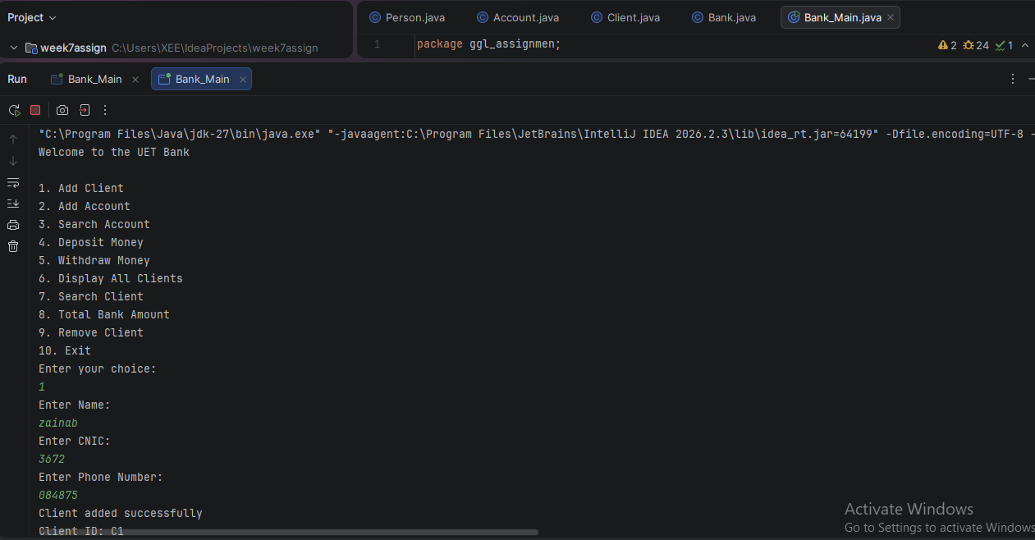

Output 2
Adding a client and creating an account
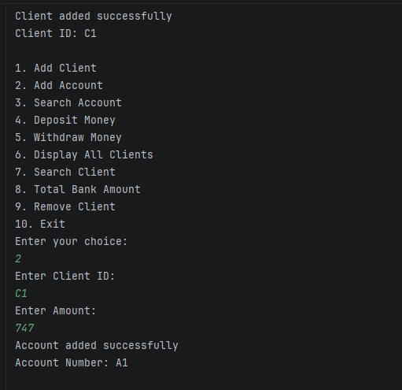

Output 3
Searching for an account
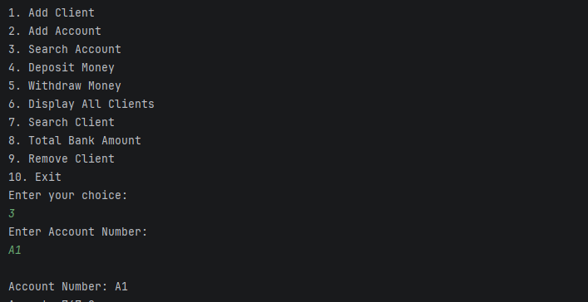

Output 4
Depositing money into an account
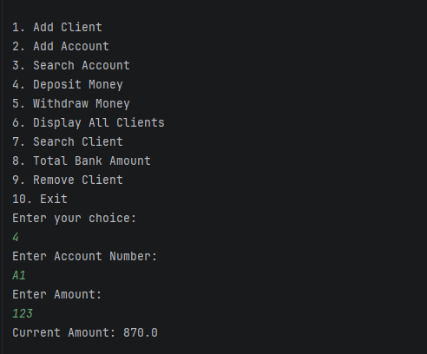

Output 5
Withdrawing money from an account
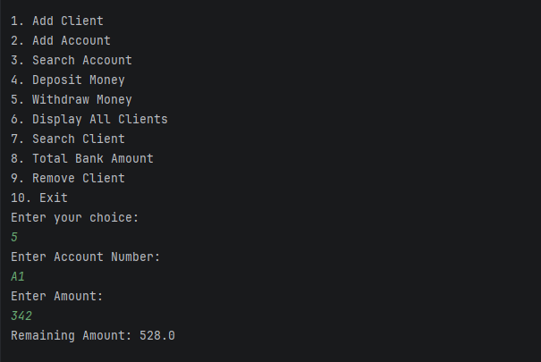

Output 6
Displaying all clients and their account details
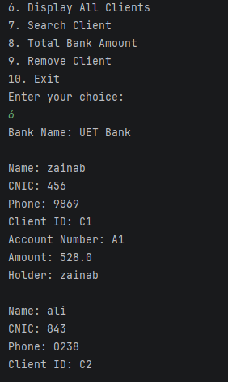

Output 7
Searching for client details using CNIC


