LAB NO. 4
CLASSES & OBJECTS
Course Name: Object Oriented Programming
Course Code: CMPE 221L
Assignment Type: Lab
Dated: 24th October 2025
Semester: 2nd
Session: CYS 2025 Spring
Lab/Project/Assignment #: 4
CLOs to be covered: CLO1
Lab Title: Classes & Objects
Teacher Name: Engr. Afeef Obaid
Hafiz Muhammad Mubashar Imran
Student Name: Zainab
Roll No: 76

Lab Goals/Objectives
• Basic OO programming in Java
• Objects and Classes

Lab Evaluation
CLO1: Implement abstraction and encapsulation to develop reusable classes for objects of real-world problems.
Scale | Marks / Level | Rubric
Excellent | 9–10 / L1 | Submitted all lab tasks, BONUS task, and showed good understanding.
Very Good | 7–8 / L2 | Submitted the lab tasks and showed good understanding.
Good | 5–6 / L3 | Submitted the lab tasks but showed weak understanding.
Basic | 3–4 / L4 | Submitted the lab tasks but showed no understanding.
Barely Acceptable | 1–2 / L5 | Submitted only one lab task.
Not Acceptable | 0 / L6 | Did not attempt.

LAB NO. 4 — CLASSES & OBJECTS
University of Engineering and Technology, Lahore
Computer Engineering Department
Course: Object Oriented Programming (CMPE 221L) Semester: 2nd
Lab Goals/Objectives: Basic OO programming in Java; Objects and Classes.
Theory/Relevant Material: Objects and classes, constructors, getters and setters, modifiers.
1. Thinking of Time as an entity, a JTime class represents a time-stamp. Convert total seconds into hours, minutes, and seconds.
import java.util.Scanner;
class Time {
void convert() {
Scanner sc = new Scanner(System.in);
System.out.print("Enter seconds: ");
int sec = sc.nextInt();
int hours = sec / 3600;
int minutes = (sec % 3600) / 60;
int remainingSeconds = sec % 60;
System.out.println("Hours = " + hours);
System.out.println("Minutes = " + minutes);
System.out.println("Seconds = " + remainingSeconds);
System.out.printf("%02d:%02d:%02d%n",
hours, minutes, remainingSeconds);
}
}
public class task1 {
public static void main(String args[]) {
Time t = new Time();
t.convert();
}
}
Code screenshot — Program 1
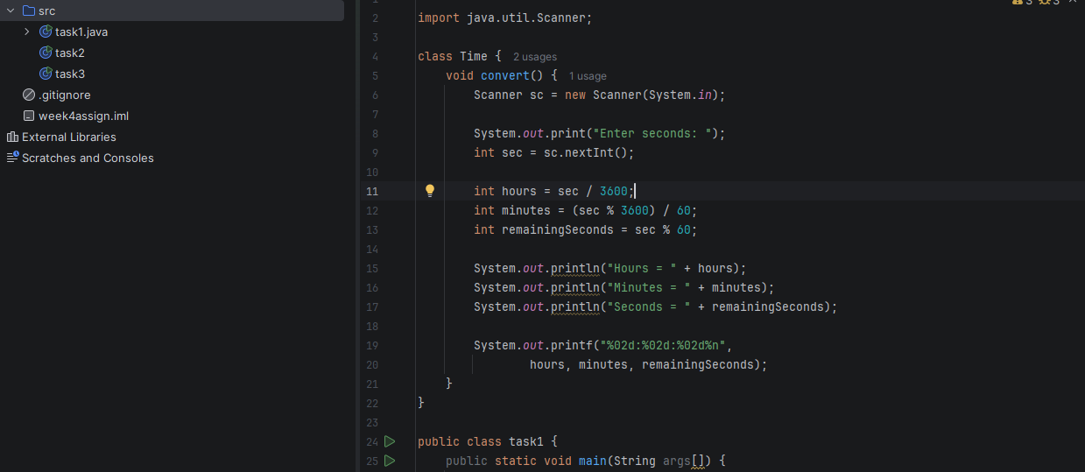

LAB NO. 4 — PROGRAMS
2. Develop a simple bank account program with options to deposit money, withdraw money, and check the balance.
import java.util.Scanner;
public class task2 {
public static void main(String[] args) {
Scanner sc = new Scanner(System.in);
int balance = 1000;
System.out.println("1 Deposit");
System.out.println("2 Withdraw");
System.out.println("3 Check Balance");
int choice = sc.nextInt();
if (choice == 1) {
int amount = sc.nextInt();
balance = balance + amount;
} else if (choice == 2) {
int amount = sc.nextInt();
balance = balance - amount;
}
System.out.println("Balance = " + balance);
}
}
Note: The program starts with a balance of 1000. Enter 1 to deposit or 2 to withdraw; the balance is then displayed.
Code screenshot — Program 2
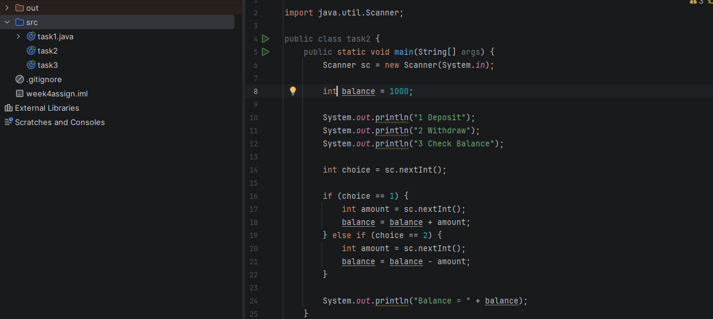

LAB NO. 4 — PROGRAMS
3. Ali walks in directions entered by the user and avoids an obstacle. Hasan walks at the same time and avoids the same obstacle.
This simple version makes Hasan move upward each turn instead of moving randomly.
import java.util.Scanner;
public class task3 {
public static void main(String[] args) {
Scanner sc = new Scanner(System.in);
int ax = 0, ay = 0;
int hx = 0, hy = 0;
for (int i = 1; i <= 3; i++) {
System.out.print("Enter direction for Ali (^, v, <, >): ");
char d = sc.next().charAt(0);
if (d == '^') ay++;
if (d == 'v') ay--;
if (d == '>') ax++;
if (d == '<') ax--;
if (ax == 1 && ay == 2) {
ax = 0;
ay = 0;
System.out.println("Ali found a hurdle!");
}
// Hasan always moves up
hy++;
if (hx == 1 && hy == 2) {
hy--;
System.out.println("Hasan found a hurdle!");
}
System.out.println("Ali is at (" + ax + ":" + ay + ")");
System.out.println("Hasan is at (" + hx + ":" + hy + ")");
}
sc.close();
}
}
Code screenshot — Program 3
