UNIVERSITY OF ENGINEERING AND TECHNOLOGY, LAHORE
Computer Engineering Department
OBJECT ORIENTED PROGRAMMING
LAB NO. 5
Constructors & Modifiers

Name: Zainab Sohail
Roll No: 76
Course Code: CMPE 221L
Session: CYS 2026 Spring
Teacher: Hafiz Muhammad Mubashar Imran

Task 1: dayType Class
Task Statement: Design and implement a class dayType that implements the day of the week in a program. The class should store a day and perform these operations: set the day, print the day, return the day, return the next day, return the previous day, and return the day after adding a number of days. For example, Monday plus 4 days is Friday.
Code:
class dayType {
String[] days = {
"Sunday", "Monday", "Tuesday", "Wednesday",
"Thursday", "Friday", "Saturday"
};

int day;

dayType(String d) {
setDay(d);
}

void setDay(String d) {
for (int i = 0; i < 7; i++) {
if (days[i].equalsIgnoreCase(d)) {
day = i;
return;
}
}
}

void printDay() {
System.out.println("Current day: " + days[day]);
}

String getDay() {
return days[day];
}

String nextDay() {
return days[(day + 1) % 7];
}

String previousDay() {
return days[(day + 6) % 7];
}

String addDays(int n) {
return days[(day + n % 7) % 7];
}

public static void main(String[] args) {
dayType d = new dayType("Monday");

d.printDay();
System.out.println("Next day: " + d.nextDay());
System.out.println("Previous day: " + d.previousDay());
System.out.println("After 4 days: " + d.addDays(4));
}
}
Output Screenshot:
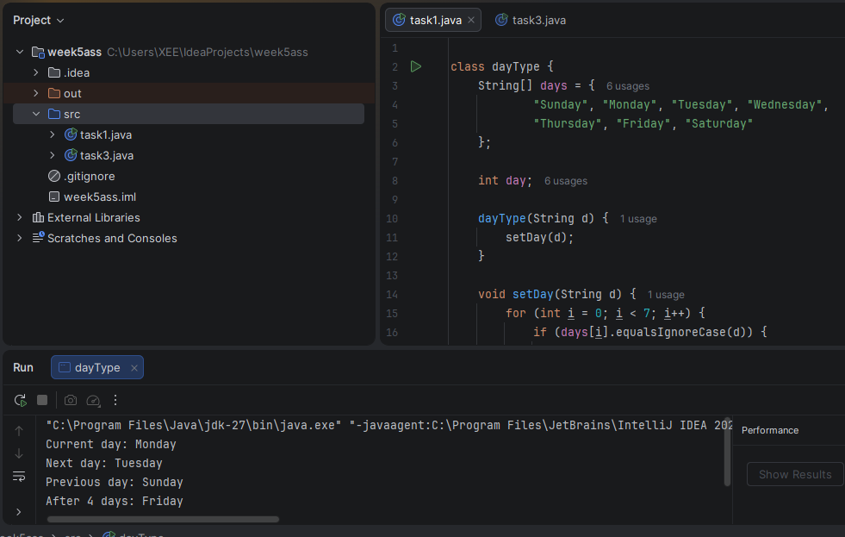

Task 2: Walls Ice Cream Class
Task Statement: Create a Walls class with flavor, number of scoops, cone type, and price fields. The default flavor is Vanilla, the default number of scoops is 1, and the default cone is Sugar. Price is Rs. 75 per scoop, plus Rs. 40 for a waffle cone. Ask the user for flavor, scoops, and cone type in main().
Code:
import java.util.Scanner;

class Walls {
String flavor;
int scoops;
String cone;
int price;

Walls() {
flavor = "Vanilla";
scoops = 1;
cone = "Sugar";
price = 75;
}

Walls(String f, int s, String c) {
flavor = f;
scoops = s;
cone = c;

price = scoops * 75;

if (cone.equalsIgnoreCase("Waffle")) {
price = price + 40;
}
}

void showData() {
System.out.println("Flavor: " + flavor);
System.out.println("Scoops: " + scoops);
System.out.println("Cone: " + cone);
System.out.println("Price: Rs. " + price);
}

public static void main(String[] args) {
Scanner sc = new Scanner(System.in);

System.out.print("Enter flavor: ");
String f = sc.nextLine();

System.out.print("Enter scoops: ");
int s = sc.nextInt();
sc.nextLine();

System.out.print("Enter cone (Sugar/Waffle): ");
String c = sc.nextLine();

Walls w = new Walls(f, s, c);
w.showData();

sc.close();
}
}
Output Screenshot:
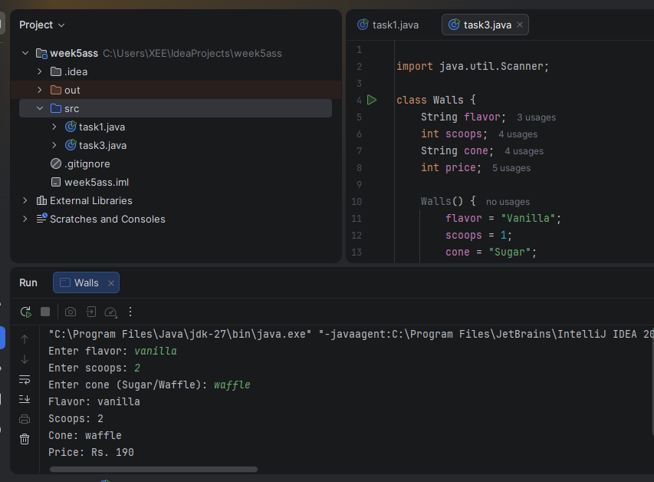

Task 3: Product Class
Task Statement: Create a Product class with private members name (String), price (int), and quantity (int). Make a parameterless and a parameterized constructor. Add getData(), static counter(), and static countProduct() methods. The static totalProduct starts at zero and increases each time a Product object is created. Creating five products should display 5.
Code:
class Product {
private String name;
private int price;
private int quantity;

static int totalProduct = 0;

Product() {
name = "Unknown";
price = 0;
quantity = 0;
counter();
}

Product(String n, int p, int q) {
name = n;
price = p;
quantity = q;
counter();
}

void getData() {
System.out.println("Name: " + name);
System.out.println("Price: " + price);
System.out.println("Quantity: " + quantity);
}

static void counter() {
totalProduct++;
}

static int countProduct() {
return totalProduct;
}

public static void main(String[] args) {
Product p1 = new Product("Pen", 50, 2);
Product p2 = new Product("Book", 200, 3);
Product p3 = new Product("Bag", 1000, 1);
Product p4 = new Product();
Product p5 = new Product();

p1.getData();
System.out.println("Total Products: "
+ Product.countProduct());
}
}
Output Screenshot:
