Line Following Robot
Using ATmega328P Microcontroller

MPS EE-222: Microprocessor Systems
Lab Instructor: Engr. Muhammad Adnan

Department of Electrical Engineering

Dated: 12th May 2026

SUBMITTED BY
Muhammad Umair | 506068
Muhammad Zain | 502138
Moeen ul Haq Farooqi | 522745
Mubashir Qureshi | 509662

Abstract

This project presents the design and implementation of an autonomous line-following robot using the ATmega328P microcontroller. The core objective was to develop a low-cost embedded system capable of detecting and tracking a black line on a white surface in real time. The system addresses the problem of autonomous path navigation, a fundamental challenge in embedded robotics and intelligent transport systems.

The robot uses a five-sensor infrared (IR) array to determine the position of the line and accordingly adjusts the speed and direction of two DC geared motors via PWM signals. The ATmega328P processes sensor inputs and drives an L298 dual H-bridge motor driver to control motor movement. Two control strategies were implemented and compared: a rule-based algorithm and a PID controller. The rule-based method provides stable and predictable operation, while the PID controller delivers smoother corrections and improved tracking accuracy.

Key components include the ATmega328P microcontroller, a five-sensor IR array, the L298 motor driver, DC geared motors, and a lithium-ion battery pack (3 × 3.7V). Experimental testing confirmed successful line following on straight paths, curves, and edges, with reliable stopping on line loss. The project demonstrates effective real-time hardware-software integration and the practical application of embedded control theory.

Problem Definition and Analysis

Complex Engineering Problem (CEP)
Modern embedded systems require efficient real-time monitoring and control, while manual systems are slow, error-prone, and lack automation. This project addresses the design of a microcontroller-based autonomous robot that processes sensor inputs, makes real-time navigation decisions, and controls motors to follow a predefined path without human intervention. It is a Complex Engineering Problem (CEP) because it integrates sensing, control, and actuation hardware with time-critical software under cost and power constraints.

Why This Problem Matters
Autonomous navigation is a cornerstone of modern robotics, automation, and intelligent transport. Line-following robots serve as foundational platforms for industrial conveyor automation, warehouse logistics, and educational robotics. Manual or pre-programmed navigation is insufficient for environments requiring real-time adaptive decision-making.

Constraints
Constraint | Details
Cost | Approximately 2,500 PKR — requires selection of low-cost, widely available components
Power | 3 × 3.7V 3000 mAh lithium-ion batteries; efficient energy utilization required for adequate runtime
Real-Time Response | Immediate processing of sensor data (~200 Hz loop) to maintain accurate path tracking at operating speed
Hardware Limitation | Limited processing power, Flash memory (32 KB), and PWM channels on the ATmega328P

Engineering Complexity

The engineering complexity of this project lies in the tight integration of hardware and software for real-time autonomous control. The system must simultaneously:

Continuously read and interpret five IR sensor inputs to detect the line position.

Apply rule-based or PID control logic to determine corrective motor actions.

Generate dual PWM signals for independent wheel speed control.

Maintain a stable control loop of approximately 200 Hz using hardware timers.

Additional complexity was introduced by implementing and comparing both rule-based and PID control approaches, including parameter tuning and performance evaluation under real-world conditions.

Literature Review & Theoretical Foundation

Embedded Systems Overview
Embedded systems are specialized computing systems designed to perform dedicated real-time tasks by tightly integrating hardware and software. They are widely deployed in automation, robotics, consumer electronics, and industrial control, where fast, reliable, and deterministic responses are essential. Unlike general-purpose computers, embedded systems are optimized for their specific application in terms of power, cost, and performance.

Microcontrollers vs. Microprocessors
A microcontroller integrates a CPU, memory (Flash and SRAM), and peripherals (GPIO, ADC, timers, UART) on a single chip, making it ideal for embedded applications that require a compact and self-contained design. In contrast, a microprocessor is a standalone processing unit requiring external memory and peripheral chips, making it more suitable for general-purpose computing. For real-time robotics applications, microcontrollers are preferred due to their low power consumption, built-in peripherals, and deterministic timing behavior.

Why ATmega328P is Widely Used
The ATmega328P is a popular 8-bit AVR microcontroller manufactured by Microchip (formerly Atmel). It is widely adopted in embedded and robotic applications because it offers:
- 8-bit AVR RISC architecture with efficient single-cycle instruction execution
- 32 KB Flash program memory and 2 KB SRAM
- 10-bit Analog-to-Digital Converter (ADC) with 6 channels
- Three hardware timers (Timer0, Timer1, Timer2) supporting PWM generation
- Multiple GPIO pins configurable as digital input or output
- Support for external and pin-change interrupts
- Low cost, low power consumption, and excellent community/documentation support

These features make the ATmega328P highly suitable for real-time control systems such as line-following robots.

Key Concepts
GPIO (General Purpose Input/Output)
GPIO pins on the ATmega328P can be configured as inputs or outputs via Data Direction Registers (DDR). In this project, IR sensor output signals are read as digital inputs, while motor driver control signals (IN1–IN4) are driven as digital outputs. Direct digital GPIO reading was selected over ADC-based reading due to its faster response and simpler processing for binary line detection.

ADC (Analog-to-Digital Converter)
The ATmega328P features a 10-bit successive approximation ADC with a reference voltage of 5V. This gives a resolution of:
Resolution = Vref / 2^n = 5V / 1024 = 4.88 mV
Both ADC-based and direct digital sensor reading approaches were evaluated. Direct digital input was ultimately selected due to faster response and reduced processing overhead for this binary detection task.

Timers and PWM Generation
Hardware timers in the ATmega328P are used for two purposes in this project: (1) generating PWM signals for motor speed control, and (2) providing precise hardware-based timing delays. Timer0 is configured in Fast PWM mode using the TCCR0A and TCCR0B registers. The OCR0A and OCR0B registers set the duty cycle for the ENA and ENB motor driver enable pins, allowing independent speed control of each wheel.

Interrupts
Interrupts allow the microcontroller to immediately respond to asynchronous events without continuous polling, improving real-time responsiveness. Although this system primarily uses a polling-based approach for sensor reading due to its simplicity, interrupt-driven designs are important in advanced embedded systems for handling time-critical events with minimal latency. Knowledge of interrupt configuration and ISR (Interrupt Service Routine) design is fundamental to embedded systems engineering.

Design and Methodology

Block Diagram
The system architecture follows a sense-decide-act loop. The block diagram below illustrates the signal flow:

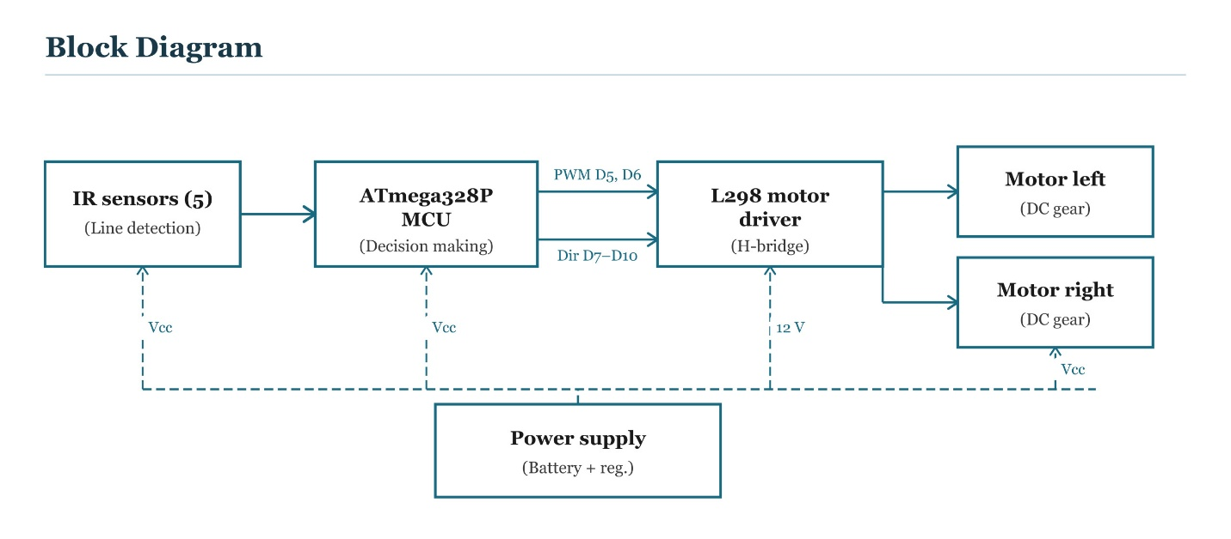

Components Used and Justification

Component | Specification / Role | Justification
ATmega328P Microcontroller | 8-bit AVR MCU @ 16 MHz | Low cost, built-in PWM, GPIO, ADC, and timers — ideal for real-time robotics
IR Sensor Array (5 Sensors) | Digital line detection module | Provides accurate line position with full edge coverage for reliable steering
L298 Motor Driver | Dual H-bridge driver, 2A max per channel | Enables bidirectional control and supplies sufficient current to DC motors safely
DC Geared Motors (×2) | Geared DC motors for differential drive | High torque for stable movement and proper turning control on the chassis
Li-ion Battery Pack | 3 × 3.7V, 3000 mAh (11.1V total) | Lightweight, rechargeable, and provides adequate current and runtime for the system
Chassis & Wheels | Mechanical robot frame | Ensures stable sensor alignment and proper weight distribution for smooth movement

Programming Approach (Assembly and C)

Embedded systems can be programmed using C language or assembly language. Assembly provides direct hardware control at the register level but is complex, time-consuming to write, and difficult to maintain for large projects. C offers a balance between high-level readability and direct hardware access, making it the preferred choice for most embedded development.

Language Used: Embedded C (Atmel Studio 7)

The entire system was implemented in C using direct register-level programming — without Arduino libraries or HAL abstraction layers — to maintain full control over hardware peripherals. This approach allows precise configuration of:
- Data Direction Registers (DDR) for GPIO configuration
- Timer Control Registers (TCCR0A, TCCR0B) for PWM setup
- Output Compare Registers (OCR0A, OCR0B) for duty cycle control
- Port registers (PORTB, PORTD, PORTC) for sensor reading and motor direction control
No full assembly code was used; however, the low-level register programming style closely mirrors assembly-level control, providing direct and deterministic hardware interaction without compiler abstraction overhead.

Code Snippet

The following key code segments demonstrate the core embedded C implementation:

With digital pins
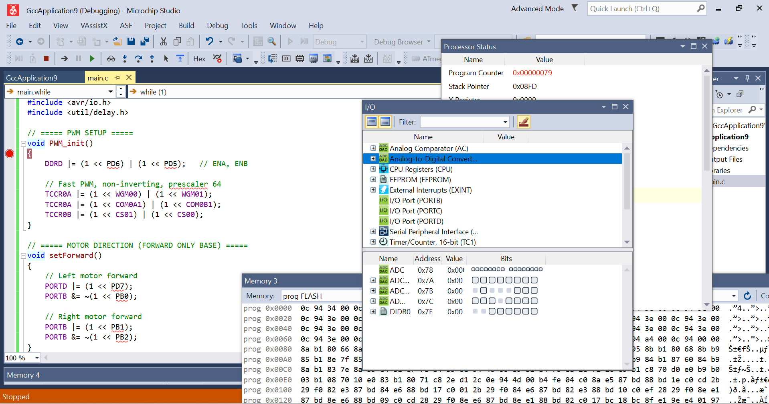

With analog/adc
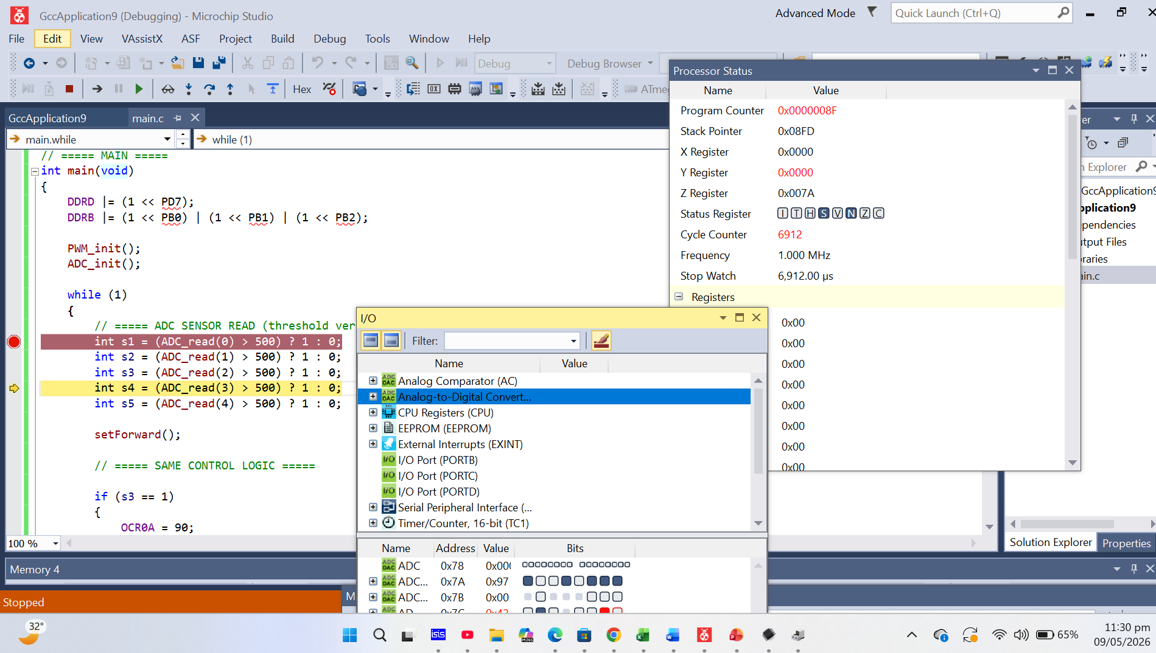

Flowchart

The following flow chart describes the main control loop of the line-following robot:
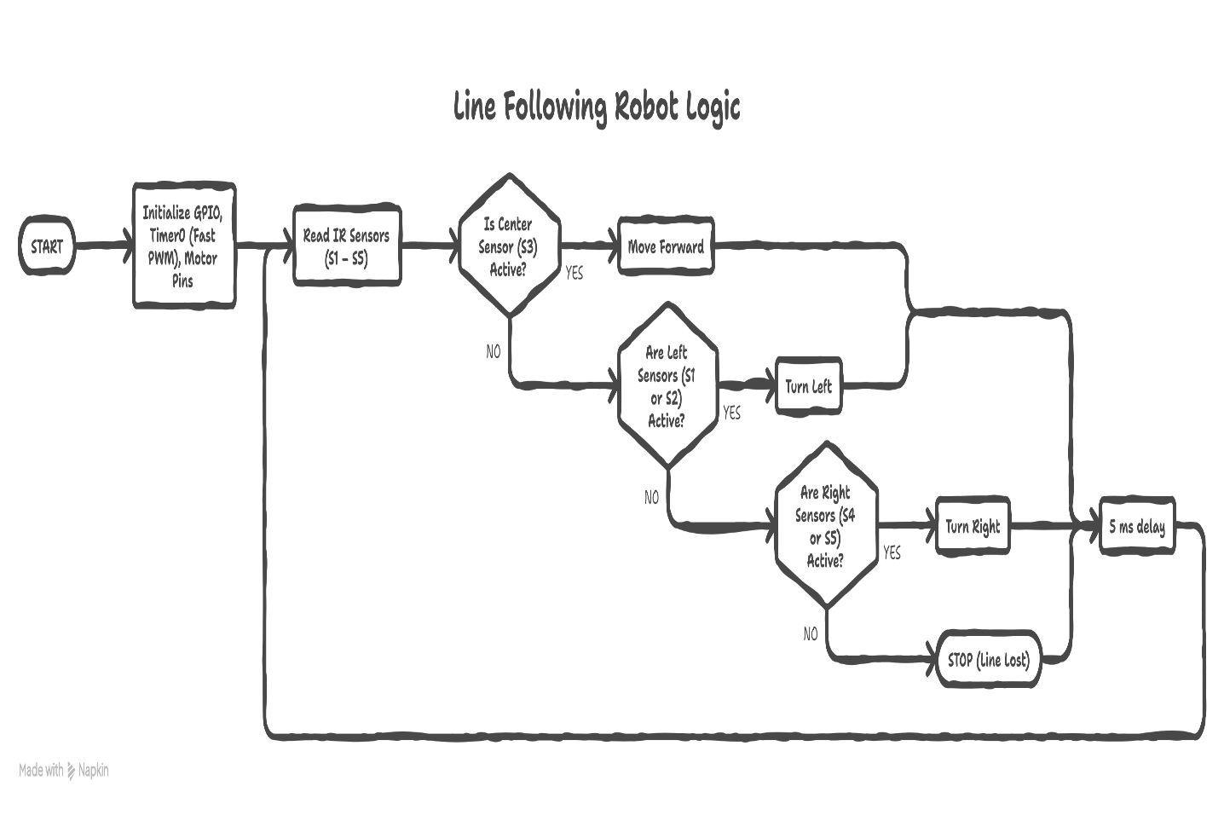

Simulation, Modeling, and Implementation

Software Tools Used

Tool | Purpose
Atmel Studio 7 | IDE for writing, compiling, and debugging the embedded C code; generates .hex file for flashing
Proteus 8 | Circuit simulation software used to verify the circuit design and logic before hardware implementation
AVRDUDE | Command-line tool for burning the compiled .hex file to the ATmega328P microcontroller via USB programmer

Simulation
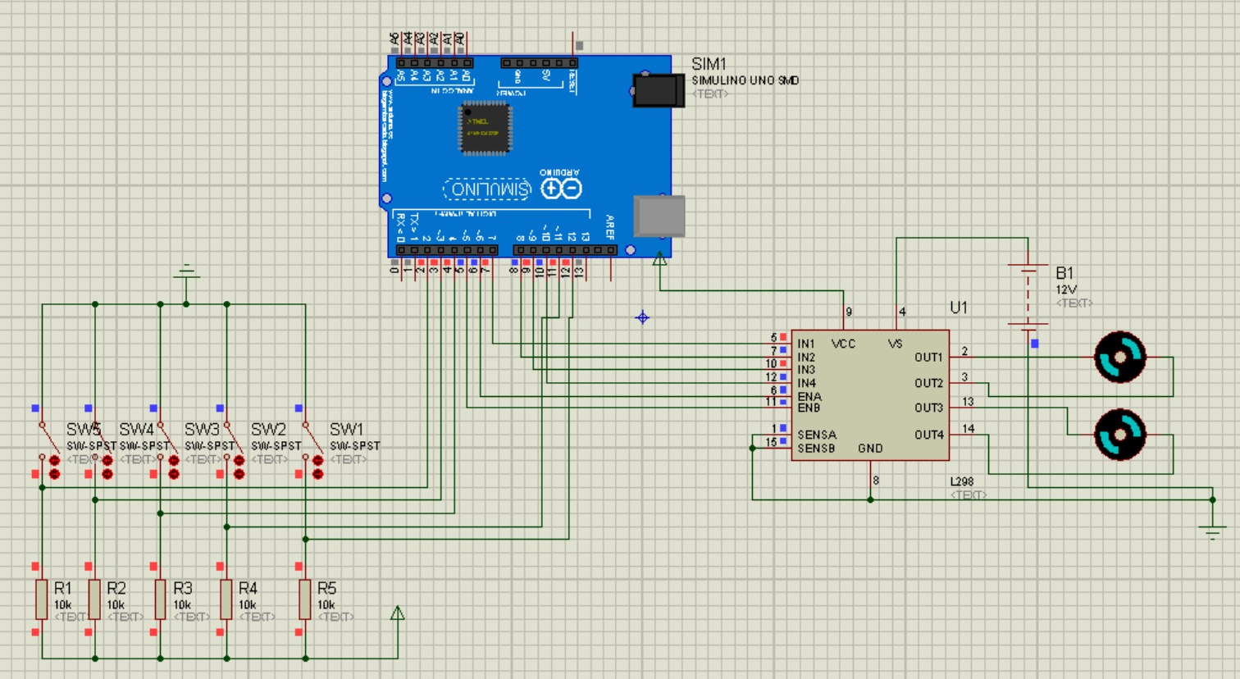

Results, Testing, and Validation

Test Cases
The robot was tested systematically under different track conditions on a continuous black-line course printed on white paper:
- Straight path tracking at nominal speed
- Gradual left and right turns (gentle curves)
- Sharp edge detection on tight curve sections
- Line loss condition (robot driven off track)

Expected vs. Actual Results

Test Case | Expected Result | Actual Result
Straight line | Smooth forward motion with no deviation | Achieved stable forward movement with minimal drift
Slight left turn | Small left correction without overshoot | Accurate and quick left correction observed
Slight right turn | Small right correction without overshoot | Accurate and quick right correction observed
Sharp edge / curve | Proper turning, no overshoot on edges | Successfully followed tight curve edges with PID control
Line loss | Robot should stop immediately | Robot stopped immediately upon line loss — confirmed reliable

Accuracy and Reliability

The system demonstrated high tracking accuracy on continuous paths with stable motion and minimal deviation. Direct digital sensor reading combined with PWM-based motor control resulted in fast response times, maintaining reliable line following during repeated test runs. The PID-based control approach showed superior smoothness on curves and reduced oscillation compared to the rule-based method. Both approaches achieved consistent performance without significant errors or instability under normal operating conditions.

Technical Analysis (Mathematics + Hardware Link)

This section presents the complete mathematical analysis for Timer0 of the ATmega328P microcontroller operating in Fast PWM mode. All calculations are derived from the hardware configuration and directly link to the embedded system design.

Given Parameters
The following hardware parameters are configured for Timer0:

CPU Clock Frequency | F₁CPU | 16 MHz
Prescaler | N | 64
Timer Type | — | 8-bit (0–255, 256 counts)

Timer Tick Time
The Timer Tick Time (Tₜick) is the time duration of a single clock tick after prescaling. It is calculated as:

Tick = Prescaler / FᴀCPU
Tick = 64 / (16 × 10⁶)
Tick = 4 μs
This means every 4 microseconds, the timer counter increments by 1.

Timer Frequency
The Timer Frequency (fₜimer) is the reciprocal of the tick time:

fₜimer = 1 / Tₜick
fₜimer = 1 / (4 × 10⁻⁶)
fₜimer = 250 kHz
The timer is increasing at a rate of 250,000 counts per second.

PWM Frequency (Fast PWM Mode)
In Fast PWM Mode, the timer counts from 0 to 255 (256 steps) and resets. The PWM frequency is:

fᴘWM = FᴀCPU / (N × 256)
fᴘWM = 16,000,000 / (64 × 256)
fᴘWM ≈ 976.56 Hz ≈ 976 Hz
This PWM frequency (~976 Hz) is suitable for motor control, LED dimming, and similar embedded applications requiring smooth signal modulation.

Time Period of PWM
The PWM time period is the total duration of one complete PWM cycle:

TᴘWM = 1 / fᴘWM
TᴘWM = 1 / 976.56
TᴘWM ≈ 1.024 ms
Each PWM cycle completes in approximately 1.024 milliseconds, meaning 256 timer ticks × 4 μs = 1.024 ms.

Duty Cycle Calculation
The duty cycle determines the percentage of the PWM period during which the signal is HIGH. It is controlled by the OCR0x register:

Duty Cycle (%) = (OCR0x / 255) × 100

Example: OCR0A = 90
Duty Cycle = (90 / 255) × 100
Duty Cycle ≈ 35%
Setting OCR0A = 90 in the C code produces a 35% duty cycle output on the PWM pin. The hardware register directly maps to the on-time proportion of the signal.

Delay Calculation (_delay_ms)
The software delay function _delay_ms(5) introduces a fixed time delay in the control loop:

Tᴅelay = 5 ms

Control Loop Frequency:
The control loop update frequency is determined by the delay period:
fₙₒₒₗ = 1 / Tᴅelay
fₙₒₒₗ = 1 / 0.005
fₙₒₒₗ = 200 Hz
The control loop executes 200 times per second, which is well above the PWM frequency band and ensures stable real-time feedback control.

Summary of Calculated Values

Timer Tick Time (Tₜick) | Prescaler / F_CPU | 4 μs
Timer Frequency (fₜimer) | 1 / Tₜick | 250 kHz
PWM Frequency (fᴘWM) | F_CPU / (N × 256) | ≈ 976 Hz
PWM Period (TᴘWM) | 1 / fᴘWM | ≈ 1.024 ms
Duty Cycle (OCR0A=90) | (90/255) × 100 | ≈ 35%
Control Loop (fₙₒₒₗ) | 1 / 0.005 | 200 Hz

Mathematical Results and Circuit Implementation Link

In our ATmega328P-based circuit, Timer0 is configured in Fast PWM Mode with a prescaler of 64, which sets the timer tick to 4 µs and drives the PWM signal on output pin OC0A. The resulting PWM frequency of ~976 Hz is fast enough that a connected DC motor or LED experiences smooth, continuous control rather than individual pulses. The duty cycle, set by writing to OCR0A, directly controls the average voltage delivered to the load — for example, OCR0A = 90 gives 35% duty cycle, which means 35% of the supply voltage reaches the component, controlling motor speed or LED brightness efficiently. The 5 ms control loop delay ensures the circuit updates its output 200 times per second, providing stable and responsive real-time behavior.

Innovation, Integration and Complexity

Innovation
This project advances beyond a basic line-following implementation in several ways. Rather than a simple fixed-speed on/off motor control, the system employs adaptive PWM-based speed control that modulates individual wheel speeds dynamically based on sensor input. Most significantly, two distinct control algorithms — rule-based logic and PID control — were both fully implemented and experimentally compared on the same hardware platform. This dual-implementation approach provides quantitative performance evaluation and demonstrates the practical benefit of feedback control theory in embedded robotics, which is uncommon in undergraduate semester projects.

Integration
The project achieves tight hardware-software integration across multiple subsystems operating simultaneously in real time:
- Five IR sensors provide continuous position feedback via GPIO digital inputs
- Timer0 generates precise PWM signals for dual-channel motor speed control
- The L298 motor driver translates low-power MCU logic signals into high-current motor drive
- The control loop integrates all subsystems at 200 Hz for real-time autonomous navigation

This level of integration — where a single microcontroller orchestrates sensing, decision-making, timing, and actuation simultaneously — demonstrates a complete embedded system design methodology.

Complexity
The system represents a real-time, multi-input embedded control system with the following dimensions of complexity:
- Multi-sensor input: Simultaneous reading and interpretation of five IR sensors to determine line position
- Real-time control: Sensor-to-motor update cycle of approximately 5 ms, requiring deterministic timing
- Dual algorithm implementation: Rule-based and PID control were both implemented, tuned, and tested
- Hardware-software co-design: Circuit design, embedded programming, and system testing were performed in parallel
- Parameter tuning: PID gains (Kp, Ki, Kd) required iterative experimental tuning for optimal performance

Teamwork and Individual Contribution

This project was completed through effective team collaboration, with each member assigned primary responsibilities while contributing to overall integration and testing.

Member | Reg. No. | Primary Contribution
Muhammad Zain | 502138 | Participated in hardware implementation and prepared the project report.
Muhammad Umair | 506068 | Participated in hardware implementation and developed the Proteus simulation.
Muhammad Moeen Ul Haq | 502138 | Participated in hardware implementation and prepared the project presentation (PPT).
Mubashir Quarishi | 502138 | Participated in hardware implementation and assisted in testing and overall project development.

All team members participated in project planning, integration testing, and final demonstration preparation. Regular team meetings were held to review progress, resolve technical issues, and coordinate hardware-software integration milestones.

Professionalism and Ethical Considerations

Safety
The system operates at low voltage levels — 5V for MCU and sensor logic, and a regulated motor supply from 11.1V batteries. These voltages are within safe limits for handling during assembly and testing. The use of the L298 motor driver provides electrical isolation between the microcontroller and the high-current motor circuits, preventing damage to the ATmega328P from inductive motor loads or current spikes. All connections were made with appropriate wire gauges rated for the expected current levels, and the battery pack was handled according to lithium-ion safety guidelines (no overcharging, no short circuits).

Reliability
The design prioritizes consistent and repeatable performance through real-time sensor processing and stable PWM motor control. The use of structured, well-commented embedded C code improves maintainability and reduces the risk of software-related failures. Hardware timer-based delays replace unreliable software delays, improving timing determinism. The system was subjected to repeated testing across multiple track runs to verify consistent behavior before final demonstration.

Ethical Use of Technology
This project was developed strictly for educational purposes within the curriculum of MPS EE-222 Microprocessor Systems at NUST. The system promotes responsible and beneficial use of embedded technology in the field of autonomous robotics and automation. All referenced materials, datasheets, and published works are properly cited. No components or methodologies were used in a manner that could cause harm to individuals or the environment. The project upholds academic integrity, with all design, implementation, and documentation work performed by the listed team members.

Conclusion

This project successfully designed and implemented an autonomous line-following robot using the ATmega328P microcontroller, a five-sensor IR array, and PWM-based dual motor control via the L298 motor driver. The system operates in real time by continuously reading sensor inputs at approximately 200 Hz and dynamically adjusting motor speed and direction to accurately follow a predefined black-line path.

Both rule-based logic and PID control strategies were implemented in embedded C and experimentally evaluated. The PID-based approach demonstrated superior performance, delivering smoother directional corrections, improved stability on curved sections, and reduced oscillation compared to the simpler rule-based method. The rule-based approach, however, proved easier to tune and provided reliable, predictable performance under straightforward track conditions.

This project enhanced our understanding of microprocessor systems by providing comprehensive hands-on experience with the ATmega328P microcontroller, embedded C programming, and hardware-software integration. We successfully applied theoretical concepts — including PWM generation, timer configuration, GPIO interfacing, ADC operation, feedback control, and Ohm's Law calculations — to a real engineering problem. The course MPS EE-222 bridged the gap between classroom theory and real-world embedded system design, strengthening our skills in real-time control, hardware debugging, and professional engineering practice.

References

- Microchip Technology – ATmega328P Datasheet. Microchip Technology Inc., 2020. This datasheet provides detailed information about the ATmega328P microcontroller, including GPIO, ADC, timers, PWM, and electrical characteristics.
- STMicroelectronics – L298 Dual Full-Bridge Driver Datasheet. STMicroelectronics. This datasheet describes the L298 motor driver IC used for bidirectional control of the robot’s DC motors.
- Design and Implementation of a Line Follower Robot Using PID Controller. This paper discusses the design of a line-following robot and compares PID control performance for improved tracking accuracy.
- Development of an Autonomous Line Follower Robot Based on AVR Microcontroller. This paper presents a similar AVR-based line-following robot and was used as a reference for system architecture and implementation methodology.
- AVR Microcontroller and Embedded Systems Using Assembly and C by Muhammad Ali Mazidi, Sarmad Naimi, and Sepehr Naimi. Pearson Education, 2011. This book was used to understand AVR programming, timers, PWM, ADC, and sensor interfacing.
- Modern Control Engineering by Katsuhiko Ogata. Pearson Education, 2010. This book was used as a reference for PID control theory and feedback system analysis.

