

**“MediCo”**

**(**An online doctor appointment system**)**



**COURSE INSTRUCTOR: PROPOSED BY:**

Sir Muhammad Umair Ehsaan Nawaz Tanoli (34271)

**COURSE NAME:** Areeb Arain (33033)

Amna Urooj (35160)

Software Engineering Yaser Brohi (33168)

**DATE:** Sehrish Malik (34530)

13th AUGUST 2018 Bilal rana (27023)

**TABLE OF CONTENTS**

ACKNOWLEDGMENTS 4

ABSTRACT 5

1. Overview of the project 6

1.1. Introduction 6

1.2. Objectives of the project 7

1.3. Scope of the project 8

2. General description 9

2.1. Product perspectives 9

2.2. Product functions 9

2.3. User characteristics 9

2.4. System implementation constraints 10

2.5. Use case model description 11

2.6. ERD diagram representation 12

3. Requirement analysis 13

3.1. Software requirement specifications 13

3.2. General requirements 16

3.3. Questionnaires survey for collecting information of proposed system 16

4. DEVELOPMENT METHODOLOGY 21

4.1. Identification of chosen methodology 21

4.2. Justification to agile approach 21

4.3. Description of methodology 22

4.4. Agile manifesto 22

4.5. Principles of agile 23

4.6. Agile methodologies 24

4.7. Overview of scrum process 24

4.8. Conclusion of scrum-based approach 25

4.9. Sprints planning 25

4.10. Chart representation of sprint planning 26

4.11. Pert chart 27

5. ILLUSTRATION DIAGRAM 28

5.1. Context diagram 28

5.2. Level 0 DFD 29

5.3. Level 1 DFDs 30

5.4. Level 2 DFD 32

6. TESTING 33

6.1. Testing 33

6.2. Testing methods 33

6.3. Box testing approach 33

6.4. Black-box Testing 34

6.5. White-box Testing 34

6.6. Testing levels 35

6.7. Testing types 36

6.8. Importance of Testing 37

7. SOFTWARE MAINTENANCE 37

7.1. Adaptive 37

7.2. Perfective 38

7.3. Corrective 38

7.4. Preventive 38

7.5. Importance of maintenance 38

8. PROBLEMS 39

9. IMPORTANCE OF THE MediCo 40

10. ADVANTAGES OF MediCo 40

11. CONCLUSION 41

**ACKNOWLEDGMENT**

The best way to begin this report we feel would be by acknowledging our gratitude towards all the individuals responsible for this project’s successful completion.

We would like to express our gratitude and appreciation to all those who gave us the possibility to complete this project. We are pleased to acknowledge our teacher, Sir M.Umair who encourage us to complete this project, and for their valuable guidance during this course project work.

Last but not the least, many thanks goes to our team leader Ehsaan Nawaz Tanoli who has given all his efforts in guiding the team in achieving the goals as well as his encouragement to maintain our project progress on track.

It gives us great pleasure to acknowledge our indebt ness to our family members for their substantial moral support and encouragement in our studies.

7th August 2018

**ABSTRACT**

Life is becoming too busy now a days to take medical appointments manually and to maintain health care. In world, countries are adopting IT in their daily life extremely. Especially medical services are extremely qualified. They can search on internet about their health related problems; Even latest technologies, services and medicine. On internet, they can even search for the best affordable doctors and hospitals. They can be admitted into it, they can make appointment online. After all, it can be said that most of the countries in the world are using IT for the medical sector as a powerful tool for giving services to the people so that they can get the best service. In Pakistan these online healthcare services and appointments systems are getting common now a days. By noticing this we decided to make the software through which patient can easily book their appointments online by sitting at home.

The main idea of this project is to provide ease and comfort to patients while taking appointments from doctors and it also resolves the problems that patients have to face while making appointments. The purpose of our online doctor appointment system is to automate the manual existing system for the user’s by the help of computerized equipment’s and full-fledged software, fulfilling their requirements, so that their data/information is stored for a long time with easy accessing. The required software and hardware are easy to use.

MediCo (online doctor appointment system) can lead to error free, secure, reliable and fast management system. Our application will provide patient’s flexibility to book their appointments from doctors.

**1. OVERVIEW OF THE PROJECT**

**1.1. INTRODUCTION:**

If anybody is ill and wants to visit a doctor for checkup, he or she needs to visit the hospital and waits until the doctor is available. The patient also waits in a queue while getting appointment. If the doctor cancels the appointment for some emergency reasons then the patient is not able to know about the cancelation of the appointment unless or until he or she visits the hospital. Medico is an electronic paperless application designed with high flexibility and ease of usage. This project aims to introduce an online appointment system application for health care institutions that would ease off the appointment-scheduling journey for users and pave the path of better doctor-patient experience. This software offers online appointment booking, to view doctor’s panel with their schedule’s and can view the available slots of doctor’s with days and time.

The proposed work in this paper is an online doctor appointment system Application that uses a WPF (desktop applications platform) that makes the task of making an appointment easy for the doctors and reliable for the users. Online doctor appointment application “MediCo” has following workings: Login page for the users that contains a login screen. The user has to register him/her before logging in to the application by signup page. If user is the patient, he/she has the option of selecting a doctor from the list of doctors and can view the doctor’s profile. The patient can request for an appointment on his/her preferred day/time. The selected day/time slot will be reserved and patient will receive the notification of the successfully added appointment. Else, if user is the doctor, he/she can see their panel, details of their line-up appointments and can see the detail of other doctors as well.

**1.2. OBJECTIVES OF THE PROJECT:**

Following are the objectives of MediCo:

* To provide a convenient way of appointment reservation for patients.
* To optimize time saving and monetary saving.
* To establish a paperless environment.
* To facilitate the patient with real-time healthcare scheduling.
* To make the use of online platform for less customer inconvenience.
* To computerized the patient information review and maintainece.
* To secure the data of patients and doctors in database.
* To manage records of patient’s details and doctors details.
* To offer an effective solution where users can view various slots of doctors available with their day and time.
* To allow users to cancel appointment anytime.
* To allow the doctor to accept/decline the appointment request.
* To give confirmation message on screen to patients after booking appointments.
* To read about doctors profile and reviews.
* To search a specialty of doctor according to your need.
* To give doctor an access to see their past and upcoming appointments.
* To save money and time.
* To provide a good user-friendly environment.
* To increase the efficiency and accuracy of a procedure.

**1.3. SCOPE OF THE PROJECT:**

The scope of the project is to enable the users to search for doctors and get appointments. User can search doctor which can make user to find specific doctor an easy task.

The requirements were gathered within the specified time of one week (2/7/2018 to 7/7/2018).There was no cost associated with the gathering of these requirements, and no special software’s was used to develop them.

The online appointment system has following scopes:

* The online scheduler, which contains the entire doctor’s available time of appointment.
* The system will involve admin, staff, doctor and patient.
* Management of doctors and patients data.
* To increase the efficiency and accuracy of the procedure.
* The implementation of this project also gives a hand on experience of using WPF, XAML, My SQL, and Ajax.
* Patients can login, make an appointment with doctor, view an appointment, and get an update about their appointments.

**2. GENERAL DESCRIPTION:**

**2.1. PRODUCT PERSPECTIVE:**

This online doctor appointment system is an online web-based application for easily taking appointments of doctor’s. Medico replaces forms of databases using manual and outdated hardcopy databases. The MediCo shall be a new management system, which shall make individual systems obsolete. The proposed system allows doctors to make their schedule online so that patients can find the doctors and make appointments from the convenience and privacy of their web browser.

**2.2. PRODUCT FUNCTIONS:**

Following are the functions, which MediCo will perform:

* Signup: Our application will give new user opportunity to sign up to the application for free either he/she is a doctor or patient.
* Login: User (patient or doctor) must login before seeing the further information’s in an application.
* Find A Doctor A patient use the panel to search for the doctor. Ultimately, patient can find the doctor by specifying the specialty of doctor.
* Doctor Dashboard: In doctor dashboard, there is information about each doctor including their name, specialization, available days, timings, free slots and availability of appointments.
* Confirmation of appointment: Patient will receive a confirmation message on dialog box, which appear on the screen after clicking on the book appointment button.
* View appointments: A patient can see after booking an appointment that he or she get an appointment or not.

**2.3. USER CHARACTERISTICS:**

Users of the system are:

1. Admin
2. Patient
3. Doctor

1. Admin:

Admin has the authority to add/delete, store/retrieve the data from database, he/she grant permission to doctor, to generate and view report and can accept/decline the patient appointment requests if there is some problem regarding it.

2. Patient:

Patient can search for doctors and make appointments according to their need.

3. Doctor:

Doctor can give appointments to patient, view his/her profile, can view other doctor’s profile also and can have access to approve the patient request of appointment.

**2.4. DESIGN AND IMPLEMENTATION CONSTRAINTS:**

Following are the things, which are not included in our application:

1. No google map facility.
2. Payment will not be paid online.
3. Login and password is used for the identification of users.
4. No web page system.
5. Not email confirmation system of appointment.

Other Constraints:

Database:

The system shall use the MySQL database, which is open source and free.

Operating system:

The development environment shall be windows 7 or 8.

Web-Based: The system shall be a web-based application.

**2.5. USE-CASE MODEL DESCRIPTION:**

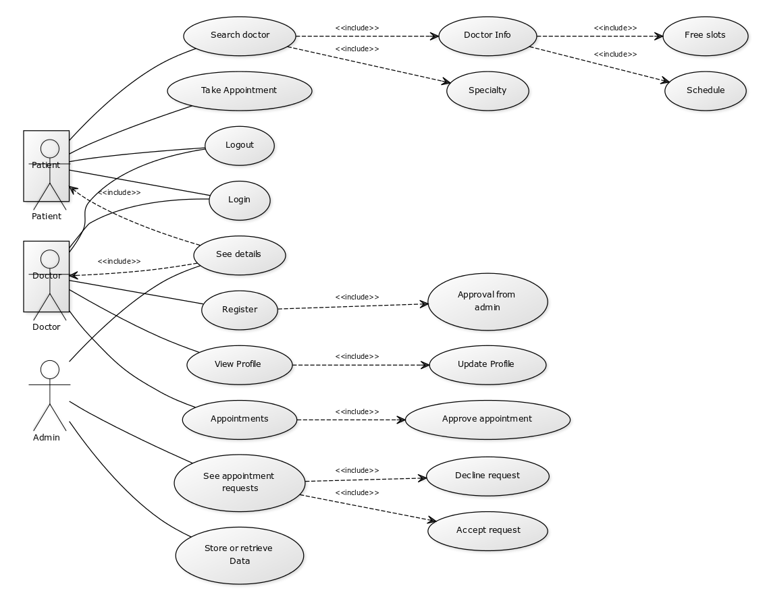

**DESCRIPTION:**

Login: The doctor/patient should be login before going to the further explore.

Search Doctor: the patient can select doctor based on various criteria.

Doctor Info: In doctor info, there will be details of doctor including their names, reviews, date and time of availability and schedule.

Take appointment: Patient can request for an appointment to a particular doctor.

Register: Doctor will register them from the registration page, which will be approving by admin.

View Profile: Every registered doctor has his/her own profile containing personal and professional details.

Update Profile: The doctor has the option to update his/her own profile.

Appointment: Doctor accept/rejects the request of patient for an appointment.

See Appointments requests: Admin panel will have authorities to accept or decline the appointment requests from patients.

Store or retrieve data: Admin can store or retrieve data.

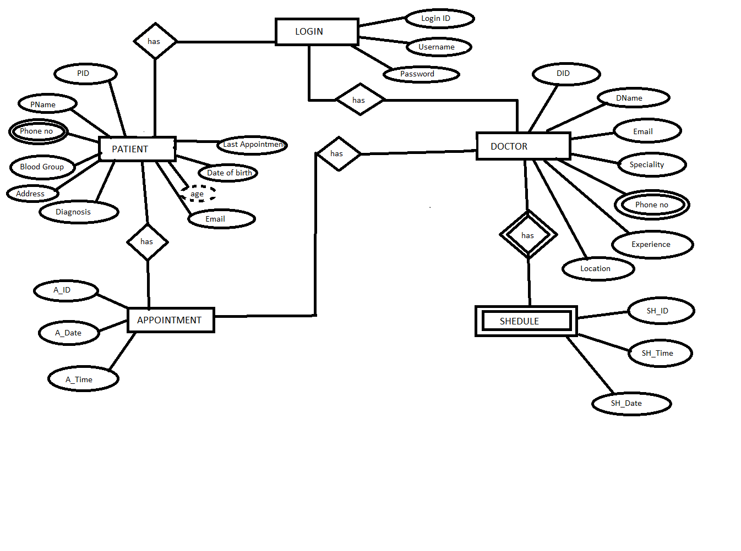**2.6. ERD DIAGRAM REPRESENTATION:**

**3.REQUIREMENTS ANALYSIS**

**3.1. SOFTWARE REQUIREMENT SPECIFICATION:**

The software requirement specification is produced at the culmination of the analysis task. The requirement that will deliver to the client is that we provide documentation and a presentation to go over the formal requirements of the project, both functional and non-functional. This deliverables ensures that group is working on the system that closely matches to the wishes of the client. The function and performance allocated to software as part of system engineering refined by establishing a complete information description, a detailed functional and behavioral description, an indication of performance requirements and design constraints, appropriate validation criteria and other data pertinent to requirements.

The requirements are splits into two sections:

* Functional requirements
* Non-functional requirements

The following sections state these requirements:

IMPORTANT FUNCTIONAL REQUIREMENTS:

* First set of functions is online registration including signup and login, selection of department, data, doctor and other online booking registration functions.
* Other one is data management that allows a database administrator (admin) to add, delete, modify and backup the data, Data addition, deletion and modification are the basic functions that are to be effectively maintained the consistency of the database to meet actual requirements. Data restore and backup is the systems security enhancer

OTHER FUNCTIONAL REQUIREMENTS:

1. Business rules:

* Given application will be delivered in 24 days.
* We don’t provide the code to the client, we will provide executable file to the client.
* Maintainece charges will be applicable whenever needed.
* There is no Warranty; however, Developers will do their best to fulfill requirements, but have no legal duties to do so.
* Money must be paid in PKR.

1. Administrative functions:

* Time savings: Staff spends less time on phone booking and managing appointments, thereby freeing up their schedule for more important and pressing tasks.
* Monetary savings: The time savings experienced by a facility can translate into monetary savings, as both staff time and services translate into expenses and revenue, respectively.
* 24-Hour Convenience: Scheduling appointments over the phone usually requires an individual to phone in during office hours, as few facilities offer round-the-clock phone booking. This is an inconvenience for most patients, as they too are working at this time. Additionally, many individuals prefer to schedule their appointments online rather than over the phone. A MediCo allows for 24-hour appointment services, not just during normal facility or office hours.

1. Authentication:

Security is must when there is an online system. Reputable providers incorporate the latest security measures and practices, such as secure server database, data storage and back-up procedures. We use the session-based authentication on our system, which will be easy to access for our client also. Session-based authentication is the preferred authentication mechanism now a day.

1. Authority: The system ensures high security, business integrity and confidentiality through full information log to the system by the administrator and eligible users. The system is defined by default according to user ID for persistence or denial to access information, for the reason of business and medical ethics.
2. Interface requirements:

User interface:

* The software provide good graphical interface for the user, admin can operate the system, performing the required task such as create, update, viewing the details of the appointments.
* Input from users will be via keyboard input, mouse point and click. The user will navigate through the software by clicking on icons and links. The icons will give appropriate responses to the given input.

**Hardware Interfaces:**

These are the minimum hardware interfaces:

* Processor: Pentium® Dual-core CPU
* RAM:256 MB
* Hard Disk:40 GB
* Operating system: Windows, Linux etc.

**Software Interfaces:**

These are the minimum software interfaces:

* Language: XAML
* Database: Microsoft sql server management studio 2015
* Browser: Any of chrome, Mozilla etc.

**NON-FUNCTIONAL REQUIREMENTS:**

1. Functionality:

The system shall be capable of providing configurable error messages, work flows and alerts.

1. Accuracy:

The online doctor appointment system shall display appointment time with appropriate time-zones.

1. Interoperability:

The system shall be capable of navigating seamlessly among related modules.

1. Security:

The system should be able to support any debugs or virus. Humans are error-prone but the negative effects of common errors should be limited.

1. Understandability:

The system shall be self-descriptive and explain itself through cues (e.g. Screen, area and group titles indicating the purpose of the respective interface element, explanations/answers available on requests and much more.

1. Usability:

The system shall be usable across multiples operating systems, browsers and platforms.

1. Testability:

The system shall provide criteria to enable the measurements to test pieces of code or functionality, or a provision added in the software so that test plans can be executed systematically.

1. Performance:

The system shall responses in 1 second after checking the patient information; system must support 100 people at a time.

1. Quality:

Good quality of the framework, bug free software which contains all necessary requirements and client satisfaction.

**3.2GENERAL REQUIREMENTS:**

* System needs store information about new entry of doctor.
* System need to maintain quantity record.
* System need to maintain the record of patient.
* System need to update and delete the record.
* Information should be tagged according to who is entering the data.
* Basic information must be stored.
* To provide login interface through which only authorized user can pass by.
* The MediCo (online doctor appointment system) portal will have three roles patient, doctors and admin.

**3.3QUESTIONAIRE SURVEY FOR COLLECTING INFORMATION OF PROPOSED SYSTEM:**

It is an effective tool for collecting and recording information about a particular system. A set of structured questionnaires would be distributed among 20 possible users in our circle in order to conduct quantitative research for MediCo.

**Justification Of Choosing The Questionnaires:**

The proposed system has three modules, Admin, Doctor and Patient. These three modules would have following deliverables:

Patient:

* Register them.
* Login and logout from the system.
* To view doctor’s list and view specifications of doctors.
* To book, update and cancel the appointments with doctor.

Doctors:

* To views patient’s details.
* To update doctor specification details.
* To view appointment.
* To show other doctors profiles.

Admin:

* To view doctors and patients details.
* To view appointment records.
* To update appointment records.
* To register new user to the system.

In order to identify the type and nature of information we need to collect from end-users, a set of questionnaires are prepared.

**Analysis Of Data Collection Through Questionnaire:**

A set of questionnaire was posted online through google form. The target audience for this research is regular day to day life populations who has internet access and are familiar with various online services. Analysis of each collected data is explained below:

QUESTION 1:

How often you use the internet?

Objective: To understand in what percent of the targeted audience have online access.

Results: From the response gathered, the majority of the participants have daily internet access which means 90% of the participants are familiar with online services. This result establishes the initial objective of the MediCo.

**QUESTION 2:**

How often you use online services?

Objective: In order to know to what extends of the participants understand the online reservation concept.

Results: Around 60% of participants are frequent online buyers. This data helps us to determine the range of the users that would be beneficial for our system MediCo.

**QUESTION 3:**

How often you purchase goods online?

Objective: To understands the user habit of using online services.

Results: Around 46.7% of the users purchase goods from various online services. This establishes the ground that the user wouldn’t face difficulties while using the MediCo.

**QUESTION 4:**

How often you suffer from non-severe health issues (e.g. headaches, flu etc.)?

Objective: This question aimed to understands the users pattern of illness to determine the user’s usability of the MediCo system.

Results: The majority opinion indicates that,56.7 % of users suffer from seasonal illness. This result in establishing the scope of the MediCo.

**QUESTION 5:**

Do you seek pharmaceutical drugs while suffering from flu?

Objective: To understands the user’s scope of using the proposed system.

Results: The majority of users stated that they would go to a clinic while suffering from viral flu. This indicates that,36.7 % of users would possibly be beneficial if they had the chance to make a doctor’s appointment online.

**QUESTION 6:**

Do u find it irritating to wait for an appointment at the clinic for non-severe illness?

Objective: To collect legitimate data to determine the issue faced by users in a traditional appointment environment.

Results: The data collected shows that,79.6% participants have agreed to the fact that they find it irritating to wait for an appointment especially for non-severe illness. This data is important to establish the ground that, local clinics could be beneficial from the MediCo.

**QUESTION 7:**

Do you have any chronicle issue?

Objective: To understand the user range for implementing the system in local clinics.

Results: 86.7 % participants stated that they do not suffer from any chronicle diseases. This result in establishes that small clinics dealing with non-chronical illness attends the majority of users. Thus, local clinics could be targeted user base.

**QUESTION 8:**

Do you think the manual appointment system is time consuming?

Objective: To understand the user’s perspectives of the manual appointment system.

Results: Majority of participants have stated that, the manual way of taking appointment is time-consuming.86.7% of people guides us to develop a time-consuming online system.

**QUESTION 9:**

Have you ever faced any difficulties while making an appointment over telephone?

Objective: To understand the convenience of users between manual and online appointment system.

Results: Even though the data collected from questionnaire shows a tie result of this question, majority of the participants agree on facing the difficulties while taking appointment over telephone.

**QUESTION 10:**

Manual appointment booking=g system limits your option to update their schedule because?

Objective: To determine the feature of the MediCo while comparing with the manual appointment booking system.

Result: The data shows that 50% of users would choose not to make a phone call and wait on line to take an appointment. This result helps us to determine the initial features of the system where users are able to make an appointment easily by sitting at home.

**QUESTION 11:**

Having an online appointment system would cause you much less time while making an appointment.

Objective: To establish the ground of how MediCo would cause the users much less time.

Results: Majority of the participants agreed in the time-consuming factor on manual appointment booking system.

**QUESTION 12:**

In what ways online appointment system making beneficial for you?

Objective: In order to understand the beneficial factors of MediCo.

Results: 30% people would prefer not to wait on telephone for appointment confirmation. While 43.4 % would prefer to be able to make changes in their appointments, this results also help us to determine the initial requirements of the system.

**QUESTION 13:**

An effective online appointment system should emphasize more on

Objective: To gather more user requirements for the system.

Results: The collected data determines more requirements for Medico, since majority of the users would prefer a system that is quick responsive and is able to provide better quality service, the focus of us will be working on this criteria.

**Analysis Of Data Gathered From Questionnaires:**

The response collected through this survey would guide us to categorize the prime features of the system. According to data collected, following are the analyses results:

* MediCo would be accessible to majority of users who are very much similar with the services that MediCo offers.
* MediCo would be less-time consuming.
* MediCo would be implemented in small local clinics where patients come for non-severe illness.

Based on the data collected, the MediCo would provide the users navigated services that are less time consuming.

**4. DEVELOPMENT METHODOLOGY:**

**4.1. IDENTIFICATION OF CHOSEN METHODOLOGY:**

**[Agile Methodology]**

During a system development lifecycle, two main factors are considered:

*“To emphasize on process and the quality of the software and process itself.”*

Since software development is a complex field that contains countless variables impacting the system, any developer would always seek for an organized structure that could be used as a base for developing the system. Different software developing methods have different characteristics of processes to reach completion of system. All software systems are imperfect because they cannot be built with physical or mathematical certainity.Thus, system development methods are introduced in order to provide developer a base line of processes and sequences to follow while building a system.

In our software, we select agile methodology. In general, terms, agile process is an iterative approach that prioritizes customer satisfaction and customers have direct involvement evaluating the software. Agile method follows the software development lifecycle that includes requirements gathering, analysis, and design, coding and testing. As a result, the approach delivers partially implemented software and waits for customer feedback.

**4.2. JUSTIFICATION TO AGILE APPROACH:**

Agile method is programming centric. While other methodologies are mainly based on the premise that software development processes are to be repeatable just predictable, agile framework emphasize on unit-by-unit development.

The aim of agile method is to allow organizations to be agile in terms of delivering the product quickly. Agile approach is the combination of group of methods. While agile techniques vary in emphasize and practices, they have common characteristics including iterative development and focus on interaction, communication and the resource-intensive intermediate artifacts.

One of the key reasons why developer chose agile methods for proposed system is that agile approach is able to identify and respond to changes more quickly than using other traditional approaches.

While selecting a development methodology for a system, Agile method was the developer’s first choice because agile process requires less planning and it divides tasks into small increments. Following this approach while developing an online doctor appointment system would allow the developer to make necessary changes according to user satisfaction.

**4.3. DESCRIPTION OF METHODOLOGY:**

Agile development methods break a problem into smaller tasks. The processes do not required direct ling-term planning for any requirements. Agile method provides modularity to the system. It decompose the complete system into manageable pieces called modules. Modularity is an important role in software development. Following agile process would allow the developer to plan iterations that are of short period such as one to four weeks.as agile is iterative in nature; it requires time limits on each module with respective cycle, thus providing the developer with sufficient time window to work on each module. The process produces increments and each increment in independent of others that would allow the developer to integrate all the increments into complete system. Agile approach is adaptive. The adaptive nature of the method allows the developer to design the system in an order that would adapt possible risks on its way to development.

**4.4. AGILE MANIFESTO:**

Agile methods stress productivity and values over heavyweight process overhead and artifacts. Agile manifesto is a combination of agile software development methodologies. In 2001, founders of many agile system development methods gathered with others who were also implementing various agile methods in the same field and created ‘agile manifesto’.

The manifesto for agile development is:

**“We are uncovering better ways of developing of software by doing it and helping others to do it. Through this work we have come to value:**

**Individual and interactions over processes and tools**

**Working software over comprehensive documentation**

**Customer collaboration over contract negotiation**

**Responding to change over following a plan”**

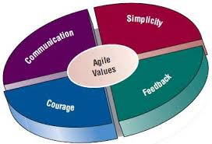

**AGILE MANIFESTO MODEL**

**4.5. PRINCIPLES OF AGILE:**

Following are the principles of agile we followed in our system:

1. Customer satisfaction:

Customer satisfaction is to satisfy user’s requirements through early and continuous delivery of valuable software, our software considered the users requirements through all process of completing this software.

2. Welcoming changes:

We make changes in each and every step, even on the last moment as well, we made the feasibility report twice, and we create a database again and again due to problems coming in it.

3. Delivering working software:

Because we have shorter-time scale, we tried our best to deliver the working software.

4. Collaboration:

In our system, there is interaction between user and developer.

5. Motivation:

The agile methodology provides an environment to support the developer in decision making.in our system; we provide the motivated environment during our whole development process of software.

6. Face-to-face conversation:

During development of each stage, we tried to have a string interaction between users developers and our team and the most effective way for this is face to face communication for us which was more easy way to convey our thoughts, ideas to the developer.

7. Measures the progress as per working software:

Working software is primary measure of progresses during system development. For this, we measured the progress of process at each step.

8. Maintaining constant Pace:

Maintaining the constant pace is one of the most import principles, and we tried our best to achieve consistent results over and over each step of process.

9. Monitoring:

We monitored each process of development from feasibility until documentation, especially in creating the application, during coding.

10. Simplicity:

We make this application as simple as we can so that everyone can use this software easily.

11. Self-organized team:

As the developer for Medico, by following the agile approach the developer of our system is able to self-organize the tasks during the system development and implementation.

12. Review the work regularly:

We reviewed the work every day in order to produce a more effective system.

**4.6. AGILE METHODOLOGIES:**

There are several methodologies that could be implemented during the development of online doctor appointment system, but we focus on scrum approach.

**SCRUM APPROACH:**

We choose scrum, because scrum is the most widely used agile method. This methodology is flexible and based on incremental software development processes in scrum approach; the entire development cycle is divided into a series of iteration where each iteration is named as sprint. There are three main artifacts produced by scrum method:

* Product backlog
* Sprint backlog
* Sprint burn-down chart

**4.7. OVERVIEW OF SCRUM PROCESS:**

The scrum process is composed of three phases:

* Pre-sprint planning:

Works are that are to be done on the system are kept in ‘release back log’. For the proposed system, user requirements and functions of the system are gathered in release blog. Then one by one, the functionalities such as user login, doctor’s list, available time slots, appointment booking, and updating are moved to sprint backlog.

The tasks in the backlog are generally at a higher level of abstraction, thus pre-sprint planning is able to identify a sprint goal that determines the core and reason of task.

* Coding:

During the sprint backlog phase, code is integrated

for each sprint such as homepage for login for users, and doctors portal. Next developer tests the acceptability of each of these functions daily.

* Post sprint review:

After every sprint, the developer to test project progress and demonstrate the functions, design, strength, weakness and trouble spots of the proposed system would carry out a post-sprint analysis.

**4.8. CONCLUSION OF SCRUM-BASED APPROACH:**

The prime prevalence of agile project management, especially the scrum-based approach is its simplicity. One of the major components in scrum approach is roles, the Scrum Master. In this project, the one of our team member act as a scrum master who is responsible for self-organization and maintains the product’s progress in a series of month-long ‘sprints’. We will be able to develop, test and organize feature of MediCo effectively. By focusing on eliminatory unnecessary bureaucracy, process and practice in managing the project, agile methodology will make it possible for us to eliminate re-occurring errors and actually finish the project on time.

**4.9. SPRINTS PLANNING:**

As we have short time for the development of the project so, we divided the each sprint into 12 days, each sprint is of approximately 12 days, and following are the lists of requirements and set milestones:

**Sprint 1**

Milestone 1(2nd July- 4th July) (Requirement Analysis): This is the initial stage of software development, where we gather information for our project and highlight the main objectives of our project.

Milestone2 (5th July-7th July) (User Design): In this stage, we will create a feasibility report of our project and design prototype or sketch.

Milestone3 (8th July-10th July) (Software Architecture and design): After making the prototype, we will establish system architecture; both hardware and software that matches the requirements of project, in this design we also design the DFDs.

Milestone4 (11th July-13th July) (Workable code and release): After the designing phase, we will start implementation, coding and then test the project and a workable code will be present.

**Sprint 2**

Milestone1 (14th July-16th July) (meeting and requirement analysis): In this stage, we shared the work that distribute among all members, meetings minutes documented as well.

Milestone2 (17thJuly-19th July) (user design): We will also discuss the GUI designing.

Milestone3 (20thJuly-21stJuly) (Add functionality to the Project): When the designing phase is being done, we added functionality to the software according to our need. Functionality includes how the software works; means which button perform which task, connectivity with database etc.

Milestone4 (22nd July-24th July) (Workable Code): After adding functionality and integrating the previous code, we tested that code again.

**Sprint 3:**

Milestone1 (25thJuly-27th July) (Final requirement gathering): After implementing all the code and testing twice we will check the code and GUI design if anything needs revision.

Milestone2 (28th July-30th July) (Creating ERD (Entity Relationship Diagram): In ERD modeling we will decide that how our database will interact with our software.

Milestone3 (31st July -2nd Aug) (Creating the database): After designing the whole project, we will create a database for our project where the data will save, where user can store and retrieve the data.

Milestone4 (3rd Aug-5th Aug) (Final release, presentation and documentation): Now at this stage project is ready to deploy and formal documentation is prepared to be present.

**4.10.CHART REPRESENTATIONS OF SPRINTS PLANNING:**

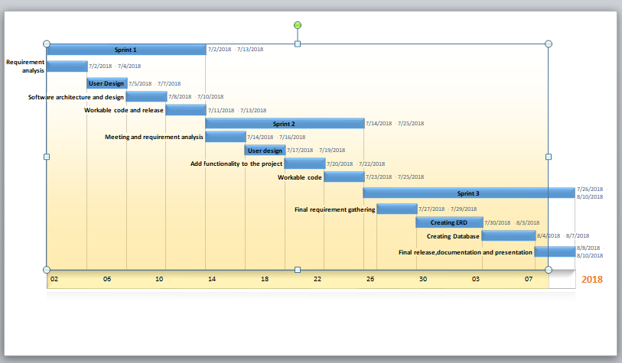

**4.11. PERT CHART:**

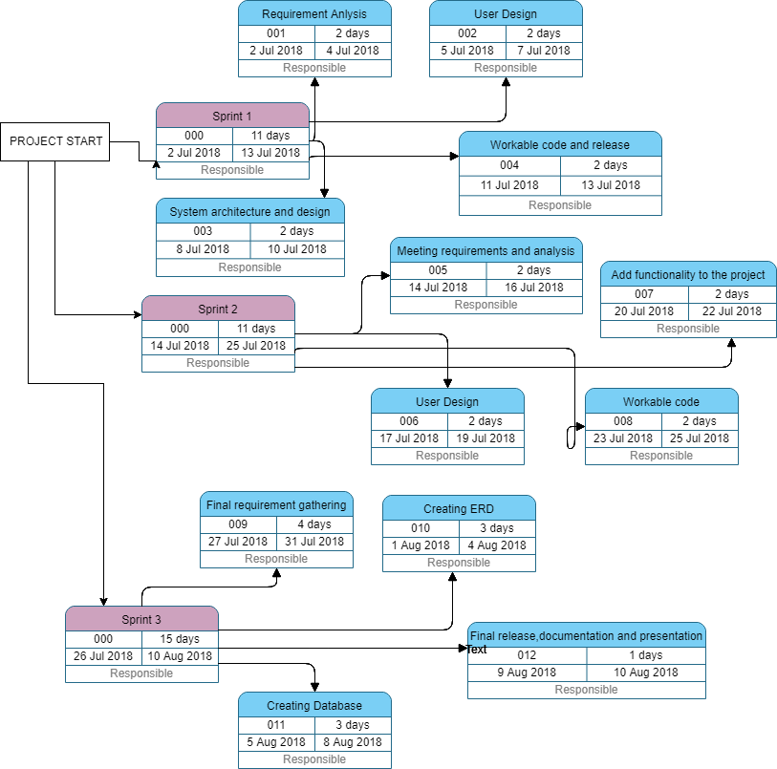

**5. ILLUSTRATION DIAGRAM**

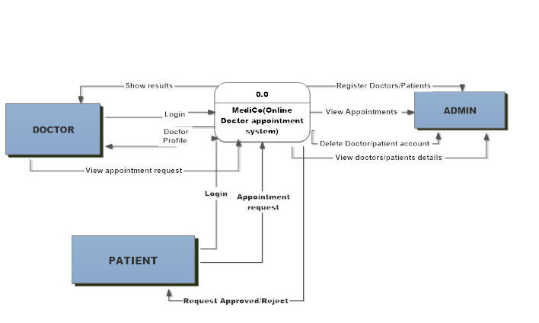**5.1. CONTEXT DIAGRAM:**

Fig 1: CONTEXT DIAGRAM OF MediCo(Online Doctor Appointment System)shows the interaction between users(Doctors,Admin and Patients) and system(MediCo).Patient can request for appointment, Doctor can see all of his/her appointments and Admin can supervise all the activities.

**5.2. LEVEL 0 DFD:**

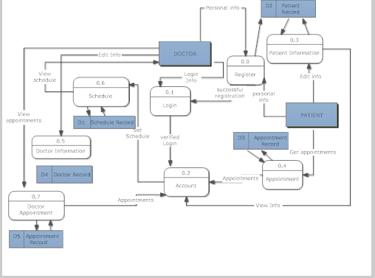

Fig 2: LEVEL 0 DFD FOR MediCo (Online Doctor Appointment System) shows level zero DFD for both patient and doctor.

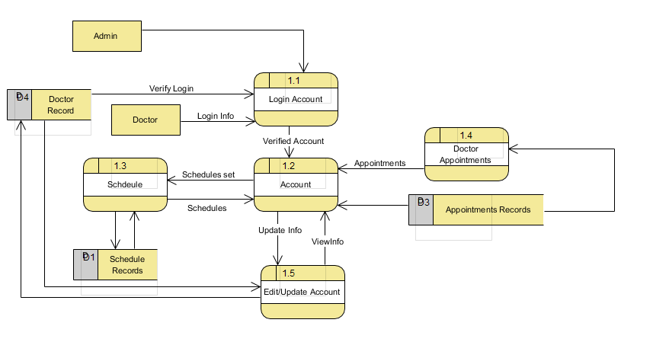**5.3. LEVEL 1 DFDS:**

Fig 3: LEVEL 1 DFD FOR DOCTOR shows the login process, all the updating information’s is stored in data stores and can be view by admin.

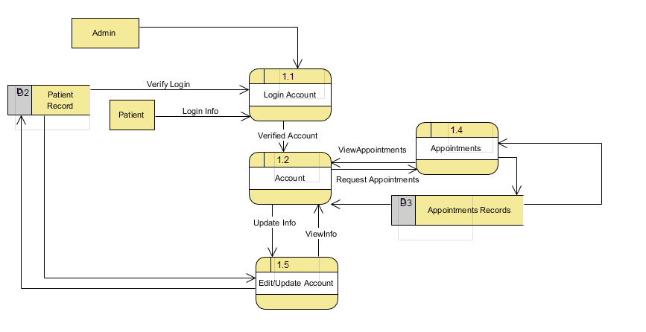

Fig 4: LEVEL 1 DFD FOR PATIENT shows the level one DFD for patient, signup, login.

**5.6. LEVEL 2 DFD:**

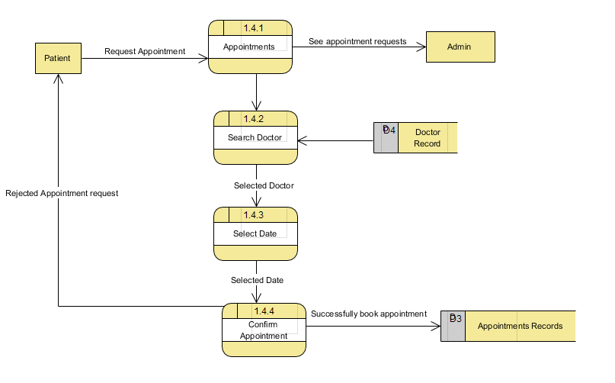

Fig 5: LEVEL 2 DFD FOR PATIENT; it is the expansion of process appointment from level one DFD of patient

**6. TESTING:**

Software testing is an investigation conducted to provide stakeholders with information about the quality of the product or service under test. The scope of software testing often includes examination of code along with execution of that code in different environments and issues as well as inspecting the aspects of code. Does it do what it is supposed to do? Does it give to desired result? Does it check predefined conditions? Moreover, do what it needs to do. Resources and information derived from software testing may be utilized to correct the process that can be used in software development.

**6.1. TESTING:**

The testing of the system is starts when we start coding. In every step of coding of the software, testing works as an important part of checking that it is okay or not. To verify and validate all activities we used different types and methods of testing. It helps to ensure that it is working fine and requirements are met properly.

**6.2. TESTING METHODS:**

There are many approaches available in software testing. For our system, we specify all of its functions in requirement. Than we design the interface. After then we started to implement the internal functions. In addition, test each functions operate fully with different test case. Following are the description of testing methods, which we test in our system.

**6.3. BOX-TESTING APPROACH:**

We used the box approach testing. In box approach, testing methods are of three types:

* Black-box testing
* White-box testing
* Grey-box testing

**6.4. BLACK-BOX TESTING:**

Black box testing is the testers are only aware of what the software supposed to do, not how it does it. This test is performing in the presence of user. We performed the black box testing by giving the software to one of our friend to use. He tried different portion of the software and give the results. From his results, we found different problems of the system. We tried to solve those problems. Some problems are given below:

**Test source Input Expected Output Output Comments**

First Name Sameer-Hasan Accepted Not Accepted First name may contain white space, but it does not take it. (Solved)

Last Name Not accepted Not Accepted Last Name couldn’t empty.

Email [Sam@Yahoo.com](mailto:Sam@Yahoo.com) Accepted Not Accepted Valid Email-add but already in used (Solved)

Patient ID 0ABC Not Accepted Not Accepted Patient ID can’t be a alphabets, it

Only contain a numbers.

**6.5. WHITE-BOX TESTING:**

In this type of testing all the lines, loops and logical expressions of code is tested by executing the program. We did some testing in the software by white-box testing. Following are some test results:

* When a user wants to select an appointment date, which is already passed, system will alert him/her by showing the alert box.
* When a user want to take appointment more than one in a same date, it can’t be done.

**6.6. TESTING LEVEL:**

Test is frequently grouped by where they are added in the software development process. There are four level of process:

* UNIT TESTING:

It is also known as component testing refers to tests that verify the functionality of specific section of code, usually at the function level. Developers usually write these type pf tests as they work on code, to ensure that the specific function is working as expected. In our system unit testing is done by visual studio 2015 feature ‘Create Unit Test’ that provides the ability to create unit test methods stubs. It is the most suitable and easy way of doing unit testing, after doing unit testing of our system we find some sort of problems in the code but we solved that then we were good to go.

* INTEGRATION TESTING:

Once we have unit tests covering the critical parts of the application, then we started assembling the parts. Interfaces between different components of system are good places for mistakes, so the integration of components needs to be tested as well. This is what integration testing is all about. Therefore, in integration testing we tested the whole module as different parts are combined together. We tested to ensure that user is logged in, he/she linked to appropriate page, and could access to database.

* INTERFACE TESTING:

It is used to check the handling of data passed between various units, or subsystems components, beyond full integration tests between those units. For interface testing, when we completed patient module test it integration parts then we combined its results with doctor module. Check the data and pass the value from the patient module are correctly found in doctor module or not, similarly for admin module as well.

* SYSTEM TESTING:

Once all bricks are combined into a system. This system may not be functioning as expected, even if integration test have not revealed anything wrong. Here system test is applied on the system. System test is also called end-to-end testing to check if system meets all its requirements, for this testing as the whole system is completed at a stage we checked whether the all system is working fine or not. If there are any contradiction among modules.

**6.7. TESTING TYPES:**

Following are the types of testing:

* **Alpha Testing:**

The focus of this testing is to identify all possible bug/issues before release the product or give to users. The black-box an white-box techniques are type of this testing. During alpha testing, one of u who wrote the requirements will check the system if the system is truly aligns with the vision of the system or not.

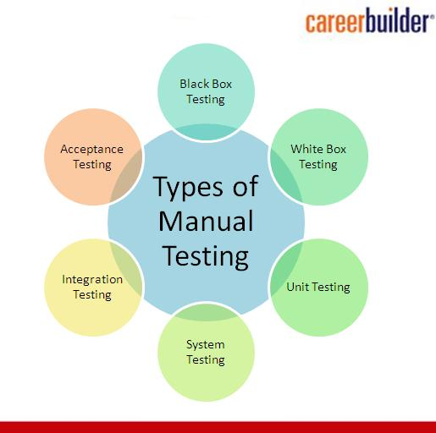

**6.9 IMPORTANCE OF TESTING:**

Testing of a system helps to improve overall performance. It also ensures reliability and efficiency; it also does the following:

* Improve the quality of the system.
* It is a process used to identify the correctness, completeness, and quality of the developed system.
* Software testing is an activity to check whether the actual results match the expected results and to ensure that the proposed system is defect free.

**7. SOFTWARE MAINTENANCE:**

To enhance overall performance or other qualities of the software it is important to maintain your software. Maintenance is evolutionary development and that maintenance decisions are aided by understanding what happens to software over time. Software maintenance is categorized into four classes:

* Adaptive
* Perfective
* Corrective
* Preventive

**7.1. ADAPTIVE:**

The adaptive maintenance, modifying or change the system to cope with changes in the software environment where it will work. It is used to make a computer program usable in a changed environment. As we are working in a team, we have software in one of us laptop, so when it will work in another computer or laptop then the configuration of hardware and software will not be same. We do not perform this maintenance yet. Therefore, we have to consider all of conditions and influences that act from outside of the system like government policy, business rules, software platforms, work patterns, hardware upgrades etc. after delivery.

**7.2. PERFECTIVE:**

It is to extend the software beyond its original functions. Some users want more. After delivering the software to the user we have to concern that, some users may want more features and functions in a system. So using perfective maintenance, we will change our software with user’s new requirements later on.

**7.3. CORRECTIVE:**

It is to diagnosing and fixing errors, possibly that is found by users. For this one we need to have a string debugging and interpersonal skills. For this type of maintenance we give the software to the person for use, they use it and told me where they faces the problem or any difficulty, we tried our best to solve that problems.

**7.4. PREVENTIVE:**

It is performed to increase software maintainability or reliability to prevent problems in the future and for preventing problems before they occur. We checked our best to removing coding errors, logical errors, and performance of each module, unwanted input error. So preventive maintenance is almost done. We use alert and confirm message boxes in every section of user and admin panel before doing something which might cause problem further, so that user will be alerted before doing something wrong.

**7.5 IMPORTANCE OF MAINTENANCE:**

Software maintenance is very much important than making a software. If proper maintenance will not be done, that software will be unusable. It completely identifies all users’ requirements; know about unexpected errors found by users.

**8. PROBLEMS**

Development of software is not as easy as we think, especially in the case when we have short period to develop the system. Following are the some problems, which we faced during the development of the software from initial to the final stage of development:

1. DECIDING THE METHODOLOGY:

One of the initial problem we face while working on the software was deciding the methodology as we are working on our first working software so we have to see the all aspects of development and fir thus reason we again and again getting confuse to choosing the methodology.

1. REVISIONS IN FEASIBILITY REPORT:

Due to delay in deciding the methodology, we made the feasibility report twice.

1. PROBLEMS IN DATABASE:

Due to problem in database connectivity once, then again we get the problem in connecting the database with the created application.

1. SYSTEM CRASH:

During the development of the software, the system in which we are working is crashed and due to that we loss the work which we did till that time.

**9. ADVANTAGES OF THE MediCo (ONLINE DOCTOR APPOINTMENT SYSTEM)**

User of this system can be benefited in the following ways:

* It is a web-based application and easy to use.
* It will save money and time of users, as they need not to go to hospital for appointment or not over telephone.
* Update and modification of the users profile is very much easy.
* Doctor, patients and admin all have to login by using username and password to access their information.
* Doctor can see all of his/her appointments prior any time.
* Doctor can change or modify his/her time and schedule any time.

**10. IMPORTANCE OF THE MediCo (ONLINE DOCTOR APPOINTMENT SYSTEM)**

This project has been a challenging journey for us. A brief concept of research has been conducted in order to construct a development framework and development methodology. While selecting the methodology we looked into several software developer methods a gathered brief knowledge about the concepts. However, the similar systems followed the traditional waterfall method but we chose the agile approach, the simplicity and organized framework of the agile method would be great choice for MediCo. Many background readings have been done to plan a primary research design. Questionnaires have been conducted in order collect initial requirement data .this way we were able to determine the system functionalities. Microsoft visual studio is used as developing environment because we were familiar with IDE. We implemented WPF XML framework for the execution of the system.

**10. CONCLUSION:**

After finishing our project, we have to state that we tried our best to develop the software in the most suitable, helpful and easiest, method that can be used by user easily. This is web base application and it will be going to accessible from any computer via internet. It is the great improvement over the manual system. We have tested the system using several techniques to determine the system flexibility. The system is secure as user can modify the information only after the proper authentication. Chances of error are also eliminated to large extent. The system is highly user-friendly.

We have left all the options open so that if there is any further future requirements in the system needed by the user for the enhancement of the system then it is possible to implement them. We hope that the project will serve its purpose for which it is develop there by underlining success pf process.