

**Name: Zain Kashif**

**Roll no: L1F22BSCS1110**

**INTRODUCTION TO DATABASE MANAGEMENT SYSTEM**

**Project Name: Rescue Management System**

**ERD (ENTITY RELATIONSHIP DIAGRAM):**

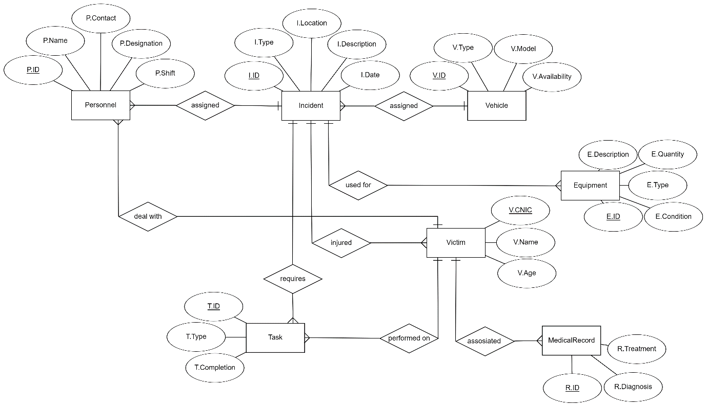

**RS (RELATIONAL SCHEMA):**

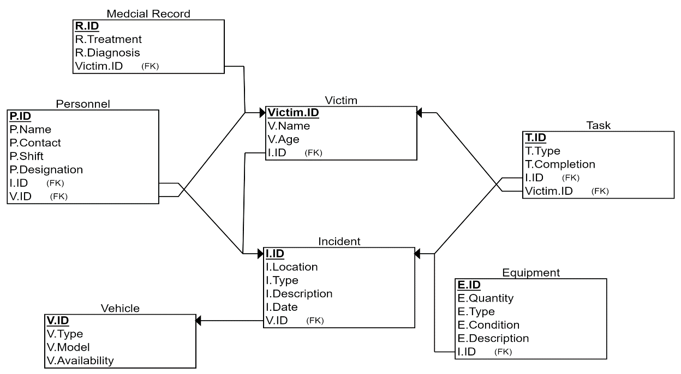

**SQL (DDL, DML):**

create database RescueManagementSystem;

use RescueManagementSystem;

create table Incident

(

IncidentID varchar (10) Primary Key,

IncidentType varchar (10),

IncidentLocation varchar (25),

IncidentDescription char (15),

IncidentDate Date

);

create table Personnel

(

PersonnelID varchar (10) Primary Key,

PersonnelName char (10),

PersonnelContact varchar (15),

PersonnelDesignation char (10),

PersonnelShift char (10)

);

create table Vehicle

(

VehicleID varchar (10) Primary key,

VehicleType char (10),

VehicleModel int (4),

VehicleAvailability char (10)

);

create table Equipment

(

EquipmentID varchar (10) Primary Key,

EquipmentType varchar (10),

EquipmentQuantity int (5),

EquipmentCondition char (20),

EquipmentDescription char (15)

);

create table Victim

(

VictimCNIC varchar (15) Primary key,

VictimName char (10),

VictimAge int (2)

);

create table Task

(

TaskID varchar (10) Primary Key,

TaskType varchar (10),

TaskCompletion char (15)

);

create table MedicalRecord

(

RecordID varchar (10) Primary Key,

RecordTreatment char (10),

RecordDiagnosis char (10)

);

insert into Incident(IncidentID ,IncidentType ,IncidentLocation ,IncidentDescription ,IncidentDate)

values ('A1' ,'Type1' ,'Street#5 ParagonCity' ,'Sucide Attempt' ,'03-05-24'),

('A2' ,'Type3' ,'Canal Road' ,'Bike Accident' ,'05-05-24'),

('A3' ,'Type2' ,'JoharTown' ,'Gun shots' ,'07-05-24'),

('A4' ,'Type5' ,'Saddar Cantt' ,'Car Accident' ,'09-05-24'),

('A5' ,'Type4' ,'GarhiShahu' ,'Fire' ,'11-05-24');

insert into Personnel(PersonnelID ,PersonnelName ,PersonnelContact ,PersonnelDesignation ,PersonnelShift)

values ('P1' ,'Mubeen' ,'+92 1234567890' ,'HOD' ,'Day'),

('P2' ,'Zunorain' ,'+92 0987654321' ,'Doctor' ,'Day'),

('P3' ,'Areeba' ,'+92 1357924680' ,'Doctor' ,'Night'),

('P4' ,'Jahanzaib' ,'+92 2143658709' ,'Driver' ,'Night'),

('P5' ,'Zaryaab' ,'+92 1234509876' ,'Driver' ,'Day');

insert into Vehicle(VehicleID ,VehicleType ,VehicleModel ,VehicleAvailability)

values ('V1' ,'Sudan' ,2014 ,'Yes'),

('V2' ,'Hashback' ,2022 ,'Yes'),

('V3' ,'Vagon' ,2010 ,'Yes'),

('V4' ,'Bus' ,2016 ,'No'),

('V5' ,'Bike' ,2023 ,'Yes');

insert into Equipment(EquipmentID ,EquipmentType ,EquipmentQuantity ,EquipmentCondition ,EquipmentDescription)

values ('E1' ,'Type1' ,8 ,'Good' ,'Imported'),

('E2' ,'Type3' ,15 ,'Best' ,'Imported'),

('E3' ,'Type2' ,31 ,'UpgraRequired' ,'Local'),

('E4' ,'Type5' ,9 ,'Acceptable' ,'Local'),

('E5' ,'Type4' ,45 ,'Good' ,'Imported');

insert into Victim(VictimCNIC ,VictimName ,VictimAge)

values ('11223-344556-67','Zain',19),

('99887-766554-43','Zayn',20),

('12345-123456-12','Zaini',21),

('13579-246801-23','Zayni',22),

('19283-746352-41','Zaynimani',23);

insert into Task(TaskID ,TaskType ,TaskCompletion)

values ('T1','Type1','Completed'),

('T2','Type2','NotCompleted'),

('T3','Type3','Reaching'),

('T4','Type4','Completed'),

('T5','Type5','Reached');

insert into MedicalRecord(RecordID ,RecordTreatment ,RecordDiagnosis)

values ('R1','Done',Null),

('R2','Done',Null),

('R3','Done',Null),

('R4','Done',Null),

('R5','Done',Null);

update Incident

set IncidentID = 'I1'

where IncidentID = 'A1';

update Incident

set IncidentID = 'I2'

where IncidentID = 'A2';

update Incident

set IncidentID = 'I3'

where IncidentID = 'A3';

update Incident

set IncidentID = 'I4'

where IncidentID = 'A4';

update Incident

set IncidentID = 'I5'

where IncidentID = 'A5';

update Equipment

set EquipmentCondition = 'Update Required'

where EquipmentID = 'E3';

alter table MedicalRecord

drop column RecordDIagnosis;

alter table MedicalRecord

add column Payment char (15);

update MedicalRecord

set Payment = 'Successful';

update MedicalRecord

set Payment = 'Pending'

where RecordID = 'R3';

alter table MedicalRecord

add column VictimCNIC varchar (15);

alter table MedicalRecord

add Foreign Key (VictimCNIC)

references Victim (VictimCNIC);

update MedicalRecord

set VictimCNIC = '11223-344556-67'

where RecordID = 'R1';

update MedicalRecord

set VictimCNIC = '99887-766554-43'

where RecordID = 'R2';

update MedicalRecord

set VictimCNIC = '12345-123456-12'

where RecordID = 'R3';

update MedicalRecord

set VictimCNIC = '13579-246801-23'

where RecordID = 'R4';

update MedicalRecord

set VictimCNIC = '19283-746352-41'

where RecordID = 'R5';

desc Incident;

select * from Incident;

desc Personnel;

select * from Personnel;

desc Vehicle;

select * from Vehicle;

desc Equipment;

select * from Equipment;

desc Victim;

select * from Victim;

desc Task;

select * from Task;

desc MedicalRecord;

select * from MedicalRecord;

select IncidentID,IncidentLocation from Incident;

select TaskID,TaskCompletion from Task

where TaskCompletion in ('Completed','Reached','Reaching');

select VictimCNIC,VictimAge from Victim

where VictimAge between 20 and 23;

select * from Victim

where VictimName like '%i';

select * from Vehicle

where VehicleAvailability = 'Yes';

select distinct (EquipmentCondition) from Equipment;

select * from Victim

where VictimName like '--y%';

SQL JOINS:

INNER JOIN:

use RescueManagementSystem;

SELECT I.IncidentID,I.IncidentType,P.PersonnelID,P.PersonnelName

FROM Incident AS I

INNER JOIN Personnel AS P ON I.IncidentID = P.PersonnelID;

SELECT V.VehicleID, V.VehicleType, E.EquipmentID, E.EquipmentType

FROM Vehicle V

INNER JOIN Equipment E ON V.VehicleID = E.EquipmentID;

SELECT V.VictimCNIC, V.VictimName, M.RecordID

FROM Victim V

INNER JOIN MedicalRecord M ON V.VictimCNIC = M.RecordID;

SELECT T.TaskID, T.TaskType, I.IncidentID, I.IncidentDescription

FROM Task T

INNER JOIN Incident I ON T.TaskID = I.IncidentID;

SELECT P.PersonnelID, P.PersonnelName, V.VehicleID, V.VehicleModel

FROM Personnel P

INNER JOIN Vehicle V ON P.PersonnelID = V.VehicleID;

LEFT JOIN:

SELECT I.IncidentID, I.IncidentType, P.PersonnelID, P.PersonnelName

FROM Incident I

LEFT JOIN Personnel P ON I.IncidentID = P.PersonnelID;

SELECT V.VehicleID, V.VehicleType, E.EquipmentID, E.EquipmentType

FROM Vehicle V

LEFT JOIN Equipment E ON V.VehicleID = E.EquipmentID;

SELECT V.VictimCNIC, V.VictimName, M.RecordID

FROM Victim V

LEFT JOIN MedicalRecord M ON V.VictimCNIC = M.RecordID;

SELECT T.TaskID, T.TaskType, I.IncidentID, I.IncidentDescription

FROM Task T

LEFT JOIN Incident I ON T.TaskID = I.IncidentID;

SELECT P.PersonnelID, P.PersonnelName, V.VehicleID, V.VehicleModel

FROM Personnel P

LEFT JOIN Vehicle V ON P.PersonnelID = V.VehicleID;

RIGHT JOIN:

SELECT I.IncidentID, I.IncidentType, P.PersonnelID, P.PersonnelName

FROM Incident I

RIGHT JOIN Personnel P ON I.IncidentID = P.PersonnelID;

SELECT V.VehicleID, V.VehicleType, E.EquipmentID, E.EquipmentType

FROM Vehicle V

RIGHT JOIN Equipment E ON V.VehicleID = E.EquipmentID;

SELECT V.VictimCNIC, V.VictimName, M.RecordID

FROM Victim V

RIGHT JOIN MedicalRecord M ON V.VictimCNIC = M.RecordID;

SELECT T.TaskID, T.TaskType, I.IncidentID, I.IncidentDescription

FROM Task T

RIGHT JOIN Incident I ON T.TaskID = I.IncidentID;

SELECT P.PersonnelID, P.PersonnelName, V.VehicleID, V.VehicleModel

FROM Personnel P

RIGHT JOIN Vehicle V ON P.PersonnelID = V.VehicleID;

FULL OUTER JOIN:

SELECT I.IncidentID, I.IncidentType, P.PersonnelID, P.PersonnelName

FROM Incident I

LEFT JOIN Personnel P ON I.IncidentID = P.PersonnelID

UNION

SELECT I.IncidentID, I.IncidentType, P.PersonnelID, P.PersonnelName

FROM Incident I

RIGHT JOIN Personnel P ON I.IncidentID = P.PersonnelID;

SELECT V.VehicleID, V.VehicleType, E.EquipmentID, E.EquipmentType

FROM Vehicle V

LEFT JOIN Equipment E ON V.VehicleID = E.EquipmentID

UNION

SELECT V.VehicleID, V.VehicleType, E.EquipmentID, E.EquipmentType

FROM Vehicle V

RIGHT JOIN Equipment E ON V.VehicleID = E.EquipmentID;

SELECT V.VictimCNIC, V.VictimName, M.RecordID, M.RecordDiagnosis

FROM Victim V

LEFT JOIN MedicalRecord M ON V.VictimCNIC = M.RecordID

UNION

SELECT V.VictimCNIC, V.VictimName, M.RecordID

FROM Victim V

RIGHT JOIN MedicalRecord M ON V.VictimCNIC = M.RecordID;

SELECT T.TaskID, T.TaskType, I.IncidentID, I.IncidentDescription

FROM Task T

LEFT JOIN Incident I ON T.TaskID = I.IncidentID

UNION

SELECT T.TaskID, T.TaskType, I.IncidentID, I.IncidentDescription

FROM Task T

RIGHT JOIN Incident I ON T.TaskID = I.IncidentID;

SELECT P.PersonnelID, P.PersonnelName, V.VehicleID, V.VehicleModel

FROM Personnel P

LEFT JOIN Vehicle V ON P.PersonnelID = V.VehicleID

UNION

SELECT P.PersonnelID, P.PersonnelName, V.VehicleID, V.VehicleModel

FROM Personnel P

RIGHT JOIN Vehicle V ON P.PersonnelID = V.VehicleID;

CROSS JOIN:

SELECT I.IncidentID, I.IncidentType, P.PersonnelID, P.PersonnelName

FROM Incident I

CROSS JOIN Personnel P;

SELECT V.VehicleID, V.VehicleType, E.EquipmentID, E.EquipmentType

FROM Vehicle V

CROSS JOIN Equipment E;

SELECT V.VictimCNIC, V.VictimName, M.RecordID

FROM Victim V

CROSS JOIN MedicalRecord M;

SELECT T.TaskID, T.TaskType, I.IncidentID, I.IncidentDescription

FROM Task T

CROSS JOIN Incident I;

SELECT P.PersonnelID, P.PersonnelName, V.VehicleID, V.VehicleModel

FROM Personnel P

CROSS JOIN Vehicle V;