University of Central Punjab

ISD TERM PROJECT

Software Requirements Specification

TravelSphere - Travel Agency Website



|  |  |
| --- | --- |
| Project Advisor  **Arshia Naeem**  Presented by:  **Group ID: Group# 5** | |
| Student Reg# 1110 | Student Name: Zain Kashif |
| Student Reg# 1101 | Student Name: Rahima Farrukh |

**Faculty of Information Technology**

University of Central Punjab

University of Central Punjab

**Software Requirements Specification**

**Version: Search Engines**

**TravelSphere - Travel Agency Website**

**Advisor: Arshia Naeem Group # 5**

**Members Contribution**

|  |  |  |  |  |  |
| --- | --- | --- | --- | --- | --- |
| **Members Name** | **Primary Responsibility** | **%**  **Contribution** | **Roll No** | **Serial #** | **Sign** |
| **Zain Kashif** | **Complete Ch 1,**  **Ch 3, Ch 4, Ch 7, Ch 8 and Ch 9** | **50%** | **1110** |  |  |
| **Rahima Farrukh** | **Complete Ch 1,**  **Ch 2, Ch 5, Ch6 and Ch 7** | **50%** | **1101** |  |  |

# Table of Contents

Table of Contents iii

List of Figures v

List of Tables vi

Revision History vii

1. Introduction and Background 8
   1. Product (Problem Statement) 9
   2. Background 9
   3. Scope 9
   4. Objective(s)/Aim(s)/Target(s) 9
   5. Challenges 9
   6. Learning Outcomes 10
   7. Nature of End Product 10
   8. Completeness Criteria. 10
   9. Business Goals 10
   10. Related Work/ Literature Survey/ Literature Review 10
   11. Document Conventions 10
2. Overall Description 11
   1. Product Features 11
   2. User Classes and Characteristics 11
   3. Operating Environment 11
   4. Design and Implementation Constraints 11
   5. Assumptions and Dependencies 11
3. Project Management. 12
   1. Work Breakdown Structure (WBS) 12
   2. Create Milestone table 13
   3. Develop an Activity Graph. 14
   4. Find the Critical Path. 15
   5. Create a Gantt chart. 19

~~~~~~~~~~ Phase II ~~~~~~~~~~ 20

1. Functional Requirements 20
   1. Name of Use-Case 1 20
   2. Name of Use-Case 2 (and so on) 21

Requirements Analysis and Modeling 21

1. Nonfunctional Requirements 24
   1. Performance Requirements 24
   2. Safety Requirements 24
   3. Security Requirements 24
   4. Additional Software Quality Attributes 24
2. Other Requirements 25
   1. Database Requirements 20
   2. External Interface Requirements 21
3. Designing 26
   1. Complete Class Diagram (DFD) 26
   2. Complete Data Flow Diagram (DFD) 26
   3. Complete ER Diagram 26
   4. Physical design of your database 26
   5. Information on use of design patterns while designing the modules 26
   6. Make a Sequence and a Collaboration diagram of following. 26
      1. Scenario 1 26
      2. Scenario 2 26
4. Estimation 27
   1. Cost Benefit Estimation 27
      1. Return of Investment (ROI) {1st year} 27
      2. %gain on ROI {1st year} 27
      3. Payback Period in years 27
   2. FP based Estimation 27
   3. COCOMO Estimation 27

References 28

**Appendix A: Glossary** **2**

# List of Figures

# List of Tables

# Revision History

|  |  |  |  |
| --- | --- | --- | --- |
| **Name** | **Date** | **Reason For Changes** | **Version** |
|  |  |  |  |
|  |  |  |  |

# Introduction and Background

Our project “**TravelSphere”**, is an innovative travel agency website designed to simplify travel planning, by providing options for booking flights, hotels, accommodations and activities, along with detailed and comprehensive travel information. **TravelSphere** provides a user-friendly platform, making it accessible on all devices, including laptops, IOS and Android. In today’s world, with the advance in technology, **TravelSphere**, is essential to stay competitive, offering an all-in-one solution for all travelers. **TravelSphere**: Your Ultimate Travel Planning Tool.

### How TravelSphere is Changing Travel Planning

The travel industry has changed a lot recently. People no longer want to visit physical travel agencies; they prefer the convenience of planning their trips online. **TravelSphere** is at the forefront of this change, providing a simple and efficient way to plan and manage your travels.

### Everything You Need in One Place

What makes **TravelSphere** special is that it combines all travel services into one platform. You can search for and book flights, find hotels, discover unique places to stay, and explore fun activities—all without switching between different websites. **TravelSphere** also gives you real-time updates, secure payment options, and personalized suggestions based on what you like, making your travel experience truly unique.

### How TravelSphere Stands Out from Competitors

**TravelSphere** enters a busy market with big names like Booking.com, Expedia, Kayak, and TripAdvisor. Here’s how it stands out:

* **Personalized Recommendations: TravelSphere** uses smart technology to suggest travel options that match your interests, like hidden gems or activities you’ll love. Other platforms offer basic suggestions but don’t personalize them as well.
* **All-in-One Booking:** You can book everything you need in one place with **TravelSphere**, while some competitors focus mainly on flights or hotels and don’t offer as many options for activities.
* **User -Friendly Design: TravelSphere** has a clean and easy-to-navigate design that works well on all devices. Some other sites can feel cluttered and confusing.
* **Real-Time Updates: TravelSphere** keeps you informed about any changes to your flights, hotel availability, or activity schedules. While other platforms provide updates, they may not always keep everything in sync.
* **Secure Payments: TravelSphere** uses advanced security measures for safe transactions and offers flexible payment options, like paying in installments for larger trips. Other sites may not provide the same level of flexibility.

### Why Choose TravelSphere?

**TravelSphere** redefines travel planning by combining the ease of technology with the personal touch of traditional travel agencies. It’s not just a booking site; it’s like having a travel buddy that understands your preferences and helps you create unforgettable trips.

## Product (Problem Statement)

**TravelSphere**, a travel agency website designed to provide accurate and reliable travel assistance, which will primarily target tourists, students or families particularly in Pakistan. This website provides all the necessary information and manages each part of its customer’s travel experience, by providing searching and booking of locations, flights and hotels as well as complete payment facilities along with specialized guides throughout their customer’s travel. Our websites also allow users to shift to their desired language for their ease making it a user-friendly multi-lingual website.

## Background

The travel industry has transformed significantly, moving from traditional in-person agency visits to online and mobile-based services. With advancements in technology, travelers now expect travel services that offer convenience, flexibility, and personalization. **TravelSphere** addresses these expectations by leveraging modern web technology, allowing users to book, manage, and customize their trips online. This shift not only reduces the need for physical interactions but also enables travelers to have complete control over their bookings. By integrating tools that support real-time bookings, secure payments, and personalized recommendations, **TravelSphere** ensures users experience a streamlined, reliable, and efficient travel planning process.

## Scope

The **scope** of our project includes creating a responsive, interactive and user-friendly website that takles various travel needs. We start with the development of an online booking system for flights, hotels, and activities, making sure our users can plan every aspect of their journey. Additionally, user authentication, profile management, and booking confirmations will be implemented for secure, personalized experiences. The website will also include customer support features, such as live chat and email assistance, to help users at every step. Together, these features will provide a complete travel management tool which will be accessible on multiple devices.

## Objective(s)/Aim(s)/Target(s)

The primary objectives of **TravelSphere** are:

* **Create a User-Friendly Platform**: Designing of an interface that will be easy to use and accessible on all kind of devices making sure our users can manage their travel on the go.
* **Enable Secure and Efficient Online Transactions:** Providing a secure payment gateway to keep our user’s data private and safe. Ensuring customer satisfaction.
* **Streamline Travel Management Processes**: Building tools planning, booking and managing the travel making it easy for both our staff and customers.
* **Customer Satisfaction:** Offering reliable and detailed travel information to our customers making sure they feel comfortable and confident in their planning and booking.

## Challenges

Developing **TravelSphere** involves many challenges, like:

* **Integrating Real-Time Data:** Real time data from flights and hotels, to get and provide accurate booking options.
* **Ensuring Data Security:** The platform must be protected and safe to use for the customer, ensuring their data (personal and financial) is not leaked in any kind of way.
* **Designing a User-Friendly Interface:** A user-friendly interface for customer ease and satisfaction.
* **Providing Reliable Customer Support:** Customer support like live chats and emails are important in providing assistance to our customers.

## Learning Outcomes

Through the development of this website we will be able to gain a better knowledge and understanding of web development and booking system integration. We also acquire knowledge of secure payment processing and data handling as well as familiarity with user experience design principles.

Additionally, we will gain a better understanding of project management skills.

## Nature of End Product

The end product will be a fully functional, responsive, and interactive travel agency website called **TravelSphere**. It will provide users with travel information, booking system, payment processing, and customer support. The platform will be secure, fast, and easy to navigate.

## Completeness Criteria

The project will be considered complete if it:

* Allows users to search, book, and pay for travels and tours.
* Secure user sign-up, login, and profile management.
* Provides an admin panel for content management by the agency.
* Passes security tests for handling sensitive data.
* Meets usability, reliability, and performance standards.

## Business Goals

* Increase bookings and customer engagement by offering an **all-in-one** platform.
* Improve operational **efficiency** through automation of booking processes.
* Enhance brand reputation by providing a professional, **reliable** online presence through

**TravelSphere**.

## Document Conventions

* Bolded text represents key concepts and section headings.

# Overall Description

## Product Features

**TravelSphere** will be providing a range of key features for its users. Such as;

* Online flight booking and reservation system
* Hotel accommodation booking system
* Payment processing system
* User account management
* Customer review and rating system
* Destination guides and information

## User Classes and Characteristics

**TravelSphere** serves three main user classes: **General Users, Travel Agents/Admins, and Site Administrators**. General Users book travel, requiring simplicity and secure access. Travel Agents, engaging frequently, manage bookings and site content with elevated access to maintain service quality. Site Administrators ensure technical support, security, and stability with full access to backend functions. Each user class varies in technical expertise, with the platform tailored to be accessible and user-friendly for all, from those with basic digital skills to experienced professionals.

## Operating Environment

**TravelSphere** will operate on a variety of hardware platforms, including desktops, laptops, and mobile devices, ensuring accessibility for users in rural and urban areas alike. The platform is compatible with common operating systems such as Windows 10 and above, macOS, Android, and iOS. It will rely on cloud computing services for data storage and processing, ensuring scalability and reliability.

Integrations include third-party APIs for travel services and payment gateways like Stripe. A stable internet connection ensures smooth site operations, offering users a responsive, accessible experience across devices for efficient browsing and booking.

## Design and Implementation Constraints

**TravelSphere** must comply with data protection laws, ensure peak server load handling, and integrate third-party travel and payment APIs. Security includes SSL encryption, access control, and data protection. Coding follows secure, efficient practices with an intuitive, responsive design for usability. Development must account for any limitations in hardware, API stability, and design standards to create a reliable, accessible, and secure platform meeting user expectation effectively.

## Assumptions and Dependencies

The development of **TravelSphere** is based on certain assumptions and dependencies**. TravelSphere’s** success depends on stable third-party APIs for travel and payment services, as well as reliable hosting with a consistent internet access for users. The technology stack is expected to stay compatible and well-maintained. Any changes, such as API updates or hosting issues, could affect the platform, so close monitoring of these dependencies is essential to ensure reliable service and user satisfaction.

# Project Management.

## Work Breakdown Structure (WBS)

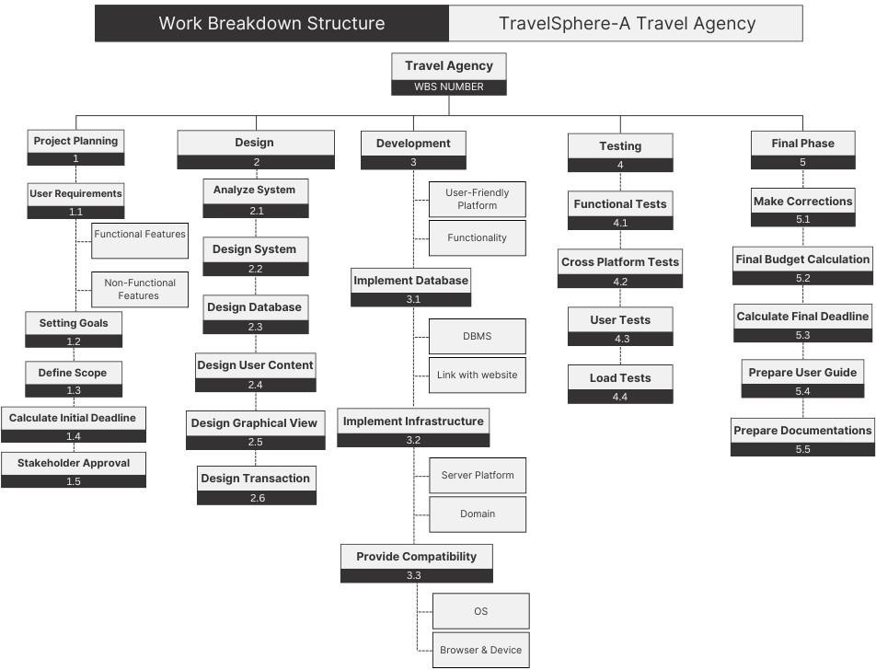

## Create Milestone table.

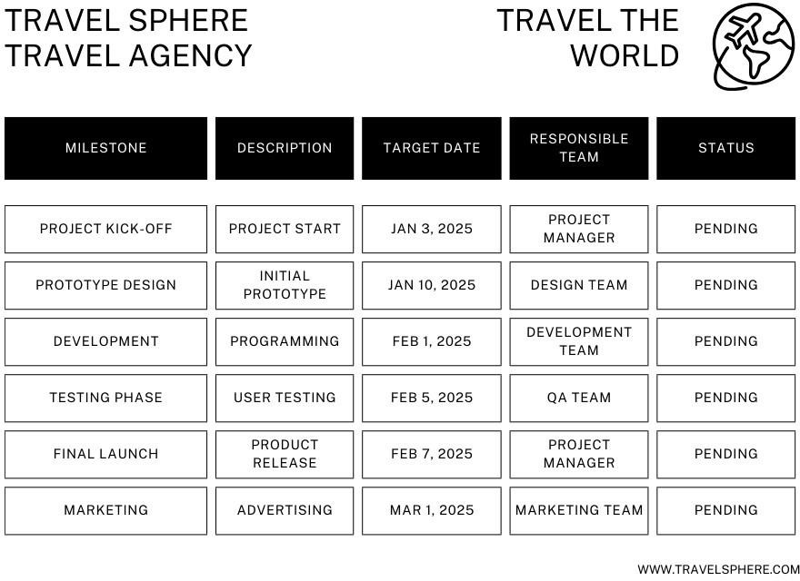

## Develop an Activity Graph.

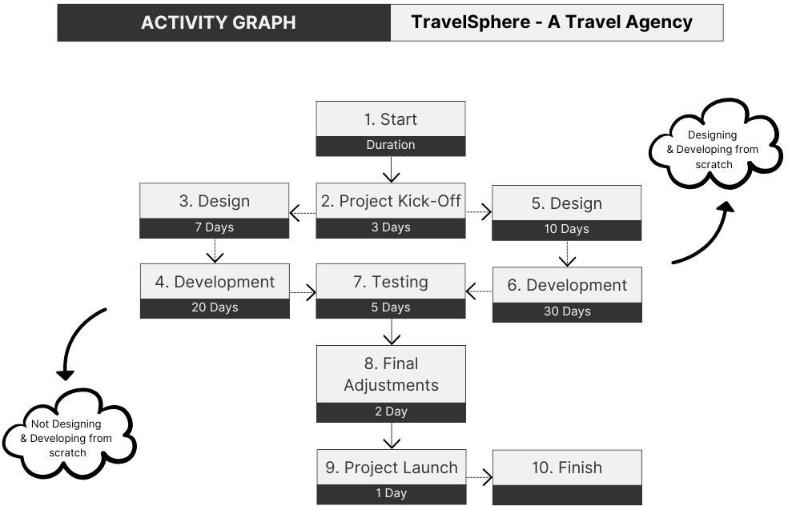

## Find the Critical Path.

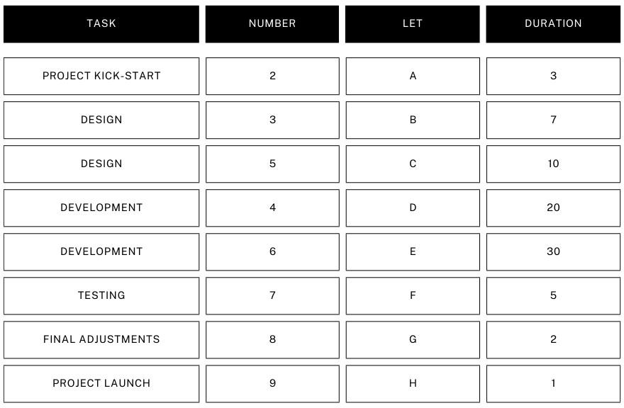

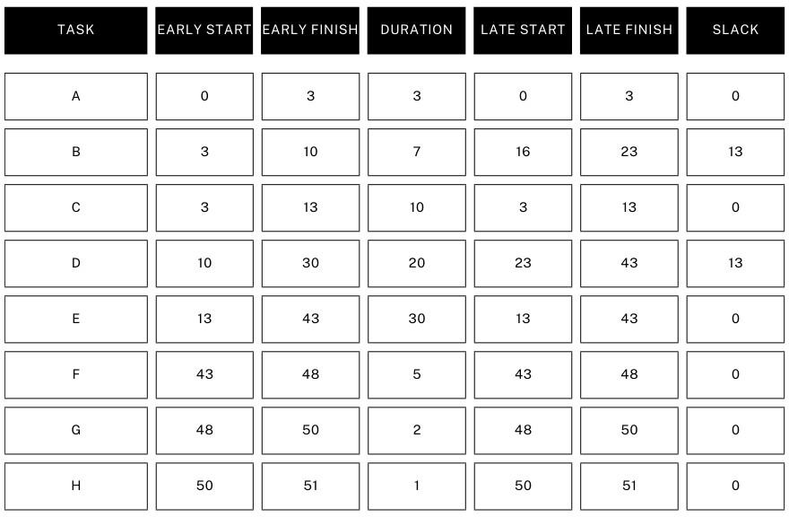

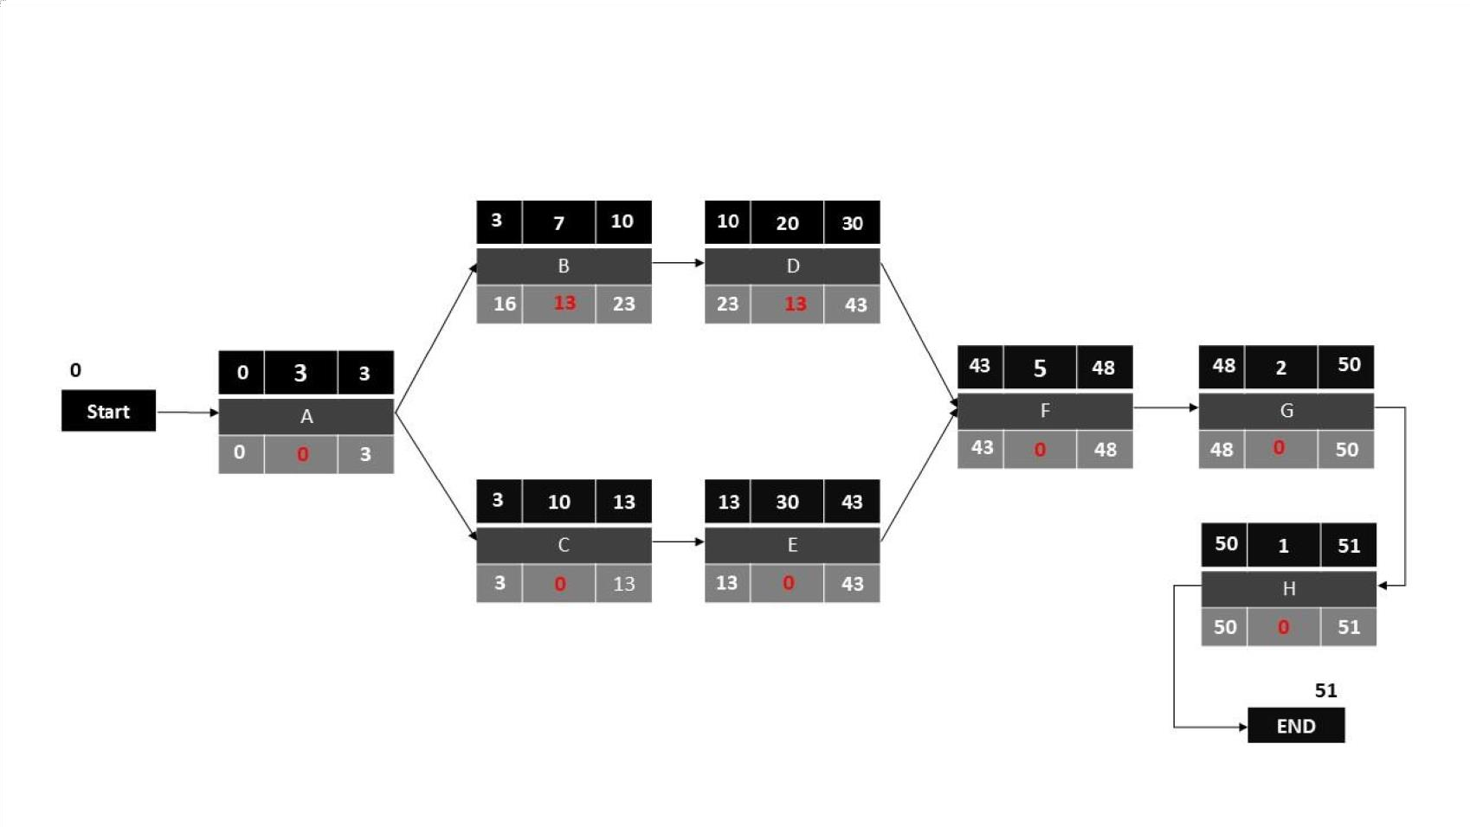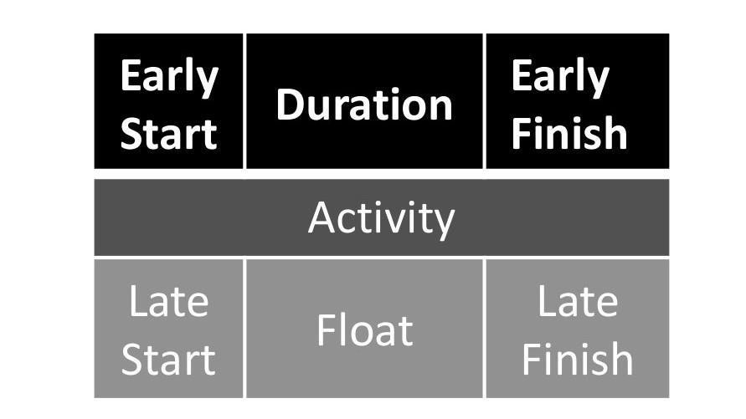

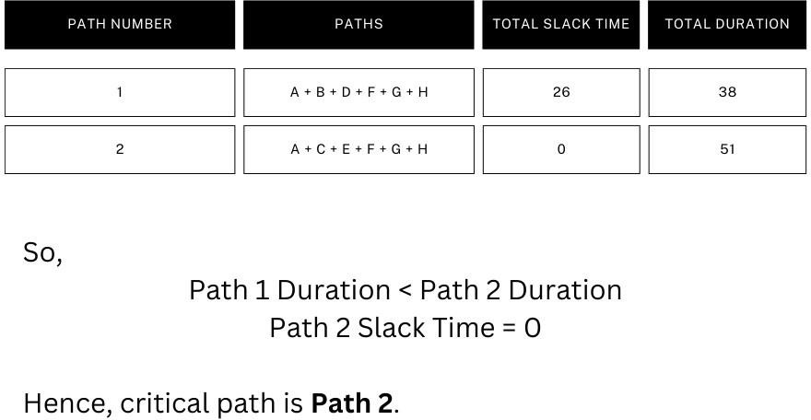

## Create a Gantt chart.

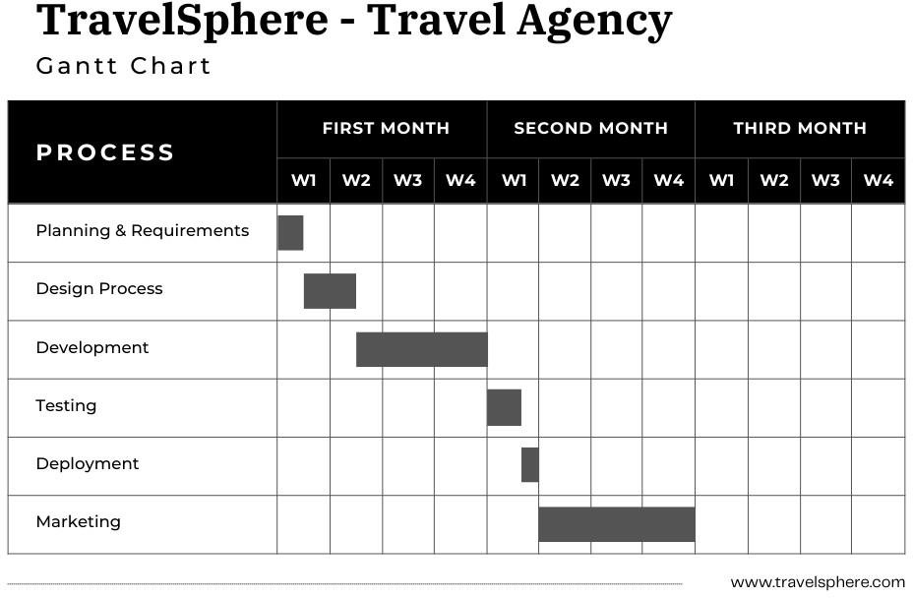

# ~~~~~~~~~~ Phase II ~~~~~~~~~~

# Functional Requirements

## Use-Case 1 : Arrange Tour

|  |  |  |  |
| --- | --- | --- | --- |
| **Identifier** | | Arrange Tour | |
| **Purpose** | | To allow staff to arrange tours for users | |
| **Priority** | | High | |
| **Pre-conditions** | | User travel data must be accessible and staff must be logged into systems | |
| **Postconditions** | | Tour is successfully arranged and a booking is created for the user | |
| **Typical Course of Action** | | | |
| **S#** | **Actor Action** | | **System Response** |
| **1** | Staff logs into the system | | Validates login credentials |
| **2** | Staff select the arrange tours | | Displays available tour options |
| **3** | Staff customize the tour details | | Saves the tour arrangement in the system |
| **Alternate Course of Action** | | | |
| **S#** | **Actor Action** | | **System Response** |
| **1** | Staff enters invalid credentials | | Prompts error and requests relogin |
| **2** | System data for tours is missing | | Shows an error message to the staff |

**Table 1: UC-1**

## Use-Case 2 : Make Payment

|  |  |  |  |
| --- | --- | --- | --- |
| **Identifier** | | Make Payment | |
| **Purpose** | | To allow users to make payments for confirmed bookings | |
| **Priority** | | High | |
| **Pre-conditions** | | A valid payment method must be available and the user must have confirmed the bookings | |
| **Postconditions** | | The payment is successfully processed, a ticket is issued and an invoice is sent to the user | |
| **Typical Course of Action** | | | |
| **S#** | **Actor Action** | | **System Response** |
| **1** | User selects "Make Payment" | | Displays payment options |
| **2** | User enters payment details | | Processes payment securely |
| **3** | User confirms payment | | Issues ticket and sends an invoice |
| **Alternate Course of Action** | | | |
| **S#** | **Actor Action** | | **System Response** |
| **1** | User enters invalid payment info | | Prompts error and requests correction |

**Table 2: UC-2**

## Use-Case 3 : Forget Password

|  |  |  |  |
| --- | --- | --- | --- |
| **Identifier** | | Forget Password | |
| **Purpose** | | To allow users and staff to reset their passwords if forgotten | |
| **Priority** | | Medium | |
| **Pre-conditions** | | User or staff must have an existing account and a valid email or phone number is associated with the account | |
| **Postconditions** | | A new password is generated or reset, and the user/staff can log in successfully | |
| **Typical Course of Action** | | | |
| **S#** | **Actor Action** | | **System Response** |
| **1** | User/staff selects Forgot Password | | Prompts for email or phone number |
| **2** | User/staff enters valid details | | Sends a password reset link/code |
| **3** | User/staff resets password | | Confirms password change |
| **Alternate Course of Action** | | | |
| **S#** | **Actor Action** | | **System Response** |
| **1** | User enters invalid details | | Prompts error and requests retry |

**Table 3: UC-3**

## Requirements Analysis and Modeling

**Use Case Diagram:**

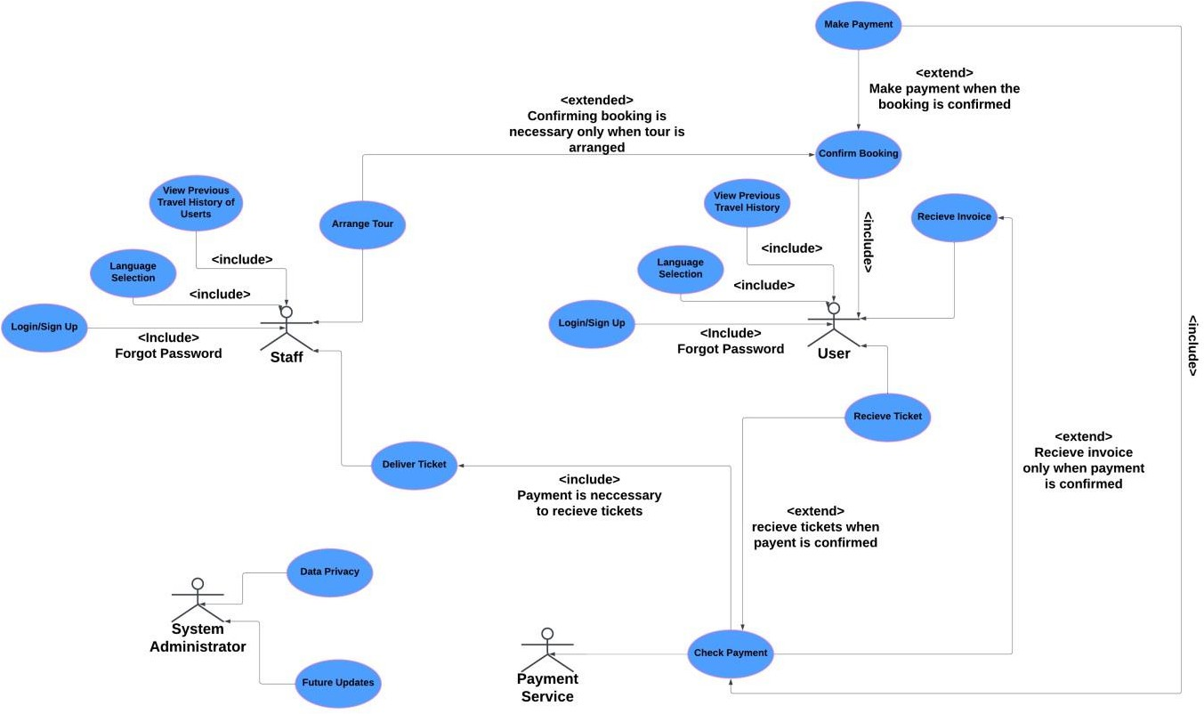

**Architectural Diagram:**

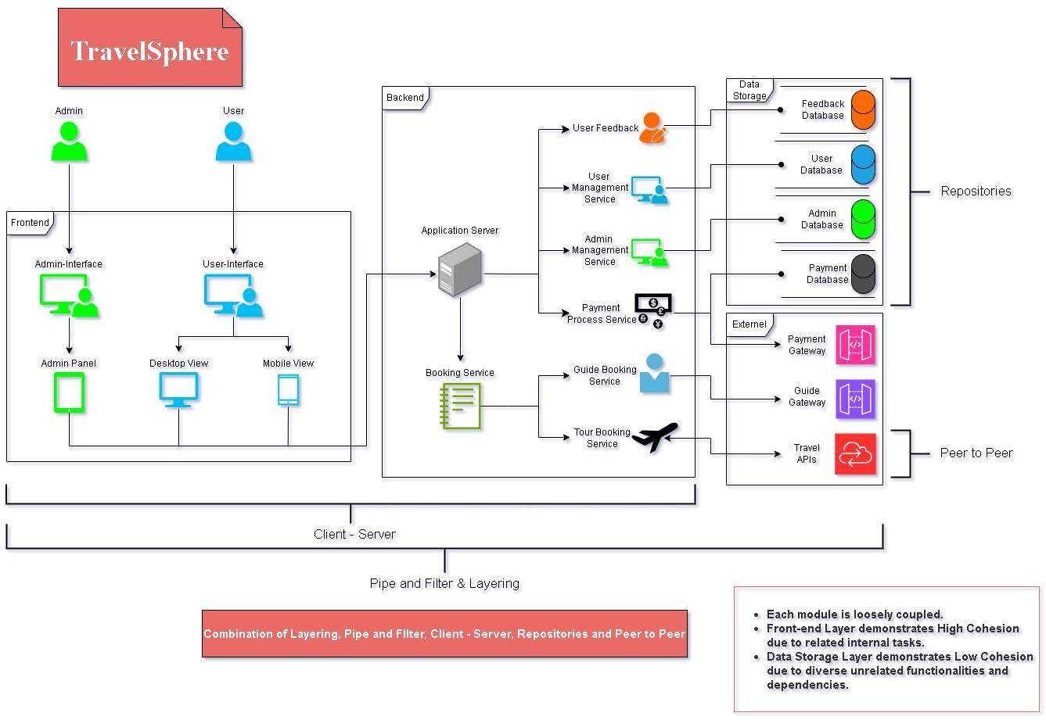

**State Diagram:**

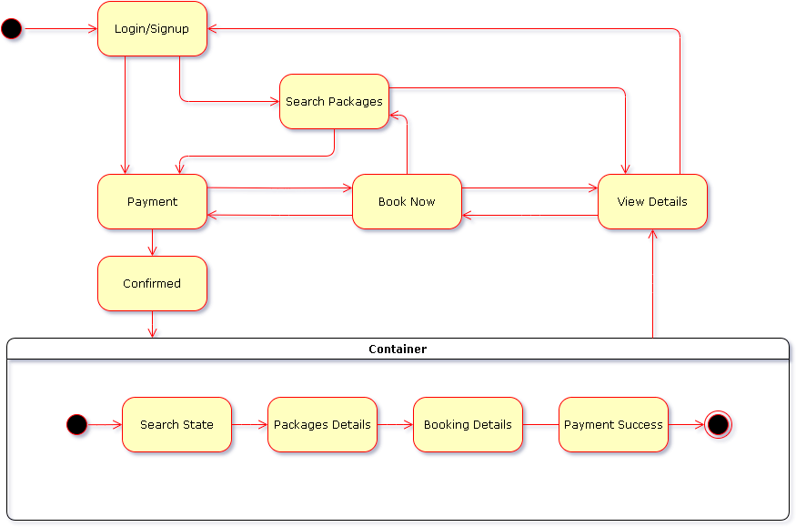

# Nonfunctional Requirements

Non-Functional Requirements make sure that the software must meet the functions effectively and deliver a positive experience for the user. These requirements include the performance, effectiveness, security, safety and additional software qualities.

## Performance Requirements

1. The software should be able to handle multiple users concurrently without degradation in performance.
2. Response time for loading pages and processing user requests should not exceed a specific threshold (e.g. 2-3 seconds).

## Safety Requirements

1. The application should secure user data and maintain consistency during unexpected scenarios, such as server crashes or network failures.
2. Data recovery and maintenance system should be present to prevent data loss.

## Security Requirements

1. Advanced encryption techniques should secure user data during storage and transmission.
2. User authentication and authorization mechanisms (e.g., login credentials) must prevent unauthorized access.

## Additional Software Quality Attributes

**Scalability:** The application should be capable of accommodating increasing numbers of users and transactions without major redesigns.

**Usability:** A clean, user-friendly interface should ensure a smooth experience for users of all technical backgrounds.

**Maintainability:** The codebase should follow industry standards, enabling easy debugging, updates, and feature additions.

**Portability:** The system should be compatible with different platforms and devices, such as desktops, iOS, and Android.

# Other Requirements

## Database Requirements

**Technology**: The project will use a relational database management system (e.g., MySQL, PostgreSQL).

## External Interface Requirements

### Hardware Interfaces:

* Server hosting requirements: Minimum 4-core CPU, 16GB RAM, and SSD storage for database and application hosting.
* User devices: Compatibility with desktops, laptops, and mobile devices (Android and iOS).

### Software Interfaces:

* Integration with third-party APIs for flight, hotel, and activity bookings (e.g., Skyscanner API, Expedia API).
* Secure payment gateways like Stripe or PayPal for transaction processing.
* Email services for sending booking confirmations and invoices.

# Designing

* 1. **Complete class diagram**

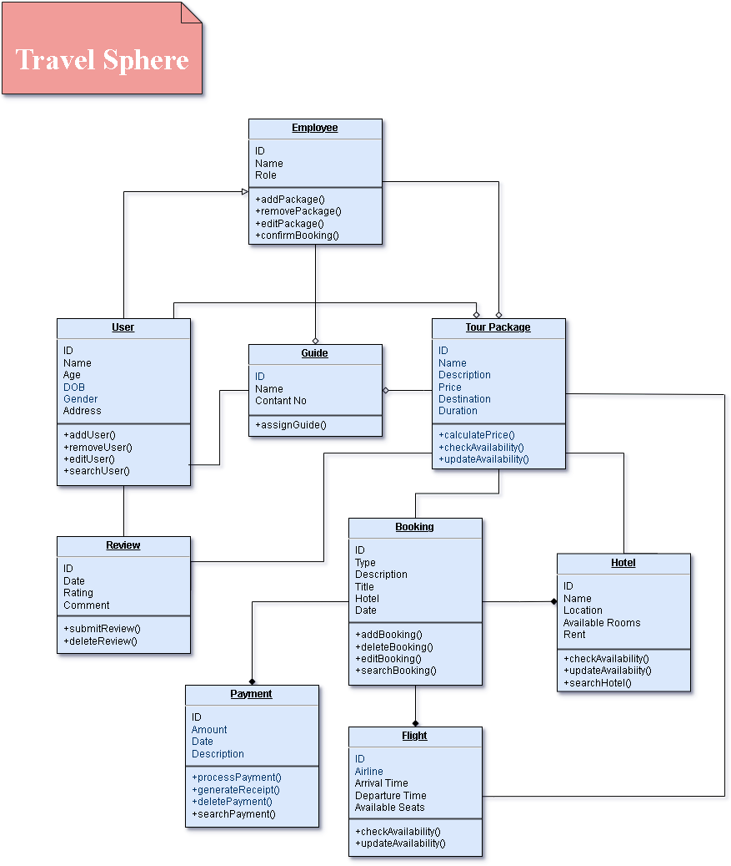

## Complete Data Flow Diagram (DFD)

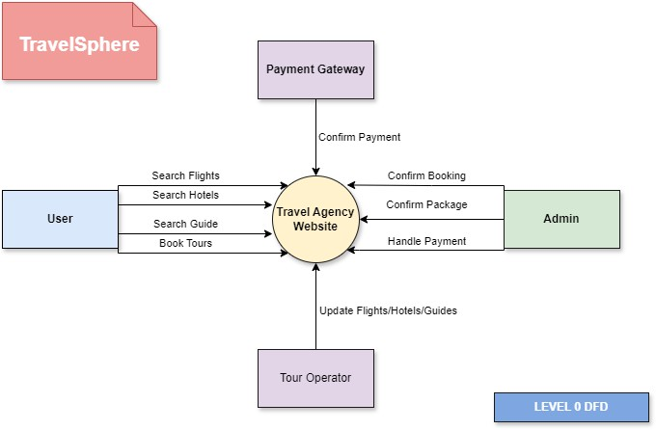

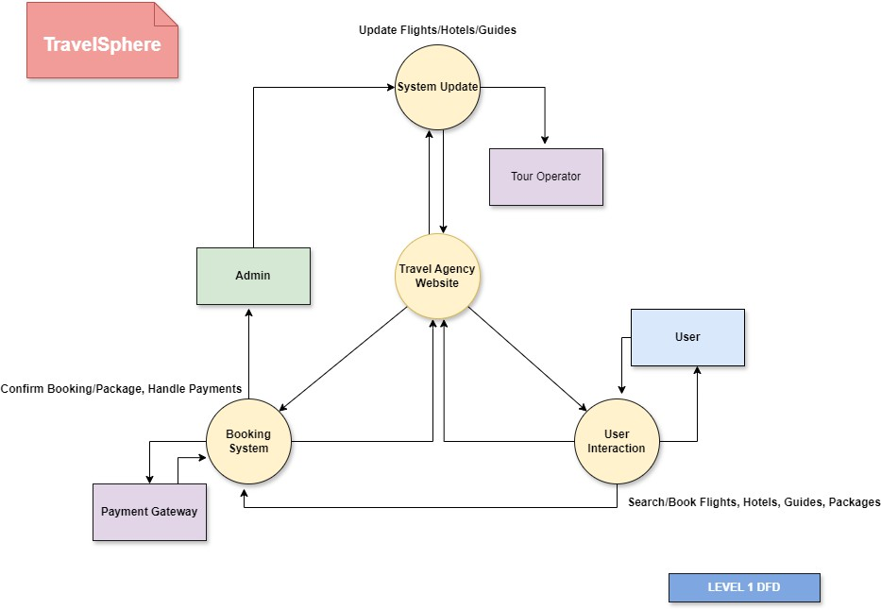

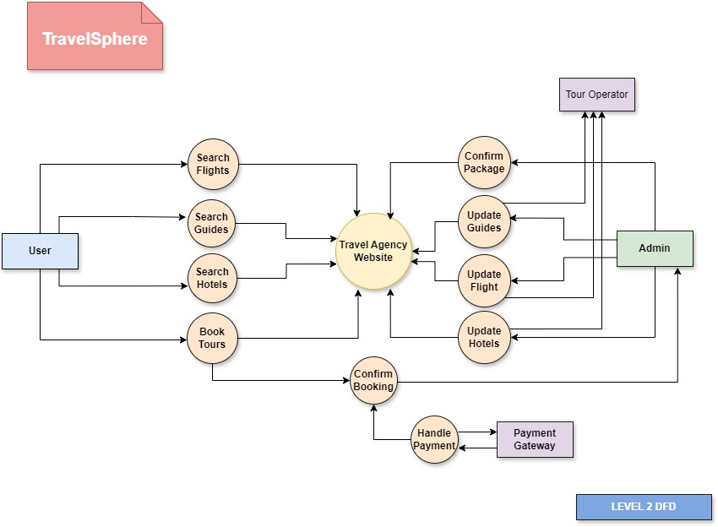

## Complete ER Diagram

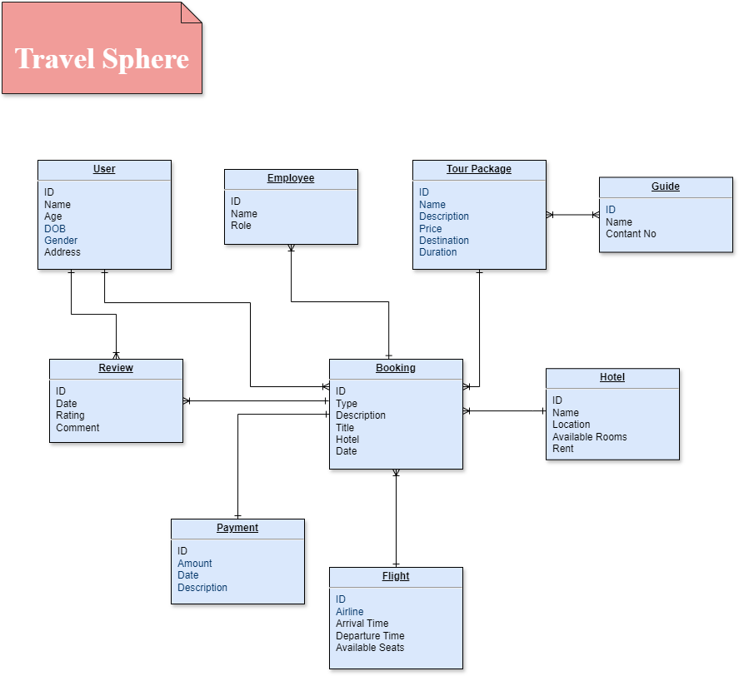

## Physical design of your database

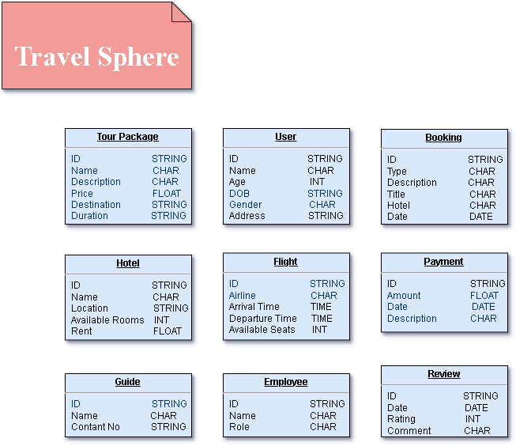

## Information on use of design patterns while designing the modules

Relevant Classes:

1. User
2. Employee
3. Payment
4. Tour Package
5. Booking
6. Flight
7. Hotels

## Make a Sequence and a Collaboration diagram of following.

* + 1. **Scenario 1 (Sequence Diagram)**

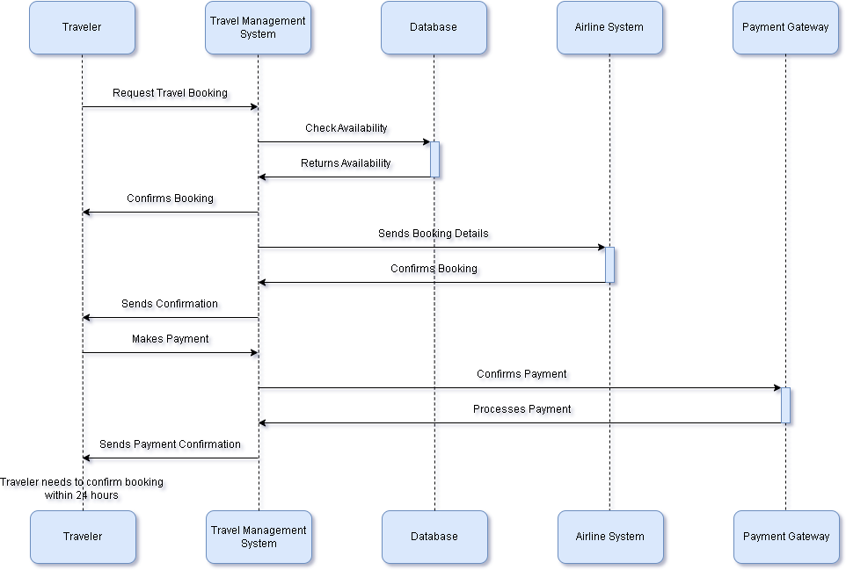

* + 1. **Scenario 2 (Collaboration Diagram)**

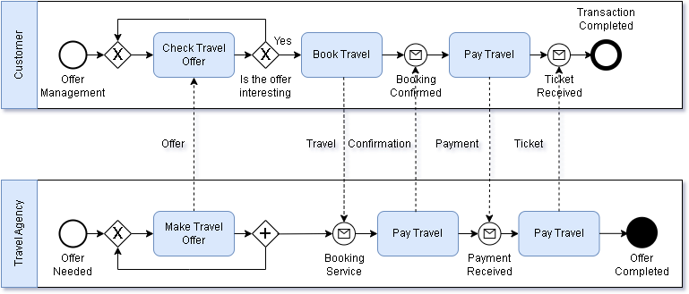

# Estimation

## Cost Benefit Estimation

1. **Initial Investment**: The estimated cost of developing the **TravelSphere** platform is Rs7,000,000. This includes development, hosting, and marketing expenses.
2. **First-Year Revenue Projection**: Based on industry benchmarks, the projected revenue for the first year is Rs14,000,000.
3. **Profit Margin**: The projected profit margin for the first year is 50%.

### Return of Investment (ROI) {1st year}

Benefit = Rs14,000,000 Cost = Rs7,000,000

ROI = 14,000,000/7,000,000 ROI = 2

The total benefits are 2 times the total cost.

### %gain on ROI {1st year}

Benefit = Rs14,000,000 Cost = Rs7,000,000

%gain of ROI = (14,000,000 – 7,000,000)/7,000,000 x 100 ROI = 100%

The earnings are 100% of the total cost.

### Payback Period in years

Benefit = Rs14,000,000 Cost = Rs7,000,000

Payback Period = 7,000,000/14,000,000 Payback Period = 0.5 years

## FP based Estimation

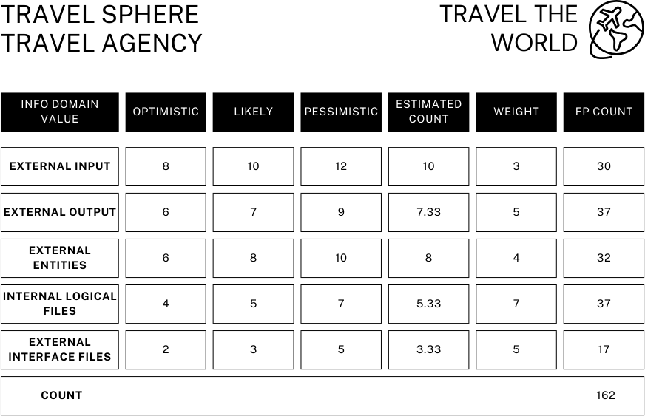

Estimated Count = (Optimistic + 4 x Likely + Pessimistic) / 6 Total FP = Estimated Count x Weight

UPF = 162

VAF = 0.65 + 0.01 x 50 = 1.15

Assume,

### Cost Per Function

1. **Total Cost**

FP = UPF x VAF FP = 162 x 1.15

FP = 186.3

FP = 186 approximately

Productivity Rate = 10 FP per Person-Month AFP = 186

Cost per Function = Cost / Productivity Cost per Function = Rs37,650

Total Cost = Count x (Cost / Productivity) Total Cost = Rs7, 002, 900

### Effort per Person-Month

1. **Productivity**

Effort = FP / Productivity Effort = 18.6 Person-Month

Productivity = FP / Effort Productivity = 10 FP per Person-Month

## COCOMO Estimation

Using the **COCOMO Model**, we estimate effort, time, and cost. Since **TravelSphere** is a moderately complex web-based system, it falls under the **Semi-Detached** category.

### Convert FP to KLOC

Using average of 100 FP approximately equal to 2 KLOC

KLOC = (AFP / 100) x 2 KLOC = (186 / 100) x 2

KLOC = 3.72

### Calculate Effort

Effort = 3.0 x (KLOC)1.12 Effort = 3.0 x (3.72)1.12

Effort = 13.06 Person-Month

### Development Time

1. **Estimated Cost**

TDEV = 2.5 x (Effort)0.35 TDEV = 2.5 x (13.06)0.35

TDEV = 6.14 months

Assume average developer salary is Rs150,000 per month

Cost = Effort x Salary Cost = Rs1,959,000

# References Appendix A: Glossary

[**https://www.youtube.com/**](https://www.youtube.com/)

<https://stackoverflow.com/>

<https://www.geeksforgeeks.org/software-engineering-functional-point-fp-analysis/>

***Appendix***