DATABASE MANAGEMENT SYSTEMS
Final Project Report

Restaurant Order System

Student Name: | Muhammad Zain Khan
Student ID: | 66157
Course: | Database Management Systems
Instructor: | Sir Ahtisham
Semester: | Spring 2026
Submission Date: | May 2026
GitHub: | https://github.com/zainkhan-bit/RestaurantOrderSystem.git  Click Here

Department of Computer Science | Riphah International University

1. Introduction
The Restaurant Order System is a relational database designed to manage all core operations of a restaurant. It handles customer records, menu management, employee assignments, table tracking, order processing, and payment handling.

1.1 Objectives
- Digitize and streamline the restaurant order-taking process
- Maintain accurate records of customers, menu items, and orders
- Track employee performance and table occupancy
- Generate sales and revenue reports
- Ensure data integrity through normalization and constraints

1.2 Scope
The system covers eight entities: MenuCategory, MenuItem, Customer, Employee, RestaurantTable, Orders, OrderItem, and Payment. It is normalized to Third Normal Form (3NF) to eliminate redundancy.

2. Entity Relationship Diagram (ERD)
The ERD below shows all entities, their attributes, and the relationships between them using Crow's Foot notation.

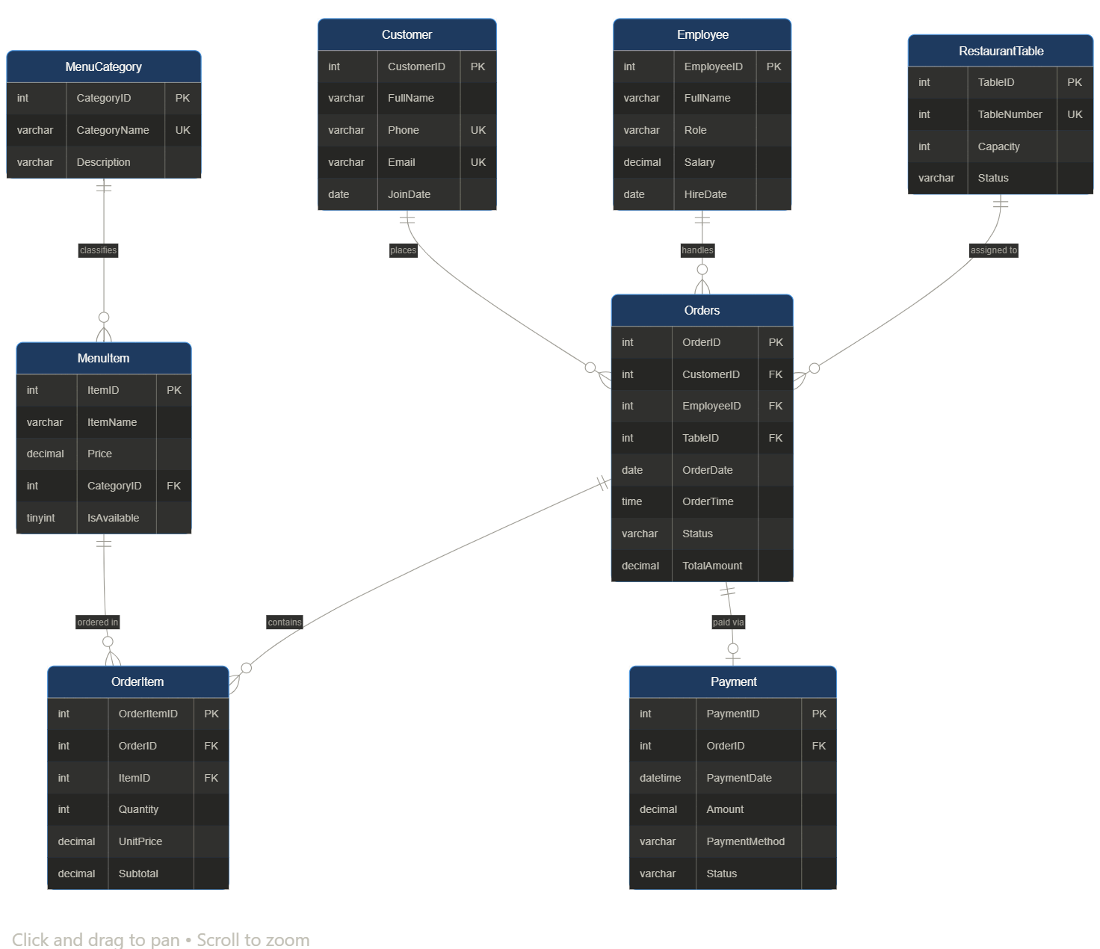

2.1 Entities and Attributes
Entity | Attributes | Primary Key
MenuCategory | CategoryID, CategoryName, Description | CategoryID
MenuItem | ItemID, ItemName, Description, Price, CategoryID, IsAvailable | ItemID
Customer | CustomerID, FullName, Phone, Email, Address, JoinDate | CustomerID
Employee | EmployeeID, FullName, Phone, Role, Salary, HireDate | EmployeeID
RestaurantTable | TableID, TableNumber, Capacity, Status | TableID
Orders | OrderID, CustomerID, EmployeeID, TableID, OrderDate, OrderTime, Status, TotalAmount | OrderID
OrderItem | OrderItemID, OrderID, ItemID, Quantity, UnitPrice, Subtotal | OrderItemID
Payment | PaymentID, OrderID, PaymentDate, Amount, PaymentMethod, Status | PaymentID

2.2 Relationships
Relationship | Cardinality | Type | Foreign Key
Customer places Orders | 1 : Many | Optional | Orders.CustomerID → Customer
Employee handles Orders | 1 : Many | Mandatory | Orders.EmployeeID → Employee
RestaurantTable used in Orders | 1 : Many | Optional | Orders.TableID → RestaurantTable
Orders contains OrderItems | 1 : Many | Mandatory | OrderItem.OrderID → Orders
MenuItem appears in OrderItems | 1 : Many | Mandatory | OrderItem.ItemID → MenuItem
MenuCategory classifies MenuItems | 1 : Many | Mandatory | MenuItem.CategoryID → MenuCategory
Orders has one Payment | 1 : 1 | Optional | Payment.OrderID → Orders

3. Normalization (1NF → 2NF → 3NF)

3.1 First Normal Form (1NF)
Rules: Each column contains atomic (indivisible) values. Each row is unique (has a primary key). No repeating groups.

Applied: All tables have a single-column primary key. Every attribute stores one value per cell (e.g., Phone stores one phone number, not a list). No multi-valued attributes exist.

3.2 Second Normal Form (2NF)
Rules: Must be in 1NF. Every non-key attribute must be fully functionally dependent on the entire primary key (applies to composite keys only).

Applied: All tables use a single-column surrogate primary key (INT AUTO_INCREMENT), so there are no partial dependencies possible. For example, in OrderItem, Quantity and UnitPrice depend on the full (OrderItemID) key.

3.3 Third Normal Form (3NF)
Rules: Must be in 2NF. No transitive dependencies — non-key attributes must not depend on other non-key attributes.

Applied: Category information (CategoryName, Description) is stored in MenuCategory, not repeated inside MenuItem. Employee details are in the Employee table, not duplicated in Orders. Customer address is stored in Customer, not in Orders.

Result: All 8 tables are in 3NF — no repeating groups, no partial dependencies, no transitive dependencies.

4. Core Schema Objects

4.1 Tables, Keys & Constraints
Below is the complete SQL for creating all tables with their primary keys, foreign keys, and constraints:

MenuCategory Table
CREATE TABLE MenuCategory (
CategoryID INT AUTO_INCREMENT PRIMARY KEY,
CategoryName VARCHAR(100) NOT NULL UNIQUE,
Description VARCHAR(255)
);

MenuItem Table
CREATE TABLE MenuItem (
ItemID INT AUTO_INCREMENT PRIMARY KEY,
ItemName VARCHAR(150) NOT NULL,
Price DECIMAL(8,2) NOT NULL CHECK (Price > 0),
CategoryID INT NOT NULL,
IsAvailable TINYINT(1) NOT NULL DEFAULT 1,
CONSTRAINT fk_item_category FOREIGN KEY (CategoryID)
REFERENCES MenuCategory(CategoryID)
);

Customer Table
CREATE TABLE Customer (
CustomerID INT AUTO_INCREMENT PRIMARY KEY,
FullName VARCHAR(150) NOT NULL,
Phone VARCHAR(15) UNIQUE,
Email VARCHAR(100) UNIQUE,
Address VARCHAR(255),
JoinDate DATE DEFAULT (CURRENT_DATE)
);

Employee Table
CREATE TABLE Employee (
EmployeeID INT AUTO_INCREMENT PRIMARY KEY,
FullName VARCHAR(150) NOT NULL,
Phone VARCHAR(15) UNIQUE,
Role VARCHAR(50) NOT NULL
CHECK (Role IN ('Waiter','Manager','Chef','Cashier')),
Salary DECIMAL(10,2) NOT NULL CHECK (Salary >= 0),
HireDate DATE NOT NULL
);

RestaurantTable Table
CREATE TABLE RestaurantTable (
TableID INT AUTO_INCREMENT PRIMARY KEY,
TableNumber INT NOT NULL UNIQUE,
Capacity INT NOT NULL CHECK (Capacity > 0),
Status VARCHAR(20) NOT NULL DEFAULT 'Available'
CHECK (Status IN ('Available','Occupied','Reserved'))
);

Orders Table
CREATE TABLE Orders (
OrderID INT AUTO_INCREMENT PRIMARY KEY,
CustomerID INT,
EmployeeID INT NOT NULL,
TableID INT,
OrderDate DATE NOT NULL DEFAULT (CURRENT_DATE),
OrderTime TIME NOT NULL DEFAULT (CURRENT_TIME),
Status VARCHAR(20) NOT NULL DEFAULT 'Pending'
CHECK (Status IN ('Pending','Preparing','Served','Completed','Cancelled')),
TotalAmount DECIMAL(10,2) DEFAULT 0.00,
FOREIGN KEY (CustomerID) REFERENCES Customer(CustomerID),
FOREIGN KEY (EmployeeID) REFERENCES Employee(EmployeeID),
FOREIGN KEY (TableID) REFERENCES RestaurantTable(TableID)
);

OrderItem Table
CREATE TABLE OrderItem (
OrderItemID INT AUTO_INCREMENT PRIMARY KEY,
OrderID INT NOT NULL,
ItemID INT NOT NULL,
Quantity INT NOT NULL CHECK (Quantity > 0),
UnitPrice DECIMAL(8,2) NOT NULL CHECK (UnitPrice > 0),
Subtotal DECIMAL(10,2) GENERATED ALWAYS AS (Quantity * UnitPrice) STORED,
FOREIGN KEY (OrderID) REFERENCES Orders(OrderID) ON DELETE CASCADE,
FOREIGN KEY (ItemID) REFERENCES MenuItem(ItemID)
);

Payment Table
CREATE TABLE Payment (
PaymentID INT AUTO_INCREMENT PRIMARY KEY,
OrderID INT NOT NULL UNIQUE,
PaymentDate DATETIME NOT NULL DEFAULT CURRENT_TIMESTAMP,
Amount DECIMAL(10,2) NOT NULL CHECK (Amount > 0),
PaymentMethod VARCHAR(30) NOT NULL
CHECK (PaymentMethod IN ('Cash','Card','Online')),
Status VARCHAR(20) NOT NULL DEFAULT 'Paid'
CHECK (Status IN ('Paid','Pending','Refunded')),
FOREIGN KEY (OrderID) REFERENCES Orders(OrderID)
);

4.2 Constraints Summary
Table | Column | Constraint Type | Rule
MenuItem | Price | CHECK | Price > 0
Employee | Role | CHECK | One of: Waiter, Manager, Chef, Cashier
RestaurantTable | Status | CHECK | One of: Available, Occupied, Reserved
Orders | Status | CHECK | One of: Pending, Preparing, Served, Completed, Cancelled
OrderItem | Quantity | CHECK | Quantity > 0
OrderItem | Subtotal | GENERATED | Quantity * UnitPrice (auto-calculated)
Payment | OrderID | UNIQUE | One payment per order only
Customer | Email / Phone | UNIQUE | No duplicate contacts
Employee | Phone | UNIQUE | No duplicate staff phone
Orders | CustomerID | FK + NULL | Walk-in customers allowed (NULL)

5. Views
Views are virtual tables created from SQL SELECT statements. They simplify complex queries and restrict direct table access.

View 1 — vw_OrderSummary (Full Order Details)
CREATE VIEW vw_OrderSummary AS
SELECT o.OrderID, c.FullName AS CustomerName,
e.FullName AS WaiterName, rt.TableNumber,
o.OrderDate, o.OrderTime, o.Status, o.TotalAmount
FROM Orders o
LEFT JOIN Customer c ON o.CustomerID = c.CustomerID
JOIN Employee e ON o.EmployeeID = e.EmployeeID
LEFT JOIN RestaurantTable rt ON o.TableID = rt.TableID;

View 2 — vw_MenuWithCategory (Menu Display)
CREATE VIEW vw_MenuWithCategory AS
SELECT mi.ItemID, mi.ItemName, mi.Price,
mc.CategoryName, mi.IsAvailable
FROM MenuItem mi
JOIN MenuCategory mc ON mi.CategoryID = mc.CategoryID;

View 3 — vw_DailyRevenue (Sales Report)
CREATE VIEW vw_DailyRevenue AS
SELECT DATE(p.PaymentDate) AS PaymentDay,
COUNT(p.PaymentID) AS TotalOrders,
SUM(p.Amount) AS TotalRevenue,
AVG(p.Amount) AS AvgOrderValue
FROM Payment p
WHERE p.Status = 'Paid'
GROUP BY DATE(p.PaymentDate);

View 4 — vw_EmployeePerformance
CREATE VIEW vw_EmployeePerformance AS
SELECT e.EmployeeID, e.FullName, e.Role,
COUNT(o.OrderID) AS TotalOrdersHandled,
SUM(o.TotalAmount) AS TotalRevenue
FROM Employee e
LEFT JOIN Orders o ON e.EmployeeID = o.EmployeeID
GROUP BY e.EmployeeID, e.FullName, e.Role;

6. SQL Queries

6.1 JOIN Queries
Query J1 — All Orders with Customer, Waiter & Table (INNER JOIN)
SELECT o.OrderID, c.FullName AS Customer,
e.FullName AS Waiter, rt.TableNumber,
o.OrderDate, o.Status, o.TotalAmount
FROM Orders o
INNER JOIN Customer c ON o.CustomerID = c.CustomerID
INNER JOIN Employee e ON o.EmployeeID = e.EmployeeID
INNER JOIN RestaurantTable rt ON o.TableID = rt.TableID;
Purpose: Shows a complete view of every order combined with customer, waiter, and table information from four tables.
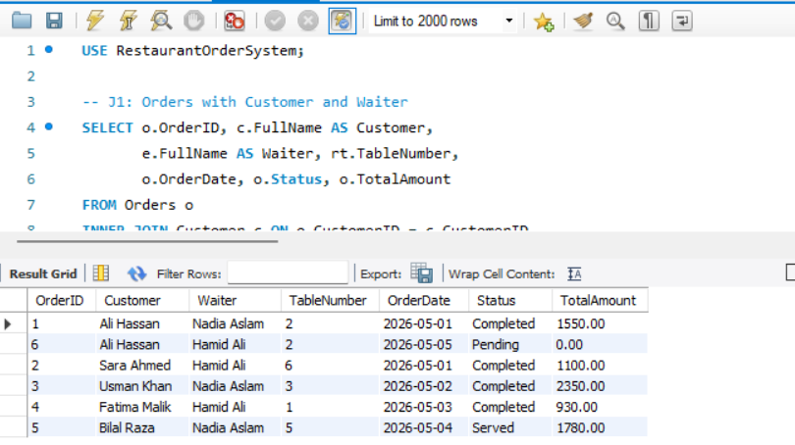

Query J2 — Order Items with Menu Names (Multi-table JOIN)
SELECT o.OrderID, mi.ItemName, mc.CategoryName,
oi.Quantity, oi.UnitPrice, oi.Subtotal
FROM OrderItem oi
INNER JOIN Orders o ON oi.OrderID = o.OrderID
INNER JOIN MenuItem mi ON oi.ItemID = mi.ItemID
INNER JOIN MenuCategory mc ON mi.CategoryID = mc.CategoryID
ORDER BY o.OrderID;
Purpose: Joins four tables to show a detailed receipt — what was ordered, from which category, and at what price.
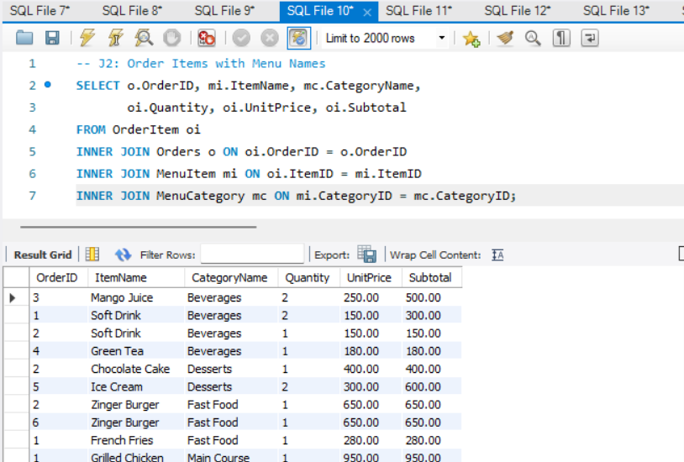

Query J3 — All Customers and Their Orders (LEFT JOIN)
SELECT c.CustomerID, c.FullName, c.Phone,
COUNT(o.OrderID) AS TotalOrders,
COALESCE(SUM(o.TotalAmount), 0) AS TotalSpent
FROM Customer c
LEFT JOIN Orders o ON c.CustomerID = o.CustomerID
GROUP BY c.CustomerID, c.FullName, c.Phone;
Purpose: LEFT JOIN ensures customers with zero orders are also shown (walk-in or newly registered customers).
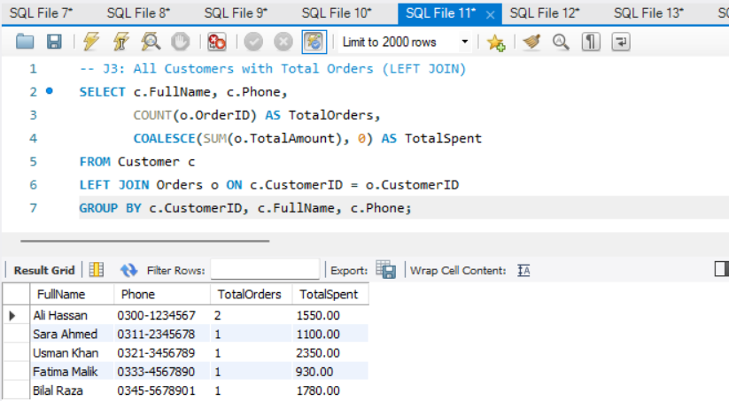

Query J4 — Payment Details with Customer Name
SELECT p.PaymentID, c.FullName AS Customer,
p.Amount, p.PaymentMethod,
p.PaymentDate, p.Status
FROM Payment p
JOIN Orders o ON p.OrderID = o.OrderID
JOIN Customer c ON o.CustomerID = c.CustomerID;
Purpose: Links payments back to the customer who placed the order through the Orders bridge table.

6.2 Subqueries
Query S1 — Menu Items Never Ordered
SELECT ItemID, ItemName, Price
FROM MenuItem
WHERE ItemID NOT IN (
SELECT DISTINCT ItemID FROM OrderItem
);
Purpose: Uses a NOT IN subquery to find menu items that have never appeared in any order — useful for menu reviews.
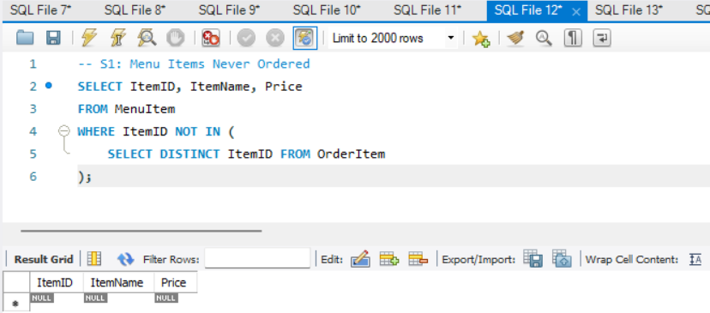

Query S2 — Customers Who Spent More Than Average
SELECT FullName, Phone
FROM Customer
WHERE CustomerID IN (
SELECT CustomerID
FROM Orders
GROUP BY CustomerID
HAVING SUM(TotalAmount) > (
SELECT AVG(TotalSpentPerCustomer)
FROM (
SELECT CustomerID, SUM(TotalAmount) AS TotalSpentPerCustomer
FROM Orders GROUP BY CustomerID
) AS sub
)
);
Purpose: A nested subquery (query inside query inside query) finds VIP customers who spend above the average.
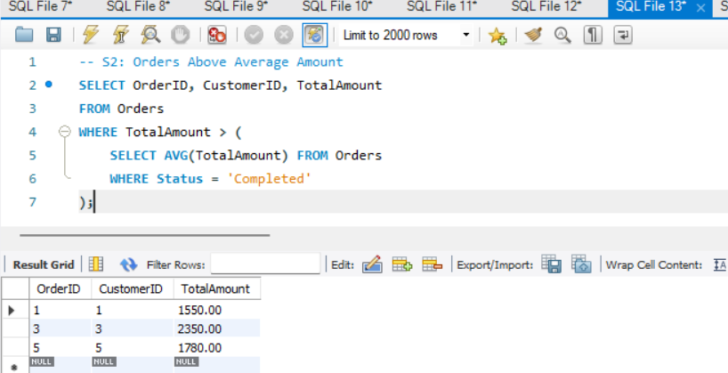

Query S3 — Orders Above Average Order Value
SELECT OrderID, CustomerID, TotalAmount
FROM Orders
WHERE TotalAmount > (
SELECT AVG(TotalAmount)
FROM Orders
WHERE Status = 'Completed'
);
Purpose: Scalar subquery calculates the average total for completed orders and filters orders that exceed it.

Query S4 — Most Expensive Item Per Category (Correlated Subquery)
SELECT mc.CategoryName, mi.ItemName, mi.Price
FROM MenuItem mi
JOIN MenuCategory mc ON mi.CategoryID = mc.CategoryID
WHERE mi.Price = (
SELECT MAX(Price)
FROM MenuItem
WHERE CategoryID = mi.CategoryID
);
Purpose: A correlated subquery re-executes for each row — finds the most expensive item within each menu category.

6.3 Aggregation Functions
Query A1 — Revenue by Payment Method
SELECT PaymentMethod,
COUNT(*) AS NumberOfPayments,
SUM(Amount) AS TotalRevenue,
AVG(Amount) AS AvgPayment,
MIN(Amount) AS MinPayment,
MAX(Amount) AS MaxPayment
FROM Payment
WHERE Status = 'Paid'
GROUP BY PaymentMethod;
Functions used: COUNT, SUM, AVG, MIN, MAX — provides a complete financial breakdown by payment type.
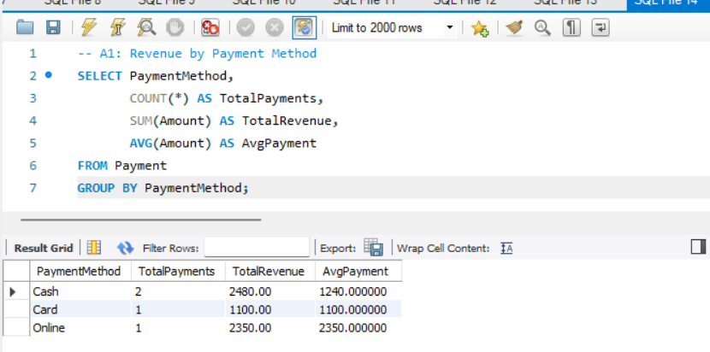

Query A2 — Most Popular Menu Items
SELECT mi.ItemName, mc.CategoryName,
SUM(oi.Quantity) AS TotalQuantityOrdered,
SUM(oi.Subtotal) AS TotalRevenue
FROM OrderItem oi
JOIN MenuItem mi ON oi.ItemID = mi.ItemID
JOIN MenuCategory mc ON mi.CategoryID = mc.CategoryID
GROUP BY mi.ItemID, mi.ItemName, mc.CategoryName
ORDER BY TotalQuantityOrdered DESC;
Purpose: Uses SUM with GROUP BY to find best-selling items — helps management optimize the menu.
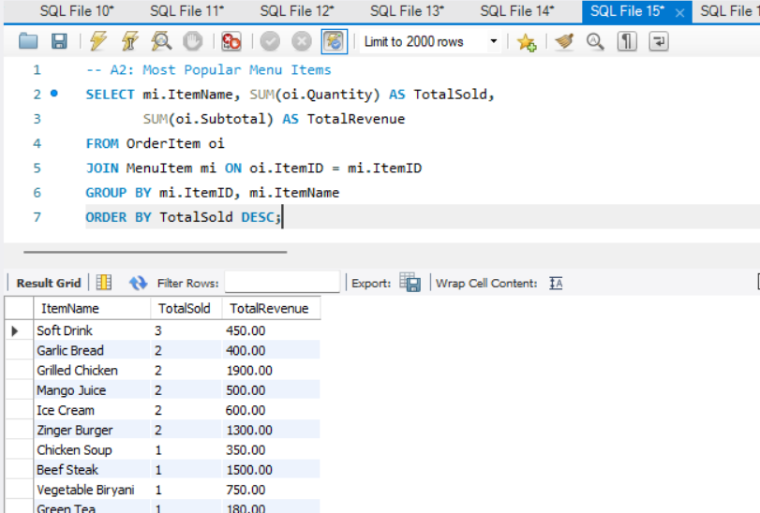

Query A3 — Revenue by Menu Category (with HAVING)
SELECT mc.CategoryName,
COUNT(DISTINCT oi.OrderID) AS OrdersContaining,
SUM(oi.Quantity) AS TotalItemsSold,
SUM(oi.Subtotal) AS TotalCategoryRevenue
FROM OrderItem oi
JOIN MenuItem mi ON oi.ItemID = mi.ItemID
JOIN MenuCategory mc ON mi.CategoryID = mc.CategoryID
GROUP BY mc.CategoryID, mc.CategoryName
HAVING SUM(oi.Subtotal) > 0
ORDER BY TotalCategoryRevenue DESC;
Purpose: Combines GROUP BY + HAVING to show only categories with actual sales, ordered by revenue.

Query A4 — Waiter Performance Report
SELECT e.FullName AS WaiterName,
COUNT(o.OrderID) AS OrdersHandled,
SUM(o.TotalAmount) AS TotalRevenue,
AVG(o.TotalAmount) AS AvgOrderValue
FROM Employee e
JOIN Orders o ON e.EmployeeID = o.EmployeeID
WHERE e.Role = 'Waiter'
GROUP BY e.EmployeeID, e.FullName
ORDER BY TotalRevenue DESC;
Purpose: Filters only Waiter role employees and aggregates their order statistics to evaluate performance.
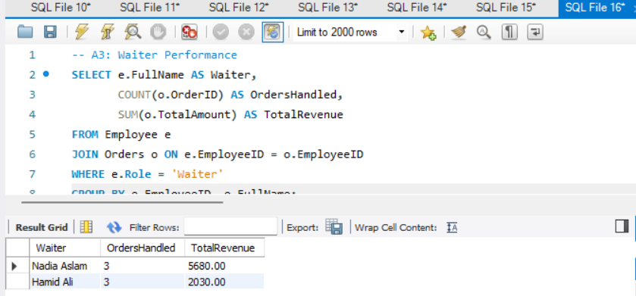

7. GitHub Repository
All project files including the complete SQL schema, INSERT statements, Views, and Queries have been uploaded to GitHub.

Item | Details
Repository Name | RestaurantOrderSystem
Repository Link | https://github.com/zainkhan-bit/RestaurantOrderSystem.git
Files Uploaded | restaurant_order_system.sql, README.md
README Includes | Project description, ERD image, setup instructions
Visibility | Public

8. Conclusion
The Restaurant Order System database was successfully designed and implemented using MySQL. The project demonstrates a complete relational database solution covering all major concepts:

- ERD with 8 entities and 7 relationships designed using proper notation
- All tables normalized to Third Normal Form (3NF)
- Primary keys, foreign keys, CHECK constraints, UNIQUE constraints, and DEFAULT values applied
- A computed column (Subtotal = Quantity × UnitPrice) using GENERATED ALWAYS AS
- 4 Views created to simplify data retrieval for common business operations
- 4 JOIN queries combining up to 4 tables
- 4 Subqueries including nested and correlated types
- 5 Aggregation queries using COUNT, SUM, AVG, MIN, MAX with GROUP BY and HAVING

This system can serve as the foundation for a full restaurant management application with a front-end interface.

References
- MySQL 8.0 Reference Manual — https://dev.mysql.com/doc/
- dbdiagram.io — https://dbdiagram.io
- draw.io — https://www.drawio.com
- GitHub — https://github.com

