Pakistan Soil Types — Crops & Pesticide Impact

- Loamy Soil
- Texture: Balanced mix of sand, silt, and clay
- pH / NPK: 7.2, N: 45, P: 15, K: 130
- Suitable Crops: Wheat, maize, vegetables, pulses
- Pesticide Impact:
  - Retains moderate pesticides → good crop protection
  - Less leaching → reduced frequency of applications
  - Balanced soil microbiota → minimal negative effects on crops



- Silty Loam
- Texture: Smooth, fine particles
- pH / NPK: 7.5, N: 50, P: 18, K: 120
- Suitable Crops: Wheat, barley, maize, vegetables
- Pesticide Impact:
  - Fertile and moisture-retentive → pesticides stay longer
  - Lower runoff risk → efficient use of chemicals
  - High crop tolerance → minimal damage if applied correctly
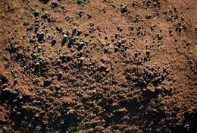

- Sandy Loam
- Texture: Coarse sand with some silt/clay
- pH / NPK: 7.0, N: 40, P: 12, K: 100
- Suitable Crops: Cotton, maize, millet, sorghum
- Pesticide Impact:
  - Leaches quickly → may need more frequent application
  - High drainage → reduces chemical residue on crops
  - Sensitive crops may require spot application
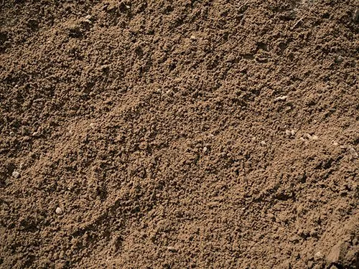

- Clay Loam / Clayey Soil
- Texture: Heavy, sticky, fine particles
- pH / NPK: 7.8, N: 48, P: 20, K: 140
- Suitable Crops: Rice (irrigated), sugarcane, wheat, maize
- Pesticide Impact:
  - Strong pesticide binding → slower degradation, longer effect
  - Risk of accumulation → avoid over-application
  - Waterlogging may reduce pesticide absorption → careful irrigation needed
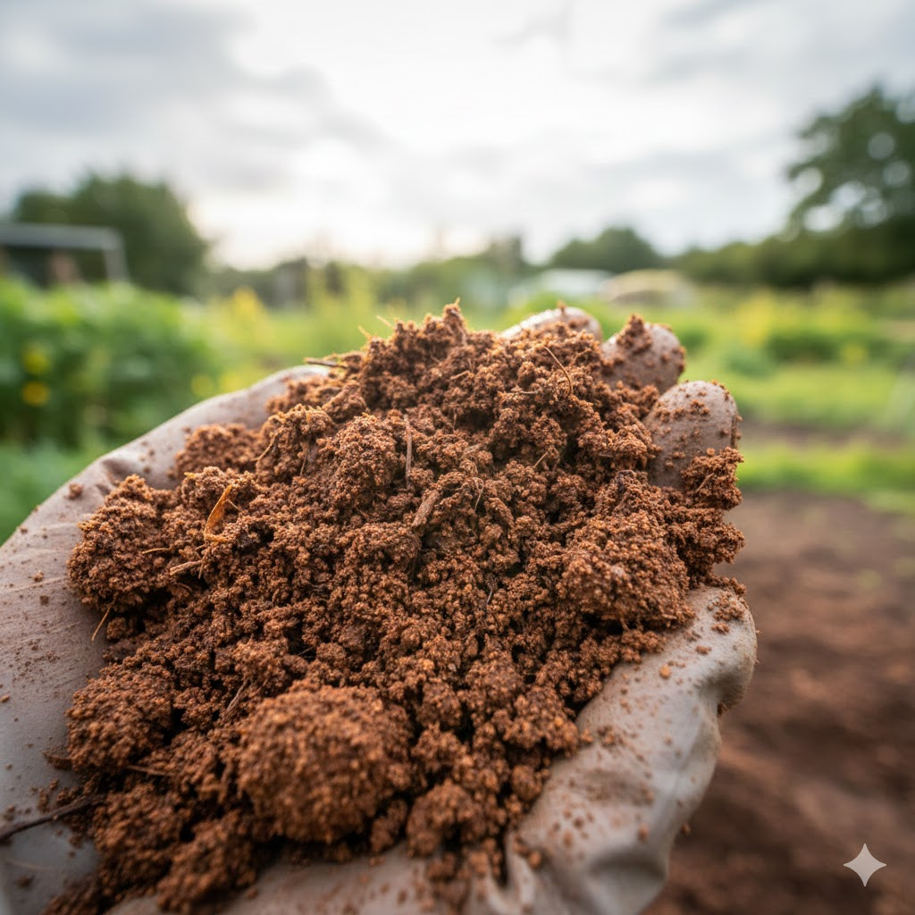

- Clay
- Texture: Very fine, dense, retains water
- pH / NPK: 7.5, N: 50, P: 20, K: 140
- Suitable Crops: Rice, sugarcane, wheat
- Pesticide Impact:
  - High retention → effective but monitor for soil toxicity
  - Best for water-intensive crops
  - Care with repeated pesticide use to avoid harming microbes
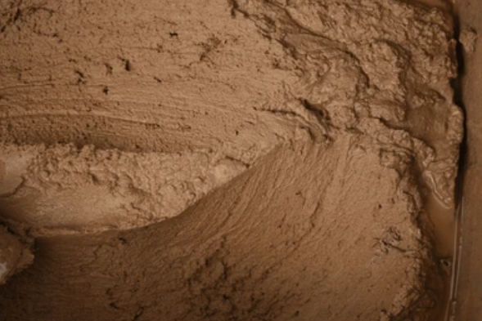

- Alluvial Soil
- Texture: Fertile, fine-textured, river-deposited
- pH / NPK: 7.2, N: 48, P: 18, K: 135
- Suitable Crops: Wheat, rice, maize, sugarcane
- Pesticide Impact:
  - Fertile soils → crops tolerate pesticides well
  - Moderate leaching → chemical effectiveness maintained
  - Optimal for almost all crops with standard pest control
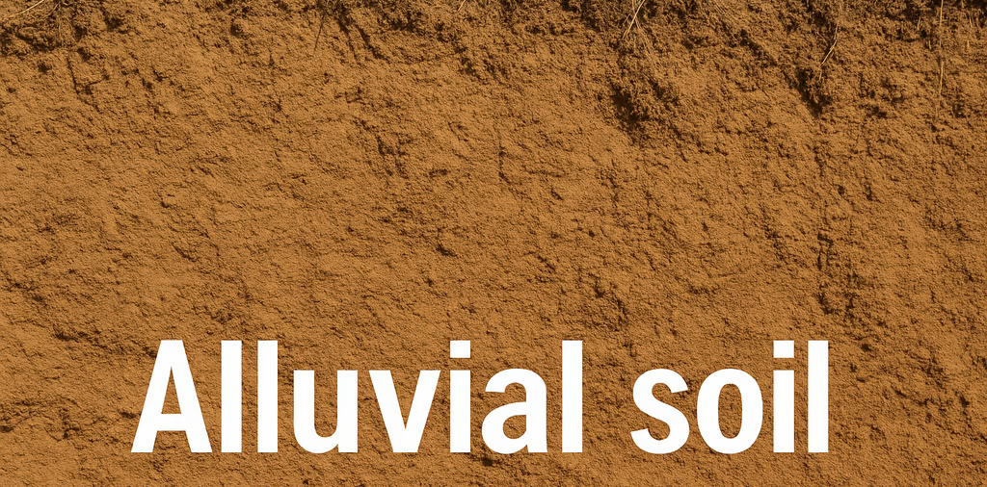

- Calcareous / Calcareous Loamy Soil
- Texture: Chalky, contains calcium carbonate
- pH / NPK: 7.8, N: 35–40, P: 12–15, K: 110–120
- Suitable Crops: Cotton, wheat, sugarcane, barley, fruits
- Pesticide Impact:
  - High pH may reduce some pesticide activity → select compatible formulations
  - Crops tolerant to slightly alkaline soils perform best
  - Slow pesticide degradation → reduces number of applications
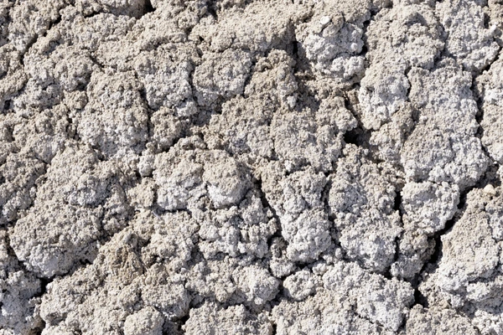

- Sandy Soil
- Texture: Coarse, fast-draining
- pH / NPK: 7.5, N: 30, P: 10, K: 90
- Suitable Crops: Millet, guar, sorghum
- Pesticide Impact:
  - Rapid leaching → chemicals may not last long
  - Frequent or spot applications recommended
  - Less risk of soil accumulation


- Silty Soil
- Texture: Fine, smooth, moisture-retaining
- pH / NPK: 7.2, N: 48, P: 18, K: 125
- Suitable Crops: Rice, wheat, vegetables
- Pesticide Impact:
  - Fertile and retains moisture → pesticides more effective
  - Low runoff risk → safer for crops and nearby water
  - Good for high-yield crops with moderate pesticide use
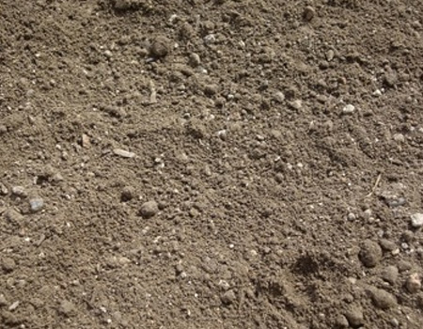

Agriculture Zones
    - Upper Indus Plain
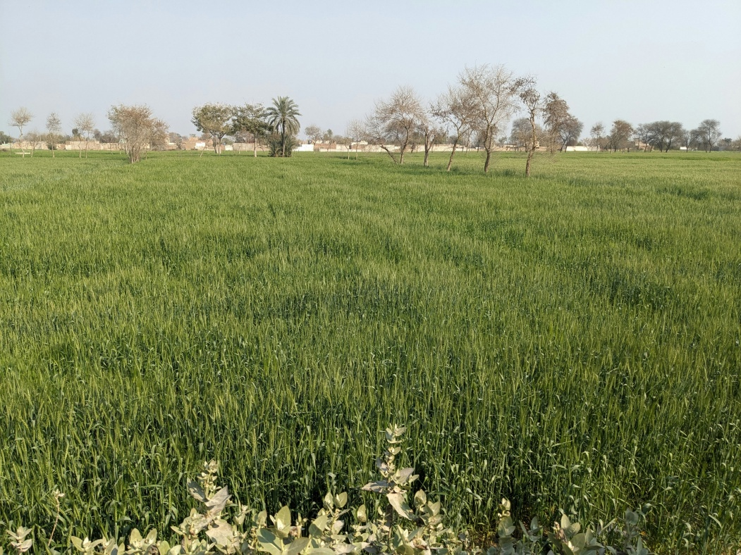

    - Lower Indus Plain
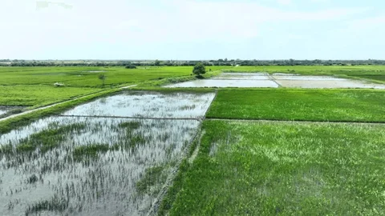
    - Southern Irrigated Plains
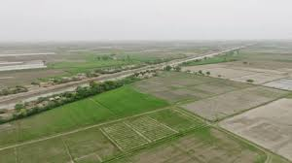

    - Arid / Desert Zone
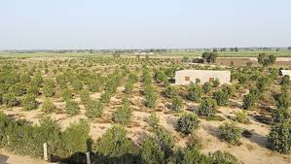

    - Barani (rainfield) zone
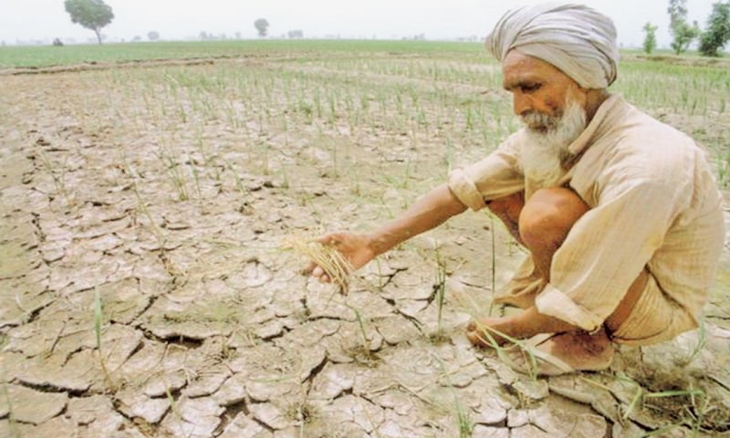

    - Western Plateau
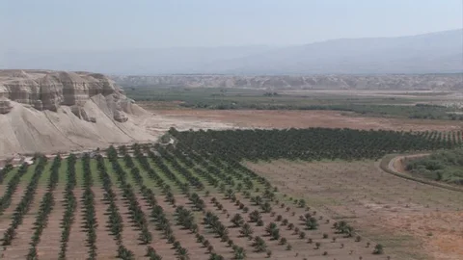

    - Northern Valleys
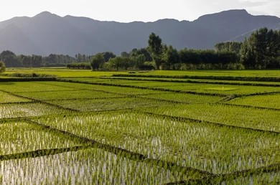

    - Sulaiman Piedmont
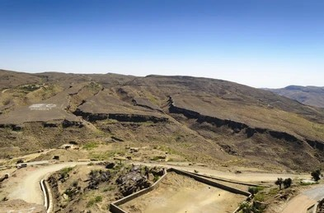

    - Northern Dry Mountains
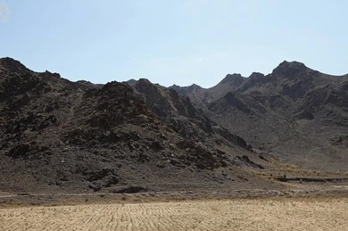

    - Western Dry Mountains
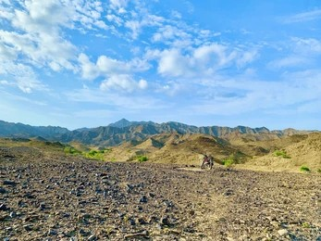
    - Western Dry Mountains
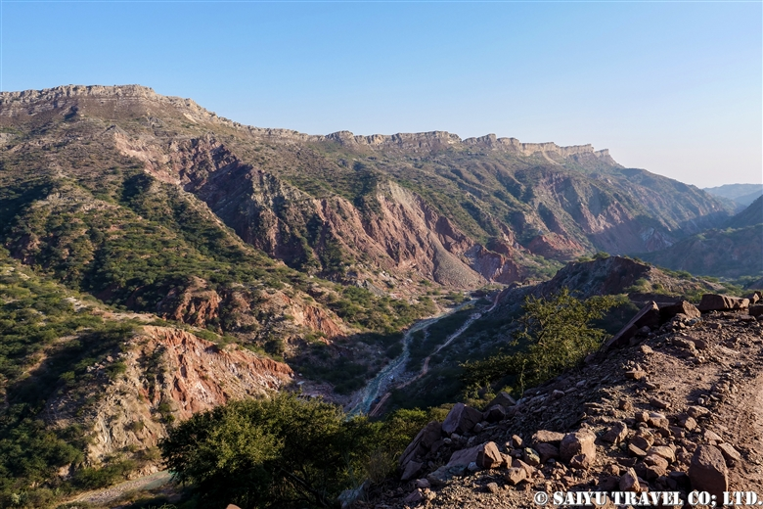

    - Indus Delta
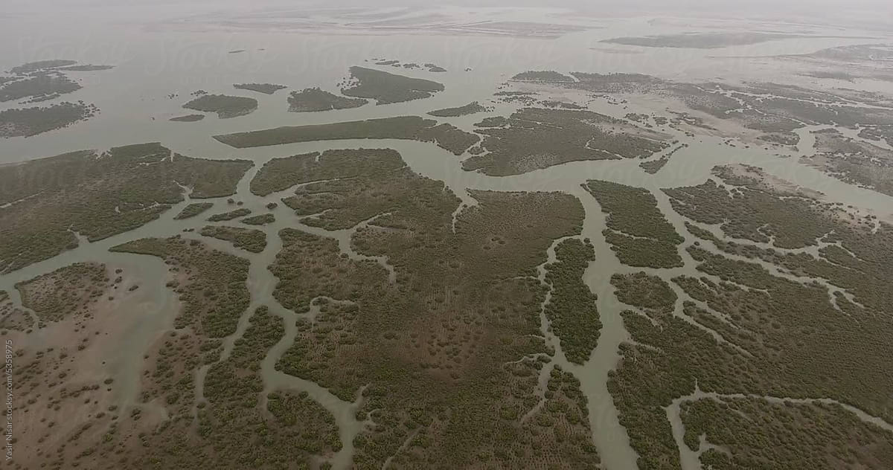

Zone | Soil Type | pH | N | P | K | Suitable Crops
Upper Indus Plain | Loamy | 7.2 | 45 | 15 | 130 | Wheat, maize, vegetables, pulses
Upper Indus Plain | Silty loam | 7.5 | 50 | 18 | 120 | Wheat, barley, vegetables
Upper Indus Plain | Sandy loam | 7.0 | 40 | 12 | 100 | Cotton, maize, millet, sorghum
Upper Indus Plain | Clay loam | 7.8 | 48 | 20 | 140 | Rice (irrigated), sugarcane, wheat
Lower Indus Plain | Clay | 7.5 | 50 | 20 | 140 | Rice, sugarcane, cotton
Lower Indus Plain | Alluvial | 7.2 | 48 | 18 | 135 | Wheat, rice, maize, sugarcane
Southern Irrigated Plains | Calcareous | 7.8 | 40 | 15 | 120 | Cotton, wheat, sugarcane, oilseeds
Southern Irrigated Plains | Loamy | 7.3 | 45 | 18 | 130 | Wheat, cotton, maize, sorghum
Arid / Desert | Sandy | 7.5 | 30 | 10 | 90 | Millet, guar, sorghum
Arid / Desert | Clayey | 7.8 | 35 | 12 | 110 | Wheat, millet, castor
Barani (Rainfed) | Silt loam | 7.0 | 40 | 15 | 120 | Wheat, maize, pulses, oilseeds
Barani (Rainfed) | Clay loam | 7.2 | 42 | 18 | 125 | Wheat, chickpea, barley
Western Plateau | Calcareous | 7.8 | 35 | 12 | 110 | Wheat, barley, fruits (apples, plums)
Northern Valleys | Silty loam | 7.0 | 45 | 15 | 130 | Maize, rice, apples, vegetables
Northern Valleys | Clay loam | 7.2 | 48 | 18 | 140 | Wheat, maize, fruits
Sulaiman Piedmont | Loamy | 7.5 | 40 | 15 | 120 | Wheat, millet, gram, mustard
Sulaiman Piedmont | Clayey | 7.8 | 42 | 18 | 125 | Wheat, maize, pulses, sorghum
Northern Dry Mountains | Clay loam | 7.5 | 38 | 12 | 110 | Wheat, maize, rice
Western Dry Mountains | Calcareous loamy | 7.8 | 35 | 12 | 110 | Wheat, barley, fruits (apples, peaches, grapes)
Dry Western Plateau | Calcareous | 7.8 | 35 | 12 | 105 | Wheat, sorghum, millet, melons
Indus Delta | Clayey | 7.5 | 45 | 15 | 130 | Rice, pulses, sugarcane, berseem, banana
Indus Delta | Silty | 7.2 | 48 | 18 | 125 | Rice, wheat, vegetables

Upper Indus Plain
Zone | Sub-Zone | Soil Type | pH Min | pH Max | N Min | P Min | K Min | Recommended Crop
Upper Indus Plain | Faisalabad | Loamy | 6.8 | 7.5 | 40 | 12 | 120 | Wheat
Upper Indus Plain | Faisalabad | Loamy | 6.8 | 7.5 | 40 | 12 | 120 | Maize
Upper Indus Plain | Faisalabad | Loamy | 6.8 | 7.5 | 40 | 12 | 120 | Vegetables
Upper Indus Plain | Gujranwala | Silty loam | 7.0 | 7.8 | 45 | 15 | 115 | Wheat
Upper Indus Plain | Gujranwala | Silty loam | 7.0 | 7.8 | 45 | 15 | 115 | Barley
Upper Indus Plain | Sahiwal | Sandy loam | 6.8 | 7.3 | 38 | 10 | 95 | Cotton
Upper Indus Plain | Multan | Clay loam | 7.2 | 8.0 | 45 | 18 | 135 | Sugarcane
Upper Indus Plain | Multan | Clay loam | 7.2 | 8.0 | 45 | 18 | 135 | Rice

Lower Indus Plain
Zone | Sub-Zone | Soil Type | pH Min | pH Max | N Min | P Min | K Min | Recommended Crop
Lower Indus Plain | Sukkur | Clayey | 7.0 | 7.8 | 45 | 18 | 130 | Rice
Lower Indus Plain | Sukkur | Clayey | 7.0 | 7.8 | 45 | 18 | 130 | Sugarcane
Lower Indus Plain | Hyderabad | Alluvial | 6.8 | 7.5 | 42 | 15 | 125 | Wheat
Lower Indus Plain | Hyderabad | Alluvial | 6.8 | 7.5 | 42 | 15 | 125 | Maize

Southern Irrigated Plains
Zone | Sub-Zone | Soil Type | pH Min | pH Max | N Min | P Min | K Min | Recommended Crop
Southern Irrigated Plains | Nawabshah | Calcareous | 7.5 | 8.2 | 35 | 12 | 110 | Cotton
Southern Irrigated Plains | Nawabshah | Calcareous | 7.5 | 8.2 | 35 | 12 | 110 | Sugarcane
Southern Irrigated Plains | Mirpurkhas | Loamy | 7.0 | 7.6 | 40 | 15 | 125 | Wheat
Southern Irrigated Plains | Mirpurkhas | Loamy | 7.0 | 7.6 | 40 | 15 | 125 | Maize

Arid / Desert Zone
Zone | Sub-Zone | Soil Type | pH Min | pH Max | N Min | P Min | K Min | Recommended Crop
Barani (Rainfed) | Potohar Plateau | Silt loam | 6.7 | 7.3 | 38 | 12 | 115 | Wheat
Barani (Rainfed) | Potohar Plateau | Silt loam | 6.7 | 7.3 | 38 | 12 | 115 | Pulses
Barani (Rainfed) | Chakwal | Clay loam | 7.0 | 7.5 | 40 | 15 | 120 | Chickpea
Barani (Rainfed) Zone
Zone | Sub-Zone | Soil Type | pH Min | pH Max | N Min | P Min | K Min | Recommended Crop
Barani (Rainfed) | Potohar Plateau | Silt loam | 6.7 | 7.3 | 38 | 12 | 115 | Wheat
Barani (Rainfed) | Potohar Plateau | Silt loam | 6.7 | 7.3 | 38 | 12 | 115 | Pulses
Barani (Rainfed) | Chakwal | Clay loam | 7.0 | 7.5 | 40 | 15 | 120 | Chickpea

Northern Valleys
Zone | Sub-Zone | Soil Type | pH Min | pH Max | N Min | P Min | K Min | Recommended Crop
Northern Valleys | Swat | Silty loam | 6.5 | 7.2 | 42 | 14 | 125 | Maize
Northern Valleys | Swat | Silty loam | 6.5 | 7.2 | 42 | 14 | 125 | Apples
Northern Valleys | Gilgit | Clay loam | 6.8 | 7.5 | 45 | 16 | 135 | Wheat

Indus Delta
Zone | Sub-Zone | Soil Type | pH Min | pH Max | N Min | P Min | K Min | Recommended Crop
Indus Delta | Thatta | Clayey | 7.0 | 7.8 | 40 | 14 | 125 | Rice
Indus Delta | Thatta | Clayey | 7.0 | 7.8 | 40 | 14 | 125 | Banana
Indus Delta | Badin | Silty | 6.8 | 7.4 | 45 | 16 | 120 | Vegetables

