SysID Plant and Excitation Comparison Report
Generated from the dashboard backend model on 2026-06-03 20:00:42

Table of Contents
1. Objective and reference basis
2. How the dashboard model generated the results
3. Why SysID changes with plant, excitation, amplitude, and noise
4. Plant and excitation comparison
5. Sensitivity analysis
6. Conclusion and stored artifacts

1. Objective and Reference Basis
This report runs the current dashboard simulator and SysID estimator for plants P01-P10 across the available excitation profiles. It also runs simple sensitivity cases for excitation amplitude, tension sensor noise, and roller-speed noise.
Reference basis: the supplementary material provides the ten plant EA values and damping/regime labels in Table S12, and the state-space matrix structure in Table S13. The extracted dashboard reference does not contain numeric per-plant arrays for R, J, f, L, or b, so the current dashboard model varies EA by plant and keeps the baseline arrays for those other parameters.
Because the supplement does not provide a numeric SysID RMSE table for every plant/excitation pair, the comparison difference reported here is the estimator error against the simulator truth used by the dashboard model: RMSE_theta plus parameter relative-error columns in the stored CSV files.

2. How the Dashboard Model Generated the Results
Each case runs a 4 s closed-loop simulation with 1 ms RK4 physics integration and 10 ms PLC logging. The SysID estimator then solves finite-difference regression equations for kt_UW, kt_Nip, kt_RW, kf_UW, kf_Nip, kf_RW, and EA.
A lower RMSE_theta means the estimated parameter vector is closer to the simulator truth. For high-EA plants outside the extracted baseline range, the dashboard currently recommends zero excitation for numerical safety; those rows are useful weak-excitation checks, not full dynamic paper reproduction.

3. Why SysID Results Change
Excitation changes the result because SysID is a regression problem: different profiles excite different combinations of roller velocity and web-tension states. A profile that does not move the needed states makes the normal equations weak or ill-conditioned.
Plant type changes the result because EA changes the stiffness and the speed-to-tension gain. The supplement also says each plant has different per-roller arrays, but the current dashboard reference only exposes EA numerically; R, J, f, L, and b remain baseline arrays in this run.
Amplitude changes the signal-to-noise ratio. Too low amplitude gives weak parameter excitation, while too high amplitude can push the reduced model into biased or unstable behavior. The useful region is the moderate range where the state motion is visible but still controlled.
Tension noise directly disturbs the finite-difference tension equation, so it mainly affects EA and any result that depends on tension derivatives.
Omega noise disturbs roller-speed derivatives, so it mainly affects the kt and kf estimates from roller dynamics.

4. Plant and Excitation Comparison
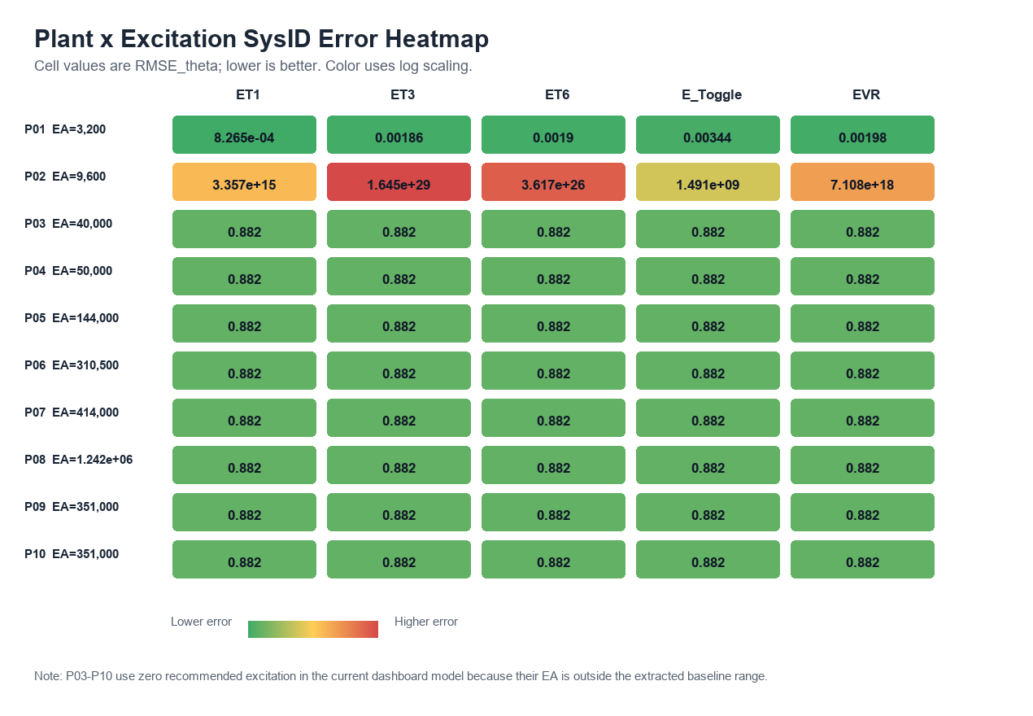
Figure 1. Heatmap of RMSE_theta for each plant/excitation pair. Lower values are better.
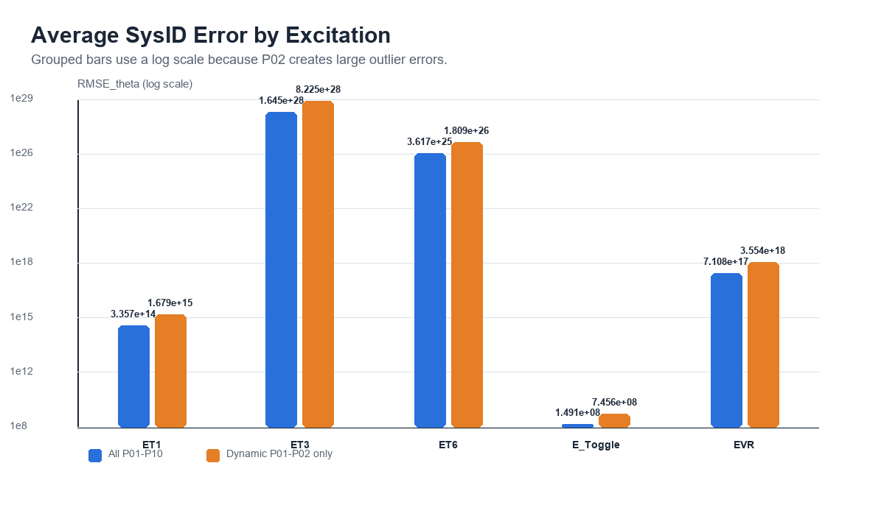
Figure 2. Average RMSE_theta by excitation, shown for all plants and for the dynamic baseline-compatible cases.
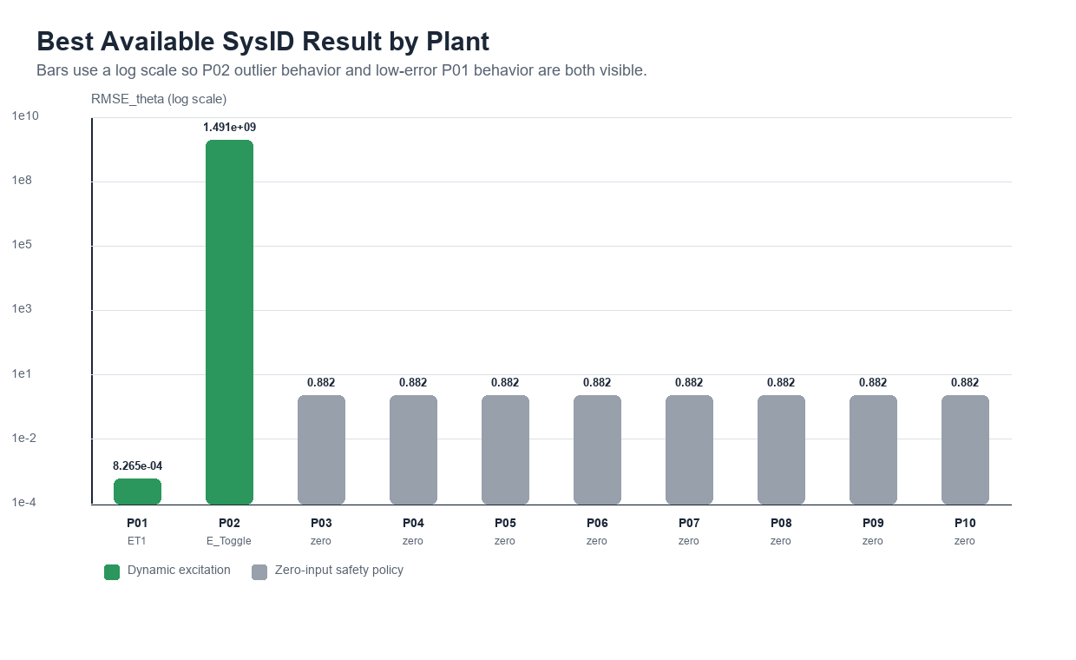
Figure 3. Best available result per plant. Gray bars indicate zero-input safety-policy cases.

Best Result by Plant
Plant | Material | Scale | EA (N) | Regime | Amp (V) | Best excitation | Best RMSE
P01 | PE | lab | 3,200 | O-UD | 0.08 | ET1 | 8.265e-04
P02 | PET | lab | 9,600 | O-UD | 0.04619 | E_Toggle | 1.491e+09
P03 | PET | lab | 40,000 | H-Osc | 0 | zero-input policy | 0.8822
P04 | PET | pilot | 50,000 | O-UD | 0 | zero-input policy | 0.8822
P05 | Paper | prod | 144,000 | O-UD | 0 | zero-input policy | 0.8822
P06 | Al | lab | 310,500 | H-Damp | 0 | zero-input policy | 0.8822
P07 | Al | pilot | 414,000 | H-Osc | 0 | zero-input policy | 0.8822
P08 | Al | prod | 1.242e+06 | O-UD | 0 | zero-input policy | 0.8822
P09 | Cu | lab | 351,000 | H-Damp | 0 | zero-input policy | 0.8822
P10 | Cu | pilot | 351,000 | O-UD | 0 | zero-input policy | 0.8822

Average Result by Excitation
Excitation | All plants mean | Dynamic P01-P02 mean | Valid cases | Dynamic cases
ET1 | 3.357e+14 | 1.679e+15 | 10.00 | 2
ET3 | 1.645e+28 | 8.225e+28 | 10.00 | 2
ET6 | 3.617e+25 | 1.809e+26 | 10.00 | 2
E_Toggle | 1.491e+08 | 7.456e+08 | 10.00 | 2
EVR | 7.108e+17 | 3.554e+18 | 10.00 | 2

5. Sensitivity Analysis
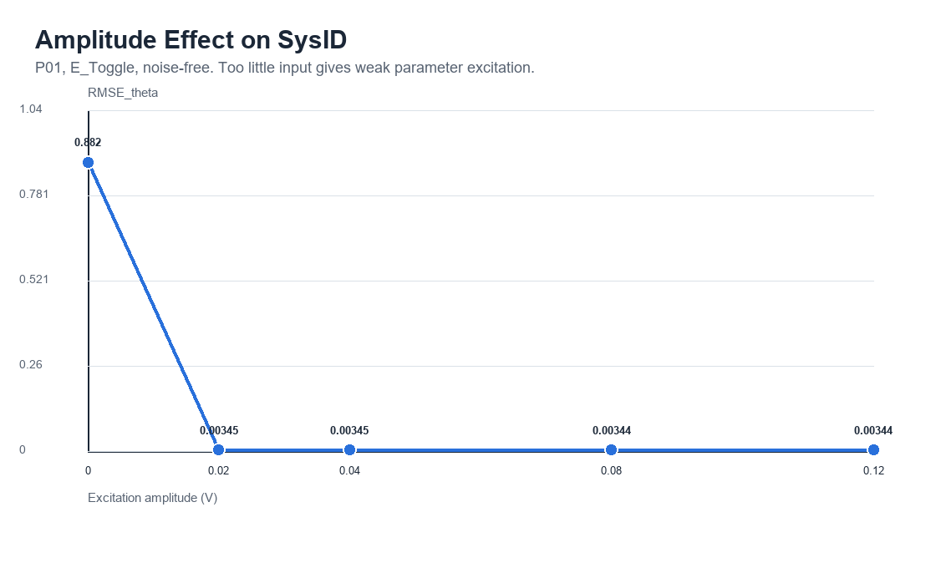
Figure 4. Amplitude sensitivity for P01 with E_Toggle.
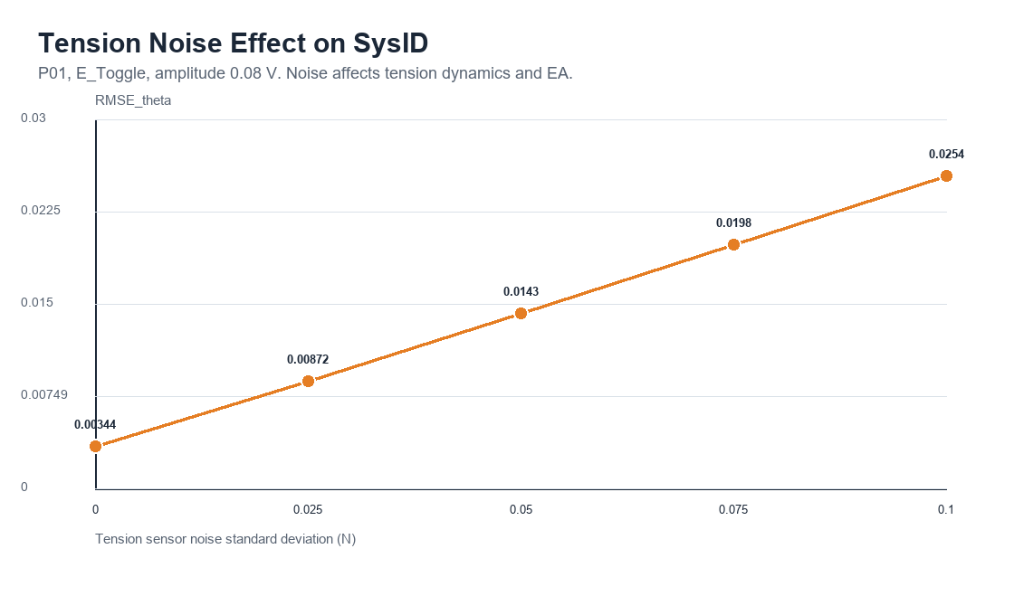
Figure 5. Tension-noise sensitivity for P01 with E_Toggle.
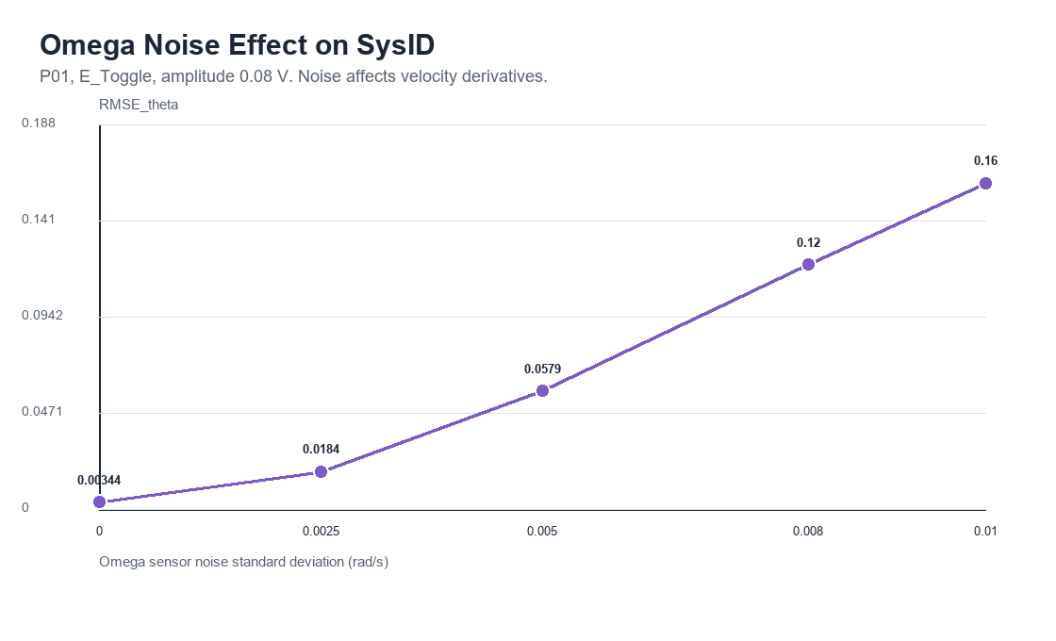
Figure 6. Roller-speed-noise sensitivity for P01 with E_Toggle.
Factor | Best setting | Best RMSE | Worst setting | Worst RMSE | Interpretation
Excitation amplitude | 0.12 | 0.003439 | 0 | 0.8822 | Too little amplitude gives poor excitation; moderate amplitude improves the regression signal.
Tension noise | 0 | 0.003443 | 0.1 | 0.0254 | Tension noise corrupts finite-difference tension dynamics and EA estimation.
Omega noise | 0 | 0.003443 | 0.01 | 0.1597 | Omega noise corrupts velocity derivatives and the kt/kf regression.

6. Conclusion and Stored Artifacts
The best dynamic baseline-compatible case was P01 with ET1 at RMSE_theta=8.265e-04.
P01 and P02 are the only plants inside the extracted Table S4 baseline EA range, so they receive nonzero recommended excitation in the current dashboard model. P03-P10 are high-EA cases and are reported as zero-input safety-policy cases unless exact per-roller arrays and retuned excitation limits are supplied.
The sensitivity plots show the practical SysID tradeoff: usable excitation amplitude improves identifiability, while tension noise and omega noise degrade estimates through the finite-difference equations.
Type | Description | File
CSV | Plant x excitation matrix | sysid_plant_excitation_sweep.csv
CSV | Amplitude sensitivity | sysid_amplitude_sensitivity.csv
CSV | Tension-noise sensitivity | sysid_tension_noise_sensitivity.csv
CSV | Omega-noise sensitivity | sysid_omega_noise_sensitivity.csv
CSV | All report cases combined | sysid_report_all_cases.csv
PNG | Heatmap, bars, and sensitivity line charts | reports/figures/sysid_*.png
JSON | Machine-readable report summary | sysid_plant_excitation_report.json
DOCX | Word report | sysid_plant_excitation_report.docx

