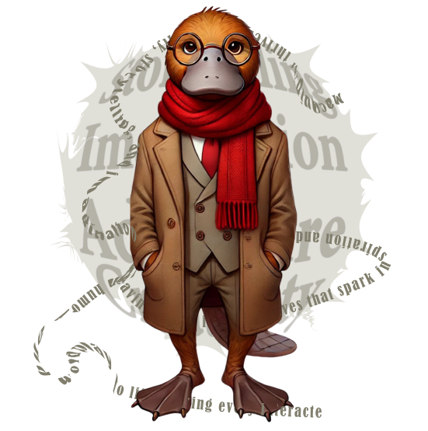

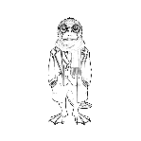
☐ PlaidLibs PromptFolio of Character Seeds™

20251218

Purpose of the PlaidLibs™ PromptFolio of Character Seeds™
The PlaidLibs™ PromptFolio of Character Seeds™ exists to provide a canonical, privacy-safe system for defining reusable characters by personality, not appearance. It captures how a character behaves, speaks, disrupts, supports, or surprises—so they can be consistently summoned, remixed, and recontextualized across PlaidLibs™ stories, games, comics, and visual experiences.
PromptFolio treats characters as creative seeds, not static portraits. Visuals are optional outputs, never identity anchors. This allows characters—real or fictional—to evolve across genres, eras, absurdity levels, and Quip personas without being constrained by stored imagery or personal data.
The system is designed to:Preserve character continuity across formats
- Enable safe fictionalization of real people
- Support non-destructive remixing
- Integrate cleanly with Quips, Genres, Literary Forms, and Visual Styles
- Scale indefinitely without accumulating sensitive data
PromptFolio remembers who a character is, not what they look like—and that distinction powers the PlaidLibs™ universe.
Prompt Seeds are treated as stable identities. Temporary exaggerations, role shifts, or visual re-skins do not alter the base seed unless the user explicitly saves changes.
Saved changes create a new version of the seed, preserving prior versions for rollback, reuse, or comparison.
Consent & Representation
Users are responsible for ensuring they have consent to fictionalize real individuals. PlaidLibs™ encourages playful exaggeration, not impersonation or misrepresentation, and provides Plaid Factor™ controls to prevent unwanted realism.

Deletion & Portability
Users may delete Prompt Seeds at any time. Deletion removes the seed and its linked outputs from active use. Export of prompt data (traits, quirks, roles) may be supported for personal archival or reuse.

Conflict Resolution Order
When conflicts arise, the following precedence applies:
Platform Guardrails → User Intent → Prompt Seed → Genre → Quip Persona → Absurdity Layer
### 🔒 **PlaidLibs PromptFolio of Character Seeds™

**What it is:**
A system to store creative, story-ready character profiles (real or fictional) based on **personality prompts**, not images.

- **What’s stored:**
- Traits, quirks, roles, and style tags
- Any **approved generated visuals** (portraits, comics, etc.)
- Linked data in your **Prompt Cast Portfolio™**

- **What’s *not* stored:**
- No personal photos or image uploads are retained
- Images are used **only once** for visual generation, then deleted

- **Why it rocks:**
- Safe, scalable, and privacy-friendly
- Turns your family, friends, and characters into **storycast-ready seeds**
- Powers PlaidLibs™, comics, Quip quests, and more—on demand

Family Prompt Creation
//RE: PlaidLibs.com - PromptFolio of Character Seeds -Concept Overview

1. The Family/Friend Prompt Seed
You fill out a personalized prompt for each family member with fun and flexible fields like:
Name/Nickname
Role in family (“Dad,” “Cousin Tina the Chaos Queen”)
Personality traits (e.g., “grumpy but secretly poetic,” “loves spreadsheets and squirrels”)
Signature phrases
Likes/dislikes
Plaid Factor™ (how wacky they get in PlaidLibs™ stories: Mild | Moderate | Max Plaidification)
Optional Add-ons:
Favorite animal, food, or holiday
Real vs exaggerated mode toggle
Voice Pack trigger (narrated like a Quip persona!)

2. Storage & Access
Your Private Cast of Characters™, stored under your Geofroggy or PlaidLibs profile. Then, in any story or game, you could say:

“Let’s drop in Uncle Daryl on Plaid Mode™”
“What if my cousin appeared in a historical PlaidLib set in 1842?”
“Remix my sister as a ninja sushi chef.”

And I could dynamically build in their personality—complete with easter eggs, inside jokes, and visual traits if image generation is included.

Prompt Portfolio™ Entry Template

1. Name / Nickname:
(e.g., Aunt Rhonda, Big Mike, Lil T, The Spreadsheet Overlord)

2. Relationship to You:
(e.g., Cousin, Imaginary Sibling, Time-Traveler Uncle)

3. Signature Personality Traits (choose 2–4):
(e.g., Dramatic, Snack-Obsessed, Sneaky Genius, Random Fact Machine)

4. Their “Thing” (quirk or obsession):
(e.g., Collects antique spatulas, speaks only in pirate metaphors, knows every postal code in Canada)

5. Catchphrase / Quote:
(e.g., “That’s not how Nana did it!”, “I demand a pie chart.”)

6. Plaid Factor™ Level:
Mild (realistic, mostly grounded)
Moderate (quirky but recognizable)
Full Plaidification™ (cartoon logic, chaos welcome)

7. Visual Cues (optional):
(e.g., wears goggles at dinner, has an eyepatch but no story, pink crocs and a cape)

8. Voice Pack Vibe (optional):
(e.g., Dramatic Shakespearean, Southern drawl, Flatly robotic, DJ airhorn energy)

9. Preferred Role in Stories (optional):
(e.g., Comic Relief, Plot Saboteur, Secret Hero, Snack Vendor)

## ✅ **Prompt Cast Visual Entry Protocol™**
**For adding real or fictional characters with image support**

## 🔒 **PlaidLibs PromptFolio Storage Philosophy**
> _“Remember the soul, not the selfie.”_

### ✅ What *will* be stored:
- The **prompt likeness** of each character:
- Their traits, quirks, story roles, voice style, etc.
- Any approved generated visuals (portraits, comic scenes, etc.)
- Links to the Prompt Cast Portfolio™ structure (e.g., `Maria → ID#004`)

### ❌ What *will not* be stored:
- No original personal **photos**
- No long-term retention of **raw uploads**
- No automatic **image previews or galleries** unless intentionally created from prompt data

### 🔄 **One-Time Use Process (Visual Input Option)**
We can still offer a "one-time image input" system for generating stylized likenesses when needed:
1. You upload a reference image.
2. I generate the requested visual (portrait, comic panel, etc.).
3. **Reference image is discarded immediately** after generation.
4. The stylized **output is stored as part of the character’s creative record**.

### 📦 What Each Prompt Seed Stores:
```json
{
"id": "PCP004",
"name": "Maria",
"traits": ["brilliant", "chatty", "fun", "easy-going"],
"quirk": "socializing",
"plaid_factor": "Moderate",
"visual_tags": ["Plaidcut™ Classic", "RealMix Portrait Available"],
"voice_pack": null,
"image_output_refs": [
{
"type": "portrait",
"style": "Plaidcut™ Classic",
"timestamp": "2025-04-07"
}
]
}
```

Prompt Seeds are treated as stable character identities, but may be temp-orarily exaggerated, re-skinned, or remixed per story without permanently altering the base seed unless explicitly saved.

