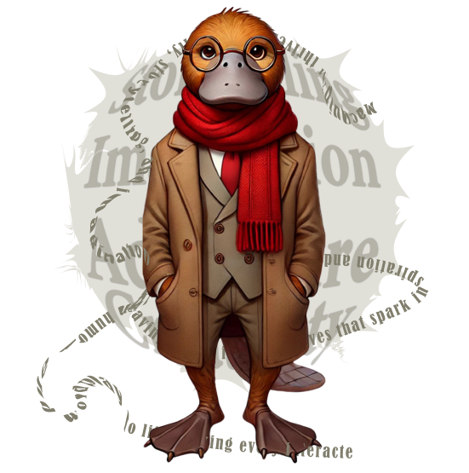
OFFICIAL PlaidLibs™ Core Genres
20251218

OFFICIAL PlaidLibs™ Core Genres
The foundational threads of narrative Plaid.
- Adventure (Narrative Genre) – Exploration, danger, and action-filled quests.
- Comedy (Tone-Based Genre) – Amusement through satire, exaggeration, or absurdity.
- Drama (Emotional Genre) – Character-driven emotional or moral conflict.
- Fantasy (Speculative Genre) – Magical worlds, mythical beings, invented rules.
- Historical (Setting-Based Genre) – Fiction rooted in real historical settings.
- Horror (Suspense Genre) – Supernatural dread, isolation, or psychological fear.
- Mystery (Puzzle Genre) – Crime-solving, secrets, and hidden truths.
- Romance (Relational Genre) – Love stories, emotional bonds, and connection.
- Science Fiction (Speculative Genre) – Tech futures, alien worlds, time riffs.
- Thriller (Tension Genre) – High-stakes survival, ticking clocks, and betrayals.
- Wild Card (Genre Anarchy)

🌀 Flexible & Meta Genres
Genre-bending formats and tonal experiments.
- Absurdist (Philosophical/Comedic Genre) – Irrationality, illogic, and existential whimsy.
- Satire (Tone/Commentary Genre) – Social critique via irony and exaggeration.
- Slice of Life (Everyday Narrative Genre) – Introspective realism and ordinary beauty.
- Speculative (Umbrella Genre) – “What if?” premises, across fantasy, sci-fi, and myth.
- Surreal (Visual/Experiential Genre) – Dream logic, symbolism, and subconscious flow.
- Parody (Comedic Mimicry Genre) – Genre imitation for humor and commentary.

🧵 Plaidverse™ Bonus Genres
Exclusive to those who walk the Plaidified Path.
- Plaidpunk (Alt-Fiction Genre) – Retro-futurism, plaid-powered inventions, and theatrical nonsense.
- Interplaidactic (Space Genre) – Galactic frogonauts, dubious physics, tartan starships.
- Courtroom Chaos (Subgenre) – Legal absurdity with surprise witnesses and plaid juries.
- Epic Quest (Adventure Subgenre / Mode)– Heroic journeys, prophecy-fueled missions, and many map detours.
- Hall of Mirrors (Meta Genre) – Recursive tales, self-aware characters, and genre collapse.

+ 🃏 Wild Card Format
The Wild Card is a flexible, unpredictable storytelling slot that can take any literary form—or break the mold entirely. It may follow traditional structure (e.g., Adventure, Horror, or Horrific Adventure) or venture into surreal, stream-of-consciousness, glitchy, or experimental territory.
It exists to surprise, challenge, and entertain—serving as a narrative playground for chaos, Quip-driven genre twists, and rare format fusions.
Sometimes it's poetry.
Sometimes it's complete nonsense, especially with ErrQuip as selected assistant.
Sometimes it's a barista arguing with a ghost through limericks.
The only rule: there are no rules.

🎲 PlaidLibs™ Random Format Selector (Core Distribution Logic)
To keep storytelling fresh and unpredictable, each story round offers users a rotating menu of 7 formats:
- 3 formats randomly selected from the Core Literary Set
- 2 formats from the Expanded or Meta Categories
- 1 format from the Bonus or Experimental pool
- 1 guaranteed Wild Card — the formatless format, always present, always unpredictable

🎭 THE OFFICIAL PLAIDLIBS™ GENRE COMPENDIUM
Sorted by Category — Unified, Expanded, and Ready for Chaos™

Purpose Statement (Foundational)

The PlaidLibs™ Genre Compendium defines the narrative promises and creative lenses that shape what a story feels like—its stakes, atmosphere, themes, and expectations. Genres do not dictate structure or length; they define the story’s world logic, the type of tension it explores, and the emotional or comedic “flavor” it delivers.

When a genre is selected, the Quip adapts tone, imagery, and pacing to align with that genre’s core promise—while remaining compatible with any Literary Form, Absurdity Level, or Remix option. Genres in PlaidLibs™ are suggestive, not exclusive: they guide creativity without limiting it, and they can be blended, subverted, or reinterpreted in PlaidLibs™ fashion.

This compendium exists to provide:
- Clarity (users know what kind of ride they’re choosing)
- Variety (fresh experiences through recombination)
- Consistency (genre “reads” correctly even when remixed)
- Play (genre-bending is encouraged, never punished)

If a story does not clearly “read” as its selected genre—whether straight or subverted—the genre selection has failed its purpose.

📚 Core Narrative Genres (The Foundations)
These are your classic genre anchors—ideal for both beginner tales and subversion.
- Adventure (Narrative Genre)
Exploration, danger, quests, and journey-based action.
- Comedy (Tone-Based Genre)
Stories designed to amuse through humor, exaggeration, and absurdity.
- Drama (Emotional Genre)
Realistic or heightened emotional conflicts, often character-driven.
- Fantasy (Speculative Genre)
Magical worlds, mythical beings, and alternate realities.
- Historical (Setting-Based Genre)
Fiction rooted in recognizable historical settings or themes.
- Horror (Suspense Genre)
Evokes fear or dread through supernatural or psychological twists.
- Mystery (Puzzle Genre)
Solving crimes, decoding clues, and uncovering secrets.
- Romance (Relational Genre)
Stories centered on emotional and romantic connections.
- Science Fiction (Speculative Genre)
Advanced technology, space, and speculative futures.
- Thriller (Tension Genre)
High-stakes, fast-paced tension with danger and survival.

🌀 Flexible & Meta Genres (For Genre Benders & Narrative Philosophers)
More about structure, tone, or commentary than setting.

- Absurdist (Philosophical/Comedic Genre)
Highlights the irrational and surreal—meaninglessness made funny.
- Satire (Commentary Genre)
Uses irony, exaggeration, or parody to critique real-world ideas.
- Slice of Life (Everyday Narrative Genre)
Focuses on ordinary experiences, introspection, and quiet truths.
- Speculative (Umbrella Genre)
“What if?” fiction encompassing sci-fi, fantasy, and more.
- Surreal (Experiential Genre)
Dream logic, symbolic imagery, and subconscious storytelling.
- Parody (Comedic Mimicry Genre)
Imitates another genre or story type for humor and commentary.
- Hall of Mirrors (Meta Genre)
Self-aware stories that break the fourth wall, loop, or fold.

🧵 Plaidverse™ Bonus Genres (Exclusive to PlaidLibs Canon)
Born of chaos, tailored to the Quip Crew™, and stitched with stylish nonsense.
- Plaidpunk (Alt-Fiction Genre)
Retro-futurism powered by plaid logic, steam-tartan, and flair.
- Interplaidactic (Space Genre)
Cosmic tales of frogonauts, unstable plaid propulsion, and alien fashion.
- Courtroom Chaos (Legal Absurdist Subgenre)
Rogue judges, talking evidence, surprise plaid juries.
- Epic Quest (Narrative Mode)
World-altering missions, ancient maps, and chosen-frog energy.
- ChronoPlaid (Time Travel Subgenre)
Every era has its own plaid—and its own narrative rules.
- Plaid Gothic (Emotive Horror-Fantasy Blend)
Cursed fabrics, haunted estates, and melancholic waistcoats.
- PlaidWestern (Genre Fusion)
Saloon shootouts, ghost cattle, and patchwork justice.
- Plaid High (Magical School Subgenre)
Plaidcraft 101, enchanted lockers, and rogue professors.
- Wild Card (Genre Anarchy)
Could be anything—ballad, telegram, prophecy, haiku, menu.

Genre defines the story’s promise and atmosphere; Literary Form defines structure; Absurdity defines reality-bend; any combination is valid.

