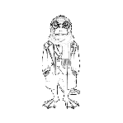
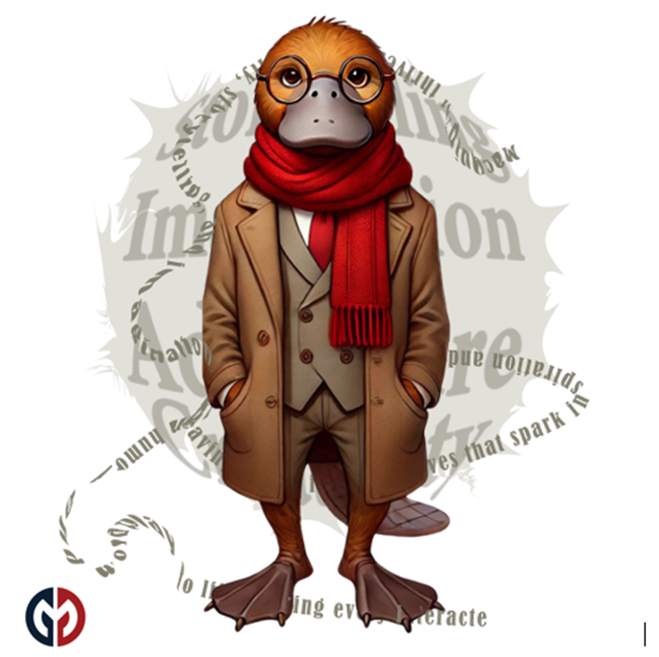
PlaidLibs™ Single Panel Story Prompts Only
20251229

PlaidLibs™ Standard Image Styles
Purpose Statement (Foundational)
The PlaidLibs™ Standard Image Styles exist to provide reliable, repeatable visual outcomes through clearly defined prompt starters. Any image generation initiated using one of these style prompts is expected to consistently produce the corresponding visual language, regardless of subject matter.
These styles function as visual contracts:
when a creator begins an image with a specific PlaidLibs™ style prompt, the resulting image should unmistakably reflect that style’s composition, rendering logic, textures, lighting rules, and aesthetic priorities.
Each style is intentionally designed to be:
- Self-contained — requiring no additional stylistic clarification
- Consistent — producing recognizable results across varied subjects
- Composable — able to accept characters, props, scenes, or concepts without visual drift
- White-background safe — always preserving a clean, modern presentation
The goal of this system is not artistic suggestion, but stylistic certainty.
These prompts define how something is rendered, not what is rendered.
If an image does not visually read as its declared style at a glance, the prompt has failed its purpose.

Optional One-Sentence Variant (If You Want It Tighter / More Technical)
Each PlaidLibs™ Standard Image Style prompt is a deterministic visual starter: any image generated using that prompt should reliably and recognizably produce the intended style without additional stylistic instructions.

PlaidLibs™ Standard Image Styles
🎨 Whimsical / Storybook — Prompt Starter
Create an image in the style of a bright, playful storybook illustration on a pure white background. Use soft, rounded shapes, cheerful pastel-leaning colors, gentle outlines, and simplified textures. Atmosphere should feel warm, imaginative, and lightly enchanted. Maintain the signature storybook linework, soft shading, and childlike clarity throughout.
🎭 Surrealist / Absurdist — Prompt Starter
Create an image in the style of a surreal, dreamlike, Dalí-esque scene on a pure white background. Emphasize improbable juxtapositions, scale distortions, symbolic objects, and painterly surrealism. Maintain the style’s signature melting-logic, dreamlike clarity, and strange visual metaphors, keeping all linework and shading consistent.
🐉 Fantasy Realism — Prompt Starter
Create an image in the style of detailed fantasy realism on a pure white background. Use rich, dimensional rendering, luminous highlights, dramatic shading, and finely textured materials. The world should feel magical yet grounded, with mythic energy and physically believable lighting. Maintain the style’s signature realism-meets-fable visual logic.
🤖 Sci-Fi / Cyberpunk — Prompt Starter
Create an image in the style of high-contrast cyberpunk sci-fi on a pure white background. Use neon accents, reflective materials, holographic interfaces, sharp geometry, digital noise, and futuristic tech motifs. Maintain the style’s signature glow rules, sleek silhouettes, and high-energy sci-fi lighting.
🕯 Gothic / Horror — Prompt Starter
Create an image in the style of moody, atmospheric gothic horror on a pure white background. Use dramatic shadows, high-contrast chiaroscuro, elongated shapes, eerie silhouettes, and unsettling details. Maintain the style’s signature gothic architecture cues, spectral textures, and tension-heavy lighting while keeping the white background pure and clean.
🕹 Vintage / 1920s Cartoon — Prompt Starter
Create an image in the style of a vintage 1920s rubber-hose cartoon on a pure white background. Use exaggerated noodle limbs, big expressive eyes, ink-black outlines, flat cel-style shading, and era-authentic animation quirks. Maintain the style’s signature bounce, visual gags, and old-school cartoon proportions.

✂️ Theatrical Paper Cutout — Prompt Starter
Create an image in the style of a theatrical paper cutout collage on a pure white background. Use layered cardstock textures, crisp scissor edges, stacked shadows, and handcrafted construction. Maintain the style’s signature multi-layered silhouettes, stage-like composition, and tactile cut-paper logic.
🖼 Renaissance — Prompt Starter
Create an image in the style of a classical Renaissance painting on a pure white background. Use realistic anatomy, soft oil-like blending, controlled chiaroscuro, rich fabrics, and historically inspired composition. Maintain the style’s signature painterly depth, golden-tone highlights, and old-master craftsmanship while keeping the background clean white.
🔲 Minimalist / Icon / Sticker — Prompt Starter
Create an image in the style of a clean minimalist sticker icon on a pure white background. Use bold shapes, strong silhouettes, simplified details, crisp edges, and flat or near-flat colors. Maintain the style’s signature clarity, playful proportions, and bold graphic readability.
🌈 Upgrade / Unlockable Image Styles
🕶 Plaid Noir — Prompt Starter
Create an image in the style of Plaid Noir on a pure white background. Use high-contrast noir lighting, sharp shadows, dramatic angles, subtle grain-free moodiness, and integrated plaid motifs woven into fabric or props. Maintain the style’s signature muted palette punctuated with stark blacks and luminous whites.
🌫 Plaid Noir Tinge — Prompt Starter
Create an image in the style of Plaid Noir Tinge on a pure white background. Use noir-inspired lighting softened by faint pastel or fog-like color washes. Integrate subtle plaid motifs, but keep the palette slightly dream-hazed. Maintain moody edges without any vintage paper effects.
🎞 Plaid Film — Prompt Starter
Create an image in the style of Plaid Film on a pure white background. Add vertical sprocket-hole borders on the far-left and far-right edges (only), keeping the main panel clean. Use cinematic composition, soft contrast, and subtle plaid accents. Maintain the style’s filmstrip logic without any retro or aged-paper coloration.

✏️ Plaid Sketch — Prompt Starter
Create an image in the style of a hand-drawn Plaid Sketch on a pure white background. Use pencil-like linework, cross-hatching, textured graphite strokes, and integrated plaid details outlined by hand. Maintain the sketchbook simplicity and artistic spontaneity.
💥 Plaid Glitch — Prompt Starter
Create an image in the style of Plaid Glitch on a pure white background. Use digital glitch artifacts, RGB splits, pixel fraying, fragmented silhouettes, and neon-accented plaid distortions. Maintain the style’s structured chaos and glitch-energy without darkening the background.
🪡 Plaid Patchwork — Prompt Starter
Create an image in the style of Plaid Patchwork on a pure white background. Use stitched fabric textures, quilted seams, layered textile panels, visible threads, and soft cloth shading. Integrate multiple tartans harmoniously. Maintain the cozy, handcrafted textile aesthetic.
🎨 Plaid Noir Pop — Prompt Starter
Create an image in the style of Plaid Noir Pop on a pure white background. Combine noir shadows with bold, symbolic color bursts and vibrant plaid accents. Use expressive poses, dramatic lighting, and striking pops of neon or saturated hues against an otherwise noir palette.
🖍 Plaid Crayon Chaos™ — Prompt Starter
Create an image in the style of Plaid Crayon Chaos™ on a pure white background. Use energetic crayon streaks, thick scribbles, vibrant overlapping colors, and playful plaid interpretations rendered as hand-drawn marks. Maintain the wild texture and chaotic childlike intensity.
🟩 Plaid Mosaic Vibe™ — Prompt Starter
Create an image in the style of Plaid Mosaic Vibe™ on a pure white background. Use tile-like geometric fragments, clean grout-like separators, bright color blocks, and plaid patterns reinterpreted as mosaic tessellations. Maintain crisp edges and luminous, glasslike texture.

PlaidLibs™ Signature Visual Styles (Core Set)
💬 Plaid Comic™ — Prompt Starter
Create an image in the style of Plaid Comic™ on a pure white background. Use bold retro-comic linework, saturated colors, dynamic shading, expressive faces, crisp speech bubbles, and stylish plaid fashion elements. Maintain the exact PlaidLibs comic-book energy.
🧶 Plaid Craft Kawaii™ — Prompt Starter
Create an image in the style of Plaid Craft Kawaii™ on a pure white background. Use voxel-like cube-headed characters, pixelated outlines, soft bright palettes, kawaii-style expressive square eyes, and plaid-themed outfits. Maintain the playful pop-craft aesthetic.
📐 Plaid Schematic — Prompt Starter
Create an image in the style of a Plaid Schematic on a pure white background. Use blueprint-like linework in cyan or neon white, clean technical diagrams, measurement marks, scale bars, and plaid motifs integrated as structural elements. Maintain the precision and clarity of a technical illustration.

