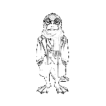
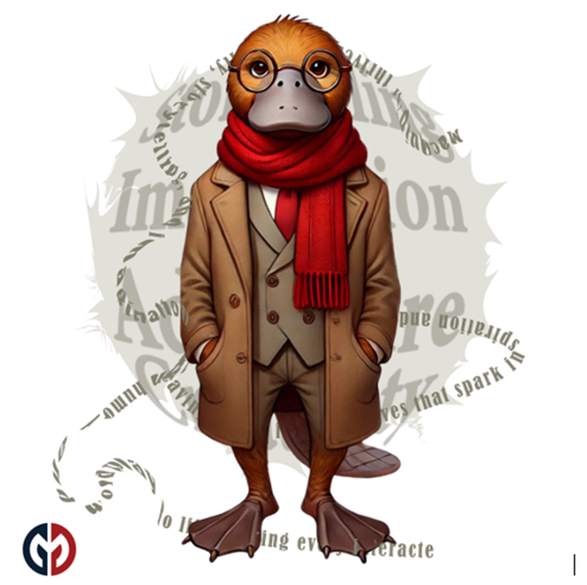
PlaidLibs™ Three Panel Story Prompts Only
20251229

PlaidLibs™ Three-Panel Image Styles
Purpose Statement
The PlaidLibs™ Three-Panel Image Styles exist to ensure consistent, repeatable visual storytelling across multiple panels using a single style invocation.
Any image generated using one of these style definitions is expected to:
- Produce exactly three coordinated panels
- Maintain strict stylistic consistency across all panels
- Preserve a pure white background
- Allow narrative or conceptual progression without visual drift
These prompts define the visual grammar of the image.
Panel prompts define what changes.
The style definition defines what must not change.
If the three panels do not visually read as belonging to the same style at a glance, the prompt has failed its purpose.

🎨 OFFICIAL 3-PANEL STYLE STARTERS
(All begin with “Create an image in the style of…")
(All enforce bright white backgrounds.)

PlaidLibs™ Standard Image Styles
✅ Universal 3-Panel Image Invocation Clause
Create a single three-panel image composition on a pure white background. All three panels must share the same visual style, rendering logic, lighting rules, and texture language. Panel content may change, but the style must remain consistent across all panels.

🎨 Whimsical / Storybook
Create an image in the style of a bright, playful storybook illustration on a pure white background. Each of the three panels must use soft rounded shapes, cheerful pastel colors, gentle outlines, and cozy, childlike textures. Maintain the consistent storybook linework and whimsical clarity across all panels.​
Panel 1 Prompt:
Panel 2 Prompt:
Panel 3 Prompt:

🎭 Surrealist / Absurdist
Create an image in the style of a surreal, dreamlike, Dalí-esque scene on a pure white background. Each of the three panels must feature symbolic objects, unusual scale shifts, and dream-logic imagery. Maintain consistent painterly surrealism, crisp clarity, and signature distortion behaviors.​
Panel 1 Prompt:
Panel 2 Prompt:
Panel 3 Prompt:

🐉 Fantasy Realism
Create an image in the style of rich, detailed fantasy realism on a pure white background. Each of the three panels must use dramatic lighting, textured materials, mythic energy, and grounded realism. Maintain consistent rendering logic, luminous shading, and magical atmosphere.​
Panel 1 Prompt:
Panel 2 Prompt:
Panel 3 Prompt:

🤖 Sci-Fi / Cyberpunk
Create an image in the style of sleek cyberpunk sci-fi on a pure white background. Each of the three panels must use neon accents, reflective surfaces, holographic UI elements, and futuristic compositions. Maintain consistent high-tech lighting and neon logic.​
Panel 1 Prompt:
Panel 2 Prompt:
Panel 3 Prompt:
🕯 Gothic / Horror
Create an image in the style of atmospheric gothic horror on a pure white background. Each of the three panels must use dramatic shadows, eerie silhouettes, elongated forms, and tension-heavy lighting. Maintain consistent gothic tone without adding dark backgrounds.​
Panel 1 Prompt:
Panel 2 Prompt:
Panel 3 Prompt:

🕹 Vintage / 1920s Cartoon
Create an image in the style of a vintage 1920s rubber-hose cartoon on a pure white background. Each of the three panels must use noodle limbs, exaggerated expressions, bold black outlines, and simple cel shading. Maintain consistent era-accurate cartoon physics and charm.​
Panel 1 Prompt:
Panel 2 Prompt:
Panel 3 Prompt:

✂️ Paper Cutout
Create an image in the style of layered theatrical paper cutout art on a pure white background. Each of the three panels must show stacked paper layers, crisp scissor edges, and subtle cast shadows. Maintain consistent handcrafted texture and layered silhouette logic.​
Panel 1 Prompt:
Panel 2 Prompt:
Panel 3 Prompt:

🖼 Renaissance
Create an image in the style of a classical Renaissance painting on a pure white background. Each of the three panels must use realistic anatomy, soft oil-like blending, rich fabrics, and controlled chiaroscuro. Maintain consistent old-master composition logic.​
Panel 1 Prompt:
Panel 2 Prompt:
Panel 3 Prompt:

🔲 Minimalist / Icon / Sticker
Create an image in the style of a bold minimalist sticker icon on a pure white background. Each of the three panels must emphasize simple silhouettes, flattening, clean contours, and high clarity. Maintain consistent graphic minimalism.​
Panel 1 Prompt:
Panel 2 Prompt:
Panel 3 Prompt:

🌈 Upgrade / Unlockable Image Styles
🕶 Plaid Noir
Create an image in the style of Plaid Noir on a pure white background. Each of the three panels must use sharp noir lighting, crisp shadows, dramatic angles, and integrated muted plaid textures. Maintain consistent noir contrast without grain or vintage tint.​
Panel 1 Prompt:
Panel 2 Prompt:
Panel 3 Prompt:

🌫 Plaid Noir Tinge
Create an image in the style of Plaid Noir Tinge on a pure white background. Each of the three panels must blend noir lighting with gentle pastel fog tones and subtle plaid hints. Maintain softened edges and dreamy noir atmosphere.​
Panel 1 Prompt:
Panel 2 Prompt:
Panel 3 Prompt:

🎞 Plaid Film
Create an image in the style of Plaid Film on a pure white background, including vertical sprocket-hole borders on the far left and far right. Each of the three panels must use cinematic framing, soft contrast, and elegant plaid accents. Maintain consistent filmstrip structure.​
Panel 1 Prompt:
Panel 2 Prompt:
Panel 3 Prompt:

✏️ Plaid Sketch
Create an image in the style of Plaid Sketch on a pure white background. Each of the three panels must feature hand-drawn graphite linework, cross-hatching, textured pencil marks, and sketched plaid elements. Maintain consistent sketchbook energy.​
Panel 1 Prompt:
Panel 2 Prompt:
Panel 3 Prompt:

💥 Plaid Glitch
Create an image in the style of Plaid Glitch on a pure white background. Each of the three panels must feature digital distortion, RGB offsets, pixel tears, and glitch-fragment plaid forms. Maintain consistent structured chaos.​
Panel 1 Prompt:
Panel 2 Prompt:
Panel 3 Prompt:

🪡 Plaid Patchwork
Create an image in the style of Plaid Patchwork on a pure white background. Each of the three panels must use quilted fabric layers, stitching, textile seams, and interwoven tartan patterns. Maintain consistent soft fabric texture.​
Panel 1 Prompt:
Panel 2 Prompt:
Panel 3 Prompt:

🎨 Plaid Noir Pop
Create an image in the style of Plaid Noir Pop on a pure white background. Each of the three panels must mix noir lighting with bold, symbolic splashes of bright color and stylish plaid elements. Maintain dramatic poses and expressive contrasts.​
Panel 1 Prompt:
Panel 2 Prompt:
Panel 3 Prompt:

🖍 Plaid Crayon Chaos™
Create an image in the style of Plaid Crayon Chaos™ on a pure white background. Each of the three panels must be filled with energetic crayon strokes, scribbles, chaotic overlaps, and plaid patterns drawn by hand. Maintain vivid, childlike intensity.​
Panel 1 Prompt:
Panel 2 Prompt:
Panel 3 Prompt:

🟩 Plaid Mosaic Vibe™
Create an image in the style of Plaid Mosaic Vibe™ on a pure white background. Each of the three panels must use geometric tile fragments, crisp grout lines, and mosaic-style plaid reinterpretations. Maintain luminous tile texture.​
Panel 1 Prompt:
Panel 2 Prompt:
Panel 3 Prompt:

PlaidLibs™ Signature Visual Styles (Core Set)
💬 Plaid Comic™
Create an image in the style of Plaid Comic™ on a pure white background. Each of the three panels must use retro comic linework, saturated colors, expressive faces, bold speech bubbles, and plaid-themed fashion. Maintain consistent comic-book energy.​
Panel 1 Prompt:
Panel 2 Prompt:
Panel 3 Prompt:

🧶 Plaid Craft Kawaii™
Create an image in the style of Plaid Craft Kawaii™ on a pure white background. Each of the three panels must feature voxel-like cube-headed characters, pixel outlines, kawaii-style eyes, and plaid outfits. Maintain soft, bright cube-craft charm.​
Panel 1 Prompt:
Panel 2 Prompt:
Panel 3 Prompt:

📐 Plaid Schematic
Create an image in the style of a Plaid Schematic on a pure white background. Each of the three panels must feature blueprint-style linework, measurement marks, clean technical diagrams, and plaid integrated as structural geometry. Maintain precision and clarity.​
Panel 1 Prompt:
Panel 2 Prompt:
Panel 3 Prompt:

