

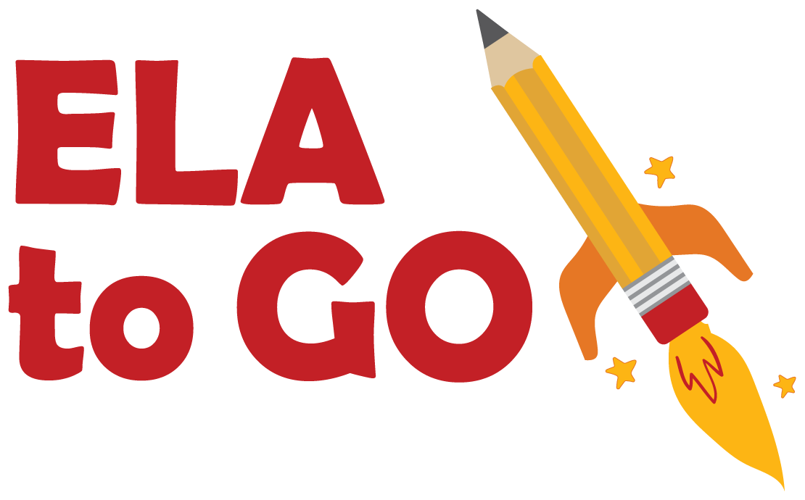

The Eiffel Tower

**By Jose Toller**

**Source 1:**

*Dear Editor, April 20, 1887*

*How can we sit by, saying nothing while the foundations for this ridiculous tower are being poured? Eiffel’s tower, meant to be a monument to the upcoming 100-year anniversary of the French Revolution will be an eyesore. It will look like a big black smokestack.*

*I for one agree with the letter published by our city’s painters, sculptors and architects. Who better to understand beauty? They see this tower for what it is – a useless thing. Listen to them! We must rid our city of this iron monster. And what about the birds that fill our skies? Won’t this big, black iron tower stop them from filling our skies with their song?*

*Citizens of Paris to stand up! Unite against this iron beast that is growing in our city! Rise up and say NO! No to the Eiffel tower. It isn’t too late. The foundation isn’t finished! We can save our city still!*

*From,*

*A Concerned Citizen*

**Source 2: Daily News: Eiffel Tower Turns 130 Years Old!**

One of the most easily recognized monuments in the world is the Eiffel Tower in Paris France. This monument turned 130 years old on March 31, 2019. There is nothing more beautiful than the Eiffel tower, during the day or at night. How strange that this symbol of France was thought to be an eyesore by some before its construction.

**The Eiffel tower sways 2-3 inches side to side in strong winds. It can shrink up to 6” in height during cold weather.**

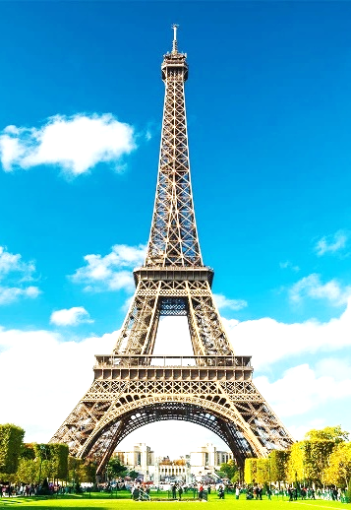

In 1889, the World’s Fair was going to be held in Paris. Something new and special needed to be built for visitors. Gustave Eiffel was asked to design a tower that would impress visitors. His idea was to build a tower taller than any other building in the world. He designed the tower to be wide at the bottom and narrow at the top so that strong winds wouldn’t be able to knock down the tower. The tower would be the entrance arch to the World’s Fair. It took about two years for the tower to be completed. The tower, which gained the nickname “Iron Lady” stands 1063 feet tall and is made of 7,300 tons of iron.

Today there are many other buildings that stand taller than the Eiffel Tower, however visitors from all over the world continue to visit. Visitors can climb up stairs to the first two levels or take a lift which also has access to the third and highest level. Visitors are amazed at the beauty of the iron structure, and the city of Paris seen from its heights. At night, visitors can delight in the Eiffel tower twinkling with millions of lights.