User Interface Design and Interaction Flows
Author: Hyma Varghese

Object Selection and Texture Change using Text

Scene 1: Enter the room
Interaction:
Walk / Navigate through the room

Story:
The user enters the virtual interior and moves around the space using walking or navigation controls. They can look around and explore the environment before interacting ith any object. The Menu and Help buttons remain accessible but unobtrusive.

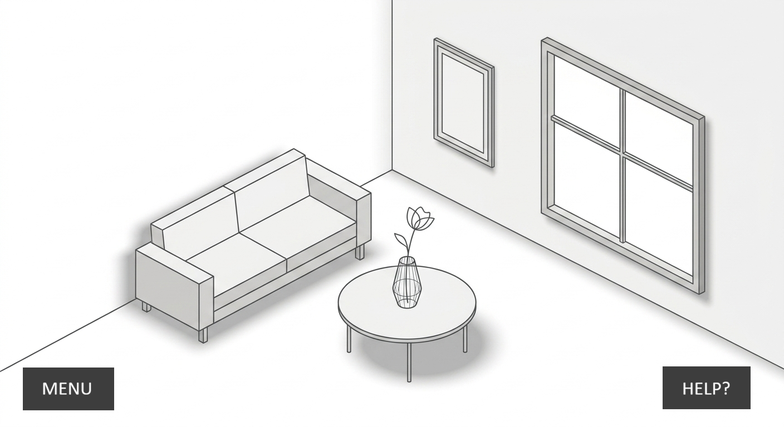

User goal:
Explore the environment and identify objects that can be customised.

Scene 2: Point at an Object
Interaction:
Point / Hover over an object
Story:
The user points toward an object, such as the sofa. When the user's pointer is over an editable object, the object receives a subtle light-coloured highlight. This provides immediate visual feedback that the object is interactive and can be customised.
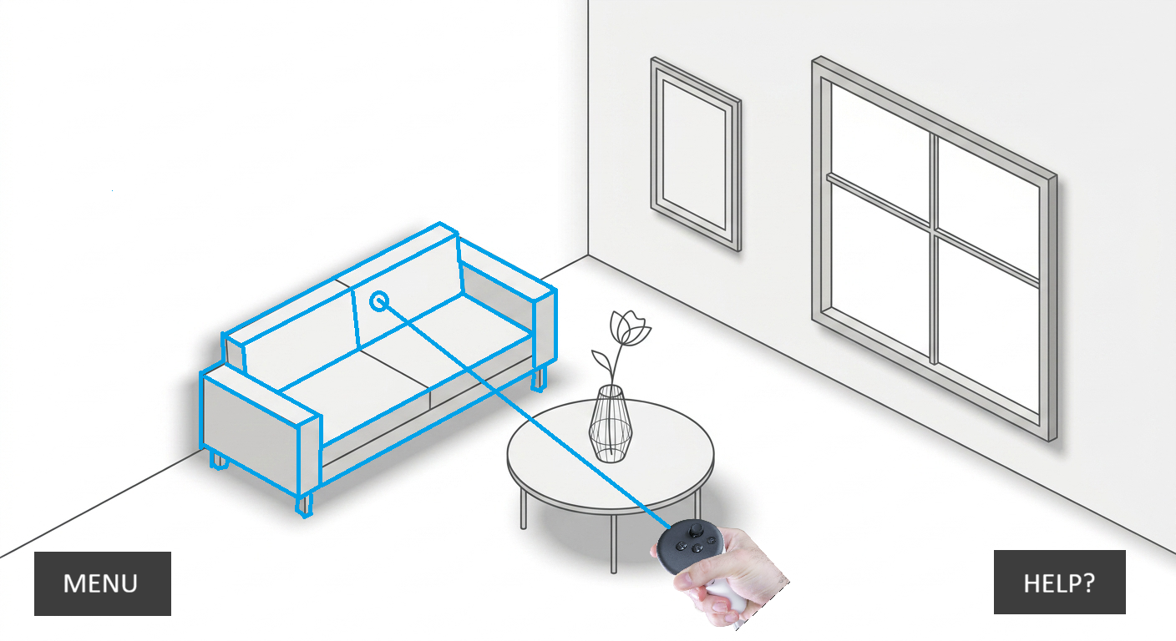
User goal:
Identify which objects in the environment are editable and available for customisation.

Scene 3: Select the Object
Interaction:
Click / Select the highlighted object
Story:
The user selects the highlighted object. The selected object changes from the light highlight to a clear dark border, confirming that the object has been successfully selected. The selection state makes it clear which object the user's next action will affect.
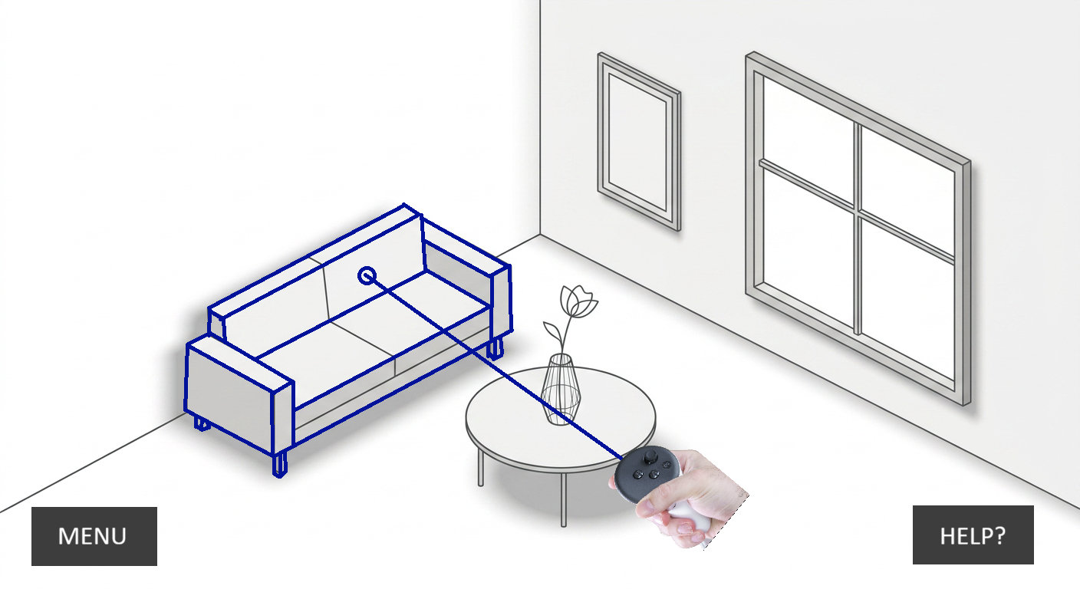
User goal:
Confirm the specific object they want to customise before moving to the editing and AI customisation flow.

Scene 4 : Customisation Panel
Interaction:
Open / access object customisation
Story:
Once the user selects an object, a contextual customisation panel appears near the selected object. The panel clearly identifies the selected object and provides an option to describe the desired change using an AI prompt.
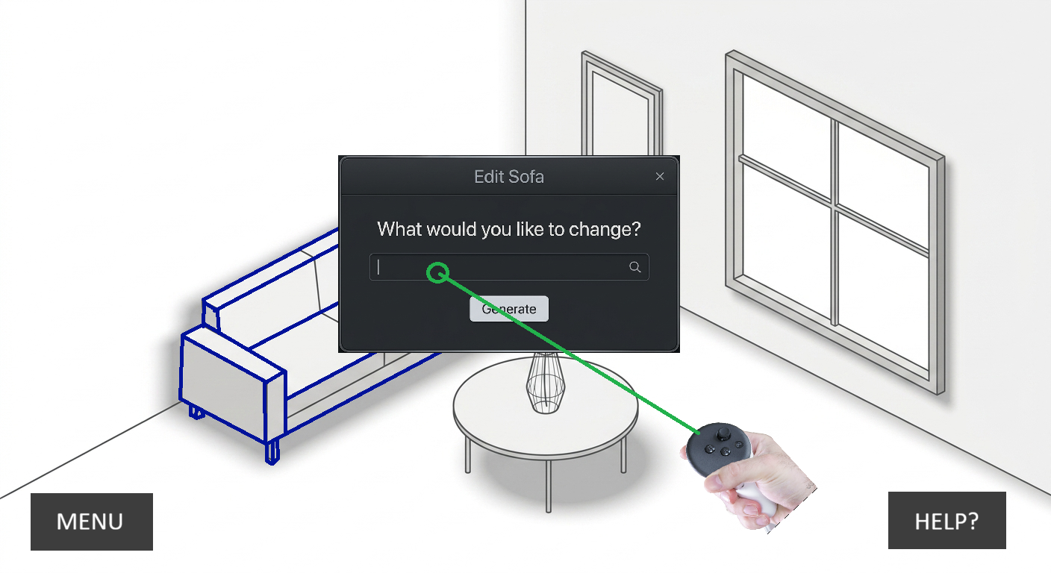
User goal:
Access the editing options and describe what they want the AI to change.

Scene 5 : AI Processing
Interaction:
Enter prompt → Generate
Story:
The user enters their desired modification and selects Generate. The system provides clear visual feedback that the AI is processing the request. The selected object remains identifiable while the system works.
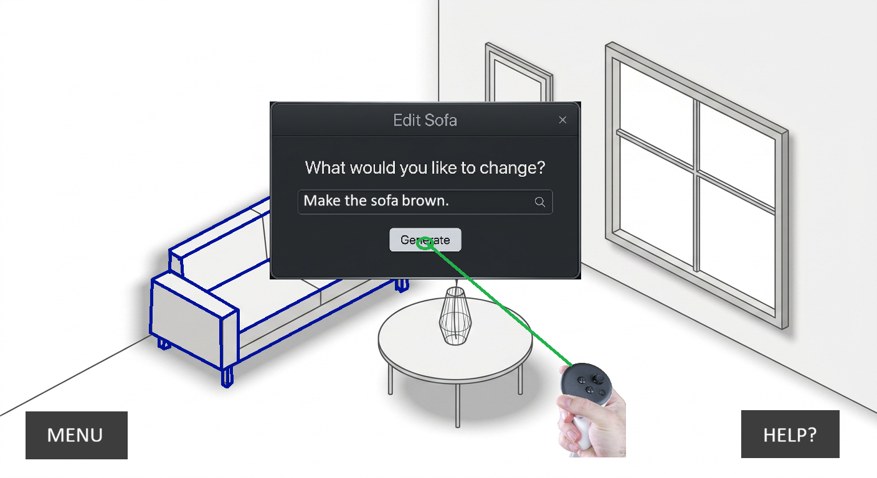

User goal:
Understand that the request has been received and the AI is generating the requested modification.

Scene 6 — AI Processing
Interaction:
Wait / Monitor AI processing
Story:
After the user clicks Generate, the system processes the request. A clear loading or progress indicator tells the user that the AI is working on the requested change.
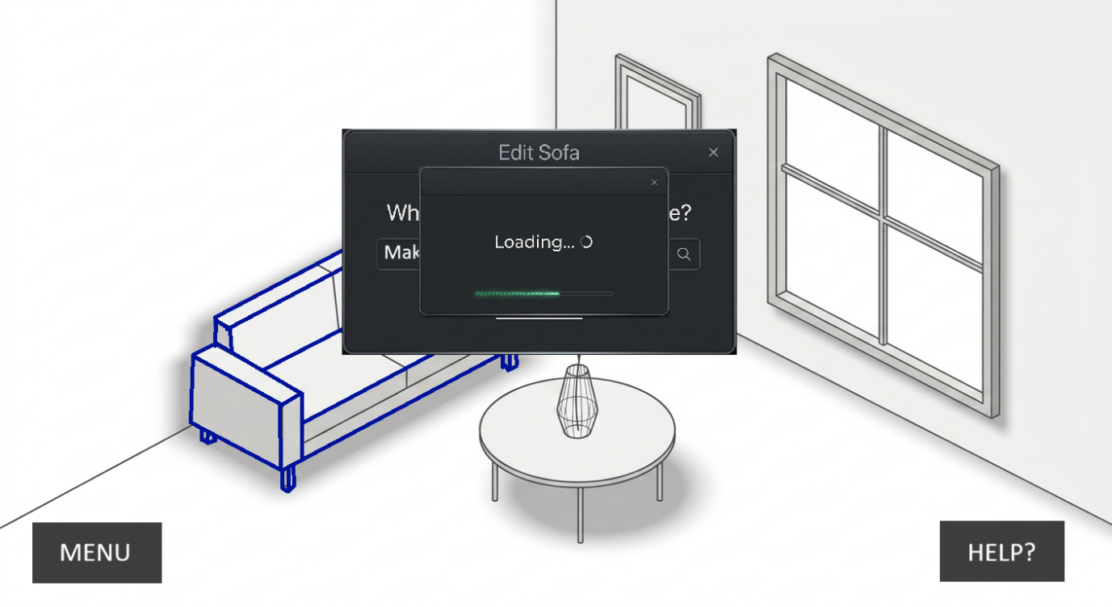

User goal:
Understand that the request has been received and the AI is currently working.

Scene 7: Generated Result & Review
Interaction:
Review → Accept / Try Again
Story:
The AI finishes processing and displays the updated object in the room. The user can clearly see the generated change. A small contextual pop-up appears beside the object without covering or obstructing the generated result. The user can review the change and choose to Accept it or Try Again.
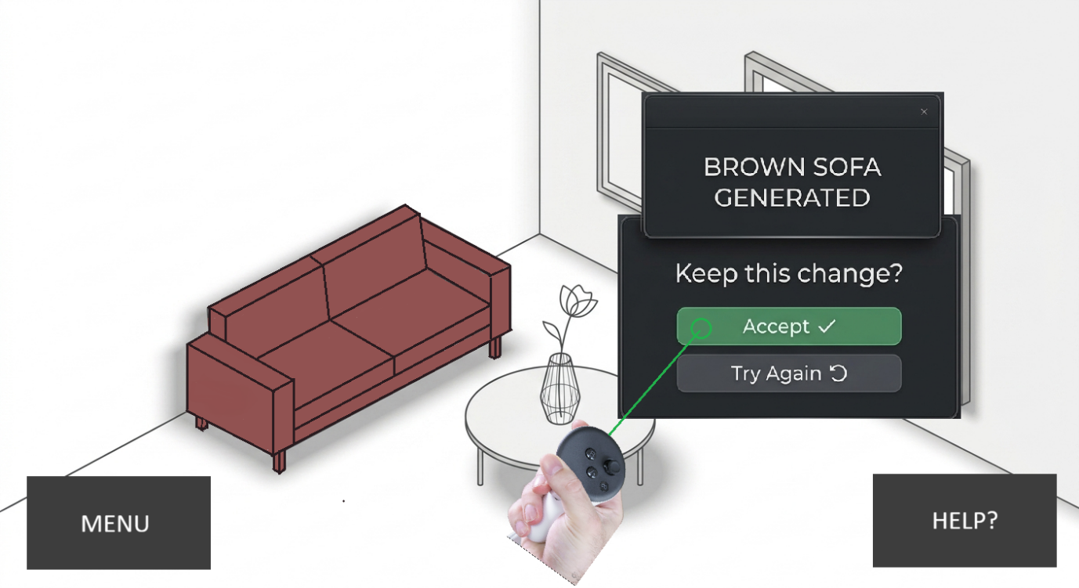
User goal:
Review the generated change and confirm whether to apply it.

Object Selection and Move the Object using the controller

Scene 1: Select the Object
Interaction:
Click / Select the highlighted object
Story:
The user selects the highlighted object. The selected object changes from the light highlight to a clear dark border, confirming that the object has been successfully selected. The selection state makes it clear which object the user's next action will affect.

User goal:
Confirm the specific object they want to customise before moving to the editing and AI customisation flow.

Scene 2 — Move / Rotate Object
Interaction:
Click, hold & move / Rotate the selected object
Story:
After selecting an object, the user can directly adjust its position or orientation within the room. By clicking and dragging the selected object, the user can move it to a new position. A rotation control allows the user to rotate the object to the desired orientation.
The object's selection indicator remains visible while it is being manipulated so the user knows which object they are controlling.
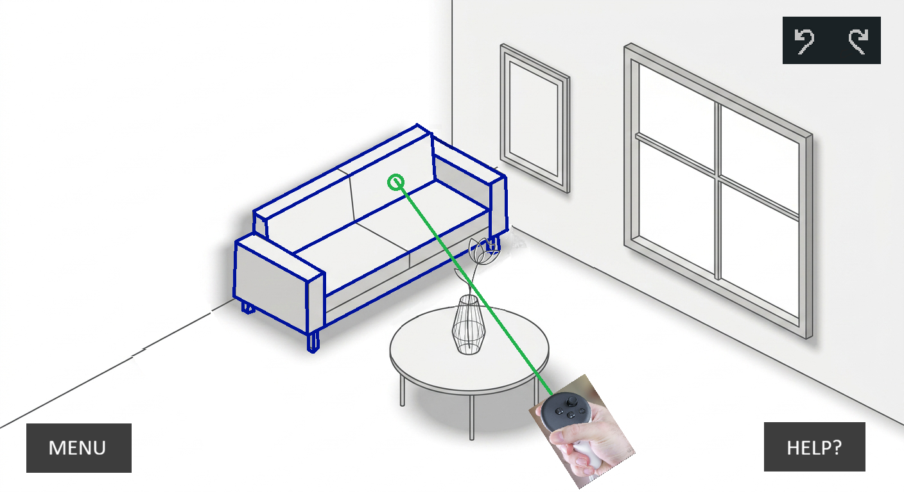
User goal:
Position and orient the selected object within the interior to achieve the desired layout.

Movement / Rotation Constraint Warning

Scene 1: Select the Object
Interaction:
Click / Select the highlighted object
Story:
The user selects the highlighted object. The selected object changes from the light highlight to a clear dark border, confirming that the object has been successfully selected. The selection state makes it clear which object the user's next action will affect.

User goal:
Confirm the specific object they want to customise before moving to the editing and AI customisation flow.

Scene 2 — Collision Detected
Interaction:
Move / Rotate → Collision detected
Story:
When the user attempts to move or rotate the selected object toward a wall or another restricted area, the system detects the spatial constraint and provides immediate visual feedback. The object indicates that the proposed position or rotation is not valid, and a warning appears without blocking the user's view
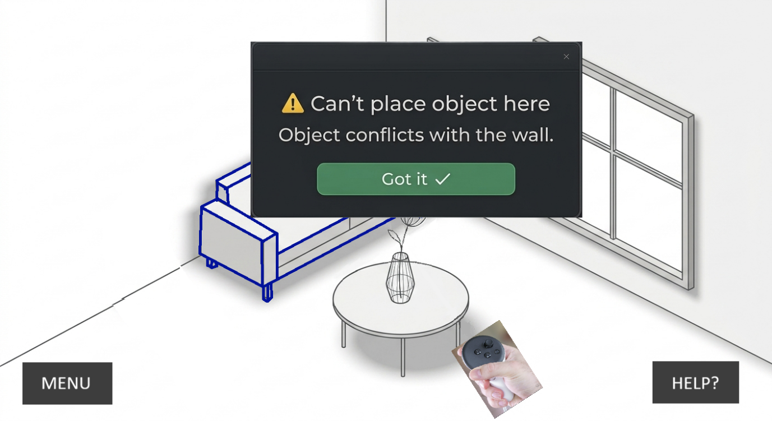

Scene 3: Acknowledge Warning
Interaction:
Click "OK" on the warning message
Story:
After reviewing the constraint warning, the user clicks OK to acknowledge the message. The warning panel closes, and the selected object remains in its last valid position. The user can then continue adjusting the object's position or rotation within the allowed space.
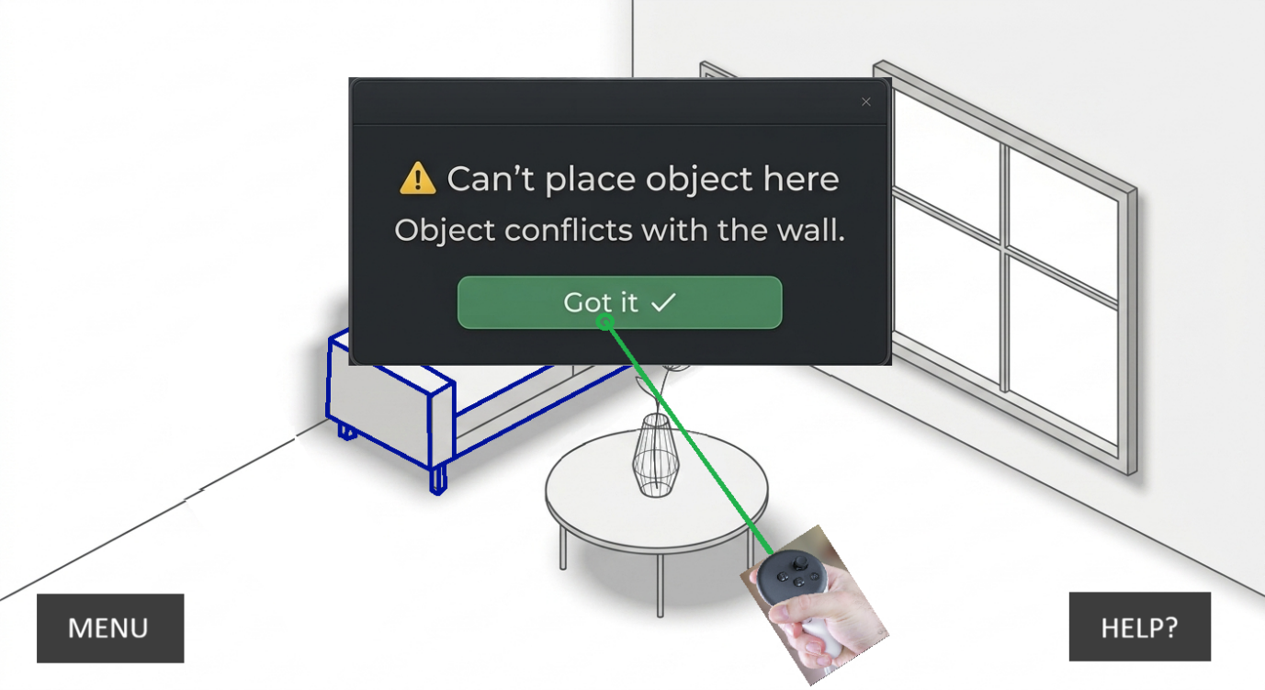

User goal:
Understand the constraint and continue editing the object without losing their current work.

Scene 4: Warning Acknowledged & Object Reverted
Interaction:
Click "OK" → Return to last valid position
Story:
After reviewing the constraint warning, the user clicks OK to acknowledge the message. The warning panel closes, and the selected object automatically returns to its last valid position and orientation before the collision occurred. The object remains selected, allowing the user to continue moving or rotating it within the available space.

User goal:
Understand the constraint and continue editing from the last valid placement without causing overlap or collision.

Undo Modification

Scene 1, 2, 3, 4 from section 3.

Scene 5: Undo Modification
Interaction:
Click Undo
Story:
The user is not satisfied with the generated result and selects Undo. The object returns to its previous state before the most recent modification was applied.
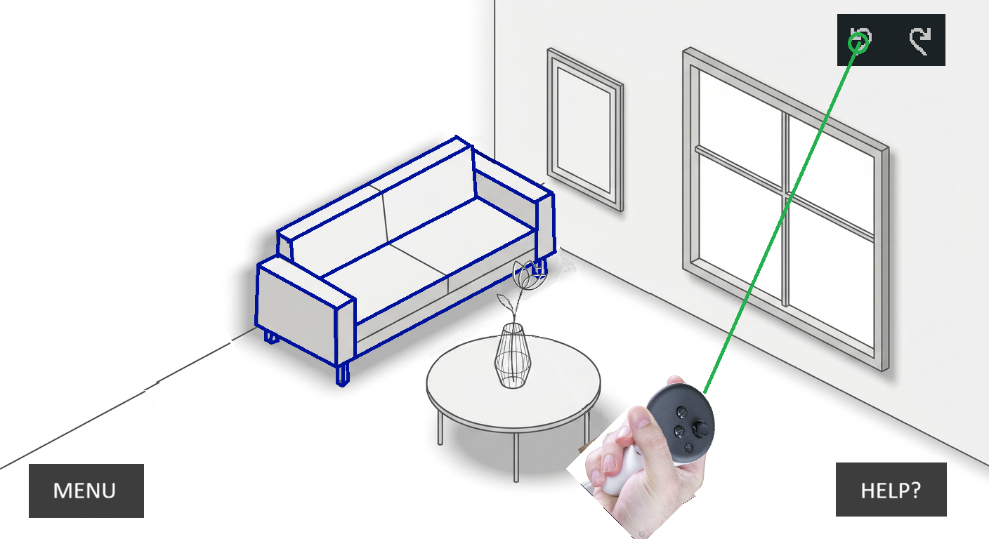

User goal:Revert an unwanted change quickly.


