**DATA WAREHOUSING – PROJECT REPORT**

**Group Members:**

Ibrahim Mahmood – 2021748

Basit Faisal – 2021126

Zain Nofal – 2021723

Muhammad Hamza – 2021378

**Abstract:**

Cryptocurrency markets are dynamic and challenging to navigate, making data-driven insights crucial for informed decision-making. The "Crypto Coins Analysis & Forecasting" project aims to provide a comprehensive solution by collecting, storing, analyzing, and visualizing both historical and real-time cryptocurrency data. Through web scraping, database integration, data analysis, and machine learning techniques, this project seeks to empower users with actionable insights into cryptocurrency market trends and forecast future movements.

**Abstract Diagram**

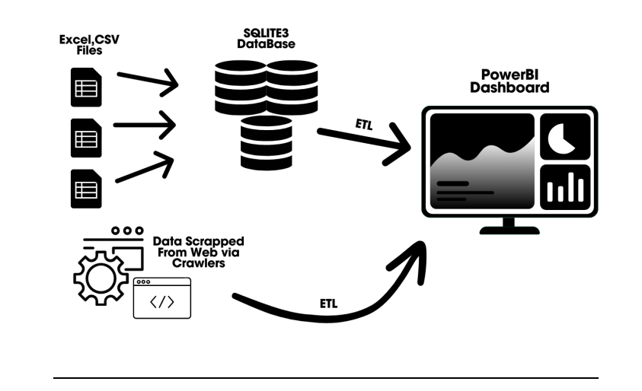

**Data Sources and Integration:**

Our project was composed of 2 parts, depending on the data.

1. **Real-time data:**

For the real-time part of our project, we targeted data from a live website:

<https://www.livecoinwatch.com/>

Following is a sample of the data represented on the website:

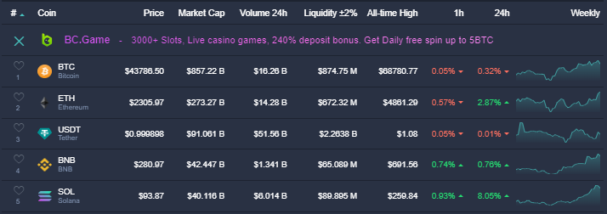

To gather this data, we configured PowerBi’s Get Data feature to meticulously scrape 1000’s of rows of data from the site, which was later transformed into a cleaner format via multitudinous ETL transformations.

1. **Historical Data:**

We first consolidated publicly available historical data, of the past 3 years, for 6 popular cryptocurrencies. Using this we were able to form multiple CSV files, which were uploaded into a database through an automated Python script. The database we decided to use was Sqlite3 which we connected to PowerBi via ODBC drivers to create a centralized database. This database may be refreshed manually at any given time. The new data will be updated in the PowerBi report upon clicking the refresh button. This helps enable a seamless data supply for the project.

**Visualizations**

Using PowerBi visualizations like Pie charts, Area Charts, Bar Charts, KPI’s and Cards, we were able to create interactive and dynamic dashboards, with a smooth and visually appealing user experience. This was further enhanced by our use of Figma’s design templates. The integration of real-time data, along with the data refresh button, allowed us to create a powerful tool capable of delivering actionable insights and information to its users.

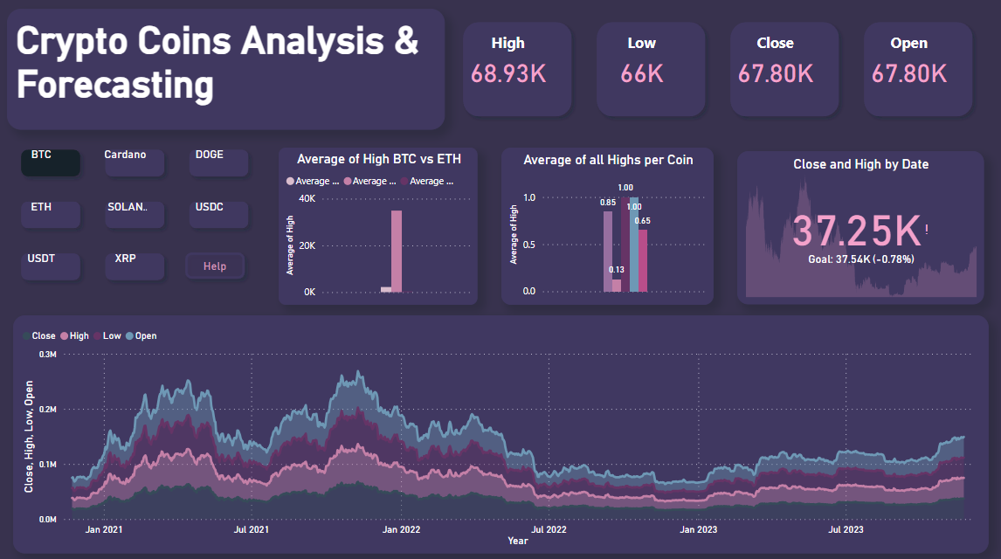

**DAX Measures**

To fully utilize some of the various visualizations, we had to make use of DAX measures. Using these, we performed intermediate calculations required to gain useful information regarding our analysis. We applied measures like SUM, FILTER, MAX, SWITCH, and the NOW time function.

We also made use of a drill-through feature to shift from historical data of a coin to its real-time information.

**Conclusion**

The successful implementation of our project helped create a useful tool to gain valuable insights into selected cryptocurrency coins, enabling users to make informed decisions by analyzing market valuation, bearish and bullish trends, and stop-loss values. It is the ideal tool for an amateur investor or someone looking to enter the cryptocurrency market.