Design Pattern

Abstract Diagrams

Zain Noreen (Fa17-mscs-0017)

2018

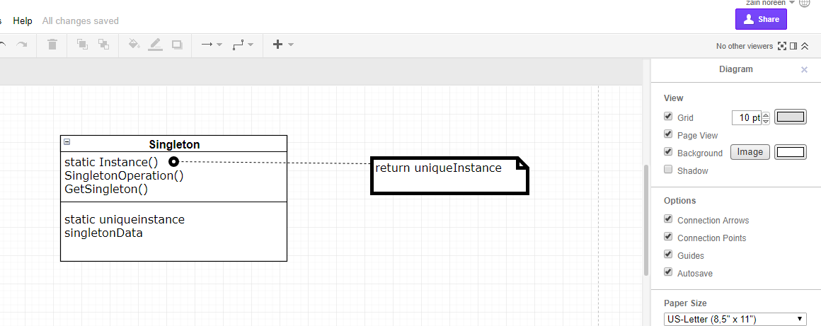1 ) Singleton Pattern Abstract Diagram

2) Factory Pattern Abstract Diagram

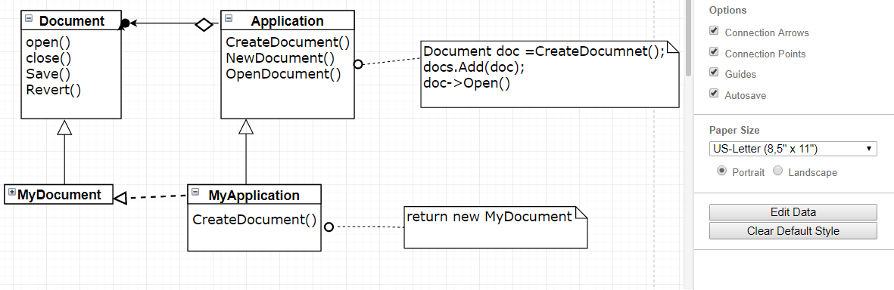

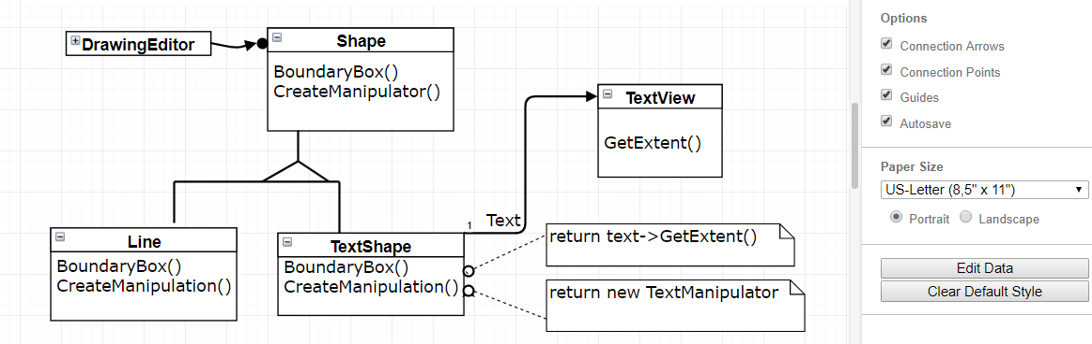3 ) Adaptor Abstract Diagram

4) Decorator Pattern Abstract Diagram

