Faculty of Engineering, Science & Technology
INDUS UNIVERSITY

BS(CS) Computer Science
Semester 5th
PROJECT TITLE
Library Management System
LEADER Name: ZAIN UR REHMAN 1701-2014
MEMBER Name: GHAZI AKBAR 1614-2014
ADVISOR Name: Dr. Zafar Nasir & Miss Laraib
Date : 04-10-2016
Description:
The project base on totally Library Management System which include some main functions and features:
Members Record, Books Record, Librarian Record and Borrowed books Record
Sign___________________
Library Management System
Requirements:
This project is totally base on library management system for INDUS University. This library management system is beneficial for the members of INDUS library and manages by the librarian of the INDUS UNIVERITY. The platform of this management system is on the android Mobile phone (Android Application “Marshmallow”) this application has functions which are stated below:
Books record:
In books record function, there is a record of each book like book’s name, book’s book ID and author name etc
Members record:
In members record function, there is a record of each member like member’s name, member’s ID and member’s address etc
Librarians record:
In librarians record function, there is a record of each librarian like librarian’s name, librarian’s ID and librarian’s address etc
Borrowed books record:
In borrowed books record function, there is a record of all borrowed book which are borrowed by the members and also information about the issue date of the borrowed book and what date and time of return of that books
Actors:
Members (Primary Actor):
Members are those who will use this android application like member can view the books and request for the book.
Librarian (Secondary Actor):
Librarian are those who manage the students record like add a student record in database, delete the student record from the database and update the student records from database and also provide some facilities.

Indus University (Offstage Actor):
INDUS UNIVERSITY is an offstage actor for this android application
Features:
It really beneficial for both members and librarian to access easier way by android app rather than accessing desktop application or web applications . As a member it always on your fingertip to search the book and as a librarian is easy to managed application and the database of the software
Functionality:
Members Records (to add, delete and update all members record which relevant to the members like name, id, address, mobile number, member type, card issue date , expire date and etc)
Books Record (to add, delete and update all books record which relevant to the books like book’s title or name, id, author name and availability)
Students record view (to view the all student records)
Issue book (to issue the requested books which would be requested by the members)
Request book (to request the librarian for borrowing the interested book)
Return book (to return the borrowed book)
Books view (to view the all books by the members and librarian to know which books are available or which books are not available in the library)
Member information (to view the member information only)
Extra Functionality: (Future Update)
- Membership card (pre_design ID card)
- Ask for online membership (to request the librarian for membership)
- Ask for the library card (Soft copy)
- Online books (pdf books stored on the database member can access the book on this app)
- Online videos (course related videos lecture videos ,those video which help for education purpose)
Usecase:
Delete students records
Delete books delatils
Sort the books
View the books
Search the books
Request the books
Member details
Students record view
Books return
Books issued
Add students records
Modify student’s records
Manage students record
Add books details
Organize books details
Modify books details
LIBRARIAN
MEMBERS
Class diagram:

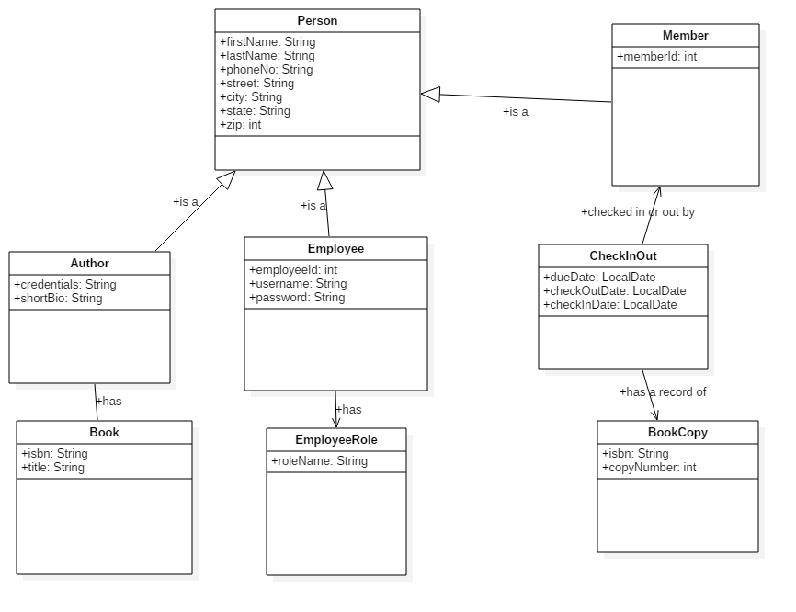
Activity Sequence Diagrams:
Add book:
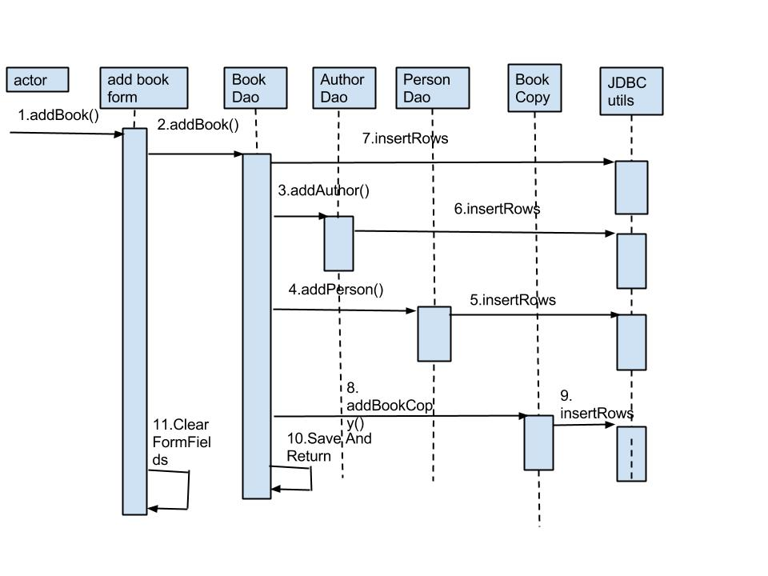
Add Member:

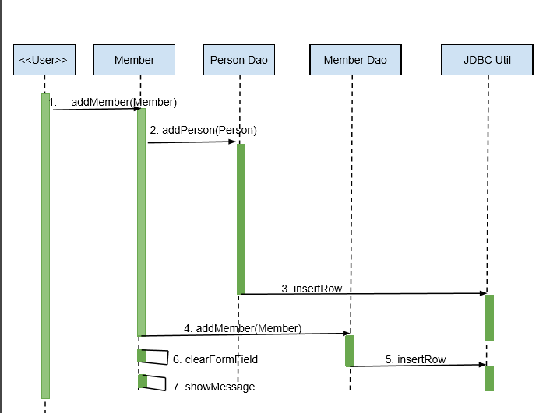
Login:

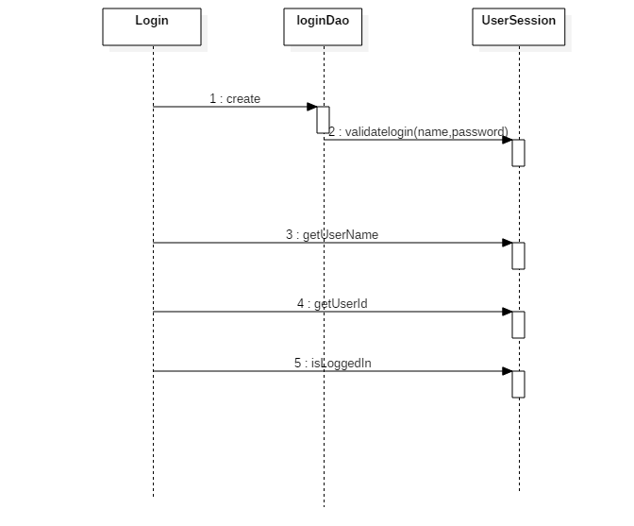
Entities :
Books, Librarians, Members
Relationships table:
Entities | Books | Members | Librarians
Books |  | Request by | Managed by
Members | Request |  | Administering
Librarians | Managed | Administering

Attributes:
Books:
Book_Name, Book_ID, Author , Availability
Librarians:
Lib_Name, Lib_ID, Lib_Address
Members:
Member_Name, Member_ID, Member_Address, Member_Type, Member_Age, Member_No, Card_Date, Expire_Date
Requested:
Due_Date, Return_Date, Issued_Date
Administring:
User_Name, Password
ERD (Entity Relationship Diagram):
Book_ID

MANAGED

Requested

ADMINISTRING
Availability
Author
Book_Name
Lib_addr
Lib_ID
Lib_name
Card_date
Memb_num
Memb_addr
Memb_ID
Exp_date
Memb_Name
Due_date
Issue_date
Return_date
Age
Memb_tyoe
User_Name
Password
BOOKS
LIBRARIAN
MEMBERS
Design (GUI):
