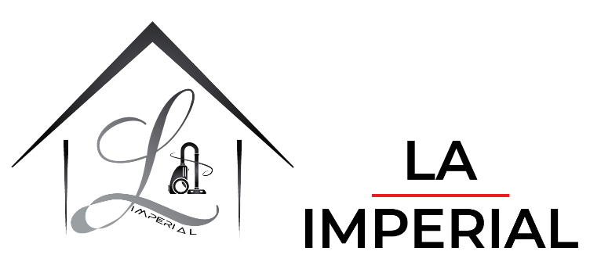

HDR LED TV

50UN74006LB 50"

**Wide Color Gamut:**

**UHD Resolution**

**Netflix**

**YouTube**

**Features:**

|  |  |
| --- | --- |
| Screen Size: | **65”** |
| Type: | **DLED** |
| System of Analog TV（VIDEO/AUDIO): | **DVB-T+C+T2 H.265+S2** |
| Smart TV: | **Android 9.0** |