Software Design Document
Exploring Deep Learning Models for Cancer Detection and Classification



Submitted by
Zain Ul Abbadin (F22BINFT1M01047)

Submitted to
Mr. Muzamil Ur Rehman

Department of Information Technology
Faculty of Computing
The Islamia University of Bahawalpur

Summery
This Software Design Document (SDD) describes the architectural design, data models, and user interface of the web-based application “Exploring Deep Learning Models for Cancer Detection and Classification”.
The project "Exploring Deep Learning Models for Cancer Detection and Classification" aims to assist pathologists in early and accurate diagnosis. The system follows an MVC (Model-View-Controller) pattern combined with a specialized Inference Layer for AI. The architecture focuses on performance and reliability, ensuring that heavy deep learning models (like U-Net and R-CNN) process histopathological images efficiently. Design considerations include high security for medical data and a minimalist UI for clinical usability.

Table of Contents
1. Application Architecture 5
1.1 Architectural Pattern 5
1.2 System Components 5
1.2.1 Models 5
1.2.2 Views 5
1.2.3 Controller and Function 5
1.3 External APIs and Libraries 6
1.4 Coding Conventions 6
1.5 Diagram 7
1.5.1 Class Diagram 7
1.5.2 Use Case Diagram 8
1.5.3 Context / Level Zero Diagram (DFD) 8
1.5.3 Sequence Diagram 9
1.5.4 Package Diagram 9
2. Data Model Schema 10
2.1 User Entity 10
2.2 Image Entity 10
2.3 DiagnosisReport Entity 10
2.4 Model Diagram 10
2.5 Framework Diagram 11
2.6 Table : User 11
3. User Interface 12
3.1 Design Philosophy 12
3.2 Screens / Pages 12
3.2.1 Login / Sign Up Page 12
3.2.2 Dashboard 12
3.2.3 Image Upload Page 12
3.2.4 Result Visualization Page 13
3.3 Input Constraints 13

Application Architecture

1.1 Architectural Pattern
The system will follow the MVC (Model-View-Controller) architecture to separate the user interface, data management, and processing logic.
- Model: Handles data storage, deep learning models, preprocessing, and business logic
- View: Web-based user interface for interaction and visualization
- Controller: Manages user requests, system workflow, and communication between Model and View

1.2 System Components

1.2.1 Models
- User Model
- Image Model
- Preprocessing Model
- Cancer Detection Model
- Classification Model
- Report Model

1.2.2 Views
- Authentication Page (login/signup)
- Image upload interface
- Processing status
- Result visualization

1.2.3 Controller and Function
- Authentication Controller
- registerUser( )
- loginUser( )

- Image Controller
- uploadImage( )
- validateImageFormate( )
- storeImage( )

- Preprocessing Controller
- normalizeImage( )
- resizeImage( )
- enhanceImage( )

- Detection Controller
- loadSegmentation( )
- detectionCancerReigion( )
- classificationCancerType( )

- Result Controller
- displayResult( )
- downloadReport( )

1.3 External APIs and Libraries
- TensorFlow/PyTorch: Used for loading the .h5 or .pth model files.
- OpenCV: For image resizing and H&E staining normalization.
- Pandas/NumPy: For numerical data handling.
- ReportLab: For generating PDF diagnostic reports.

1.4 Coding Conventions
- Language: Python
- Standard: Follows PEP 8 style guide.
- Variable Naming: CamelCase for Uses (DetectionModel)
- Documentation: Every function will have Docstrings explaining inputs and return types.

1.5 Diagram

1.5.1 Class Diagram
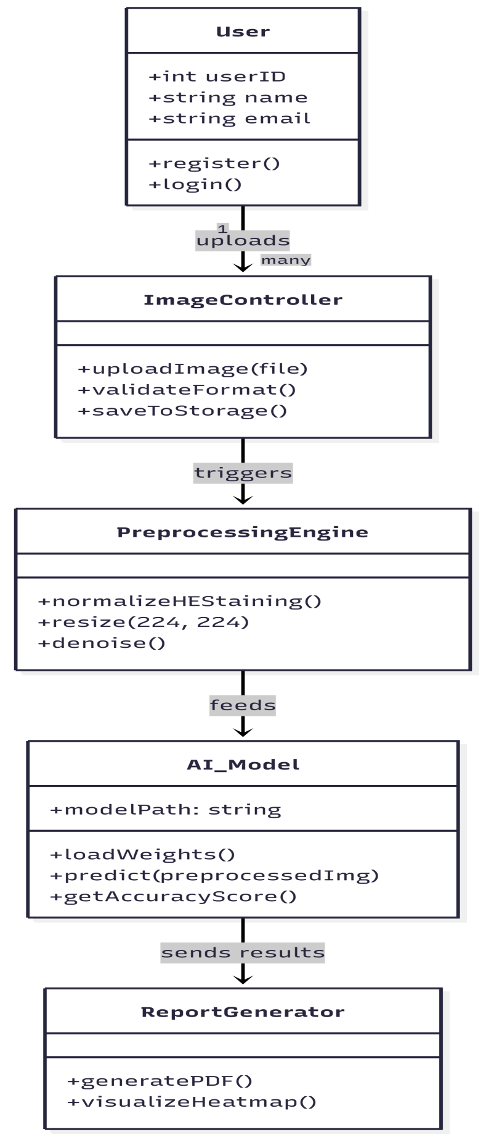

1.5.2 Use Case Diagram

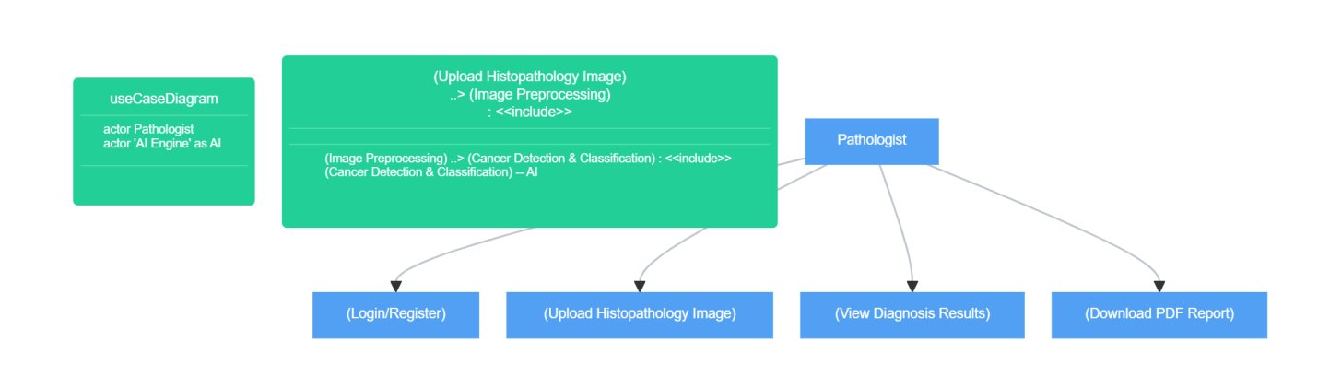

1.5.3 Context / Level Zero Diagram (DFD)
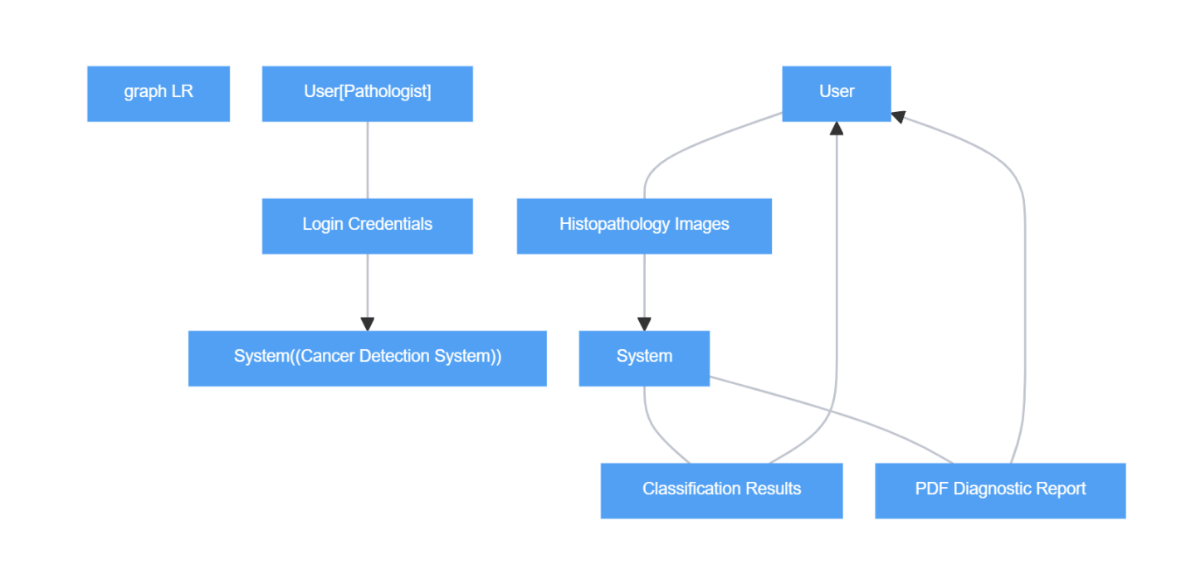

1.5.3 Sequence Diagram
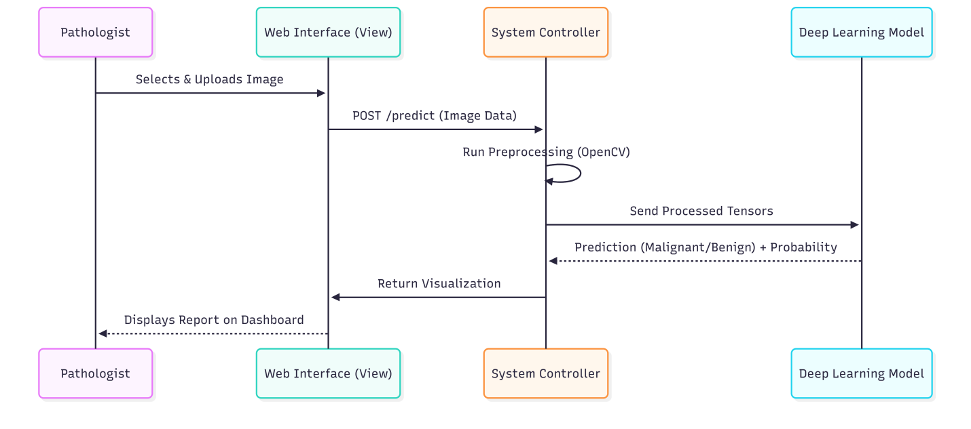

1.5.4 Package Diagram
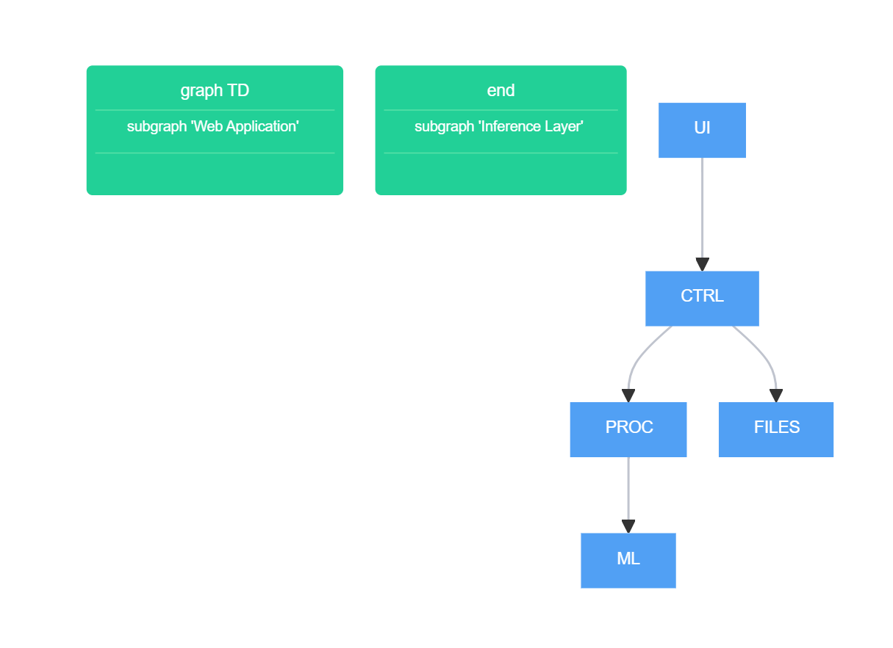

Data Model Schema

2.1 User Entity
- Properties: UserID, FullName, Email, Password, Department, Role.
- Relation: One user can upload multiple images.

2.2 Image Entity
- Properties: ImageID, UserID, FilePath, UploadDate, Status.
- Relation: Uploaded Image Processed.

2.3 DiagnosisReport Entity
- Properties: ReportID, ImageID, CancerType, AccuracyScore,
AnnotatedImagePath.
- Relation: Each image generates exactly one report.

2.4 Model Diagram
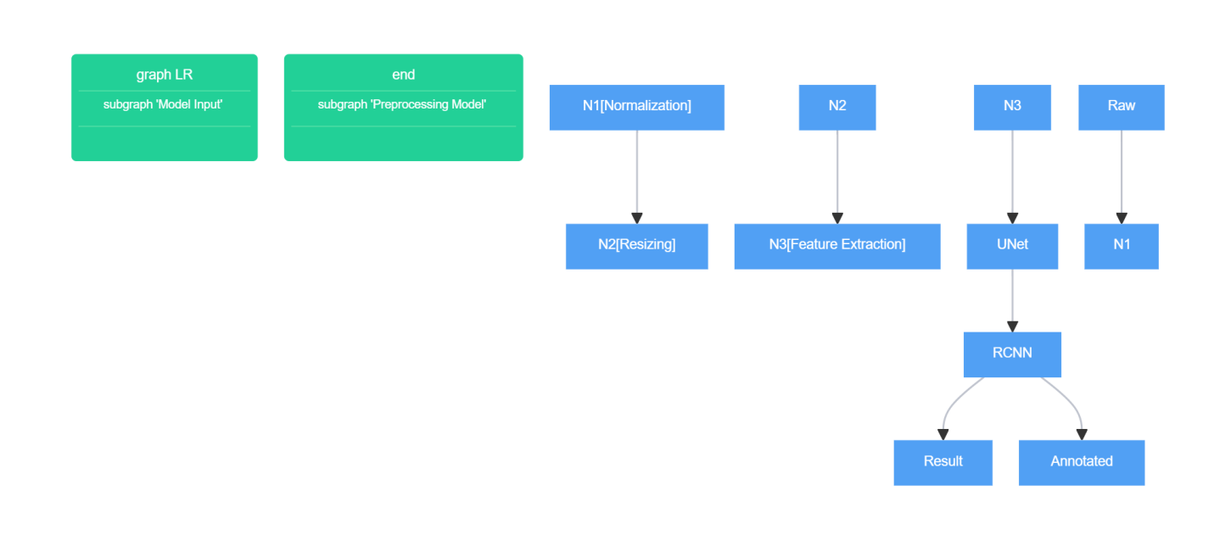

2.5 Framework Diagram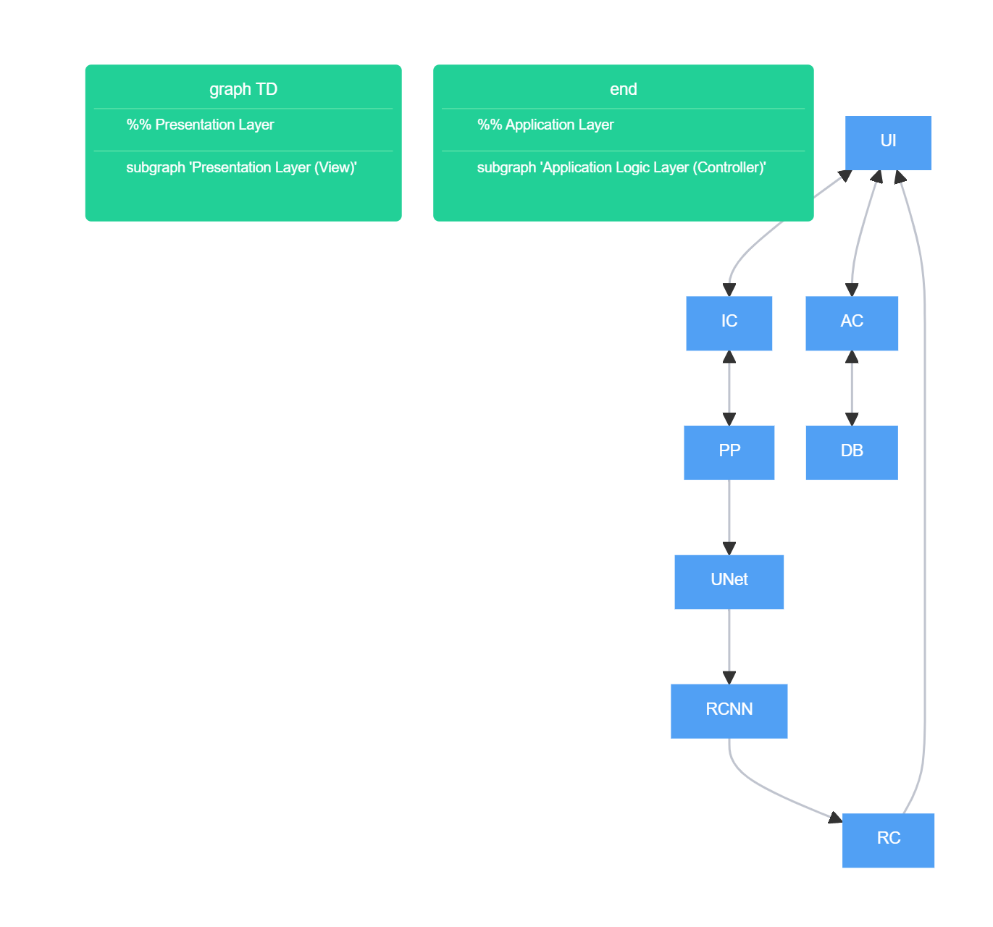

2.6 Table : User

Field | Data Type | Constraint | Description
UserID | Integer | Primary Key, Auto-Increment | Unique ID for Pathologist
FullName | Varchar(100) | Not Null | User's full name
Email | Varchar(50) | Unique, Not Null | Login email
Password | Varchar(255) | Not Null | Hashed password
Department | Varchar(100) | Optional | Medical department

User Interface

3.1 Design Philosophy
- Responsive design
- Simple and clean interface
- Medical friendly color scheme ( white, blue, gray )

3.2 Screens / Pages

3.2.1 Login / Sign Up Page
- Controls
- Textbox: Email
- Textbox: Password
- Button: Login
- Button: Sign Up
- Input Constraints
- Valid email format
- Password minimum length

3.2.2 Dashboard
- Displays
- User profile
- Uploaded images list
- Processing status

3.2.3 Image Upload Page
- Controls
- File chooser (JPG, PNG)
- Upload button
- Constraints
- File type validation
- File size limit

3.2.4 Result Visualization Page
- Displays
- Annotated image
- Cancer type
- Confidence score
- Download report
- Controls
- Download report

3.3 Input Constraints
- No Empty Field
- Image Formats
- Resolution

