Software Requirement Specifications
Exploring Deep Learning Models for Cancer Detection and Classification



Submitted by
Zain Ul Abbadin (F22BINFT1M01047)

Submitted to
Mr. Muzamil Ur Rehman

Department of Information Technology
Faculty of Computing
The Islamia University of Bahawalpur
Meeting Details
Sr No | Details | Date | Supervisor Signature
Summary
This document presents the requirements for designing an intelligent deep learning system to detect and classify cancer in histopathological images. The system will use the neural network architectures, image segmentation, and web-based application to deliver highly accurate, annotated visualizations for medical professionals. The project aims to assist clinicians with rapid, interpretable diagnostic support without replacing their expertise.

Table of Contents
1 Introduction 5
1.1 Purpose 5
1.2 Scope 5
1.3 Product Perspective 5
1.4 User Characteristics 5
1.5 Similar apps and systems Review 5
1.6 Proposed Technologies 6
2 Requirements 7
2.1 Function Requirements 7
2.1.1 Sign Up 7
2.1.2 Login 7
2.1.3 Image Upload 7
2.1.4 Preprocessing 7
2.1.5 Cancer Detection and Classification 8
2.1.6 Visualization 8
2.2 Non-Functional 8
2.2.1 Performance 8
2.2.2 Security 8
2.2.3 Usability 8
2.2.4 Scalability 8
3 Use Cases and Flow of Processes 9
3.1 Use Case 1 9
3.2 Use Case 2 10
3.3 Use Case 3 12
3.4 Use Case 4 14
3.5 UseCase 5 16
4 References 18
• https://ieeexplore.ieee.org/stamp/stamp.jsp?arnumber=10579976 18

Introduction
The cancer is dangerous disease where the abnormal cells grow and spread to others body parts.The cells continually divide and filling the body needs.They damage the body parts.This project aims to make a web-based Application that benefit deep learning models for automated analysis of histopathological images, helping pathologists detect and classify cancer with improved speed and reliability. The software module will focus on image segmentation and region annotation, especially for decision-support in clinical situations.

Purpose
The objective is to construct an AI-powered system that aids medical practitioners by offering automated cancer detection and classification based on histopathology pictures. It seeks to provide real-time, comprehensible visuals for improved clinical decision-making, lessen burden, and improve diagnostic accuracy.

Scope
In this study, deep learning techniques are used to analyse digital histopathology images for cancer diagnosis and categorisation. The system is for research and educational use, showcases AI’s promise in healthcare, and does not replace clinical expertise. Direct patient data processing and integration with electronic medical record systems will not be supported in the initial version.

Product Perspective
The proposed module is a standalone online application that processes input medical images, detects and highlights malignant spots, and delivers annotated results for pathologists. Future improvements may include it into larger healthcare systems.

User Characteristics
• Users: IT administrators, lab technicians, pathologists, and oncologists
• Experience: Users' knowledge of computer interfaces and digital pathology ranges from basic to advanced. Minimal training required to use main features.

Similar apps and systems Review
Several commercial and research-grade systems (e.g., Mindpeak Software, CANCERSCOPEX, Xylexa) offer automated cancer detection; their limitations include specific type of cancer detection like Mindpeak Software (used for specific tasks in breast cancer pathology), interpretability, and dataset specificity.
This study addresses problems by applying advanced segmentation models (e.g., U-Net, Mask R-CNN, ViT) and assuring transparent, annotated outputs for clinical review.

Proposed Technologies
- Programming Language: Python
- Deep Learning Frameworks: TensorFlow / PyTorch
- Image Processing Tools: OpenCV, NumPy, Pandas
- Model Architectures: U-Net, Mask R-CNN, Hover-Net, Vision Transformer (ViT)
- Visualization Tools: Matplotlib, Seaborn, Streamlit, QuPath
- Deployment Tools: Flask / FastAPI, ONNX Runtime, Docker

Requirements

Function Requirements

Sign Up
- Name: FR001
- Purpose: Allow Users to register for system use
- Users: Admin, Pathologist
- Inputs: Name, email, password, department
- Outputs: User account creation

Login
- Name: FR002
- Purpose: Allow Users to login for system use
- Users: Admin, Pathologist
- Inputs: Name/ email, password
- Outputs: User account login

Image Upload
- Name: FR003
- Purpose: Upload histopathological images securely
- Users: Pathologist, Admin
- Inputs: Image files (JPG, PNG)
- Outputs: Image stored, Confirmation, Ready for preprocessing

Preprocessing
- Name: FR004
- Purpose: Normalize
- Users: Automated system
- Inputs: Uploaded image
- Outputs: Image preprocessed ready for cancer detection

Cancer Detection and Classification
- Name: FR005
- Purpose: Cancer detect and classification
- Users: Pathologist
- Inputs: Preprocessed image
- Outputs: Cancer detect and classification report

Visualization
- Name: FR006
- Purpose: Display results and downloadable reports
- Users: Pathologist
- Inputs: Detected and classification reports
- Outputs: Display of results and downloadable reports

Non-Functional

Performance
- System processes the image with in few seconds
- System provide the accurate result (accuracy > 90%)

Security
- Users details is secured
- All data is secured

Usability
- User interface must be simple
- User friendly

Scalability
- Support large dataset
- Support multiple user at a time

Use Cases and Flow of Processes

Use Case 1
ID: UC001
Name: User login / Sign Up
Description: Allows new users (Admin, Pathologist) to register onto the system by entering essential details. Log in if you already have an account.
Requirements

Requirements: FR001, FR002
Actors: Administrator, Pathologist
Precondition: User is not registered in the system.or not login
Postcondition: User account is created and stored in the system database. or login
Basic Flow:
Basic Flow

- User click “Sign Up” / login
- Enters name, email,password, department
- System inputs validates
- System stores user details
- System confirms account creation / login
Alternative Flow
- Admin login
- If email already exists → system shows "Account Already Exists".
Exceptions
- Invalid Inputs
- Invalid email
- Wrong password
UC001 Activity Diagram
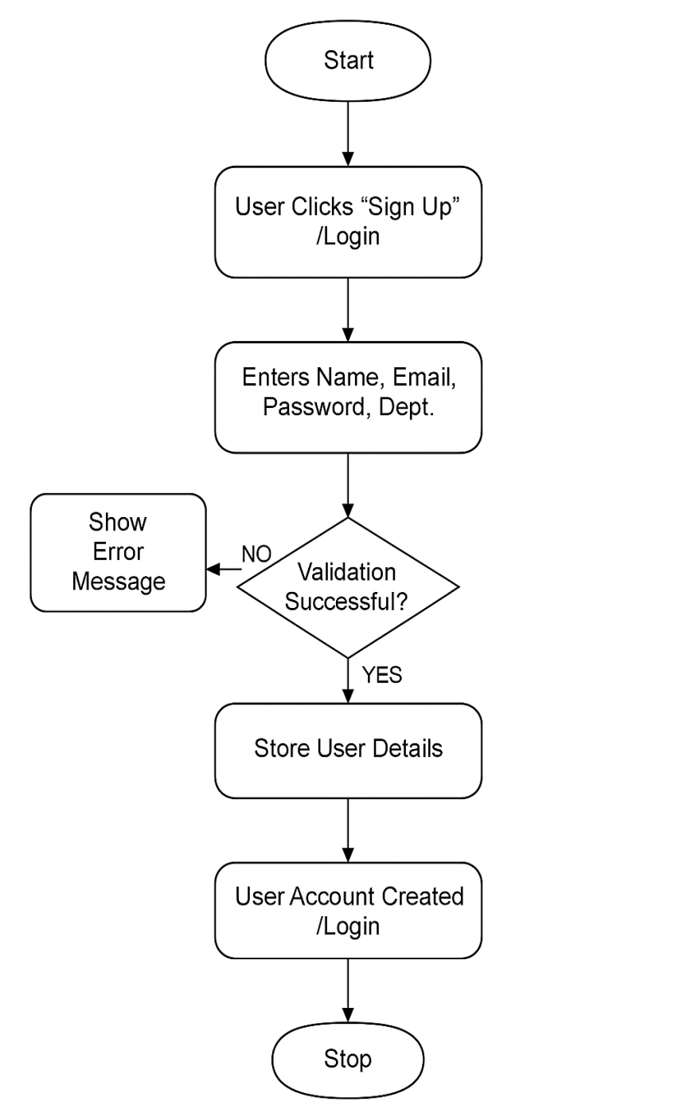

Use Case 2
ID: UC002
Name: Upload Image
Description: The pathologist uploads histopathology images for cancer detection.
Requirements: FR003
Actors: Pathologist, Admin
Precondition: User must login in the system
Postcondition: Image is uploaded and stored for preprocessing.
Basic Flow:
Basic Flow
- User selects “Upload Image”
- User chooses a file must JPG/PNG
- Validates file size
- Store images
- Confirmation successful upload images

Alternative Flow
User uploads invalid format → system shows “Unsupported File Type”.
Exceptions
- File not supported farmet
- Upload failure due to network issues
- Corrupted file image

UC002 Activity Diagram

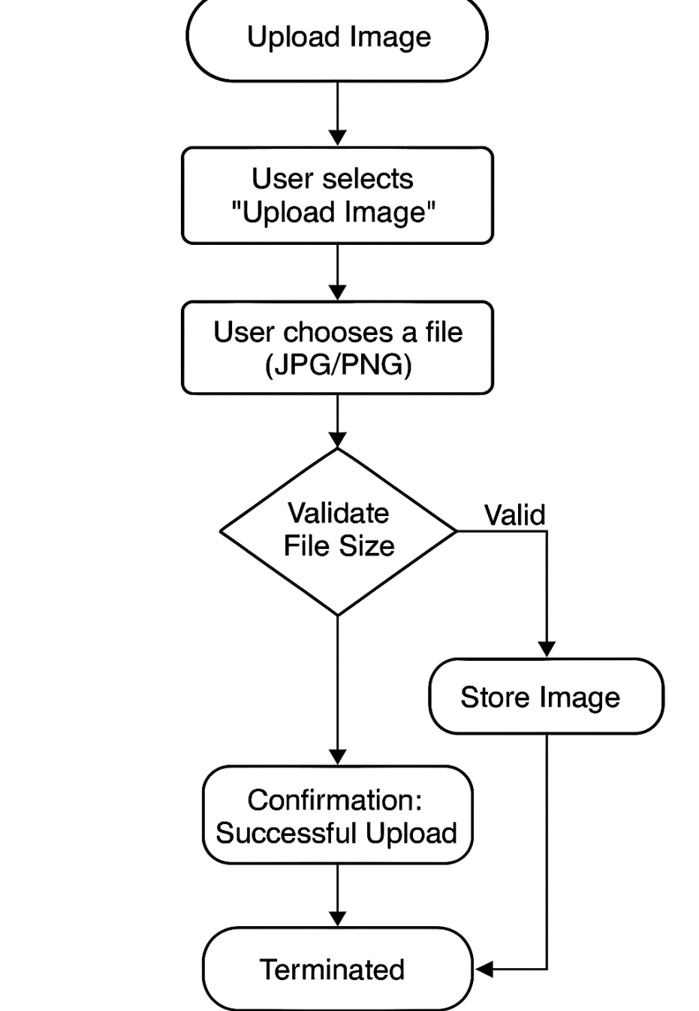

Use Case 3
ID: UC003
Name: Preprocess image
Description: System automatically normalizes and prepares the uploaded image for model analysis.
Requirements: FR004
Actors: System
Precondition: Images successfully uploaded
Postcondition: Preprocessed image stored for cancer detection
Basic Flow:
Basic Flow
- System retrieves uploaded image
- System normalizes color channels
- System resizes image
- Preprocessed image saved
Exceptions
- Image unreadable
- Preprocessing modules fails

UC003 Activity Diagram
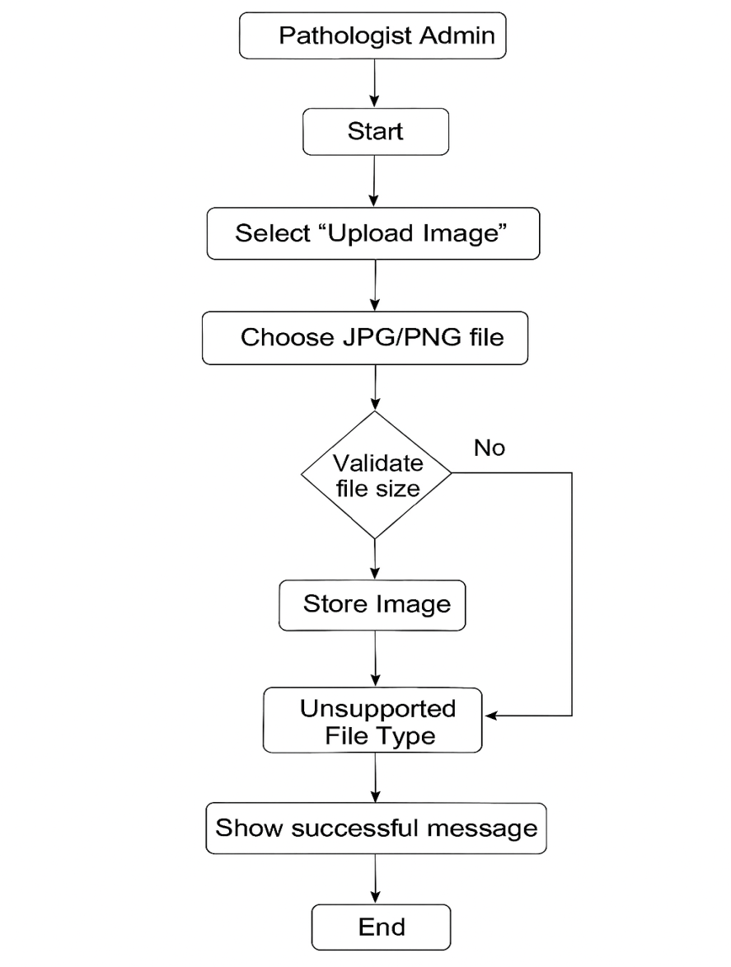

Use Case 4
ID: UC004
Name: Cancer Detection and Classification
Description: The system detects cancers regions and classifies cancer type using deep learning models
Requirements: FR005
Actors: Pathologist
Precondition: Preprocessed image available
Postcondition: Detect cancer and classification report generated
Basic Flow:
Basic Flow
- System loads the segmentation models
- System identifies the regions
- System runs classification model
- Cancer type detect
- Detect report generated
Exceptions
- Models fails to load
- GPU/CPU error

UC004 Activity Diagram

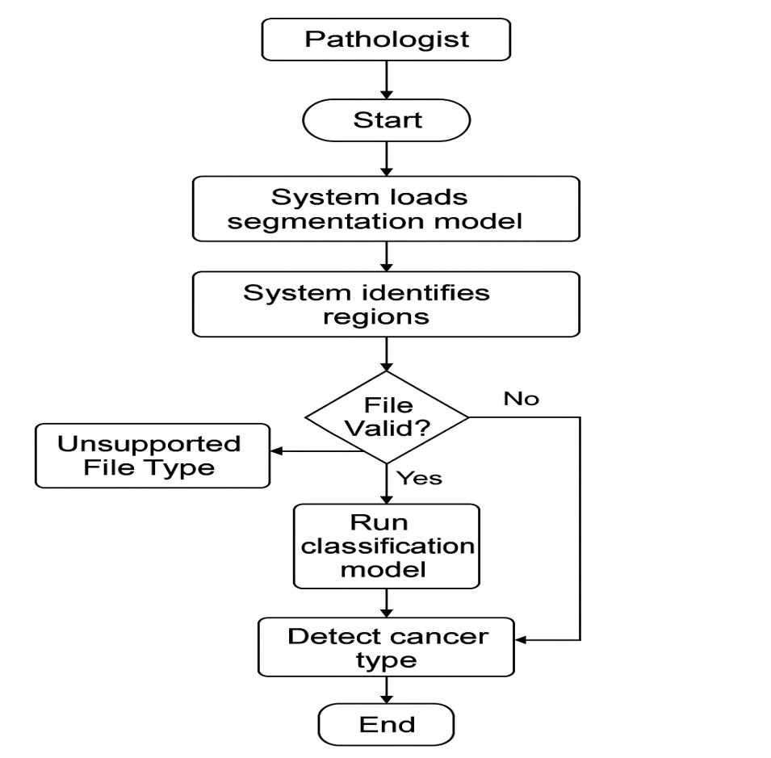

UseCase 5
ID: UC005
Name: Result visualization
Description: System displays the cancer classification result
Requirements: FR006
Actors: Pathologist
Precondition: Cancer detection and classification successfully completed
Postcondition: Users view the final result output
Basic Flow:
Basic Flow
- System loads the cancer detection result
- System displays the classification results
- Users views or downloads reports
Exceptions
- System report rendering failure

UC005 Activity Diagram
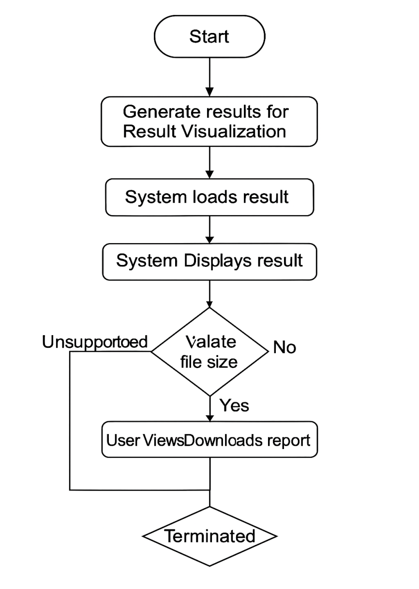

References

https://ieeexplore.ieee.org/stamp/stamp.jsp?arnumber=10579976

