***Project Proposal***



**Supervisor: Ma’am Anum Kaleem**

**Group Members: M. Umar Liaquat, Mazhar Subhani**

**Enrolment No: 01-134171-058 , 01-134171-101**

**Sections: BSCS-7A/B**

**Department of Computer Science**

**BAHRIA UNIVERSITY, ISLAMABAD**

Personalized Product Recommender System (An Android Application)

**Introduction:**

Buying Products Online has become a very important parts of many people’s lives. Both businesses/sellers as well as customers have embraced online sales as a cheaper and more convenient way to shop, but just like anything associated with the Internet, there are features/benefits and dangers associated with shopping online. Buying a specific product can be stressful if you can’t find products in your budget. When a customer can’t seem to find a product with in his budget range, he will have two choices either buy product available or choose not to buy that product because it’s not in your budget. Due to which person faces a dilemma in a basic shopping experience.

Existing online shopping websites lack product’s price and specification recommendation. Our application will allow the user to have a border search view and comparison of similar product using their features.

**Objective:**

The objectives of our project are given below

# To take product specifications using personalized forms.

1. To display a categorized list of products and discounted prices.
2. To identify any deals or special offers on the products.
3. To perform a comparison of similar products.
4. To display a price comparison between similar product.
5. To provide a link towards product or item from given website .
6. Combine the result from different websites to this platform.

**Problem Description:**

This recommended system will allow its users to compare prices of two similar products from many sellers/websites. The users have to select the product specification using our comparison forms and get an idea about the product according to their need. This application will benefit both the users as well as the store or websites/platform owner as their product will get famous in regards with price as compared to other stores and the user who wants to save money on their purchases and get a good quality product.

**Proposed Solution:**

We will try to recommend a mobile phone using the specification gathered through the personalize form which will result in showing a product (set) on the top of list. Other than this we are trying to add another feature for comparison of similar mobile phones which will help the user decide which product to buy. We will be implementing only mobile phones section.

Just Prototype)

**Search Form:**

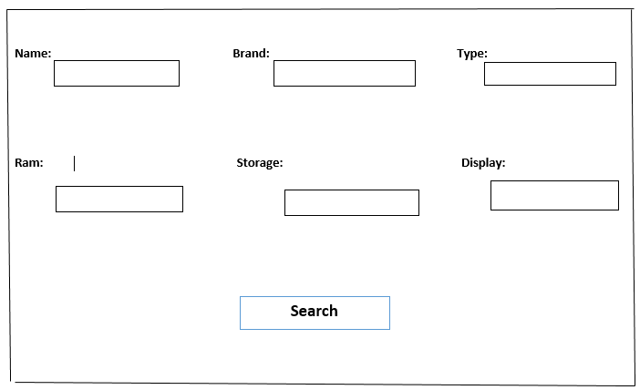

**Comparison Form:**

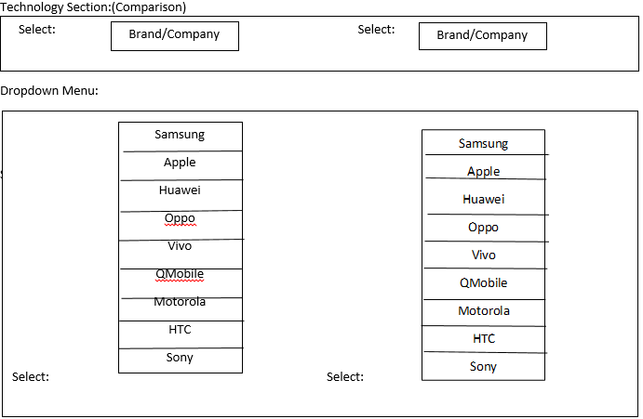

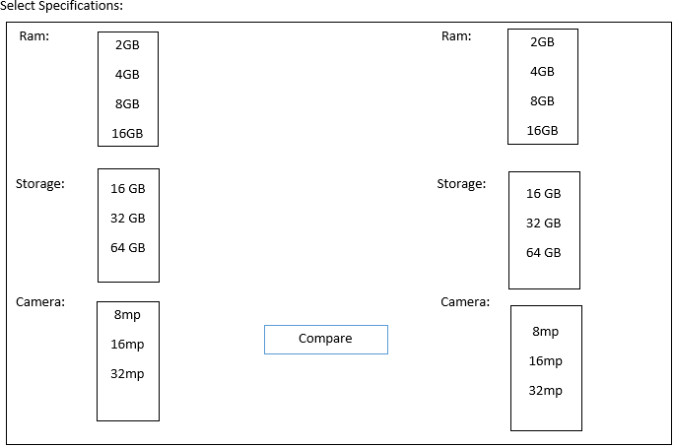

**Comparison Cell Phones**

|  |  |  |
| --- | --- | --- |
| No of Product /Features | Product 1 | Product 2 |
| Memory |  |  |
| Display |  |  |
| Size |  |  |
| Camera |  |  |
| Sound |  |  |
| Battery |  |  |
|  | Price 01 | Price 02 |

# **Recommendation System:**

A product recommendation is basically a prediction which show the items that a user would like to purchase according to his needs.

# **Methodology:**

# The methodology we would be following is in the form of different stages of the software development life cycle (SDLC). We will use the agile methodology for this project. We are using this model because most of our project is related to dynamic and different categories. Actually we have a categorical data so whenever we will not complete our one phase we can’t go to another phase after the one phase competition our testing is important to go to another activity.

The main phases of this methodology is given below:

* Planning
* Requirements Analysis
* Design
* Coding
* Unit Testing and
* Acceptance Testing.

# **Project Scope:**

User will get the product from different websites or a different platform. We will provide a personalized form for the searching a specific product. User can choose the product with the help of a comparison of similar product The Order will be taken by respected website. We will provide the path or link of order to the selected product. We will also provide the rating of that product. We are not planning to deliver the product by ourselves and may not gather all the information related to a specific product.

# **Feasibility Study:**

**Risks Involved**:

* + 1. One of the main risk which can arose is that all the listed regarding a specific product are not mentioned
    2. It may be user not fulfill the searching criteria
    3. It important for the user to have some idea about that product

**Resource Requirement**:

The resources required for this project include.

* + Android Studio Installation
  + Geny motion
  + Databases
  + Front end design
  + Backend language

# **Solution Application Areas:**

This projects application areas

* It can be a great platform for different Stores/Brands/Platforms looking to sell their product.
* It will provide the users a platform to check prices of different projects.
* It will allow the user to have more clear mind while selecting a specific product

# **Tools/Technology**

* Android Studio
* API
* RMS
* Genymotion
* Databases

# **Milestones:**

Following are the different activities that we need to perform in the project

* Understanding the target audience
* Defining our main objectives
* User Preferences(Requirements)
* Designing UI
* Create the front-end
* Link it with backend
* Execute& Test

|  |  |
| --- | --- |
| **Project Phase** | **Month/Time** |
| Requirement Gathering and Analysis | 1 Month |
| Design(UI) | 2 Month |
| Implementation | 2 Month |
| Execution & Testing | 1 Month |

