***Operating system Lab***

***CSL-320***

***Lab Journal#02***



**Student Name:** Mazhar Subhani Siddiqui

**Enrolment No.** 01-134171-101

**Class and Section** BS(CS)-6A

**Department of Computer Science**

**BAHRIA UNIVERSITY, ISLAMABAD**

**Lab # 02:**

**Objective:**

The Main Objective Of This Lab Was To Learn About VMWARE Workstation And UBUNTO .

**Tools Used:**

Install VMWARE Workstation And UBUNTO.

**Task Performed :**

In This Lab We Have Learn How to Install VMWARE Workstation And UBUNTO . After Installing the VMWARE Workstation And UBUNTO We Have Create A New Machine and assign a memory known as dedicated memory.

**Home:**

A **home directory**, also called a login **directory**, is the **directory** on Unix-like operating systems that serves as the repository for a **user's** personal files, **directories** and programs.

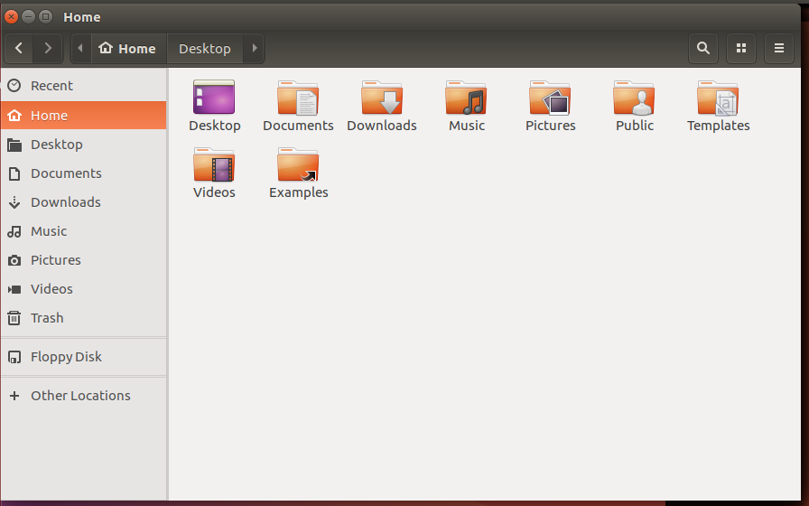

**Bin:**

**Bin** is an abbreviation of Binaries. It's just a directory where a user of an operating system can expect to find applications. ... It contains essential binary files (unlike /usr/**bin** directory) also for booting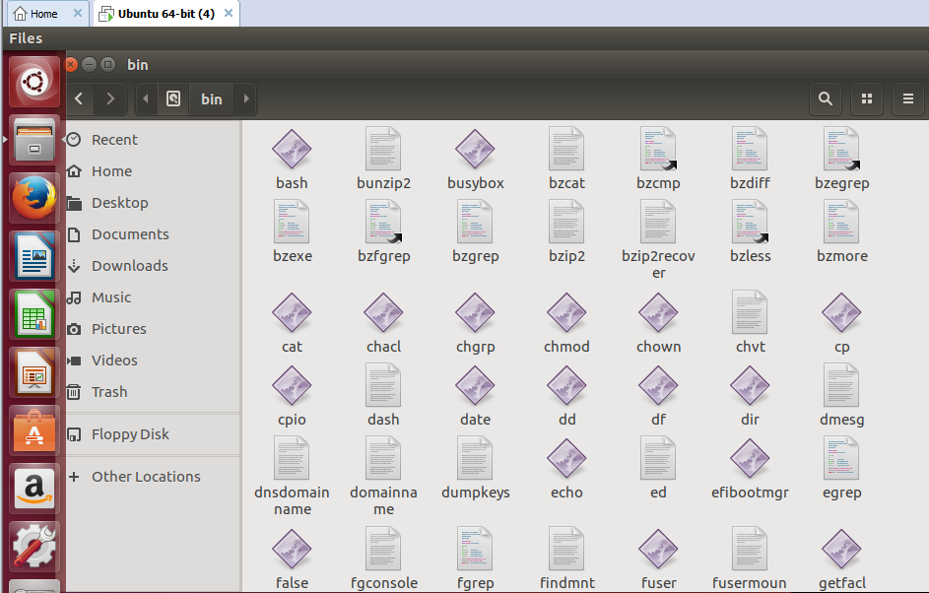

**Boot:**

/**boot** is an important **folder in Linux**. /**boot folder** contains all the **boot** related info files and folders such as grub.conf, vmlinuz image aka kernel etc. In this post we will try to explore what each file is used for.

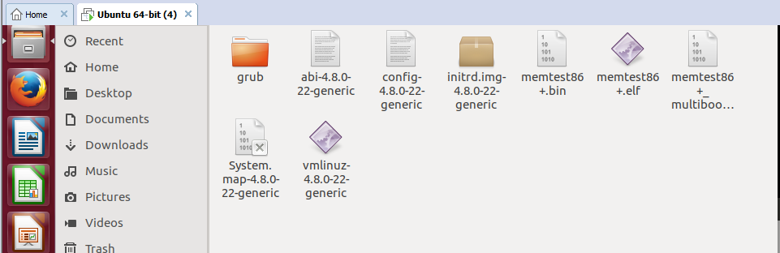

**Boot_Grub:**

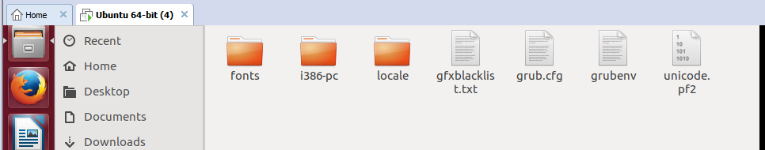

ETC:

. /**etc**. This is the nerve center of your system, it contains all system related configuration files in here or in its sub-**directories**. A "configuration file" is defined as a local file used to control the operation of a program; it must be static and cannot be an executable binary

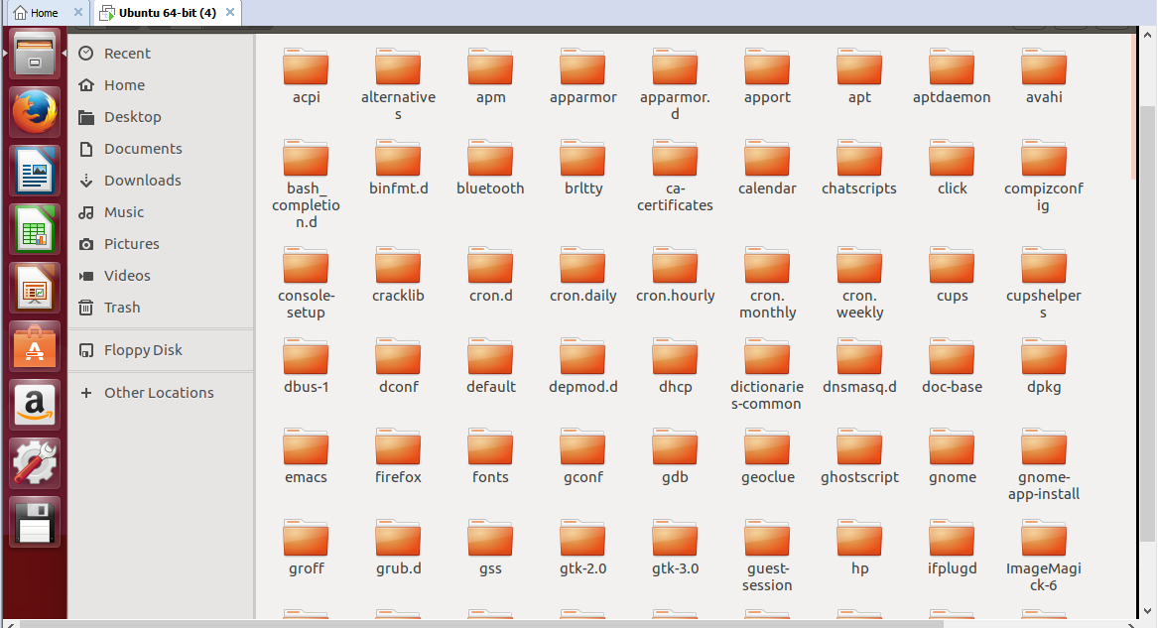

MNT:

The /**mnt Directory**. ... On Unix-like **operating systems**, the **directories** start with the root **directory**, which is the **directory** that contains all other **directories** and files on the **system** and which is designated by a forward slash. The currently accessible filesystem is the filesystem that is currently in use in the computer ..

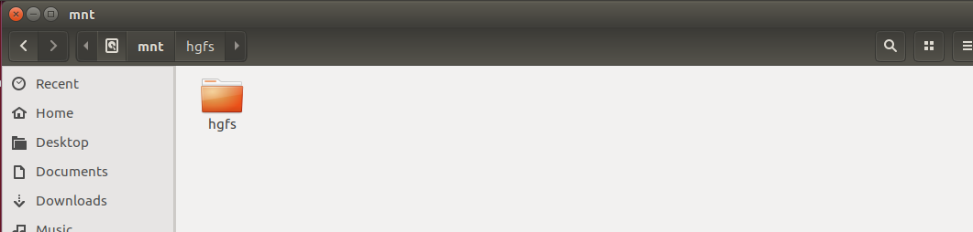

If your guest **operating system** has the version of VMware Tools that shipped with VMware Workstation 4.0, shared folders appear as folders on a designated drive letter. In a Linux virtual machine, shared folders appear under /mnt/**hgfs**. ... The **path** on the host to the **directory** you want to share

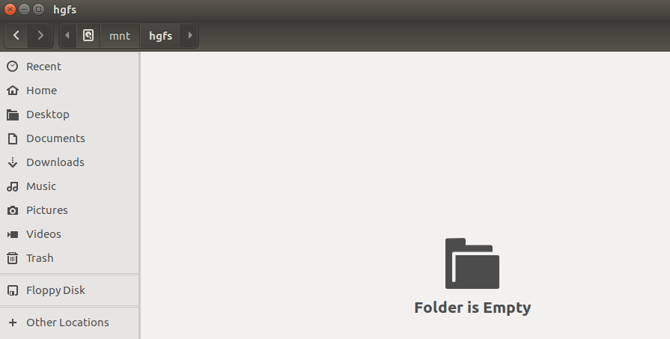

**SYS:**

Files and directories The following list describes some of the files and directories under the /**sys** hierarchy. / **sys**/block This subdirectory contains one symbolic link for each block device that has been discovered on the system. The symbolic links point to corresponding directories under /**sys**/devices. /  
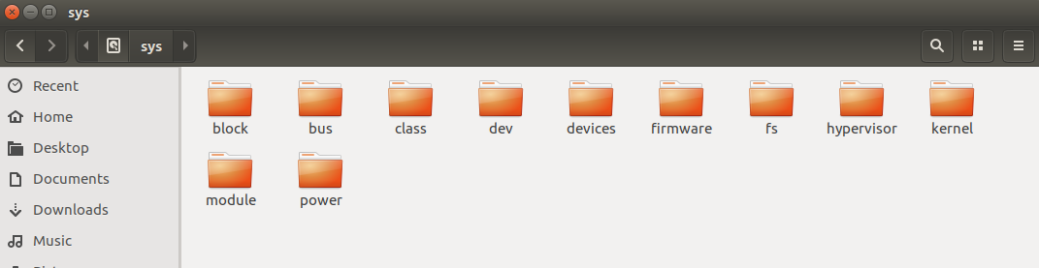

In simple terms, these are helpful files which are used by an application or a command or a process for their proper execution. The commands in /bin or /sbin dynamic **library** files are located just in this **directory**

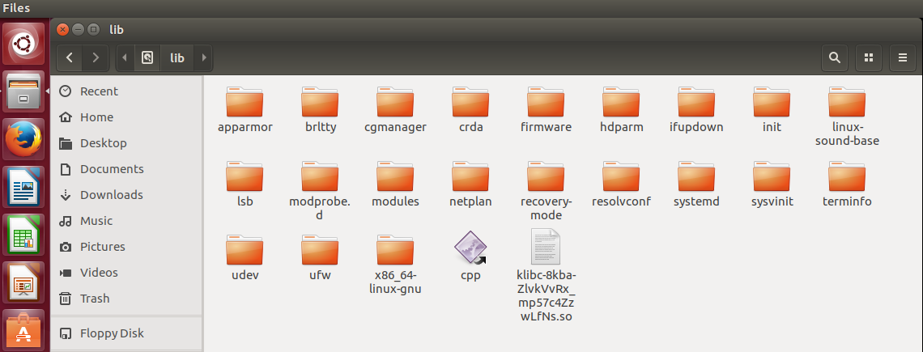

**Proc:**

. It contains the useful information about the processes that are currently running, it is regarded as control and information centre for kernel.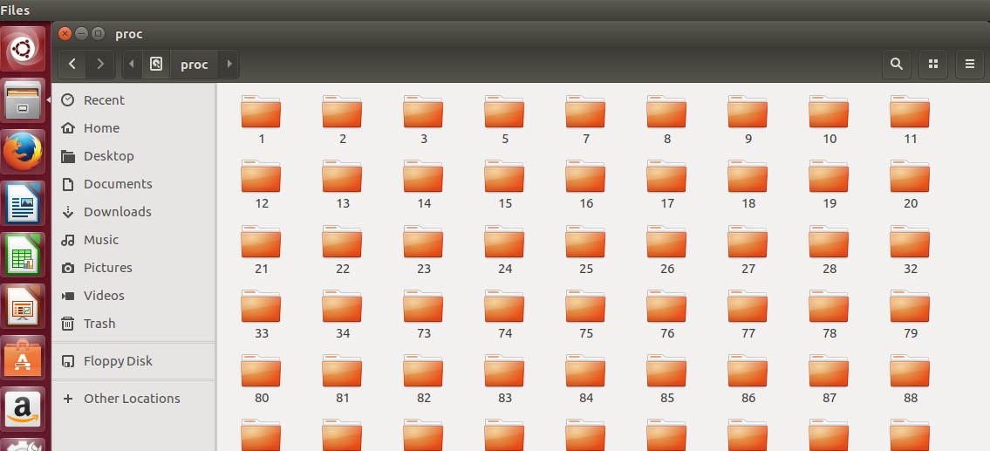

**/dev directory :**

The /**dev directory** contains the special device files for all the devices. The device files are created during installation, and later with the /**dev**/MAKEDEV script.

s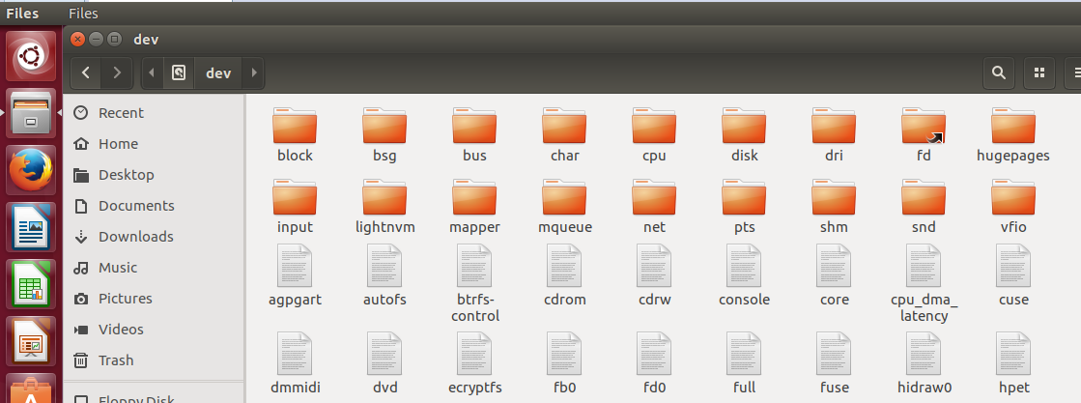

**Block:**

Each of the pointers is separately pointing to a disk **block** which also contains a collection of pointers which are separately pointing to an index **block** that contains the pointers to the file **blocks**.

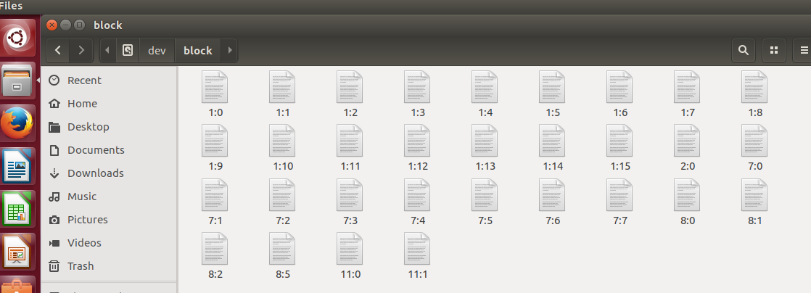

**/sbin** :

is a standard subdirectory of the root **directory** in Linux and other Unix-like **operating systems** that contains executable (i.e., ready to run) programs. They are mostly administrative tools, that should be made available only to the root (i.e., administrative) user.

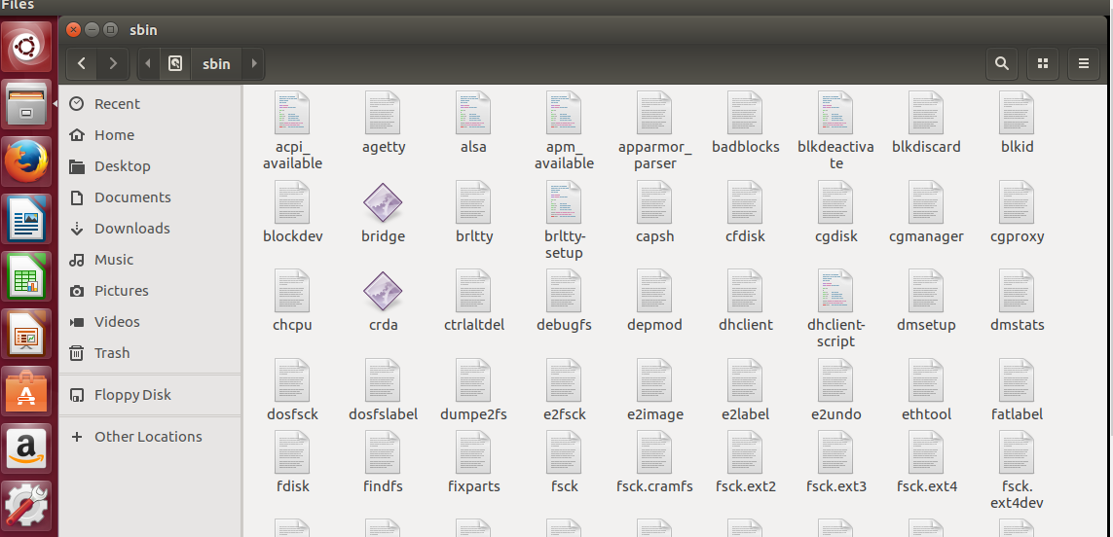

**/usr/bin directory**

It is also the default location of user home directories. The /**usr**/bin **directory** contains more UNIX commands. These commands are used less frequently or are considered nonessential to UNIX **system** operation.

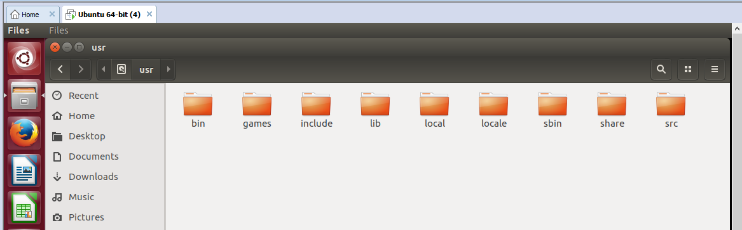

**Submission Date:**

**Evaluation: Signatures of Lab Engineer:**