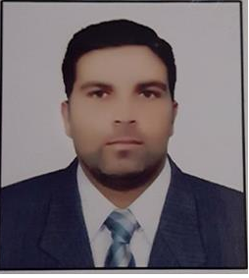



**NAVEED ASLAM**





**OBJECTIVE: SKILLS:** Average Good Excellent

To gain confidence and fame using my potential in the Planning field of “Teaching” and express my innovative Organizing creative skills for self and company growth and seeking Admin to work in the environment that will challenge me. Microsoft office    

Driving      

* 



# FIELDS INTERESTED IN:

* Teaching
* Marketing

# CAREER:

Teacher in government school since 11-3-2012 to 31-08-2017.

# EDUCATION:

2012– 2013 **BACHLOR OF ARTS** ALLAMA IQBAL OPEN UNIVERSITY

2005 – 2007 **HSSC (F.A)** HIGHER SECONDARY SCHOOL BHIMBER**.**

2003 – 2005  **SSC (Arts)** THE GOVT HIGH SCHOOL DAB SANDHOA BHIMBER.

* **CONTACT:**

ADDRESS: **District bhimber tehsil and post office samahni village kalich .**

* 0346-5872674
* 05828476900
* **Languages:**
* URDU
* ENGLISH(Normal)

[

Type text

]

Page

1

* punjabi

# DECLARATION:

I hereby declare that all the details shown above are true to the best of my knowledge and belief.