

Software Requirements Specification

AI-Powered HR Screening and Document Retrieval System Using RAG
  - Final Year Project
STUDENT INFORMATION
Sr. | Student ID | Name | Email
1. | UET-SHCET-LHR-CS-02 | AMNA IKRAM | Ikramamna980@gmail.com
2. | UET-SHCET-LHR-CS-12 | ZAIN UL HASSAN | Zainulhassan4330@gmail.com
3. | UET-SHCET-LHR-CS-13 | EZZA ANSAR | Ezzaansar05@gmail.com

Sharif College of Engineering & Technology
  - Computer Science Department

Table of Contents

Introduction

Purpose
The project is intended to help organizations in effectively managing, searching, and extracting meaningful information from large and unstructured collection of documents. Manual document review and resume screening processes are time-consuming, error-prone, and inefficient. This project aims to reduce human effort and operational delays by introducing an automated solution that enhances document understanding and information retrieval. By leveraging artificial intelligence techniques, the system seeks to improve accuracy, consistency, and speed in document analysis and HR decision-making processes.
Additionally, the project is proposed to support automated documentation. The system serves as a foundation for scalable AI-driven documentation that can be applied to a variety of organizational domains, such as management and recruitment.

Project Scope
The problem that most businesses face when trying to manage and gain insight from large collections of documents is addressed by the AI-Powered HR Screening and Document Retrieval System Using RAG. The time-consuming manual review of documents is eliminated by the system, which also provides a capable system for document comprehension and analysis.

Key Capabilities
Comprehensive Document Analysis Through Automated Processing
- PDF files
- Microsoft Word documents
- Scanned images
Optical Character Recognition (OCR) Technology
Extract readable text from scanned and image-based documents:
- Documents are classified by type
- Documents are tagged with relevant metadata
- Documents are converted into vector embeddings for semantic search
Natural Language Interface
- Search documents using plain English queries
- Ask questions related to document content
Retrieval-Augmented Generation (RAG)
- Retrieves relevant document content based on the user’s query
- Uses semantic search with vector embeddings
- Provides factual context from stored documents to the AI model
- Generates accurate, context-aware responses grounded in source data
- Reduces incorrect or irrelevant AI-generated answers
- Supports reliable question answering for HR and document analysis tasks

HR Resume Screening
- Assists HR personnel in resume screening and candidate shortlisting
- Collects resume attachments from incoming emails
- Processes multiple resume formats
- Extracts candidate information such as:
  - Skills
  - Educational qualifications
  - Work experience
  - Contact details
- Matches and ranks candidates against:
  - Predefined job descriptions
  - Required skills and experience criteria
- Significantly reduces:
  - Manual resume screening effort
  - HR workload and processing time

Benefits
- Application will improve operational efficiency by reducing manual document processing
- Application will minimize human error in document review and analysis
- Application will enhance productivity across departments such as HR and knowledge management

Objectives
- To streamline repetitive document review and classification tasks
- To provide automation (powered by AI) for HR screening and compliance monitoring
- To Improve accessibility and management of organizational knowledge

Strategic Alignment
The system is designed to support the use of AI Powered automation for improving document retrieval and resume screening tasks. It provides a practical implementation of AI-based document search and analysis that can be adapted to different types of organizational documents. The system is intended to handle moderate document volumes and may be extended in future to support larger datasets as per organizational requirements.

Out of Scope
This release does not include integration with third-party applicant tracking systems (i.e. indeed, greenhouse), nor does it support the processing of video or audio file formats. Native mobile applications for iOS and Android platforms are planned for future releases and are therefore not covered within the scope of this specification.

References
The following documents and resources were consulted during the preparation of this SRS:
- Google Cloud Documentation - Document AI Overview https://cloud.google.com/document-ai
- Amazon Web Services - Amazon Textract: Extract Text and Data from Documents https://aws.amazon.com/textract
- Microsoft Azure - Form Recognizer Documentation https://azure.microsoft.com/en-us/products/form-recognizer
- LangChain Documentation - Building Applications with Retrieval-Augmented Generation (RAG) https://python.langchain.com
- Hugging Face - Document AI: Understanding Documents with Transformers https://huggingface.co/blog/document-ai
- Hugging Face - Transformers and Large Language Models Documentation https://huggingface.co/docs
- PyMuPDF Documentation - Working with PDFs in Python https://pymupdf.readthedocs.io
- FAISS - Facebook AI Similarity Search Library https://faiss.ai
- Tesseract OCR - Optical Character Recognition Engine https://github.com/tesseract-ocr/tesseract
- IEEE Standard 830-1998 - IEEE Recommended Practice for Software Requirements Specification

Overall Description

Product Perspective
The AI-Powered HR Screening and Document Retrieval System Using RAG is a new, self-contained product designed to address the growing need for intelligent document processing solutions. The system provides advanced AI capabilities including semantic search, automated extraction, and intelligent question answering.

System Context
The system functions as a standalone document processing and analysis platform that can integrate with existing enterprise tools and workflows. It is designed to complement rather than replace existing content management systems by providing AI-based search and analysis features that traditional systems typically do not support.

Major System Components
The system architecture consists of several interconnected components working together to deliver comprehensive document intelligence:
Component | Description
Document Ingestion Layer | Handles file uploads, format validation, and initial document routing
Processing Engine | Performs OCR, text extraction, classification, and metadata generation
AI/NLP Module | Generates vector embeddings, executes semantic search, and powers the RAG pipeline
Vector Database | Stores document embeddings and enables efficient similarity-based retrieval
HR Automation Module | Manages Gmail integration, resume collection, and candidate shortlisting
Backend API Layer | Coordinates all system operations and handles business logic
Frontend Interface | Provides user-facing web application for all system interactions
Security Layer | Implements authentication, authorization, and data protection mechanisms
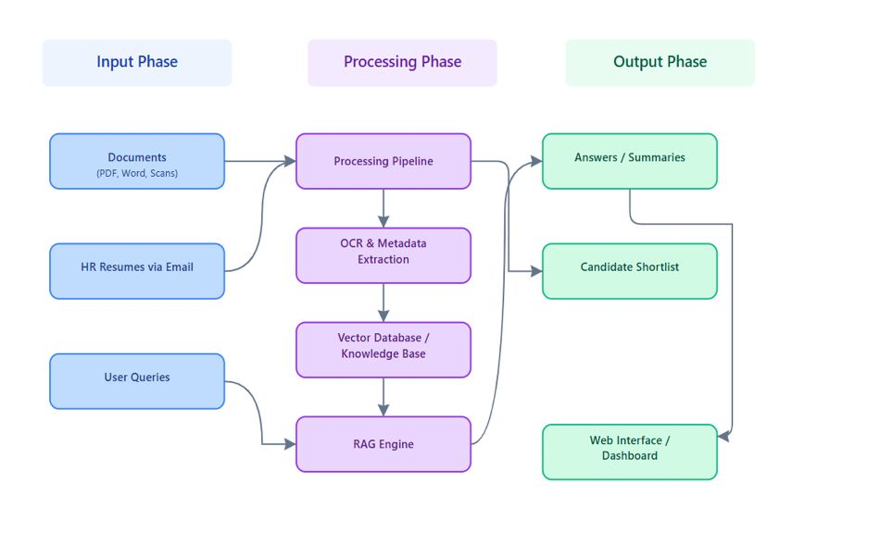
Figure 1: Architecture Diagram

External Interfaces
The system interfaces with Gmail (i.e. hr specific email) for automated resume collection in the HR module. All email integration occurs through secure OAuth authentication without storing credentials. Future versions may also include interfaces to enterprise resource planning (ERP) systems and document management platforms.

Hardware Platform
The system is designed to run on standard server hardware or private cloud instances. Client devices access the system through standard web browsers without requiring any software installation.

Product Features
The system provides a comprehensive suite of features organized into functional modules:

Document Processing and Management
Users can upload various document formats including PDF, Word documents, and scanned images through an intuitive drag-and-drop interface supporting batch uploads. The system automatically processes each document through OCR for text extraction, classifies documents by type such as resumes, reports, contracts, or letters, generates structured metadata including document type, date, author, and relevant attributes, and stores all information in searchable format. A centralized dashboard provides visibility into all processed documents with capabilities for sorting, filtering, preview, download, and deletion.

Intelligent Search and Retrieval
The semantic search engine allows users to find information using natural language queries rather than exact keyword matching. Vector embeddings enable retrieval based on conceptual similarity and meaning. Users can filter search results by document type, date range, or other metadata attributes. The system presents ranked results showing the most relevant documents and text segments with highlighted matches and contextual snippets.

Question Answering System
Using Retrieval-Augmented Generation technology, the system provides context-aware answers to user questions about uploaded documents. Users interact through a conversational chat interface asking questions in natural language. The system retrieves relevant content from the document collection and generates concise, accurate responses.
Example queries:
- “Extract skills from candidate John’s resume”
- “Summarize the findings in the Q3 report”
- “What are the key terms in this contract?”

Resume Screening
HR personnel create and save job descriptions defining required skills, education levels, experience requirements, and other criteria. The HR module connects securely to organizational Gmail accounts through OAuth authentication. It automatically syncs and collects resume attachments from incoming emails, maintaining a complete history of collected resumes. The module also supports sending follow-up emails or digital forms to selected candidates.

Integration and Automation
A well-defined API layer facilitates integration with external applications and automated workflows. For instance, résumés received via email can trigger automated processing pipelines. Processed results can be shared with HR management systems or reporting tools through dedicated API endpoints.

Privacy and Security
The system implements role-based access control, secure authentication mechanisms, activity logging, and audit trails to maintain data security and privacy compliance.

User Classes and Characteristics

HR Personnel
HR staff members use the system primarily for resume screening and candidate management. They possess moderate technical skills and familiarity with recruitment workflows and applicant tracking concepts. This user class requires specific features for connecting email accounts, defining job descriptions, reviewing candidate information, and managing shortlists. They need the ability to export candidate data and communicate with applicants. HR personnel are frequent users during active recruitment cycles and occasional users during other periods. The system must streamline their workflow and significantly reduce the time spent on manual resume review.

Email Service
The Email Service is an external, non-human system that enables automated email-based recruitment workflows in the HR module of the project. It connects securely to organizational email accounts using OAuth 2.0, allowing the system to access incoming resumes and send recruitment-related messages such as interview invitations or rejection notifications. Operating as a background service, it performs predefined communication tasks without independent decision-making, ensuring reliable synchronization of resumes and secure email transfer while reducing manual effort for HR personnel.

Operating Environment

Server Environment
- The system can be deployed on Linux-based servers (Ubuntu 20.04 LTS or higher, CentOS 8 or higher) or Windows Server 2019 or higher
- Minimum hardware requirements include:
  - 16 GB RAM (32 GB recommended for optimal performance)
  - Quad-core processor (eight-core recommended)
  - At least 500 GB storage, with SSD preferred for database and document storage

Software Dependencies
- The system requires Python 3.9 or higher as the primary runtime environment
- A relational database such as PostgreSQL 13 or higher is used for metadata and user data storage
- A vector database is used for embedding storage and semantic search, such as:
  - FAISS (Facebook AI Similarity Search)
  - Weaviate
  - Chroma
- Additional software dependencies include:
  - OCR libraries for text extraction
  - NLP frameworks for document processing
  - Web frameworks for API and frontend services
  - Containerization tools such as Docker for deployment and scalability

Client Environment
- Users access the system through modern web browsers, including:
  - Google Chrome (version 90 or higher)
  - Mozilla Firefox (version 88 or higher)
  - Microsoft Edge (version 90 or higher)
  - Safari (version 14 or higher)
- JavaScript must be enabled in the browser
- A stable internet or intranet connection is required
- No additional plugins or software installations are required on client devices
- The user interface is responsive and adapts to various screen sizes, including desktop monitors and tablets

Network Environment
- The system requires secure network connectivity between server components and client devices
- For the HR module, outbound HTTPS connections to Gmail servers are required for email integration
- The system supports deployment behind firewalls with appropriate port configurations
- All communication between clients and servers is conducted using encrypted HTTPS connections

Integration Environment
- The system integrates with Gmail services using OAuth 2.0 for the HR resume collection feature
- It integrates with organizational LDAP or Active Directory services for centralized user authentication
- Future integrations may include document management systems, enterprise resource planning platforms, or other business applications via RESTful APIs

Design and Implementation Constraints

Privacy and Security Constraints
- The system must implement appropriate security measures to protect sensitive information
- Data encryption must be applied both at rest and in transit
- Audit trails must be maintained for all data access and processing activities
- Role-based access control (RBAC) must be supported to restrict functionality based on user privileges
- All data storage and processing must comply with relevant data protection regulations, including GDPR, CCPA, and local privacy laws as applicable to the deployment location

Technology and Tool Constraints
- The system should use modular, replaceable components to minimize vendor lock-in
- AI models must be deployable on available infrastructure, including cloud-based or locally-hosted options based on organizational requirements
- The system should support CPU-only and GPU-accelerated deployments to accommodate varying hardware availability

Performance Constraints
Metric | Requirement
OCR Processing | Complete within 30 seconds for a standard document
Search Queries | Return results within 2 seconds for typical document collections
RAG Question Answering | Generate responses within 10 seconds
Concurrent Users | Handle multiple users without significant performance degradation
Document Capacity | Support at least 100,000 documents in initial deployment

Interface Constraints
- The Gmail integration for HR resume collection must use official OAuth 2.0 authentication and comply with Gmail API usage policies and rate limits
- The web interface must be accessible and fully usable without requiring installation of special software or browser plugins
- The system must provide clear error messages and guidance when processing fails or produces unexpected results

Regulatory and Policy Constraints
- The system must not violate copyright or intellectual property rights when processing and analyzing documents
- Organizations deploying the system are responsible for ensuring they have appropriate rights to process uploaded documents
- The system must maintain separation between different users’ data and enforce appropriate access controls
- Any AI-generated content must be clearly identified to prevent misrepresentation

User Documentation
The following documentation will be delivered with the system:

Installation and Deployment Guide
- The system shall be deployable on both Linux and Windows servers, using Docker-based or manual installation methods
- The system shall require standard hardware resources and support optional GPU acceleration for AI processing
- The system shall use open-source, self-hosted components, including backend, frontend, OCR, and AI modules
- The system shall include a relational database for metadata and a vector database for semantic search and retrieval
- The system shall support automated OCR, Retrieval-Augmented Generation (RAG) for question answering, email-based HR resume ingestion, and role-based access control

HR Module User Guide
- The system shall provide specialized documentation for HR personnel explaining the use of the automated resume screening module
- The documentation shall cover Gmail account connection, resume collection, and synchronization procedures
- The documentation shall explain how to create, update, and manage job descriptions and screening criteria
- The documentation shall guide HR users in reviewing extracted candidate information and using AI-based shortlisting features
- The documentation shall include instructions for exporting shortlisted candidate data and communicating with applicants
- The documentation shall provide workflow examples and best practices to ensure effective and consistent resume screening

API Documentation
- The system shall provide technical documentation for developers to support system integration and feature extension
- The documentation shall include API endpoint descriptions, along with supported operations and parameters
- The documentation shall define request and response formats, including data structures and validation rules
- The documentation shall specify authentication mechanisms, authorization requirements, and access controls
- The documentation shall document error codes, error messages, and recommended handling procedures
- The system shall generate API documentation automatically using Swagger/OpenAPI based on in-code annotations and provide example usage for multiple programming languages

Quick Start Guide
- The system shall provide a condensed quick reference guide to help new users start using the system efficiently
- The guide shall cover common tasks and core workflows, including document upload, search, and question answering
- The guide shall present instructions in a simplified, step-by-step format for ease of understanding
- The guide shall be designed in a print-friendly format suitable for use as a reference card
- The guide shall enable users to perform basic system operations without requiring detailed technical knowledge

Video Tutorials
- The system shall provide short instructional videos demonstrating key system workflows
- The videos shall cover document upload, semantic search, question answering, and HR module setup
- The videos shall present workflows in a clear, step-by-step manner for easy user understanding
- The videos shall be accessible within the system interface or available as downloadable files
- The videos shall support user training and onboarding without requiring extensive written documentation

Release Notes
- The system shall provide release documentation for each system version
- The release notes shall describe new features, enhancements, and resolved issues
- The release notes shall list known issues and limitations, if any
- The release notes shall include upgrade and deployment instructions where applicable
- The release documentation shall be maintained and updated throughout the project lifecycle

Assumptions and Dependencies

Technical Assumptions
- The system will be deployed on hardware with sufficient CPU, memory, and storage resources
- GPU hardware may be available to improve performance, but the system will remain functional on CPU-only machines
- A stable local network connection will be available for communication between system components
- Internet connectivity will be sufficient for email integration features in the HR module
- Standard Python runtime environments and commonly used libraries will remain compatible throughout development and deployment

AI and NLP Model Assumptions
- Suitable language and embedding models will be available for local deployment
- OCR technology will provide acceptable accuracy for standard printed documents
- Document quality will affect extraction accuracy, especially for scanned or handwritten files
- Retrieval-augmented generation will return relevant and context-aware answers for most queries

Organizational Assumptions
- Organizations will provide administrative support for system setup and maintenance
- Users will have basic computer and web application usage skills
- Backup and recovery procedures will be implemented by the deploying organization
- HR departments will define clear job requirements for effective candidate evaluation

Dependencies
- The project depends on the continued availability of Python and its supporting ecosystem
- OCR, NLP, and vector storage libraries must remain actively maintained and compatible
- Web frameworks and containerization tools will be available for deployment
- The HR module depends on Gmail API access and OAuth 2.0 authentication services
- Development depends on access to suitable test documents and datasets
- Progress and quality depend on continuous academic supervision and feedback
- Long-term system maintenance depends on trained personnel and documentation availability

System Features

User Authentication and Access Control

Description
This feature provides secure user authentication and role-based access control to ensure that only authorized users can access system functionalities appropriate to their roles.

Actors
- HR Personnel

Functional Requirements
REQ-3.1.1: User Login Authentication
The system shall allow users to log in using registered email and password credentials.
Use Case Reference: UC-1 – Login
REQ-3.1.2: Password Reset Functionality
The system shall allow users to reset their password using a secure verification mechanism.
Use Case Reference: UC-2 – Reset Password
REQ-3.1.3: Access Restriction for Unauthenticated Users
The system shall restrict access to system features unless the user is successfully authenticated.
Use Case Reference: UC-1 – Login

Document Upload and Processing

Description
This feature allows HR users to upload documents and automatically process them for further analysis.

Actors
- HR Personnel

Functional Requirements
REQ-3.2.1: Document Upload
The system shall allow HR users to upload files such as resumes and HR documents.
Use Case Reference: UC-3 – Upload Files
REQ-3.2.2: Text Extraction from Documents
The system shall extract text from uploaded documents using OCR when required.
Use Case Reference: UC-4 – Process Document
REQ-3.2.3: Secure Document Storage
The system shall store uploaded documents along with extracted text for future retrieval.
Use Case Reference: UC-3 – Upload Files

Search Document

Description
This feature enables users to search documents and refine results using filters.

Actors
- HR Personnel

Functional Requirements
REQ-3.3.1: Keyword and Natural Language Document Search
The system shall allow users to search documents using keywords or natural language queries.
Use Case Reference: UC-5 – Search
REQ-3.3.2: Search Functionality
The system shall allow users to search results based on criteria such as skills, job role, or date.
Use Case Reference: UC-5 – Search
REQ-3.3.3: Relevance Based Search Result Ranking
The system shall display ranked search results based on relevance.
Use Case Reference: UC-5 – Search

Filter Document

Description
This feature enables HR users to create and manage job postings for resume screening.

Actors
- HR Personnel

Functional Requirements
REQ-3.4.1: Document Filter Functionality
The system shall allow users to filter documents based on criteria such as skills, job role, or date.
Use Case Reference: UC-6 – Filter Document

Job Creation and Management

Description
This feature enables HR users to create and manage job postings for resume screening.

Actors
- HR Personnel

Functional Requirements
REQ-3.4.1: Job Description Creation
The system shall allow HR users to create job descriptions with required criteria.
Use Case Reference: UC-7 – Create Job
REQ-3.4.2: Job Posting Editing
The system shall allow HR users to edit existing job postings.
Use Case Reference: UC-8 – Edit Job

Resume Viewing and Candidate Screening

Description
This feature enables HR users to review resumes and perform candidate shortlisting.

Actors
- HR Personnel

Functional Requirements
REQ-3.5.1: View Resume
The system shall allow HR users to view and read extracted resume content.
Use Case Reference: UC-10 – View Resume
REQ-3.5.2: Shortlist Candidate
The system shall allow HR users to shortlist candidates based on job relevance.
Use Case Reference: UC-11 – Shortlist Candidate
REQ-3.5.3: Reject Candidate
The system shall allow HR users to reject candidates.
Use Case Reference: UC-12 – Reject Candidate
REQ-3.5.4: Export Shortlisted Candidates to Excel
The system shall allow HR users to export shortlisted candidates to Excel format.
Use Case Reference: UC-13 – Export Excel

Email Integration and Resume Synchronization

Description
This feature integrates the system with email services to automate resume collection and communication.

Actors
- HR Personnel
- Email Service

Functional Requirements
REQ-3.6.1: Connect Email
The system shall allow HR users to connect their email account securely.
Use Case Reference: UC-14 – Connect Email
REQ-3.6.2: Sync Resume from Email
The system shall automatically sync resume attachments from connected email accounts.
Use Case Reference: UC-15 – Sync Resume
REQ-3.6.3: Send Email to Candidate
The system shall allow HR users to send emails to candidates.
Use Case Reference: UC-16 – Send Email

Logs and Metadata Management

Description
This feature provides transparency and traceability of system activities and document data.

Actors
- HR Personnel

Functional Requirements
REQ-3.7.1: View System Activity Logs
The system shall allow users to view system activity logs.
Use Case Reference: UC-17 – View Logs
REQ-3.7.2: View Document Metadata
The system shall allow users to view extracted document metadata such as skills and experience.
Use Case Reference: UC-18 – View Metadata

Use Cases

UC-01: Login
Field | Description
Use Case # | UC-01
Context of Use | HR user logs in to access the Document AI system
Scope | User Authentication
Primary Actor | HR
Stakeholders & Interests | HR – secure access to system
Pre-Conditions | 1. System is running 2. User is registered
Trigger | HR selects Login
Main Course | 1. Open Login Page 2. Enter email and password 3. Validate credentials 4. Grant access
Post-Conditions | User redirected to dashboard
Failure Protection | Invalid credentials block access
Extensions | UC-02 Reset Password
Open Issues | Account lock after multiple failures
References | Use Case Diagram

UC-02: Reset Password
Field | Description
Use Case # | UC-02
Context of Use | User resets forgotten password
Scope | User Authentication
Primary Actor | HR
Stakeholders & Interests | HR – account recovery
Pre-Conditions | User email exists
Trigger | User clicks “Reset Password”
Main Course | 1. Enter email 2. Verify identity 3. Set new password
Post-Conditions | Password updated
Failure Protection | Invalid email rejected
Extensions | Verification timeout
Open Issues | Password policy
References | Use Case Diagram

UC-03: Search Documents
Field | Description
Use Case # | UC-03
Context of Use | HR searches stored documents
Scope | Document Retrieval
Primary Actor | HR
Stakeholders & Interests | HR – fast document access
Pre-Conditions | Documents exist
Trigger | HR enters search query
Main Course | 1. Enter keywords 2. Search documents 3. Display results
Post-Conditions | Matching documents shown
Failure Protection | No results handled
Extensions | UC-04 Filter Search, UC-05 Export Excel
Open Issues | Ranking logic
References | Use Case Diagram

UC-04: Filter Search
Field | Description
Use Case # | UC-04
Context of Use | HR refines search results
Scope | Search Filtering
Primary Actor | HR
Stakeholders & Interests | HR – accurate results
Pre-Conditions | Search performed
Trigger | HR selects filters
Main Course | 1. Choose filters 2. Apply criteria
Post-Conditions | Filtered results displayed
Failure Protection | Invalid filters ignored
Extensions | Multi-filter selection
Open Issues | Filter performance
References | Use Case Diagram

UC-05: Export Excel
Field | Description
Use Case # | UC-05
Context of Use | HR exports search results
Scope | Data Export
Primary Actor | HR
Stakeholders & Interests | HR – offline analysis
Pre-Conditions | Search results available
Trigger | HR selects Export
Main Course | 1. Select export option 2. Generate Excel file
Post-Conditions | Excel downloaded
Failure Protection | Export failure handled
Extensions | Custom fields
Open Issues | File size limits
References | Use Case Diagram

UC-06: Create Job
Field | Description
Use Case # | UC-06
Context of Use | HR creates job opening
Scope | Job Management
Primary Actor | HR
Stakeholders & Interests | HR – job posting
Pre-Conditions | User logged in
Trigger | HR selects Create Job
Main Course | 1. Enter job details 2. Save job
Post-Conditions | Job created
Failure Protection | Invalid data blocked
Extensions | UC-07 Edit/Delete Job
Open Issues | Job template
References | Use Case Diagram

UC-07: Edit/Delete Job
Field | Description
Use Case # | UC-07
Context of Use | HR updates job information
Scope | Job Management
Primary Actor | HR
Stakeholders & Interests | HR – job accuracy
Pre-Conditions | Job exists
Trigger | HR selects edit/delete
Main Course | 1. Modify Job 2. Save or delete
Post-Conditions | Job updated
Failure Protection | Unauthorized action blocked
Extensions | Job history
Open Issues | Audit trail
References | Use Case Diagram

UC-08: Send Email
Field | Description
Use Case # | UC-08
Context of Use | HR sends emails to candidates
Scope | Communication
Primary Actor | HR
Secondary Actor | Email Service
Stakeholders & Interests | HR – candidate communication
Pre-Conditions | Email service connected
Trigger | HR selects Send Email
Main Course | 1. Compose email 2. Send via email service
Post-Conditions | Email delivered
Failure Protection | Retry mechanism
Extensions | Attach documents
Open Issues | Email templates
References | Use Case Diagram

UC-09: Receive Email
Field | Description
Use Case # | UC-09
Context of Use | System receives resumes via email
Scope | Candidate
Primary Actor | Email Service
Secondary Actor | System
Stakeholders & Interests | HR – automated resume intake
Pre-Conditions | Email integration enabled
Trigger | Incoming email
Main Course | 1. Receive email 2. Extract attachments 3. Store resumes
Post-Conditions | Resume added to system
Failure Protection | Invalid attachment ignored
Extensions | Multiple attachments
Open Issues | Spam handling
References | Use Case Diagram

UC-10: Sync Resumes
Field | Description
Use Case # | UC-10
Context of Use | System syncs resumes from email
Scope | Resume Synchronization
Primary Actor | Email Service
Stakeholders & Interests | HR – updated data
Pre-Conditions | New emails received
Trigger | Sync scheduled
Main Course | 1. Fetch emails 2. Process resumes
Post-Conditions | Resumes indexed
Failure Protection | Duplicate check
Extensions | Manual sync
Open Issues | Sync frequency
References | Use Case Diagram

UC-11: View Logs
Field | Description
Use Case # | UC-11
Context of Use | HR reviews system activity
Scope | Logging
Primary Actor | HR
Stakeholders & Interests | HR – auditing
Pre-Conditions | Logs exist
Trigger | HR selects View Logs
Main Course | 1. Retrieve logs 2. Display entries
Post-Conditions | Logs shown
Failure Protection | Empty logs handled
Extensions | Filter logs
Open Issues | Log retention
References | Use Case Diagram

UC-12: View Metadata
Field | Description
Use Case # | UC-12
Context of Use | HR views document metadata
Scope | Metadata Management
Primary Actor | HR
Stakeholders & Interests | HR – document insight
Pre-Conditions | Document exists
Trigger | Select View Metadata
Main Course | 1. Fetch metadata 2. Display info
Post-Conditions | Metadata shown
Failure Protection | Missing metadata handled
Extensions | Metadata edit
Open Issues | Standard fields
References | Use Case Diagram

UC-13: Read Resumes
Field | Description
Use Case # | UC-13
Context of Use | HR reads resume content
Scope | Resume Analysis
Primary Actor | HR
Stakeholders & Interests | HR – candidate review
Pre-Conditions | Resume processed
Trigger | Select resume
Main Course | 1. Load resume 2. Display content
Post-Conditions | Resume displayed
Failure Protection | OCR fallback
Extensions | Highlight skills
Open Issues | Formatting
References | Use Case Diagram

Diagrams

Use Case Diagram
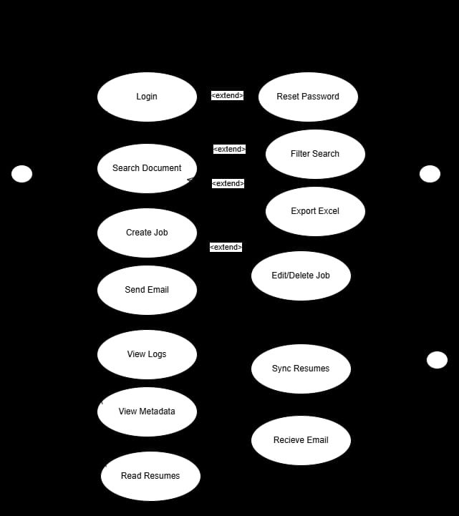
Figure 2: Use Case Diagram

Activity Diagram
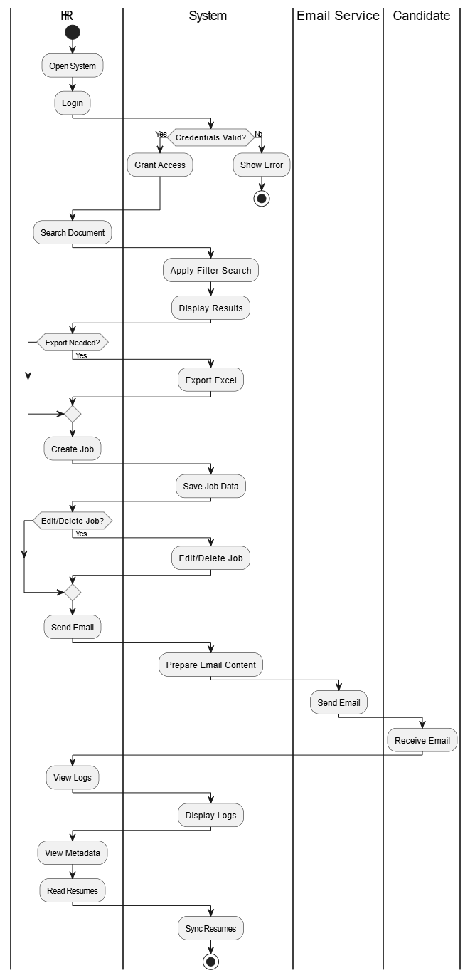
Figure 3: Activity Diagram

DFD Diagrams

Level 0
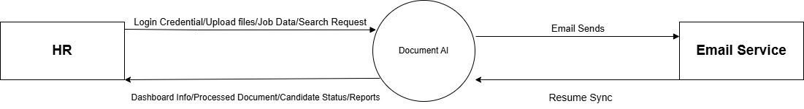
Figure 4: DFD Level 0 Diagram

Level 1
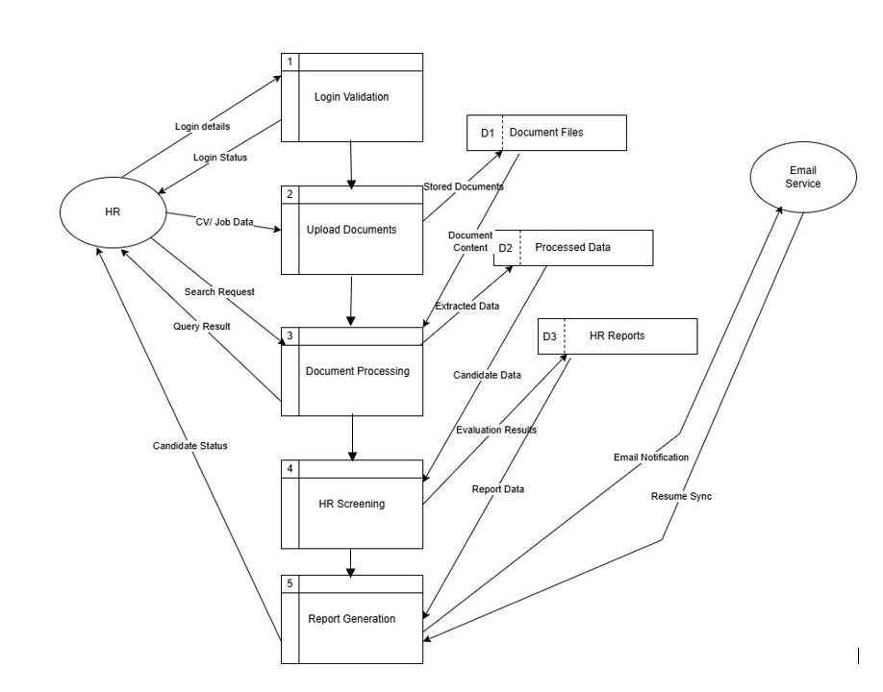
Figure 5: DFD Level 1 Diagram

Level 2
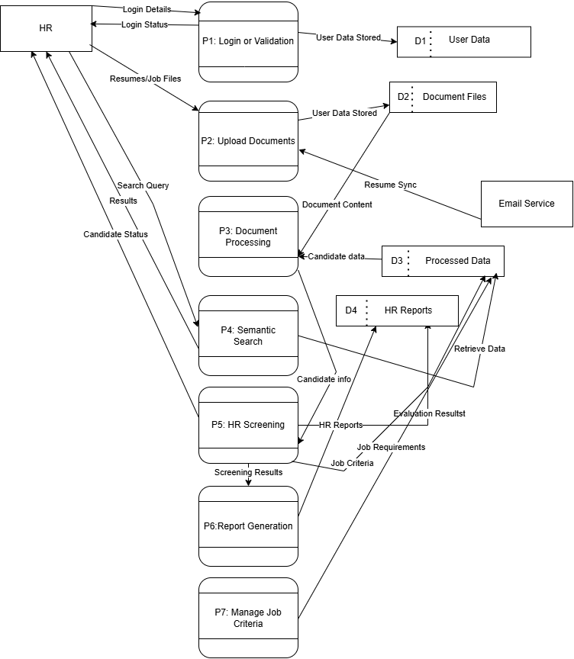
Figure 6: DFD Level 2 Diagram

