

SHARIF COLLEGE OF ENGINEERING & TECHNOLOGY
Department of Computer Science
FINAL YEAR PROJECT REPORT
AI Powered HR Screening and Document Retrieval System Using RAG
Submitted in partial fulfillment of the requirements for the degree of
Bachelor of Science in Computer Science (BSCS)
Submitted By
Sr No. | Student Name | Registration No. | Signature
1 | AMNA IKRAM | UET-SHCET-LHR-CS-02
2 | ZAIN UL HASSAN | UET-SHCET-LHR-CS-12
3 | EZZA ANSAR | UET-SHCET-LHR-CS-13
Supervisor
Ms. Hirra Mustafa
Co-Supervisor
Dr. Mazhar Iqbal

I. Industrial Supervisor Approval Certificate
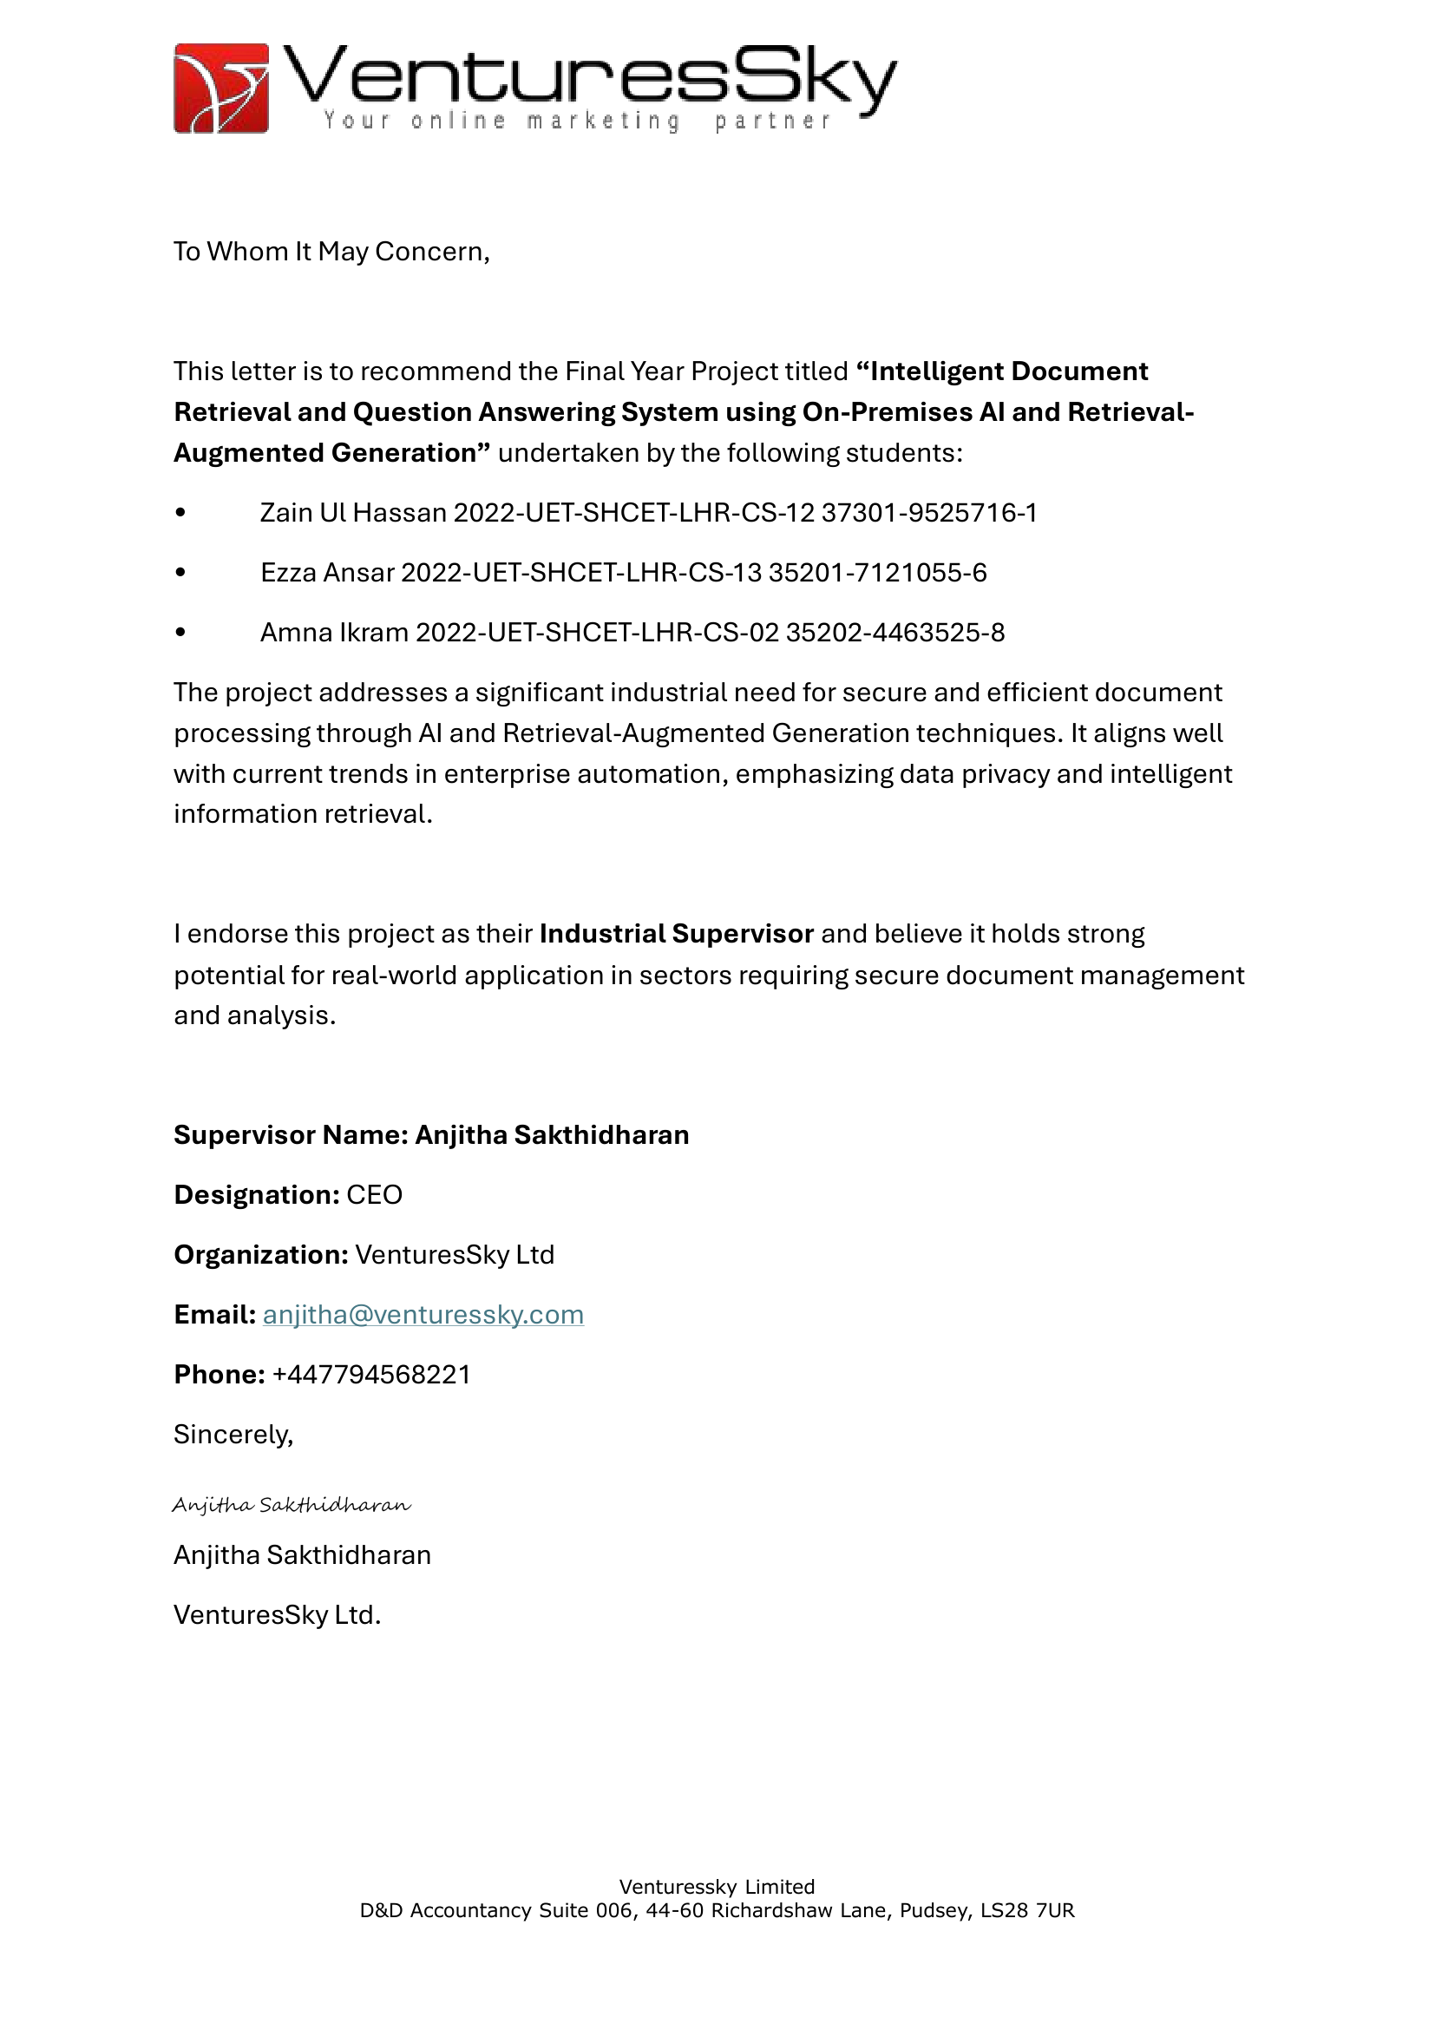

II. Declaration
We hereby declare that this Final Year Project Report entitled:
"AI Powered HR Screening and Document Retrieval System Using RAG"
submitted to the Department of Computer Science, Sharif College of Engineering & Technology, in partial fulfillment of the requirements for the award of the degree of Bachelor of Science in Computer Science (BSCS), is our original work.
This project has been carried out by us under the supervision of Ms. Hirra Mustafa.
We further declare that:
- The work contained in this report is entirely our own except where appropriate acknowledgment and references have been made.
- All sources of information, including published literature, books, journals, websites, and other materials, have been properly cited in accordance with APA 7th Edition referencing guidelines.
- We accept full responsibility for the authenticity and originality of the work presented in this report.
- Any similarity with previously published work beyond acceptable academic limits is unintentional and subject to the academic policies of Sharif College of Engineering & Technology.
We understand that if any part of this declaration is found to be false or misleading, the College reserves the right to cancel the submission and take disciplinary action in accordance with its academic regulations.
Supervisor's Verification
I certify that the above declaration has been read and that, to the best of my knowledge, the work presented in this Final Year Project Report has been carried out by the above-mentioned students under my supervision.
Supervisor Name: Ms. Hirra Mustafa
Designation: ________________________
Department: Computer Science
Signature: ________________________
Date: _____________________________

III. Plagiarism Declaration/ Plagiarism Report
We hereby declare that this Final Year Project Report is our original work and has been prepared in accordance with the academic integrity policies of the Department of Computer Science, Sharif College of Engineering & Technology (SCET).
We confirm that all sources of information have been properly acknowledged and cited. Any text, figures, code, or other material taken from published or unpublished sources has been appropriately referenced.
We understand and agree to the following submission requirements:
- Similarity Score: The overall similarity index must be 15% or less.
- AI Content Score: The AI-generated content score must be less than 20%.
We acknowledge that failure to comply with these requirements or submission of plagiarized work may result in rejection of the project and disciplinary action in accordance with the academic regulations of SCET.

IV. Dedication
To our beloved parents, whose prayers, sacrifices, and endless encouragement made this journey possible, and to our teachers, whose guidance and patience shaped the way we think and work. This project is dedicated to you, with gratitude and love.

V. Acknowledgements
First and foremost, we thank Almighty Allah for granting us the strength, patience, and determination to complete this project.
We are deeply grateful to our supervisor, Ms. Hirra Mustafa, for her constant guidance, valuable feedback, and encouragement at every stage of this work. Her insight kept the project on track and pushed us to do better. We are equally thankful to our co-supervisor, Dr. Mazhar Iqbal, whose technical advice and thoughtful suggestions strengthened both our approach and our understanding.
We also extend our sincere appreciation to our industrial supervisor, Anjitha Sakthidharan (CEO, VenturesSky Ltd), for endorsing the project and offering an industry perspective that helped us ground our work in real-world needs.
Our gratitude goes to the Department of Computer Science at Sharif College of Engineering and Technology for providing the resources, facilities, and learning environment that made this work possible, and to the faculty members whose feedback during evaluations helped us refine the system.
Finally, we thank our families and friends for their unconditional love, patience, and support throughout this journey. Their belief in us was a constant source of motivation.

Abstract
Human resource teams that manage large collections of unstructured documents spend considerable time manually reviewing and screening resumes, with inconsistent results, while keyword search fails to surface semantically relevant content. This project presents Hireflow, an AI-powered HR screening and document retrieval system built on Retrieval-Augmented Generation. Documents in PDF, Word, and scanned-image form are processed through an OCR and text-extraction pipeline, then chunked, embedded with sentence-transformer models, and indexed in a vector database. A hybrid retrieval engine fuses vector, lexical, metadata, and fuzzy signals, and a retrieval-augmented generation service returns concise, source-attributed answers while declining questions that fall outside the document collection. Candidate resumes are ranked against job criteria using a transparent weighted scoring model, and intake is automated through Gmail synchronization. The system is implemented as a FastAPI backend with PostgreSQL, Redis, Celery, and MinIO, paired with a React frontend. The result is a single self-hostable platform delivering semantic search, grounded question answering, and explainable candidate ranking.
Keywords: Retrieval-Augmented Generation, Semantic Search, Resume Screening, Optical Character Recognition, Vector Database, Human Resources.

