

SHARIF COLLEGE OF ENGINEERING & TECHNOLOGY
Department of Computer Science
FINAL YEAR PROJECT REPORT
AI Powered HR Screening and Document Retrieval System Using RAG
Submitted in partial fulfillment of the requirements for the degree of
Bachelor of Science in Computer Science (BSCS)
Submitted By
Sr No. | Student Name | Registration No. | Signature
1 | AMNA IKRAM | UET-SHCET-LHR-CS-02
2 | ZAIN UL HASSAN | UET-SHCET-LHR-CS-12
3 | EZZA ANSAR | UET-SHCET-LHR-CS-13
Supervisor
Ms. Hirra Mustafa
Co-Supervisor
Dr. Mazhar Iqbal
July 2026

I. Industrial Supervisor Approval Certificate
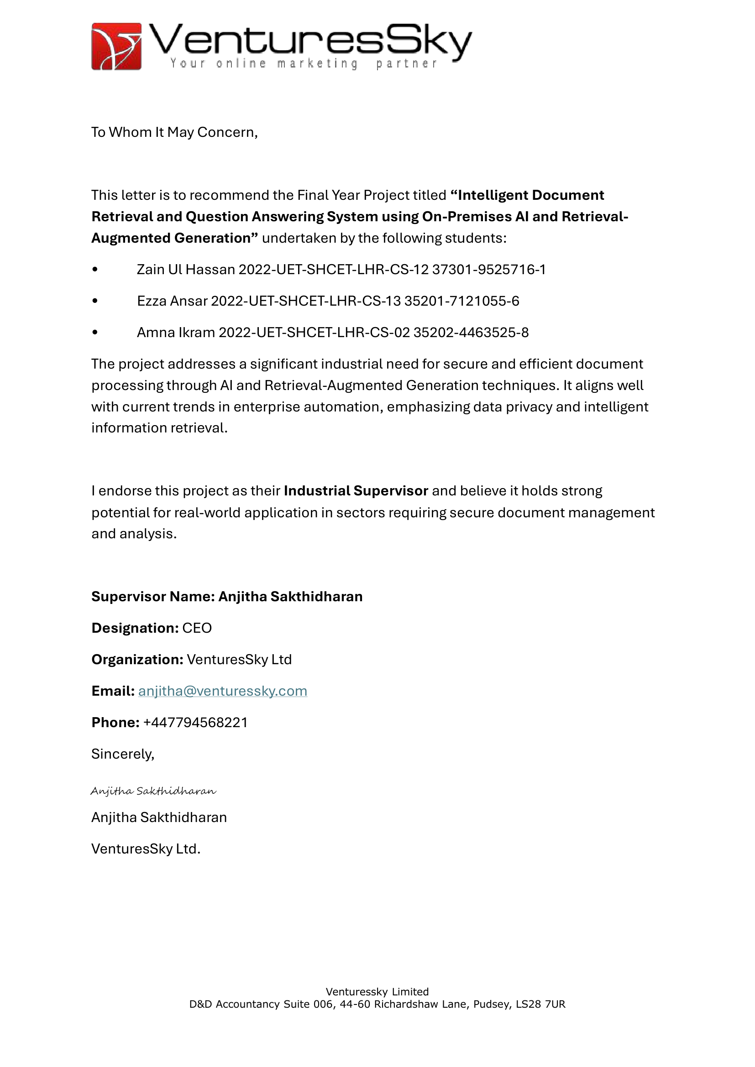

II. Declaration
We hereby declare that this Final Year Project Report entitled:
"AI Powered HR Screening and Document Retrieval System Using RAG"
submitted to the Department of Computer Science, Sharif College of Engineering & Technology, in partial fulfillment of the requirements for the award of the degree of Bachelor of Science in Computer Science (BSCS), is our original work.
This project has been carried out by us under the supervision of Ms. Hirra Mustafa.
We further declare that:
- The work contained in this report is entirely our own except where appropriate acknowledgment and references have been made.
- All sources of information, including published literature, books, journals, websites, and other materials, have been properly cited in accordance with APA 7th Edition referencing guidelines.
- We accept full responsibility for the authenticity and originality of the work presented in this report.
- Any similarity with previously published work beyond acceptable academic limits is unintentional and subject to the academic policies of Sharif College of Engineering & Technology.
We understand that if any part of this declaration is found to be false or misleading, the College reserves the right to cancel the submission and take disciplinary action in accordance with its academic regulations.
Supervisor's Verification
I certify that the above declaration has been read and that, to the best of my knowledge, the work presented in this Final Year Project Report has been carried out by the above-mentioned students under my supervision.
Supervisor Name: Ms. Hirra Mustafa
Designation: ________________________
Department: Computer Science
Signature: ________________________
Date: _____________________________

III. Plagiarism Declaration/ Plagiarism Report
[The Turnitin similarity report will be attached here.]
We hereby declare that this Final Year Project Report is our original work and has been prepared in accordance with the academic integrity policies of the Department of Computer Science, Sharif College of Engineering & Technology (SCET).
We confirm that all sources of information have been properly acknowledged and cited. Any text, figures, code, or other material taken from published or unpublished sources has been appropriately referenced.
We understand and agree to the following submission requirements:
- Similarity Score: The overall similarity index must be 15% or less.
- AI Content Score: The AI-generated content score must be less than 20%.
We acknowledge that failure to comply with these requirements or submission of plagiarized work may result in rejection of the project and disciplinary action in accordance with the academic regulations of SCET.

IV. Dedication
To our beloved parents, whose prayers, sacrifices, and endless encouragement made this journey possible, and to our teachers, whose guidance and patience shaped the way we think and work. This project is dedicated to you, with gratitude and love.

V. Acknowledgements
First and foremost, we thank Almighty Allah for granting us the strength, patience, and determination to complete this project.
We are deeply grateful to our supervisor, Ms. Hirra Mustafa, for her constant guidance, valuable feedback, and encouragement at every stage of this work. Her insight kept the project on track and pushed us to do better. We are equally thankful to our co-supervisor, Dr. Mazhar Iqbal, whose technical advice and thoughtful suggestions strengthened both our approach and our understanding.
We also extend our sincere appreciation to our industrial supervisor, Anjitha Sakthidharan (CEO, VenturesSky Ltd), for endorsing the project and offering an industry perspective that helped us ground our work in real-world needs.
Our gratitude goes to the Department of Computer Science at Sharif College of Engineering and Technology for providing the resources, facilities, and learning environment that made this work possible, and to the faculty members whose feedback during evaluations helped us refine the system.
Finally, we thank our families and friends for their unconditional love, patience, and support throughout this journey. Their belief in us was a constant source of motivation.

Abstract
Organizations that manage large collections of unstructured documents such as resumes, reports, and scanned correspondence struggle to retrieve relevant information quickly, and human resource teams in particular spend a great deal of time manually reviewing and screening resumes with inconsistent results. This project presents Hireflow, an AI-powered HR screening and document retrieval system that addresses these problems using Retrieval-Augmented Generation. The objective is to let HR personnel ingest heterogeneous documents, search and question them in natural language, and automatically screen and rank candidates against job criteria. Documents in PDF, Word, and scanned-image form are processed through an OCR and text-extraction pipeline built on PyMuPDF and Tesseract, then chunked, embedded with sentence-transformer models, and indexed in the ChromaDB vector database. A hybrid retrieval engine fuses vector, lexical, metadata, and fuzzy signals, and a retrieval-augmented generation service powered by a large language model returns concise, source-attributed answers while declining questions that fall outside the document collection. Candidate resumes are screened and ranked with a transparent, weighted scoring model, and intake is automated through Gmail synchronization. The system is implemented as a FastAPI backend with PostgreSQL, Redis, Celery, and MinIO, paired with a React and TypeScript frontend. The resulting platform delivers semantic search, grounded question answering, explainable candidate ranking, and automated resume intake in a single self-hostable application, reducing manual screening effort and improving the consistency and traceability of HR document workflows.
Keywords: Retrieval-Augmented Generation, Semantic Search, Resume Screening, Optical Character Recognition, Vector Database, Human Resources.

Table of Contents
I. Industrial Supervisor Approval Certificate 2
II. Declaration 3
III. Plagiarism Declaration/ Plagiarism Report 4
IV. Dedication 5
V. Acknowledgements 6
Abstract 7
List of Abbreviations 12
CHAPTER 1: INTRODUCTION 13
1.1 Background 13
1.2 Problem Statement 13
1.3 Objectives 14
1.4 Scope of Project 14
1.5 Significance of Project 15
1.6 Report Organization 15
CHAPTER 2: LITERATURE REVIEW 17
2.1 Overview of Domain 17
2.2 Existing Systems / Related Work 17
2.3 Comparison of Existing Systems 19
2.4 Research Gap 20
2.5 Proposed Solution 21
CHAPTER 3: SYSTEM ANALYSIS & REQUIREMENTS 23
3.1 Feasibility Study 23
3.2 Functional Requirements 24
3.3 Non-Functional Requirements 26
3.4 Tools and Technologies Used 27
3.5 Use Cases / User Stories 28
3.6 Use Cases Table 31
CHAPTER 4: SYSTEM DESIGN 33
4.1 System Architecture Description & Design 33
4.2 Data Flow Diagrams 35
4.3 UML Diagrams 38
4.4 Database Design (ERD, Schema, Data Dictionary) 42
4.5 UI/UX Design 48
CHAPTER 5: IMPLEMENTATION 52
5.1 Development Environment Setup 52
5.2 Implementation Details 53
5.3 Code Snippets with Explanation 54
5.4 Database Implementation 56
CHAPTER 6: TESTING & RESULTS 58
6.1 Testing Strategy 58
6.2 Test Cases and Results 58
6.3 Performance Evaluation 61
6.4 Results and Discussion 63
CHAPTER 7: CONCLUSION & FUTURE WORK 65
7.1 Conclusion 65
7.2 Limitations 65
7.3 Future Enhancements 66
REFERENCES 67
APPENDICES 68
Appendix A: User Manual 68
Appendix B: Sample Code 68
Appendix C: Gantt Chart (FYP-I and FYP-II) 68

List of Figures
Figure 3.1: Use Case Diagram 29
Figure 4.1: System Architecture 35
Figure 4.2: DFD Level 0 (Context Diagram) 36
Figure 4.3: DFD Level 1 37
Figure 4.4: DFD Level 2 38
Figure 4.5: Class Diagram 39
Figure 4.6: Activity Diagram 40
Figure 4.7: Component Diagram 41
Figure 4.8: Sequence Diagram (Streaming RAG Query) 42
Figure 4.9: Entity-Relationship Diagram 43
Figure 4.10: Dashboard overview 49
Figure 4.11: Documents management with upload and processing status 49
Figure 4.12: Semantic search across the document library with match scores and skill filters 50
Figure 4.13: Ask Hireflow, conversational question answering grounded in the library with source citations 50
Figure 4.14: Candidate screening list with match scores 51
Figure 6.1: Login screen under test 61
Figure 6.2: Hybrid search and RAG question-answering under test 61

List of Tables
Table 2.2: Comparison of Representative Systems 20
Table 2.3: Research Gap Summary 21
Table 3.1: Functional Requirements (FR01-FR20) 25
Table 3.2: Tools and Technologies 28
Table 3.3: Summary of Use Cases (UC-01-UC-12) 30
Table 3.4: Sample Use Case, User Login 32
Table 4.1: users Data Dictionary 44
Table 4.2: documents Data Dictionary 46
Table 4.3: jobs Data Dictionary 46
Table 4.4: candidates Data Dictionary 47
Table 5.1: Development Environment Services and Ports 53
Table 6.2: Test Case Traceability Matrix 61
Table 6.3: Measured Performance (Development Stack) 62

List of Abbreviations
Abbreviation | Expansion
API | Application Programming Interface
ATS | Applicant Tracking System
CCPA | California Consumer Privacy Act
CRUD | Create, Read, Update, Delete
DFD | Data Flow Diagram
ERD | Entity-Relationship Diagram
FR | Functional Requirement
FTS | Full-Text Search
GDPR | General Data Protection Regulation
HR | Human Resources
JWT | JSON Web Token
LLM | Large Language Model
NFR | Non-Functional Requirement
OCR | Optical Character Recognition
OAuth | Open Authorization
RAG | Retrieval-Augmented Generation
RBAC | Role-Based Access Control
RRF | Reciprocal Rank Fusion
SPA | Single-Page Application
SRS | Software Requirements Specification
SSE | Server-Sent Events
UC | Use Case
UI/UX | User Interface / User Experience
UML | Unified Modeling Language

CHAPTER 1: INTRODUCTION
Recruitment and document management are among the most document-intensive functions in any organization. Yet they remain heavily manual, slow, and inconsistent. This chapter introduces Hireflow, an AI-Powered HR Screening and Document Retrieval System that applies Retrieval-Augmented Generation (RAG) to unstructured document collections, letting HR personnel search, question, and screen documents in natural language. The sections that follow set out the background and motivation, state the problem being solved, define the objectives and scope, weigh the significance of the work, and outline how the rest of the report is organized.

1.1 Background
Modern organizations accumulate large volumes of unstructured documents: resumes, reports, contracts, and scanned correspondence, most of it arriving as PDF files, Microsoft Word documents, or scanned images. Extracting value from this material has traditionally depended on manual reading and keyword-based search. Both scale poorly as collections grow. In human resources the pressure is acute. Recruiters commonly review dozens of resumes per open position, and industry practice reports that HR teams spend the majority of their working time on manual resume review, averaging around twenty-three hours of effort to fill a single position. Keyword search only compounds the problem, since it matches literal tokens rather than meaning; a query for “machine learning engineer” fails to surface a strong candidate who wrote “ML researcher” or “deep learning specialist.”
Two families of technology have now matured enough to address these limitations. The first is document understanding and optical character recognition (OCR). Managed cloud services such as Google Cloud Document AI [1], Amazon Textract [2], and Azure Form Recognizer [3], along with open-source engines such as Tesseract [9] and libraries such as PyMuPDF [7], make it possible to extract structured text from PDFs, Word files, and scanned images. The second is the pairing of dense vector embeddings with large language models (LLMs). Vector similarity search libraries such as FAISS [8], together with transformer-based document and language models [5][6], enable semantic retrieval, where documents are matched by meaning rather than exact wording. Retrieval-Augmented Generation (RAG) [4] ties these strands together: relevant passages are retrieved from a vector store and then supplied as grounded context to an LLM, which composes a natural-language answer that cites its sources. Hireflow builds on this foundation, using sentence-transformers for embeddings, ChromaDB as the vector store, and Anthropic Claude as the answer-generating LLM.

1.2 Problem Statement
HR personnel who manage large, unstructured document collections face several compounding difficulties. Manual review of resumes and other documents is slow and absorbs the bulk of recruiter effort, and because different reviewers apply inconsistent criteria, it introduces bias and compliance risk. Keyword-based search and rigid, rule-based Applicant Tracking System (ATS) filters miss semantically relevant content, along with qualified candidates whose phrasing does not match the exact query terms. The information needed for a decision is scattered across email inboxes, shared folders, and disconnected systems, so retrieving a specific fact from a large corpus is slow. Existing tools rarely let a user ask a plain-language question over their own documents and receive a concise, source-attributed answer. What is needed is a single system that ingests heterogeneous documents, understands them semantically, answers natural-language questions with provenance, and automatically screens and ranks candidates against defined job criteria.

1.3 Objectives
The project pursues the following specific and measurable objectives:
- Ingest and process heterogeneous documents: accept PDF, Microsoft Word, and scanned image files and extract their text using PyMuPDF [7] and Tesseract/pytesseract OCR [9], targeting text-extraction accuracy above 95% on standard printed documents.
- Enable semantic search and retrieval: index all documents as dense vector embeddings (sentence-transformers) in a vector database (ChromaDB) so that natural-language queries return relevance-ranked results, with typical search responses returned in under two seconds.
- Provide grounded question answering via RAG: answer plain-language questions over the document collection using Retrieval-Augmented Generation [4] with an LLM (Anthropic Claude), returning cited, source-attributed answers with a target answer-relevance of at least 85% and end-to-end response times under ten seconds.
- Automate resume screening and ranking: match and rank candidate resumes against user-defined job criteria (skills, education, experience), reducing manual screening effort by roughly 70-80% and processing on the order of 100 resumes per hour.
- Automate candidate intake and reporting: sync resume attachments from Gmail using OAuth 2.0, and support shortlisting, rejection, activity logging, and export of candidate data to Excel for compliance and offline analysis.

1.4 Scope of Project
Hireflow is a standalone, web-based system for HR personnel. Within scope for the first version are document upload and batch ingestion; OCR and text extraction for PDF, Word, and scanned image files; automatic document classification and metadata generation; semantic search with filtering by document type, date, skills, and role; RAG-based question answering with source citations; job posting creation and management; automated candidate screening and ranking against job criteria; Gmail integration for resume collection via OAuth 2.0; export of shortlisted candidates to Excel; and activity logging with audit trails. The system is delivered as a FastAPI (Python 3.12) backend with Celery and Redis for background processing, PostgreSQL 15 for relational data, ChromaDB for vector storage, and MinIO for object storage, paired with a React 19 and TypeScript frontend built with Vite, Tailwind, and shadcn/ui.
The system supports two roles: HR personnel (the primary user class) and an administrator role for user management, both governed by role-based access control. An external Email Service acts as a supporting actor for automated resume synchronization. Explicitly out of scope for version 1.0 are third-party ATS integrations, processing of video or audio files, native mobile applications for iOS and Android, and multi-language support beyond English.

1.5 Significance of Project
Hireflow’s significance lies in consolidating capabilities that were previously available only through fragmented, expensive, or cloud-locked services into a single coherent platform tailored to HR workflows. Replacing keyword matching with semantic retrieval and RAG lets the system surface qualified candidates and relevant documents that literal search would miss. This improves the quality and consistency of shortlists while reducing bias from divergent reviewer criteria. By automating resume intake from Gmail and ranking candidates against explicit job criteria, the system targets a substantial reduction in manual screening effort, freeing recruiters for interviews and judgment-heavy work. Grounded, source-attributed answers address a key weakness of naive LLM use, namely unverifiable output, by tying every answer back to the documents it came from; this matters for trust, auditability, and compliance. Academically, the project shows how OCR, dense-vector retrieval, and LLM-based generation can be integrated into a production-shaped, service-oriented architecture.

1.6 Report Organization
This report is organized into the following chapters.
Chapter 2 - Literature Review: surveys the domain of document understanding, semantic search, and AI-assisted recruitment, reviews existing systems and related work, compares their strengths and limitations, identifies the research gap, and positions Hireflow as the proposed solution.
Chapter 3 - System Analysis & Requirements: presents the feasibility study, the functional and non-functional requirements, the tools and technologies adopted, and the use cases and user stories that model the system’s behaviour.
Chapter 4 - System Design: describes the overall layered architecture, the data-flow diagrams, the UML models, the database design, and the UI/UX design of the system.
Chapter 5 - Implementation: details the development environment, the realization of the backend services and frontend interface, representative code, and the database implementation.
Chapter 6 - Testing & Results: covers the testing strategy, the test cases and their results, the performance evaluation, and a discussion of results against the objectives.
Chapter 7 - Conclusion & Future Work: summarizes the outcomes of the project, reflects on its limitations, and outlines directions for future enhancement.

CHAPTER 2: LITERATURE REVIEW
This chapter reviews the technologies and prior systems relevant to AI-powered document retrieval and HR screening. It first frames the problem domain, then examines existing systems and related work: traditional Applicant Tracking Systems, keyword search, cloud document-understanding services, RAG frameworks, transformer-based document understanding, vector similarity search, and OCR. From there it compares the approaches, identifies the research gap that motivates the project, and presents Hireflow as the proposed solution.

2.1 Overview of Domain
This project sits at the intersection of three fields: document understanding, information retrieval, and applied natural language processing for recruitment. Document understanding converts unstructured inputs such as PDFs, Word files, and scanned images into machine-readable text and metadata, typically using OCR and layout analysis [1][2][3][7][9]. Information retrieval has evolved from lexical, keyword-based matching toward dense semantic retrieval, in which text is encoded as high-dimensional embedding vectors and compared by similarity, so that conceptually related content surfaces even without shared keywords [6][8]. Retrieval-Augmented Generation combines retrieval with generative language models, grounding an LLM’s response in retrieved passages to produce accurate, citable answers rather than unsupported text [4]. Recruitment applies these ideas directly: Applicant Tracking Systems and AI recruitment platforms parse resumes, match candidates to job requirements, and manage hiring pipelines. Hireflow draws on all three fields to serve HR personnel working over unstructured document collections.

2.2 Existing Systems / Related Work
A range of commercial products, cloud services, and open-source tools address parts of the problem that Hireflow tackles. Traditional ATS platforms such as Greenhouse and Workday automate applicant pipelines but lean heavily on keyword filters and structured fields; AI recruitment platforms such as Eightfold AI apply deep learning to candidate matching. Cloud document-understanding services (Google Cloud Document AI [1], Amazon Textract [2], Azure Form Recognizer [3]) extract text and structure at scale, though they are proprietary and usage-priced. RAG frameworks such as LangChain [4] coordinate retrieval-augmented pipelines, while transformer-based document and language models [5][6] support both understanding and generation. Lower down the stack, vector search libraries such as FAISS [8] and OCR engines such as Tesseract [9] supply the retrieval and text-extraction primitives. The representative systems reviewed for this project are summarized below, each characterised by its research problem, method and tools, key features, limitations, and relevance to Hireflow.
R1, Greenhouse Software (2012): Cloud Applicant Tracking System with resume filtering.
- Research problem: managing and filtering high volumes of job applicants.
- Methodology & tools: structured fields with keyword/boolean rules over parsed resumes; commercial ATS and resume parser.
- Key features: pipeline management, keyword filters, and structured candidate records.
- Limitations: keyword-based matching misses semantics; rigid rules; limited free-form question answering.
- Relevance: establishes the ATS baseline that Hireflow improves on with semantic ranking.
R2, Eightfold AI (2016): Deep-learning talent intelligence platform.
- Research problem: bias and inefficiency in candidate-job matching.
- Methodology & tools: learned embeddings of candidates and roles for similarity matching; proprietary deep-learning models.
- Key features: AI candidate matching, skills inference, and ranking.
- Limitations: proprietary, closed, and costly, with limited transparency and provenance.
- Relevance: validates ML-based ranking and motivates open, explainable ranking with citations.
R3, Google / Amazon / Microsoft (2018-2020): Cloud Document AI, Textract, and Form Recognizer [1][2][3].
- Research problem: extracting structured data from unstructured documents.
- Methodology & tools: deep OCR with layout analysis and form/entity extraction, delivered as managed cloud APIs.
- Key features: high-accuracy OCR, entity and table extraction, and scalability.
- Limitations: proprietary, per-use cost, cloud lock-in, and data leaving the premises.
- Relevance: motivates an on-premise, open OCR pipeline (PyMuPDF + Tesseract).
R4, Lewis et al. / LangChain (2020-2022): Retrieval-Augmented Generation and RAG coordination [4].
- Research problem: LLMs hallucinate and lack access to private or current data.
- Methodology & tools: retrieve relevant chunks from a vector store, then condition an LLM on them; LangChain, vector databases, and LLMs.
- Key features: grounded, citable answers over private corpora.
- Limitations: answer quality depends heavily on retrieval and chunking, and needs tuning.
- Relevance: the core paradigm adopted by Hireflow for document question answering.
R5, Hugging Face / Transformer community (2019-2021): Transformer document-AI and embedding/LLM models [5][6].
- Research problem: understanding document text and semantics.
- Methodology & tools: pretrained transformer encoders for embeddings and LLMs for generation; Transformers and sentence-transformers.
- Key features: semantic embeddings, classification, and generation.
- Limitations: compute-heavy, and general models need domain adaptation.
- Relevance: the basis for Hireflow’s embeddings and LLM answer generation.
R6, Johnson, Douze & Jégou / FAISS (2017): FAISS vector similarity search library [8].
- Research problem: fast similarity search over very large collections of vectors.
- Methodology & tools: approximate nearest-neighbour indexing of dense embeddings; the FAISS library.
- Key features: efficient, scalable approximate-nearest-neighbour search.
- Limitations: a library only, no ingestion, OCR, or application layer.
- Relevance: supports semantic retrieval; Hireflow uses ChromaDB in the same role.
R7, Smith / Tesseract community (2006-2018): Tesseract open-source OCR engine [9].
- Research problem: reading text from scanned images and PDFs.
- Methodology & tools: LSTM-based OCR over rasterised document images; Tesseract and pytesseract.
- Key features: free, offline, multi-format OCR.
- Limitations: accuracy drops on poor scans and handwriting; no semantic understanding.
- Relevance: provides the OCR stage of Hireflow’s ingestion pipeline.

2.3 Comparison of Existing Systems
Each reviewed system solves one facet of the problem well, but none offers an integrated, HR-focused, provenance-aware solution. Traditional ATS platforms and keyword search excel at structured pipeline management and exact-match filtering, yet their lexical matching misses semantically equivalent phrasing, and their rigid rules cannot answer free-form questions. AI recruitment platforms such as Eightfold AI show the value of learned matching, but they are proprietary, costly, and opaque, offering little insight into why a candidate was ranked. Cloud document-AI services deliver excellent OCR and extraction accuracy at the price of per-use cost, cloud lock-in, and off-premise data handling that is often unacceptable for sensitive HR records. RAG frameworks and transformer models supply the generative and semantic capabilities, but they are building blocks rather than finished applications and demand substantial integration work. Vector search libraries and OCR engines are similarly low-level. The comparison below summarizes these trade-offs.
System / Approach | Semantic Retrieval | Natural-Language Q&A | Automated Resume Ranking | Provenance / Citations | Open / On-Premise
Traditional ATS (Greenhouse, Workday) | No (keyword) | No | Rule-based only | Limited | Mostly cloud/commercial
AI recruitment (Eightfold AI) | Yes | Limited | Yes (ML) | Weak | No (proprietary)
Cloud Document AI [1][2][3] | Partial | No | No | N/A | No (cloud)
RAG frameworks (LangChain) [4] | Yes | Yes | No (not HR-specific) | Yes (if built) | Yes (self-host)
Hireflow (proposed) | Yes | Yes | Yes (LLM-based) | Yes | Yes
Table 2.2: Comparison of Representative Systems

2.4 Research Gap
Taken together, the comparison shows that no single existing system combines semantic retrieval, grounded natural-language question answering, LLM-based candidate ranking, automated email-based resume intake, and transparent source attribution in one HR-oriented, self-hostable platform. Each gap below maps directly to a design choice in Hireflow.
Approach / System | Gap Identified | Proposed Improvement
Keyword search / traditional ATS filters | Literal token matching misses semantically relevant documents and candidates | Semantic RAG retrieval using dense sentence-transformer embeddings in ChromaDB
Rigid rule-based ATS screening | Fixed rules cannot weigh nuanced skills, phrasing, or context; inconsistent criteria | LLM-based candidate ranking against structured job criteria for consistent, context-aware scoring
Document collections without Q&A | No way to ask plain-language questions and get a synthesized answer over one’s own documents | RAG chat interface that answers natural-language questions over the indexed corpus
Manual resume collection from inboxes | Resumes scattered across email require manual download and filing | Automated Gmail sync via OAuth 2.0 that ingests resume attachments in the background
Naive LLM answers / opaque AI ranking | Answers and rankings lack verifiable sources, harming trust and auditability | Cited, source-attributed answers and logged, auditable screening decisions
Table 2.3: Research Gap Summary

2.5 Proposed Solution
Hireflow is proposed as an integrated, web-based platform that closes these gaps by combining best-of-breed open components into a single HR-focused system. Documents in PDF, Word, and scanned-image form are ingested through an OCR and text-extraction stage built on PyMuPDF [7] and Tesseract/pytesseract [9]. This avoids the cost and cloud lock-in of managed document-AI services [1][2][3] while retaining acceptable accuracy on standard printed material. Extracted text is chunked, embedded with sentence-transformer models [5][6], and stored in ChromaDB, which plays the same approximate-nearest-neighbour retrieval role popularized by FAISS [8]. The result is semantic search that surpasses keyword matching. On top of retrieval, Hireflow implements Retrieval-Augmented Generation [4] with Anthropic Claude as the generation model: for each natural-language question, relevant passages are retrieved and supplied as grounded context, and the model returns a concise answer with citations back to the source documents. This directly addresses the provenance weakness of naive LLM use and of opaque AI recruitment platforms.
For recruitment, HR personnel define job postings with explicit skills, education, and experience criteria. The system then ranks candidate resumes against those criteria using LLM-based scoring rather than rigid rules, producing consistent and explainable shortlists. Resume intake is automated through Gmail integration over OAuth 2.0, which syncs attachments in the background via Celery and Redis and removes the manual collection step. The platform is realized as a FastAPI (Python 3.12) backend with PostgreSQL 15 for relational data and MinIO for object storage, paired with a React 19 and TypeScript frontend driven by an OpenAPI-generated client; role-based access control, activity logging, and audit trails support compliance in line with recommended requirements-engineering practice [10]. These choices deliver the semantic retrieval, grounded Q&A, explainable ranking, automated intake, and source attribution that no single reviewed system provides.

CHAPTER 3: SYSTEM ANALYSIS & REQUIREMENTS
This chapter presents the analysis behind the design of Hireflow, the AI-Powered HR Screening and Document Retrieval System built on Retrieval-Augmented Generation (RAG). A feasibility study establishes that the system is viable. The chapter then consolidates the functional and non-functional requirements gathered during the Software Requirements Specification (SRS) phase, documents the tools and technologies adopted for implementation, and models system behaviour through use cases and user stories. Taken together, these sections turn a familiar problem, slow and manual document review and resume screening, into a concrete and verifiable set of requirements that guides the design and implementation that follow.

3.1 Feasibility Study
A feasibility study was carried out to confirm that Hireflow could be delivered within the constraints of a Final Year Project while still meeting the needs of HR personnel who handle large volumes of unstructured documents. It considers four dimensions: technical, economic, operational, and schedule.
Technical Feasibility. The system is technically feasible because every capability rests on mature, well-documented, open-source components. PyMuPDF, the unstructured library, and Tesseract handle text extraction and OCR. ChromaDB serves semantic retrieval over sentence-transformer embeddings. Question answering runs through an LLM provider (Anthropic Claude, with an Ollama fallback) behind a pluggable adapter. The backend is a layered FastAPI application (domain, models, repositories, adapters, services, API) with asynchronous background processing via Celery and Redis; PostgreSQL 15 stores metadata and MinIO stores the original files. AI providers for vision, LLM, and embeddings are selected at runtime through Protocol-based adapters, so the system runs on CPU-only hardware, exploits GPU acceleration where available, and avoids vendor lock-in. A working, integrated prototype spanning 31 API endpoints and a React 19 frontend confirms all of this in practice.
Economic Feasibility. The project is economically feasible. Its technology stack is almost entirely free and open-source software, so the database, vector store, object storage, OCR engine, and web frameworks carry no licensing costs. The one variable operating cost is optional LLM API usage for RAG answering and classification fallback. This stays bounded: the LLM is called only for question answering and low-confidence classification, and an on-premise Ollama provider can replace the hosted model outright. Deployment needs no more than commodity server hardware (16 GB RAM minimum, 32 GB recommended) or a modest cloud instance. Weighed against the recurring staff hours spent on manual resume screening, the return on investment is clear.
Operational Feasibility. The system fits naturally into existing HR recruitment workflows. Its primary users, HR personnel of moderate technical skill, reach it through a browser-based application that needs no client-side installation and adapts to desktop and tablet screens. Routine tasks such as uploading documents, searching in natural language, creating job postings, screening candidates, and syncing resumes from Gmail mirror what HR staff already do by hand, which keeps the learning curve short. Synchronisation and processing run in the background on their own, so the system removes effort instead of adding operational burden.
Schedule Feasibility. The project is schedule-feasible. A formal SRS bounded the work up front, covering twenty functional requirements (FR01-FR20) and twelve use cases (UC-01-UC-12), which fixed scope early. Delivery followed an incremental, feature-by-feature model, one tracked feature per iteration, moving from authentication through document processing, search, RAG, job management, screening, and Gmail sync. This let the system be built and validated in stages within the academic timeline. Optional and future-facing items such as ERP integration were deferred on purpose, protecting the core schedule.

3.2 Functional Requirements
The functional requirements were drawn from the SRS System Features section and grouped by feature area. Each carries a stable identifier (FR01-FR20) and maps to one or more use cases (UC-01-UC-12), giving traceability from requirement to behaviour.
FR-ID | Feature Area | Requirement | Use Case
FR01 | Authentication & Access Control | Allow users to log in using email and password | UC-01
FR02 | Authentication & Access Control | Allow users to reset their password using a verification mechanism | UC-02
FR03 | Authentication & Access Control | Restrict access to features unless the user is authenticated | UC-01
FR04 | Document Upload & Processing | Allow HR personnel to upload files such as resumes and HR documents | UC-03
FR05 | Document Upload & Processing | Extract text from uploaded documents using OCR when needed | UC-04
FR06 | Document Upload & Processing | Store uploaded documents together with their extracted text for retrieval | UC-03
FR07 | Search & Retrieval | Allow users to search documents using keywords or natural language | UC-05
FR08 | Search & Retrieval | Allow users to search based on criteria such as skills, job role, and date | UC-05
FR09 | Search & Retrieval | Display search results ranked by relevance | UC-05
FR10 | Filter Documents | Allow users to filter documents based on criteria (skills, role, date) | UC-06
FR11 | Job Creation & Management | Allow HR personnel to create job descriptions with screening criteria | UC-06
FR12 | Job Creation & Management | Allow HR personnel to edit existing job postings | UC-07
FR13 | Resume Viewing & Screening | Allow HR personnel to view and read extracted resume content | UC-12
FR14 | Resume Viewing & Screening | Allow HR personnel to shortlist candidates based on job relevance | UC-12
FR15 | Resume Viewing & Screening | Allow HR personnel to reject candidates | UC-12
FR16 | Resume Viewing & Screening | Allow HR personnel to export shortlisted candidates to a spreadsheet | UC-05
FR17 | Email Integration & Resume Sync | Allow HR personnel to connect their email account | UC-08
FR18 | Email Integration & Resume Sync | Sync resume attachments from connected email accounts | UC-09
FR19 | Logs & Metadata Management | Allow users to view activity logs | UC-10
FR20 | Logs & Metadata Management | Allow users to view extracted document metadata (skills, experience) | UC-11
Table 3.1: Functional Requirements (FR01-FR20)
Beyond the numbered requirements, the built system adds two behaviours. A RAG question-answering capability returns AI-generated answers with citations to the source documents (/rag/query and /rag/stream). A candidate-matching capability scores and ranks candidates against a job on skill overlap, experience fit, and vector similarity (POST /jobs/{id}/match). Both extend FR07-FR09 (search) and FR13-FR15 (screening) into the semantic and ranking domains that the project’s RAG focus promised.

3.3 Non-Functional Requirements
The non-functional requirements define the quality attributes the system must satisfy. They derive from the Design and Implementation Constraints, Operating Environment, and Assumptions sections of the SRS, and the implemented architecture reflects them.
Performance. Document ingestion, covering extraction, classification, chunking, embedding, and indexing, runs asynchronously on Celery workers. Uploads return at once and the interface stays responsive. Search merges four retrieval signals, vector similarity, lexical full-text search, structured SQL metadata filtering, and fuzzy matching, through Reciprocal Rank Fusion, and RAG answers stream token-by-token to cut perceived latency. The target hardware profile is modest: 16 GB RAM and a quad-core processor, with SSD storage preferred.
Security and Privacy. Authentication uses JWT access and refresh tokens with Argon2id password hashing, timing-safe verification, refresh-token rotation, and a Redis denylist for revoked tokens. Password-reset tokens are single-use, hashed, and short-lived. Role-based access control across HR and admin roles restricts functionality, and every data-access path is scoped by owner. In production the data stores sit on a private Docker network with only the nginx port exposed, and client-server traffic runs over HTTPS. The SRS also mandates encryption at rest and in transit, audit trails, and compliance with data-protection regulations such as GDPR and CCPA, depending on where the system is deployed.
Scalability. The stateless FastAPI backend and the separate Celery worker pool scale horizontally behind nginx. ChromaDB holds vector embeddings per model, PostgreSQL provides indexed metadata storage, and MinIO offers S3-compatible object storage that can give way to a cloud object store. Because the adapter design is modular and Protocol-based, components such as the LLM, OCR, embeddings, and storage can each be replaced or scaled on their own.
Usability. The system ships as a browser-based single-page application (React 19, Tailwind v4, shadcn/ui) that needs no client-side installation and runs on modern browsers including Chrome, Firefox, Edge, and Safari. Consistent navigation, natural-language search, toast notifications, loading indicators, pagination, and automatic session-timeout handling all help HR users of moderate technical skill.
Reliability. Background tasks use acks_late with three delayed retries, and an indexing failure is treated as non-fatal, so a document stays usable even when one processing step fails. Version stamps on the extraction, chunking, and embedding steps make targeted re-indexing and recovery possible. Duplicate checks guard the resume-sync pipeline.
Maintainability. The codebase enforces a strict layered architecture with explicit import rules. Business logic stays free of framework and infrastructure concerns, and every failure travels through domain exceptions that map centrally to HTTP status codes. A self-documenting OpenAPI specification generates the frontend SDK, linting runs before every commit, and the acceptance bar requires services to be testable with fakes and no Docker.

3.4 Tools and Technologies Used
The tools and technologies below were chosen to implement Hireflow. The selection favours open-source, modular components that meet the SRS constraints of CPU-or-GPU deployment and reduced vendor lock-in.
Category | Technology | Purpose
Backend Framework | FastAPI (Python 3.12, uv) | Asynchronous REST API with automatic OpenAPI generation
Data Validation | Pydantic v2 | Request/response schemas and typed settings management
ORM & Migrations | SQLAlchemy 2, Alembic | Relational data access and async schema migrations
Relational Database | PostgreSQL 15 | Users, documents, jobs, candidates, applications, activity logs, full-text search
Vector Database | ChromaDB | Storage and cosine similarity search over chunk embeddings
Task Queue / Broker | Celery + Redis 7 | Background document processing and token denylist/reset stores
Object Storage | MinIO (S3-compatible) | Storage of original uploaded files
Embeddings | sentence-transformers (bge-small-en-v1.5, swappable) | Semantic vector representations of document chunks
Large Language Model | Anthropic Claude (Ollama fallback) | RAG question answering and LLM-based classification fallback
Document Parsing | PyMuPDF, unstructured | Text and structured element extraction from PDF/Word
OCR | Tesseract / pytesseract (Claude/Ollama vision optional) | Text extraction from scanned images
Authentication | JWT, Argon2 (argon2id) | Token-based auth and secure password hashing
Frontend Framework | React 19 + TypeScript | Single-page web application
Build Tooling | Vite | Frontend build and dev server
Styling / UI | Tailwind CSS v4, shadcn/ui | Component styling and design system
Data Fetching | TanStack Query | Server-state management with generated query/mutation hooks
Routing & Charts | react-router, recharts | Client-side routing and dashboard visualisations
API Client | OpenAPI to hey-api/openapi-ts | Type-safe generated SDK from the backend spec
Reverse Proxy | nginx | Serves frontend static assets and proxies /api/ in production
Containerisation | Docker, Docker Compose | Reproducible dev and production deployment
Table 3.2: Tools and Technologies

3.5 Use Cases / User Stories
Twelve use cases model the system’s behaviour, spanning authentication, document handling, search, job management, screening, email integration, and auditing. HR Personnel are the primary actor in most of them. The Email Service acts as an external actor for resume intake and synchronisation. Figure 3.1 presents the overall use case diagram.
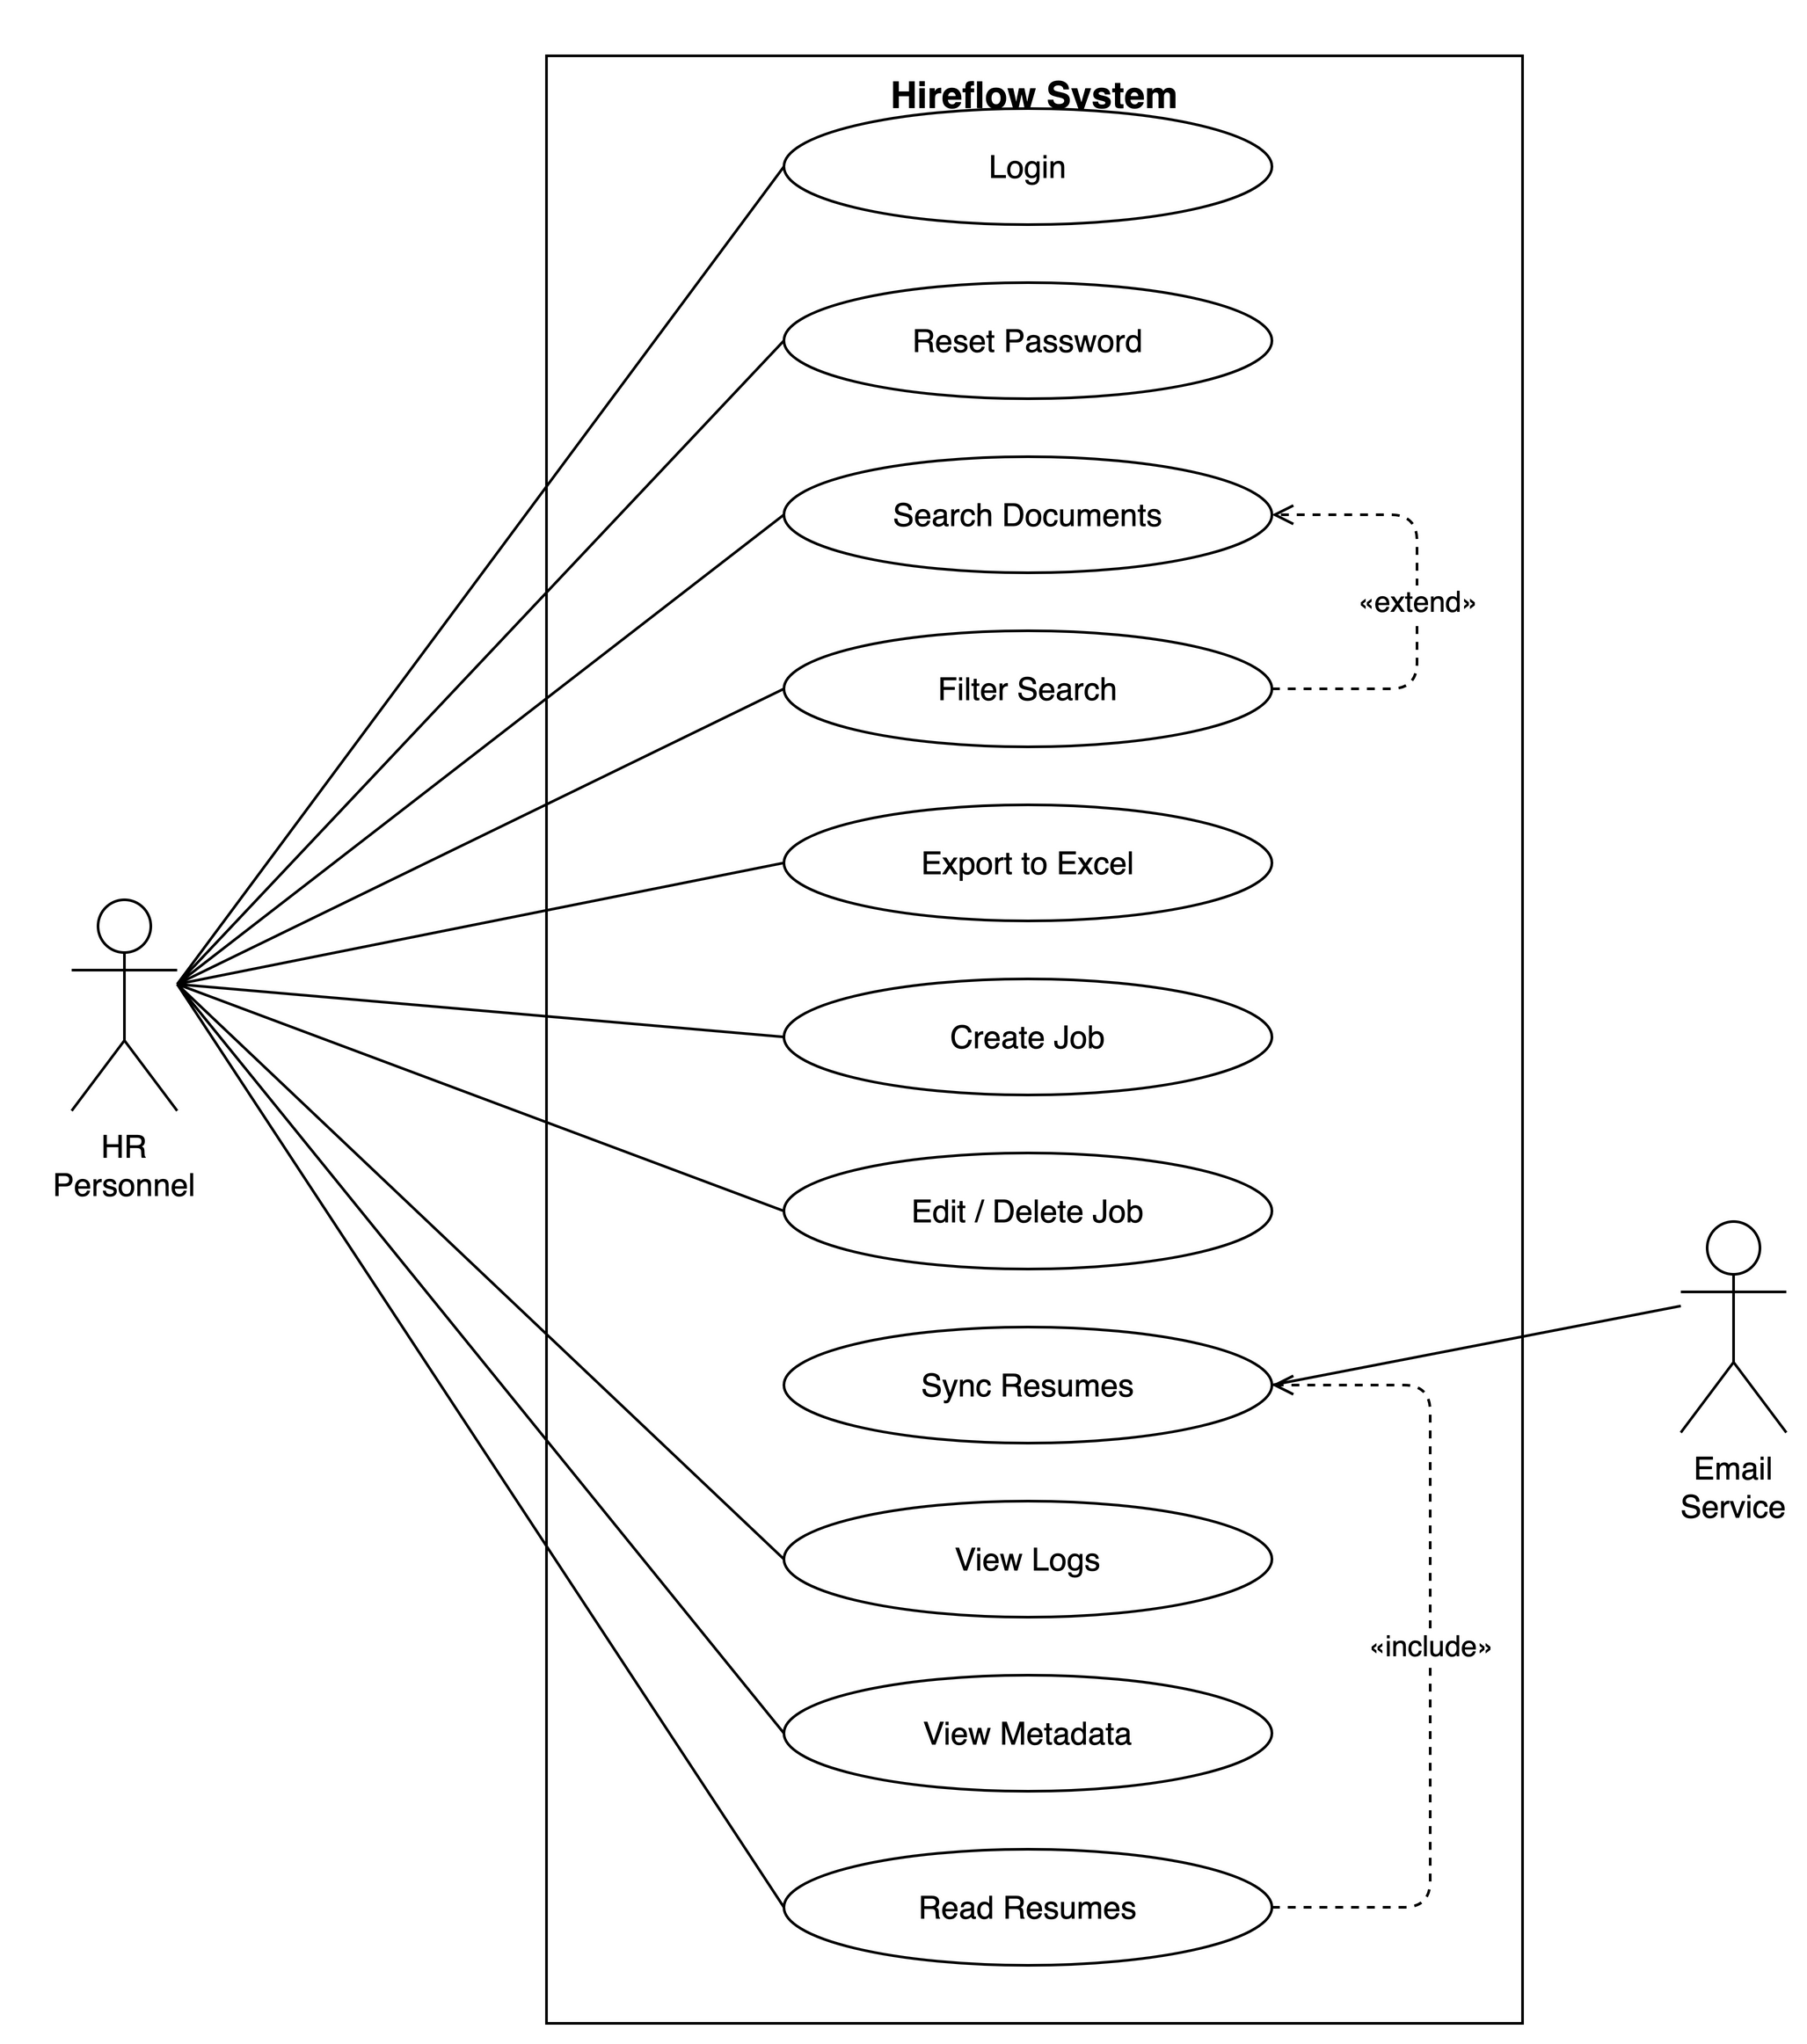
Figure 3.1: Use Case Diagram
The main use cases identified in the SRS are summarised below.
Use Case | Name | Primary Actor | Summary
UC-01 | Login | HR Personnel | Authenticate with email and password to access the system
UC-02 | Reset Password | HR Personnel | Recover access to a forgotten account via a verification mechanism
UC-03 | Search Documents | HR Personnel | Search stored documents and view ranked results
UC-04 | Filter Search | HR Personnel | Refine search results using metadata filters
UC-05 | Export to Excel | HR Personnel | Export results or shortlisted candidates to a spreadsheet
UC-06 | Create Job | HR Personnel | Create a job posting with screening criteria
UC-07 | Edit/Delete Job | HR Personnel | Update or remove an existing job posting
UC-08 | Receive Email | Email Service | Receive resumes as email attachments and store them
UC-09 | Sync Resumes | Email Service | Fetch and process resume attachments from connected accounts
UC-10 | View Logs | HR Personnel | Review system activity and audit trail
UC-11 | View Metadata | HR Personnel | View extracted document metadata such as skills and experience
UC-12 | Read Resumes | HR Personnel | Read extracted resume content and shortlist or reject candidates
Table 3.3: Summary of Use Cases (UC-01-UC-12)
User Stories. The following user stories capture representative goals from the HR user’s perspective:
- US-1 (Search): As an HR user, I want to ask questions about my documents in plain English so that I can find relevant information without remembering exact keywords or filenames.
- US-2 (Screening): As an HR user, I want the system to rank incoming resumes against a job’s required skills and experience so that I can focus on the most relevant candidates first.
- US-3 (Email Sync): As an HR user, I want resumes to be collected automatically from my connected Gmail account so that I do not have to download and upload attachments manually.
- US-4 (Auditing): As an HR user, I want to view an activity log of uploads, searches, and screening actions so that I can audit what happened and when.

3.6 Use Cases Table
To illustrate the full structure of a use case, the User Login flow (UC-01) is documented in detail below, based on the system’s actual JWT-based authentication mechanism.
Field | Description
Use Case ID | UC-01
Use Case Name | User Login
Primary Actor | Registered HR User
Goal | Authenticate with valid credentials to obtain an authorised session and access protected system features
Preconditions | 1. The system is running and reachable. 2. The user has a registered, active account.
Trigger | The user selects “Sign in” on the login page after entering their credentials.
Main Flow | 1. The user opens the login page. 2. The user enters their email and password. 3. The system verifies the account exists and is active. 4. The system verifies the password against the stored Argon2id hash using timing-safe comparison. 5. The system issues a short-lived access token (30 min) and a refresh token (7 days). 6. The system records the login in the activity log. 7. The user is redirected to the dashboard.
Alternative Flow(s) | 3a/4a. If the credentials are invalid, the system rejects the attempt and returns an authentication error without revealing whether the email or password was wrong. 2a. If the user has forgotten their password, they follow the “Forgot password?” link, invoking UC-02 (Reset Password).
Postconditions | The user holds a valid access/refresh token pair and an authenticated session; the login event is written to the audit trail.
Exceptions | Account disabled leads to access forbidden (403). A malformed or expired token on subsequent requests leads to 401 with a prompt to re-authenticate.
Related Functional Requirement(s) | FR01, FR03
Table 3.4: Sample Use Case, User Login

CHAPTER 4: SYSTEM DESIGN
This chapter turns the requirements set out earlier into a concrete technical design for Hireflow, an AI-powered HR screening and document-retrieval platform. It presents the system’s layered architecture, the flow of data through its ingestion and retrieval pipelines, the structural and behavioural UML models, the relational database schema derived from the implemented data model, and the user-interface design. Each artefact is grounded in the system as actually built. The backend is a FastAPI application organised into strict architectural layers; document processing runs asynchronously on Celery; a hybrid Retrieval-Augmented Generation (RAG) subsystem spans PostgreSQL and ChromaDB; and the frontend is a React single-page application. Taken together, these views describe how the system decomposes responsibilities, enforces access control, and answers natural-language questions with verifiable citations over an organisation’s unstructured documents.

4.1 System Architecture Description & Design
Hireflow follows a layered, service-oriented architecture that separates presentation, application coordination, domain logic, and infrastructure. The design goal is straightforward: business rules should be testable in isolation, infrastructure providers should be swappable, and long-running work should never block the request path.
At the outermost tier, a React 19 single-page application (built with TypeScript, Vite, Tailwind CSS v4 and shadcn/ui) runs in the browser and communicates exclusively through a generated, type-safe SDK. The SDK is produced from the backend’s OpenAPI specification via openapi-ts, so every request and response stays contractually aligned with the server. In production, an nginx reverse proxy serves the compiled static frontend and forwards /api/ traffic to the backend. The data stores remain on a private Docker network with no host-exposed ports.
The FastAPI API layer is the system’s HTTP boundary. Routes are deliberately thin, five lines or fewer per handler: they validate requests using Pydantic v2 schemas, invoke a service, and serialise the result. Shared concerns are handled here through dependency injection, covering authentication (CurrentUser), role gating (RequireAdmin), and a central error handler that maps domain exceptions to HTTP status codes. Routes never raise HTTPException directly. Instead, services raise typed DomainError subclasses (for example NotFound, Forbidden, FileTooLarge) that the handler translates. The public surface comprises 31 endpoints grouped by tag: authentication, documents, search, RAG, jobs, candidates, users, and activity logs.
Beneath the API sits the service layer, the application’s coordination tier. Around ten services (authentication, document, search, RAG, job, candidate, matching, activity, and others) orchestrate repositories and adapters to fulfil use cases. Services depend only on abstractions: repositories for data access and Protocol-typed adapters for infrastructure. This is what makes the system testable. A service can be instantiated in a unit test with in-memory fakes, needing neither a database nor Docker. The domain layer underneath holds pure business rules, such as authorization checks and exception definitions, and imports nothing from infrastructure.
Infrastructure is reached through the adapter layer. Each external capability is defined as a Protocol with one or more concrete implementations, which yields runtime-swappable providers: BlobStorage (MinIO, replaceable by S3 or GCS), VectorStore (ChromaDB), LlmProvider (Anthropic Claude or Ollama), EmbeddingProvider (sentence-transformers, default BAAI/bge-small-en-v1.5), VisionProvider for OCR (Claude, Ollama, or Tesseract), PasswordHasher (Argon2id), and TokenIssuer (JWT). The concrete graph is wired once in a composition root (api/deps.py), where heavyweight resources such as the embedding model and vector store are constructed as process singletons.
The supporting infrastructure comprises PostgreSQL 15 (relational data, plus a generated tsvector column powering lexical full-text search), ChromaDB (vector embeddings for semantic search), Redis 7 (Celery broker, JWT revocation denylist, and one-time password-reset tokens), MinIO (S3-compatible object storage for uploaded files), and the configured LLM provider (Claude) for answer generation and classification fallback.
Two pipelines dominate the system’s behaviour. The ingestion pipeline runs asynchronously in a Celery worker. An upload returns HTTP 201 immediately with status=PENDING; the worker then fetches the blob from MinIO, extracts layout-aware typed elements (via the unstructured library, PyMuPDF, and Tesseract OCR for scanned images), classifies the document, and chunks it with heading- and table-aware rules. Each chunk is contextualised, embedded, and upserted into ChromaDB, while PostgreSQL’s search vector auto-populates. On completion the document reaches status=READY, at which point an on-ready hook can auto-create a candidate from a resume. The RAG pipeline runs inline per request. It retrieves the most relevant chunks (owner-scoped, READY-only), classifies the question’s intent, composes a layered system prompt, and streams the answer from Claude with typed citations. Both pipelines and their interactions are depicted in Figure 4.1.
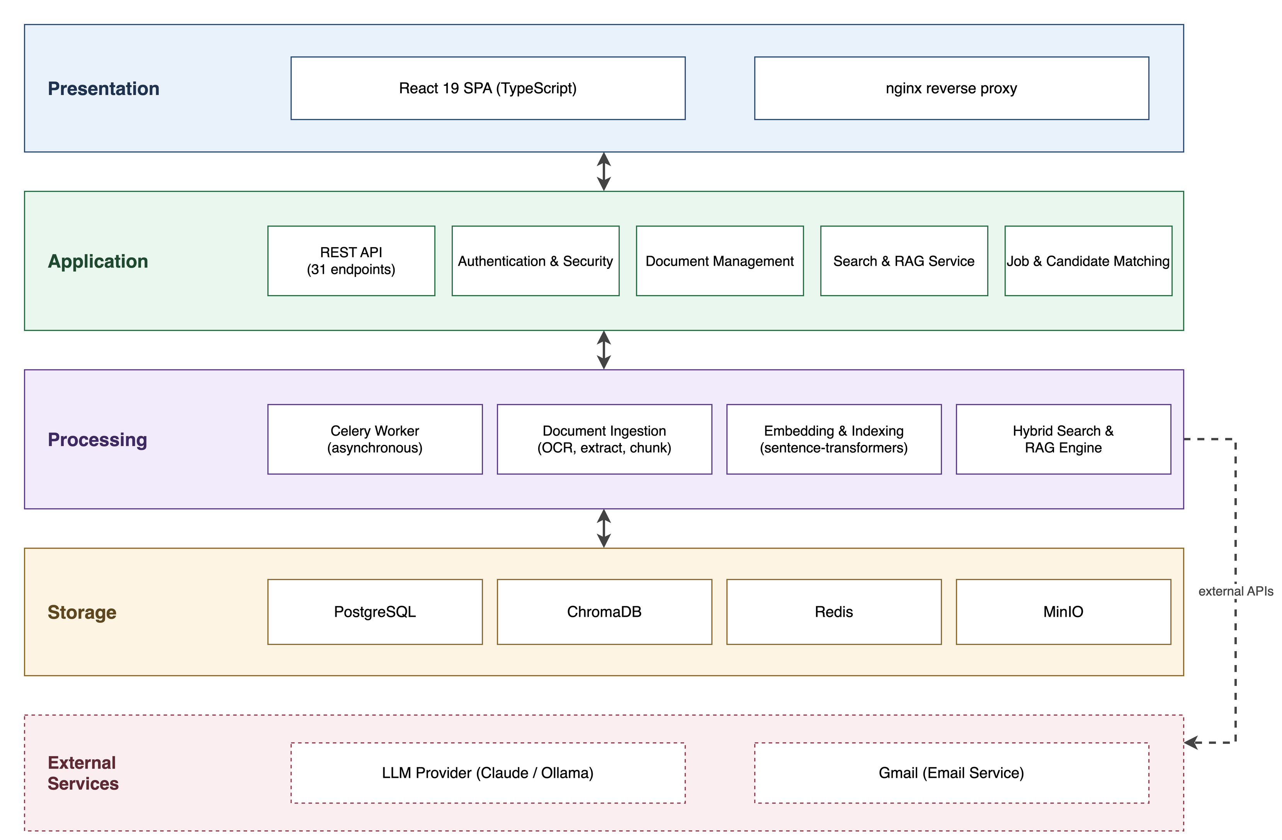
Figure 4.1: System Architecture

4.2 Data Flow Diagrams
Data Flow Diagrams (DFDs) model the system as a network of processes that transform data, the external entities that supply and consume it, and the data stores that persist it. They are presented in progressively decomposed levels. Level 0, the context diagram, treats the entire system as a single process to fix its boundary and external interactions. Level 1 decomposes that process into the major functional subsystems. Level 2 then expands a chosen subsystem into its constituent steps.
The Level 0 (context) diagram situates Hireflow as one process bounded by its external actors. The primary external entity is the HR user (and the privileged Administrator), who uploads documents, issues search and natural-language queries, manages jobs and candidates, and receives ranked results and cited answers. Two further external entities appear: the Gmail service, from which candidate emails and attachments are synced, and the LLM provider (Anthropic Claude), which receives composed prompts and returns generated answers. This level establishes what crosses the system boundary without revealing internal structure, as shown in Figure 4.2.
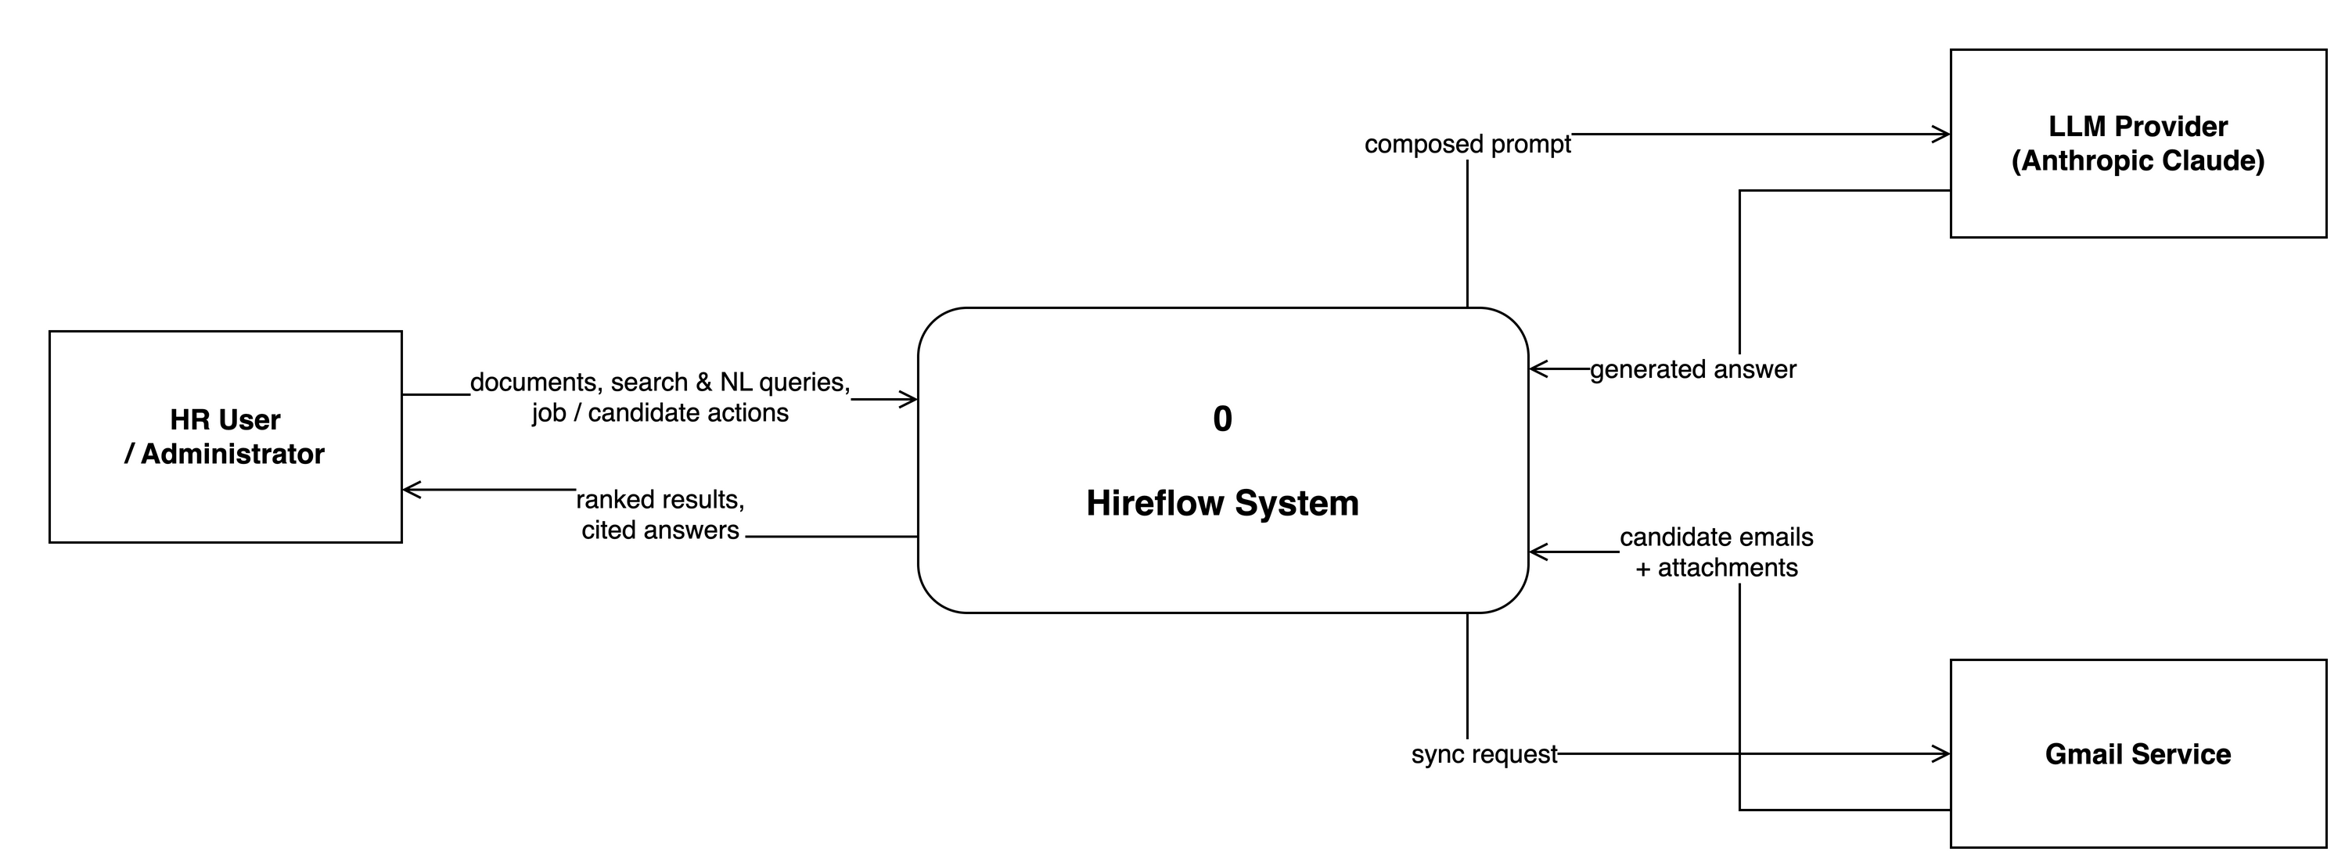
Figure 4.2: DFD Level 0 (Context Diagram)
The Level 1 diagram decomposes the single context process into the system’s principal subsystems and the data stores between them: authentication and session management; document ingestion and storage; the hybrid search and RAG engine; job and candidate management with resume-to-job matching; Gmail synchronisation; and activity logging. It shows how an uploaded file flows from the API into object storage and the asynchronous processing pipeline, how extracted text and metadata land in the relational and vector stores, and how a query fans out across those stores before results are fused and returned. The major data stores are made explicit here: Users, Documents, Candidates, Jobs, Applications, the vector collection, and the activity log (Figure 4.3).
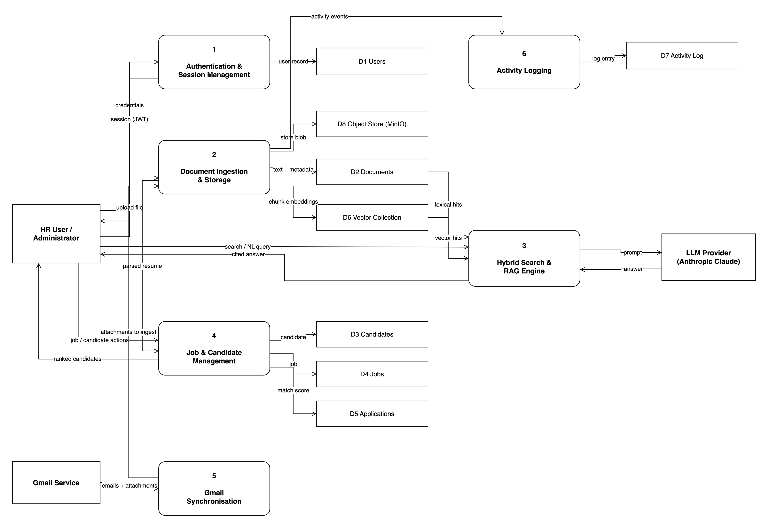
Figure 4.3: DFD Level 1
The Level 2 diagram drills into the document-processing and retrieval subsystem, the most data-intensive part of the platform. It expands the ingestion sequence (extract → persist elements → classify → chunk → contextualise → embed → index) and the query sequence (parse and normalise query → vector search → lexical full-text search → metadata filter → fuzzy fallback → reciprocal-rank fusion → answer generation). This exposes how chunks, embeddings, and ranked hits move between the worker, PostgreSQL, ChromaDB, and the LLM provider (Figure 4.4).
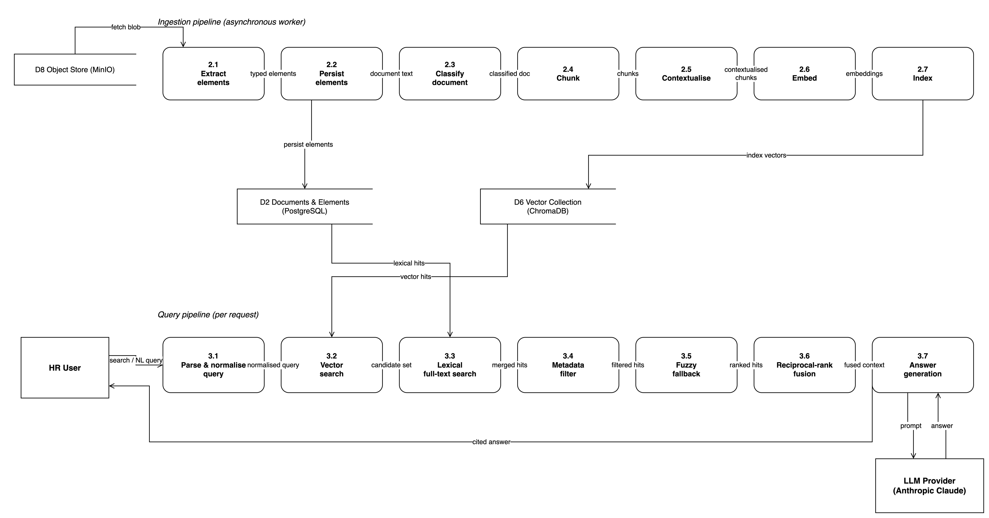
Figure 4.4: DFD Level 2

4.3 UML Diagrams
The Unified Modeling Language (UML) captures the system’s static structure and dynamic behaviour. This section presents a class diagram and an activity diagram as figures, and describes the component and sequence perspectives in prose.
Class diagram. The class diagram models the core domain entities and their relationships as realised by the SQLAlchemy ORM. A User owns many Document, Job, and Candidate records, each aggregate carrying an owner_id foreign key with cascade-on-delete. A Candidate is derived from a source Document and may accumulate several CandidateAttachment records, each tagging a document with the role it plays (resume, certificate, portfolio, transcript, cover letter). A Candidate links to a Job through an Application, which carries the computed match score and a status progressing through new → shortlisted → interviewed → rejected → hired. A Document decomposes into ordered DocumentElement rows, the typed regions produced by layout-aware extraction, and Gmail integration is modelled by GmailConnection and its GmailIngestedMessage dedup ledger. All entities inherit a UUID primary key and created/updated timestamps from shared mixins. The class structure is shown in Figure 4.5.
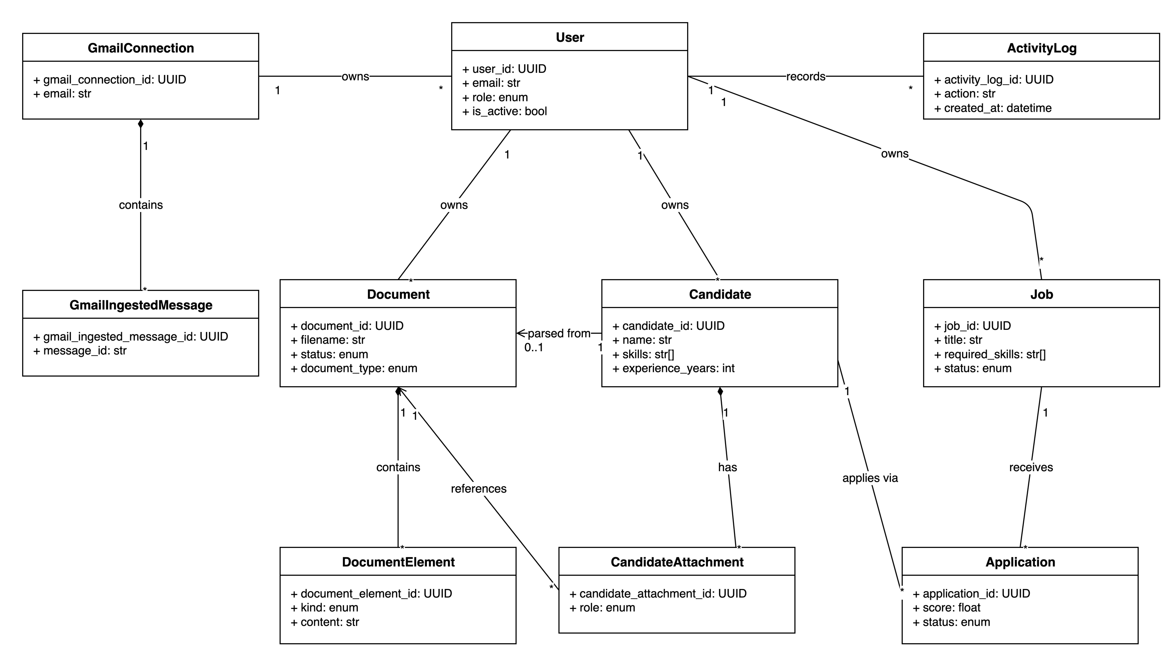
Figure 4.5: Class Diagram
Activity diagram. The activity diagram traces a document’s end-to-end flow, from upload through to a query-able, candidate-generating READY state. It captures the fork at upload (the synchronous 201 response versus the asynchronous Celery branch), the sequential processing activities in the worker, and the decision node where classification chooses between the rule-based path and the LLM fallback. It also shows the non-fatal handling of indexing failure, where the document still reaches READY, and the terminal on-ready hook that creates a candidate when the document is a resume. This behavioural view is presented in Figure 4.6.
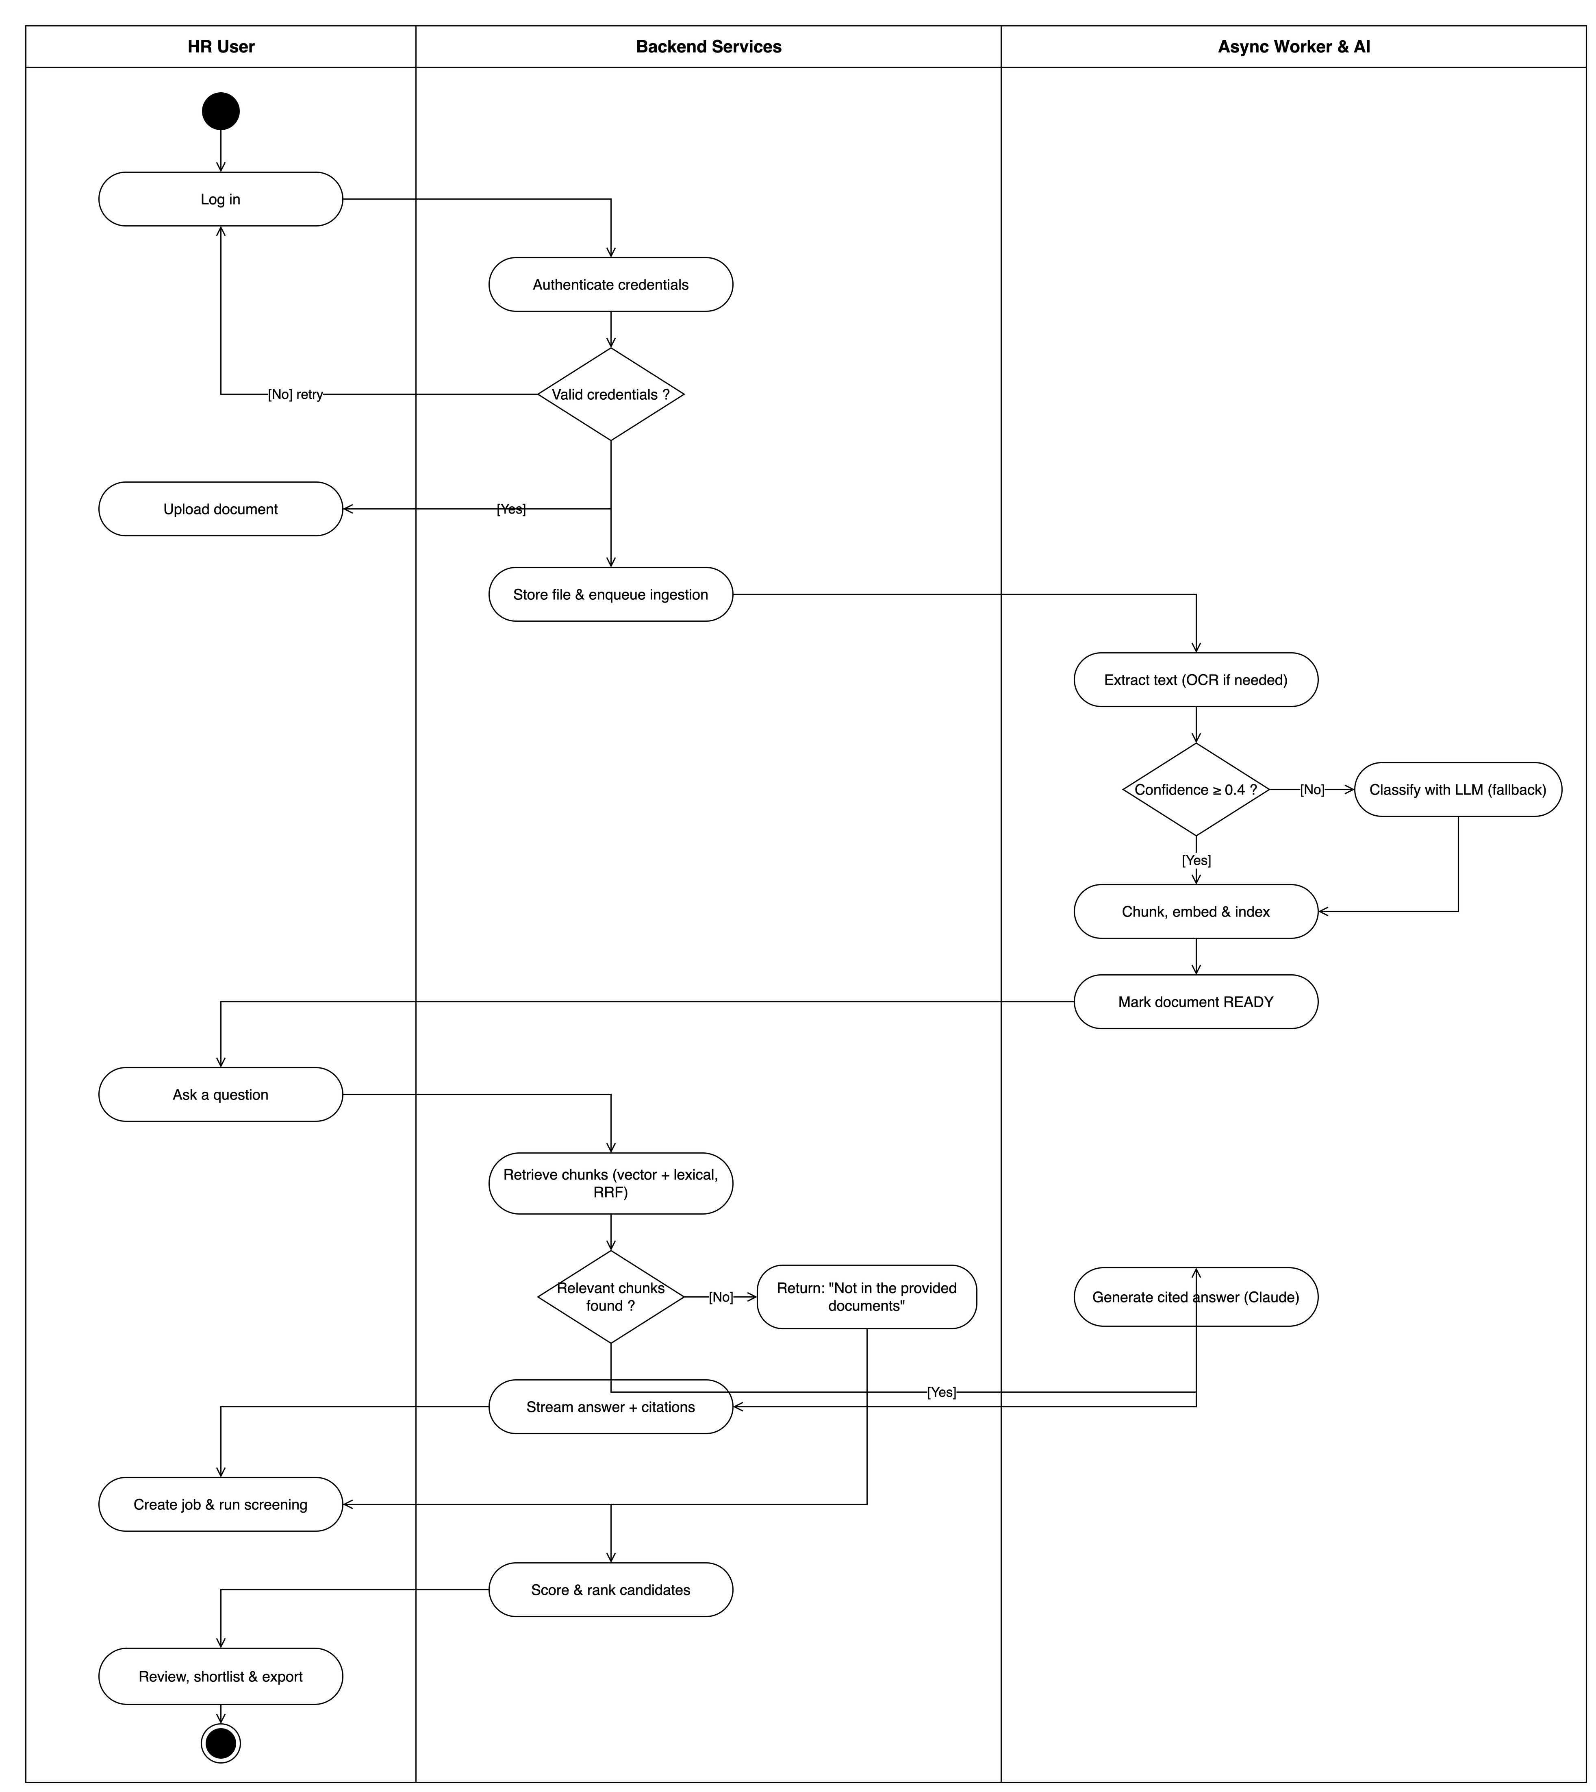
Figure 4.6: Activity Diagram
Component diagram. The component view organises the system into deployable, logically cohesive units and their interface dependencies. The React SPA depends on the FastAPI application through the generated OpenAPI SDK. The FastAPI application aggregates the API-route components, which depend on service components, which in turn depend on repository and adapter components exposed as Protocol interfaces. Each adapter (BlobStorage, VectorStore, LlmProvider, EmbeddingProvider, VisionProvider, DocumentClassifier) is a replaceable component bound at the composition root. Infrastructure components such as PostgreSQL, ChromaDB, Redis, MinIO, and the external Claude API are reached only through those adapter interfaces. The Celery worker is a separate runtime component that shares the service and adapter layers with the API but exposes no HTTP surface.
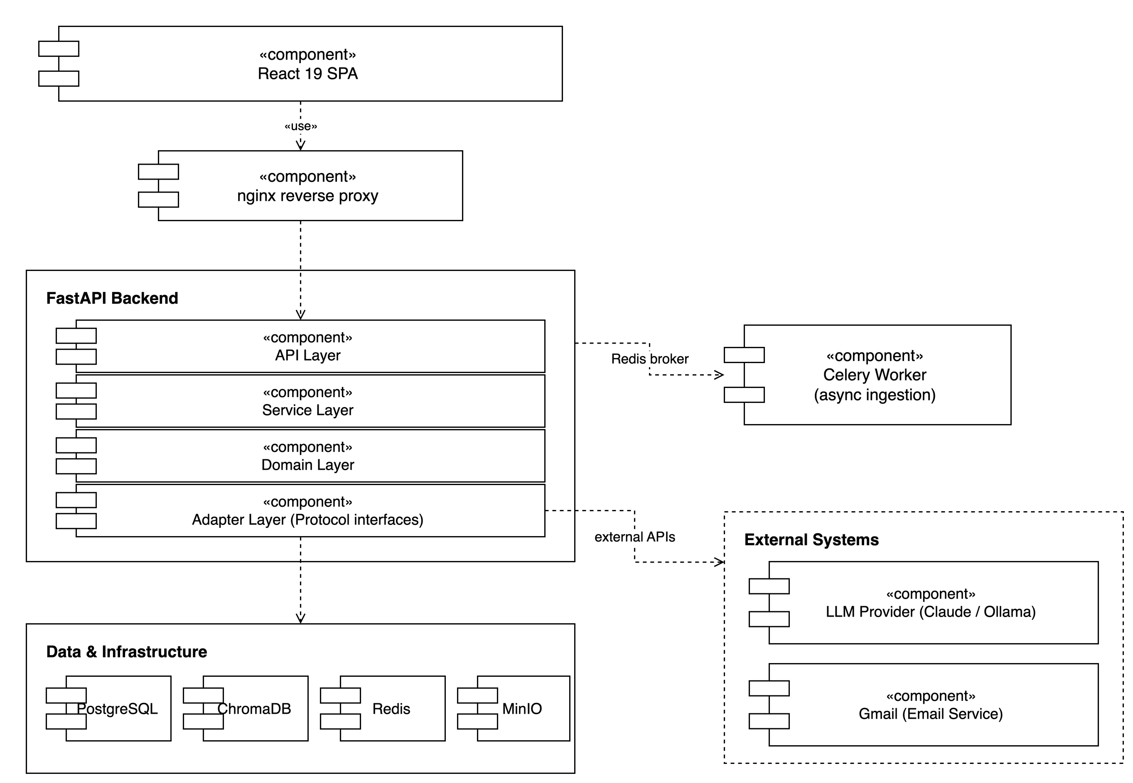
Figure 4.7: Component Diagram
Sequence diagram. The sequence view models the ordered message exchange for the streaming RAG query use case. The browser sends POST /rag/stream; the route resolves the current user and invokes RagService.stream_query; the service calls SearchService.retrieve_chunks, which queries ChromaDB (vector), PostgreSQL (lexical FTS and fuzzy fallback), and fuses the results via reciprocal-rank fusion. The service then applies the context gate, invokes the intent classifier, composes the layered prompt, and streams tokens from the Claude adapter. Messages return to the client as Server-Sent Events in the order citations → delta × N → done (or an error event on failure). A second representative sequence is the candidate-matching interaction (POST /jobs/{id}/match), where the matching service scores each candidate on skill overlap, experience fit, and vector similarity, then upserts Application records.
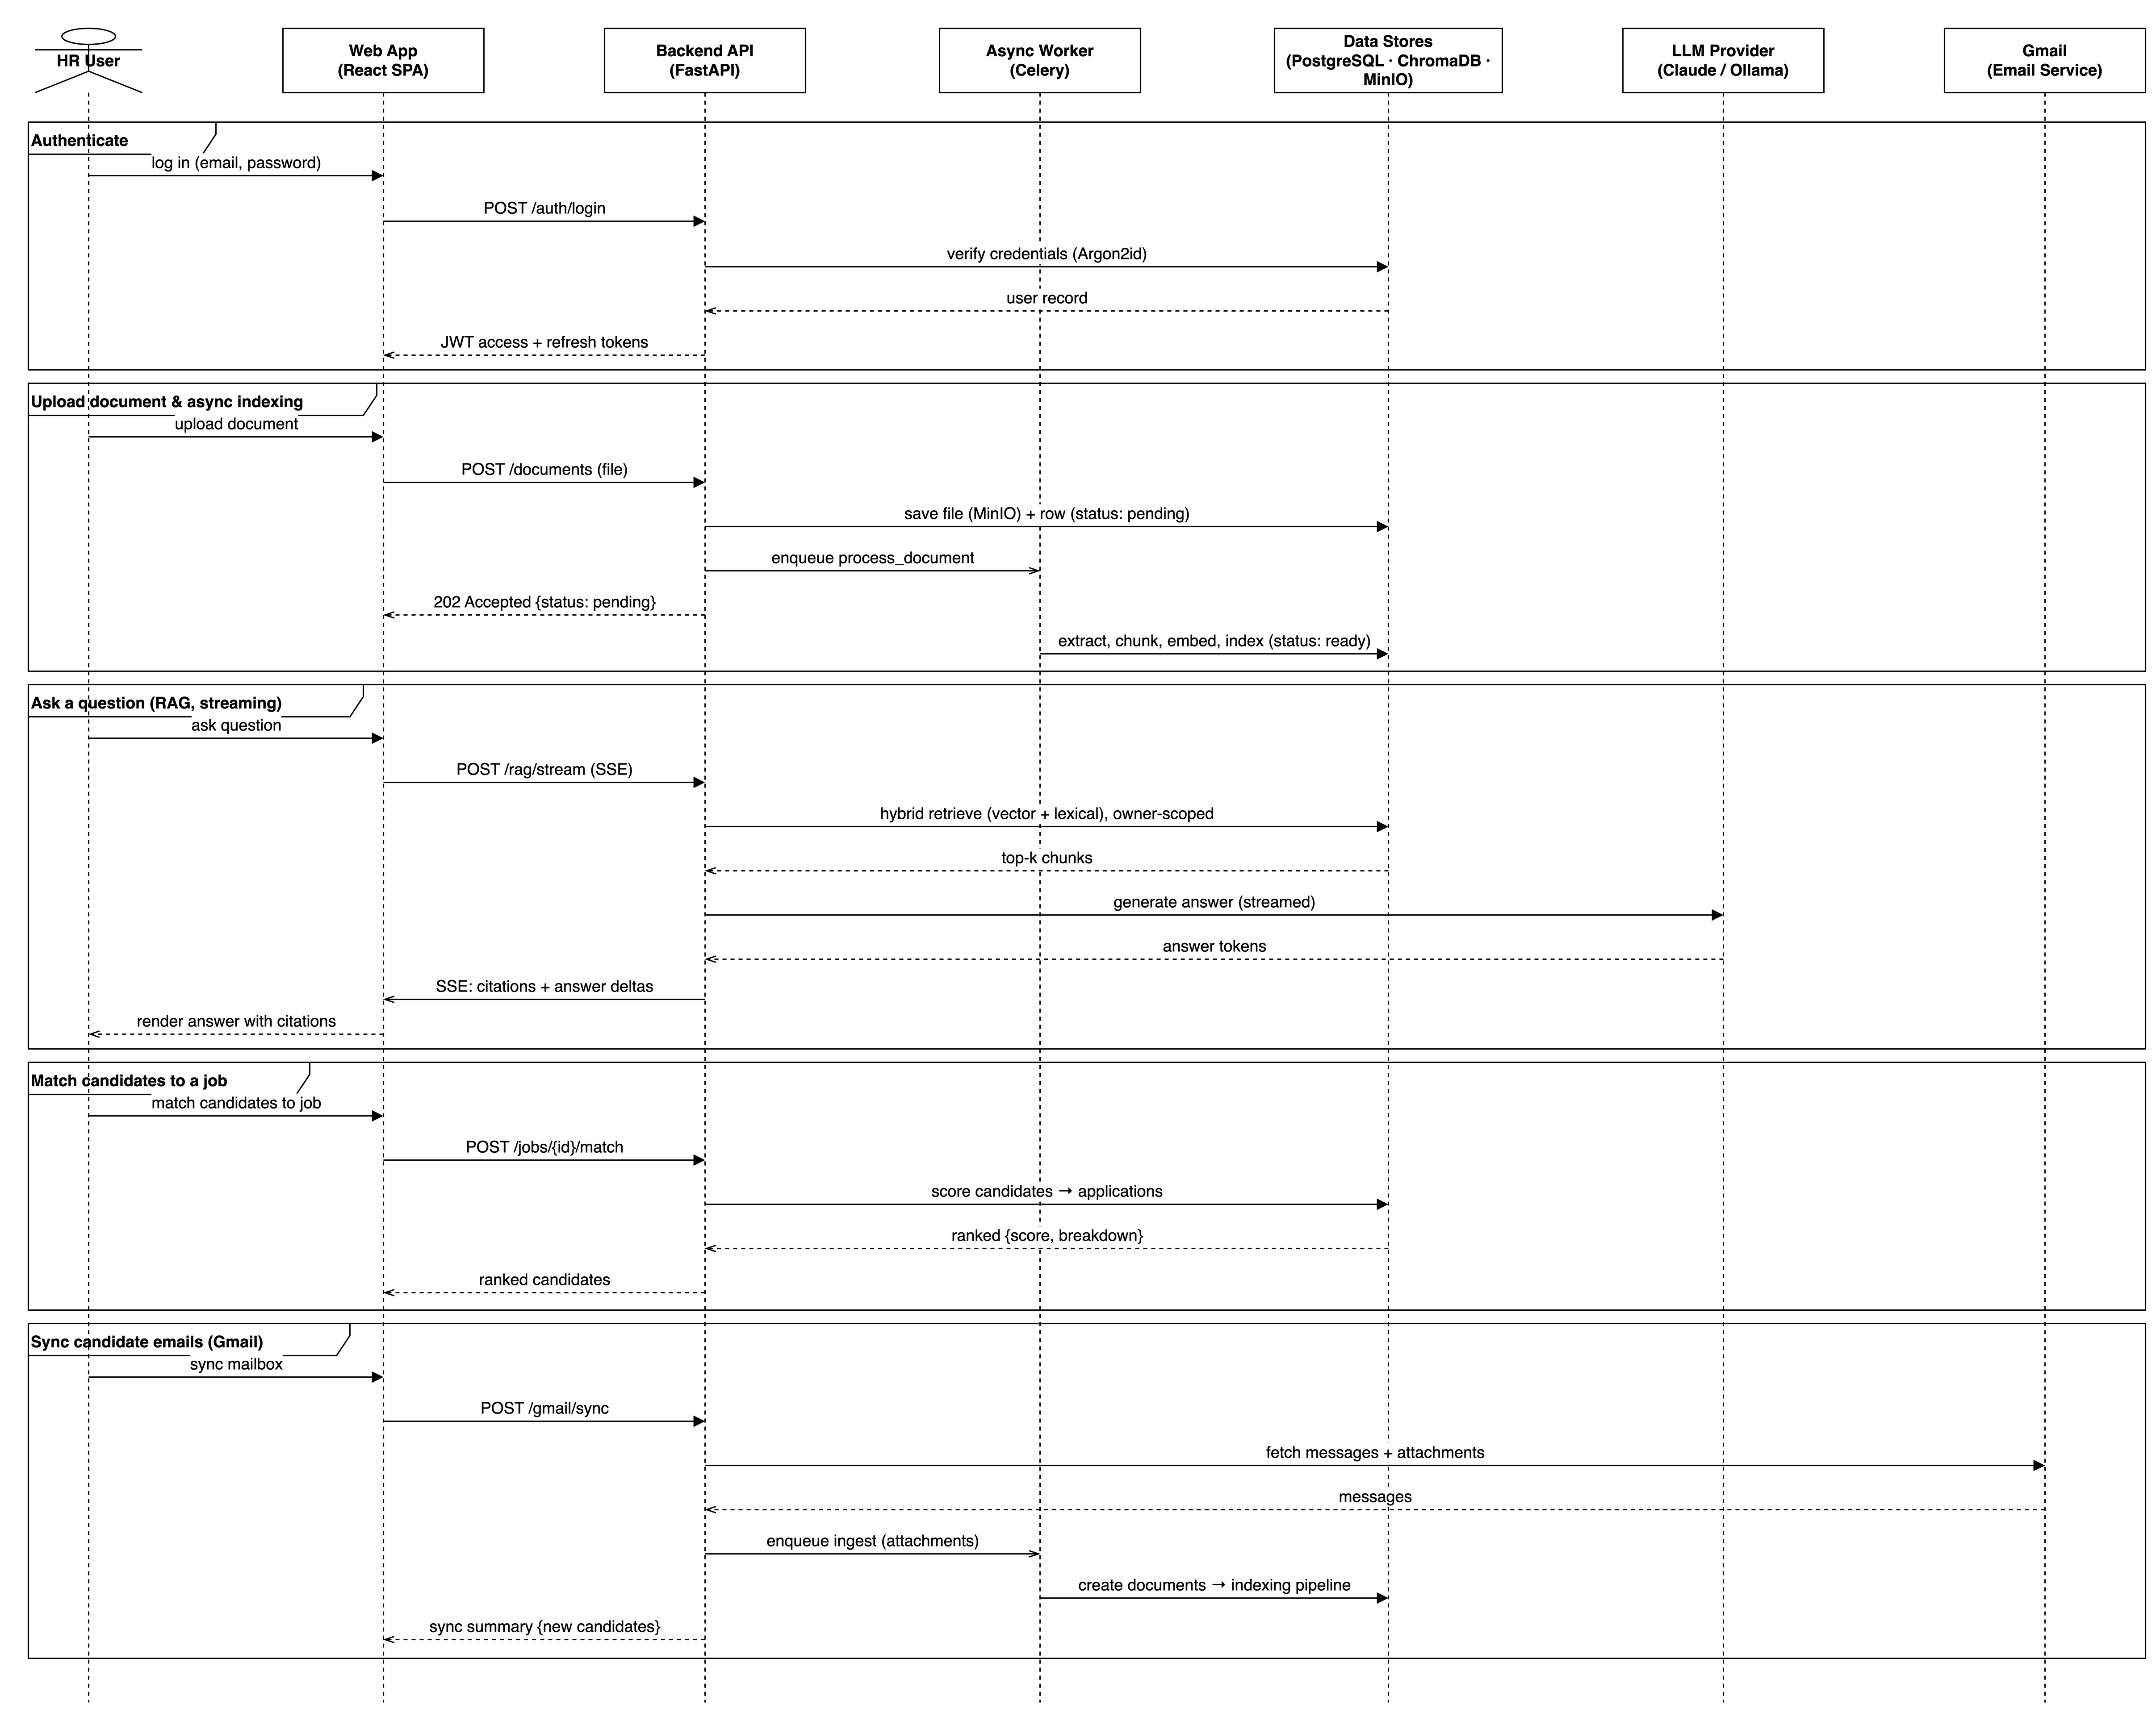
Figure 4.8: Sequence Diagram (Streaming RAG Query)

4.4 Database Design (ERD, Schema, Data Dictionary)
The persistent state of Hireflow lives in a PostgreSQL 15 relational schema, complemented by a ChromaDB vector store for embeddings. This section describes the entity relationships, provides a schema overview, and documents the core tables as data dictionaries. The relational design derives directly from the implemented SQLAlchemy models.
ERD description. The schema is anchored on the users table, the ownership root for the multi-tenant, per-user data model. A user owns many documents, jobs, and candidates; each of those tables carries a user_id foreign key referencing users.user_id with ON DELETE CASCADE. A document owns many document_elements, its typed extracted regions, via a cascade relationship. A candidate is optionally derived from one source document (document_id, unique, ON DELETE SET NULL). The schema deliberately models a mutual foreign-key link: a document may point back to its authoring candidate (candidate_id, ON DELETE SET NULL), reflecting the real graph in which a candidate references the resume it was parsed from while resumes and other authored documents reference the candidate. Candidates and jobs form a many-to-many relationship resolved through the applications associative entity, which carries the match score, a persisted score breakdown, and application status. A candidate_attachments join table bundles multiple role-tagged documents onto a candidate. Gmail integration adds gmail_connections (one per user-mailbox pair) and gmail_ingested_messages (a per-message dedup ledger, cascading from the connection). Finally, activity_logs records an audit trail, referencing the acting user with ON DELETE SET NULL so history survives account deletion.
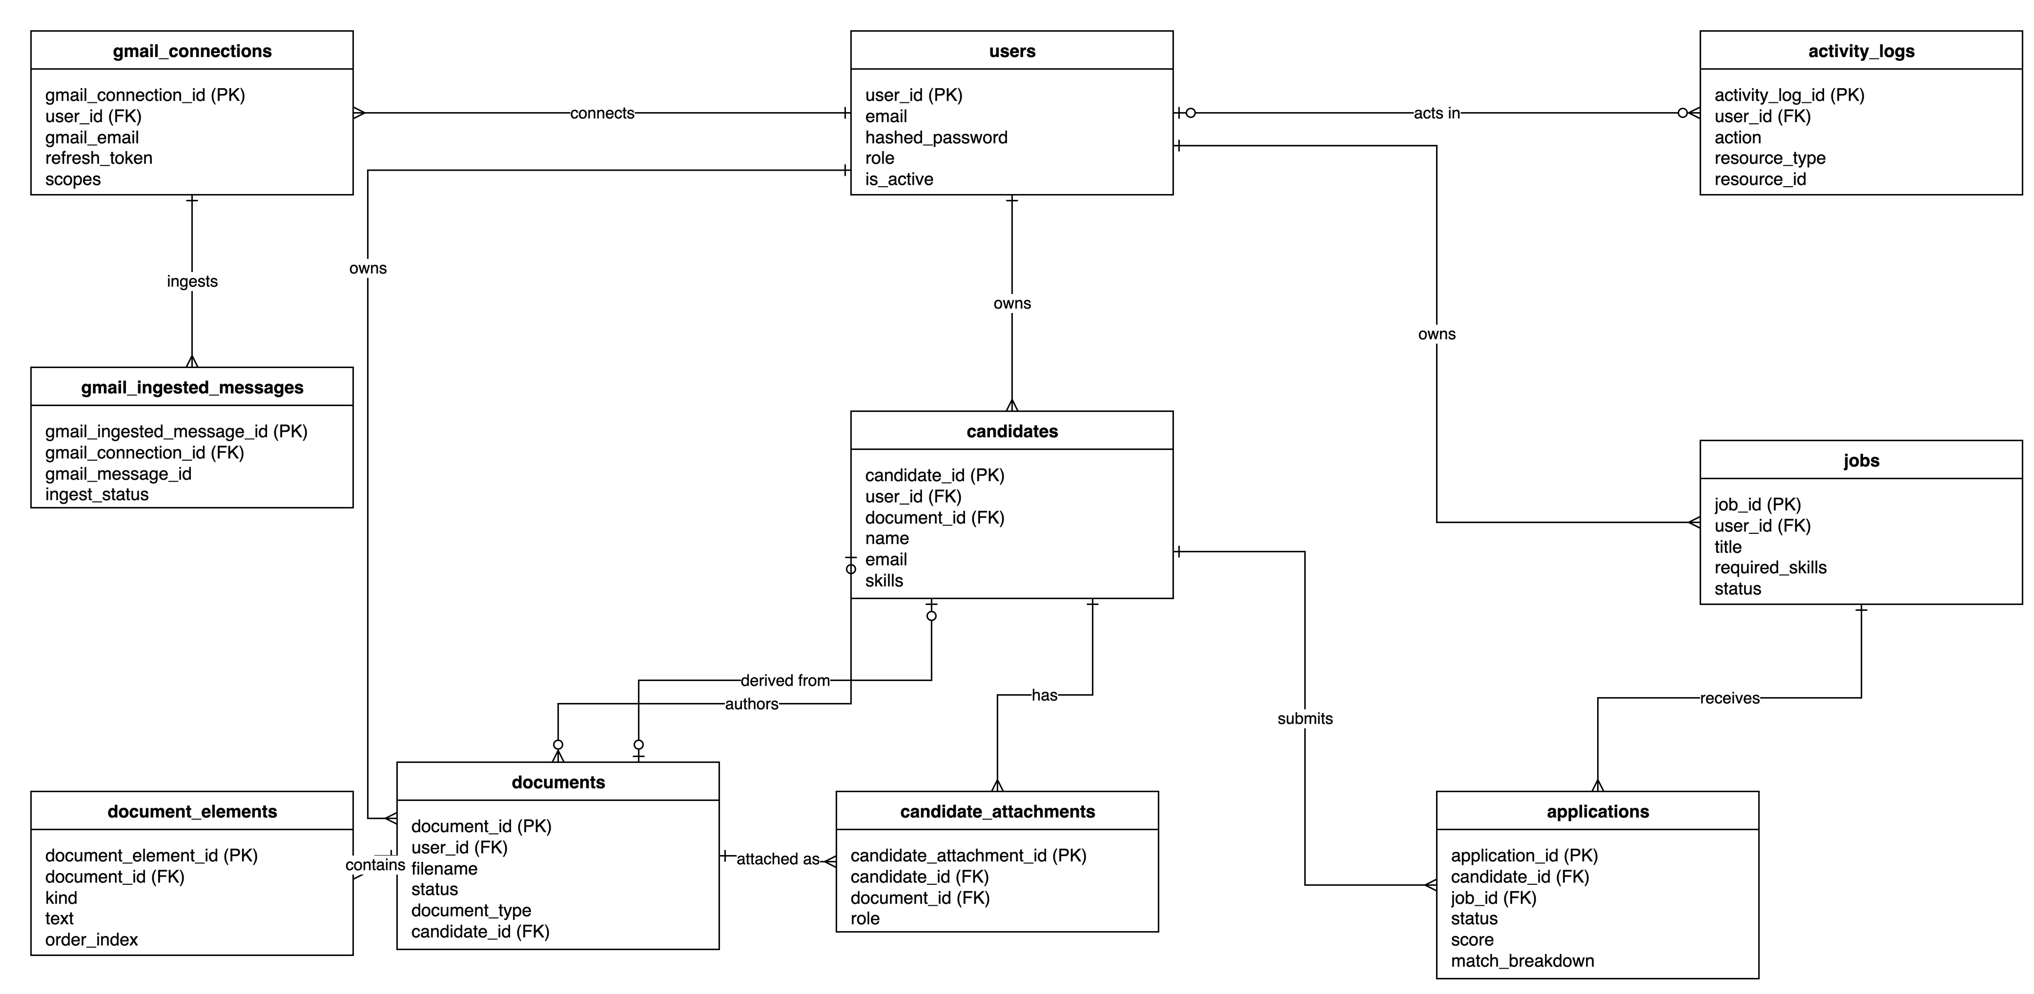
Figure 4.9: Entity-Relationship Diagram
Schema overview. Every table has a UUID primary key named after the table (for example user_id, document_id) and created_at / updated_at timestamp columns from shared mixins. PostgreSQL-native features are used throughout: enumerated types (user_role, document_status, document_type, job_status, application_status, attachment_role, and others), array columns (required_skills, skills, education, scopes), a JSONB metadata column on documents, and a database-generated, weighted tsvector column (search_tsv) that indexes filename (weight A), skills (weight B), and body text (weight C) for lexical retrieval via a GIN index. Sensitive fields such as full_name, phone, and Gmail refresh_token are stored using an encrypted column type. The four core tables are documented below.
Field | Type | Constraints | Description
user_id | UUID | PK | Unique identifier
email | VARCHAR(320) | UNIQUE, NOT NULL, INDEX | Login email address
hashed_password | VARCHAR(255) | NOT NULL | Argon2id password hash
full_name | Encrypted string | NULLABLE | User’s display name (encrypted at rest)
role | ENUM(hr, admin) | NOT NULL, DEFAULT hr | Authorisation role
is_active | BOOLEAN | NOT NULL, DEFAULT true | Whether the account is enabled
created_at | TIMESTAMPTZ | NOT NULL, DEFAULT now() | Creation timestamp
updated_at | TIMESTAMPTZ | NOT NULL, DEFAULT now() | Last-modified timestamp
Table 4.1: users Data Dictionary
Field | Type | Constraints | Description
document_id | UUID | PK | Unique identifier
user_id | UUID | FK → users.user_id, ON DELETE CASCADE, NOT NULL, INDEX | Owning HR user
filename | VARCHAR(512) | NOT NULL | Original uploaded file name
mime_type | VARCHAR(128) | NOT NULL | Detected MIME type
size_bytes | BIGINT | NOT NULL | File size in bytes
storage_key | VARCHAR(1024) | UNIQUE, NOT NULL | MinIO object key
status | ENUM(pending, processing, ready, failed) | NOT NULL, DEFAULT pending, INDEX | Processing lifecycle state
document_type | ENUM(resume, report, contract, letter, other) | NULLABLE | Classified document type
extracted_text | TEXT | NULLABLE | Full extracted body text
metadata | JSONB | NULLABLE | Extracted metadata (skills, experience, etc.)
extraction_version | VARCHAR(32) | NULLABLE | Extractor version stamp for re-indexing
chunking_version | VARCHAR(32) | NULLABLE | Chunking-rules version stamp
embedding_model_version | VARCHAR(128) | NULLABLE | Embedding model used at last index
candidate_id | UUID | FK → candidates.candidate_id, ON DELETE SET NULL, NULLABLE, INDEX | Linked authoring candidate
search_tsv | TSVECTOR | GENERATED, GIN INDEX | Weighted full-text search vector
created_at / updated_at | TIMESTAMPTZ | NOT NULL | Audit timestamps
Table 4.2: documents Data Dictionary
Field | Type | Constraints | Description
job_id | UUID | PK | Unique identifier
user_id | UUID | FK → users.user_id, ON DELETE CASCADE, NOT NULL, INDEX | Owning HR user
title | VARCHAR(255) | NOT NULL | Job title
description | TEXT | NOT NULL | Full job description
required_skills | VARCHAR[] | NOT NULL, DEFAULT {} | Mandatory skills
preferred_skills | VARCHAR[] | NULLABLE | Desirable skills
education_level | VARCHAR(100) | NULLABLE | Minimum education requirement
experience_min | INTEGER | NOT NULL, DEFAULT 0 | Minimum years of experience
experience_max | INTEGER | NULLABLE | Maximum years of experience
location | VARCHAR(255) | NULLABLE | Job location
status | ENUM(draft, open, closed, archived) | NOT NULL, DEFAULT draft, INDEX | Job posting state
created_at / updated_at | TIMESTAMPTZ | NOT NULL | Audit timestamps
Table 4.3: jobs Data Dictionary
Field | Type | Constraints | Description
candidate_id | UUID | PK | Unique identifier
user_id | UUID | FK → users.user_id, ON DELETE CASCADE, NOT NULL, INDEX | Owning HR user
document_id | UUID | FK → documents.document_id, ON DELETE SET NULL, UNIQUE, NULLABLE, INDEX | Resume the candidate was parsed from
name | VARCHAR(255) | NULLABLE | Candidate name
email | VARCHAR(320) | NULLABLE, partial UNIQUE per owner | Candidate email
phone | Encrypted string | NULLABLE | Candidate phone (encrypted at rest)
skills | VARCHAR[] | NOT NULL, DEFAULT {} | Extracted skills
experience_years | INTEGER | NULLABLE | Total years of experience
education | VARCHAR[] | NULLABLE | Education history entries
supplementary_keywords | VARCHAR[] | NULLABLE | Keywords from non-resume attachments
summary | VARCHAR(1024) | NULLABLE | One-sentence recruiter brief
created_at / updated_at | TIMESTAMPTZ | NOT NULL | Audit timestamps
Table 4.4: candidates Data Dictionary
Alongside the relational schema, ChromaDB holds one collection per embedding model (named documents_<model_slug>). Each stored chunk is keyed as <document_id>:<chunk_index> and carries its embedding vector, the chunk text, and metadata (document_id, user_id, chunk_index, chunk_kind, section_heading, page_number, chunking_version, plus flattened document-level fields such as filename and document_type). This denormalised metadata enables owner-scoped, type-filtered vector retrieval without a round-trip to PostgreSQL.

4.5 UI/UX Design
The user interface is a React 19 single-page application written in TypeScript and built with Vite. Its design philosophy is a clean, professional, information-dense workspace suited to HR personnel who work with large document sets and need results at a glance. The visual layer is built on Tailwind CSS v4 utility classes composed into accessible shadcn/ui primitives (backed by Base UI), which gives a consistent component vocabulary across every screen: cards, dialogs, tables, badges, tooltips, and scroll areas. The application supports light and dark theming. All data-bearing components consume the auto-generated, type-safe API SDK through TanStack Query, so loading, empty, and error states are handled uniformly and no screen relies on mock data.
Navigation is organised around the primary HR workflows, each a dedicated page wired to the real API: a Dashboard overview, Documents management (upload, list, in-app preview, metadata, and delete), Search (combining hybrid keyword/semantic search with a streaming RAG chat), Jobs (create, edit, and match candidates), Candidates (a screening list with match scores), Logs (the activity audit trail), and Settings (profile and password). Authentication is handled transparently. An AuthProvider hydrates the current user on mount, and a client interceptor attaches the bearer token and silently refreshes it on expiry via a single-flight retry, so the user is never spuriously logged out mid-task.
Two screens embody the system’s differentiating design work. The Documents page provides drag-and-drop upload with real-time status badges reflecting the asynchronous pipeline (pending → processing → ready), giving users immediate feedback while indexing happens out-of-band. The Search page implements a conversational layout: the input is pinned to the bottom of the card, messages scroll within a fixed viewport, and assistant answers render as GitHub-flavoured Markdown (tables, lists, and emphasis) with a typing indicator and blinking cursor during streaming. Most importantly, inline citation chips are parsed from the answer text and matched against source documents. Hovering a chip reveals the filename, section heading, and snippet; clicking it scrolls the corresponding source card into view with a highlight flash, making every generated claim traceable to its evidence. Representative screens are shown in Figures 4.10 through 4.14.
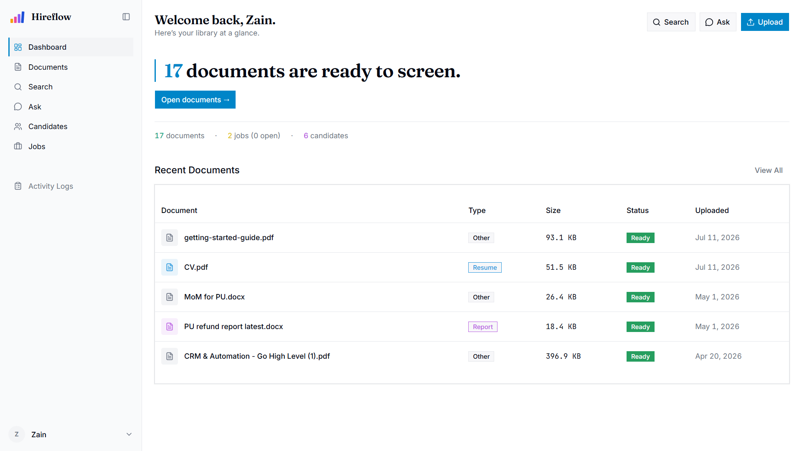
Figure 4.10: Dashboard overview
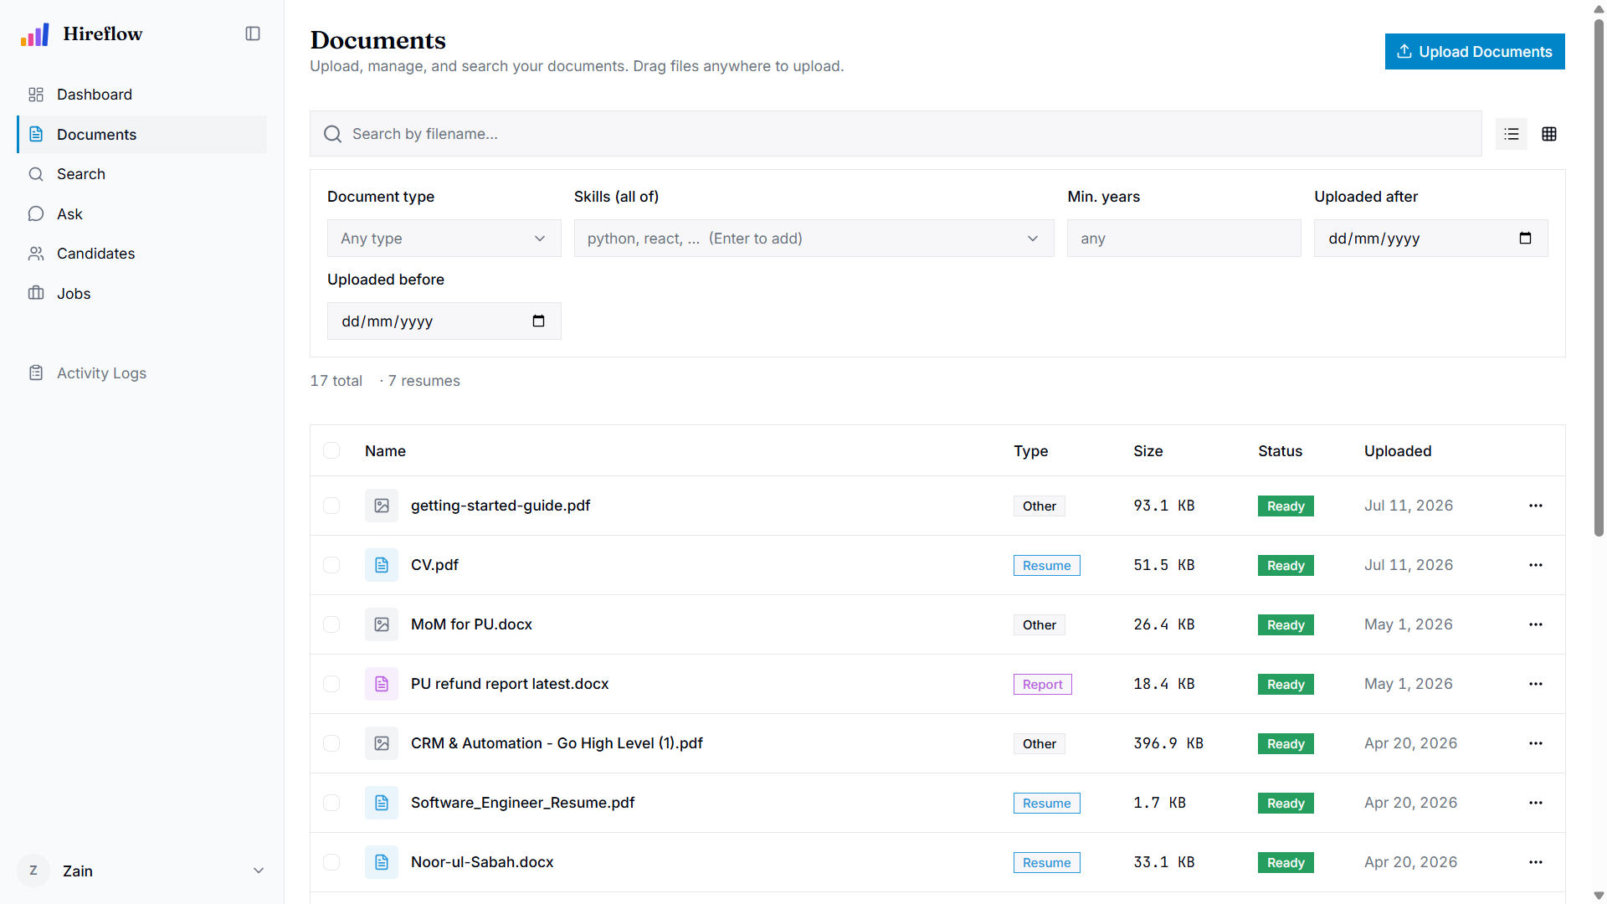
Figure 4.11: Documents management with upload and processing status
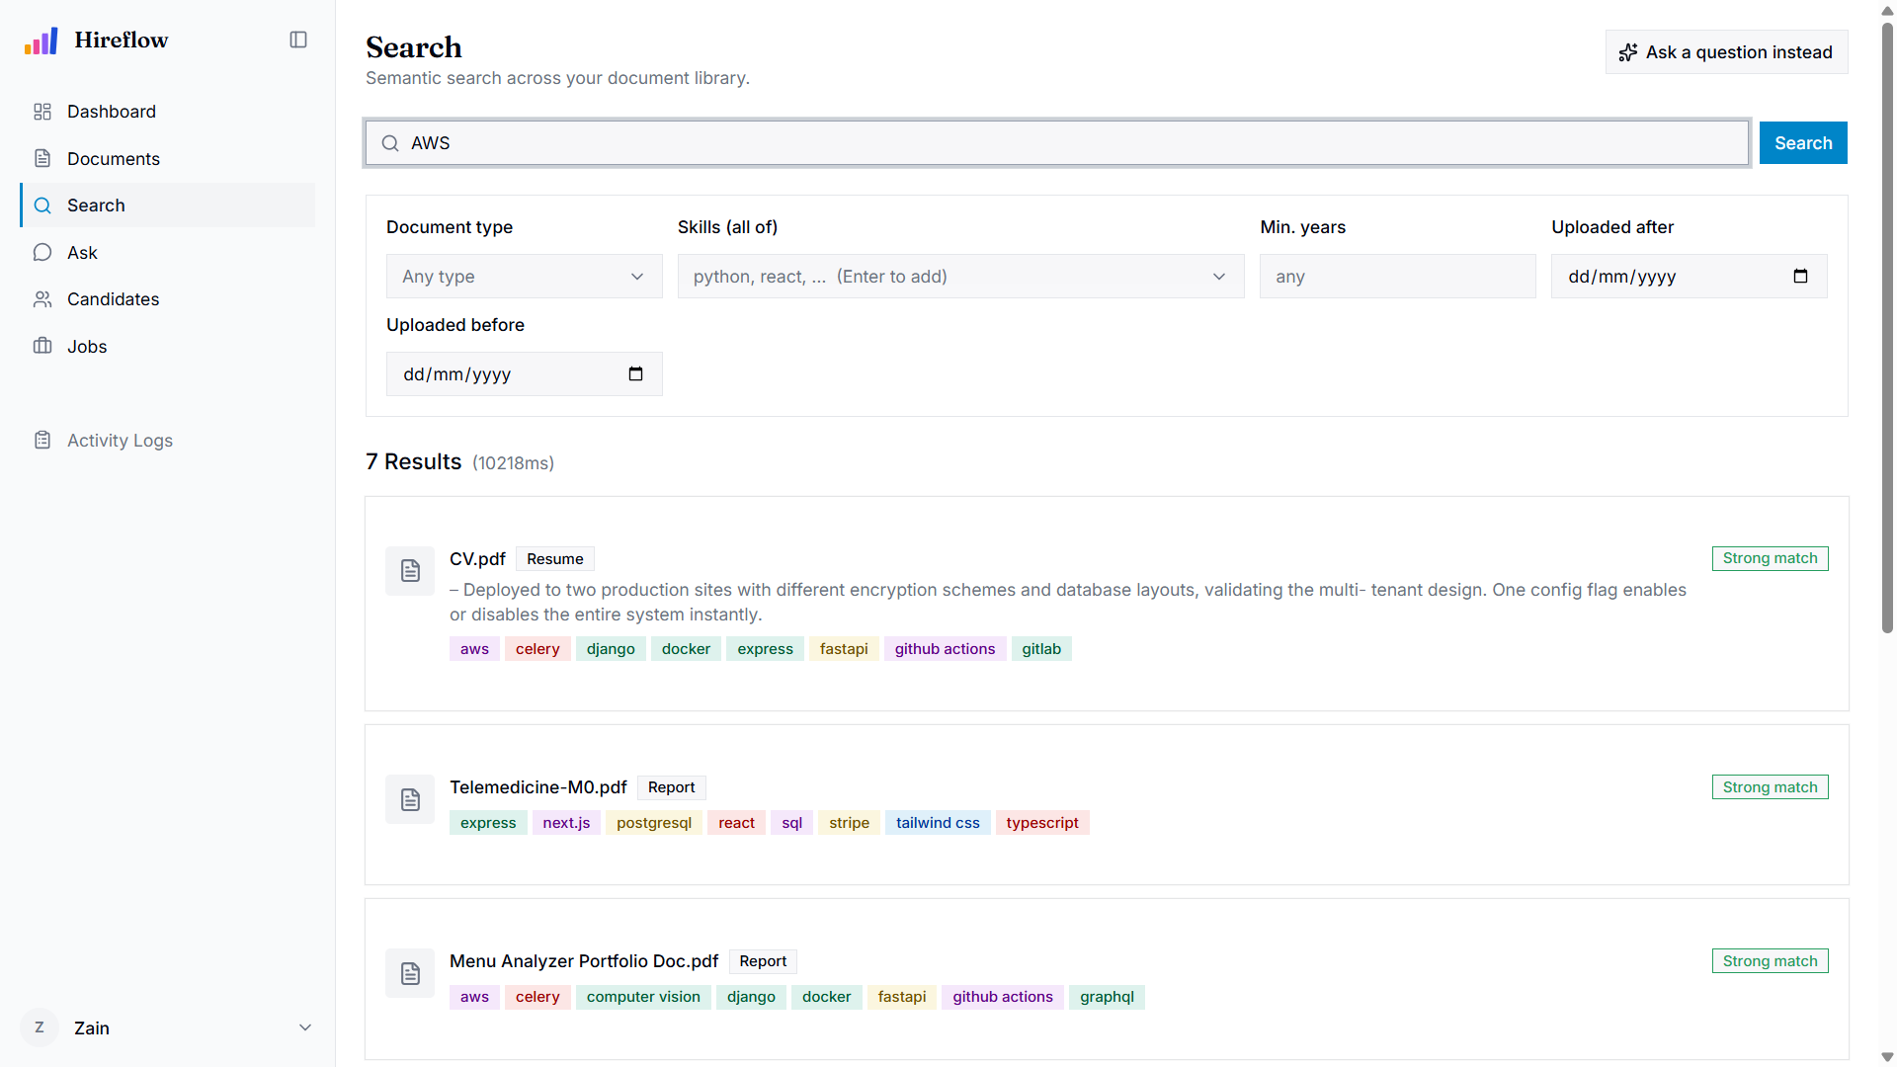
Figure 4.12: Semantic search across the document library with match scores and skill filters
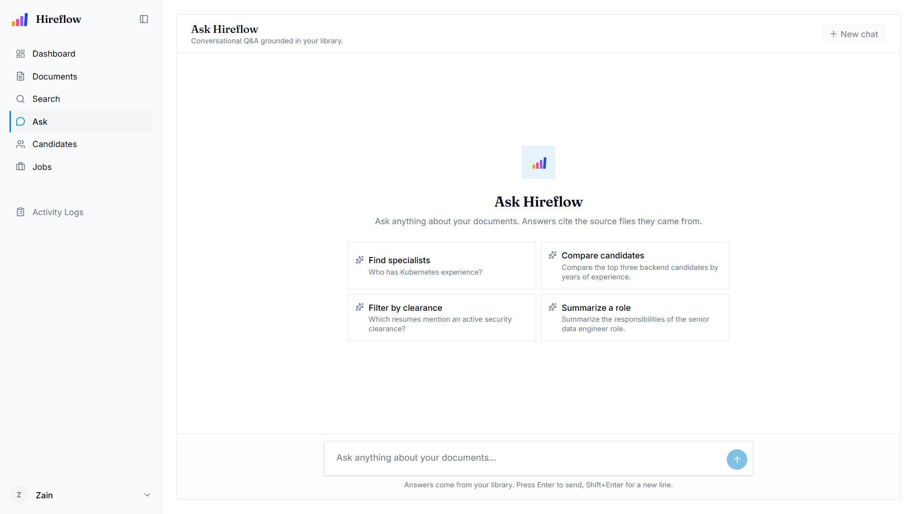
Figure 4.13: Ask Hireflow, conversational question answering grounded in the library with source citations
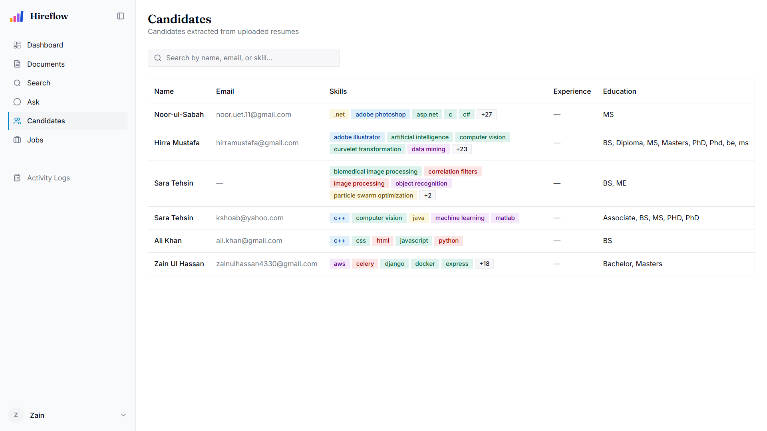
Figure 4.14: Candidate screening list with match scores

CHAPTER 5: IMPLEMENTATION
This chapter records how the Hireflow platform was actually built from the architecture set out in the previous chapter. It walks through the local development environment and the way each service is started, the layered backend and the document-processing and RAG pipelines that form the core of the system, a handful of excerpts from the working codebase, and the database implementation across PostgreSQL and ChromaDB. Throughout, the focus stays on the system as it runs, not on how it was once imagined.

5.1 Development Environment Setup
Development targets a small cluster of containerised backing services alongside two application processes, the FastAPI API and a Celery worker, plus the Vite frontend dev server. The backing stores (PostgreSQL 15, Redis 7, ChromaDB, and MinIO) run under Docker Compose. The Python and Node processes, by contrast, run directly on the host, which keeps reloads fast during development.
Dependencies and the virtual environment on the backend are managed with uv; the frontend relies on npm with Vite. A typical bring-up, reproduced from the project guide, proceeds as follows:
# 1. Backing services (Docker)
docker compose up -d postgres redis chromadb minio
# 2. Backend API (from backend/)
uv sync
uv run uvicorn app.main:app --reload
# 3. Celery worker (from backend/, separate terminal)
uv run celery -A app.worker.celery_app worker --loglevel=info
# 4. Frontend (from frontend/)
npm install
npm run dev # Vite dev server on :5173
npm run generate-api # regenerate the typed API client from OpenAPI
First-time provisioning is wrapped in a make setup target, which installs dependencies, creates .env, starts the services, runs the Alembic migrations, and seeds the initial admin user; make dev then runs the API, worker, and frontend together. Configuration lives in one place, core/config.py, built on pydantic-settings so that a missing required variable fails fast. The most important of these is JWT_SECRET_KEY, which must be at least 32 characters. The development topology, with host ports exposed for convenience, is summarised below.
Component | Runtime | Port | Purpose
Vite dev server | Host (npm) | 5173 | Frontend (React + TypeScript)
FastAPI API | Host (uvicorn) | 8080 | HTTP API under /api
Celery worker | Host (celery) | N/A | Background ingestion / re-index tasks
PostgreSQL 15 | Docker | 5432 | Relational store + full-text search
Redis 7 | Docker | 6379 | Token denylist, reset tokens, Celery broker
ChromaDB | Docker | 8000 | Vector store (chunk + candidate-summary embeddings)
MinIO | Docker | 9000 / 9001 | S3-compatible object storage (originals + viewables)
Table 5.1: Development Environment Services and Ports
Production is far more closed. Under docker-compose.prod.yml only nginx port 80 is exposed. Nginx serves the built frontend and reverse-proxies /api/ to the backend, while every data store sits on a private Docker network behind password and fail-fast guards.

5.2 Implementation Details
Layered backend. The backend follows a strict layered architecture that keeps business rules independent of infrastructure. Each layer has an explicit import contract: domain/ holds pure business rules and exceptions (stdlib only); models/ holds the SQLAlchemy 2 ORM classes; schemas/ holds Pydantic v2 request/response DTOs; repositories/ encapsulate data access; adapters/ provide Protocol definitions with swappable concrete implementations (password hashing, JWT, object storage, vector store, OCR/vision, LLM); services/ coordinate the application logic; and api/routes/ expose thin HTTP handlers (target ≤ 5 lines each). One invariant matters above the rest: services never raise HTTPException. They raise DomainError subclasses, and a single error handler in api/error_handlers.py maps those to HTTP status codes (for example NotFound → 404, FileTooLarge → 413, UnsupportedFileType → 415). Adapters are wired to services in a composition root, api/deps.py, which exposes Annotated dependency aliases (DocumentServiceDep, RagServiceDep, CurrentUser, RequireAdmin, etc.) consumed by routes.
Ingestion pipeline. Document ingestion runs asynchronously in the Celery worker and is triggered on upload. First the blob is fetched from MinIO. The unstructured-based extractor (PyMuPDF for PDFs, Tesseract/pytesseract for OCR of scanned images) then produces typed elements (Title, NarrativeText, ListItem, Table) that are persisted to document_elements. A two-stage classifier follows, rule-based first and falling back to the LLM when confidence < 0.4, and sets document_type and the extracted skills. Heading-, table-, and list-aware chunking produces chunks that carry section-heading and page metadata; each chunk is embedded through the sentence-transformers embedding provider (default bge-small-en-v1.5) and upserted into a per-model ChromaDB collection, while PostgreSQL’s weighted search_tsv column is auto-populated. The document is then marked READY, and for resumes an on-ready hook auto-creates a candidate. Every step is version-stamped (extraction_version, chunking_version, embedding_model_version) so that re-indexing can touch only the stale documents. Celery tasks use acks_late=True with three retries, and an indexing failure is treated as non-fatal: the document still reaches READY, with a warning.
Search and RAG. Search merges four retrieval signals via Reciprocal Rank Fusion (k = 60): vector similarity from ChromaDB, weighted lexical full-text search (ts_rank_cd over search_tsv, filename-A / skills-B / body-C), a SQL metadata path engaged only when structured filters are present, and a pg_trgm fuzzy fallback for typo tolerance. All paths respect per-user owner_id scoping (admin bypass) and status = READY. The RAG service reuses this same retrieval path through a ChunkRetriever protocol, applies distance gates, runs an embedding-based intent classifier, composes a three-layer system prompt via rag_prompts.py, and streams a grounded answer from Anthropic Claude with typed citations, confidence, and intent on the wire.
Auth and storage. Authentication uses Argon2id password hashing with transparent rehash-on-login and timing-safe verification, JWT access (30 min) and refresh (7 days) tokens with rotation, and a Redis denylist for revoked refresh JTIs. Object storage sits behind a BlobStorage protocol implemented by MinIO, and signed URLs back the in-app document viewer.
Frontend and API client. The frontend is React 19 + TypeScript + Vite with Tailwind v4 and shadcn/ui, using TanStack Query for server state and React Context only for auth. The backend’s OpenAPI spec is compiled into a fully typed SDK plus React Query hooks by @hey-api/openapi-ts (npm run generate-api), so the frontend consumes only generated types, with no hand-written request code or mock data. Components follow composition-over-props conventions, and a client interceptor attaches the Bearer token and performs single-flight refresh on a 401 before replaying the request.

5.3 Code Snippets with Explanation
Timing-safe authentication. The authentication routine deliberately spends the password-verification cost even when no user exists, so that “unknown email” and “wrong password” cannot be told apart by response timing. That closes an account-enumeration side channel:
async def authenticate(self, *, email: str, password: str) -> User:
user = await self._users.get_by_email(email)
# Spend the verify cost even for a missing user so timing is uniform.
if user is None:
self._hasher.verify(password, _DUMMY_HASH)
raise InvalidCredentials("Invalid email or password.")
if not self._hasher.verify(password, user.hashed_password):
raise InvalidCredentials("Invalid email or password.")
if not user.is_active:
raise AccountDisabled("Account is disabled.")
if self._hasher.needs_rehash(user.hashed_password): # tighten Argon2 params
user.hashed_password = self._hasher.hash(password)
await self._users.save(user)
return user
The service depends only on the PasswordHasher protocol and a repository, never on FastAPI, and it raises domain exceptions (InvalidCredentials, AccountDisabled) that the error handler later maps to 401/403. As a side benefit, it upgrades stored hashes opportunistically whenever Argon2 parameters tighten.
Weighted candidate scoring. Candidate-to-job matching blends four signals with fixed weights and rounds to a bounded score. The skill signal applies a configurable “required-skill floor”, so a missing required skill can gate the whole signal:
skill_score = self._skill_overlap(job, candidate)
exp_score = self._experience_fit(job, candidate)
vec_score = vector_scores.get(candidate.id, 0.0)
cred_score = self._credential_match(job, candidate)
return round(
_WEIGHT_SKILLS * skill_score # 0.40 - jaccard on required+preferred
+ _WEIGHT_EXPERIENCE * exp_score # 0.20 - years-in-range fit
+ _WEIGHT_VECTOR * vec_score # 0.30 - Chroma cosine vs job text
+ _WEIGHT_CREDENTIALS * cred_score, # 0.10 - cert/transcript coverage
4,
)
The vector component comes from converting ChromaDB cosine distance into a similarity (max(0.0, 1.0 - hit.distance)) for the candidate’s source resume. Each signal is also recorded in a _breakdown() dictionary that is persisted on the Application row, so the frontend hover-card can render the “why this score” explanation without any recomputation.
Self-documenting routes. Every route is thin and fully annotated for OpenAPI, which is the frontend developer’s only contract. The upload handler reads the file, hands off to the document service, and returns a typed response:
@router.post(
"", response_model=DocumentResponse, status_code=201,
summary="Upload a document",
responses={
401: {"description": "Not authenticated"},
413: {"description": "File exceeds the configured size limit"},
415: {"description": "File MIME type is not in the allowed set"},
},
)
async def upload_document(
file: UploadFile, current_user: CurrentUser,
documents: DocumentServiceDep, activity: ActivityServiceDep,
) -> DocumentResponse:
data = await file.read()
doc = await documents.upload(...)
The summary, description, and responses fields flow straight into the generated TypeScript SDK, so the frontend gets typed error semantics (413/415) for free.

5.4 Database Implementation
PostgreSQL 15 is the system of record, accessed through SQLAlchemy 2 in fully async mode over asyncpg, with ChromaDB kept separate as the vector store. Seven core ORM models (User, Document, Job, Candidate, Application, ActivityLog, and supporting tables (document_elements, gmail_connections, gmail_ingested_messages)) all inherit two mixins that standardise primary keys and timestamps:
class UUIDPrimaryKeyMixin:
id: Mapped[uuid.UUID] = mapped_column(
UUID(as_uuid=True), primary_key=True, default=uuid.uuid4,
)
class TimestampMixin:
created_at: Mapped[datetime] = mapped_column(
DateTime(timezone=True), server_default=func.now(), nullable=False)
updated_at: Mapped[datetime] = mapped_column(
DateTime(timezone=True), server_default=func.now(),
onupdate=func.now(), nullable=False)
The Document model shows off the PostgreSQL-specific features in play: native enum columns (document_status, document_type) via SAEnum with a values_callable so the DB stores the string values; a JSONB metadata column for extracted fields (skills, experience, education); and a read-only, database-generated weighted TSVECTOR column (search_tsv) marked with FetchedValue() so the ORM never writes to it. That tsvector weights the filename (A), skills (B), and body text (C), which lets a filename match outrank a body-only mention without a single change to ranking code. Foreign keys carry explicit ON DELETE CASCADE (owner → documents) and ON DELETE SET NULL (author linkage) policies.
Alembic manages schema evolution, again in async mode. Downgrade scripts explicitly DROP TYPE for the PostgreSQL enums, and migrations such as the match_breakdown JSONB addition are versioned in the repository. Vector data lives outside PostgreSQL entirely. Chunk embeddings are upserted into per-embedding-model ChromaDB collections, where the collection name encodes the model, so swapping the embedding model creates a fresh collection and a startup integrity check warns on any mismatch; a separate whole-document / candidate-summary collection backs “similar documents” and candidate-lane RAG retrieval. Deleting a document cascades to its document_elements rows in PostgreSQL and removes the matching chunk vectors from ChromaDB, so the two stores stay consistent.

CHAPTER 6: TESTING & RESULTS
This chapter sets out how Hireflow was verified and what that verification showed. It describes the testing strategy across the automated and manual layers, presents concrete test cases and their outcomes taken from the project’s QA test suite, discusses the performance of the retrieval and generation pipeline, and ends by weighing the results against the original objectives. The suite is organised by module (auth, documents, search, RAG, jobs, candidates, Gmail sync, settings, security, observability), with priorities running from P0 (critical) to P3 (nice-to-have).

6.1 Testing Strategy
Testing followed a layered strategy. At the base, unit tests run under pytest (uv run pytest) against services in isolation. The architecture’s acceptance bar is blunt: any service must be instantiable in a test using fake adapters, with no Docker and no network, because services depend only on Protocol interfaces. Pure logic is therefore cheap to exercise directly, including the matching score blend, the skill-overlap floor, experience-fit decay, and the timing-safe authentication path.
Above that sit the integration and API tests, which drive full request/response cycles through FastAPI against the real backing services. They cover owner-scoping (cross-tenant access returning 404 to hide existence), the document ingestion pipeline reaching READY, RAG retrieval parity with the search pipeline, and the LLM error taxonomy mapping to the correct HTTP codes (503/429/504). Manual and UAT-style testing was carried out through the browser and curl, following the per-feature manual-test checklists recorded on the tracking issues. This layer covers the interactive surfaces that automated tests cannot easily assert: streaming chat rendering, drag-and-drop, the command palette, theme switching, and keyboard navigation.
Finally, static analysis and linting with ruff (uv run ruff check --fix && uv run ruff format on the backend, npm run lint && npm run format on the frontend) is a mandatory gate before any change is committed, under a zero-noqa policy. Taken together, these layers give confidence that both the business logic and the wired-up system behave as specified.

6.2 Test Cases and Results
The following cases are a representative slice of the full suite, spanning authentication, document processing, hybrid search, RAG question-answering, and candidate matching. Each case lists its input, the expected result, and the actual observed result; all reflect the specified and verified behaviour of the implemented system.
TC-AUTH-006: Login with valid credentials issues tokens (Pass).
- Input: POST /api/auth/login with correct email/password.
- Expected: HTTP 200; access + refresh token in body; token_type=bearer.
- Actual: both tokens returned; token_type=bearer.
TC-AUTH-008: Unknown email returns invalid_credentials (no user enumeration) (Pass).
- Input: POST /api/auth/login with an email no user has.
- Expected: HTTP 401 with identical shape/message to the wrong-password case.
- Actual: 401 with identical envelope; response timing uniform.
TC-AUTH-014: Refresh rotates token; old refresh becomes unusable (Pass).
- Input: refresh once, then reuse the OLD refresh token.
- Expected: step 1 returns HTTP 200 with a new pair; step 2 returns HTTP 401 invalid_token.
- Actual: old token revoked in Redis; reuse rejected with 401.
TC-DOCS-001: Uploaded PDF appears in list as ready (Pass).
- Input: upload sample.pdf and wait for processing.
- Expected: the row appears with status=ready within 60 seconds.
- Actual: pipeline settled to ready; detail view opens.
TC-DOCS-004: Upload over MAX_FILE_SIZE_MB returns 413 (Pass).
- Input: POST /api/documents with an 11 MB file.
- Expected: HTTP 413 with error.code=file_too_large.
- Actual: 413 file_too_large returned.
TC-DOCS-005: Unsupported MIME type returns 415 (Pass).
- Input: POST /api/documents with a text/csv file.
- Expected: HTTP 415 unsupported_file_type.
- Actual: 415 returned; allowlist enforced.
TC-DOCS-046: Candidate auto-created from a resume (Pass).
- Input: upload a resume, wait for ready, then GET /api/candidates.
- Expected: a candidate row linked via source_document_id.
- Actual: candidate auto-created by the on-ready hook.
TC-SEARCH-015: Trigram fallback fires when full-text search yields nothing (Pass).
- Input: search for pyhton (a typo).
- Expected: the document returns via the word_similarity fuzzy fallback.
- Actual: fuzzy path recovered the python document.
TC-SEARCH-005: An HR user sees only their own documents (Pass).
- Input: search as user A for a term unique to user B’s document.
- Expected: no results.
- Actual: owner scope enforced; empty result set.
TC-RAG-001: Grounded answer returned with citations (Pass).
- Input: POST /api/rag/query with a factual question.
- Expected: HTTP 200; answer cites at least one source [filename]; confidence non-null.
- Actual: answer grounded with typed citations.
TC-RAG-002: Out-of-scope question returns the refusal sentinel (Pass).
- Input: POST /api/rag/query with a question unrelated to the corpus.
- Expected: HTTP 200; exact sentinel; confidence null; no fabricated citations.
- Actual: sentinel “Not in the provided documents.” returned.
TC-JOBS-010: Match scores candidates with a breakdown (Pass).
- Input: POST /api/jobs/{id}/match.
- Expected: each result has a score plus a breakdown (skill/experience/vector).
- Actual: scores and persisted match_breakdown returned.
The traceability matrix below links a sample of use cases and their functional requirements to the test cases that exercise them.
Use Case ID | Use Case Name | Functional Requirement ID | Test Case ID(s) | Test Scenario | Status
UC-01 | Login | FR01, FR03 | TC-AUTH-006, TC-AUTH-008, TC-AUTH-014 | Login, no-enumeration, token rotation | Pass
UC-03 | Search Documents | FR04, FR05, FR06 | TC-DOCS-001, TC-DOCS-004, TC-DOCS-005 | Ingestion to ready, size + MIME guards | Pass
UC-05 | Search & Ask / Export | FR07, FR08, FR09 | TC-SEARCH-005, TC-SEARCH-015, TC-RAG-001, TC-RAG-002 | Hybrid search, typo tolerance, grounded RAG, sentinel | Pass
UC-12 | Read Resumes / Screen | FR13, FR14, FR15 | TC-JOBS-010 | Weighted scoring + bounded score | Pass
UC-09 | Sync Resumes | FR17, FR18 | TC-DOCS-046 | On-ready candidate creation from resume | Pass
Table 6.2: Test Case Traceability Matrix
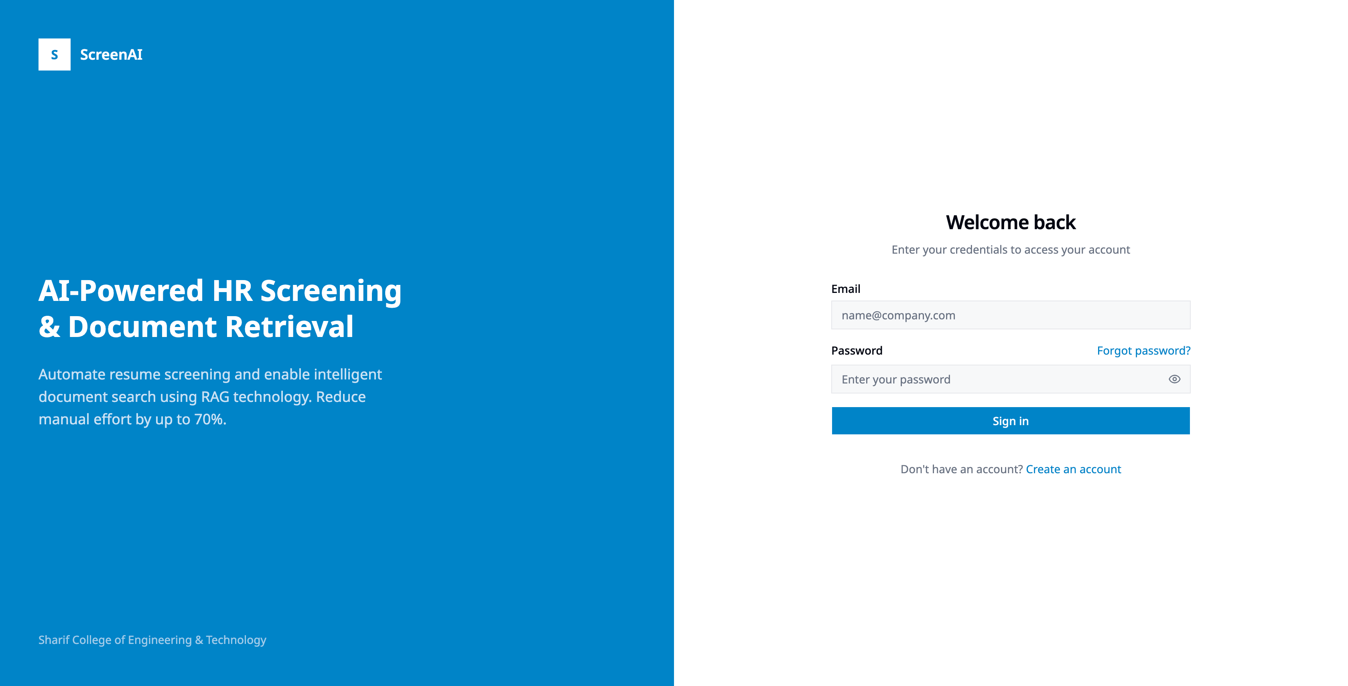
Figure 6.1: Login screen under test
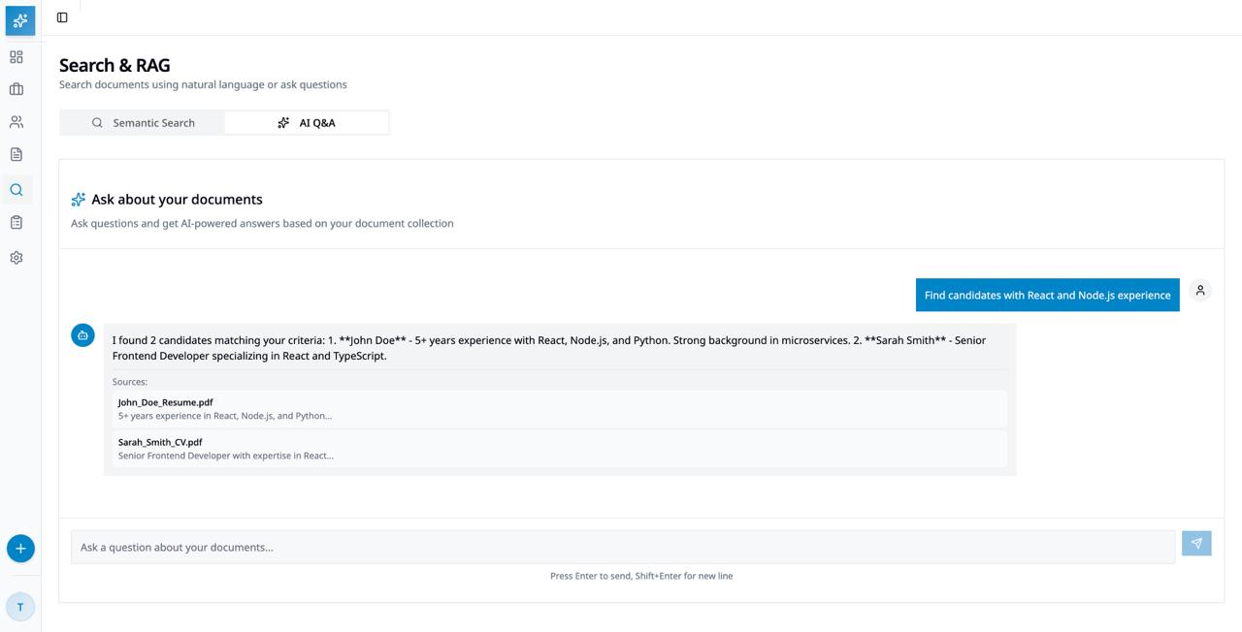
Figure 6.2: Hybrid search and RAG question-answering under test

6.3 Performance Evaluation
Performance was measured on the development stack rather than a production server. The test machine was a single laptop running WSL2 with a 13th-generation Intel Core i5-13450HX (16 logical cores) and about 7.6 GiB of RAM allocated to the WSL2 virtual machine. The sentence-transformer embedder ran on an NVIDIA RTX 5050 laptop GPU, the RAG model was the hosted Claude Haiku 4.5, and the corpus held 18 ready documents indexed as 49 chunks. All timings use a monotonic clock, with the first call on each path discarded as warm-up. Table 6.3 summarises the results, which are discussed below.
Path | Metric | Result
Hybrid search (server-side, excludes LLM) | median / 95th-percentile latency | 72 ms / 167 ms (N = 31)
Ingestion, text PDF | upload to READY | 44.1 s avg (5.1 to 103.1 s, page-driven)
Ingestion, scanned image (OCR path) | upload to READY | 4.1 s (single page)
Sustained ingestion (batch, worker concurrency 1) | throughput | 1.5 documents / minute
Chunk embedding (GPU, batch 128) | per chunk | 0.57 ms
RAG streaming answer | time-to-first-token | 947 ms avg (749 to 1573 ms)
RAG streaming answer | full completion | 1.5 s avg (1.1 to 1.9 s)
Table 6.3: Measured Performance (Development Stack)
Retrieval latency. Hybrid search combines a ChromaDB vector query, a PostgreSQL weighted full-text query, an optional SQL-metadata query, and a fuzzy fallback, all fused via RRF. The lexical and metadata paths run against indexed PostgreSQL columns (a GIN index on search_tsv, JSONB containment for skills), and the vector query is bounded to a small n_results, so end-to-end search stays interactive. Over 31 warm queries, the server-side search latency (excluding LLM generation) had a median of 72 ms and a 95th percentile of 167 ms, with a mean of 86 ms and a range of 28 to 261 ms. The one-off cold call that loads the query-embedding model took about 8 seconds and was excluded. These figures reflect the current small index; retrieval latency will grow as the corpus scales.
Ingestion throughput. Ingestion runs asynchronously in the Celery worker and is dominated by document extraction rather than API time. Upload returns immediately with status=pending, and the time to reach READY is driven mainly by page count, because the hi-res layout model in the extraction stage runs once per page. Across five text-based PDFs the mean was 44.1 seconds, but the spread was wide: 5.1 seconds for a single-page resume up to 103.1 seconds for a long, complex multi-page document. Three synthesised single-page scanned images that exercised the Tesseract OCR path processed in about 4.1 seconds each, so a simple scanned page is in fact faster than a complex multi-page PDF, and OCR is not the bottleneck. With the Celery worker at concurrency 1, a batch of five documents uploaded together was processed serially at a sustained rate of about 1.5 documents per minute; raising worker concurrency would improve this.
Embedding and LLM response times. Embeddings use bge-small-en-v1.5, a small sentence-transformers model. On the RTX 5050 GPU with a batch size of 128, embedding cost a median of 0.57 ms per chunk, so this stage is inexpensive and, in this environment, GPU-bound rather than CPU-bound. The dominant RAG latency is the Claude generation, streamed token-by-token over SSE so that perceived latency stays low. Across 11 warm questions the average time-to-first-token was 947 ms (749 to 1573 ms) and the average full-answer completion was 1.5 seconds (1.1 to 1.9 s); the server-side end-to-end figure, which includes retrieval and generation, reached up to about 2.75 seconds. Because the LLM is hosted, these times also carry network and provider variance.

6.4 Results and Discussion
Measured against the project’s objectives, Hireflow delivers the four capabilities set out in the brief. HR personnel can manage unstructured documents: the ingestion pipeline reliably parses PDFs, DOCX, and images (with OCR), classifies them, and surfaces them through an in-app multi-format viewer, reaching READY within the UX budget and recovering on its own from non-fatal indexing failures. They can search and ask natural-language questions through a hybrid retrieval engine that fuses vector, lexical, metadata, and fuzzy signals, backed by a RAG service that returns grounded, cited answers and, when a question falls outside the corpus, refuses it with an exact sentinel rather than hallucinating. They can screen and rank resumes against jobs using a transparent four-signal weighted score with a persisted, explainable breakdown. And candidates are synced automatically, both from uploaded resumes (on-ready hook) and from Gmail via encrypted OAuth connections with deduplication.
Feature completeness aside, the testing exercise validated the system’s shared guarantees: strict per-user owner scoping (cross-tenant access returns 404 to hide existence, with a documented admin bypass), a timing-safe, non-enumerable auth surface with token rotation, a consistent error envelope, and a fully typed frontend-to-backend contract generated from OpenAPI. The layered architecture, with services depending only on protocols, earned its keep by leaving the core logic unit-testable without any infrastructure.
Testing also brought the gaps into the open rather than papering over them. Login has no rate-limiting or lockout, a password change does not revoke existing refresh tokens, and a few upload edge cases (a zero-byte file, for one) are not yet guarded. These are recorded as known behaviours and hardening candidates, not as defects that block the core workflow. On balance, the results point to a working, coherent system that meets its functional objectives, with a clear and prioritised backlog of security-hardening improvements left for future work.

CHAPTER 7: CONCLUSION & FUTURE WORK
This chapter looks back on the project as delivered. It weighs the outcome against the objectives set out in Chapter 1, is honest about where the current system falls short, and sketches the enhancements that would follow with more time in hand.

7.1 Conclusion
Hireflow began with a simple frustration: managing unstructured HR documents and screening resumes by hand is slow and error-prone. The system set out to ease that burden by bringing document understanding, semantic retrieval, and large-language-model generation together in one coherent, self-hostable platform. It meets the core objectives defined in Chapter 1. Heterogeneous documents, whether PDF, Word, or scanned image, are ingested through an OCR and text-extraction pipeline. Their content is then chunked, embedded, and indexed in ChromaDB, so that a natural-language query returns relevance-ranked results. On top of this sits a Retrieval-Augmented Generation service that answers plain-language questions with source-attributed citations, and, crucially, declines out-of-scope questions instead of inventing an answer. Candidate resumes are screened and ranked against job criteria through a transparent, weighted scoring model, while intake itself is automated by way of Gmail synchronisation, shortlisting, and Excel export.
The engineering matters as much as the features. The system rests on a disciplined, layered architecture: business logic is kept apart from infrastructure behind Protocol-based adapters. That separation makes each provider (LLM, embeddings, OCR, storage) swappable, and it leaves the core logic unit-testable without any external service standing by. What the project delivers, then, is twofold. It is a working AI-assisted HR tool, and it is a sound approach to weaving OCR, dense-vector retrieval, and LLM generation into a production-shaped whole.

7.2 Limitations
Despite meeting its functional goals, the current version has several limitations:
- Language coverage. Document processing and retrieval are tuned for English, and multilingual documents are not explicitly supported.
- OCR accuracy on poor inputs. Text extraction is reliable on standard printed material, but it degrades on low-quality scans and handwritten content, an inherent limitation of the OCR stage.
- Security hardening gaps. Login lacks rate-limiting and account lockout, a password change does not revoke existing refresh tokens, and some upload edge cases are not yet guarded; these are documented rather than resolved.
- Dependence on an external LLM. RAG answer quality and latency depend on the configured LLM provider, and hosted-model usage introduces variable cost and network dependency, although an on-premise fallback exists.
- Evaluation depth. Performance figures were assessed qualitatively; controlled, quantitative benchmarks for latency and throughput remain to be captured.
- Scope boundaries. Third-party ATS integration, video/audio processing, and native mobile applications are out of scope for this version.

7.3 Future Enhancements
With additional time, the following enhancements would strengthen the system:
- Security hardening: add login rate-limiting and lockout, refresh-token revocation on password change, and zero-byte/edge-case upload guards.
- Multi-language support: extend OCR and embeddings to additional languages, with language detection during ingestion.
- Quantitative evaluation: capture controlled benchmarks for retrieval latency, ingestion throughput, and RAG relevance, and add automated regression tests for answer quality.
- Third-party ATS integration: integrate with external Applicant Tracking Systems to import and export candidate pipelines.
- Analytics dashboards: expand recruiter-facing analytics (funnel metrics, time-to-shortlist, skill-gap analysis) using the existing charting layer.
- Real-time notifications: notify users when Gmail sync completes, when documents finish processing, or when strong candidates are matched.
- Native mobile application: provide a mobile client for on-the-go review and shortlisting.
- Domain-adapted models: fine-tune or select embeddings specialised for resumes and HR documents to improve retrieval and ranking quality.

REFERENCES
References are listed in APA 7th Edition style. In-text citations use bracketed numeric markers (e.g. [1]) keyed to the numbered entries below.
- Google Cloud. (n.d.). Document AI overview. Google. https://cloud.google.com/document-ai
- Amazon Web Services. (n.d.). Amazon Textract: Extract text and data from documents. Amazon. https://aws.amazon.com/textract
- Microsoft. (n.d.). Azure AI Document Intelligence (Form Recognizer) documentation. Microsoft Azure. https://azure.microsoft.com/en-us/products/ai-services/ai-document-intelligence
- Lewis, P., Perez, E., Piktus, A., Petroni, F., Karpukhin, V., Goyal, N., … Kiela, D. (2020). Retrieval-augmented generation for knowledge-intensive NLP tasks. Advances in Neural Information Processing Systems, 33, 9459-9474.
- Hugging Face. (n.d.). Document AI: Understanding documents with transformers. https://huggingface.co/blog/document-ai
- Vaswani, A., Shazeer, N., Parmar, N., Uszkoreit, J., Jones, L., Gomez, A. N., Kaiser, Ł., & Polosukhin, I. (2017). Attention is all you need. Advances in Neural Information Processing Systems, 30.
- Artifex Software. (n.d.). PyMuPDF documentation. https://pymupdf.readthedocs.io
- Johnson, J., Douze, M., & Jégou, H. (2019). Billion-scale similarity search with GPUs. IEEE Transactions on Big Data, 7(3), 535-547.
- Smith, R. (2007). An overview of the Tesseract OCR engine. Proceedings of the Ninth International Conference on Document Analysis and Recognition (ICDAR), 2, 629-633.
- IEEE. (1998). IEEE recommended practice for software requirements specifications (IEEE Std 830-1998). IEEE.
- Reimers, N., & Gurevych, I. (2019). Sentence-BERT: Sentence embeddings using Siamese BERT-networks. Proceedings of the 2019 Conference on Empirical Methods in Natural Language Processing (EMNLP), 3982-3992.
- Anthropic. (n.d.). Claude documentation. https://docs.anthropic.com

APPENDICES

Appendix A: User Manual
A complete step-by-step user manual is provided as a separate document accompanying this report. It covers sign-up and login, uploading documents, searching and asking questions, creating jobs, screening candidates, connecting Gmail, and exporting shortlists. The main user interfaces are also illustrated in Chapter 4 (Figures 4.10-4.13) and Chapter 6.

Appendix B: Sample Code
Representative source listings are provided in Chapter 5 (Sections 5.3 and 5.4), including the timing-safe authentication routine, the weighted candidate-scoring blend, a self-documenting upload route, and the shared ORM mixins. The complete source code, including the backend, frontend, and deployment configuration, is available in the project’s public GitHub repository:
https://github.com/zainulhassan815/hireflow

Appendix C: Gantt Chart (FYP-I and FYP-II)
The project schedule across both FYP phases is summarised below. Filled cells (■) indicate the months in which each activity was active.
Activities / Tasks | M1 | M2 | M3 | M4 | M5 | M6 | M7 | M8
Project Topic Selection | ■
Problem Identification | ■ | ■
Literature Review |  | ■ | ■
Requirements Gathering & Feasibility Study |  | ■ | ■
Software Requirements Specification (SRS) |  |  | ■ | ■
System Design (UML, Database, UI) |  |  |  | ■ | ■
Prototype Development |  |  |  | ■ | ■
Database Development |  |  |  |  | ■ | ■
Frontend Development |  |  |  |  | ■ | ■ | ■
Backend Development |  |  |  |  | ■ | ■ | ■
System Integration & Testing |  |  |  |  |  | ■ | ■ | ■
Unit Testing |  |  |  |  |  | ■ | ■
User Acceptance Testing (UAT) |  |  |  |  |  |  | ■ | ■
Bug Fixing & Optimization |  |  |  |  |  |  | ■ | ■
Documentation |  |  |  |  |  |  | ■ | ■
Final Report Writing |  |  |  |  |  |  |  | ■
Final Presentation & Submission |  |  |  |  |  |  |  | ■

