

SHARIF COLLEGE OF ENGINEERING & TECHNOLOGY
Department of Computer Science
FINAL YEAR PROJECT REPORT
AI Powered HR Screening and Document Retrieval System Using RAG
Submitted in partial fulfillment of the requirements for the degree of
Bachelor of Science in Computer Science (BSCS)
Submitted By
Sr No. | Student Name | Registration No. | Signature
1 | AMNA IKRAM | UET-SHCET-LHR-CS-02
2 | ZAIN UL HASSAN | UET-SHCET-LHR-CS-12
3 | EZZA ANSAR | UET-SHCET-LHR-CS-13
Supervisor
Ms. Hirra Mustafa
Co-Supervisor
Dr. Mazhar Iqbal

I. Industrial Supervisor Approval Certificate
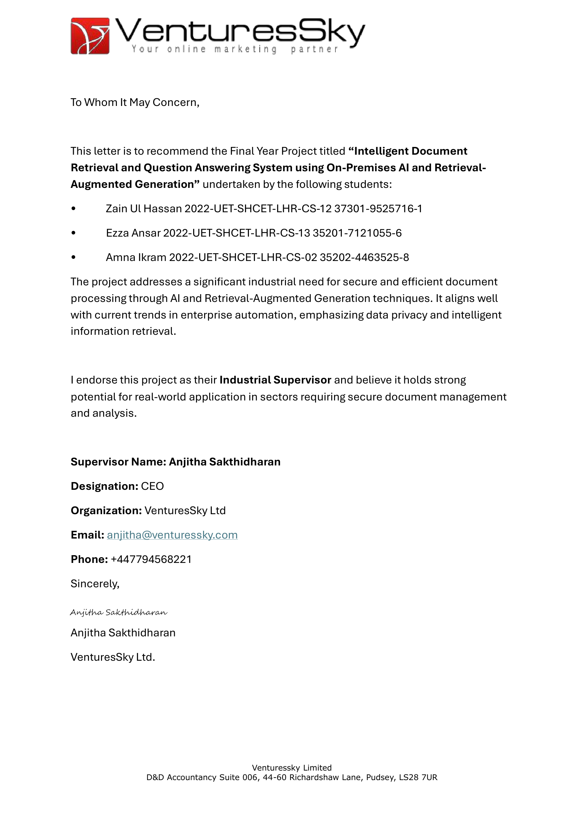

II. Declaration
We hereby declare that this Final Year Project Report entitled:
"AI Powered HR Screening and Document Retrieval System Using RAG"
submitted to the Department of Computer Science, Sharif College of Engineering & Technology, in partial fulfillment of the requirements for the award of the degree of Bachelor of Science in Computer Science (BSCS), is our original work.
This project has been carried out by us under the supervision of Ms. Hirra Mustafa.
We further declare that:
- The work contained in this report is entirely our own except where appropriate acknowledgment and references have been made.
- All sources of information, including published literature, books, journals, websites, and other materials, have been properly cited in accordance with APA 7th Edition referencing guidelines.
- We accept full responsibility for the authenticity and originality of the work presented in this report.
- Any similarity with previously published work beyond acceptable academic limits is unintentional and subject to the academic policies of Sharif College of Engineering & Technology.
We understand that if any part of this declaration is found to be false or misleading, the College reserves the right to cancel the submission and take disciplinary action in accordance with its academic regulations.
Supervisor's Verification
I certify that the above declaration has been read and that, to the best of my knowledge, the work presented in this Final Year Project Report has been carried out by the above-mentioned students under my supervision.
Supervisor Name: Ms. Hirra Mustafa
Designation: ________________________
Department: Computer Science
Signature: ________________________
Date: _____________________________

III. Plagiarism Declaration/ Plagiarism Report
We hereby declare that this Final Year Project Report is our original work and has been prepared in accordance with the academic integrity policies of the Department of Computer Science, Sharif College of Engineering & Technology (SCET).
We confirm that all sources of information have been properly acknowledged and cited. Any text, figures, code, or other material taken from published or unpublished sources has been appropriately referenced.
We understand and agree to the following submission requirements:
- Similarity Score: The overall similarity index must be 15% or less.
- AI Content Score: The AI-generated content score must be less than 20%.
We acknowledge that failure to comply with these requirements or submission of plagiarized work may result in rejection of the project and disciplinary action in accordance with the academic regulations of SCET.

IV. Dedication
To our beloved parents, whose prayers, sacrifices, and endless encouragement made this journey possible, and to our teachers, whose guidance and patience shaped the way we think and work. This project is dedicated to you, with gratitude and love.

V. Acknowledgements
First and foremost, we thank Almighty Allah for granting us the strength, patience, and determination to complete this project.
We are deeply grateful to our supervisor, Ms. Hirra Mustafa, for her constant guidance, valuable feedback, and encouragement at every stage of this work. Her insight kept the project on track and pushed us to do better. We are equally thankful to our co-supervisor, Dr. Mazhar Iqbal, whose technical advice and thoughtful suggestions strengthened both our approach and our understanding.
We also extend our sincere appreciation to our industrial supervisor, Anjitha Sakthidharan (CEO, VenturesSky Ltd), for endorsing the project and offering an industry perspective that helped us ground our work in real-world needs.
Our gratitude goes to the Department of Computer Science at Sharif College of Engineering and Technology for providing the resources, facilities, and learning environment that made this work possible, and to the faculty members whose feedback during evaluations helped us refine the system.
Finally, we thank our families and friends for their unconditional love, patience, and support throughout this journey. Their belief in us was a constant source of motivation.

Abstract
Human resource teams that manage large collections of unstructured documents spend considerable time manually reviewing and screening resumes, with inconsistent results, while keyword search fails to surface semantically relevant content. This project presents Hireflow, an AI-powered HR screening and document retrieval system built on Retrieval-Augmented Generation. Documents in PDF, Word, and scanned-image form are processed through an OCR and text-extraction pipeline, then chunked, embedded with sentence-transformer models, and indexed in a vector database. A hybrid retrieval engine fuses vector, lexical, metadata, and fuzzy signals, and a retrieval-augmented generation service returns concise, source-attributed answers while declining questions that fall outside the document collection. Candidate resumes are ranked against job criteria using a transparent weighted scoring model, and intake is automated through Gmail synchronization. The system is implemented as a FastAPI backend with PostgreSQL, Redis, Celery, and MinIO, paired with a React frontend. The result is a single self-hostable platform delivering semantic search, grounded question answering, and explainable candidate ranking.
Keywords: Retrieval-Augmented Generation, Semantic Search, Resume Screening, Optical Character Recognition, Vector Database, Human Resources.

Table of Contents
I. Industrial Supervisor Approval Certificate ii
II. Declaration iii
III. Plagiarism Declaration/ Plagiarism Report iv
IV. Dedication v
V. Acknowledgements vi
Abstract vii
List of Abbreviations xiii
CHAPTER 1: INTRODUCTION 1
1.1 Background 1
1.2 Problem Statement 2
1.3 Objectives 2
1.4 Scope of Project 3
1.5 Significance of Project 3
1.6 Report Organization 4
CHAPTER 2: LITERATURE REVIEW 5
2.1 Overview of Domain 5
2.2 Existing Systems / Related Work 5
2.3 Comparison of Existing Systems 7
2.4 Research Gap 8
2.5 Proposed Solution 8
CHAPTER 3: SYSTEM ANALYSIS & REQUIREMENTS 10
3.1 Feasibility Study 10
3.1.1 Technical Feasibility 10
3.1.2 Economic Feasibility 10
3.1.3 Operational Feasibility 11
3.1.4 Schedule Feasibility 11
3.2 Functional Requirements 11
3.3 Non-Functional Requirements 14
3.3.1 Performance 14
3.3.2 Security and Privacy 14
3.3.3 Scalability 15
3.3.4 Usability 15
3.3.5 Reliability 15
3.3.6 Maintainability 15
3.4 Tools and Technologies Used 15
3.5 Use Cases / User Stories 18
3.6 Use Cases Table 21
3.7 Development Methodology 23
CHAPTER 4: SYSTEM DESIGN 25
4.1 System Architecture Description & Design 25
4.2 Data Flow Diagrams 27
4.3 UML Diagrams 30
4.3.1 Class Diagram 31
4.3.2 Activity Diagram 32
4.3.3 Component Diagram 33
4.3.4 Sequence Diagram 34
4.3.5 State Machine Diagram 34
4.4 Database Design (ERD, Schema, Data Dictionary) 35
4.5 UI/UX Design 39
CHAPTER 5: IMPLEMENTATION 44
5.1 Development Environment Setup 44
5.2 Implementation Details 45
5.2.1 Layered Backend 45
5.2.2 Request Validation and Error Handling 46
5.2.3 Ingestion Pipeline 48
5.2.4 Search and RAG 49
5.2.5 Conversations and Follow-up Questions 50
5.2.6 Authentication and Storage 50
5.2.7 Gmail Synchronisation 50
5.2.8 Frontend and API Client 51
5.3 Code Snippets with Explanation 52
5.3.1 Timing-Safe Authentication 52
5.3.2 Weighted Candidate Scoring 52
5.3.3 Self-Documenting Routes 53
5.4 Database Implementation 54
CHAPTER 6: TESTING & RESULTS 56
6.1 Testing Strategy 56
6.2 Test Cases and Results 56
6.3 Performance Evaluation 59
6.3.1 Retrieval Latency 60
6.3.2 Ingestion Throughput 60
6.3.3 Embedding and LLM Response Times 61
6.4 Results and Discussion 61
CHAPTER 7: CONCLUSION & FUTURE WORK 63
7.1 Conclusion 63
7.2 Limitations 63
7.3 Future Enhancements 64
REFERENCES 65
APPENDICES 67
Appendix A: User Manual 67
Appendix B: Sample Code 67
Appendix C: Gantt Chart (FYP-I and FYP-II) 67

List of Figures
Figure 3.1: Use Case Diagram 19
Figure 3.2: Development Methodology Flowchart 23
Figure 4.1: System Architecture 27
Figure 4.2: DFD Level 0 (Context Diagram) 28
Figure 4.3: DFD Level 1 29
Figure 4.4: DFD Level 2 30
Figure 4.5: Class Diagram 31
Figure 4.6: Activity Diagram 32
Figure 4.7: Component Diagram 33
Figure 4.8: Sequence Diagram (Streaming RAG Query) 34
Figure 4.9: Document Status State Machine 34
Figure 4.10: Entity-Relationship Diagram 35
Figure 4.11: Dashboard overview 41
Figure 4.12: Documents management with upload and processing status 41
Figure 4.13: Semantic search across the document library with match scores and skill filters 42
Figure 4.14: Ask Hireflow, conversational question answering grounded in the library with source citations 42
Figure 4.15: Candidate screening list with match scores 43
Figure 6.1: Login screen under test 59
Figure 6.2: Hybrid search and RAG question-answering under test 59

List of Tables
Table 2.1: Review of Existing Systems and Related Work 6
Table 2.2: Comparison of Representative Systems 7
Table 2.3: Research Gap Summary 8
Table 3.1: Functional Requirements (FR01-FR22) 11
Table 3.2: Tools and Technologies 16
Table 3.3: Summary of Use Cases (UC-01-UC-12) 20
Table 3.4: Sample Use Case, User Login 21
Table 4.1: users Data Dictionary 35
Table 4.2: documents Data Dictionary 36
Table 4.3: jobs Data Dictionary 37
Table 4.4: candidates Data Dictionary 38
Table 5.1: Development Environment Services and Ports 45
Table 5.2: Domain Error to HTTP Status Mapping 46
Table 5.3: Document Ingestion Pipeline Stages 48
Table 6.1: Test Cases and Results 57
Table 6.2: Test Case Traceability Matrix 58
Table 6.3: Measured Performance (Development Stack) 60

List of Abbreviations
Abbreviation | Expansion
API | Application Programming Interface
ATS | Applicant Tracking System
CCPA | California Consumer Privacy Act
CRUD | Create, Read, Update, Delete
DFD | Data Flow Diagram
ERD | Entity-Relationship Diagram
FR | Functional Requirement
FTS | Full-Text Search
GDPR | General Data Protection Regulation
HR | Human Resources
JWT | JSON Web Token
LLM | Large Language Model
NFR | Non-Functional Requirement
OCR | Optical Character Recognition
OAuth | Open Authorization
RAG | Retrieval-Augmented Generation
RBAC | Role-Based Access Control
RRF | Reciprocal Rank Fusion
SPA | Single-Page Application
SRS | Software Requirements Specification
SSE | Server-Sent Events
UC | Use Case
UI/UX | User Interface / User Experience
UML | Unified Modeling Language

CHAPTER 1: INTRODUCTION
Recruitment and document management are among the most document-intensive functions in any organisation. Yet they remain heavily manual, slow, and inconsistent. This chapter introduces Hireflow, an AI-Powered HR Screening and Document Retrieval System that applies Retrieval-Augmented Generation (RAG) to unstructured document collections, letting HR personnel search, question, and screen documents in natural language. The sections that follow set out the background and motivation, state the problem being solved, define the objectives and scope, weigh the significance of the work, and outline how the rest of the report is organised.

1.1 Background
Modern organisations accumulate large volumes of unstructured documents: resumes, reports, contracts, and scanned correspondence, most of it arriving as PDF files, Microsoft Word documents, or scanned images. Extracting value from this material has traditionally depended on manual reading and keyword-based search. Both scale poorly as collections grow. In human resources the pressure is acute. Recruiters commonly review dozens of resumes per open position, and industry practice reports that HR teams spend the majority of their working time on manual resume review, averaging around twenty-three hours of effort to fill a single position. Keyword search only compounds the problem, since it matches literal tokens rather than meaning; a query for “machine learning engineer” fails to surface a strong candidate who wrote “ML researcher” or “deep learning specialist.”
Two families of technology have now matured enough to address these limitations. The first is document understanding and optical character recognition (OCR). Managed cloud services such as Google Cloud Document AI [1], Amazon Textract [2], and Azure Form Recognizer [3], along with open-source engines such as Tesseract [4] and libraries such as PyMuPDF [5], make it possible to extract structured text from PDFs, Word files, and scanned images. The second is the pairing of dense vector embeddings with large language models (LLMs). Vector similarity search libraries such as FAISS [6], together with transformer-based document and language models [7][8], enable semantic retrieval, where documents are matched by meaning rather than exact wording.
Retrieval-Augmented Generation (RAG) [9] ties these two strands together. It is a technique for using a language model, not a product or a model in its own right, and the idea is the difference between a closed-book and an open-book exam. Asked a question on its own, a language model answers from memory: it writes fluently, but it has never seen a private document collection, and when it does not know something it tends to produce a plausible-sounding invention. RAG makes the exam open-book. The system first retrieves the passages from the collection that are most relevant to the question, then gives the model those passages along with the question and instructs it to answer from that material only. The answer is still written in ordinary language, but the facts come from the retrieved passages, so every statement can be traced back to the document it came from. Hireflow builds on this foundation, using sentence-transformers [10] for embeddings, ChromaDB as the vector store, and Anthropic Claude [11] as the answer-generating LLM.

1.2 Problem Statement
HR personnel who manage large, unstructured document collections face several compounding difficulties. Manual review of resumes and other documents is slow and absorbs the bulk of recruiter effort, and because different reviewers apply inconsistent criteria, it introduces bias and compliance risk. Keyword-based search and rigid, rule-based Applicant Tracking System (ATS) filters miss semantically relevant content, along with qualified candidates whose phrasing does not match the exact query terms. The information needed for a decision is scattered across email inboxes, shared folders, and disconnected systems, so retrieving a specific fact from a large corpus is slow. Existing tools rarely let a user ask a plain-language question over their own documents and receive a concise, source-attributed answer. What is needed is a single system that ingests heterogeneous documents, understands them semantically, answers natural-language questions with provenance, and automatically screens and ranks candidates against defined job criteria.

1.3 Objectives
The project pursues the following specific and measurable objectives:
- Ingest and process heterogeneous documents: accept PDF, Microsoft Word, and scanned image files and extract their text using PyMuPDF [5] and Tesseract/pytesseract OCR [4], targeting text-extraction accuracy above 95% on standard printed documents.
- Enable semantic search and retrieval: index all documents as dense vector embeddings (sentence-transformers) in a vector database (ChromaDB) so that natural-language queries return relevance-ranked results, with typical search responses returned in under two seconds.
- Provide grounded question answering via RAG: answer plain-language questions over the document collection using Retrieval-Augmented Generation [9] with an LLM (Anthropic Claude), returning cited, source-attributed answers with a target answer-relevance of at least 85% and end-to-end response times under ten seconds.
- Automate resume screening and ranking: match and rank candidate resumes against user-defined job criteria (skills, education, experience), reducing manual screening effort by roughly 70-80% and processing on the order of 100 resumes per hour.
- Automate candidate intake and reporting: sync resume attachments from Gmail using OAuth 2.0 [12], and support shortlisting, rejection, activity logging, and export of candidate data to Excel for compliance and offline analysis.

1.4 Scope of Project
Hireflow is a standalone, web-based system for HR personnel. Within scope for the first version are document upload and batch ingestion; OCR and text extraction for PDF, Word, and scanned image files; automatic document classification and metadata generation; semantic search with filtering by document type, date, skills, and role; RAG-based question answering with source citations; job posting creation and management; automated candidate screening and ranking against job criteria; Gmail integration for resume collection via OAuth 2.0; export of shortlisted candidates to Excel; and activity logging with audit trails. The system is delivered as a FastAPI (Python 3.12) backend with Celery and Redis for background processing, PostgreSQL 15 for relational data, ChromaDB for vector storage, and MinIO for object storage, paired with a React 19 and TypeScript frontend built with Vite, Tailwind, and shadcn/ui.
The system supports two roles: HR personnel (the primary user class) and an administrator role for user management, both governed by role-based access control. An external Email Service acts as a supporting actor for automated resume synchronisation. Explicitly out of scope for version 1.0 are third-party ATS integrations, processing of video or audio files, native mobile applications for iOS and Android, and multi-language support beyond English.

1.5 Significance of Project
Hireflow’s significance lies in consolidating capabilities that were previously available only through fragmented, expensive, or cloud-locked services into a single coherent platform tailored to HR workflows. Replacing keyword matching with semantic retrieval and RAG lets the system surface qualified candidates and relevant documents that literal search would miss. This improves the quality and consistency of shortlists while reducing bias from divergent reviewer criteria. By automating resume intake from Gmail and ranking candidates against explicit job criteria, the system targets a substantial reduction in manual screening effort, freeing recruiters for interviews and judgment-heavy work. Grounded, source-attributed answers address a key weakness of naive LLM use, namely unverifiable output, by tying every answer back to the documents it came from; this matters for trust, auditability, and compliance. Academically, the project shows how OCR, dense-vector retrieval, and LLM-based generation can be integrated into a production-shaped, service-oriented architecture.

1.6 Report Organization
This report is organised into seven chapters. Following this introduction, Chapter 2 reviews the literature on document understanding, semantic search, and AI-assisted recruitment, compares the existing systems, and identifies the research gap. Chapter 3 covers the analysis and requirements, from the feasibility study through the functional and non-functional requirements, the tools and technologies adopted, and the use cases. Chapter 4 presents the system design, including the layered architecture, the data-flow diagrams, the UML models, the database design, and the user interface. Chapter 5 describes the implementation, covering the development environment, the backend and frontend, representative code, and the database. Chapter 6 reports the testing strategy, the test cases and their results, and the performance evaluation. Chapter 7 concludes with the outcomes of the project, its limitations, and directions for future work.

CHAPTER 2: LITERATURE REVIEW
This chapter reviews the technologies and prior systems relevant to AI-powered document retrieval and HR screening. It first frames the problem domain, then examines existing systems and related work: traditional Applicant Tracking Systems, keyword search, cloud document-understanding services, RAG frameworks, transformer-based document understanding, vector similarity search, and OCR. From there it compares the approaches, identifies the research gap that motivates the project, and presents Hireflow as the proposed solution.

2.1 Overview of Domain
This project draws on three fields: document understanding, information retrieval, and applied natural language processing for recruitment. Document understanding converts unstructured inputs such as PDFs, Word files, and scanned images into machine-readable text and metadata, typically using OCR and layout analysis [1][2][3][5][4]. Information retrieval has evolved from lexical, keyword-based matching toward dense semantic retrieval, in which text is encoded as high-dimensional embedding vectors and compared by similarity, so that conceptually related content surfaces even without shared keywords [8][6]. Retrieval-Augmented Generation combines retrieval with generative language models, grounding an LLM’s response in retrieved passages to produce accurate, citable answers rather than unsupported text [9]. Recruitment applies these ideas directly: Applicant Tracking Systems and AI recruitment platforms parse resumes, match candidates to job requirements, and manage hiring pipelines. Hireflow draws on all three fields to serve HR personnel working over unstructured document collections.

2.2 Existing Systems / Related Work
A range of commercial products, cloud services, and open-source tools address parts of the problem that Hireflow tackles. Traditional ATS platforms such as Greenhouse [13] and Workday [14] automate applicant pipelines but lean heavily on keyword filters and structured fields; AI recruitment platforms such as Eightfold AI [15] apply deep learning to candidate matching. Cloud document-understanding services (Google Cloud Document AI [1], Amazon Textract [2], Azure Form Recognizer [3]) extract text and structure at scale, though they are proprietary and usage-priced. RAG frameworks such as LangChain [16] coordinate retrieval-augmented pipelines, while transformer-based document and language models [7][8] support both understanding and generation. Lower down the stack, vector search libraries such as FAISS [6] and OCR engines such as Tesseract [4] supply the retrieval and text-extraction primitives.
The representative systems reviewed for this project are summarised in Table 2.1, each characterised by its research problem, method and tools, key features, limitations, and relevance to Hireflow.
Table 2.1: Review of Existing Systems and Related Work
Ref | System (Year) | Research Problem | Methodology & Tools | Key Features | Limitations | Relevance to Hireflow
R1 | Smith / Tesseract community (2006-2018) [4] | Reading text from scanned images and PDFs | LSTM-based OCR over rasterised document images; Tesseract and pytesseract | Free, offline, multi-format OCR | Accuracy drops on poor scans and handwriting; no semantic understanding | Provides the OCR stage of Hireflow’s ingestion pipeline
R2 | Greenhouse Software (2012) | Managing and filtering high volumes of job applicants | Structured fields with keyword/boolean rules over parsed resumes; commercial ATS and resume parser | Pipeline management, keyword filters, structured candidate records | Keyword matching misses semantics; rigid rules; limited free-form question answering | Establishes the ATS baseline that Hireflow improves on with semantic ranking
R3 | Eightfold AI (2016) | Bias and inefficiency in candidate-job matching | Learned embeddings of candidates and roles for similarity matching; proprietary deep-learning models | AI candidate matching, skills inference, ranking | Proprietary, closed, and costly, with limited transparency and provenance | Validates ML-based ranking and motivates open, explainable ranking with citations
R4 | Johnson, Douze & Jegou / FAISS (2017) [6] | Fast similarity search over very large collections of vectors | Approximate nearest-neighbour indexing of dense embeddings; the FAISS library | Efficient, scalable approximate-nearest-neighbour search | A library only, no ingestion, OCR, or application layer | Supports semantic retrieval; Hireflow uses ChromaDB in the same role
R5 | Google Cloud Document AI, Amazon Textract, Azure Form Recognizer (2018-2020) [1][2][3] | Extracting structured data from unstructured documents | Deep OCR with layout analysis and form/entity extraction, delivered as managed cloud APIs | High-accuracy OCR, entity and table extraction, scalability | Proprietary, per-use cost, cloud lock-in, data leaving the premises | Motivates an on-premise, open OCR pipeline (PyMuPDF + Tesseract)
R6 | Hugging Face / Transformer community (2019-2021) [7][8] | Understanding document text and semantics | Pretrained transformer encoders for embeddings and LLMs for generation; Transformers and sentence-transformers | Semantic embeddings, classification, generation | Compute-heavy, and general models need domain adaptation | The basis for Hireflow’s embeddings and LLM answer generation
R7 | Lewis et al. / LangChain (2020-2022) [9] | LLMs hallucinate and lack access to private or current data | Retrieve relevant chunks from a vector store, then condition an LLM on them; LangChain, vector databases, LLMs | Grounded, citable answers over private corpora | Answer quality depends heavily on retrieval and chunking, and needs tuning | The core paradigm adopted by Hireflow for document question answering

2.3 Comparison of Existing Systems
Each reviewed system solves one facet of the problem well, but none offers an integrated, HR-focused, provenance-aware solution. Traditional ATS platforms and keyword search excel at structured pipeline management and exact-match filtering, yet their lexical matching misses semantically equivalent phrasing, and their rigid rules cannot answer free-form questions. AI recruitment platforms such as Eightfold AI show the value of learned matching, but they are proprietary, costly, and opaque, offering little insight into why a candidate was ranked. Cloud document-AI services deliver excellent OCR and extraction accuracy at the price of per-use cost, cloud lock-in, and off-premise data handling that is often unacceptable for sensitive HR records. RAG frameworks and transformer models supply the generative and semantic capabilities, but they are building blocks rather than finished applications and demand substantial integration work. Vector search libraries and OCR engines are similarly low-level. The comparison below summarises these trade-offs.
Table 2.2: Comparison of Representative Systems
System / Approach | Semantic Retrieval | Natural-Language Q&A | Automated Resume Ranking | Provenance / Citations | Open / On-Premise
Traditional ATS (Greenhouse, Workday) | No (keyword) | No | Rule-based only | Limited | Mostly cloud/commercial
AI recruitment (Eightfold AI) | Yes | Limited | Yes (ML) | Weak | No (proprietary)
Cloud Document AI [1][2][3] | Partial | No | No | N/A | No (cloud)
RAG frameworks (LangChain) [9] | Yes | Yes | No (not HR-specific) | Yes (if built) | Yes (self-host)
Hireflow (proposed) | Yes | Yes | Yes (LLM-based) | Yes | Yes

2.4 Research Gap
The comparison shows that no single existing system combines semantic retrieval, grounded natural-language question answering, LLM-based candidate ranking, automated email-based resume intake, and transparent source attribution in one HR-oriented, self-hostable platform. Each gap below maps directly to a design choice in Hireflow.
Table 2.3: Research Gap Summary
Approach / System | Gap Identified | Proposed Improvement
Keyword search / traditional ATS filters | Literal token matching misses semantically relevant documents and candidates | Semantic RAG retrieval using dense sentence-transformer embeddings in ChromaDB
Rigid rule-based ATS screening | Fixed rules cannot weigh nuanced skills, phrasing, or context; inconsistent criteria | LLM-based candidate ranking against structured job criteria for consistent, context-aware scoring
Document collections without Q&A | No way to ask plain-language questions and get a synthesized answer over one’s own documents | RAG chat interface that answers natural-language questions over the indexed corpus
Manual resume collection from inboxes | Resumes scattered across email require manual download and filing | Automated Gmail sync via OAuth 2.0 that ingests resume attachments in the background
Naive LLM answers / opaque AI ranking | Answers and rankings lack verifiable sources, harming trust and auditability | Cited, source-attributed answers and logged, auditable screening decisions

2.5 Proposed Solution
Hireflow is proposed as an integrated, web-based platform that closes these gaps by combining best-of-breed open components into a single HR-focused system. Documents in PDF, Word, and scanned-image form are ingested through an OCR and text-extraction stage built on PyMuPDF [5] and Tesseract/pytesseract [4]. This avoids the cost and cloud lock-in of managed document-AI services [1][2][3] while retaining acceptable accuracy on standard printed material. Extracted text is chunked, embedded with sentence-transformer models [7][8][10], and stored in ChromaDB, which plays the same approximate-nearest-neighbour retrieval role popularized by FAISS [6]. This gives semantic search that goes beyond keyword matching. On top of retrieval, Hireflow implements Retrieval-Augmented Generation [9] with Anthropic Claude as the generation model: for each natural-language question, relevant passages are retrieved and supplied as grounded context, and the model returns a concise answer with citations back to the source documents. This directly addresses the provenance weakness of naive LLM use and of opaque AI recruitment platforms.
For recruitment, HR personnel define job postings with explicit skills, education, and experience criteria. The system then ranks candidate resumes against those criteria using LLM-based scoring rather than rigid rules, producing consistent and explainable shortlists. Resume intake is automated through Gmail integration over OAuth 2.0, which syncs attachments in the background via Celery and Redis and removes the manual collection step. The platform is realised as a FastAPI (Python 3.12) backend with PostgreSQL 15 for relational data and MinIO for object storage, paired with a React 19 and TypeScript frontend driven by an OpenAPI-generated client; role-based access control, activity logging, and audit trails support compliance in line with recommended requirements-engineering practice [17]. These choices deliver the semantic retrieval, grounded Q&A, explainable ranking, automated intake, and source attribution that no single reviewed system provides.

CHAPTER 3: SYSTEM ANALYSIS & REQUIREMENTS
This chapter presents the analysis behind the design of Hireflow, the AI-Powered HR Screening and Document Retrieval System built on Retrieval-Augmented Generation (RAG). A feasibility study establishes that the system is viable. The chapter then consolidates the functional and non-functional requirements gathered during the Software Requirements Specification (SRS) phase, documents the tools and technologies adopted for implementation, models system behaviour through use cases and user stories, and closes with the development methodology the project followed. These sections turn a familiar problem, slow and manual document review and resume screening, into a concrete and verifiable set of requirements that guides the design and implementation that follow.

3.1 Feasibility Study
A feasibility study was carried out to confirm that Hireflow could be delivered within the constraints of a Final Year Project while still meeting the needs of HR personnel who handle large volumes of unstructured documents. It considers four dimensions: technical, economic, operational, and schedule.

3.1.1 Technical Feasibility
The system is technically feasible because every capability rests on mature, well-documented, open-source components. PyMuPDF, the unstructured library, and Tesseract handle text extraction and OCR. ChromaDB serves semantic retrieval over sentence-transformer embeddings. Question answering runs through an LLM provider (Anthropic Claude, with an Ollama fallback) behind a pluggable adapter. The backend is a layered FastAPI application (domain, models, repositories, adapters, services, API) with asynchronous background processing via Celery and Redis; PostgreSQL 15 stores metadata and MinIO stores the original files. AI providers for vision, LLM, and embeddings are selected at runtime through Protocol-based adapters, so the system runs on CPU-only hardware, exploits GPU acceleration where available, and avoids vendor lock-in. A working, integrated prototype spanning 31 API endpoints and a React 19 frontend confirms all of this in practice.

3.1.2 Economic Feasibility
The project is economically feasible. Its technology stack is almost entirely free and open-source software, so the database, vector store, object storage, OCR engine, and web frameworks carry no licensing costs. The one variable operating cost is optional LLM API usage for RAG answering and classification fallback. This stays bounded: the LLM is called only for question answering and low-confidence classification, and an on-premise Ollama provider can replace the hosted model outright. Deployment needs no more than commodity server hardware (16 GB RAM minimum, 32 GB recommended) or a modest cloud instance. Weighed against the recurring staff hours spent on manual resume screening, the return on investment is clear.

3.1.3 Operational Feasibility
The system fits naturally into existing HR recruitment workflows. Its primary users, HR personnel of moderate technical skill, reach it through a browser-based application that needs no client-side installation and adapts to desktop and tablet screens. Routine tasks such as uploading documents, searching in natural language, creating job postings, screening candidates, and syncing resumes from Gmail mirror what HR staff already do by hand, which keeps the learning curve short. Synchronisation and processing run in the background on their own, so the system removes effort instead of adding operational burden.

3.1.4 Schedule Feasibility
The project is schedule-feasible. A formal SRS bounded the work up front, covering twenty-two functional requirements (FR01-FR22) and twelve use cases (UC-01-UC-12), which fixed scope early. Delivery followed an incremental, feature-by-feature model, one tracked feature per iteration, moving from authentication through document processing, search, RAG, job management, screening, and Gmail sync. This let the system be built and validated in stages within the academic timeline. Optional and future-facing items such as ERP integration were deferred on purpose, protecting the core schedule.

3.2 Functional Requirements
The functional requirements were drawn from the SRS System Features section and grouped by feature area. Each carries a stable identifier (FR01-FR22) and maps to one or more use cases (UC-01-UC-12), giving traceability from requirement to behaviour.
Table 3.1: Functional Requirements (FR01-FR22)
FR-ID | Feature Area | Requirement | Use Case
FR01 | Authentication & Access Control | Allow users to log in using email and password | UC-01
FR02 | Authentication & Access Control | Allow users to reset their password using a verification mechanism | UC-02
FR03 | Authentication & Access Control | Restrict access to features unless the user is authenticated | UC-01
FR04 | Document Upload & Processing | Allow HR personnel to upload files such as resumes and HR documents | UC-03
FR05 | Document Upload & Processing | Extract text from uploaded documents using OCR when needed | UC-03
FR06 | Document Upload & Processing | Store uploaded documents together with their extracted text for retrieval | UC-03
FR07 | Search & Retrieval | Allow users to search documents using keywords or natural language | UC-04
FR08 | Search & Retrieval | Allow users to search based on criteria such as skills, job role, and date | UC-05
FR09 | Search & Retrieval | Display search results ranked by relevance | UC-04
FR10 | Filter Documents | Allow users to filter documents based on criteria (skills, role, date) | UC-05
FR11 | Job Creation & Management | Allow HR personnel to create job descriptions with screening criteria | UC-07
FR12 | Job Creation & Management | Allow HR personnel to edit existing job postings | UC-08
FR13 | Resume Viewing & Screening | Allow HR personnel to view and read extracted resume content | UC-12
FR14 | Resume Viewing & Screening | Allow HR personnel to shortlist candidates based on job relevance | UC-12
FR15 | Resume Viewing & Screening | Allow HR personnel to reject candidates | UC-12
FR16 | Resume Viewing & Screening | Allow HR personnel to export shortlisted candidates to a spreadsheet | UC-06
FR17 | Email Integration & Resume Sync | Allow HR personnel to connect one or more email accounts | UC-09
FR18 | Email Integration & Resume Sync | Sync resume attachments from connected email accounts | UC-09
FR19 | Logs & Metadata Management | Allow users to view activity logs | UC-10
FR20 | Logs & Metadata Management | Allow users to view extracted document metadata (skills, experience) | UC-11
FR21 | Search & Retrieval | Keep question-and-answer threads so that follow-up questions can be understood in context | UC-04
FR22 | Email Integration & Resume Sync | Optionally remove documents when their source email is permanently deleted in Gmail | UC-09
Beyond the numbered requirements, the built system adds two behaviours. A RAG question-answering capability returns AI-generated answers with citations to the source documents (/rag/query and /rag/stream). A candidate-matching capability scores and ranks candidates against a job on skill overlap, experience fit, and vector similarity (POST /jobs/{id}/match). Both extend FR07-FR09 (search) and FR13-FR15 (screening) into the semantic and ranking domains that the project’s RAG focus promised.

3.3 Non-Functional Requirements
The non-functional requirements define the quality attributes the system must satisfy. They derive from the Design and Implementation Constraints, Operating Environment, and Assumptions sections of the SRS, and the implemented architecture reflects them.

3.3.1 Performance
Document ingestion, covering extraction, classification, chunking, embedding, and indexing, runs asynchronously on Celery workers. Uploads return at once and the interface stays responsive. Search merges four retrieval signals, vector similarity, lexical full-text search, structured SQL metadata filtering, and fuzzy matching, through Reciprocal Rank Fusion, and RAG answers stream token-by-token to cut perceived latency. The target hardware profile is modest: 16 GB RAM and a quad-core processor, with SSD storage preferred.

3.3.2 Security and Privacy
Authentication uses JWT [18] access and refresh tokens with Argon2id [19] password hashing, timing-safe verification, refresh-token rotation, and a Redis denylist for revoked tokens. Password-reset tokens are single-use, hashed, and short-lived. Role-based access control across HR and admin roles restricts functionality, and every data-access path is scoped by owner. In production the data stores sit on a private Docker network with only the nginx port exposed, and client-server traffic runs over HTTPS. The SRS also mandates encryption at rest and in transit, audit trails, and compliance with data-protection regulations such as GDPR and CCPA, depending on where the system is deployed.

3.3.3 Scalability
The stateless FastAPI backend and the separate Celery worker pool scale horizontally behind nginx. ChromaDB holds vector embeddings per model, PostgreSQL provides indexed metadata storage, and MinIO offers S3-compatible object storage that can give way to a cloud object store. Because the adapter design is modular and Protocol-based, components such as the LLM, OCR, embeddings, and storage can each be replaced or scaled on their own.

3.3.4 Usability
The system ships as a browser-based single-page application (React 19, Tailwind v4, shadcn/ui) that needs no client-side installation and runs on modern browsers including Chrome, Firefox, Edge, and Safari. Consistent navigation, natural-language search, toast notifications, loading indicators, pagination, and automatic session-timeout handling all help HR users of moderate technical skill.

3.3.5 Reliability
Background tasks use acks_late with three delayed retries, and an indexing failure is treated as non-fatal, so a document stays usable even when one processing step fails. Version stamps on the extraction, chunking, and embedding steps make targeted re-indexing and recovery possible. Duplicate checks guard the resume-sync pipeline.

3.3.6 Maintainability
The codebase enforces a strict layered architecture with explicit import rules. Business logic stays free of framework and infrastructure concerns, and every failure travels through domain exceptions that map centrally to HTTP status codes. A self-documenting OpenAPI specification generates the frontend SDK, linting runs before every commit, and the acceptance bar requires services to be testable with fakes and no Docker.

3.4 Tools and Technologies Used
The tools and technologies below were chosen to implement Hireflow. The selection favours open-source, modular components that meet the SRS constraints of CPU-or-GPU deployment and reduced vendor lock-in.
Table 3.2: Tools and Technologies
Category | Tool / Technology | Purpose
Backend Framework | FastAPI (Python 3.12, uv) [20] | Asynchronous REST API with automatic OpenAPI generation
Data Validation | Pydantic v2 | Request/response schemas and typed settings management
ORM & Migrations | SQLAlchemy 2, Alembic | Relational data access and async schema migrations
Relational Database | PostgreSQL 15 [21] | Users, documents, jobs, candidates, applications, activity logs, full-text search
Vector Database | ChromaDB [22] | Storage and cosine similarity search over chunk embeddings
Task Queue / Broker | Celery [23] + Redis 7 [24] | Background document processing and token denylist/reset stores
Object Storage | MinIO (S3-compatible) [25] | Storage of original uploaded files
Embeddings | sentence-transformers (bge-small-en-v1.5 [26], swappable) | Semantic vector representations of document chunks
Large Language Model | Anthropic Claude (Ollama fallback) | RAG question answering and LLM-based classification fallback
Document Parsing | PyMuPDF, unstructured | Text and structured element extraction from PDF/Word
OCR | Tesseract / pytesseract (Claude/Ollama vision optional) | Text extraction from scanned images
Authentication | JWT, Argon2 (argon2id) | Token-based auth and secure password hashing
Frontend Framework | React 19 [27] + TypeScript | Single-page web application
Build Tooling | Vite | Frontend build and dev server
Styling / UI | Tailwind CSS v4, shadcn/ui | Component styling and design system
Data Fetching | TanStack Query | Server-state management with generated query/mutation hooks
Routing & Charts | react-router, recharts | Client-side routing and dashboard visualisations
API Client | OpenAPI to hey-api/openapi-ts | Type-safe generated SDK from the backend spec
Reverse Proxy | nginx | Serves frontend static assets and proxies /api/ in production
Containerisation | Docker, Docker Compose [28] | Reproducible dev and production deployment
Local Orchestration | Make, Tilt | One-command bring-up of the API, worker, frontend, and backing services
Version Control | Git, GitHub | Source control and issue tracking for the feature-per-iteration workflow
Testing | pytest, pytest-asyncio | Unit, integration, and API test suites
Code Quality | ruff | Linting and formatting, run as a gate before a change is committed
Diagramming | draw.io | UML, data-flow, and entity-relationship figures in this report

3.5 Use Cases / User Stories
Twelve use cases model the system’s behaviour, spanning authentication, document upload and handling, search, job management, screening, email integration, and auditing. HR Personnel are the primary actor in most of them. The Email Service acts as an external actor for resume intake and synchronisation. Figure 3.1 presents the overall use case diagram.
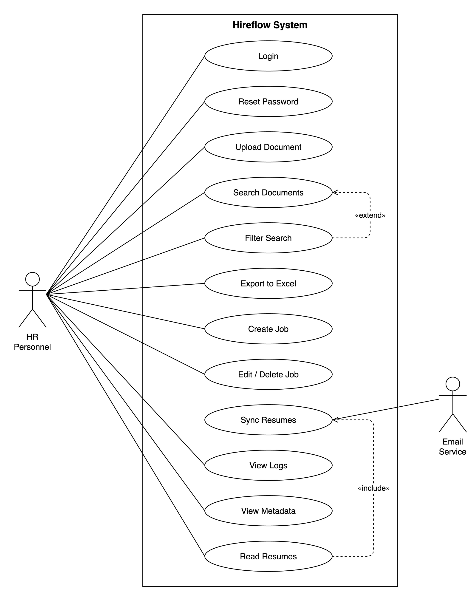
Figure 3.1: Use Case Diagram
The main use cases identified in the SRS are summarised below.
Table 3.3: Summary of Use Cases (UC-01-UC-12)
Use Case | Name | Primary Actor | Summary
UC-01 | Login | HR Personnel | Authenticate with email and password to access the system
UC-02 | Reset Password | HR Personnel | Recover access to a forgotten account via a verification mechanism
UC-03 | Upload Document | HR Personnel | Upload resumes and HR documents for text extraction, indexing, and storage
UC-04 | Search Documents | HR Personnel | Search stored documents and view ranked results
UC-05 | Filter Search | HR Personnel | Refine search results using metadata filters
UC-06 | Export to Excel | HR Personnel | Export results or shortlisted candidates to a spreadsheet
UC-07 | Create Job | HR Personnel | Create a job posting with screening criteria
UC-08 | Edit/Delete Job | HR Personnel | Update or remove an existing job posting
UC-09 | Sync Resumes | Email Service | Fetch and process resume attachments from connected accounts
UC-10 | View Logs | HR Personnel | Review system activity and audit trail
UC-11 | View Metadata | HR Personnel | View extracted document metadata such as skills and experience
UC-12 | Read Resumes | HR Personnel | Read extracted resume content and shortlist or reject candidates
User Stories. The following user stories capture representative goals from the HR user’s perspective:
- US-1 (Search): As an HR user, I want to ask questions about my documents in plain English so that I can find relevant information without remembering exact keywords or filenames.
- US-2 (Screening): As an HR user, I want the system to rank incoming resumes against a job’s required skills and experience so that I can focus on the most relevant candidates first.
- US-3 (Email Sync): As an HR user, I want resumes to be collected automatically from my connected Gmail account so that I do not have to download and upload attachments manually.
- US-4 (Auditing): As an HR user, I want to view an activity log of uploads, searches, and screening actions so that I can audit what happened and when.

3.6 Use Cases Table
To illustrate the full structure of a use case, the User Login flow (UC-01) is documented in detail below, based on the system’s actual JWT-based authentication mechanism.
Table 3.4: Sample Use Case, User Login
Field | Description
Use Case ID | UC-01
Use Case Name | User Login
Primary Actor | Registered HR User
Goal | Authenticate with valid credentials to obtain an authorised session and access protected system features
Preconditions | 1. The system is running and reachable. 2. The user has a registered, active account.
Trigger | The user selects “Sign in” on the login page after entering their credentials.
Main Flow | 1. The user opens the login page. 2. The user enters their email and password. 3. The system verifies the account exists and is active. 4. The system verifies the password against the stored Argon2id hash using timing-safe comparison. 5. The system issues a short-lived access token (30 min) and a refresh token (7 days). 6. The system records the login in the activity log. 7. The user is redirected to the dashboard.
Alternative Flow(s) | 3a/4a. If the credentials are invalid, the system rejects the attempt and returns an authentication error without revealing whether the email or password was wrong. 2a. If the user has forgotten their password, they follow the “Forgot password?” link, invoking UC-02 (Reset Password).
Postconditions | The user holds a valid access/refresh token pair and an authenticated session; the login event is written to the audit trail.
Exceptions | Account disabled leads to access forbidden (403). A malformed or expired token on subsequent requests leads to 401 with a prompt to re-authenticate.
Related Functional Requirement(s) | FR01, FR03

3.7 Development Methodology
Hireflow was built with an incremental, feature-driven process rather than a single-pass waterfall. Scope was fixed early by the SRS, which bounded the work at twenty-two functional requirements and twelve use cases, but the system itself was delivered one tracked feature at a time. Each iteration carried a single feature from implementation through its own tests before the next was started, so a working subset of the platform existed throughout, and integration problems surfaced early instead of piling up at the end. Figure 3.2 sets out the flow.
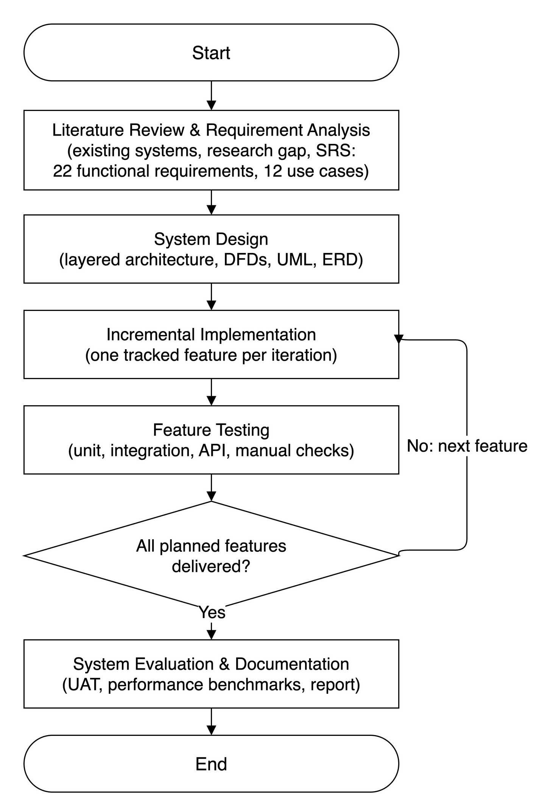
Figure 3.2: Development Methodology Flowchart
The process opens with a literature review and requirement analysis, which together establish the research gap and produce the SRS. System design follows, fixing the layered architecture, the data flow diagrams, the UML models, and the relational schema before any feature is coded. The implementation stage is the iterative core: a feature is built, then exercised by unit, integration, and API tests along with manual checks, and the decision point asks whether every planned feature has been delivered. While features remain, control returns to implementation and the next one begins; that loop is the difference between an incremental model and a sequential one. Once the feature set is complete the system moves to full-system evaluation, covering user-acceptance testing and the performance benchmarks reported in Chapter 6, and finally to documentation.

CHAPTER 4: SYSTEM DESIGN
This chapter turns the requirements set out earlier into a concrete technical design for Hireflow, an AI-powered HR screening and document-retrieval platform. It presents the system’s layered architecture, the flow of data through its ingestion and retrieval pipelines, the structural and behavioural UML models, the relational database schema derived from the implemented data model, and the user-interface design. Each artefact is grounded in the system as actually built. The backend is a FastAPI application organised into strict architectural layers; document processing runs asynchronously on Celery; a hybrid Retrieval-Augmented Generation (RAG) subsystem spans PostgreSQL and ChromaDB; and the frontend is a React single-page application. Between them, these views describe how the system divides responsibilities, enforces access control, and answers natural-language questions with verifiable citations over an organisation’s unstructured documents.

4.1 System Architecture Description & Design
Hireflow follows a layered, service-oriented architecture that separates presentation, application coordination, domain logic, and infrastructure. The design goal is straightforward: business rules should be testable in isolation, infrastructure providers should be swappable, and long-running work should never block the request path.
At the outermost tier, a React 19 single-page application (built with TypeScript, Vite, Tailwind CSS v4 and shadcn/ui) runs in the browser and communicates exclusively through a generated, type-safe SDK. The SDK is produced from the backend’s OpenAPI specification via openapi-ts, so every request and response stays contractually aligned with the server. In production, an nginx reverse proxy serves the compiled static frontend and forwards /api/ traffic to the backend. The data stores remain on a private Docker network with no host-exposed ports.
The FastAPI API layer is the system’s HTTP boundary. Routes are kept thin, five lines or fewer per handler: they validate requests using Pydantic v2 schemas, invoke a service, and serialise the result. Shared concerns are handled here through dependency injection, covering authentication (CurrentUser), role gating (RequireAdmin), and a central error handler that maps domain exceptions to HTTP status codes. Routes never raise HTTPException directly. Instead, services raise typed DomainError subclasses (for example NotFound, Forbidden, FileTooLarge) that the handler translates. The public surface comprises 31 endpoints grouped by tag: authentication, documents, search, RAG, jobs, candidates, users, and activity logs.
Beneath the API sits the service layer, the application’s coordination tier. Around ten services (authentication, document, search, RAG, job, candidate, matching, activity, and others) orchestrate repositories and adapters to fulfil use cases. Services depend only on abstractions: repositories for data access and Protocol-typed adapters for infrastructure. That is why the system is testable. A service can be instantiated in a unit test with in-memory fakes, needing neither a database nor Docker. The domain layer underneath holds pure business rules, such as authorization checks and exception definitions, and imports nothing from infrastructure.
Infrastructure is reached through the adapter layer. Each external capability is defined as a Protocol with one or more concrete implementations, which yields runtime-swappable providers: BlobStorage (MinIO, replaceable by S3 or GCS), VectorStore (ChromaDB), LlmProvider (Anthropic Claude or Ollama), EmbeddingProvider (sentence-transformers, default BAAI/bge-small-en-v1.5), VisionProvider for OCR (Claude, Ollama, or Tesseract), PasswordHasher (Argon2id), and TokenIssuer (JWT). The concrete graph is wired once in a composition root (api/deps.py), where heavyweight resources such as the embedding model and vector store are constructed as process singletons.
The supporting infrastructure comprises PostgreSQL 15 (relational data, plus a generated tsvector column powering lexical full-text search), ChromaDB (vector embeddings for semantic search), Redis 7 (Celery broker, JWT revocation denylist, and one-time password-reset tokens), MinIO (S3-compatible object storage for uploaded files), and the configured LLM provider (Claude) for answer generation and classification fallback.
Two pipelines dominate the system’s behaviour. The ingestion pipeline runs asynchronously in a Celery worker. An upload returns HTTP 201 immediately with status=PENDING; the worker then fetches the blob from MinIO, extracts layout-aware typed elements (via the unstructured library, PyMuPDF, and Tesseract OCR for scanned images), classifies the document, and chunks it with heading- and table-aware rules. Each chunk is contextualised, embedded, and upserted into ChromaDB, while PostgreSQL’s search vector auto-populates. On completion the document reaches status=READY, at which point an on-ready hook can auto-create a candidate from a resume. The RAG pipeline runs inline per request. It retrieves the most relevant chunks (owner-scoped, READY-only), classifies the question’s intent, composes a layered system prompt, and streams the answer from Claude with typed citations. Both pipelines and their interactions are depicted in Figure 4.1.
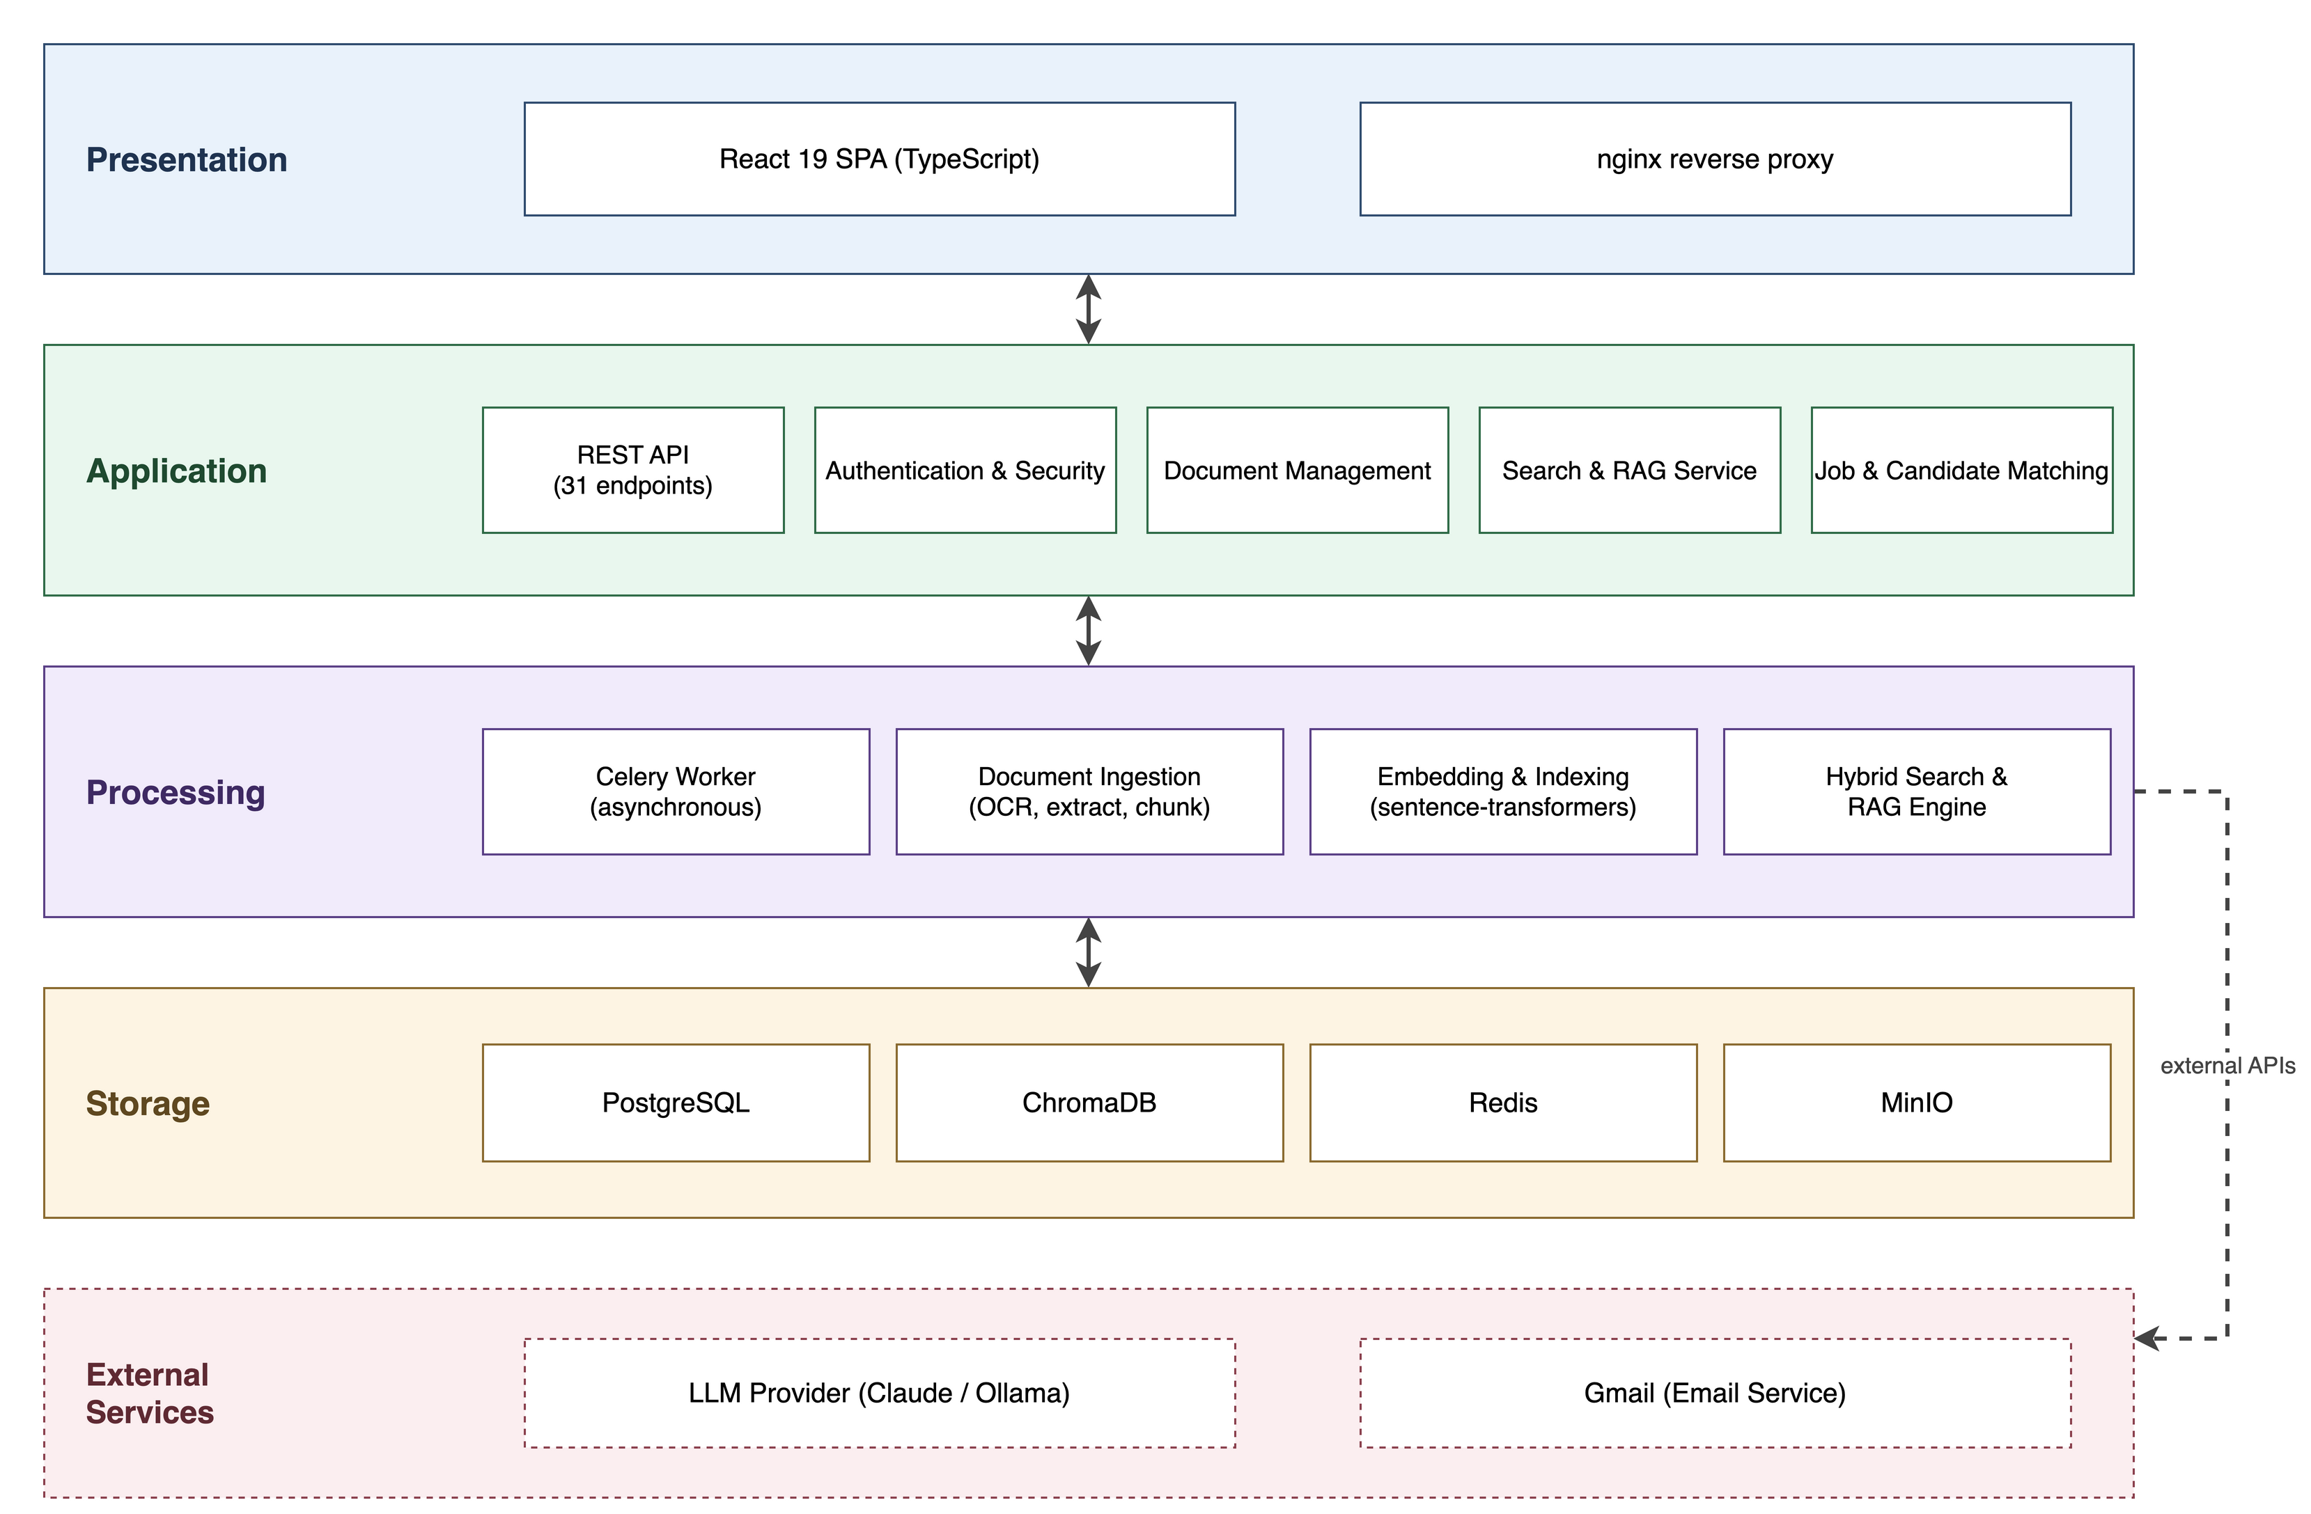
Figure 4.1: System Architecture

4.2 Data Flow Diagrams
Data Flow Diagrams (DFDs) model the system as a network of processes that transform data, the external entities that supply and consume it, and the data stores that persist it. They are presented in progressively decomposed levels. Level 0, the context diagram, treats the entire system as a single process to fix its boundary and external interactions. Level 1 decomposes that process into the major functional subsystems. Level 2 then expands a chosen subsystem into its constituent steps.
The Level 0 (context) diagram situates Hireflow as one process bounded by its external actors. The primary external entity is the HR user (and the privileged Administrator), who uploads documents, issues search and natural-language queries, manages jobs and candidates, and receives ranked results and cited answers. Two further external entities appear: the Gmail service, from which candidate emails and attachments are synced, and the LLM provider (Anthropic Claude), which receives composed prompts and returns generated answers. This level establishes what crosses the system boundary without revealing internal structure, as shown in Figure 4.2.
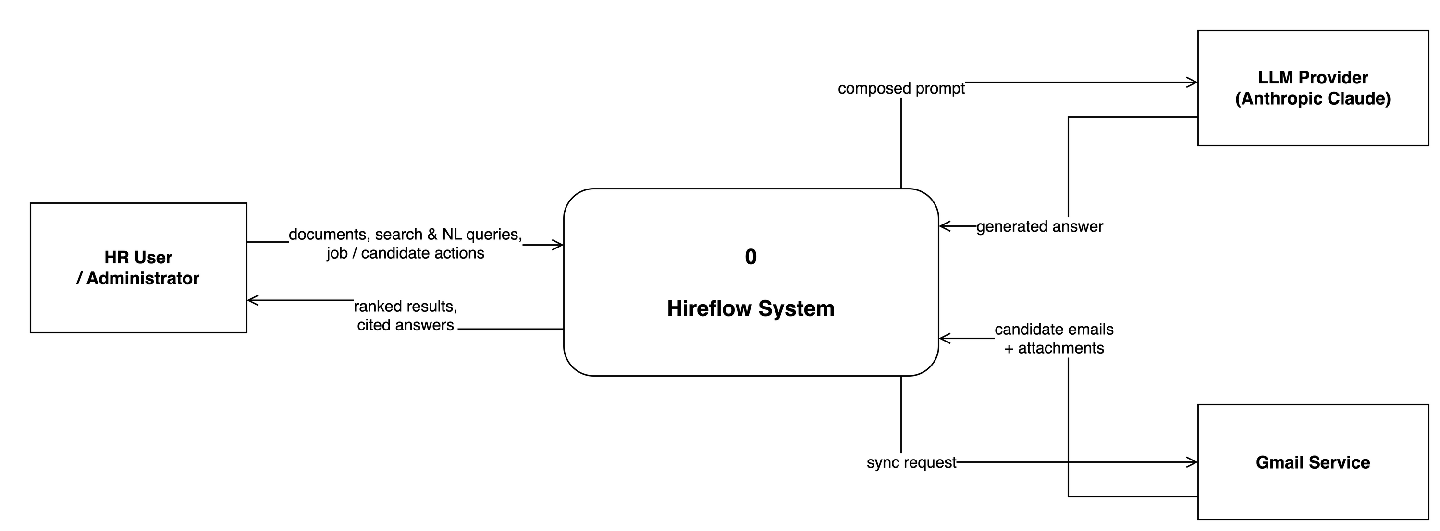
Figure 4.2: DFD Level 0 (Context Diagram)
The Level 1 diagram decomposes the single context process into the system’s principal subsystems and the data stores between them: authentication and session management; document ingestion and storage; the hybrid search and RAG engine; job and candidate management with resume-to-job matching; Gmail synchronisation; and activity logging. It shows how an uploaded file flows from the API into object storage and the asynchronous processing pipeline, how extracted text and metadata land in the relational and vector stores, and how a query fans out across those stores before results are fused and returned. The major data stores are made explicit here: Users, Documents, Candidates, Jobs, Applications, the vector collection, and the activity log (Figure 4.3).
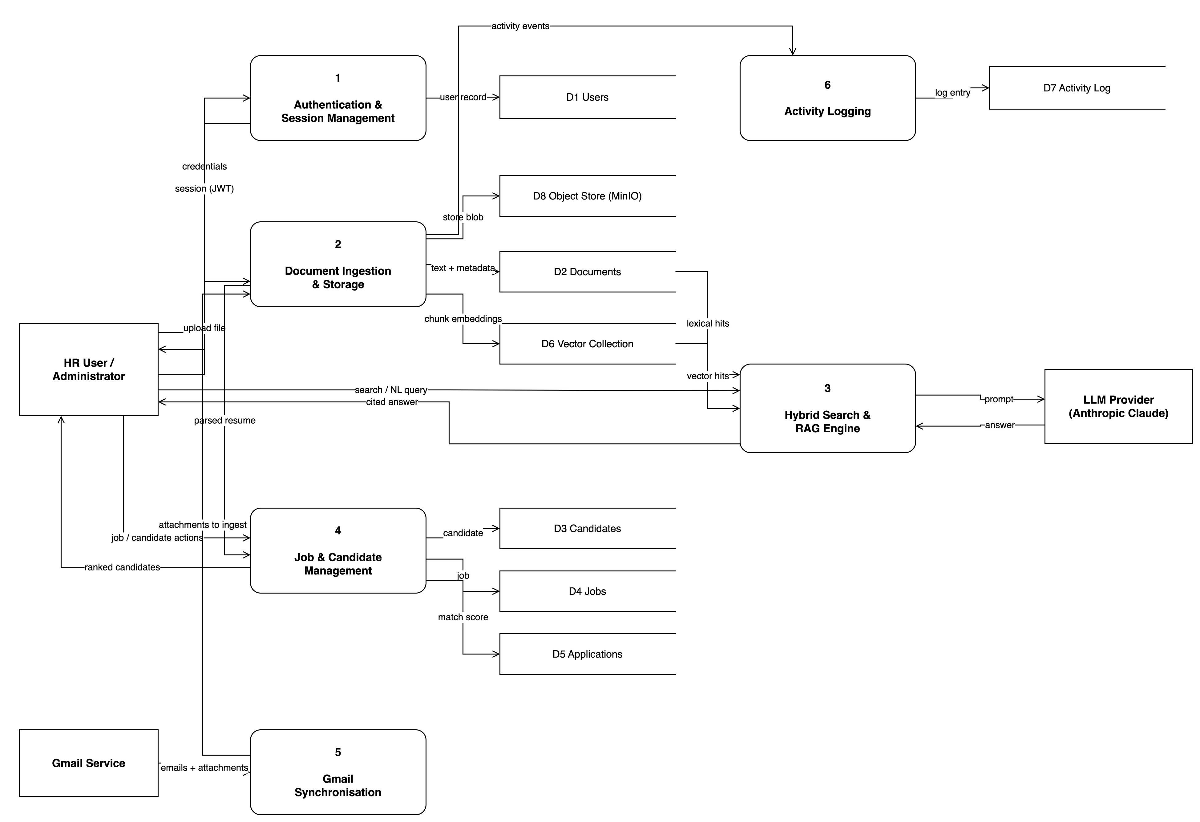
Figure 4.3: DFD Level 1
The Level 2 diagram drills into the document-processing and retrieval subsystem, the most data-intensive part of the platform. It expands both the ingestion pipeline and the query pipeline into their constituent processes, exposing how chunks, embeddings, and ranked hits move between the worker, PostgreSQL, ChromaDB, and the LLM provider. The individual ingestion stages are documented in Table 5.2 (Figure 4.4).
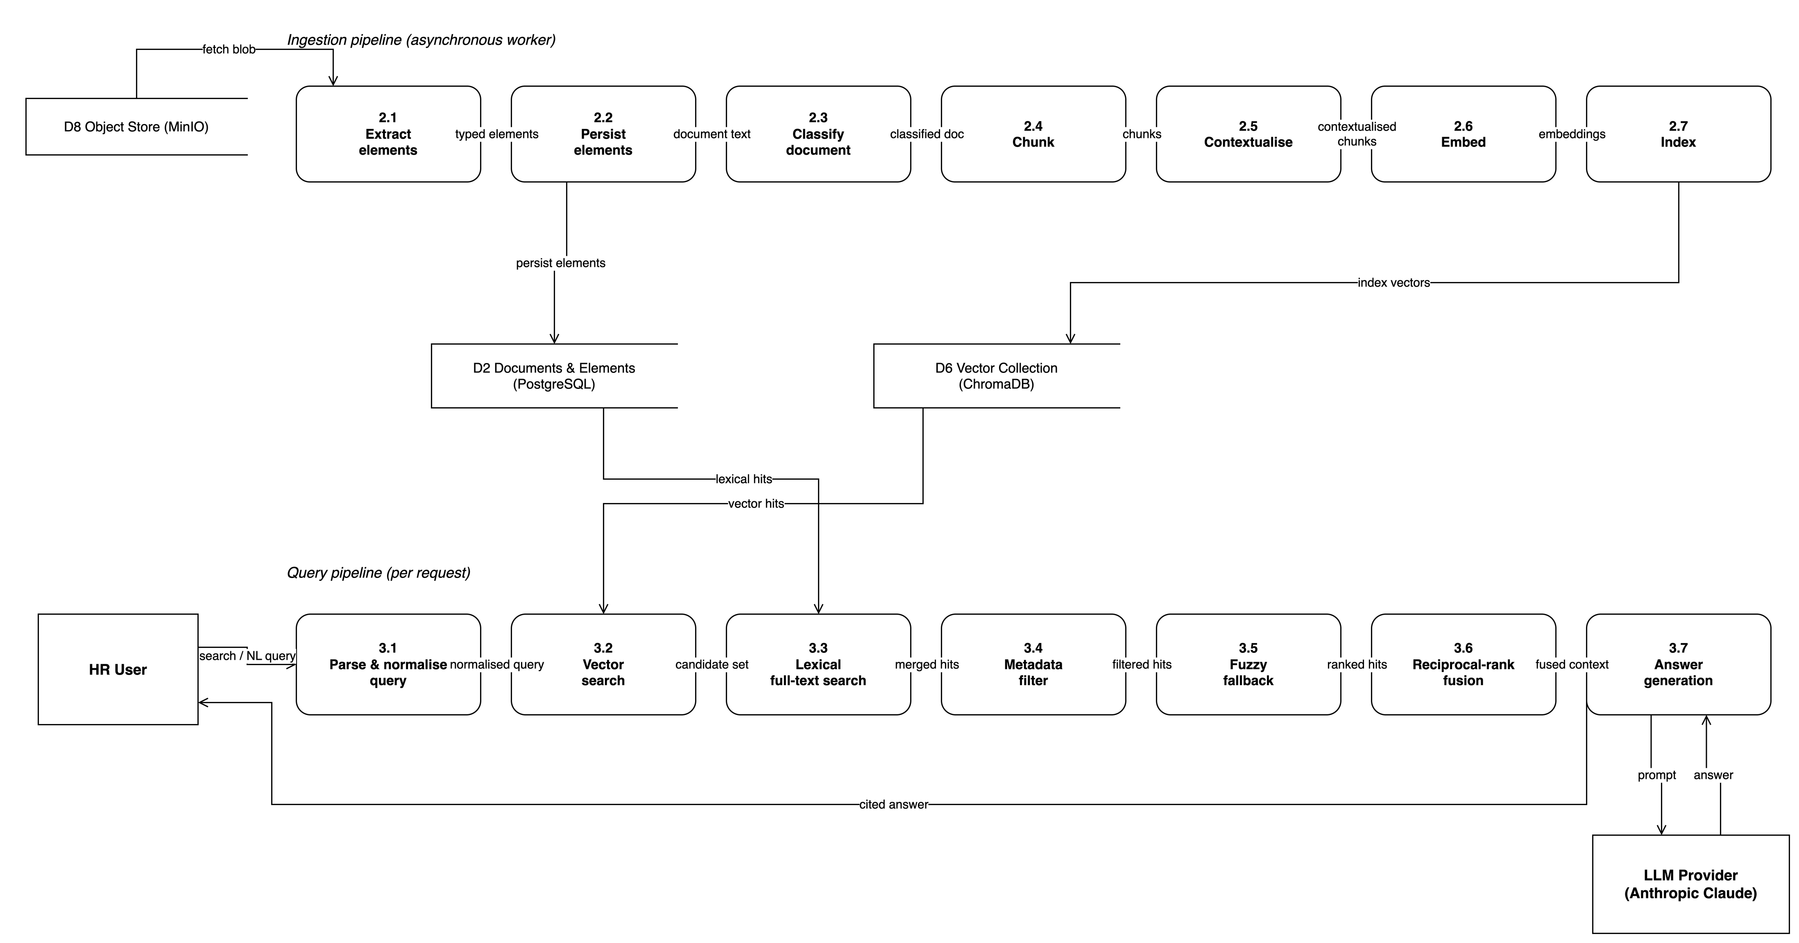
Figure 4.4: DFD Level 2

4.3 UML Diagrams
The Unified Modeling Language (UML) captures the system’s static structure and dynamic behaviour. The class, activity, component, and sequence views of Hireflow are presented below.

4.3.1 Class Diagram
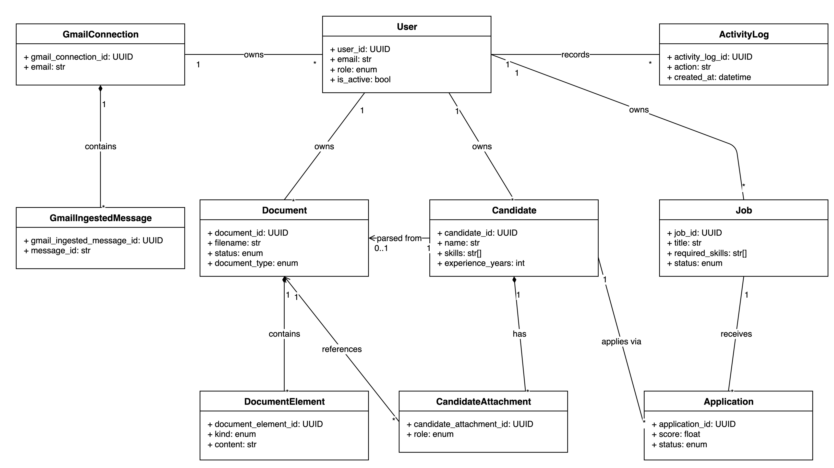
Figure 4.5: Class Diagram

4.3.2 Activity Diagram
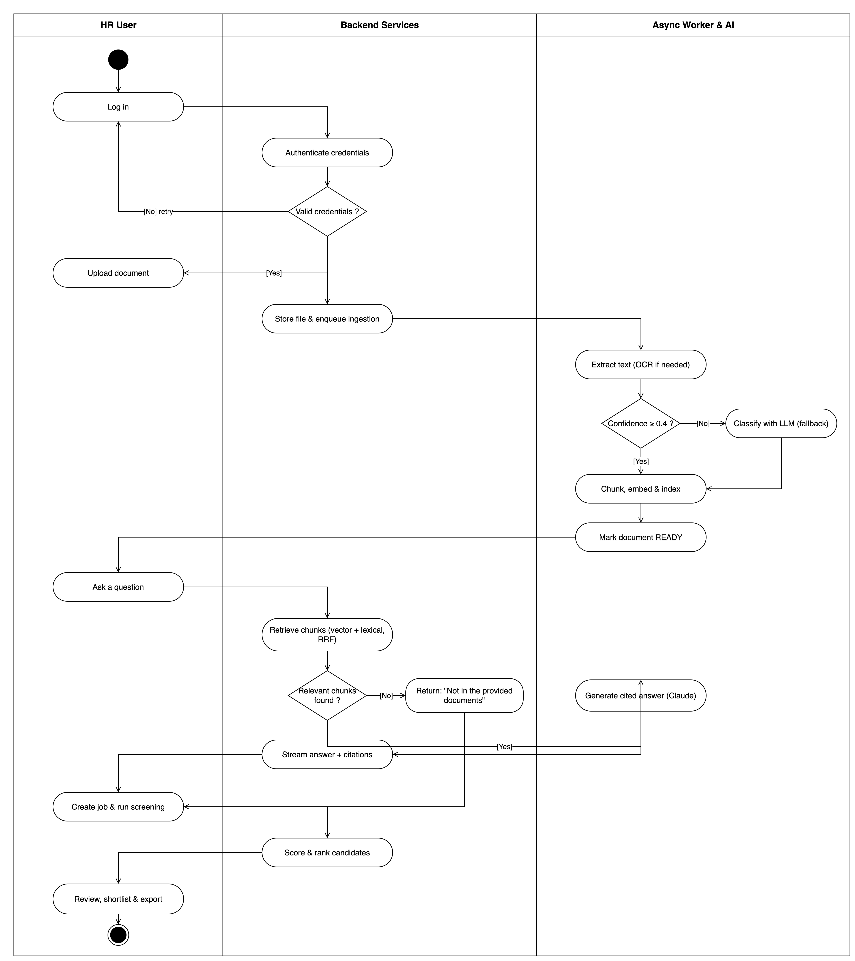
Figure 4.6: Activity Diagram

4.3.3 Component Diagram
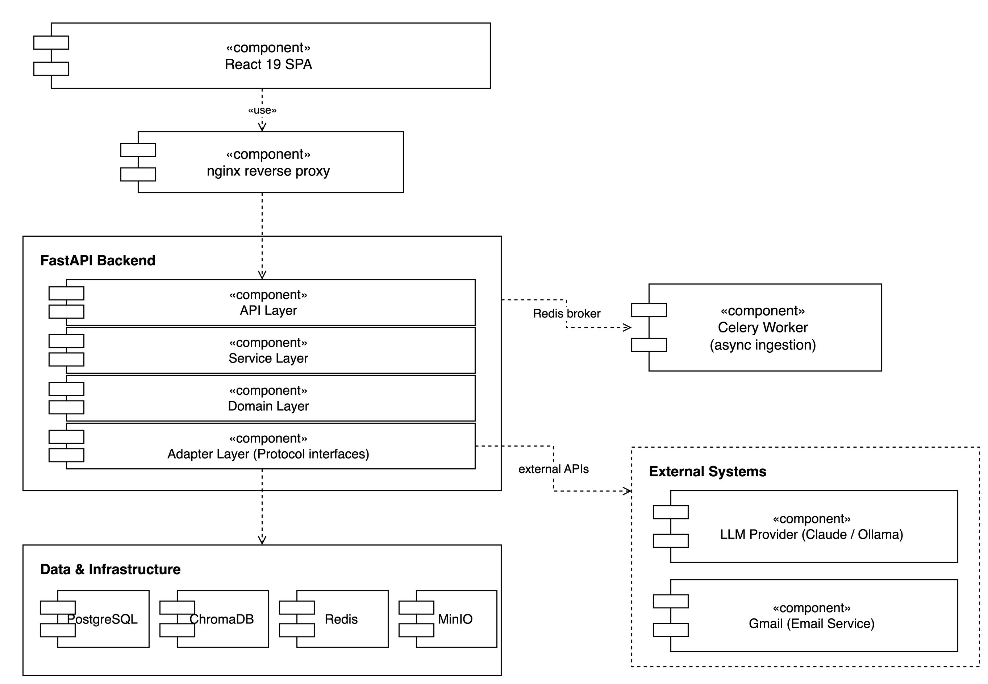
Figure 4.7: Component Diagram

4.3.4 Sequence Diagram
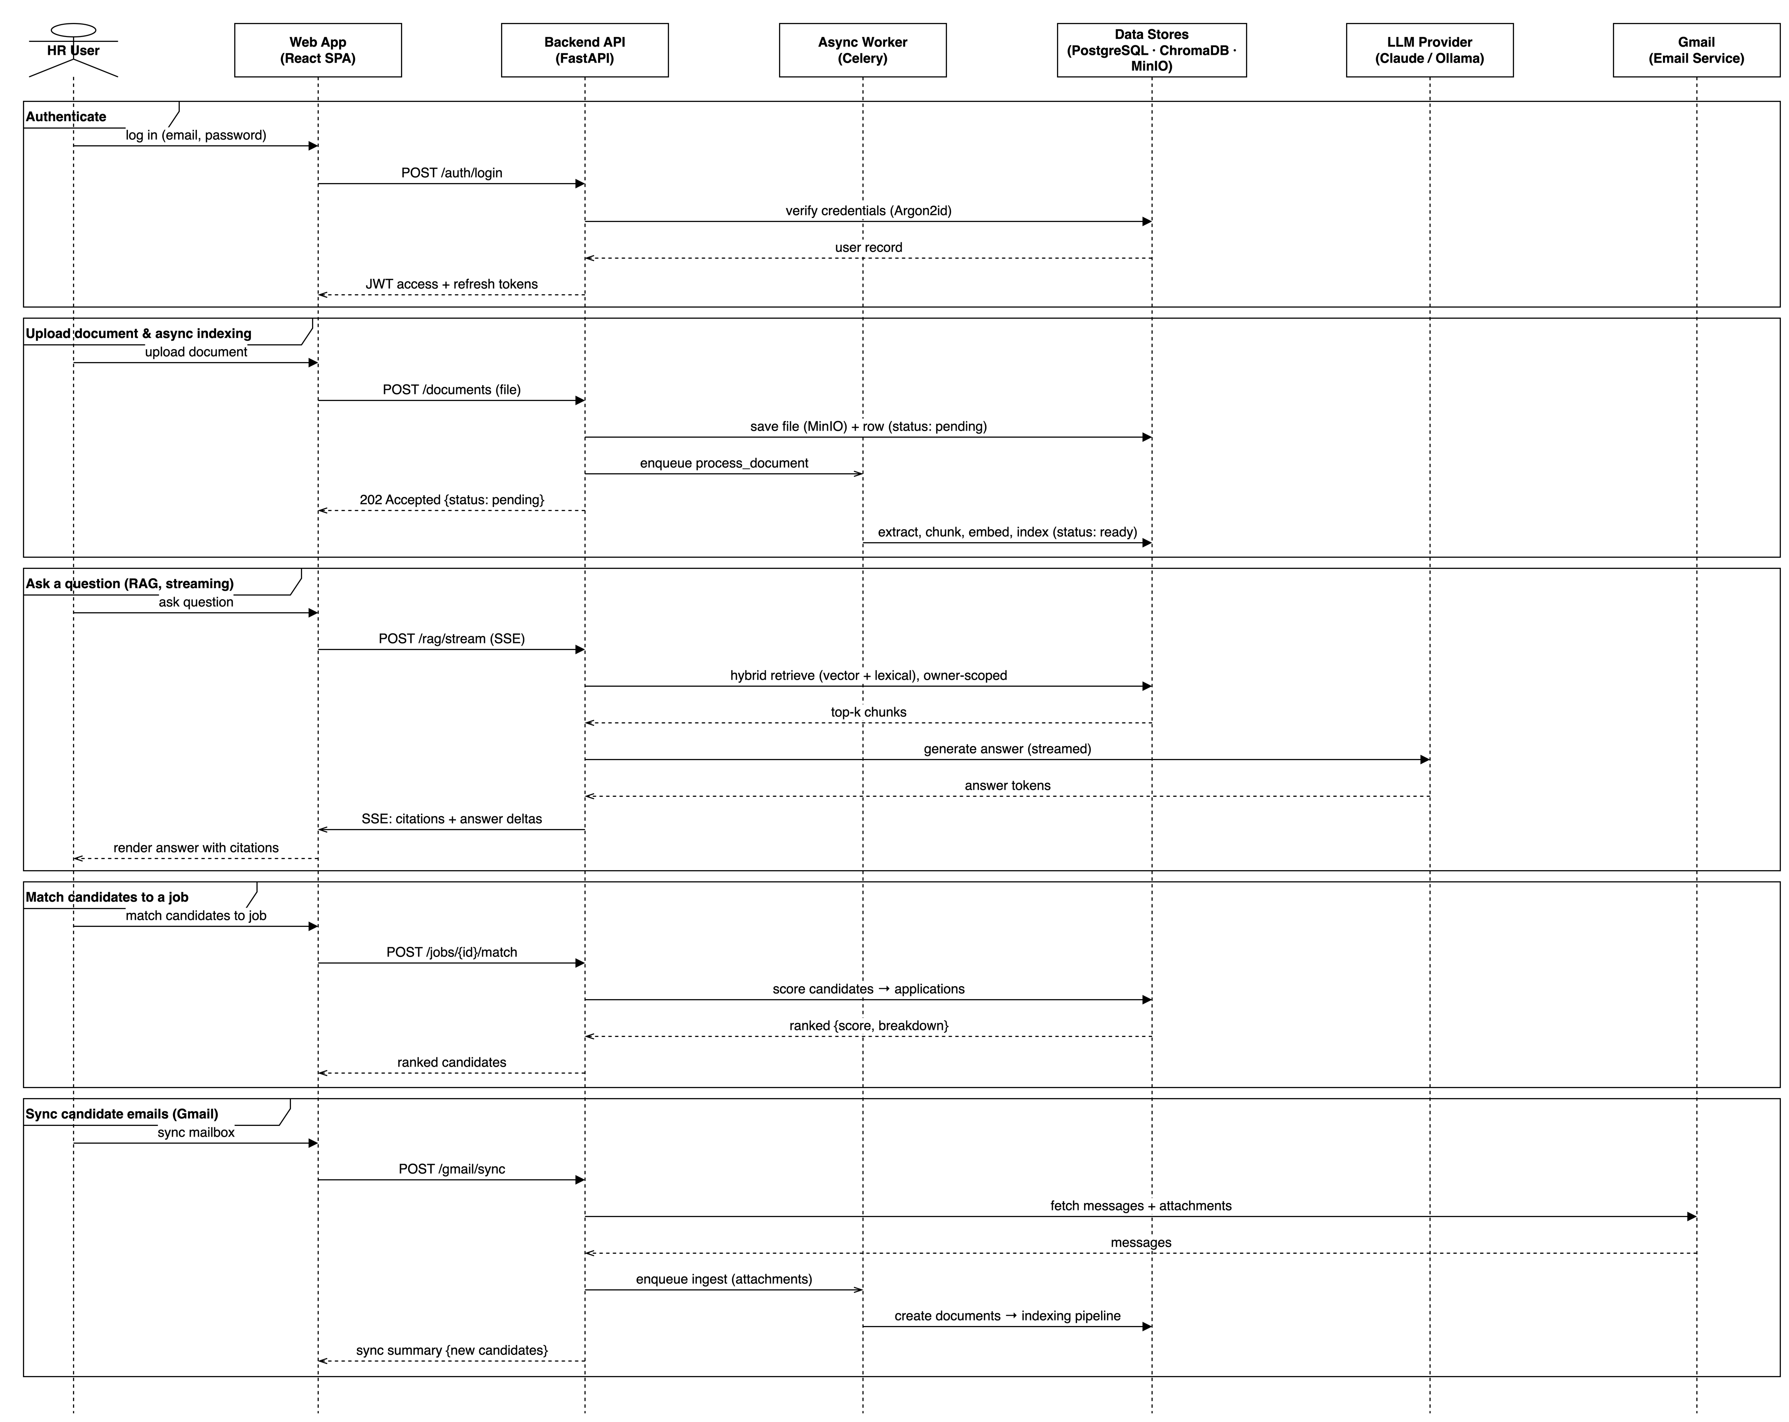
Figure 4.8: Sequence Diagram (Streaming RAG Query)

4.3.5 State Machine Diagram
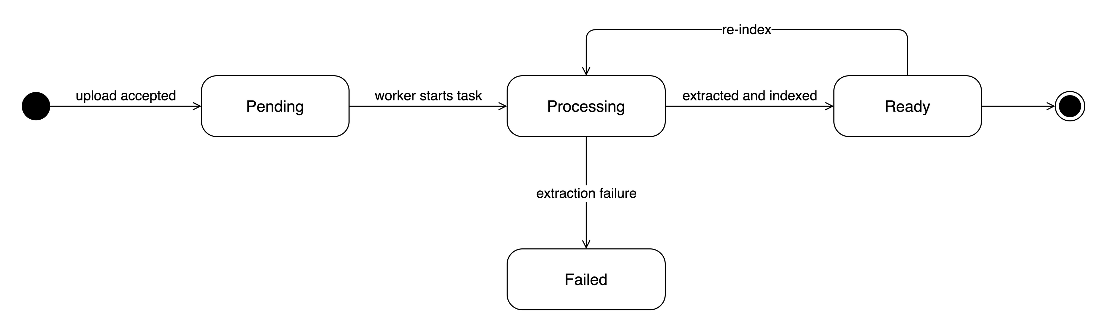
Figure 4.9: Document Status State Machine

4.4 Database Design (ERD, Schema, Data Dictionary)
The persistent state of Hireflow lives in a PostgreSQL 15 relational schema, complemented by a ChromaDB vector store for embeddings. This section describes the entity relationships, provides a schema overview, and documents the core tables as data dictionaries. The relational design derives directly from the implemented SQLAlchemy models.
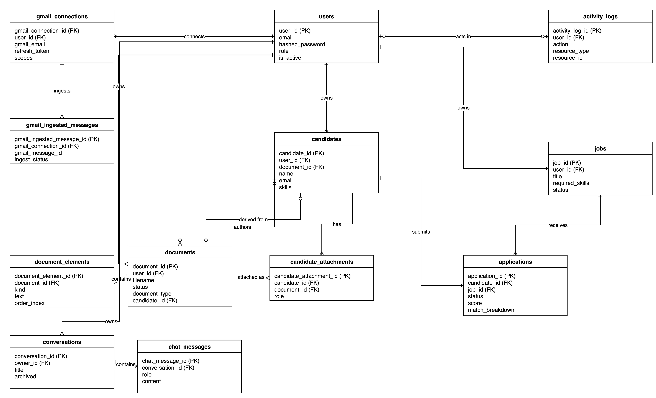
Figure 4.10: Entity-Relationship Diagram
Schema overview. Every table has a UUID primary key named after the table (for example user_id, document_id) and created_at / updated_at timestamp columns from shared mixins. PostgreSQL-native features are used throughout: enumerated types (user_role, document_status, document_type, job_status, application_status, attachment_role, and others), array columns (required_skills, skills, education, scopes), a JSONB metadata column on documents, and a database-generated, weighted tsvector column (search_tsv) that indexes filename (weight A), skills (weight B), and body text (weight C) for lexical retrieval via a GIN index. Sensitive fields such as full_name, phone, and Gmail refresh_token are stored using an encrypted column type. The four core tables are documented below.
Table 4.1: users Data Dictionary
Field | Type | Constraints | Description
user_id | UUID | PK | Unique identifier
email | VARCHAR(320) | UNIQUE, NOT NULL, INDEX | Login email address
hashed_password | VARCHAR(255) | NOT NULL | Argon2id password hash
full_name | Encrypted string | NULLABLE | User’s display name (encrypted at rest)
role | ENUM(hr, admin) | NOT NULL, DEFAULT hr | Authorisation role
is_active | BOOLEAN | NOT NULL, DEFAULT true | Whether the account is enabled
created_at | TIMESTAMPTZ | NOT NULL, DEFAULT now() | Creation timestamp
updated_at | TIMESTAMPTZ | NOT NULL, DEFAULT now() | Last-modified timestamp
Table 4.2: documents Data Dictionary
Field | Type | Constraints | Description
document_id | UUID | PK | Unique identifier
user_id | UUID | FK → users.user_id, ON DELETE CASCADE, NOT NULL, INDEX | Owning HR user
filename | VARCHAR(512) | NOT NULL | Original uploaded file name
mime_type | VARCHAR(128) | NOT NULL | Detected MIME type
size_bytes | BIGINT | NOT NULL | File size in bytes
storage_key | VARCHAR(1024) | UNIQUE, NOT NULL | MinIO object key
status | ENUM(pending, processing, ready, failed) | NOT NULL, DEFAULT pending, INDEX | Processing lifecycle state
document_type | ENUM(resume, report, contract, letter, other) | NULLABLE | Classified document type
extracted_text | TEXT | NULLABLE | Full extracted body text
metadata | JSONB | NULLABLE | Extracted metadata (skills, experience, etc.)
extraction_version | VARCHAR(32) | NULLABLE | Extractor version stamp for re-indexing
chunking_version | VARCHAR(32) | NULLABLE | Chunking-rules version stamp
embedding_model_version | VARCHAR(128) | NULLABLE | Embedding model used at last index
candidate_id | UUID | FK → candidates.candidate_id, ON DELETE SET NULL, NULLABLE, INDEX | Linked authoring candidate
search_tsv | TSVECTOR | GENERATED, GIN INDEX | Weighted full-text search vector
created_at / updated_at | TIMESTAMPTZ | NOT NULL | Audit timestamps
Table 4.3: jobs Data Dictionary
Field | Type | Constraints | Description
job_id | UUID | PK | Unique identifier
user_id | UUID | FK → users.user_id, ON DELETE CASCADE, NOT NULL, INDEX | Owning HR user
title | VARCHAR(255) | NOT NULL | Job title
description | TEXT | NOT NULL | Full job description
required_skills | VARCHAR[] | NOT NULL, DEFAULT {} | Mandatory skills
preferred_skills | VARCHAR[] | NULLABLE | Desirable skills
education_level | VARCHAR(100) | NULLABLE | Minimum education requirement
experience_min | INTEGER | NOT NULL, DEFAULT 0 | Minimum years of experience
experience_max | INTEGER | NULLABLE | Maximum years of experience
location | VARCHAR(255) | NULLABLE | Job location
status | ENUM(draft, open, closed, archived) | NOT NULL, DEFAULT draft, INDEX | Job posting state
created_at / updated_at | TIMESTAMPTZ | NOT NULL | Audit timestamps
Table 4.4: candidates Data Dictionary
Field | Type | Constraints | Description
candidate_id | UUID | PK | Unique identifier
user_id | UUID | FK → users.user_id, ON DELETE CASCADE, NOT NULL, INDEX | Owning HR user
document_id | UUID | FK → documents.document_id, ON DELETE SET NULL, UNIQUE, NULLABLE, INDEX | Resume the candidate was parsed from
name | VARCHAR(255) | NULLABLE | Candidate name
email | VARCHAR(320) | NULLABLE, partial UNIQUE per owner | Candidate email
phone | Encrypted string | NULLABLE | Candidate phone (encrypted at rest)
skills | VARCHAR[] | NOT NULL, DEFAULT {} | Extracted skills
experience_years | INTEGER | NULLABLE | Total years of experience
education | VARCHAR[] | NULLABLE | Education history entries
supplementary_keywords | VARCHAR[] | NULLABLE | Keywords from non-resume attachments
summary | VARCHAR(1024) | NULLABLE | One-sentence recruiter brief
created_at / updated_at | TIMESTAMPTZ | NOT NULL | Audit timestamps
Alongside the relational schema, ChromaDB holds one collection per embedding model (named documents_<model_slug>). Each stored chunk is keyed as <document_id>:<chunk_index> and carries its embedding vector, the chunk text, and metadata (document_id, user_id, chunk_index, chunk_kind, section_heading, page_number, chunking_version, plus flattened document-level fields such as filename and document_type). This denormalised metadata enables owner-scoped, type-filtered vector retrieval without a round-trip to PostgreSQL.

4.5 UI/UX Design
The user interface is a React 19 single-page application written in TypeScript and built with Vite. Its design philosophy is a clean, professional, information-dense workspace suited to HR personnel who work with large document sets and need results at a glance. The visual layer is built on Tailwind CSS v4 utility classes composed into accessible shadcn/ui primitives (backed by Base UI), which gives a consistent component vocabulary across every screen: cards, dialogs, tables, badges, tooltips, and scroll areas. The application supports light and dark theming. All data-bearing components consume the auto-generated, type-safe API SDK through TanStack Query, so loading, empty, and error states are handled uniformly and no screen relies on mock data.
Navigation is organised around the primary HR workflows, each a dedicated page wired to the real API: a Dashboard overview, Documents management (upload, list, in-app preview, metadata, and delete), Search (combining hybrid keyword/semantic search with a streaming RAG chat), Jobs (create, edit, and match candidates), Candidates (a screening list with match scores), Logs (the activity audit trail), and Settings (profile and password). Authentication is handled transparently. An AuthProvider hydrates the current user on mount, and a client interceptor attaches the bearer token and silently refreshes it on expiry via a single-flight retry, so the user is never spuriously logged out mid-task.
Two screens embody the system’s differentiating design work. The Documents page provides drag-and-drop upload with real-time status badges that follow the document status lifecycle shown in Figure 4.9, giving users immediate feedback while indexing happens out-of-band. The Search page implements a conversational layout: the input is pinned to the bottom of the card, messages scroll within a fixed viewport, and assistant answers render as GitHub-flavoured Markdown (tables, lists, and emphasis) with a typing indicator and blinking cursor during streaming. Most importantly, inline citation chips are parsed from the answer text and matched against source documents. Hovering a chip reveals the filename, section heading, and snippet; clicking it scrolls the corresponding source card into view with a highlight flash, making every generated claim traceable to its evidence. Representative screens are shown in Figures 4.11 through 4.15.
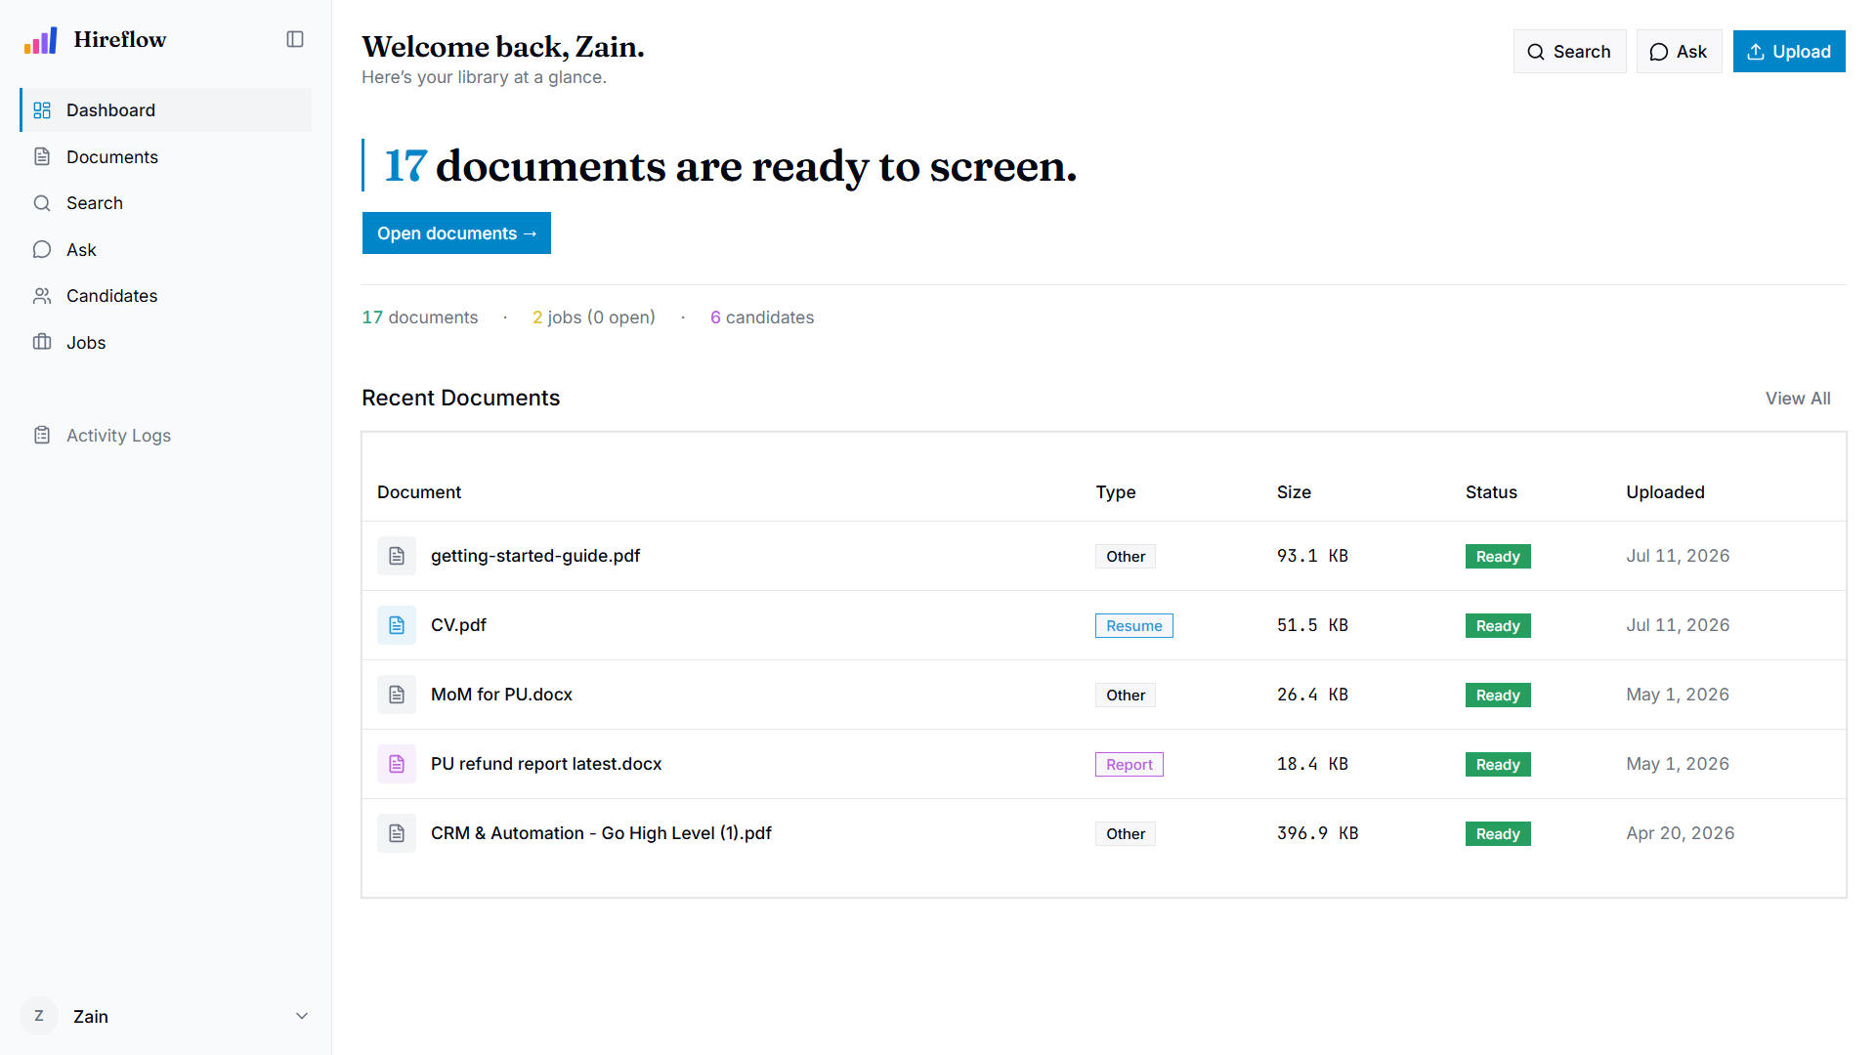
Figure 4.11: Dashboard overview
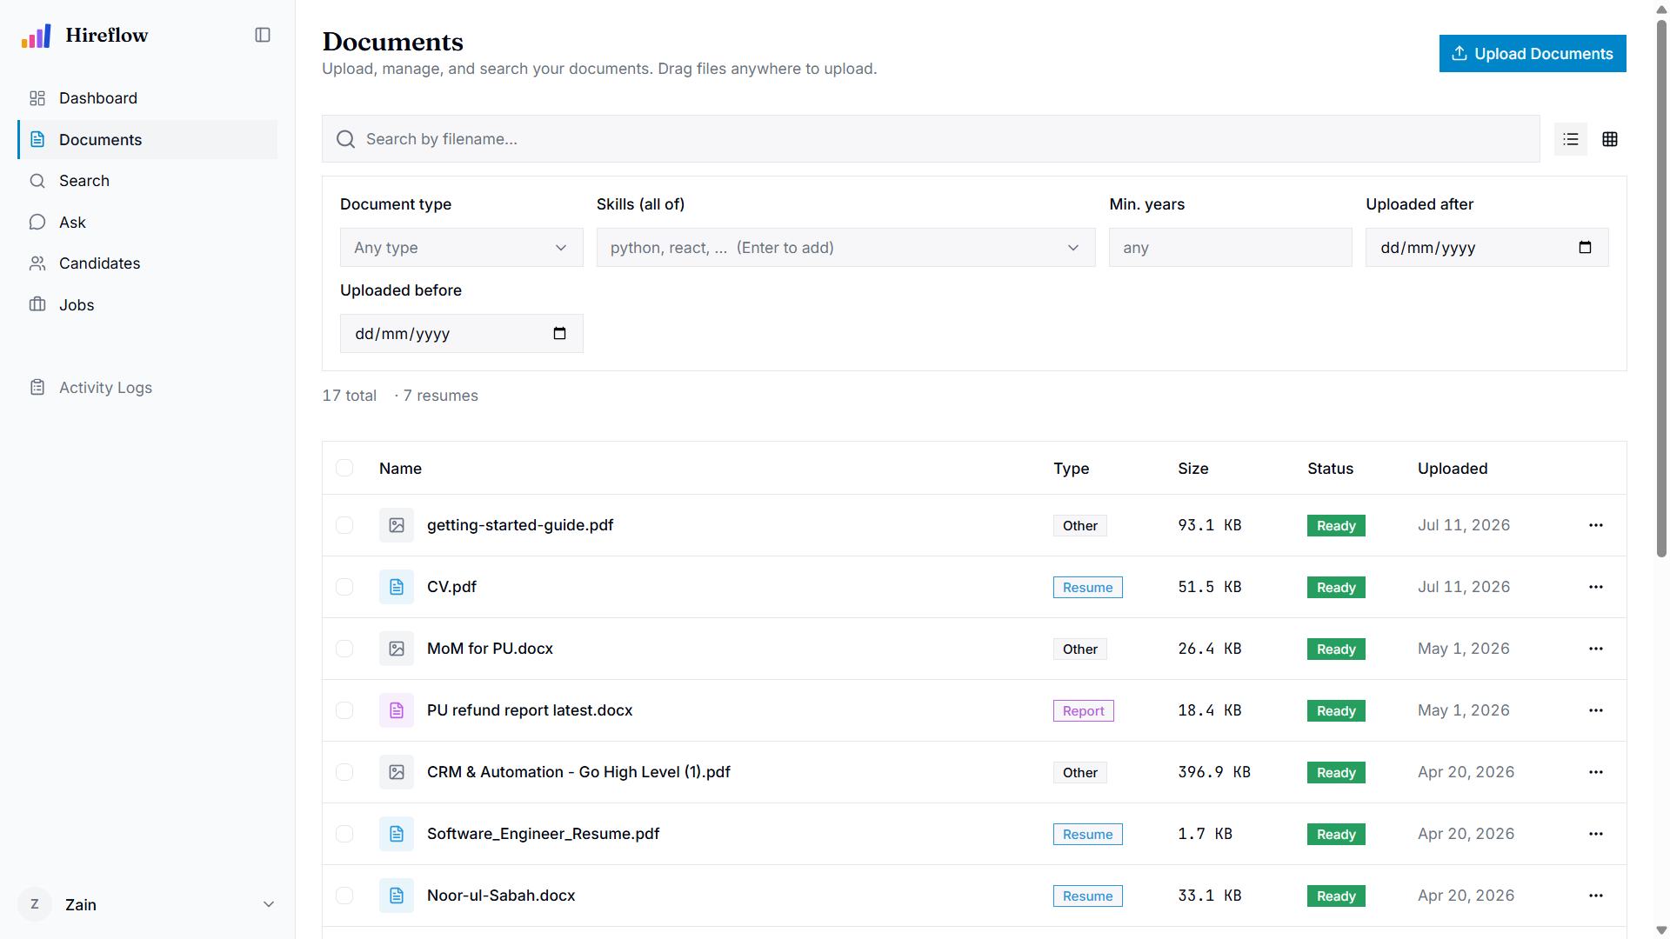
Figure 4.12: Documents management with upload and processing status
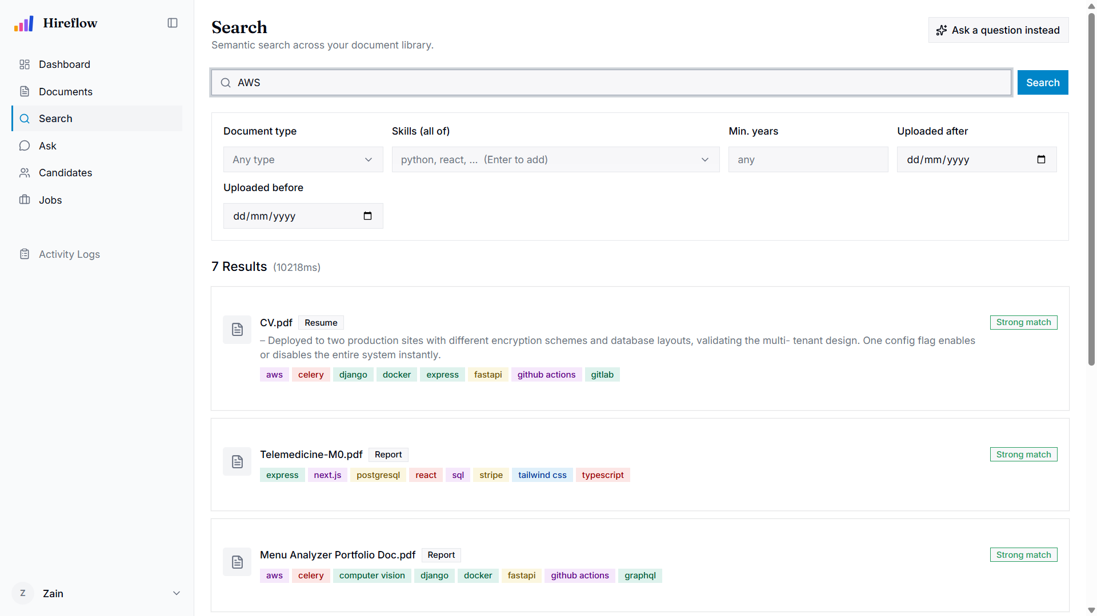
Figure 4.13: Semantic search across the document library with match scores and skill filters
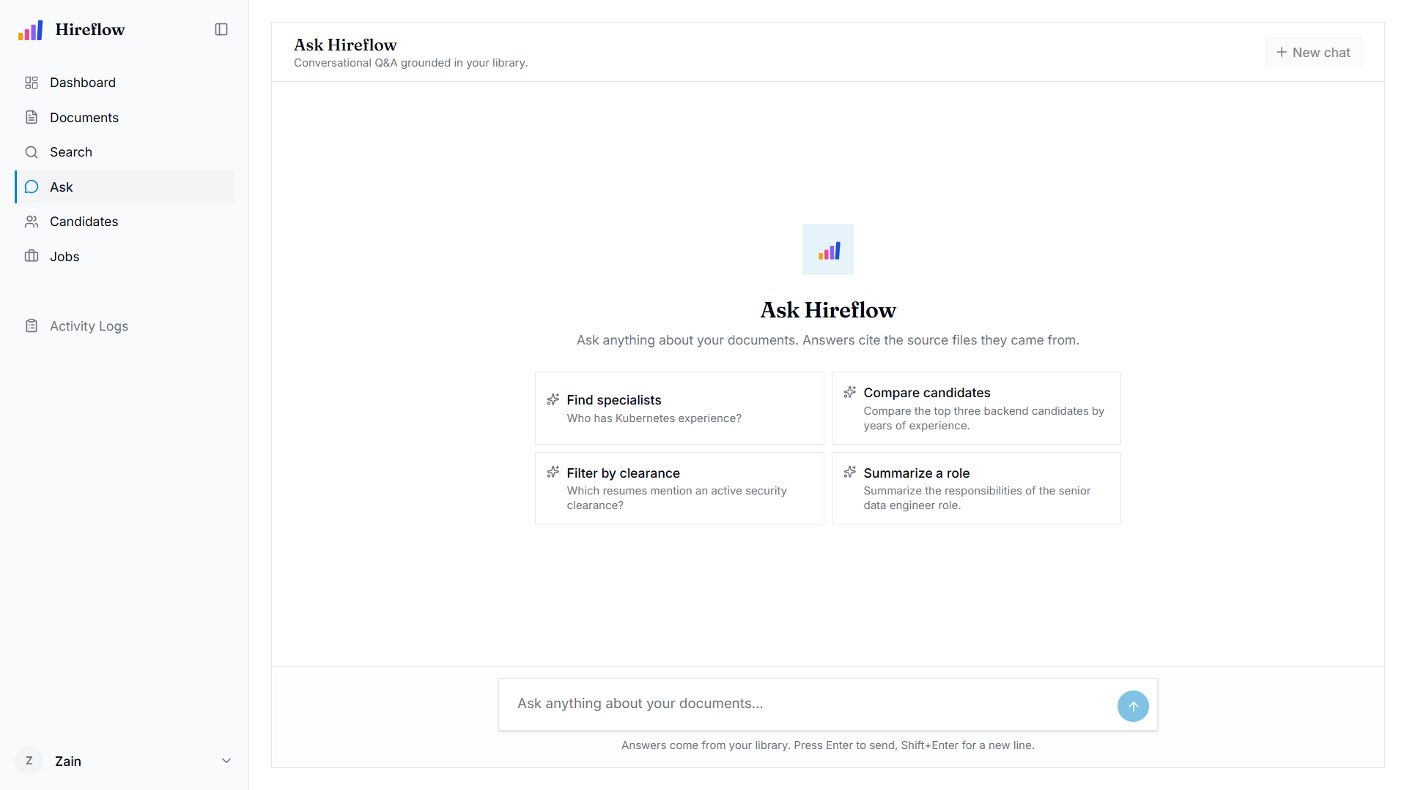
Figure 4.14: Ask Hireflow, conversational question answering grounded in the library with source citations
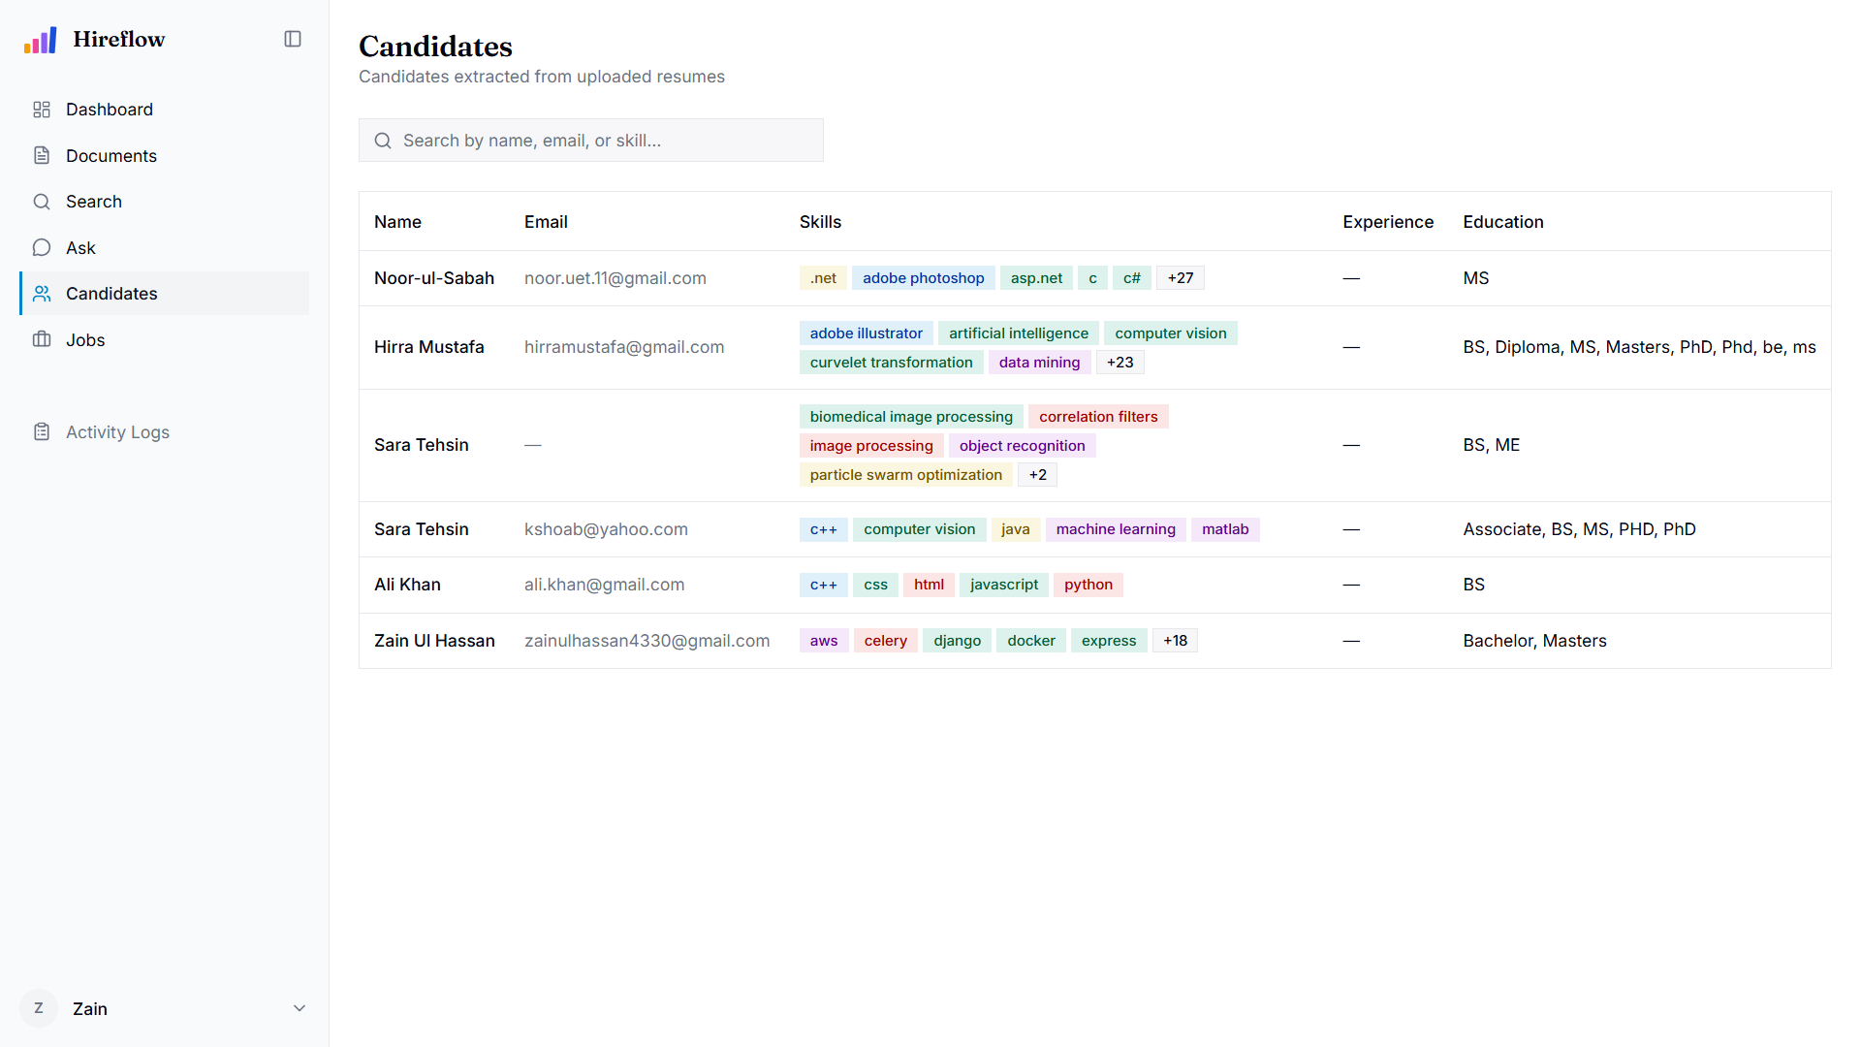
Figure 4.15: Candidate screening list with match scores

CHAPTER 5: IMPLEMENTATION
This chapter records how the Hireflow platform was actually built from the architecture set out in the previous chapter. It walks through the local development environment and the way each service is started, the layered backend and the document-processing and RAG pipelines that form the core of the system, a handful of excerpts from the working codebase, and the database implementation across PostgreSQL and ChromaDB. Throughout, the focus stays on the system as it runs, not on how it was once imagined.

5.1 Development Environment Setup
Development targets a small cluster of containerised backing services alongside two application processes, the FastAPI API and a Celery worker, plus the Vite frontend dev server. The backing stores (PostgreSQL 15, Redis 7, ChromaDB, and MinIO) run under Docker Compose. The Python and Node processes, by contrast, run directly on the host, which keeps reloads fast during development.
Dependencies and the virtual environment on the backend are managed with uv; the frontend relies on npm with Vite. A typical bring-up, reproduced from the project guide, proceeds as follows:
# 1. Backing services (Docker)
docker compose up -d postgres redis chromadb minio
# 2. Backend API (from backend/)
uv sync
uv run uvicorn app.main:app --reload --port 8090
# 3. Celery worker (from backend/, separate terminal)
uv run celery -A app.worker.celery_app worker --loglevel=info
# 4. Frontend (from frontend/)
npm install
npm run dev # Vite dev server on :5173
npm run generate-api # regenerate the typed API client from OpenAPI
First-time provisioning is wrapped in a make setup target, which installs dependencies, creates .env, starts the services, runs the Alembic migrations, and seeds the initial admin user; make dev then runs the API, worker, and frontend together. Configuration lives in one place, core/config.py, built on pydantic-settings so that a missing required variable fails fast. The most important of these is JWT_SECRET_KEY, which must be at least 32 characters. The development topology, with host ports exposed for convenience, is summarised below.
Table 5.1: Development Environment Services and Ports
Component | Runtime | Port | Purpose
Vite dev server | Host (npm) | 5173 | Frontend (React + TypeScript)
FastAPI API | Host (uvicorn) | 8090 | HTTP API under /api
Celery worker | Host (celery) | N/A | Background ingestion / re-index tasks
PostgreSQL 15 | Docker | 5432 | Relational store + full-text search
Redis 7 | Docker | 6379 | Token denylist, reset tokens, Celery broker
ChromaDB | Docker | 8000 | Vector store (chunk + candidate-summary embeddings)
MinIO | Docker | 9000 / 9001 | S3-compatible object storage (originals + viewables)
Production is far more closed. Under docker-compose.prod.yml only nginx port 80 is exposed. Nginx serves the built frontend and reverse-proxies /api/ to the backend, while every data store sits on a private Docker network behind password and fail-fast guards.

5.2 Implementation Details

5.2.1 Layered Backend
The backend follows a strict layered architecture that keeps business rules independent of infrastructure. Each layer has an explicit import contract: domain/ holds pure business rules and exceptions (stdlib only); models/ holds the SQLAlchemy 2 ORM classes; schemas/ holds Pydantic v2 request/response DTOs; repositories/ encapsulate data access; adapters/ provide Protocol definitions with swappable concrete implementations (password hashing, JWT, object storage, vector store, OCR/vision, LLM); services/ coordinate the application logic; and api/routes/ expose thin HTTP handlers (target ≤ 5 lines each). One invariant matters above the rest: services never raise HTTPException. They raise DomainError subclasses, and a single error handler in api/error_handlers.py maps those to HTTP status codes, so that NotFound becomes a 404, FileTooLarge a 413, and UnsupportedFileType a 415. Adapters are wired to services in a composition root, api/deps.py, which exposes Annotated dependency aliases (DocumentServiceDep, RagServiceDep, CurrentUser, RequireAdmin, etc.) consumed by routes.

5.2.2 Request Validation and Error Handling
Every request is checked before it reaches business logic, and the checks sit in layers rather than in the handlers. Request bodies are Pydantic v2 schemas, so field rules such as minimum and maximum lengths, allowed enumerated values and required fields are enforced by the schema rather than by code in the route. Query parameters carry their own bounds at the route: a listing endpoint accepts a page size between one and one hundred and a non-negative offset, so a client cannot ask for an unbounded page. Uploads are guarded twice, once on size against a configured ceiling of ten megabytes and once on media type against an allowlist, and both guards run before the file is stored.
Access is checked on the same path. Protected routes depend on the current authenticated user, and administrator-only routes sit behind a separate guard. Beyond that, every service scopes its queries to the owner of the record. A request for something belonging to another user is answered as though the record does not exist, rather than as a refusal, because a refusal would confirm that the record is real. The same reasoning applies when linking records across owners.
Failures are handled in one place. Services never raise HTTP errors of their own; they raise domain exceptions, and a single handler translates those into status codes and into one response shape for the whole API, carrying a machine-readable code, a human-readable message, and optional details. A schema validation failure is reported as a 422 that lists the offending field and the reason, so a client can point at the input that was wrong. Anything unanticipated becomes a 500 with the detail logged on the server and kept out of the response. Table 5.2 lists the mapping.
Table 5.2: Domain Error to HTTP Status Mapping
Domain error | HTTP status | Raised when
Invalid credentials | 401 | Email or password is wrong. An unknown address returns the same shape, so accounts cannot be enumerated
Invalid token | 401 | Access or refresh token is missing, expired, or has been revoked
Account disabled | 403 | Credentials are valid but the account is deactivated
Forbidden | 403 | Authenticated, but the route requires a role the user does not hold
Not found | 404 | The record is missing, or belongs to another user
Document not indexed | 404 | Similar documents were requested for a document with no vector yet
Email already registered | 409 | Sign-up used an address that already has an account
Invalid status transition | 409 | An application was moved to a status it cannot reach from its current one
Resume already attached | 409 | The resume is already linked to a candidate
File too large | 413 | Upload exceeds the configured size limit
Unsupported file type | 415 | Media type is outside the upload allowlist
LLM rate limited | 429 | The language model provider refused for rate reasons; the response carries a retry delay
Gmail authorisation error | 400 | The Gmail OAuth exchange failed
Service unavailable | 503 | A dependency, or the language model provider, could not be reached
LLM timeout | 504 | The provider accepted the request but did not answer in time
Validation error | 422 | The request body or parameters failed schema validation

5.2.3 Ingestion Pipeline
Ingestion is the path a file travels from the moment it is uploaded to the moment it becomes searchable and answerable. It runs asynchronously in the Celery worker so that the interface never blocks: the upload endpoint stores the raw file in MinIO, creates a document row with status = PENDING, returns HTTP 201 at once, and enqueues a Celery task that performs the remaining work in the background. The pipeline has seven stages, each consuming the output of the one before it, as summarised in Table 5.3 and depicted in Figure 4.4.
Table 5.3: Document Ingestion Pipeline Stages
# | Stage | Input | Processing | Output
1 | Fetch | Document ID | The worker fetches the raw blob from MinIO object storage using the stored object key | Raw file bytes
2 | Extract | Raw file bytes | The unstructured-based extractor performs layout-aware parsing: PyMuPDF for digital PDFs, and Tesseract/pytesseract OCR for scanned images and image-only pages | Typed elements (Title, NarrativeText, ListItem, Table) persisted to document_elements
3 | Classify | Extracted text | A two-stage classifier runs rule-based keyword and structural heuristics first and falls back to the LLM only when rule confidence is below 0.4 | document_type (resume, certificate, report, …) and extracted skills
4 | Chunk | Typed elements | Heading-, table-, and list-aware chunking splits the text on semantic boundaries rather than fixed character counts, so a chunk does not straddle two sections | Chunks carrying section-heading and page-number metadata
5 | Contextualise | Chunks | Each chunk is prefixed with its document title and section heading so that an isolated chunk still carries the context needed to be retrieved and cited correctly | Context-enriched chunk text
6 | Embed | Enriched chunks | Chunks are batched through the sentence-transformers embedding provider (default bge-small-en-v1.5) to produce dense vectors | Embedding vector per chunk
7 | Index | Vectors + chunk text | Vectors are upserted into a per-model ChromaDB collection while PostgreSQL’s weighted search_tsv column is auto-populated for lexical search | Document searchable by both semantic and lexical paths
Once indexing succeeds the document is marked status = READY, and an on-ready hook fires: for a document classified as a resume, the hook automatically creates a candidate record from the extracted fields, so email-sourced and manually uploaded resumes both enter the candidate pool without further action.
Two design decisions make the pipeline maintainable in production. First, every stage is version-stamped with extraction_version, chunking_version, and embedding_model_version, so when a stage is improved a re-index can be limited to the documents whose stamps are stale, rather than reprocessing the whole corpus. Second, failure is handled by severity rather than uniformly: Celery tasks run with acks_late = True and up to three retries so a transient error such as a brief storage outage is retried rather than lost, while an indexing failure is treated as non-fatal, leaving the document at READY with a warning so that it remains viewable and lexically searchable even if its vectors are missing. Only an extraction failure, which leaves no text at all, marks the document as failed.

5.2.4 Search and RAG
Search merges four retrieval signals via Reciprocal Rank Fusion [29] (k = 60): vector similarity from ChromaDB, weighted lexical full-text search (ts_rank_cd over search_tsv, filename-A / skills-B / body-C), a SQL metadata path engaged only when structured filters are present, and a pg_trgm fuzzy fallback for typo tolerance. All paths respect per-user owner_id scoping (admin bypass) and status = READY. Fusion is tuned rather than uniform: the lexical signal is weighted up so the filename and skills weighting carries through to the merged ranking. Reciprocal Rank Fusion is good at recall but leaves the order inside the top results unreliable, so a cross-encoder reranker [30] (BAAI/bge-reranker-base) reorders the leading candidates before they are returned. Retrieval widens to twenty candidates when the reranker is on, giving it room to reshuffle, and the model is kept off the main path by scoring only that shortlist rather than the whole corpus. The reranker can be switched off through configuration for comparison runs. The RAG service reuses this same retrieval path through a ChunkRetriever protocol, applies distance gates, runs an embedding-based intent classifier, composes a three-layer system prompt via rag_prompts.py, and streams a grounded answer from Anthropic Claude with typed citations, confidence, and intent on the wire.

5.2.5 Conversations and Follow-up Questions
Asking a question through /rag/query or /rag/stream is a single, self-contained exchange: the server keeps nothing, so a second question cannot refer back to the first. Because real users ask follow-ups, a conversation layer sits on top of that. A conversation is a chat thread private to its owner, stored in conversations with its individual turns in chat_messages, so a thread survives a page reload or a move to another machine.
Sending a question to POST /conversations/{id}/messages behaves like the streaming endpoint and emits the same events, with three differences. The server loads the earlier turns in the thread first and uses them to work out what a follow-up is actually referring to, so a question like “what about her education?” is resolved against the previous answer before retrieval runs. Both sides of the exchange are then written to the thread. Finally, a thread with no title yet is titled automatically once its first assistant reply lands, which is why a first turn that failed does not leave a thread permanently unnamed.
Deleting a thread is deliberately soft. Archiving hides it from the default listing but keeps it recoverable, because the thread is often the only record of how a hiring question was reasoned through. The original stateless endpoints are unchanged and still used by the evaluation harness.

5.2.6 Authentication and Storage
Authentication uses Argon2id password hashing with transparent rehash-on-login and timing-safe verification, JWT access (30 min) and refresh (7 days) tokens with rotation, and a Redis denylist for revoked refresh JTIs. Object storage sits behind a BlobStorage protocol implemented by MinIO, and signed URLs back the in-app document viewer.

5.2.7 Gmail Synchronisation
Hireflow connects to a user’s mailbox through Gmail’s OAuth 2.0 flow and keeps the resumes it finds there in step with the document library. One HR user can connect more than one mailbox: a connection is identified by the user together with the mail address rather than by the user alone, so a personal recruiting inbox and a shared careers address can both feed the same library. Each connection is synced separately and carries its own settings, including whether deletions are mirrored.
A sync run checks the mailbox for new messages with resume-style attachments. The list of accepted types is narrower here than for manual upload: PDF and Word only. Email bodies are full of signature logos and screenshots, and without that restriction every one of them would be pulled in, put through OCR, and left behind as a failed document. Each accepted attachment then goes through the same processing pipeline as a file uploaded by hand. The system keeps a record of every message it has already taken in, and a database constraint on the message identifier stops the same message being ingested twice. If a run does not use its whole budget on new mail, it spends what is left working backwards through older mail, one batch at a time, until the mailbox has been covered.
Keeping the two sides aligned also means noticing when mail disappears. Each connection remembers how far it has read through Gmail’s record of changes, so a run can ask what has changed instead of scanning the whole mailbox again. If that position is too old for Gmail to answer from, the run starts tracking again from the present. When Gmail reports that a message Hireflow ingested has been moved to the Trash, the record for that message is stamped with the time it went away, and the stamp is cleared again if the user pulls the message back out. Moving a message to the Trash is reversible, so on its own it never removes anything from Hireflow.
Deletion is mirrored only when a message is permanently gone, either because the user emptied the Trash or because Gmail’s own thirty-day purge removed it, and only on connections where the user has switched mirroring on. The setting is off by default, so an existing installation never starts deleting documents just because the feature was added. Where it does apply, the documents that message produced are removed properly: the stored file, its embeddings, and its link to any candidate all go. Every mirrored deletion is written to the activity log along with the message that caused it, so an audit can always answer why a document disappeared.

5.2.8 Frontend and API Client
The frontend is React 19 + TypeScript + Vite with Tailwind v4 and shadcn/ui, using TanStack Query for server state and React Context only for auth. The backend’s OpenAPI spec is compiled into a fully typed SDK plus React Query hooks by @hey-api/openapi-ts (npm run generate-api), so the frontend consumes only generated types, with no hand-written request code or mock data. Components follow composition-over-props conventions, and a client interceptor attaches the Bearer token and performs single-flight refresh on a 401 before replaying the request.

5.3 Code Snippets with Explanation

5.3.1 Timing-Safe Authentication
The authentication routine deliberately spends the password-verification cost even when no user exists, so that “unknown email” and “wrong password” cannot be told apart by response timing. That closes an account-enumeration side channel:
async def authenticate(self, *, email: str, password: str) -> User:
user = await self._users.get_by_email(email)
# Spend the verify cost even for a missing user so timing is uniform.
if user is None:
self._hasher.verify(password, _DUMMY_HASH)
raise InvalidCredentials("Invalid email or password.")
if not self._hasher.verify(password, user.hashed_password):
raise InvalidCredentials("Invalid email or password.")
if not user.is_active:
raise AccountDisabled("Account is disabled.")
if self._hasher.needs_rehash(user.hashed_password): # tighten Argon2 params
user.hashed_password = self._hasher.hash(password)
await self._users.save(user)
return user
The service depends only on the PasswordHasher protocol and a repository, never on FastAPI, and it raises domain exceptions (InvalidCredentials, AccountDisabled) that the error handler later maps to 401/403. As a side benefit, it upgrades stored hashes opportunistically whenever Argon2 parameters tighten.

5.3.2 Weighted Candidate Scoring
Candidate-to-job matching blends four signals with fixed weights and rounds to a bounded score. The skill signal applies a configurable “required-skill floor”, so a missing required skill can gate the whole signal:
skill_score = self._skill_overlap(job, candidate)
exp_score = self._experience_fit(job, candidate)
vec_score = vector_scores.get(candidate.id, 0.0)
cred_score = self._credential_match(job, candidate)
return round(
_WEIGHT_SKILLS * skill_score # 0.40 - jaccard on required+preferred
+ _WEIGHT_EXPERIENCE * exp_score # 0.20 - years-in-range fit
+ _WEIGHT_VECTOR * vec_score # 0.30 - Chroma cosine vs job text
+ _WEIGHT_CREDENTIALS * cred_score, # 0.10 - cert/transcript coverage
4,
)
The vector component comes from converting ChromaDB cosine distance into a similarity (max(0.0, 1.0 - hit.distance)) for the candidate’s source resume. Each signal is also recorded in a _breakdown() dictionary that is persisted on the Application row, so the frontend hover-card can render the “why this score” explanation without any recomputation.

5.3.3 Self-Documenting Routes
Every route is thin and fully annotated for OpenAPI, which is the frontend developer’s only contract. The upload handler reads the file, hands off to the document service, and returns a typed response:
@router.post(
"", response_model=DocumentResponse, status_code=201,
summary="Upload a document",
responses={
401: {"description": "Not authenticated"},
413: {"description": "File exceeds the configured size limit"},
415: {"description": "File MIME type is not in the allowed set"},
},
)
async def upload_document(
file: UploadFile, current_user: CurrentUser,
documents: DocumentServiceDep, activity: ActivityServiceDep,
) -> DocumentResponse:
data = await file.read()
doc = await documents.upload(...)
The summary, description, and responses fields flow straight into the generated TypeScript SDK, so the frontend gets typed error semantics (413/415) for free.

5.4 Database Implementation
PostgreSQL 15 is the system of record, accessed through SQLAlchemy 2 in fully async mode over asyncpg, with ChromaDB kept separate as the vector store. The core ORM models (User, Document, Job, Candidate, Application, ActivityLog, Conversation, and ChatMessage, together with the supporting tables document_elements, candidate_attachments, gmail_connections, and gmail_ingested_messages) all inherit two mixins that standardise primary keys and timestamps:
class UUIDPrimaryKeyMixin:
id: Mapped[uuid.UUID] = mapped_column(
UUID(as_uuid=True), primary_key=True, default=uuid.uuid4,
)
class TimestampMixin:
created_at: Mapped[datetime] = mapped_column(
DateTime(timezone=True), server_default=func.now(), nullable=False)
updated_at: Mapped[datetime] = mapped_column(
DateTime(timezone=True), server_default=func.now(),
onupdate=func.now(), nullable=False)
The Document model shows off the PostgreSQL-specific features in play: native enum columns (document_status, document_type) via SAEnum with a values_callable so the DB stores the string values; a JSONB metadata column for extracted fields (skills, experience, education); and a read-only, database-generated weighted TSVECTOR column (search_tsv) marked with FetchedValue() so the ORM never writes to it. That tsvector weights the filename (A), skills (B), and body text (C), which lets a filename match outrank a body-only mention without a single change to ranking code. Foreign keys carry explicit ON DELETE CASCADE policies from an owner to its documents, and ON DELETE SET NULL on the author linkage.
Alembic manages schema evolution, again in async mode. Downgrade scripts explicitly DROP TYPE for the PostgreSQL enums, and migrations such as the match_breakdown JSONB addition are versioned in the repository. Vector data lives outside PostgreSQL entirely. Chunk embeddings are upserted into per-embedding-model ChromaDB collections, where the collection name encodes the model, so swapping the embedding model creates a fresh collection and a startup integrity check warns on any mismatch; a separate whole-document / candidate-summary collection backs “similar documents” and candidate-lane RAG retrieval. Deleting a document cascades to its document_elements rows in PostgreSQL and removes the matching chunk vectors from ChromaDB, so the two stores stay consistent.

CHAPTER 6: TESTING & RESULTS
This chapter sets out how Hireflow was verified and what that verification showed. It describes the testing strategy across the automated and manual layers, presents concrete test cases and their outcomes taken from the project’s QA test suite, discusses the performance of the retrieval and generation pipeline, and ends by weighing the results against the original objectives. The suite is organised by module (auth, documents, search, RAG, jobs, candidates, Gmail sync, settings, security, observability), with priorities running from P0 (critical) to P3 (nice-to-have).

6.1 Testing Strategy
Testing followed a layered strategy. At the base, unit tests run under pytest (uv run pytest) against services in isolation. The architecture’s acceptance bar is blunt: any service must be instantiable in a test using fake adapters, with no Docker and no network, because services depend only on Protocol interfaces. Pure logic is therefore cheap to exercise directly, including the matching score blend, the skill-overlap floor, experience-fit decay, and the timing-safe authentication path.
Above that sit the integration and API tests, which drive full request/response cycles through FastAPI against the real backing services. They cover owner-scoping (cross-tenant access returning 404 to hide existence), the document ingestion pipeline reaching READY, RAG retrieval parity with the search pipeline, and the LLM error taxonomy mapping to the correct HTTP codes (503/429/504). Manual and UAT-style testing was carried out through the browser and curl, following the per-feature manual-test checklists recorded on the tracking issues. This layer covers the interactive surfaces that automated tests cannot easily assert: streaming chat rendering, drag-and-drop, the command palette, theme switching, and keyboard navigation.
Finally, static analysis and linting with ruff (uv run ruff check --fix && uv run ruff format on the backend, npm run lint && npm run format on the frontend) is a mandatory gate before any change is committed, under a zero-noqa policy. These layers together give confidence that both the business logic and the wired-up system behave as specified.

6.2 Test Cases and Results
Table 6.1 presents a representative slice of the full suite, spanning authentication, document processing, hybrid search, RAG question-answering, and candidate matching. Each case names the use case it exercises and gives an example input, the expected result, and the actual observed result; all reflect the specified and verified behaviour of the implemented system.
Table 6.1: Test Cases and Results
Use Case | Test Case | Input | Expected Result | Actual Result | Status
UC-01 | TC-AUTH-006: Login with valid credentials issues tokens | POST /api/auth/login with email hr@test.hireflow.io and password hr-test-password | HTTP 200; access + refresh token in body; token_type=bearer | Both tokens returned; token_type=bearer | Pass
UC-01 | TC-AUTH-008: Unknown email returns invalid_credentials (no user enumeration) | POST /api/auth/login with email nobody@test.hireflow.io and any password | HTTP 401 with identical shape/message to the wrong-password case | 401 with identical envelope; response timing uniform | Pass
UC-01 | TC-AUTH-014: Refresh rotates token; old refresh becomes unusable | POST /api/auth/refresh with a valid refresh token, then the same request again reusing that same token | Step 1 returns HTTP 200 with a new pair; step 2 returns HTTP 401 invalid_token | Old token revoked in Redis; reuse rejected with 401 | Pass
UC-03 | TC-DOCS-001: Uploaded PDF appears in list as ready | POST /api/documents with alice_resume.pdf (two-page PDF, 180 KB), then poll the document list | The row appears with status=ready within 60 seconds | Pipeline settled to ready; detail view opens | Pass
UC-03 | TC-DOCS-004: Upload over the size limit returns 413 | POST /api/documents with an 11 MB scanned PDF, against the 10 MB limit | HTTP 413 with error code file_too_large | 413 file_too_large returned | Pass
UC-03 | TC-DOCS-005: Unsupported MIME type returns 415 | POST /api/documents with candidates.csv, media type text/csv | HTTP 415, unsupported file type | 415 returned; allowlist enforced | Pass
UC-09 | TC-DOCS-046: Candidate auto-created from a resume | POST /api/documents with alice_resume.pdf, wait for status ready, then GET /api/candidates | A candidate row linked via source_document_id | Candidate auto-created by the on-ready hook | Pass
UC-04 | TC-SEARCH-005: An HR user sees only their own documents | Signed in as hr@test.hireflow.io, search for admin_python, a term that appears only in the administrator account documents | No results | Owner scope enforced; empty result set | Pass
UC-04 | TC-SEARCH-015: Trigram fallback fires when full-text search yields nothing | Search for pyhton, a transposition of python, where no filename contains either spelling | The document returns via the word_similarity fuzzy fallback | Fuzzy path recovered the python document | Pass
UC-04 | TC-RAG-001: Grounded answer returned with citations | POST /api/rag/query with the question: Which candidates have Kubernetes experience? | HTTP 200; answer cites at least one source [filename]; confidence non-null | Answer grounded with typed citations | Pass
UC-04 | TC-RAG-002: Out-of-scope question returns the refusal sentinel | POST /api/rag/query with the question: Explain quantum physics | HTTP 200; exact sentinel; confidence null; no fabricated citations | Sentinel “Not in the provided documents.” returned | Pass
UC-12 | TC-JOBS-010: Match scores candidates with a breakdown | Run match for a job requiring Python, Django and PostgreSQL against eight indexed resumes | Each result has a score plus a breakdown (skill, experience, vector) | Scores and persisted match_breakdown returned | Pass
The traceability matrix below links a sample of use cases and their functional requirements to the test cases that exercise them.
Table 6.2: Test Case Traceability Matrix
Use Case ID | Use Case Name | Functional Requirement ID | Test Case ID(s) | Test Scenario | Status
UC-01 | Login | FR01, FR03 | TC-AUTH-006, TC-AUTH-008, TC-AUTH-014 | Login, no-enumeration, token rotation | Pass
UC-03 | Upload Document | FR04, FR05, FR06 | TC-DOCS-001, TC-DOCS-004, TC-DOCS-005 | Ingestion to ready, size + MIME guards | Pass
UC-04 | Search Documents / Ask | FR07, FR08, FR09 | TC-SEARCH-005, TC-SEARCH-015, TC-RAG-001, TC-RAG-002 | Hybrid search, typo tolerance, grounded RAG, sentinel | Pass
UC-12 | Read Resumes / Screen | FR13, FR14, FR15 | TC-JOBS-010 | Weighted scoring + bounded score | Pass
UC-09 | Sync Resumes | FR17, FR18 | TC-DOCS-046 | On-ready candidate creation from resume | Pass
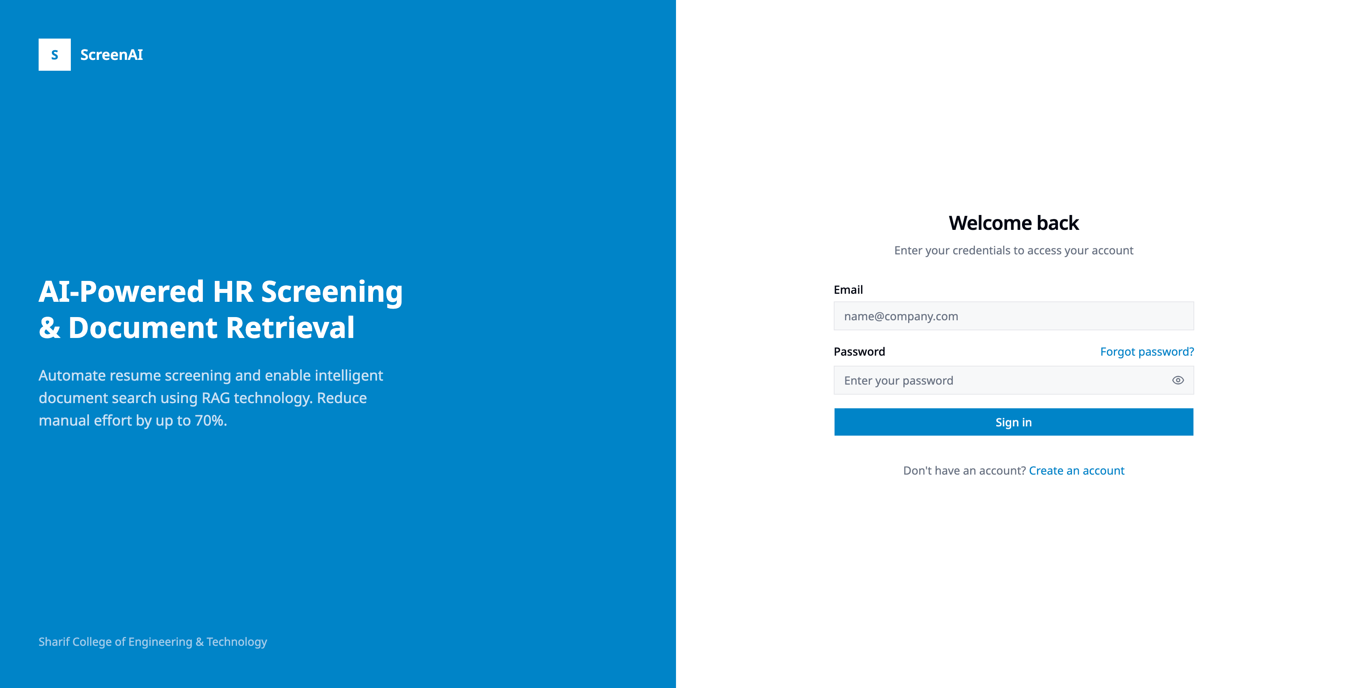
Figure 6.1: Login screen under test
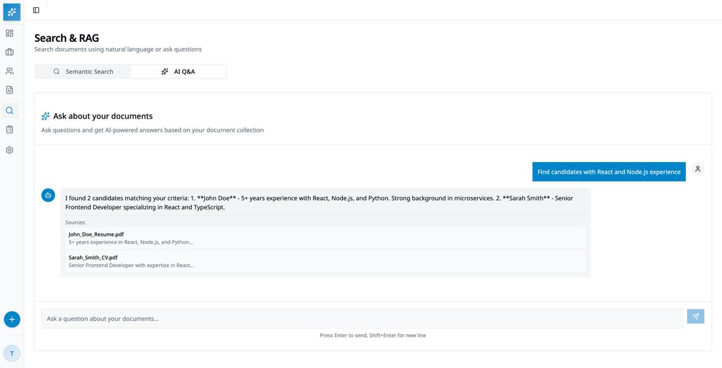
Figure 6.2: Hybrid search and RAG question-answering under test

6.3 Performance Evaluation
Performance was measured on the development stack rather than a production server. The test machine was a single laptop running WSL2 with a 13th-generation Intel Core i5-13450HX (16 logical cores) and about 7.6 GiB of RAM allocated to the WSL2 virtual machine. The sentence-transformer embedder ran on an NVIDIA RTX 5050 laptop GPU, the RAG model was the hosted Claude Haiku 4.5, and the corpus held 18 ready documents indexed as 49 chunks. All timings use a monotonic clock, with the first call on each path discarded as warm-up. Table 6.3 summarises the results, which are discussed below.
Table 6.3: Measured Performance (Development Stack)
Path | Metric | Result
Hybrid search (server-side, excludes LLM) | median / 95th-percentile latency | 72 ms / 167 ms (N = 31)
Ingestion, text PDF | upload to READY | 44.1 s avg (5.1 to 103.1 s, page-driven)
Ingestion, scanned image (OCR path) | upload to READY | 4.1 s (single page)
Sustained ingestion (batch, worker concurrency 1) | throughput | 1.5 documents / minute
Chunk embedding (GPU, batch 128) | per chunk | 0.57 ms
RAG streaming answer | time-to-first-token | 947 ms avg (749 to 1573 ms)
RAG streaming answer | full completion | 1.5 s avg (1.1 to 1.9 s)

6.3.1 Retrieval Latency
Hybrid search combines a ChromaDB vector query, a PostgreSQL weighted full-text query, an optional SQL-metadata query, and a fuzzy fallback, all fused via RRF. The lexical and metadata paths run against indexed PostgreSQL columns (a GIN index on search_tsv, JSONB containment for skills), and the vector query is bounded to a small n_results, so end-to-end search stays interactive. Over 31 warm queries, the server-side search latency (excluding LLM generation) had a median of 72 ms and a 95th percentile of 167 ms, with a mean of 86 ms and a range of 28 to 261 ms. The one-off cold call that loads the query-embedding model took about 8 seconds and was excluded. These figures reflect the current small index; retrieval latency will grow as the corpus scales.

6.3.2 Ingestion Throughput
Ingestion runs asynchronously in the Celery worker and is dominated by document extraction rather than API time. Upload returns immediately with status=pending, and the time to reach READY is driven mainly by page count, because the hi-res layout model in the extraction stage runs once per page. Across five text-based PDFs the mean was 44.1 seconds, but the spread was wide: 5.1 seconds for a single-page resume up to 103.1 seconds for a long, complex multi-page document. Three synthesised single-page scanned images that exercised the Tesseract OCR path processed in about 4.1 seconds each, so a simple scanned page is in fact faster than a complex multi-page PDF, and OCR is not the bottleneck. With the Celery worker at concurrency 1, a batch of five documents uploaded together was processed serially at a sustained rate of about 1.5 documents per minute; raising worker concurrency would improve this.

6.3.3 Embedding and LLM Response Times
Embeddings use bge-small-en-v1.5, a small sentence-transformers model. On the RTX 5050 GPU with a batch size of 128, embedding cost a median of 0.57 ms per chunk, so this stage is inexpensive and, in this environment, GPU-bound rather than CPU-bound. The dominant RAG latency is the Claude generation, streamed token-by-token over SSE so that perceived latency stays low. Across 11 warm questions the average time-to-first-token was 947 ms (749 to 1573 ms) and the average full-answer completion was 1.5 seconds (1.1 to 1.9 s); the server-side end-to-end figure, which includes retrieval and generation, reached up to about 2.75 seconds. Because the LLM is hosted, these times also carry network and provider variance.

6.4 Results and Discussion
Measured against the project’s objectives, Hireflow delivers the four capabilities set out in the brief. HR personnel can manage unstructured documents: the ingestion pipeline reliably parses PDFs, DOCX, and images (with OCR), classifies them, and surfaces them through an in-app multi-format viewer, reaching READY within the UX budget and recovering on its own from non-fatal indexing failures. They can search and ask natural-language questions through a hybrid retrieval engine that fuses vector, lexical, metadata, and fuzzy signals, backed by a RAG service that returns grounded, cited answers and, when a question falls outside the corpus, refuses it with an exact sentinel rather than hallucinating. They can screen and rank resumes against jobs using a transparent four-signal weighted score with a persisted, explainable breakdown. And candidates are synced automatically, both from uploaded resumes (on-ready hook) and from Gmail via encrypted OAuth connections with deduplication.
Feature completeness aside, the testing exercise validated the system’s shared guarantees: strict per-user owner scoping (cross-tenant access returns 404 to hide existence, with a documented admin bypass), a timing-safe, non-enumerable auth surface with token rotation, a consistent error envelope, and a fully typed frontend-to-backend contract generated from OpenAPI. The layered architecture, with services depending only on protocols, earned its keep by leaving the core logic unit-testable without any infrastructure.
Testing also brought the gaps into the open rather than papering over them. Login has no rate-limiting or lockout, a password change does not revoke existing refresh tokens, and a few upload edge cases (a zero-byte file, for one) are not yet guarded. These are recorded as known behaviours and hardening candidates, not as defects that block the core workflow. On balance, the results point to a working, coherent system that meets its functional objectives, with a clear and prioritised backlog of security-hardening improvements left for future work.

CHAPTER 7: CONCLUSION & FUTURE WORK
This chapter looks back on the project as delivered. It weighs the outcome against the objectives set out in Chapter 1, is honest about where the current system falls short, and sketches the enhancements that would follow with more time in hand.

7.1 Conclusion
Hireflow began with a simple frustration: managing unstructured HR documents and screening resumes by hand is slow and error-prone. The system set out to ease that burden by bringing document understanding, semantic retrieval, and large-language-model generation together in one coherent, self-hostable platform. It meets the core objectives defined in Chapter 1. Heterogeneous documents, whether PDF, Word, or scanned image, are ingested through an OCR and text-extraction pipeline. Their content is then chunked, embedded, and indexed in ChromaDB, so that a natural-language query returns relevance-ranked results. On top of this sits a Retrieval-Augmented Generation service that answers plain-language questions with source-attributed citations, and declines out-of-scope questions instead of inventing an answer. Candidate resumes are screened and ranked against job criteria through a transparent, weighted scoring model, while intake itself is automated by way of Gmail synchronisation, shortlisting, and Excel export.
The engineering matters as much as the features. The system rests on a disciplined, layered architecture: business logic is kept apart from infrastructure behind Protocol-based adapters. That separation makes each provider (LLM, embeddings, OCR, storage) swappable, and it leaves the core logic unit-testable without any external service standing by. What the project delivers, then, is twofold. It is a working AI-assisted HR tool, and it is a sound approach to weaving OCR, dense-vector retrieval, and LLM generation into a production-shaped whole.

7.2 Limitations
Despite meeting its functional goals, the current version has several limitations:
- Language coverage. Document processing and retrieval are tuned for English, and multilingual documents are not explicitly supported.
- OCR accuracy on poor inputs. Text extraction is reliable on standard printed material, but it degrades on low-quality scans and handwritten content, an inherent limitation of the OCR stage.
- Security hardening gaps. Login lacks rate-limiting and account lockout, a password change does not revoke existing refresh tokens, and some upload edge cases are not yet guarded; these are documented rather than resolved.
- Dependence on an external LLM. RAG answer quality and latency depend on the configured LLM provider, and hosted-model usage introduces variable cost and network dependency, although an on-premise fallback exists.
- Evaluation depth. Retrieval quality is measured against a small labelled fixture, which is large enough to tune the pipeline but too small to prove that the results generalise. A larger, more varied corpus would be needed before the retrieval scores could be reported with confidence.
- Scope boundaries. Third-party ATS integration, video/audio processing, and native mobile applications are out of scope for this version.

7.3 Future Enhancements
With additional time, the following enhancements would strengthen the system:
- Security hardening: add login rate-limiting and lockout, refresh-token revocation on password change, and zero-byte/edge-case upload guards.
- Multi-language support: extend OCR and embeddings to additional languages, with language detection during ingestion.
- Quantitative evaluation: capture controlled benchmarks for retrieval latency, ingestion throughput, and RAG relevance, and add automated regression tests for answer quality.
- Third-party ATS integration: integrate with external Applicant Tracking Systems to import and export candidate pipelines.
- Analytics dashboards: expand recruiter-facing analytics (funnel metrics, time-to-shortlist, skill-gap analysis) using the existing charting layer.
- Real-time notifications: notify users when Gmail sync completes, when documents finish processing, or when strong candidates are matched.
- Native mobile application: provide a mobile client for on-the-go review and shortlisting.
- Domain-adapted models: fine-tune or select embeddings specialised for resumes and HR documents to improve retrieval and ranking quality.

REFERENCES
References are numbered in the order in which they are first cited in the text, and are referred to by a bracketed number such as [1]. Entries follow IEEE reference style.
- Google Cloud. “Document AI overview.” Google Cloud. https://cloud.google.com/document-ai (accessed Sep. 11, 2026).
- Amazon Web Services. “Amazon Textract: Extract text and data from documents.” AWS. https://aws.amazon.com/textract (accessed Sep. 11, 2026).
- Microsoft. “Azure AI Document Intelligence documentation.” Microsoft Azure. https://azure.microsoft.com/en-us/products/ai-services/ai-document-intelligence (accessed Sep. 11, 2026).
- R. Smith, “An overview of the Tesseract OCR engine,” in Proc. 9th Int. Conf. Document Analysis and Recognition (ICDAR), vol. 2, 2007, pp. 629-633.
- Artifex Software. “PyMuPDF documentation.” Artifex. https://pymupdf.readthedocs.io (accessed Sep. 11, 2026).
- J. Johnson, M. Douze, and H. Jegou, “Billion-scale similarity search with GPUs,” IEEE Trans. Big Data, vol. 7, no. 3, pp. 535-547, 2021.
- Hugging Face. “Document AI: Understanding documents with transformers.” Hugging Face. https://huggingface.co/blog/document-ai (accessed Sep. 11, 2026).
- A. Vaswani et al., “Attention is all you need,” in Advances in Neural Information Processing Systems, vol. 30, 2017, pp. 5998-6008.
- P. Lewis et al., “Retrieval-augmented generation for knowledge-intensive NLP tasks,” in Advances in Neural Information Processing Systems, vol. 33, 2020, pp. 9459-9474.
- N. Reimers and I. Gurevych, “Sentence-BERT: Sentence embeddings using Siamese BERT-networks,” in Proc. Conf. Empirical Methods in Natural Language Processing (EMNLP-IJCNLP), 2019, pp. 3982-3992.
- Anthropic. “Claude documentation.” Anthropic. https://docs.anthropic.com (accessed Sep. 11, 2026).
- D. Hardt, “The OAuth 2.0 authorization framework,” IETF RFC 6749, Oct. 2012.
- Greenhouse Software. “Greenhouse applicant tracking system.” Greenhouse. https://www.greenhouse.io (accessed Sep. 11, 2026).
- Workday. “Workday Recruiting.” Workday. https://www.workday.com (accessed Sep. 11, 2026).
- Eightfold AI. “Eightfold AI talent intelligence platform.” Eightfold AI. https://eightfold.ai (accessed Sep. 11, 2026).
- LangChain. “LangChain documentation.” LangChain. https://python.langchain.com (accessed Sep. 11, 2026).
- IEEE Recommended Practice for Software Requirements Specifications, IEEE Std 830-1998, 1998.
- M. Jones, J. Bradley, and N. Sakimura, “JSON Web Token (JWT),” IETF RFC 7519, May 2015.
- A. Biryukov, D. Dinu, D. Khovratovich, and S. Josefsson, “Argon2 memory-hard function for password hashing and proof-of-work applications,” IETF RFC 9106, Sep. 2021.
- S. Ramirez. “FastAPI documentation.” FastAPI. https://fastapi.tiangolo.com (accessed Sep. 11, 2026).
- PostgreSQL Global Development Group. “PostgreSQL 15 documentation.” PostgreSQL. https://www.postgresql.org/docs/15/ (accessed Sep. 11, 2026).
- Chroma. “Chroma documentation.” Chroma. https://docs.trychroma.com (accessed Sep. 11, 2026).
- Celery Project. “Celery documentation.” Celery. https://docs.celeryq.dev (accessed Sep. 11, 2026).
- Redis. “Redis documentation.” Redis. https://redis.io/docs/latest/ (accessed Sep. 11, 2026).
- MinIO. “MinIO object storage documentation.” MinIO. https://min.io/docs/minio/linux/index.html (accessed Sep. 11, 2026).
- S. Xiao, Z. Liu, P. Zhang, and N. Muennighoff, “C-Pack: Packed resources for general Chinese embeddings,” arXiv:2309.07597, 2023.
- Meta. “React documentation.” React. https://react.dev (accessed Sep. 11, 2026).
- Docker. “Docker documentation.” Docker. https://docs.docker.com (accessed Sep. 11, 2026).
- G. V. Cormack, C. L. A. Clarke, and S. Buettcher, “Reciprocal rank fusion outperforms Condorcet and individual rank learning methods,” in Proc. 32nd Int. ACM SIGIR Conf. Research and Development in Information Retrieval, 2009, pp. 758-759.
- R. Nogueira and K. Cho, “Passage re-ranking with BERT,” arXiv:1901.04085, 2019.

APPENDICES

Appendix A: User Manual
A complete step-by-step user manual is provided as a separate document accompanying this report. It covers sign-up and login, uploading documents, searching and asking questions, creating jobs, screening candidates, connecting Gmail, and exporting shortlists. The main user interfaces are also illustrated in Chapter 4 (Figures 4.11-4.15) and Chapter 6.

Appendix B: Sample Code
Representative source listings are provided in Chapter 5 (Sections 5.3 and 5.4), including the timing-safe authentication routine, the weighted candidate-scoring blend, a self-documenting upload route, and the shared ORM mixins. The complete source code, including the backend, frontend, and deployment configuration, is available in the project’s public GitHub repository:
https://github.com/zainulhassan815/hireflow

Appendix C: Gantt Chart (FYP-I and FYP-II)
The project schedule across both FYP phases is summarised below. Filled cells (■) indicate the months in which each activity was active.
Activities / Tasks | M1 | M2 | M3 | M4 | M5 | M6 | M7 | M8
Project Topic Selection | ■
Problem Identification | ■ | ■
Literature Review |  | ■ | ■
Requirements Gathering & Feasibility Study |  | ■ | ■
Software Requirements Specification (SRS) |  |  | ■ | ■
System Design (UML, Database, UI) |  |  |  | ■ | ■
Prototype Development |  |  |  | ■ | ■
Database Development |  |  |  |  | ■ | ■
Frontend Development |  |  |  |  | ■ | ■ | ■
Backend Development |  |  |  |  | ■ | ■ | ■
System Integration & Testing |  |  |  |  |  | ■ | ■ | ■
Unit Testing |  |  |  |  |  | ■ | ■
User Acceptance Testing (UAT) |  |  |  |  |  |  | ■ | ■
Bug Fixing & Optimisation |  |  |  |  |  |  | ■ | ■
Documentation |  |  |  |  |  |  | ■ | ■
Final Report Writing |  |  |  |  |  |  |  | ■
Final Presentation & Submission |  |  |  |  |  |  |  | ■

