# MirMuhammadSaifAli-BSE23S-108-blog

**My Personal Blog**

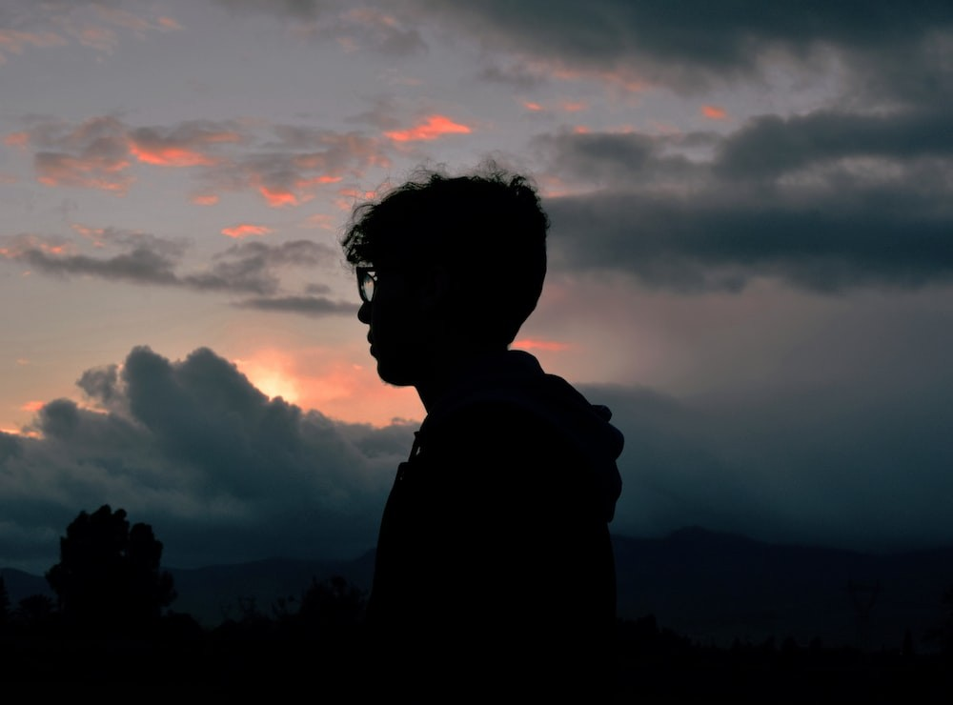

## Introduction

Greetings, viewers! Welcome to my individual blog. My opinions, experiences, and observations on a variety of subjects will be shared in this blog. Thus, let's begin!

## About Me

* Name: Mir Muhammad Saif Ali
* Age: 19
* Occupation: Software Engineer
* Hobbies: Reading, Traveling, and Photography

## My Journey

I began working as a software developer. It's been a fantastic learning opportunity that's been full with obstacles and potential for development. I've been working on a variety of

projects over this period, honing my skills in a number of programming languages and frameworks.

Building a cutting-edge mobile app that transformed how people interact was one of the pinnacles of my professional career. The chance to collaborate with an excellent team and add to a product that will benefit millions of consumers was a fantastic opportunity.

## My Passions

I have a strong enthusiasm for reading in addition to my job life. My doorway into other places and viewpoints has always been through books. Science fiction, fantasy, and self- improvement books are a few of my favourites.



I also enjoy taking pictures of stunning situations when travelling. My perspectives are expanded, and my creativity is stimulated, by travelling to new locations and experiencing other cultures.

## Get in Touch

If you want to connect with me or have any questions, feel free to reach out to me via email. I would love to hear from you!

Thanks for visiting my blog!

Remember, life is an adventure. Embrace it with an open mind and a curious spirit.

# CODE

### # **My Personal Blog**

![My Profile Picture](https://images.unsplash.com/photo-1529665253569- 6d01c0eaf7b6?ixlib=rb- 4.0.3&ixid=M3wxMjA3fDB8MHxzZWFyY2h8NHx8cHJvZmlsZXxlbnwwfHwwfHx8MA%3D%3D&w= 1000&q=80)

### ## Introduction

---

Greetings, viewers! Welcome to my individual blog. My opinions, experiences, and observations on a variety of subjects will be shared in this blog. Thus, let's begin!

### ## About Me

---

* Name: Mir Muhammad Saif Ali
* Age: 19
* Occupation: Software Engineer
* Hobbies: Reading, Traveling, and Photography

### ## My Journey

---

I began working as a software developer. It's been a fantastic learning opportunity that's been full with obstacles and potential for development. I've been working on a variety of projects over this period, honing my skills in a number of programming languages and frameworks.

Building a cutting-edge mobile app that transformed how people interact was one of the pinnacles of my professional career. The chance to collaborate with an excellent team and add to a product that will benefit millions of consumers was a fantastic opportunity.

### ## My Passions

---

I have a strong enthusiasm for reading in addition to my job life. My doorway into other places and viewpoints has always been through books. Science fiction, fantasy, and self-improvement books are a few of my favourites.

![Image Source](https://encrypted- tbn0.gstatic.com/images?q=tbn:ANd9GcS8OFa7ZwZmLs5KzlEpXPYktVlDypCqGCuUJg&u sqp=CAU)

I also enjoy taking pictures of stunning situations when travelling. My perspectives are expanded, and my creativity is stimulated, by travelling to new locations and experiencing other cultures.

**## Get in Touch**

---

If you want to connect with me or have any questions, feel free to reach out to me via [email](mailto:itxsaif9808786@gmail.com). I would love to hear from you!

Thanks for visiting my blog!

*_***\*\*Remember\*\****, life is an adventure, Embrace it with an open mind and a curious spirit._*

# Repository Link

https://github.com/Saifali9808/MirMuhammadSaifAli-BSE23S-108-blog.git